Supplementary material
As a result of the study of the species diversity of lichens in the vicinity of the Burabay National Park, 44 species of lichens belonging to 9 families, and 19 genera were identified. The results of the study are shown in the tab 1.
Table 1. Species composition of lichens in the territory of the Burabay National Park
Genera | Species | Photo
Families Dermatocarpaceae
1. Dermatocarpon | Dermatocarpon aquaticum (Weiss.) Zahlbr. | 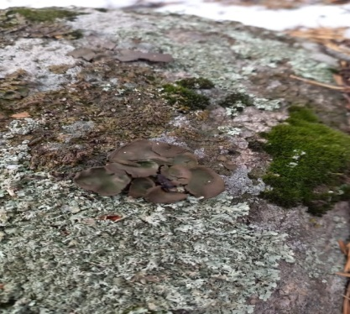
Families Verrucariaceae
2. Verrucaria | Verrucaria nigrescens (Асh.) Pers. | 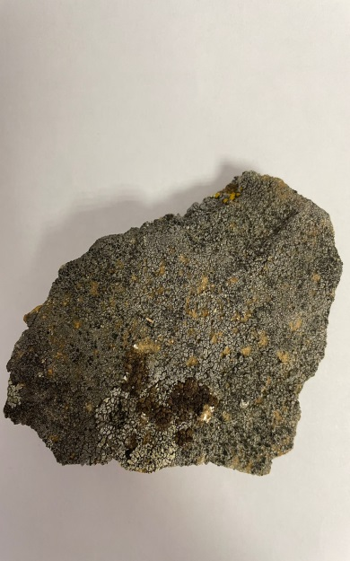
Families Peltigeraceae
3. Peltigera | Peltigera spuria (Асh.) DС. | 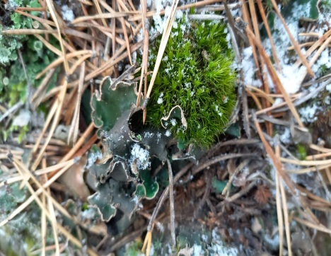
3. Peltigera | Peltigera canina (L.) Willd. | 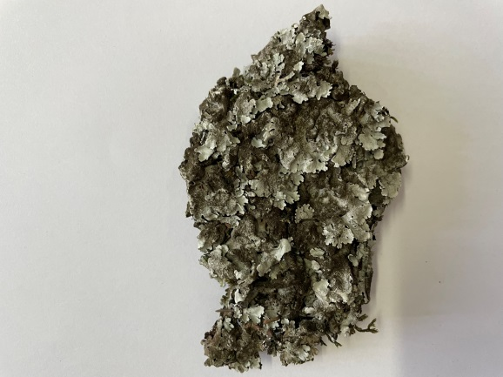
3. Peltigera | Peltiqera rufescens (Weis.) Humb. | 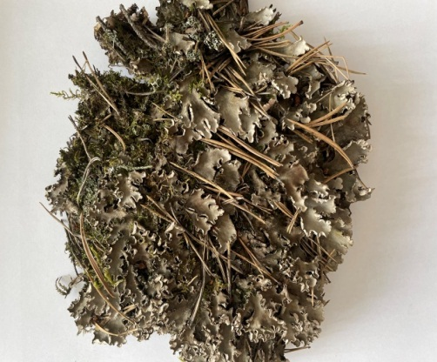
Families Lecideaceae
4. Psora | Hypocenomyce scalaris (Ach. ex Lilj.) M. Choisy (Psora оstreata) | 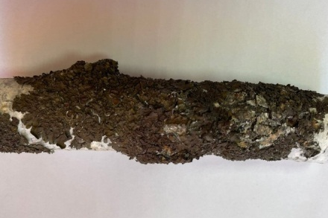
5. Rhizocarpon | Rhizocarpon geographicum (L.) DC. | 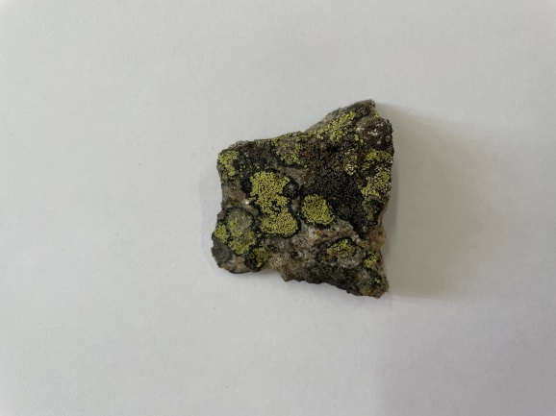
6. Lecidea | Lecidea glomerulosa Steud. | 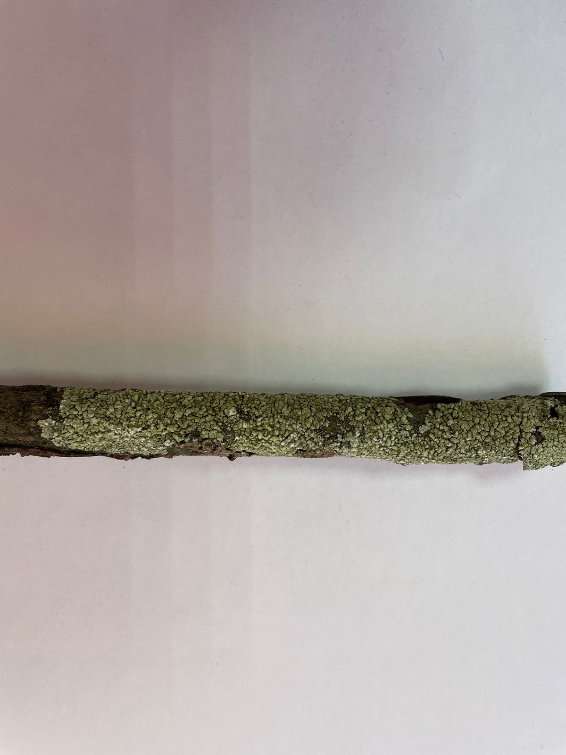
Families Cladoniaceae
7. Cladonia | Cladonia fimbriata (L.) Fr. | 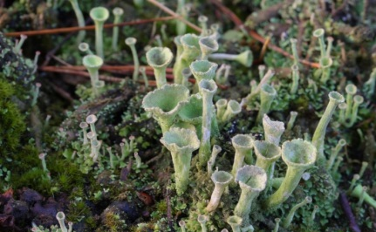
7. Cladonia | Cladonia gracilis (L.) Willd. | 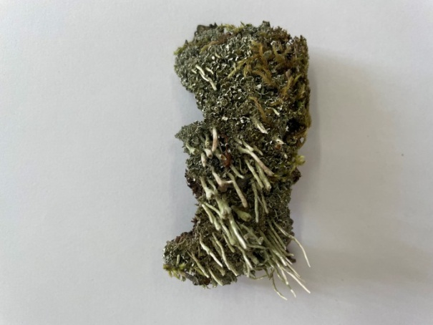
7. Cladonia | Cladonia sylvatica (L.) Hoffm. | 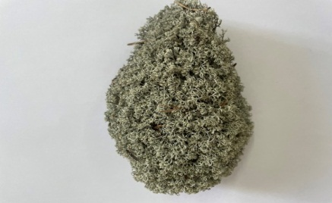
7. Cladonia | Cladonia rangiferina (L.) | 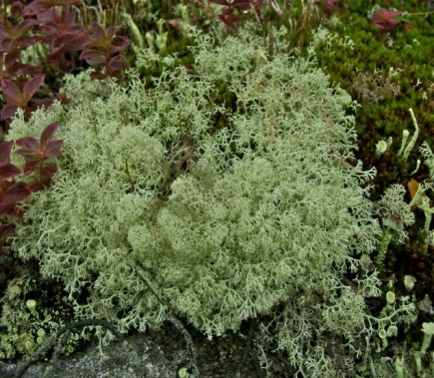
7. Cladonia | Cladonia coccifera (L.) Willd. | 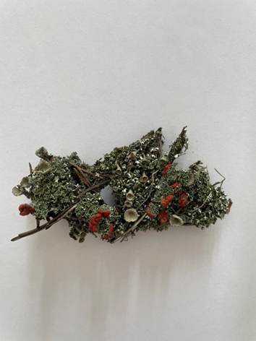
7. Cladonia | Cladonia alpicola (Flоt.) Vain. | 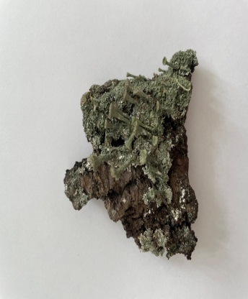
7. Cladonia | Cladonia verticillata (Hoffm.) Schaer. | 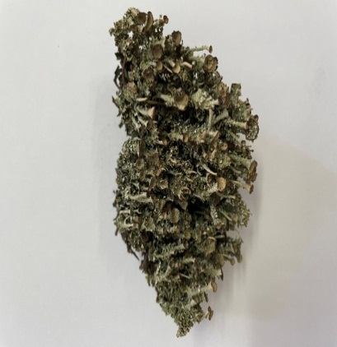
7. Cladonia | Cladonia deformis (L.) | 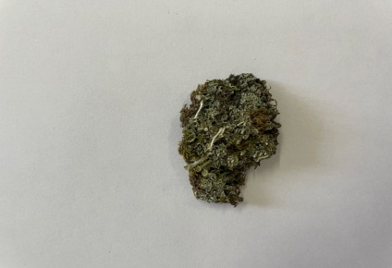
7. Cladonia | Cladonia crispate (Ach.) Flot. | 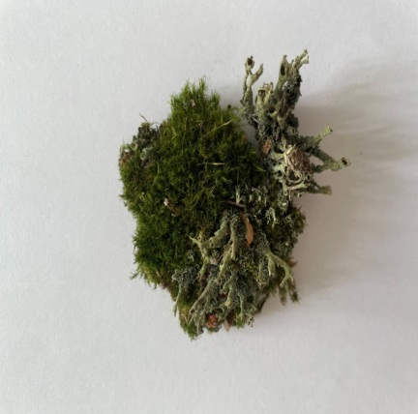
7. Cladonia | Cladonia cornuta (L.) Hoffm. | 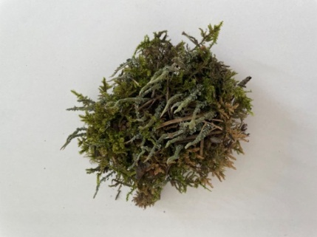
7. Cladonia | Cladonia tenuis (F I k.) Нагm. | 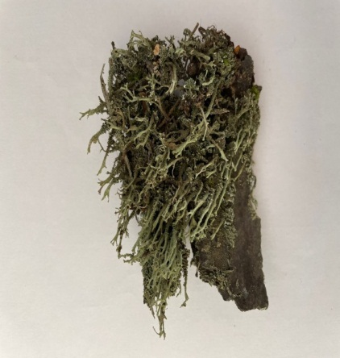
7. Cladonia | Cladonia coniocraea (Flk.) Spreng. | 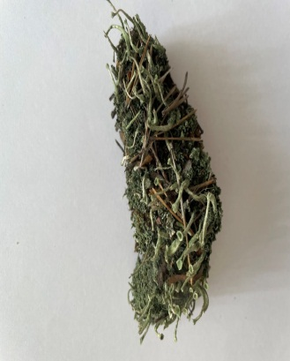
7. Cladonia | Cladonia alpestris (L.) Rabenh. | 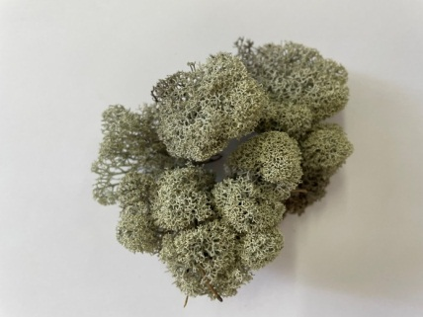
Families Lecanoraceae
8. Haematomma | Haematomma ventosum (L.) | 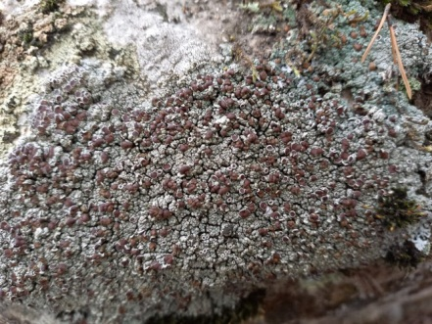
Families Parmeliaceae
9. Parmellia | Parmelia vegans Nyl. | 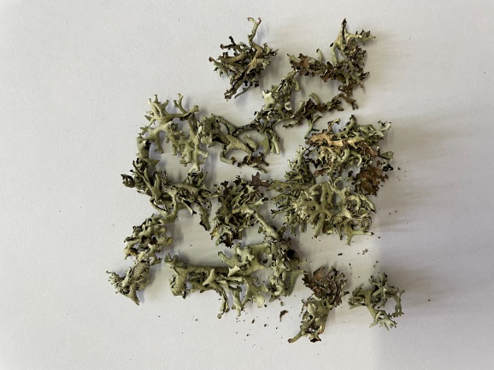
9. Parmellia | Parmelia sulcatа Taylor | 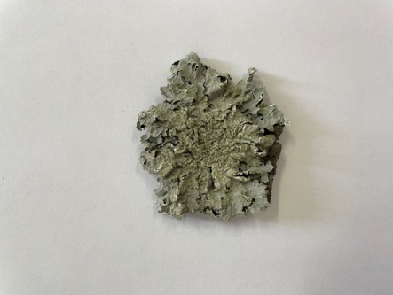
9. Parmellia | Parmelia caperata (L.) Ach. | 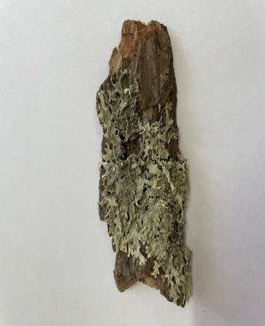
9. Parmellia | Parmelia acetabulum (Neck.) Duby. | 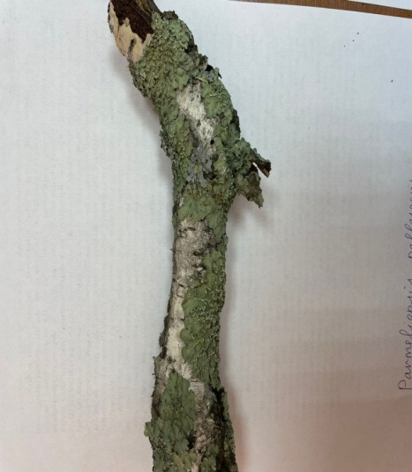
9. Parmellia | Parmelia saxatilis Linds. | 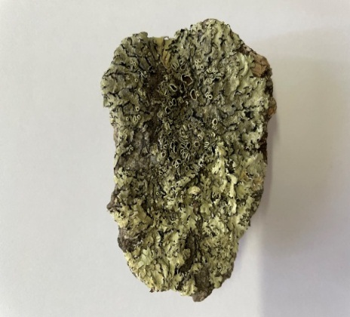
9. Parmellia | Parmelia olivacea (L.) Ach. | 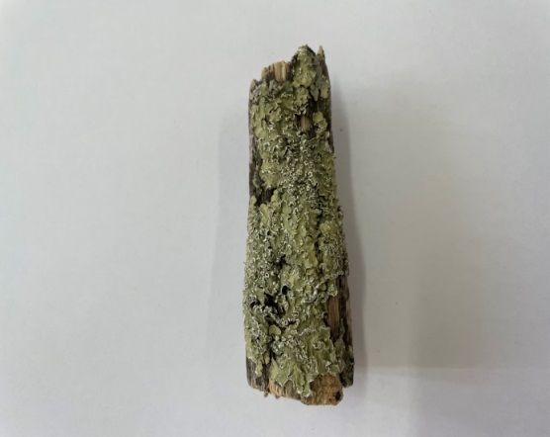
10. Hypogymnia | Hypogymnia physodes (L.) Nyl. | 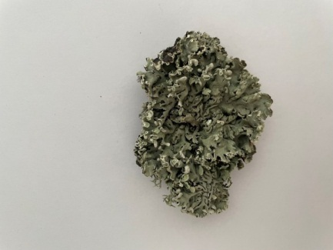
11. Evernia | Evernia prunastri (L.) Ach. | 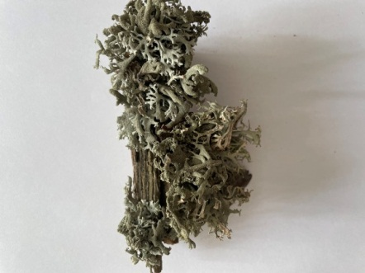
11. Evernia | Evernia thamnodes (Flot.) Arnold.  (син.: Letharia thamnodes (Flot.) Arnold.) | 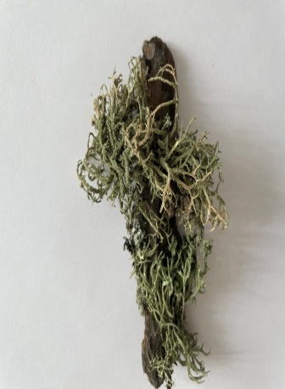
12. Xanthoparmelia | Xanthoparmelia conspersa (Ehrh.) Ach. | 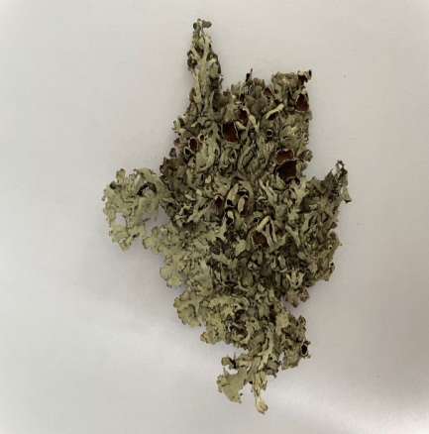
13. Parmeliopsis | Parmeliopsis hyperopta (Ach.) Vain. | 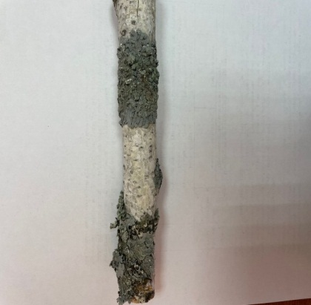
13. Parmeliopsis | Parmeliopsis pallescens (Hoffm.) Hillm. | 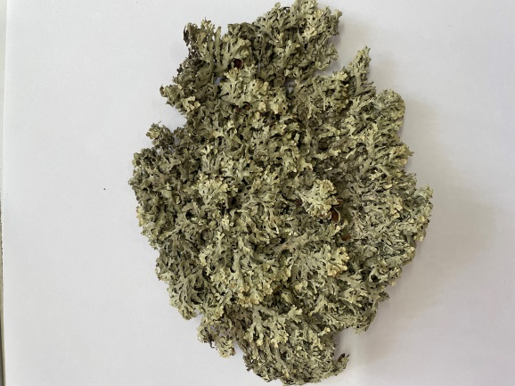
14. Cetraria | Cetraria glauca (L.) Ach. | 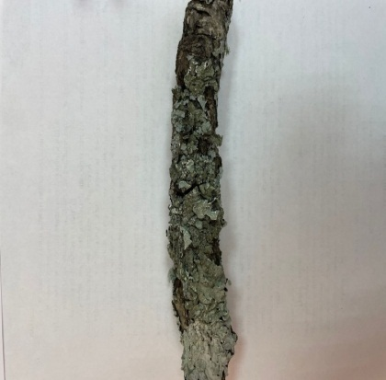
14. Cetraria | Cetraria pinastri (Scop) S.F. Gray. | 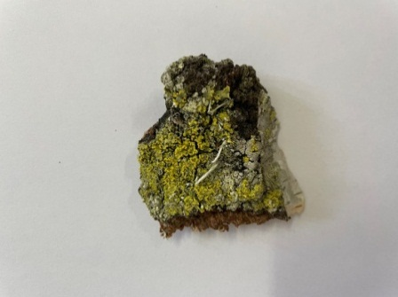
Families Teloschistaceae
15. Caloplaca | Caloplaca murorum (Hоffm.) Th. Fr. | 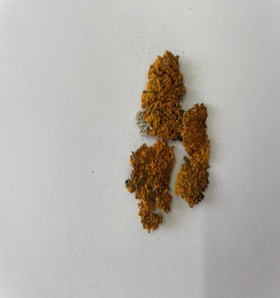
15. Caloplaca | Caloplaca aurantiaca (Lightf.) Тh. Fr. | 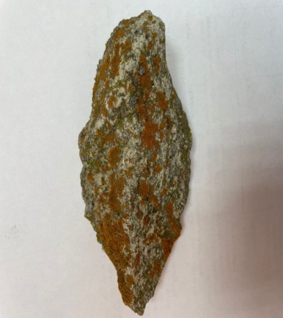
16. Xantoria | Xantoria candelaria (L.) Th. Fr. | 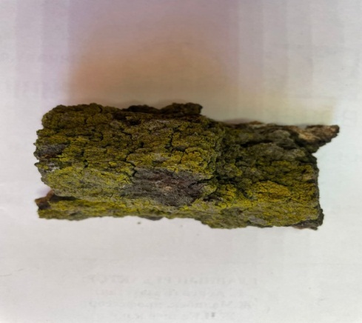
Families Physciaceae
17. Physcia | Physcia aipolia (Ehrh.) Furnr. | 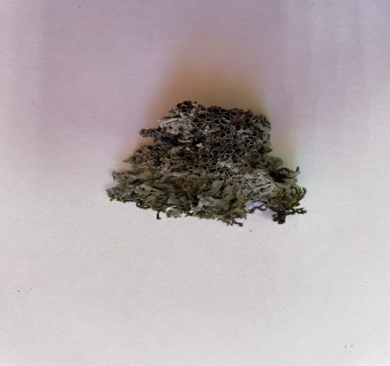
17. Physcia | Physcia stellaris (L.) Nyl. | 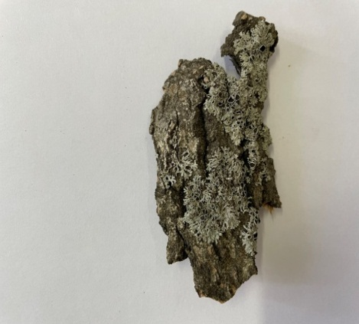
18. Gasparrinia | Gasparrinia elegans (Link.) Stein | 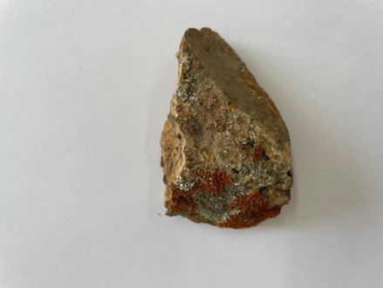
19. Gyrophora | Gyrophora murina (Ach.) | 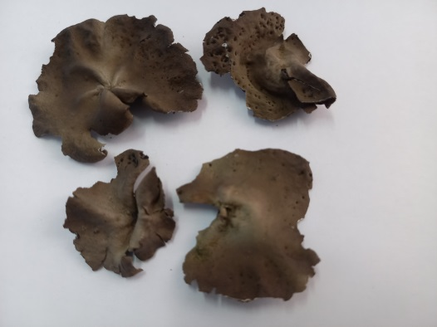
19. Gyrophora | Gyrophora polyphylla (L.) Funсk. | 