Supporting Information

Vanadium Selenide Nanobelt Electrocatalyst for Extremely High Dopamine-Selective Detection

Sudong Chae^{1#}, Chaeheon Woo^{1#}, Geun Ho Gu^{2#}, Tae Yeong Kim¹, Jiho Jeon³, Hyeok Jin Kwon⁴, Seungbae Oh¹, Kyung Hwan Choi³, Xue Dong³, Jungyoon Ahn¹, Ghulam Asghar³, Hyung-Suk Oh^{5,6}, Hak Ki Yu⁷, Hyo Won Kim^{4*}, and Jae-Young Choi^{1,3,6*}

¹School of Advanced Materials Science & Engineering, Sungkyunkwan University, Suwon 16419, Republic of Korea.
²KENTECH Institute for Hydrogen Energy Technology, Korea Institute of Energy Technology (KENTECH), 200 Hyeoksin-ro, Naju 58330, Korea
³SKKU Advanced Institute of Nanotechnology (SAINT), Sungkyunkwan University, Suwon 16419, Republic of Korea.
⁴KENTECH Institute for Environmental and Climate Technology, Korea Institute of Energy Technology (KENTECH), 200 Hyeoksin-ro, Naju 58330, Korea
⁵Clean Energy Research Center, Korea Institute of Science and Technology (KIST), Hwarang-ro 14-gil 5, Seongbuk-gu, Seoul, 02792, Republic of Korea
⁶KIST-SKKU Carbon-Neutral Research Center, Sungkyunkwan University, 2066 Seobu-ro, Jangan-gu, Suwon, 16419, Republic of Korea
⁷ Department of Materials Science and Engineering & Department of Energy Systems Research, Ajou University, Suwon, 16499, Republic of Korea.
# S. Chae, C. Woo, and G. H. Gu contributed equally to this work.

E-mail: hwkim@kentech.ac.kr, jy.choi@skku.edu

Keywords: colloidal synthesis; dopamine sensing; electrochemical sensing; 1D van der Waals materials; vanadium selenide

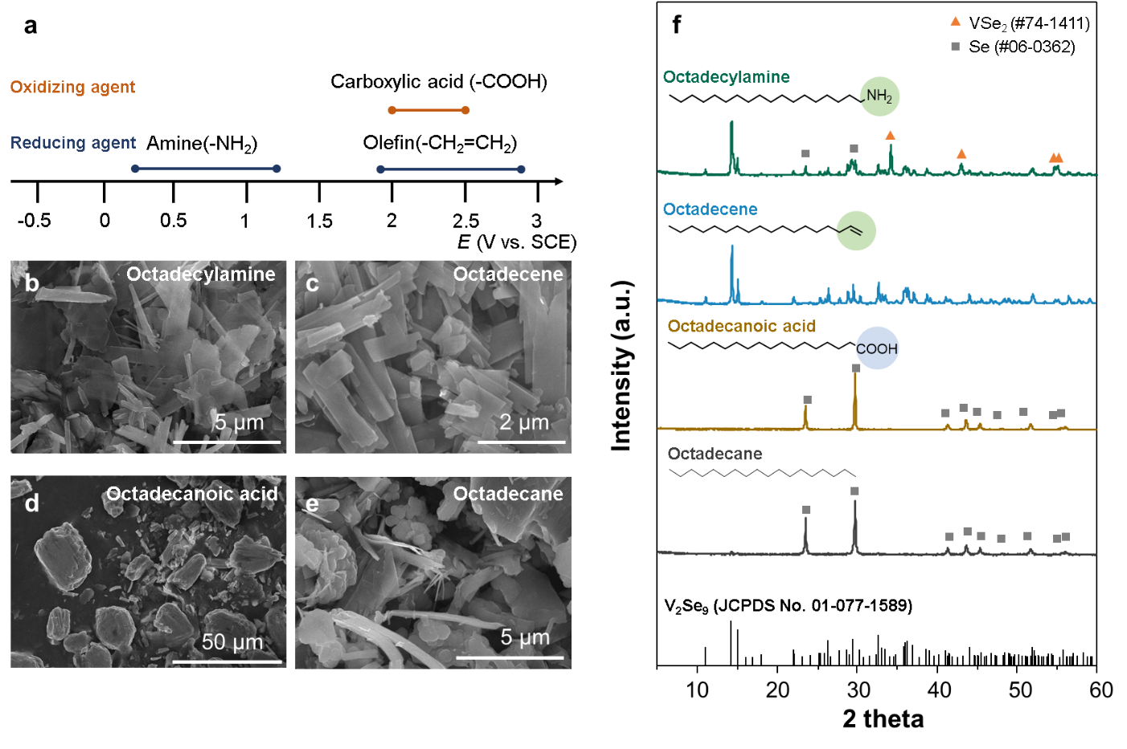
Fig. S1. (a) redox potential range of common organic reducing functional group (amine, olefin) and common oxidizing functional group (carboxylic acid), (b-e) SEM images and (f) XRD patterns of as prepared powders using 1-octaceylamine, 1-octadecene, 1-octadecanoic acid, and n-octadecane, respectably.

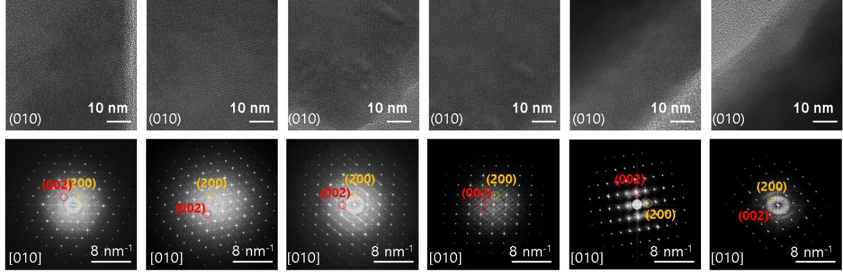
Fig. S2. HR-TEM images (top) and corresponding FFT patterns (bottom) of several V₂Se₉ nanobelts basal plane.

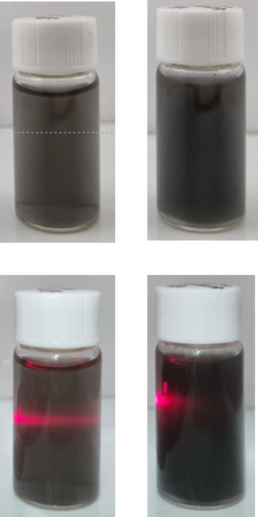
Fig. S3. Digital photographs of V₂Se₉ bulk(left) and V₂Se₉ nanobelt(right) dispersed solution

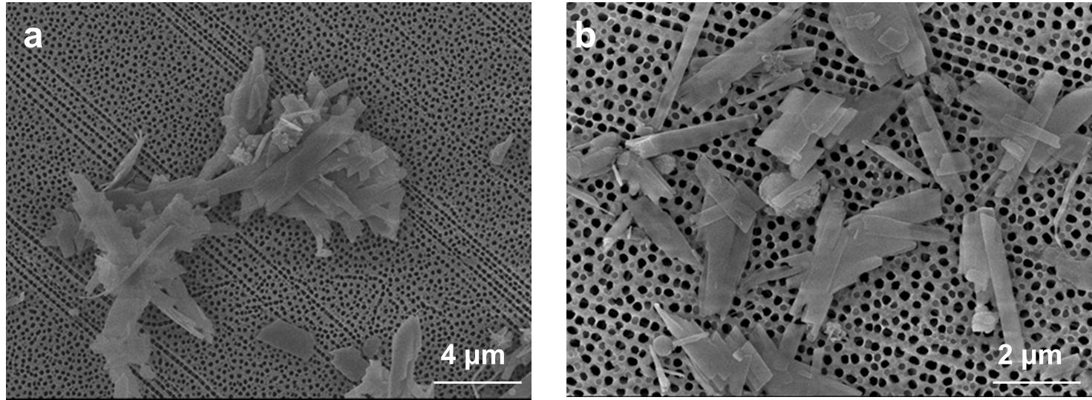
Fig. S4. SEM images of V₂Se₉ nanobelts dispersed (a) without and (b) with dopamine

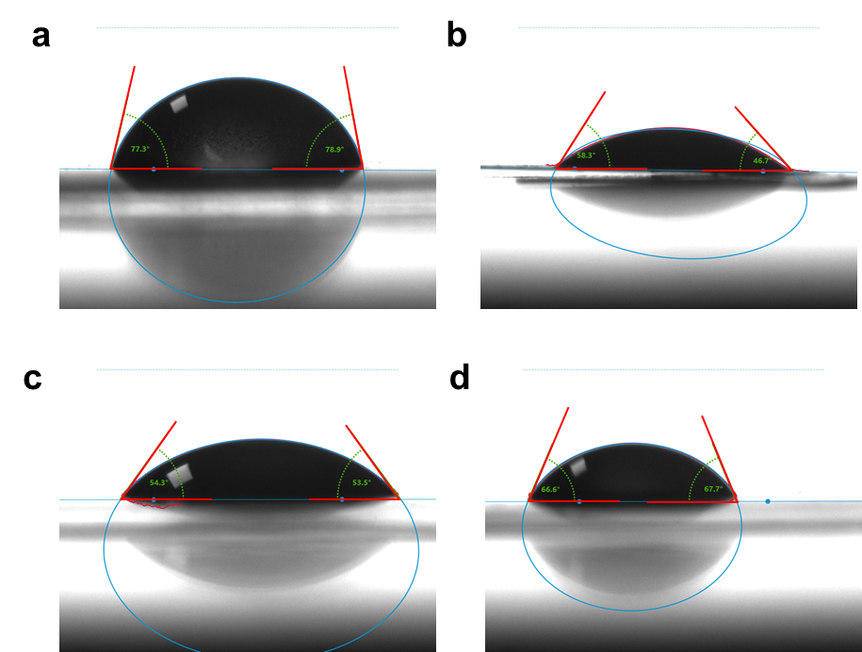
Fig. S5. Contact angle measurement on water for (a) pristine V₂Se₉, (b)V₂Se₉ with dopamine, (c)V₂Se₉ with ascorbic acid, and (d) V₂Se₉ with uric acid film coated on anodisc

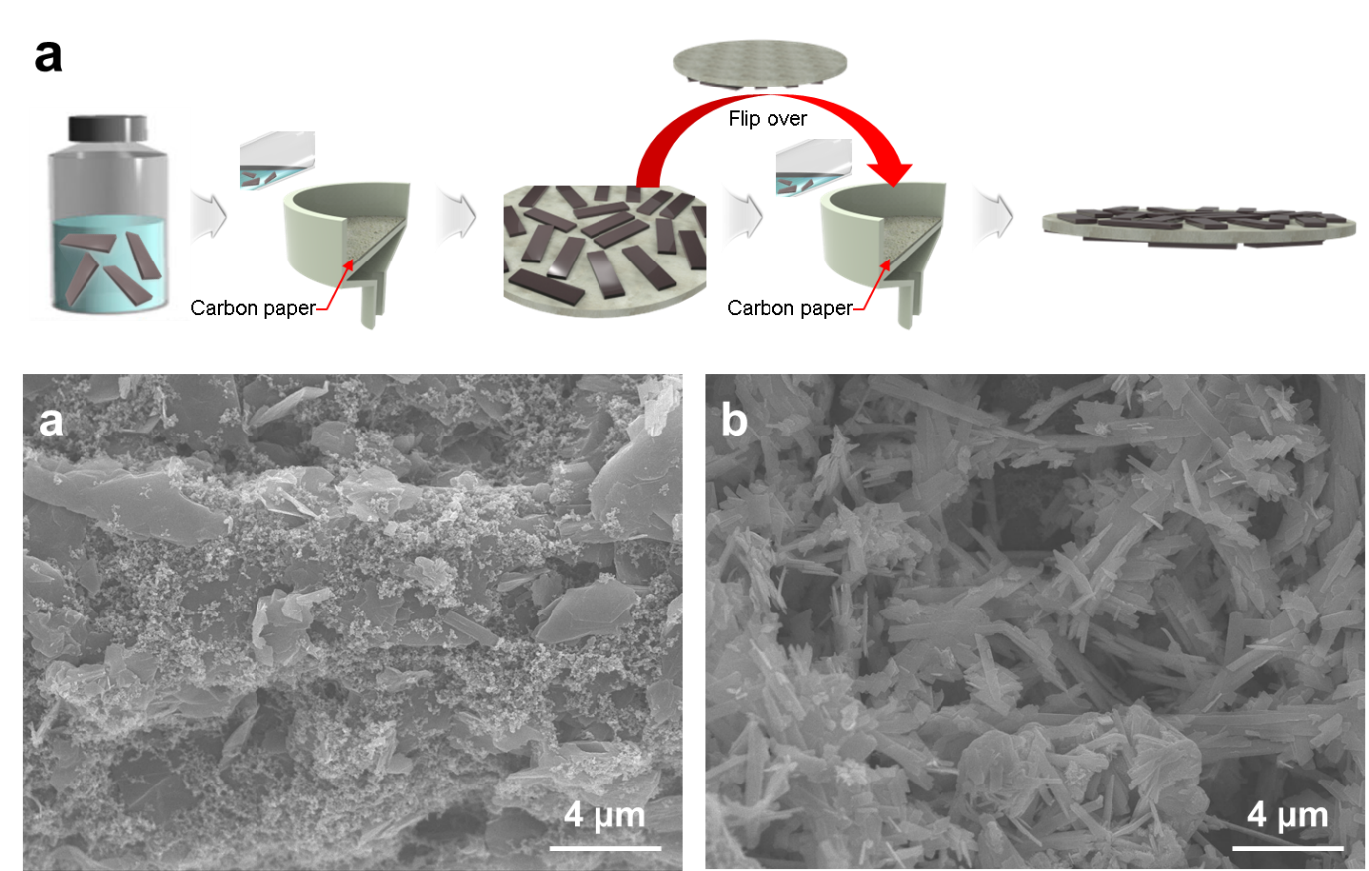
Fig. S6. (a) Schematic illustration of electrode preparation. And SEM images of (b) bare CP and (c) nV₂Se₉/CP

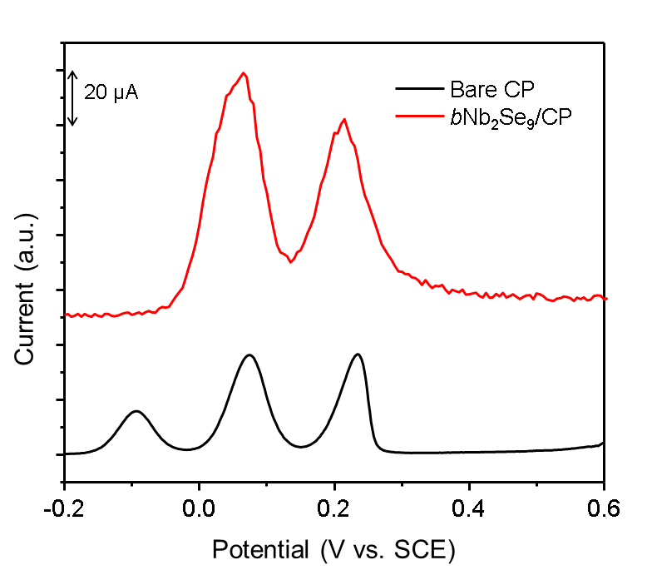
Fig. S7. DPV response observed for 100 μM DA, AA, UA in PBS (pH 7.4) at bare CP, and bNb₂Se₉/CP.

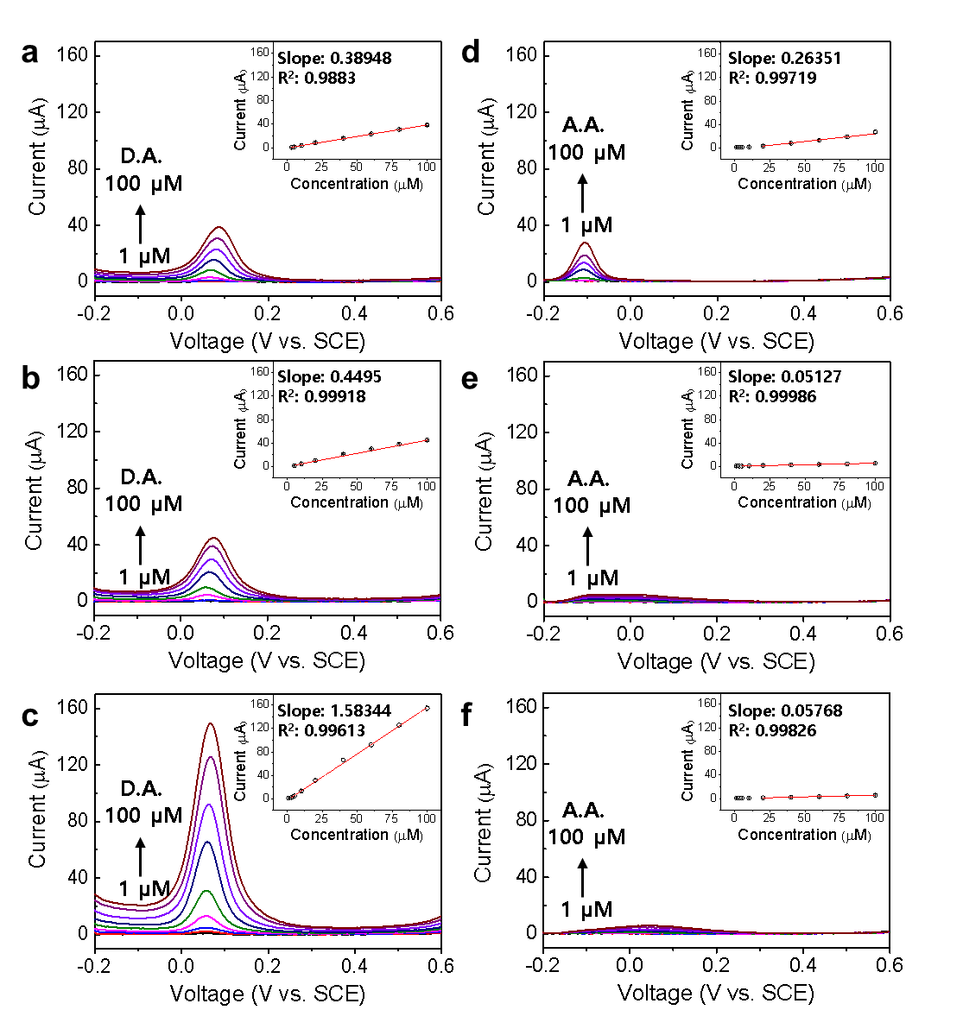
Fig. S8. DPV response of (a-c) 1 – 100 μM DA and (d-f) 1 – 100 μM AA at CP, V₂Se₉ bulk crystal/CP, and V₂Se₉ nanobelt/CP, respectively. The inset shows a plot of the oxidation peak current against the concentration of analyte. The error bars represent standard deviations for three tests.

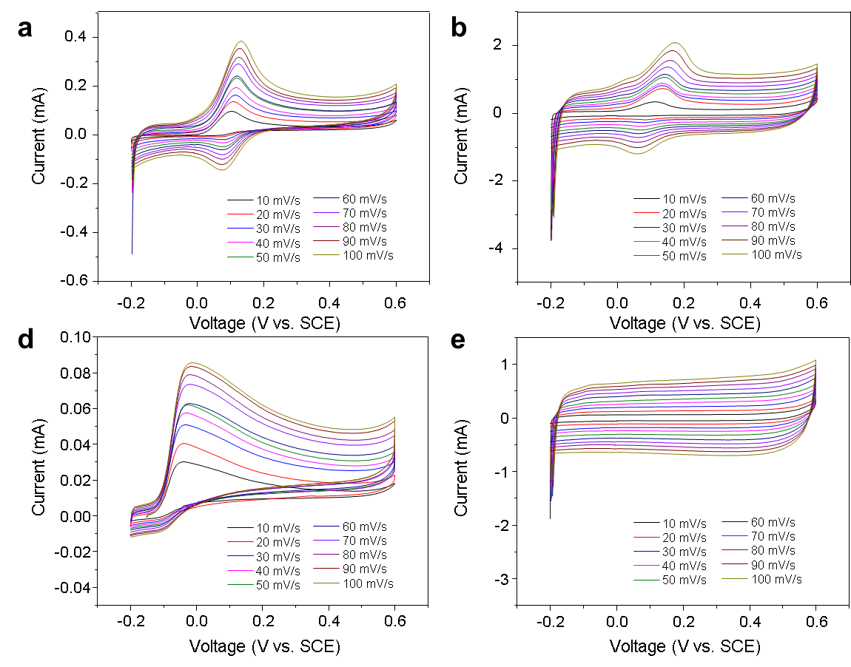
Fig. S9. Scan rate-dependent CV curves of (a) bare CP and (b) nV₂Se₉/CP in 1X PBS solution containing 100 μM DA. Scan rate-dependent CV curves of (c) bare CP and (d) nV₂Se₉/CP in 1X PBS solution containing 100 μM AA.

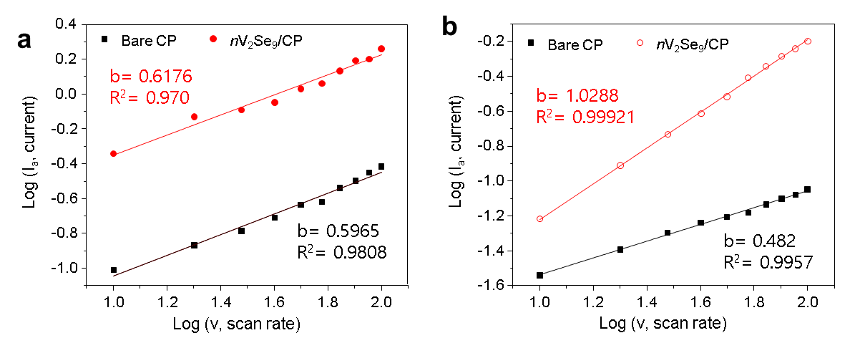

Fig. S10. (a) Log (scan rate) versus log (current) graph for the anodic peaks in scan rate dependent CV of bare CP with 100 uM of DA. (b) Log (scan rate) versus log (current) graph for the anodic peaks in scan rate dependent CV of bare CP with 100 uM of AA. and Log (scan rate) versus log (current) graph for the current value at -0.05 V in scan rate dependent CV curve of nV₂Se₉/CP with 100uM of AA.
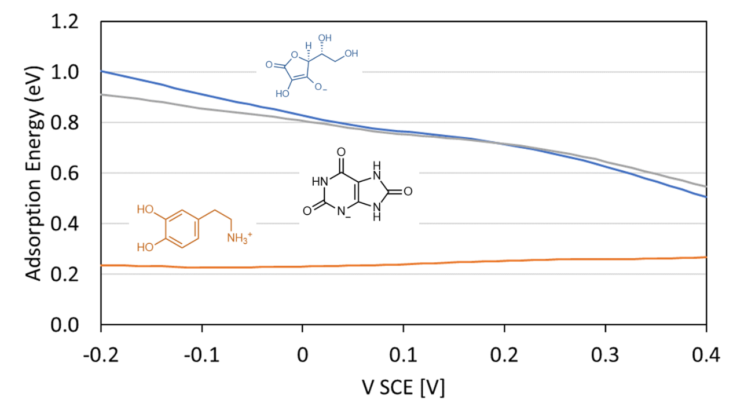
Fig. S11. The adsorption energy of deprotonated AA (blue), protonated DA (orange), and deprotonated UA (black). While the anionic deprotonated AA and UA adsorption becomes stronger with increasing potential, it is not enough to overtake the protonated DA in the kinetically relevant potential.

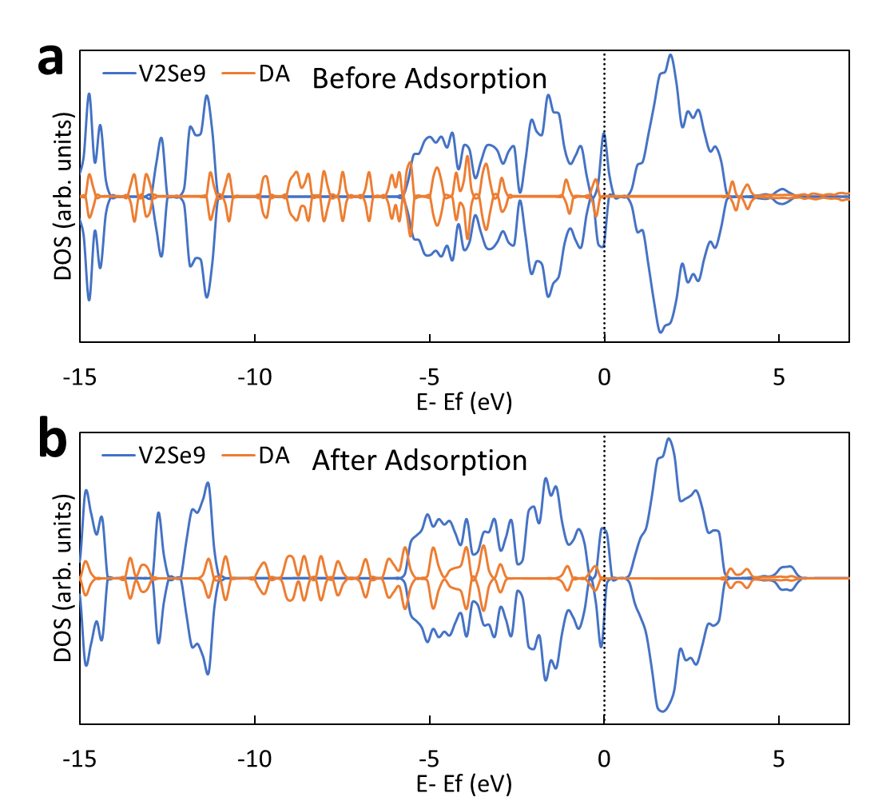
Fig. S12. The density of state of the V₂Se₉ and DA (a) before adsorption and (b) after adsorption. The insignificant change indicates that the bonding is mostly electrostatic and not covalent.

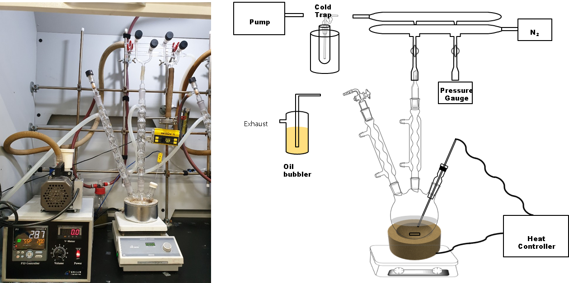
Fig. S13. Digital photograph and schematic illustration of experimental setup for colloidal synthesis.

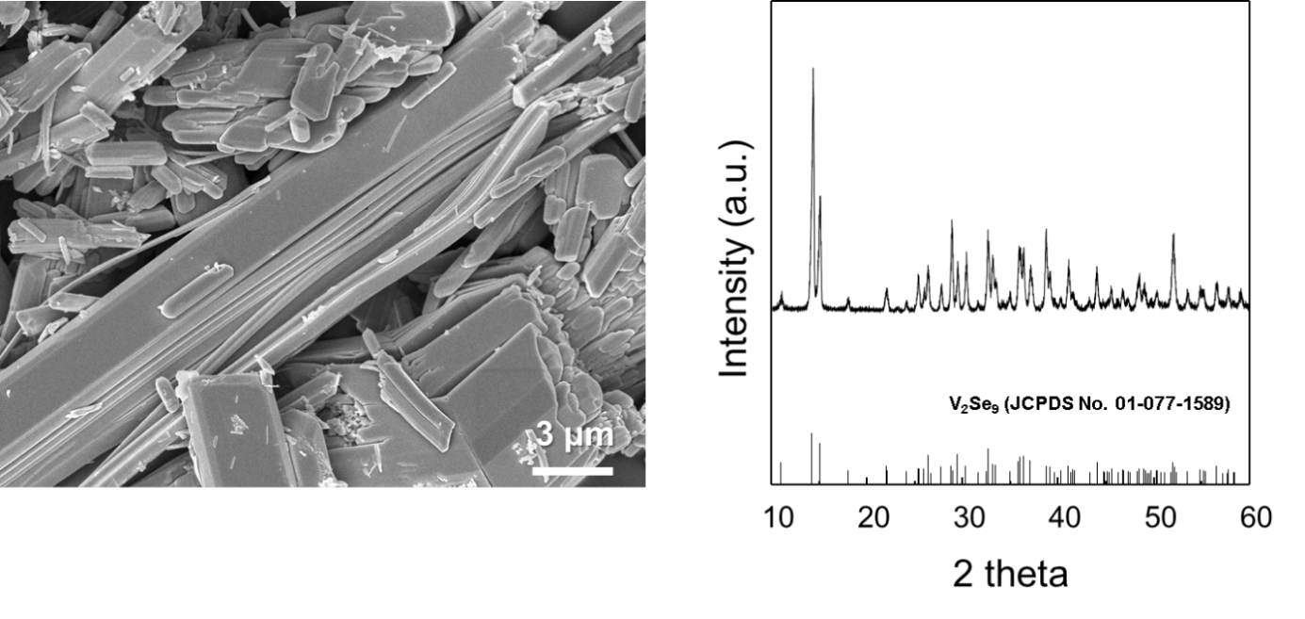
Fig. S14. SEM image and powder XRD pattern of as synthesized V₂Se₉ bulk crystal by solid-state reaction.

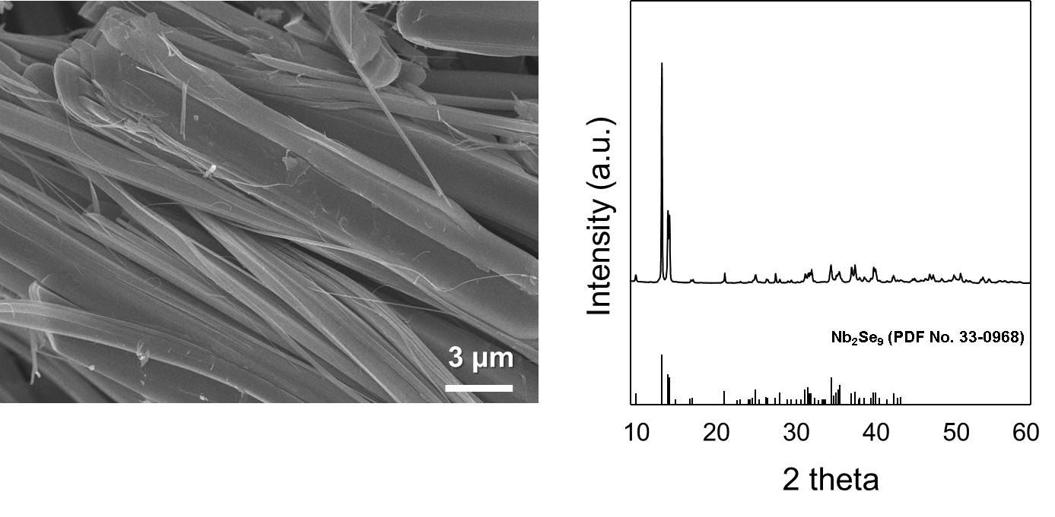
Fig. S15. SEM image and powder XRD pattern of as synthesized Nb₂Se₉ bulk crystal by solid-state reaction.

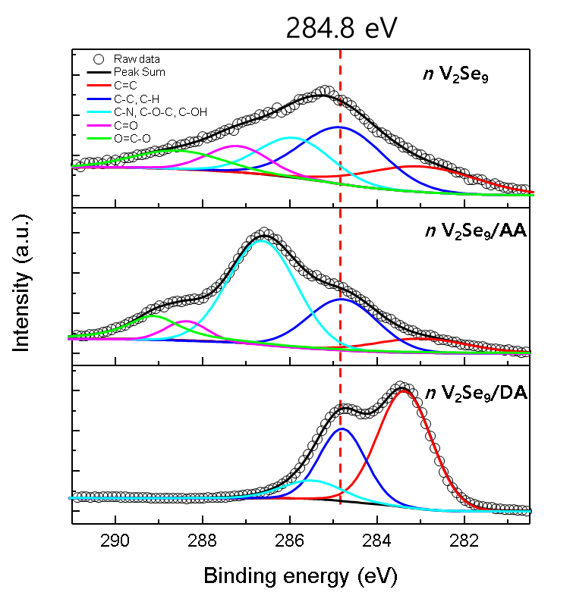
Fig. S16. XPS spectra of C 1s core level for the nV₂Se₉ without and with ascorbic acid or dopamine.

Table S1. Analytical characteristics for detection of DA in the presence of AA on modified electrode with different nano materials.
Modified electrode | Method | Linear range  (μM) | Detection limit  (μM) | Sensitivity  (μA/μM) | R² | Molar ratio  (DA:AA) | Ref.
Carbon nanotube-polypyrrole | DPV | 0.625-100 | 0.06 | 0.086 | 0.992 | 1:50 | ¹
Au-silica core shell | DPV | 0.048-50 | 0.02 | 0.0417 | 0.9936 | - | ²
Graphene oxide-silica | DPV | 0.05-160 | 0.03 | 0.0047 | 0.9982 | - | ³
Au nanoparticles-polymer | CV | 0.02-0.56 | 0.0078 | 0.2443 | 0.9987 | 1:100 | ⁴
Au nanoparticles-polymer | DPV | 1.0-2.4 |  |  | 0.9932 |  | ⁴
Graphene-polymer | LSV | 0.1-830 | 0.11 | 0.025 | 0.995 | - | ⁵
Graphene | DPV | 4-100 | 2.64 | 0.0659 | 0.988 | 1:250 | ⁶
β-Cyclodextrin-graphene nanocomposite | CV | 0.009-12.7 | 0.005 | - | - | 1:1000 | ⁷
Amino-β-cyclodextrin-carbon nanotubes | SWV | 0.7-700 | 0.5 | 0.514 | - | 1:100 | ⁸
Graphene-Au, Ag | SWV | 0.3-300 | 0.205 | 0.03 | - | 1:1000 | ⁹
Gold nanorods | SWV | 0.01-0.1 | 0.0055 | 3.28 | - | 1:1000 | ¹⁰
Phytic acid-single walled carbon nanotube | DPV | 0.0-10 | 0.08 | - | 0.998 | 1:250 | ¹¹
Silanized graphene | DPV | 0.20-25 | 0.01 | - | - | 1:1000 | ¹¹
Poly-methylthiophene-Pd, Pt | DPV | 0.05-1 | 0.008 | 1.44 | 0.9993 | 1:100 | ¹²
Nanoporous gold | DPV | 0.2-1 | 0.017 | - | 0.998 | 1:500 | ¹³
Electrodeposited molecularly imprinted silica | CA | 0.1-1 | 0.014 | 22.3 | 0.994 | 1:50,000 | ¹⁴
AuNP | UV-visible | 0.54-5.4 | 0.36 | - | 0.999 | - | ¹⁵
Au/Pt/Pd/TiO₂NT/Ti | DPV | 0.05-30 | 0.03 | - | 0.98 | 1:2 | ¹⁶
AuNP/TiO₂NT/Ti | CV | 500-2500 | - | - | 0.99 | - | ¹⁷
Au nanostructured | DPV | 1-100 | 5 | 139 | 0.998 | 1:100 | ¹⁸
nanoZnO/GC | DPV | 0.11-800 | 0.06 | - | 0.9963 | 1:25 | ¹⁹
Au@Pd-RGO/GCE | DPV | 0.01-100 | 0.002 | 6.08 | 0.9984 | 1:20 | ²⁰
Pd-CNFs/CPE | DPV | 0.5-160 | 0.2 | - | 0.9988 | 1:40 | ²¹
V₂Se₉ nanobelt/CP | DPV, CA | 1 - 100 | 1 | 1.58 | 0.99613 | 1:10,000 | This work

Calculation of b value for reaction-behavior analysis
To investigate the electrocatalytic oxidation kinetics, the voltametric response by the effect of scan rates was studied. The oxidation behaviors of DA at the electrodes were studied by analyzing the relationship between peak current and scan rate using equations 1 and 2.
$i\left(v\right)= i_{cap}+i_{diff}=av^{b}$ (1)
$i_{cap}= k_{1}v$ (1-a)
$i_{diff}= k_{2}v^{0.5}$ (1-b)

$\log\left(i\right)=\log\left(a\right)+b log⁡(v)$ (2)
The value of b derived by the slope of Equation 2 can be used to determine the controlling mechanism of the reaction. Typically, b values close to 0.5 and 1 indicate diffusion and adsorption controlled behavior, respectively. As depicted in Fig. S9 and S10, DA showed partially reversible redox behavior in both bare CP and nV₂Se₉/CP, and current response increased with increasing scan rate. The b values for the anodic peaks of DA in bare CP and nV₂Se₉/CP were 0.5965 and 0.6176, respectively, indicating that the generated currents in each electrode are derived from a mixed controlled mechanism between diffusion and adsorption. The similar oxidation behaviors of bare CP and nV₂Se₉/CP are attributed to their similar DA philic surface characteristics. On the other hand, AA showed an irreversible anodic peak in bare CP only with a b value of 0.482 indicating diffusion-controlled reaction behavior. Notably, the anodic peak was not observed on the nV₂Se₉/CP electrode, despite of the fast oxidation kinetics of AA observed on the bare CP. To further prove the absence of an anodic peak in nV₂Se₉/CP, the b value was derived from the current value at -0.05 V. The obtained b value of nV₂Se₉/CP was 1.028, indicating that the current response was generated by the pseudo-capacitance only, not faradaic reaction. All these voltametric analyses consistently exhibit the selective response of DA on nV₂Se₉/CP.

REFERENCES
[1] X. Kan, H. Zhou, C. Li, A. Zhu, Z. Xing, Z. Zhao, Electrochimica acta 2012, 63, 69.
[2] D. Yu, Y. Zeng, Y. Qi, T. Zhou, G. Shi, Biosensors and Bioelectronics 2012, 38, 270.
[3] Y. Zeng, Y. Zhou, L. Kong, T. Zhou, G. Shi, Biosensors and Bioelectronics 2013, 45, 25.
[4] C. Xue, Q. Han, Y. Wang, J. Wu, T. Wen, R. Wang, J. Hong, X. Zhou, H. Jiang, Biosensors and Bioelectronics 2013, 49, 199.
[5] Y. Mao, Y. Bao, S. Gan, F. Li, L. Niu, Biosensors and Bioelectronics 2011, 28, 291.
[6] Y.-R. Kim, S. Bong, Y.-J. Kang, Y. Yang, R. K. Mahajan, J. S. Kim, H. Kim, Biosensors and Bioelectronics 2010, 25, 2366.
[7] L. Tan, K.-G. Zhou, Y.-H. Zhang, H.-X. Wang, X.-D. Wang, Y.-F. Guo, H.-L. Zhang, Electrochemistry Communications 2010, 12, 557.
[8] A. Gaied, N. Jaballah, M. Tounsi, M. Braiek, N. Jaffrezic‐Renault, M. Majdoub, Electroanalysis 2014, 26, 2747.
[9] S. Pruneanu, A. R. Biris, F. Pogacean, C. Socaci, M. Coros, M. C. Rosu, F. Watanabe, A. S. Biris, Electrochimica Acta 2015, 154, 197.
[10] Z. Jia, J. Liu, Y. Shen, Electrochemistry communications 2007, 9, 2739.
[11] S. Jo, H. Jeong, S. R. Bae, S. Jeon, Microchemical Journal 2008, 88, 1.
[12] N. F. Atta, M. F. El-Kady, Sensors and Actuators B: Chemical 2010, 145, 299.
[13] H.-J. Qiu, G.-P. Zhou, G.-L. Ji, Y. Zhang, X.-R. Huang, Y. Ding, Colloids and Surfaces B: Biointerfaces 2009, 69, 105.
[14] M. Porcel-Valenzuela, A. Salinas-Castillo, E. Morallón, F. Montilla, Sensors and Actuators B: Chemical 2016, 222, 63.
[15] Y. Zheng, Y. Wang, X. Yang, Sensors and Actuators B: Chemical 2011, 156, 95.
[16] S. Mahshid, C. Li, S. S. Mahshid, M. Askari, A. Dolati, L. Yang, S. Luo, Q. Cai, Analyst 2011, 136, 2322.
[17] M. Hosseini, M. M. Momeni, M. Faraji, Journal of Applied Electrochemistry 2010, 40, 1421.
[18] B. J. Plowman, M. Mahajan, A. P. O’Mullane, S. K. Bhargava, Electrochimica Acta 2010, 55, 8953.
[19] C. Xia, N. Wang, L. Wang, L. Guo, Sensors and Actuators B: Chemical 2010, 147, 629.
[20] J. Jiang, X. Du, Nanoscale 2014, 6, 11303.
[21] J. Huang, Y. Liu, H. Hou, T. You, Biosensors and Bioelectronics 2008, 24, 632.

