Supplementary Materials
DRD2 expression based on ¹⁸F-fallypride PET/MR predicts the dopamine agonist sensitivity of prolactinomas: A pilot study
Hao Tang*¹, Yijun Cheng*¹, Xiaohui Lou*², Hong Yao*¹, Jing Xie³, Weiting Gu¹, Xinyun Huang⁴, Yanting Liu¹, Shaojian Lin¹, Yuting Dai⁵, Li Xue¹, Xiaozhu Lin^{#4}, Zhe Bao Wu^{#1,6}

PET/MR Imaging and analysis
The images were acquired with the patient in supine position 60-90 minutes after an intravenous injection of 200 to 400 MBq of ¹⁸F-Fallypride. The PET images were acquired in list mode for 30 minutes. A matrix size of 344 × 344 × 127 was used, resulting in a voxel size of 2.1 × 2.1 × 2.0 mm³. In order to improve the accuracy of the standardized uptake value (SUV), we applied an additional model-based bone compartment on the basis of Dixon method for attenuation correction. The PET images were reconstructed using ordered subset expectation maximization algorithm (four iterations, 21 subsets). Post-filtering was performed using a 2 mm full width half-maximum (FWHM) Gaussian filter.
Simultaneous PET/MR images were acquired using a Biograph mMR scanner (Siemens Healthcare, Erlangen, Germany). The MR sequences were performed as below: (1) sagittal (TR =390 ms, TE = 6.7 ms, FOV = 19 cm × 19 cm, slice thickness = 2 mm, slice spacing 0.2mm, matrix = 192 × 256) and coronal T1WI with turbo spin echo (TSE) (TR =450 ms, TE = 6.6 ms, FOV = 18 cm × 18 cm, slice thickness = 2 mm, slice spacing 0.2mm, matrix = 192 × 256), and coronal T2WI with TSE (TR =3980 ms, TE = 86 ms, FOV = 18 cm × 18 cm, slice thickness = 2 mm, slice spacing 0.2mm, matrix = 256 × 320), covered the whole sellar region and tumor, including bilateral cavernous sinus. (2) Coronal T2WI with TSE (TR =4930 ms, TE = 86 ms, FOV = 18 cm × 18 cm, slice thickness = 2.5 mm, slice spacing 0.25mm, matrix = 240 × 320), with fat saturation, covered the optic nerve. (3) Axial T2WI with TSE (TR =5000 ms, TE = 91 ms, FOV = 20 cm × 23 cm, slice thickness = 5 mm, slice spacing 1.5mm, matrix = 252 × 384), covered the whole brain. (4) Sagittal T1WI with magnetization-prepared rapid gradient echo (MPRAGE) (TR = 1900 ms, TE = 2.4 ms, flip angle (FA) = 9°, FOV = 25 cm × 25 cm, slice thickness = 1.0 mm, no slice spacing, number of slices = 192) covered the whole brain before and after contrast enhanced. (4) Dynamic coronal T1WI with TWIST(time-resolved angiography with interleaved stochastic trajectories) (TR = 4.8 ms, TE = 1.9 ms, FOV = 24.4 cm × 26.0 cm, slice thickness = 3.6 mm, no slice spacing, matrix = 124 × 192, 20 slices to cover the whole sellar region and tumor, 3 seconds per phase, scanning time = 5 min). The contrast agent Gadopentetate dimeglumine was bolus injected by a power injector with a dose of 0.2 ml/kg of body weight at a rate of 2.5 mL/sec. After that, T1WI sagittal covered the whole sellar region and tumor (TR = 380 ms, TE = 6.7 ms, FOV = 19 cm × 19 cm, slice thickness = 2.0 mm, matrix = 192 × 256), coronal covered the optic nerve (TR = 536 ms, TE = 2.5 ms, FOV = 23 cm ×23 cm, slice thickness = 3.0 mm, matrix = 205 × 256) and axial covered the whole brain (TR = 729 ms, TE = 8.7 ms, FOV = 18 cm ×18 cm, slice thickness = 5.0 mm, matrix = 240 × 320) with fat saturation were also performed.
Immunohistochemistry Stainings
The paraffin-fixed tissues were sectioned and de-waxed. Antigen retrieval was done by heating the slides in a microwave for 3 minutes using citrate buffer (pH 6.0). The slides were incubated with anti-PIT-1 (ZM-0208), anti-Prolactin (ZA-0596), anti-CAM5.2 (ZM-0316), anti-DRD2 (ab150532) or anti-DRD3 (ab115675) antibody for 60 min at room temperature followed by incubation with secondary antibody for 30 min. The slides were then counterstained with hematoxylin. Negative controls were performed by replacing the primary antibody with antibody dilution buffer. Clinicopathological features of stained tumors were assessed by two pathologists blinded to the patients’ clinical characteristics.

Supplementary Figures and legends:

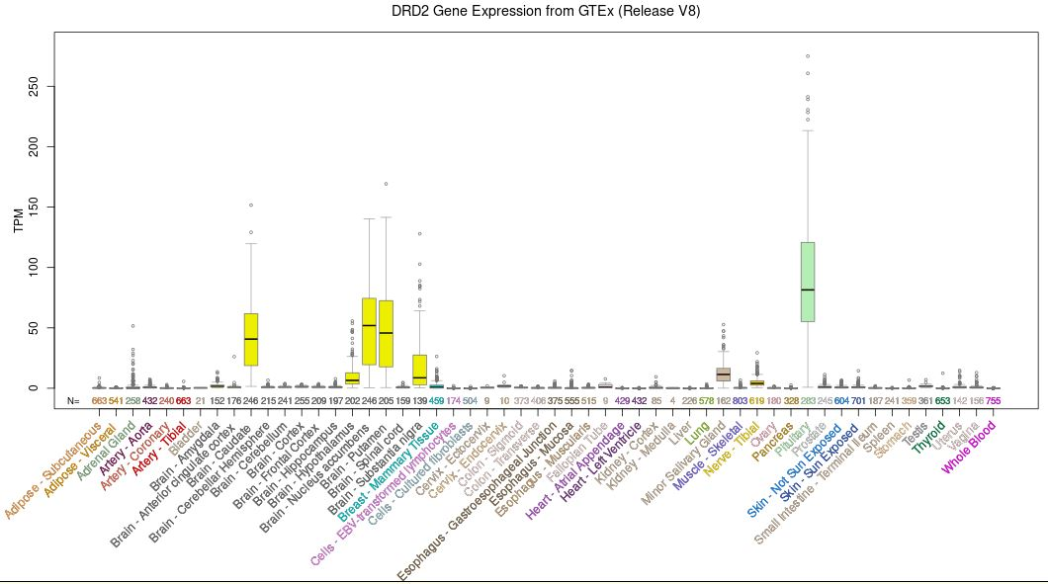Fig. S1 Differentially expressed DRD2 in brain and other tissues.

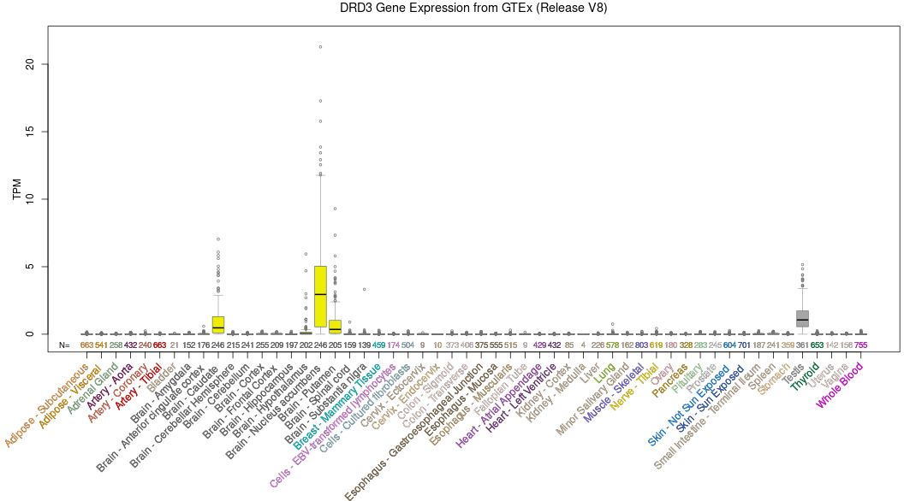
Fig. S2 Differentially expressed DRD3 in brain and other tissues. 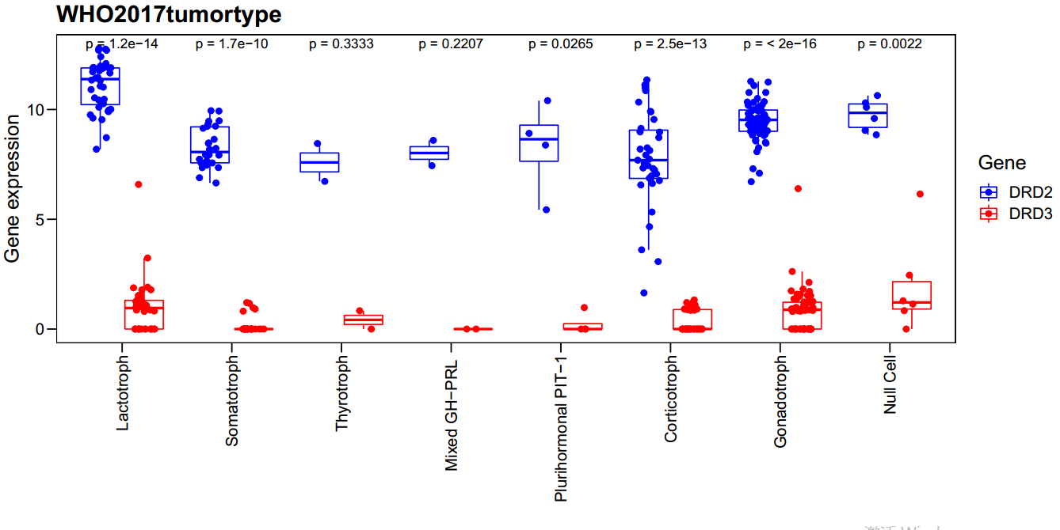
Fig. S3 DRD2 and DRD3 expression in 180 pituitary neuroendocrine tumors.

Supplemental table 1. Standard uptake value in all 7 patients with prolactinoma
Patient | Target_{Max} |  | Target_{mean} |  | Cerebellum | Hypothalamus | Substantia nigra | Putamen
Patient | Whole tumor | Cavernous sinus | Whole tumor | Cavernous sinus
1 | 26.90 | NA | 18.00 | NA | 0.68 | 2.82 | 2.56 | 16.90
2 | 5.06 | NA | 3.03 | NA | 0.54 | 2.26 | 2.76 | 13.70
3 | 11.00 | 9.89 | 7.28 | 8.67 | 0.29 | 1.76 | 1.45 | 15.40
4 | 7.10 | 7.10 | 3.70 | 3.87 | 0.58 | 3.36 | 2.82 | 13.30
5 | 25.00 | 17.40 | 17.50 | 9.79 | 0.64 | 2.74 | 2.89 | 14.60
6 | 11.60 | NA | 9.10 | NA | 0.68 | 3.45 | 3.29 | 18.40
7 | 15.30 | NA | 9.66 | NA | 0.77 | 4.02 | 3.97 | 18.90
NA, not available.

