Supplemental Appendix

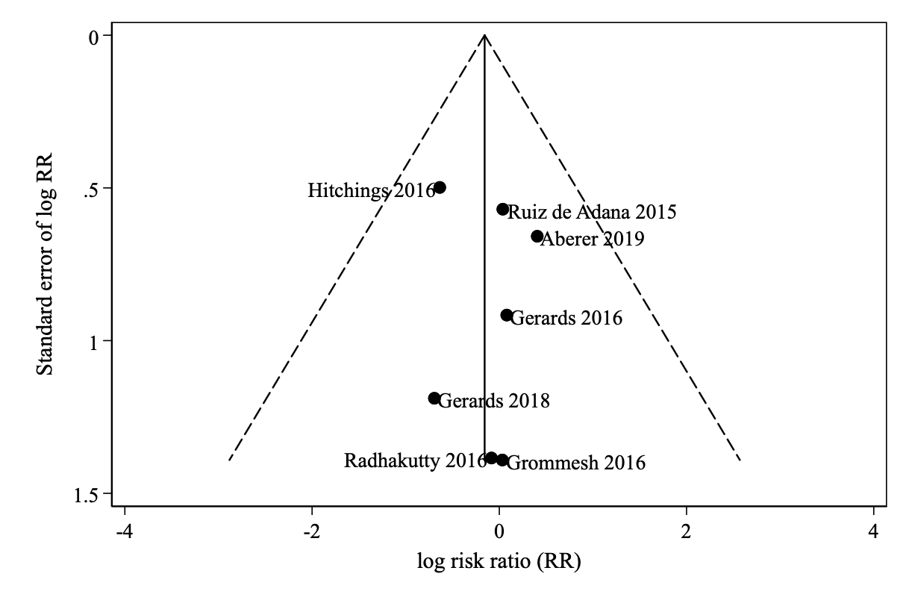
Supplemental Figure 1. Funnel Plot for Risk of Hypoglycemia.

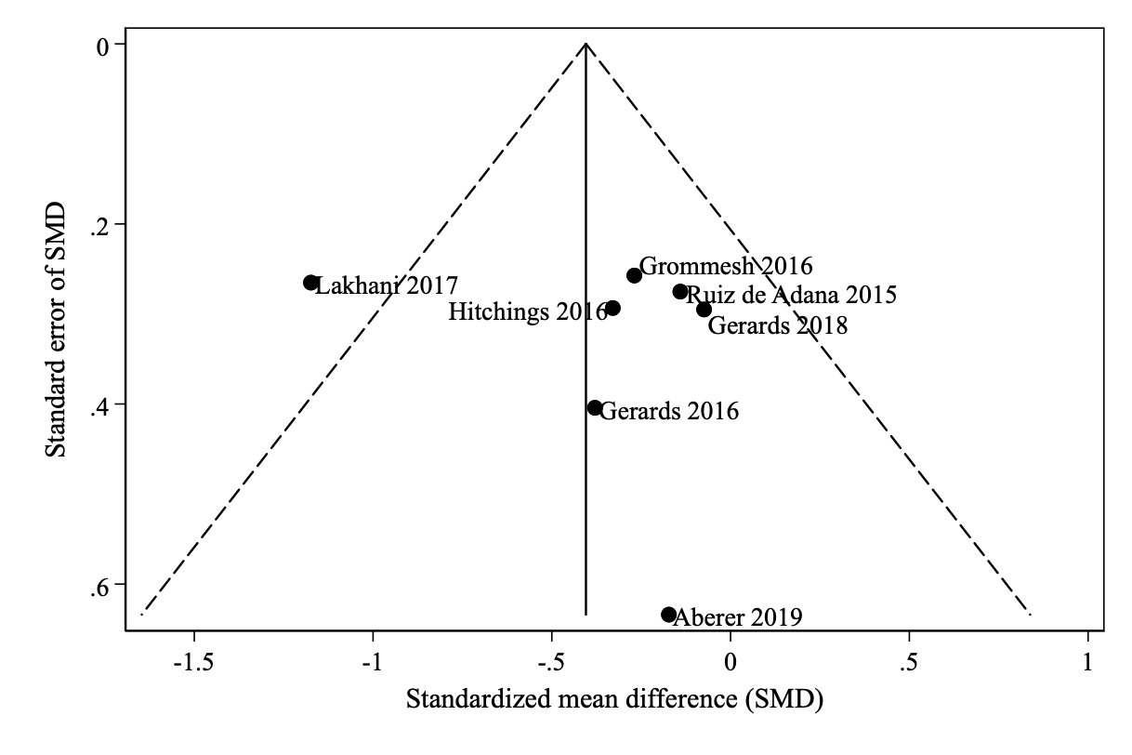
Supplemental Figure 2. Funnel Plot for Glucose Values.

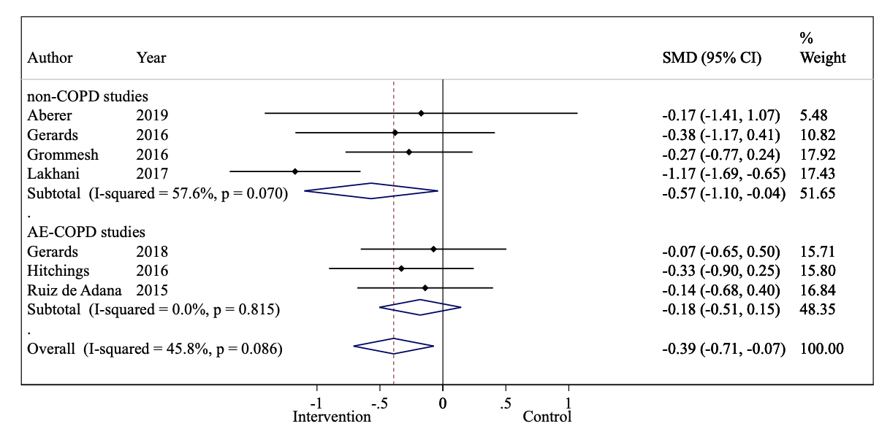
Supplemental Figure 3. Splitted Forest Plots, Glucose in AECOPD-studies vs. all other.

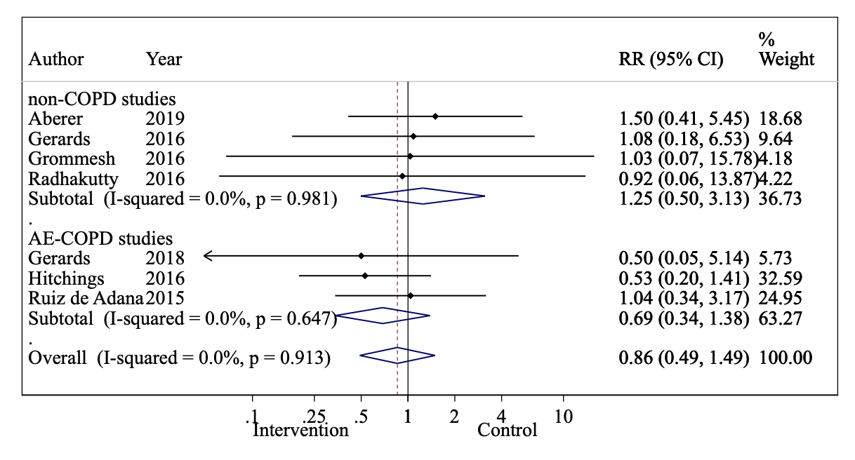
Supplemental Figure 4. Splitted Forest Plots, Hypoglycemia in AECOPD-studies vs. all other.

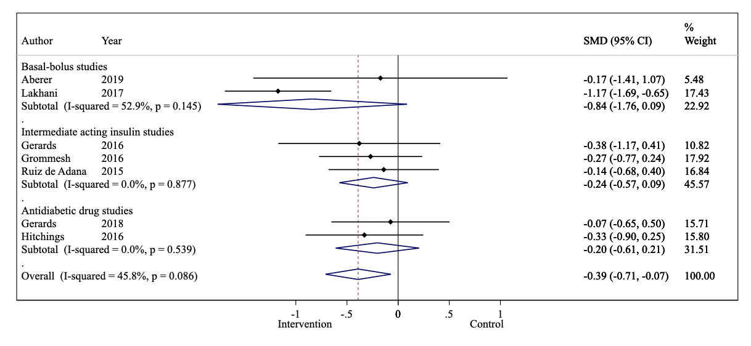
Supplemental Figure 5. Splitted Forest Plots, Glucose according to type of intervention.

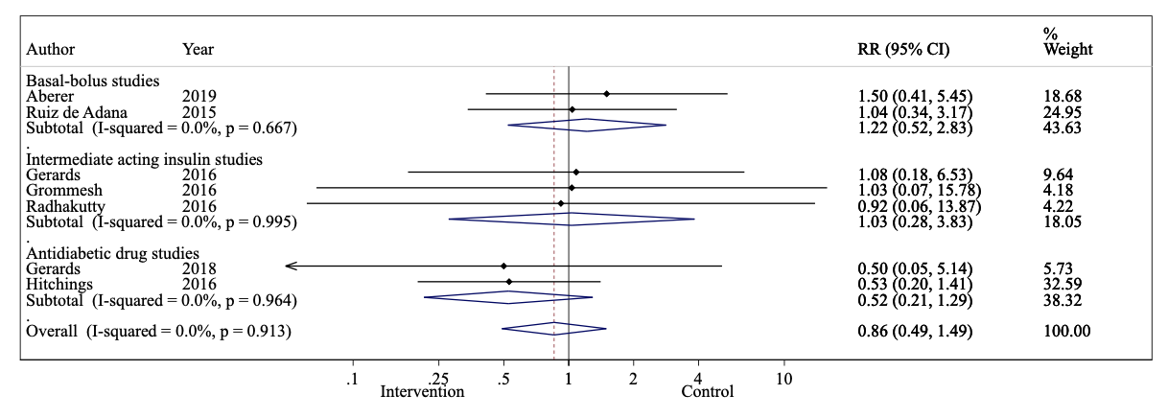
Supplemental Figure 6. Splitted Forest Plots, Hypoglycemia according to type of intervention.

Complete Search Strings
PubMed
Search (((((Hypoglycemic Agent*[Title/Abstract] OR Hypoglycemic drug*[Title/Abstract] OR Hyperglycemia therap*[Title/Abstract] OR hyperglycemia treatment*[Title/Abstract] OR Insulin[Title/Abstract] OR Insulin Glargin[Title/Abstract] OR Dipeptidyl-Peptidase IV Inhibitor*[Title/Abstract] OR Metformin*[Title/Abstract] OR Thiazolidinedion*[Title/Abstract]))) OR ((((((((((( "Hyperglycemia/drug therapy"[Mesh] OR "Hyperglycemia/therapy"[Mesh] ))) OR (( "Insulin/administration and dosage"[Mesh] OR "Insulin/therapeutic use"[Mesh] ))) OR (( "Insulin Glargine/administration and dosage"[Mesh] OR "Insulin Glargine/therapeutic use"[Mesh] ))) OR (( "Hypoglycemic Agents/administration and dosage"[Mesh] OR "Hypoglycemic Agents/therapeutic use"[Mesh] ))) OR (( "Dipeptidyl-Peptidase IV Inhibitors/administration and dosage"[Mesh] OR "Dipeptidyl-Peptidase IV Inhibitors/therapeutic use"[Mesh] ))) OR (( "Metformin/administration and dosage"[Mesh] OR "Metformin/therapeutic use"[Mesh] ))) OR (( "Thiazolidinediones/administration and dosage"[Mesh] OR "Thiazolidinediones/therapeutic use"[Mesh] )))) AND Humans[Mesh]))) AND ((((((((((("Hyperglycemia/chemically induced"[Mesh]) OR "Diabetes Mellitus/chemically induced"[Mesh:NoExp]) OR "Diabetes Mellitus, Type 2/chemically induced"[Mesh:NoExp])) AND Humans[Mesh])) AND (((((((((((("Immunosuppressive Agents/adverse effects"[Mesh:NoExp]) OR "Anti-Inflammatory Agents/adverse effects"[Mesh:NoExp]) OR "Glucocorticoids/adverse effects"[Mesh]) OR "Betamethasone/adverse effects"[Mesh]) OR "Dexamethasone/adverse effects"[Mesh]) OR "Methylprednisolone/adverse effects"[Mesh]) OR "Prednisolone/adverse effects"[Mesh]) OR "Prednisone/adverse effects"[Mesh]) OR "Hydrocortisone/adverse effects"[Mesh]) OR "Triamcinolone/adverse effects"[Mesh])) AND Humans[Mesh]))))) OR (((((((Immunosuppressive Agents*[Title/Abstract] OR Anti-Inflammatory Agent*[Title/Abstract] OR Steroid[Title/Abstract] OR glucocorticoid*[Title/Abstract] OR corticosteroid*[Title/Abstract] OR Betamethason*[Title/Abstract] OR Dexamethason*[Title/Abstract] OR Methylprednisolon*[Title/Abstract] OR Prednisolon*[Title/Abstract] OR Prednison*[Title/Abstract] OR Hydrocortison*[Title/Abstract] OR Triamcinolon*[Title/Abstract])) AND ((diabetes mellitus[Title/Abstract] OR diabetes[Title/Abstract] OR Hyperglycem*[Title/Abstract] OR hyperglycaem*[Title/Abstract]))) AND ((adverse effect[Title/Abstract] OR adverse effects[Title/Abstract])))) OR ((((steroid related[Title/Abstract] OR corticosteroid related[Title/Abstract] OR glucocorticoid related[Title/Abstract]))) AND ((diabetes mellitus[Title/Abstract] OR diabetes[Title/Abstract] OR Hyperglycem*[Title/Abstract] OR hyperglycaem*[Title/Abstract])))) OR ((Steroid Diabet*[Title/Abstract] OR GIDM[Title/Abstract] OR GC-DM[Title/Abstract] OR (GID[Title/Abstract] AND diabetes[Title/Abstract]) OR "glucocorticoid induced diabetes"[Title/Abstract] OR "glucocorticoid induced diabetes mellitus"[Title/Abstract] OR "glucocorticoid induced hyperglycemia"[Title/Abstract] OR "corticosteroid induced diabetes"[Title/Abstract] OR "corticosteroid induced diabetes mellitus"[Title/Abstract] OR "corticosteroid induced hyperglycemia"[Title/Abstract] OR "steroid induced diabetes"[Title/Abstract] OR "steroid induced diabetes mellitus"[Title/Abstract] OR "steroid induced hyperglycemia"[Title/Abstract] OR "steroid induced hyperglycaemia"[Title/Abstract]))))

Embase
Query(('corticosteroid'/exp/dd_ae OR 'immunosuppressive agent'/exp/dd_ae OR 'immunosuppressive agent'/dd_ae OR 'antiinflammatory agent'/exp/dd_ae OR 'antiinflammatory agent'/dd_ae OR 'dexamethasone'/exp/dd_ae OR 'methylprednisolone'/exp/dd_ae OR 'prednisolone'/exp/dd_ae OR 'prednisone'/exp/dd_ae OR 'hydrocortisone'/exp/dd_ae OR 'triamcinolone'/exp/dd_ae) AND 'chemically induced'/exp AND ('hyperglycemia'/exp OR 'diabetes mellitus'/exp OR 'diabetes mellitus'/de OR 'non insulin dependent diabetes mellitus'/exp OR 'non insulin dependent diabetes mellitus'/de) AND [humans]/lim OR (('steroid diabet*':ab,ti OR 'gidm':ab,ti OR 'gc-dm':ab,ti OR '(gid':ab,ti) AND 'diabetes)':ab,ti) OR 'glucocorticoid induced diabetes':ab,ti OR 'glucocorticoid induced diabetes mellitus':ab,ti OR 'glucocorticoid induced hyperglycemia':ab,ti OR 'corticosteroid induced diabetes':ab,ti OR 'corticosteroid induced diabetes mellitus':ab,ti OR 'corticosteroid induced hyperglycemia':ab,ti OR 'steroid induced diabetes':ab,ti OR 'steroid induced diabetes mellitus':ab,ti OR 'steroid induced hyperglycemia':ab,ti OR 'steroid induced hyperglycaemia':ab,ti OR (('(steroid related':ab,ti OR 'corticosteroid related':ab,ti OR 'glucocorticoid related)':ab,ti) AND ('(diabetes mellitus':ab,ti OR 'diabetes':ab,ti OR 'hyperglycem*':ab,ti OR 'hyperglycaem*)':ab,ti)) OR (('(immunosuppressive agents*':ab,ti OR 'anti-inflammatory agent*':ab,ti OR 'steroid':ab,ti OR 'glucocorticoid*':ab,ti OR 'corticosteroid*':ab,ti OR 'betamethason*':ab,ti OR 'dexamethason*':ab,ti OR 'methylprednisolon*':ab,ti OR 'prednisolon*':ab,ti OR 'prednison*':ab,ti OR 'hydrocortison*':ab,ti OR 'triamcinolon*)':ab,ti) AND ('(adverse effect':ab,ti OR 'adverse effects)':ab,ti) AND ('(diabetes mellitus':ab,ti OR 'diabetes':ab,ti OR 'hyperglycem*':ab,ti OR 'hyperglycaem*)':ab,ti))) AND (('hypoglycemic agent*':ab,ti OR 'hypoglycemic drug*':ab,ti OR 'hyperglycemia therap*':ab,ti OR 'hyperglycemia treatment*':ab,ti OR 'insulin':ab,ti OR 'insulin glargin':ab,ti OR 'dipeptidyl-peptidase iv inhibitor*':ab,ti OR 'metformin*':ab,ti OR 'thiazolidinedion*':ab,ti OR 'sodium glucose cotransporter 2 inhibitor*':ab,ti OR 'sglt 2 inhibitor*':ab,ti OR 'glp 1 ra':ab,ti OR 'glucagon like peptide 1 receptor antagonist':ab,ti OR 'glucagon like peptide 1 receptor agonist':ab,ti OR 'glp 1 r agonist':ab,ti OR 'glp 1 r antagonist':ab,ti OR 'sulfonylurea*':ab,ti) OR ((('hyperglycemia'/exp/dm_dt,dm_th OR 'insulin'/exp/dd_ad,dd_cr,dd_dt OR 'insulin glargine'/exp/dd_ad,dd_cr,dd_dt OR 'antidiabetic agent'/exp/dd_ad,dd_cr,dd_dt OR 'dipeptidyl peptidase iv inhibitor'/exp/dd_ad,dd_cr,dd_dt OR 'metformin'/exp/dd_ad,dd_cr,dd_dt OR '2,4 thiazolidinedione derivative'/exp/dd_ad,dd_cr,dd_dt OR 'sodium glucose cotransporter 2 inhibitor'/exp/dd_ad,dd_cr,dd_dt OR 'glucagon like peptide 1 receptor agonist'/exp/dd_ad,dd_cr,dd_dt OR 'sulfonylurea'/exp/dd_ad,dd_cr,dd_dt) AND [humans]/lim) AND 'human'/de))

