. MATERIALS AND METHOD

2.1. Samples;
All fish samples used in this study were conveniently sampled from the five Dar Es Salaam Districts namely Ilala, Temeke, Ubungo, Kigamboni and Kinondoni. Some of the mackerel fish were in frozen state and others in normal state, since the collection involves market, supermarket and street vendors. The time frame was three consecutive weeks of April 2017. The researcher pretended to be a normal customer and bought those samples. Descriptions of the collected samples were noted (Number of collected samples, state of the samples).Collected fish were kept in the icebox and carried to the laboratory for freshness evaluation and analysis of formaldehyde. Samples collected were stored in a refrigerator at a temperature of -24ºC in Medicinal Chemistry Laboratory, School of pharmacy.
In total 61 samples were collected within five districts of Dar Es Salaam.

Table 1: Description of the selected samples
Districts | Place of collection | Sample code | State of sample collected
Temeke | Market | TMA | F
Temeke | Market | TMB | F
Temeke | Market | TMC | N
Temeke | Market | TMD | N
Temeke | Street vendors | TSA | F
Temeke | Street vendors | TSB | N
Temeke | Street vendors | TSC | N
Temeke | Street vendors | TSD | N
Temeke | Supermarket | TSPA | F
Temeke | Supermarket | TSPB | F
Temeke | Supermarket | TSPC | F
Temeke | Supermarket | TSPD | F
Ubungo | Market | UBMA | N
Ubungo | Market | UBMB | N
Ubungo | Market | UBMC | N
Ubungo | Market | UBMD | N
Ubungo | Streetvendors | UBSA | F
Ubungo | Streetvendors | UBSB | N
Ubungo | Streetvendors | UBSC | N
Ubungo | Streetvendors | UBSD | N
Ubungo | Supermarket | UBSPA | F
Ubungo | Supermarket | UBSPB | F
Ubungo | Supermarket | UBSPC | F
Ubungo | Supermarket | UBSPD | F
Kigamboni | Market | KGMA | N
Kigamboni | Market | KGMB | N
Kigamboni | Market | KGMC | N
Kigamboni |  | KGMD | N
Kigamboni | Street vendors | KGSA | F
Kigamboni | Street vendors | KGSB | N
Kigamboni | Street vendors | KGSC | N
Kigamboni | Street vendors | KGSD | N
Kigamboni | Supermarket | KGSPA | F
Kigamboni | Supermarket | KGSPB | F
Kigamboni | Supermarket | KGSPC | F
 | Supermarket | KGSPD | F
Kinondoni | Market | KNMA | N
Kinondoni | Market | KNMB | N
Kinondoni | Market | KNMC | N
Kinondoni | Market | KNMD | N
Kinondoni | Street vendors | KNSA | N
Kinondoni | Street vendors | KNSB | N
Kinondoni | Street vendors | KNSC | N
Kinondoni | Street vendors | KNSD | N
Kinondoni | Supermarket | KNSPA | F
Kinondoni | Supermarket | KNSPB | F
Kinondoni | Supermarket | KNSPC | F
Kinondoni | Supermarket | KNSPD | F
Ilala | Market | ILMA | N
Ilala | Market | ILMB | N
Ilala | Market | ILMC | N
Ilala | Market | ILMD | N
Ilala |  | ILME | N
Ilala | Street vendors | ILSA | N
Ilala | Street vendors | ILSB | F
Ilala | Street vendors | ILSC | N
Ilala | Street vendors | ILSD | N
Ilala | Supermarket | ILSPA | F
Ilala | Supermarket | ILSPB | F
Ilala | Supermarket | ILSPC | F
 | Supermarket | ILSPD | F
 | Supermarket | ILSPE | F

2.2 Determination of freshness by organoleptic characteristics
During the study, on hold practice exercised by whole sellers to the street vendors before selling to the consumers was assessed. Samples of mackerel were conveniently collected from five markets, five streets in five districts for laboratory analysis. In the laboratory the content of contamination of formalin in fish will be analyzed by High Performance Liquid chromatography. Physical parameters which define fish freshness was done by sensory method checking the organoleptic characteristics of fish which include odor of the neck, odor of gills, color of gills ,general appearance of the fish, slime on the skin of the fish, eyes and texture of the fish
All the collected samples were evaluated on freshness through sensory assessment; grades were used in categorizing the freshness of mackerel as follows
Grade less than 2 : Excellent
Grade 2 to less than 5 : Acceptable/good
Grade 5 and above : Rejected.

2.3ANALYSIS OF FORMALIN IN MACKEREL FISH

2.3.1 Reagents, chemicals and solvents.
Analytical reagents were used throughout the experiment. Reagents used were Distilled water (in- house prepared at School of pharmacy, Medicinal Chemistry laboratory). (From BDH laboratory Ltd, Poole, England).Formalin 37% (Merck, Darmstadt, Germany).2,4-dinitrophenylhydrazine (DNPH) (Carlo Erba Reagent group, Barcelona, Spain). Acetonitrile 99.9% (Sigma Aldrich, St Louis, USA), Double distilled water bought from the University of Dar Es salaam (Chemistry Department).All reagents were purchased from local suppliers.

2.3.2 Instruments;
High Performance Liquid Chromatography Merck Hitachi Model D- 70001F(Tokyo, Japan), Analytical balance model ML204, (Mettler Toledo, Greifensee, Switzerland), Ultrasonic water bath Sonicator Model KQ2200DE(Malaysia), centrifuge machine Model No Z206A (Germany), and Vortex mixer Model No F5A (USA).

2.4 ANALYTICAL PROCEDURE

2.4.1 EVALUATION OF MATRIX EFFECT
Matrix effect was evaluated through statistical tests (T- test) by comparing two means. Standard curves were prepared, one of the standard formaldehyde solutionand the other from the fish spiked with formaldehyde in a given concentration ranging from 2.5mg/l to 120mg/l, including the lower limit of quantification .Three injections were made at each concentration. Data were analyzed using an online T-Test calculator (MEDCALC). The significance level was 95% during the calculations.

2.4.2 METHOD VALIDATION
The adopted method used for analysis was partial validated in accordance with Food and Drug Administration (FDA) On Bioanalytical method validation Revision 1 (2013) for linearity, accuracy, limit of detection and limit of quantification, and precision(33).
2.4.2.1Linearity
Preparation of standard calibration curve.
Linearity was evaluated by using a matrix-based calibration standard. This was established by preparing seven known concentrations of formaldehyde spiked on fish. Seven concentrations were obtained from stock solution of 400mg/l formaldehyde. The range of concentrations included Lower limit of quantification and the upper limit of quantification. Three injections were made at each concentration. Acceptance limit, coefficient of variation of at least four concentrations should not deviate by more than 15% except at lower limit of quantification should not deviate by more than 20%.
2.4.2.1.1 Preparation of derivatizing agent (2, 4-dinitrophenyl hydrazine)
It was dissolved 1.5g of 2, 4 dinitrophenyl hydrazine crystals in 50mls of a 20% solution of sulphuric acid (98%). This solution was prepared immediately before use.
2.4.2.2 Precision
Inter –Day precision was carried out using a minimum of six determinations per concentration. Three concentrations of Quality Control samples (QCs) were used, of which the low quality control sample concentration was 3*LLOQ (7.5mg/l), Midrange concentration corresponding to 50% of the ULOQ (45mg/l) and the higher concentration correspond to 75% of the Upper limit of quantification (68mg/l). The acceptance criteria involved the coefficient of variation not to exceed 15% at each concentration.
2.4.2.3 Accuracy
Accuracy was completed by determining the recovery of known concentration of formaldehyde in mackerel fish. Three Quality control samples were used. Three concentrations spiked on the sample corresponding to low concentration that is 7.5mg/l, Midrange concentration 45mg/l and high concentration 68mg/l. Accuracy was determined by evaluating the mean recovery at three concentration levels using a minimum of six determinations per concentration. The mean value should be within 15% of the nominal value, and LLOQ which is 2.5mg/l should not be more than the 20%.
2.4.2.4 Limit of Detection and Limit of Quantification
Limit of detection was obtained based on the standard deviation of the peak area and the slope of the calibration curve. From the matrix – based calibration curve the slope of the calibration curve and peak area were used to obtain the limit of detection and limit of quantitation.

2.4.2.5Sample preparation
The skin and bones were removed from the fish flesh. Fins were removed with the help of a scalpel. The fillets were minced and homogenized in blender, Fivegrams (5gm) of the minced sample were weighed and put in a conical flask. The homogenized sample was added with 5mls of distilled water. The flask was then capped and sonicated for 40minutes at a temperature of20ºC and the vortex at 7000rpm for ten minutes. Then filtered with filter paper Whatman no 1, then 2mls (twenty) of the supernatant solution in a conical flask was added with 1ml (one) of the DNPH (2, 4 dinitropheny hydrazine). Then those flasks were placed in a dark place for 6hours at 20-25˚C to complete the reaction between formaldehyde and 2, 4-dinitrophenylhydrazine to form an orange precipitate of hydrazone, then filtered by the membrane filter of 0.45µm. The precipitate was dissolved in 2mls of acetonitrile. Then filtered through a membrane filter of 0.45µm(23)(29) .

2.4.4Chromatographic Conditions
Parameter | Conditions
Column | Extend C-18 (150mm x 2.1,5µm)
Mobile phase | Acetonitrile:Water (60:40)
Detector | Diode array detector
Detection Wavelength | 365nm
Flow rate | 1mls
Temperature of the column | 40ºC
Sample volume | 20µl

CHAPTER THREE

3. RESULTS:

3.1 Evaluation of degree of freshness by organoleptic characteristics
Table 2, 3,4,5,6 shows the degree of freshness based on organoleptic characteristics,the freshness of the mackerel was evaluated by grading them in scores. On the average number of grade points as follows, all the mackerel fish collected in all districts were presentedwith some good and bad characteristics such as theodor of the neck was not natural, no slime on their skin, body appearance was not firm. However, some of the good characteristics observed include bright and protruding eyes, texture was firm. So they were all acceptable due to those grades between 2 and 5.
Table 2: Degree of freshness of mackerel from Temeke district
Place of collected samples | Average grade of freshness |  |  |  | Overall grade
Place of collected samples | Day 1 | Day 2 | Day 3 | Average
Market | 3.14 | 2.1 | 2.03 | 2.8 | Acceptable
Street vendors | 2.4 | 2.1 | 3.2 | 2.5 | Acceptable
Supermarket | 2 | 2.1 | 3.2 | 2.4 | Acceptable

Table 3: Degree of freshness of mackerel from Kinondoni district
Place of collected samples | Average grade of freshness |  |  |  | Overall grade
Place of collected samples | Day 1 | Day 2 | Day 3 | Average
Market | 2.29 | 1.75 | 2.71 | 2.25 | Acceptable
Street vendors | 3.3 | 3.1 | 2 | 2.8 | Acceptable
Supermarket | 2.1 | 2.2 | 2.9 | 2.4 | Acceptable
Table 4: Degree of freshness of mackerel from Ubungo district
Place of collected samples | Average grade of freshness |  |  |  | Overall grade
Place of collected samples | Day 1 | Day 2 | Day 3 | Average
Market | 2.46 | 2.1 | 2.3 | 2.28 | Acceptable
Streetvendors | 2.46 | 2.4 | 2.5 | 2.45 | Acceptable
Supermarket | 1.54 | 2.4 | 2.04 | 1.93 | Excellent

Table 5: Degree of freshness of mackerel from Kigamboni district
Place of collected samples | Average grade of freshness |  |  |  | Overall grade
Place of collected samples | Day 1 | Day 2 | Day 3 | Average
Market | 2.3 | 2.4 | 2.2 | 2.3 | Acceptable
Street vendors | 3.1 | 4.5 | 4 | 4 | Acceptable
Supermarket | 2 | 2.2 | 1.9 | 2.03 | Acceptable

Table 6: Degree of freshness of mackerel from Ilala district
Place of collected samples | Average grade of freshness |  |  |  | Overall grade
Place of collected samples | Day 1 | Day 2 | Day 3 | Average
Market | 2.1 | 3 | 1.3 | 2.1 | Acceptable
Street vendors | 2.6 | 2.1 | 2.75 | 2.5 | Acceptable
Supermarket | 2.2 | 2.1 | 2.1 | 2.1 | Acceptable

Table 7: Overall grade of freshness of mackerel in Dar es Salaam
Dar es Salaam districts | Market | Street Vendors | Supermarket | Grade of freshness
 |  |  |  | Average | Overall grade
Ubungo | 2.28 | 2.45 | 1.93 | 2.22 | Acceptable
Kigamboni | 2.3 | 4 | 2.03 | 2.78 | Acceptable
Ilala | 2.1 | 2.5 | 2.1 | 2.23 | Acceptable
Temeke | 2.8 | 2.5 | 2.4 | 2.57 | Acceptable
Kinondoni | 2.25 | 2.8 | 2.4 | 2.48 | Acceptable
Average grade | 2.346 | 2.85 | 2.172
Overall grade | Acceptable | Acceptable | Acceptable

3.3 Analysis of formaldehyde in mackerel fish by HPLC

3.3.1 Method Validation
The method used in detecting the presence and quantification of formaldehyde was validated for linearity, Accuracy, Precision and limit of detection and limit of quantification as per the validation guideline of FDA.

      - Linearity
Linearity was evaluated by injecting spiked matrix with standard formaldehyde ranging from 2.5mg/l to 90mg/l. The calibration curve was obtained with a correlation coefficient of 0.997 and slope of 1019. The accuracy of the LLOQ was found to be 100.88% of the nominal value with coefficient of variation of 3.49. The Accuracy of ULOQ was found to be 98.3455% of the nominal value with coefficient of variation of 0.55. The rest of the concentrations had accuracy and coefficient of variation lies not exceeding 15% of their nominal values.
Table 8: Calibration curve
Runs | Nominal values (mg/l)
Runs | 2.5 | 10 | 15 |  | 20 |  | 25 |  | 60 |  | 90
1 | 2587 | 10266 | 15078 |  | 20939 |  | 26731 |  | 60631 |  | 90065
2 | 2473 | 10444 | 15374 |  | 20348 |  | 22026 |  | 66105 |  | 90744
3 | 2650 | 10482 | 16085 |  | 21476 |  | 25236 |  | 63934 |  | 89769
Mean | 2570 | 10397.33 | 15512.333 |  | 20921 |  | 24664.333 |  | 63556.6667 |  | 90192.6667
Back calculated conc Y=1019X | 2.52 | 10.20 | 15.22 |  | 20.53 |  | 24.20 |  | 62.37 |  | 88.51
Accuracy | 100.88 | 102.03 | 101.49 |  | 102.65 |  | 96.82 |  | 103.95 |  | 98.35
Stdev | 89.72 | 115.31 | 517.56 |  | 564.22 |  | 2404.03 |  | 2756.44 |  | 499.88
CV | 3.49 | 1.11 | 3.34 |  | 2.70 |  | 9.75 |  | 4.34 |  | 0.55

      - Precision
This was determined by repeatability using three concentrations of quality control samples. The coefficient of variation at each concentration level was found less than 15%.
Table 9: Precision of Quality control samples
Run | Peak Areas
Run | 7.5mg/l | 45mg/l | 68mg/l
1 | 7549 | 48362 | 68233
2 | 7997 | 48567 | 68210
3 | 7942 | 48047 | 67975
4 | 8015 | 48704 | 68271
5 | 8025 | 49227 | 68248
6 | 8586 | 47953 | 69342
Average | 8019.0 | 48476.7 | 68379.8
Standard Deviation | 331.3168 | 467.9379 | 483.5872
CV | 4.13 | 0.97 | 0.71

      - Accuracy
The mean value of the three quality control samples indicated that the methodhas an acceptable level from 85% to 115% of their nominal values.

Table 10 : Accuracy of the Quality control samples
 | Nominal concentrations (mg/l)
 | LQS | MID QCS | HQCS
n=6 | 7.5 | 45 | 68
Mean back calculated conc  Y=1019X | 7.52 | 45.48 | 64.15
Accuracy | 100.3 | 101.06 | 94.33

      - Limit of detection and Limit of quantification
Based on the standard deviation and of the slope of the calibration curve, the limit of detection and quantitation were 0.003mg/kg and 0.01mg/kg respectively of spiked sample.

3.2 Detecting the presence of formalin in Mackerel
This was done by HPLC, All the samples were analyzed in triplicates to detect the presence of formaldehyde. Samples with formaldehyde above the detection limit which is 0.003mg/kg were stated to have formalin in it, and those below the detection limit.

3.2.1 Detection of formalin in Mackerel Collected in Kinondon District

Table 11: Detection of formaldehyde in mackerel from kinondoni
Sample Code Name | Average formaldehyde content (mg/kg) | Absence (A) or Presence (P) Of formalin
KNMA | ND | BDL
KNM B | ND | BDL
KNM C | 1.41368 | P
KNM D | 4.95854 | P
KNS A | 18.86513 | P
KNS B | 7.76261 | P
KNS C | ND | BDL
KNS D | 8.63926 | P
KNSPA | 23.06512 | P
KNSP B | 18.87937 | P
KNSP C | 12.33204 | P
KNSP D | 22.67182 | P

It was observed in samples collected from kinondon district some of them had presented with formaldehyde. Out of 12 samples nine (9) samples had detected with formaldehyde.

3.2.2 Detection of formalin in Mackerel Collected in Kigamboni District
Table 12: Presence of formaldehyde in sample from Kigamboni District.
 | Sample Code Name | Average formaldehyde content (mg/kg) | Absence (A) or Presence (P) Of formalin
 | KGMA | 2.43 | P
 | KGM B | 2.87 | P
 | KGM C | 2.09 | P
 | KGM D | 0.71 | P
 | KGS A | 12.48 | P
 | KGS B | 7.89 | P
 | KGS C | 3.90 | P
 | KGS D | 20.22 | P
 | KGSPA | ND | BDL
 | KGSP B | 5.89 | P
 | KGSP C | 6.76 | P
 | KGSP D | 12.12 | P
It was found that out of twelve (12) samples from kigamboni11 (eleven) were detected with formaldehyde.

3.2.3 Detection of formalin in Mackerel Collected in Temeke District
Table 13: Presence of formaldehyde in sample from Temeke District.
Sample Code Name | Average formaldehyde content (mg/kg) | Absence (A) or Presence (P) Of formalin
TMA | 2.5139 | P
TM B | 1.30106 | P
TM C | ND | BDL
TM D | 10.9149 | P
TS A | 13.915 | P
TS B | 6.5482 | P
TS C | 1.5912 | P
TS D | ND | BDL
TSPA | 6.7297 | p
TSP B | 14.527 | P
TSP C | 29.1203 | P
TSP D | 26.6076 | P

In Temeke District, ten (10) samples out of twelve (12) samples had detected with formaldehyde.

3.2.4 Detection of formalin in Mackerel Collected in Ubungo District
Table 14: Presence of formaldehyde in sample from Ubungo District
SAMPLE CODE NAME | Average formaldehyde content (mg/kg) | Absence (A) or Presence (P) Of formalin
UBMA | 1.664 | P
UBM B | 6.451 | P
UBM C | 3.115 | P
UBM D | 15.37 | P
UBS A | 7.626 | P
UBS B | 10.009 | P
UBS C | 20.799 | P
UBS D | 13.327 | P
UBSPA | 19.094 | p
UBSP B | 14.099 | P
UBSP C | 7.296 | P
UBSP D | 20.228 | P

It was observed that all the twelve (12) samples from Ubungo were detected with formaldehyde.

3.2.5 Detection of formalin in Mackerel Collected in Ilala District
Table 15: Presence of formaldehyde in sample from Ilala District
SAMPLE CODE NAME | Average formaldehyde content (mg/kg) | Absence (A) or Presence (P) Of formalin
ILMA | BDL | BDL
ILM B | 3.4358 | P
ILM C | 2.7639 | P
ILM D | 2.1025 | P
ILME | BDL | BDL
ILS A | 22.9651 | P
ILS B | 46.0102 | P
ILS C | 8.699 | P
ILS D | 3.6036 | P
ILSPA | 16.6343 | P
ILSP B | 20.6029 | P
ILSP C | 23.4295 | P
ILSP D | 13.0838 | P
In Ilala district, out of the thirteen (13) samples collected, ten (10) sample were detected with formaldehyde.

3.3 Quantification of formaldehyde in Mackerel
Content of formaldehyde were determined by HPLC, fresh Mackerel and mackerel in all districts were determined their content of formalin. The content of formaldehyde was calculated by use of calibration equation.
Y=1019X
Y=peak Area
X=concentration

3.3.1 Formaldehyde content in Fresh fish
There was no formaldehyde detected in fresh mackerel, chromatogram of fresh mackerel.

3.3.2 Formaldehyde content in Mackerel from kinondoni district.
Table 16: Formaldehyde content in mackerel from kinondoni district
Days of collection | Market | Supermarket | Street vendors
1 | 0 | 23.07 | 18.87
2 | 0 | 18.88 | 7.76
3 | 1.41 | 12.33 | 0.00
4 | 4.96 | 22.67 | 8.64
Average content(mg/kg) | 1.59 | 19.24 | 8.82

The mean content of Formaldehyde of Mackerel from Kinondoni ranges between 1.59mg/kg to 19.24 mg/kg.
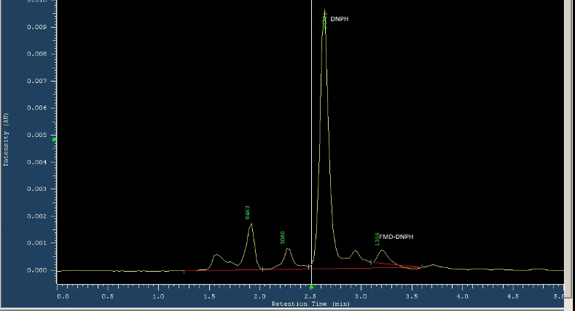
Figure 1: Chromatogram of formaldehyde content in sample from kinondoni market.
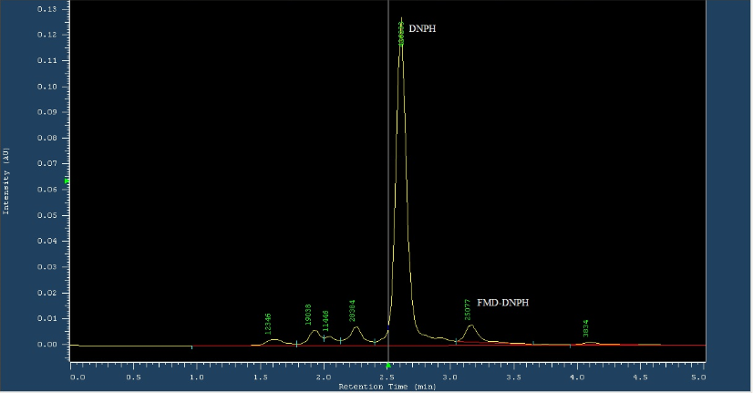
Figure 2: Chromatogram of formaldehyde content in sample from kinondoni supermarket
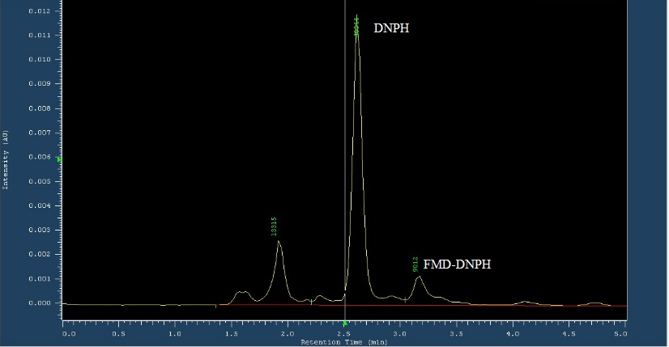

Figure 3: Chromatogram of formaldehyde content in sample from kinondoni street vendors

3.3.3 Formaldehyde content in mackerel from Kigamboni District
There was presence of formaldehyde in mackerel collected in Kigambonidistrict . The mean range was 2.03mg/kg to11.13mg/kg(Table 17).

Table 17: Formaldehyde content in mackerel from Kigamboni district
Days of collection | Market | supermarket | Streetvendors
1 | 2.44 | 0 | 12.49
2 | 2.87 | 5.89 | 7.90
3 | 2.09 | 6.77 | 3.90
4 | 0.71 | 12.12 | 20.22
Average content (mg/kg) | 2.03 | 6.20 | 11.13
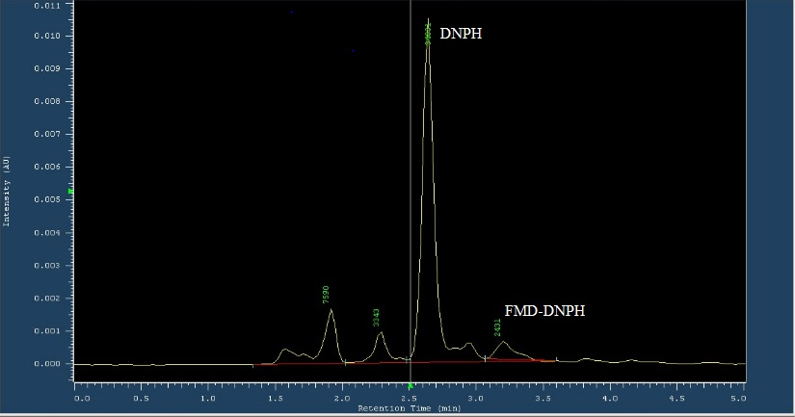

Figure 4: Chromatogram of formaldehyde content in sample from kigamboni market.
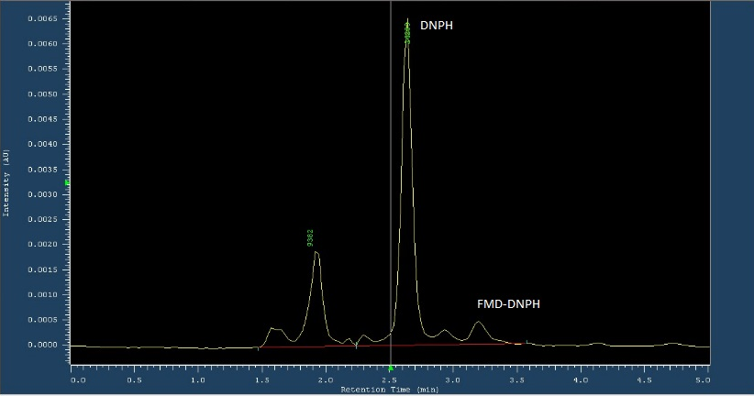
Figure 5: Chromatogram of formaldehyde content in sample from kigamboni street vendors.
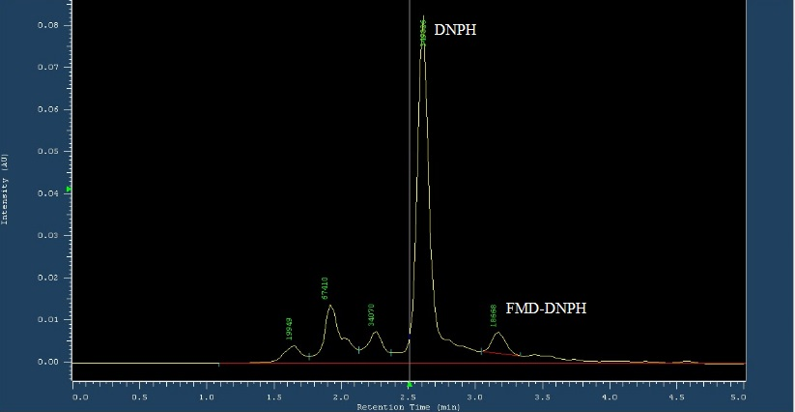

Figure 6: Chromatogram of formaldehyde content in sample from kigamboni supermarket

3.3.4 Formaldehyde content in Mackerel from Ubungo district
The mean content of formaldehyde present in mackerel collected from Ubungo district ranged between6.65mg/kg to15.18mg/kg (Table 7).
Table 18: Formaldehyde content in mackerel from Ubungo district
Days of collection | Market | supermarket | Streetvendors
1 | 1.66 | 19.09 | 7.63
2 | 6.45 | 14.10 | 10.01
3 | 3.12 | 7.30 | 20.80
4 | 15.37 | 20.23 | 13.33
Average content (mg/kg) | 6.65 | 15.18 | 12.94
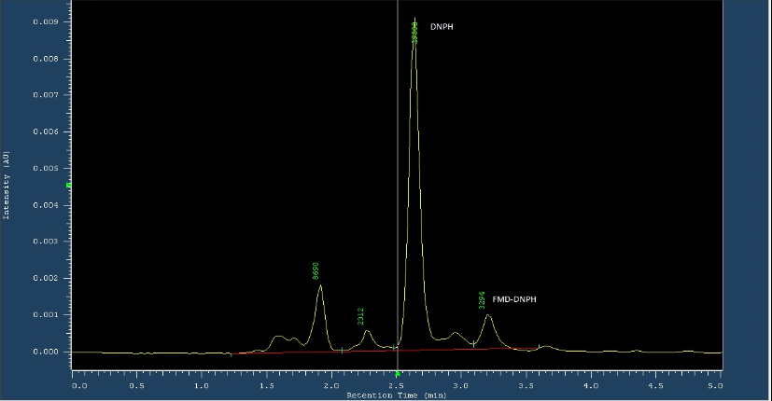

Figure 7:: Chromatogram of formaldehyde content in sample from Ubungo market
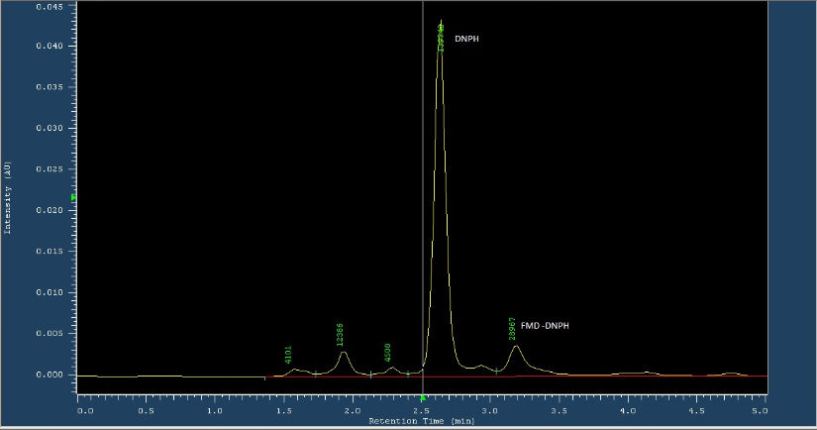
Figure 8: Chromatogram of formaldehyde content of sample from Ubungo street vendors
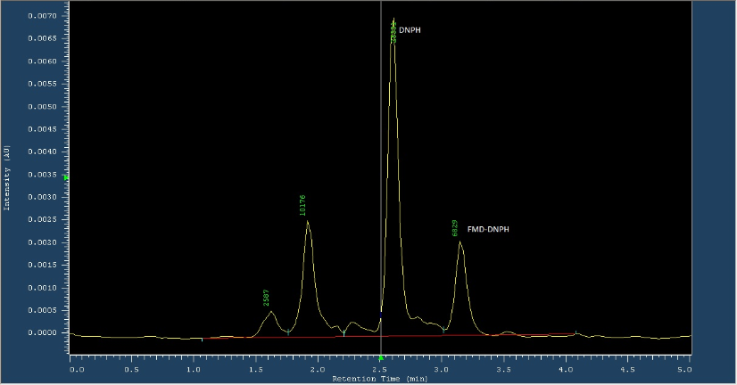

Figure 9: Chromatogram of formaldehyde content in sample from Ubungo supermarket.
3.3.3.5 Formaldehyde content in Mackerel from Ilala District
It was observed in Ilala district’s mackerel were having content of formaldehyde between 2.77mg/kg to 20.32mg/kg.

Table 19: Formaldehyde content in mackerel from Ilala district
Days of collection | Market | supermarket | streetvendors
1 | BDL | 16.63 | 22.97
2 | 3.44 | 20.60 | 46.01
3 | 2.76 | 23.43 | 8.70
4 | 2.10 | 13.08 | 3.60
5 | BDL
Average content (mg/kg) | 2.77 | 18.44 | 20.32

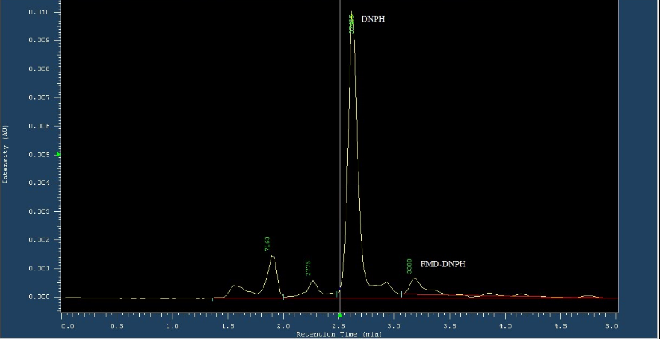
Figure 10: Chromatogram of formaldehyde content in sample from Ilala market
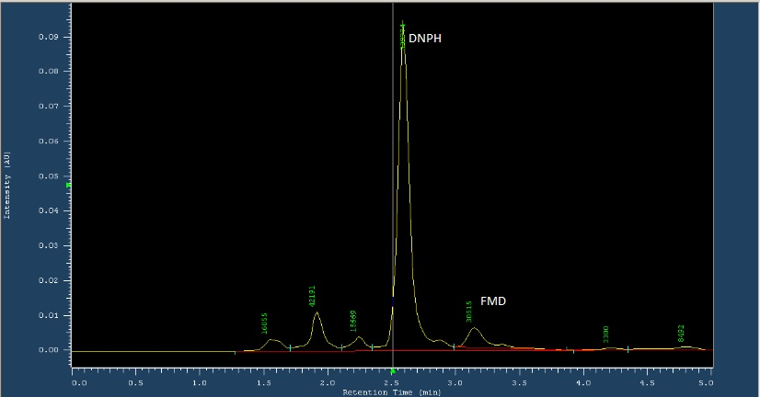

Figure 11 : Chromatogram of formaldehyde content in sample from Ilala Street vendors

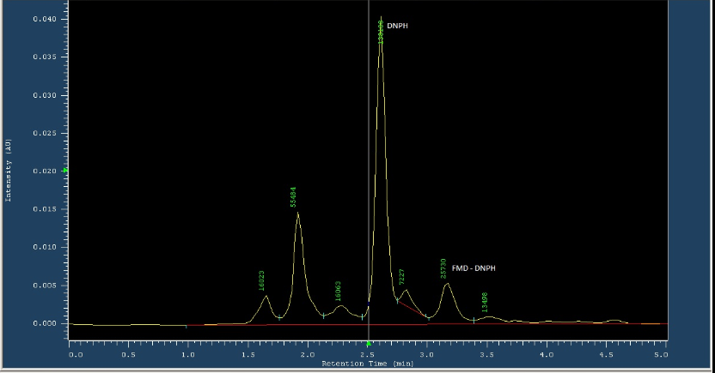

Figure 12 : Chromatogram of formaldehyde content in sample from Ilala Supermarket
3.3.3.5 Formaldehyde content of Mackerel from Temeke District.
It was observed on mackerel collected from Temeke district had presented with formaldehyde, however the mean content of formaldehyde was between 4.69mg/kg to 18.40mg/kg.

Table 20: Formaldehyde content in mackerel from Temeke district
Days of collection | Market | Supermarket | Streetvendors
1 | 2.40 | 6.43 | 13.30
2 | 1.24 | 13.89 | 6.26
3 | ND | 27.84 | 1.52
4 | 10.43 | 25.43 | ND
Average content (mg/kg) | 4.69 | 18.40 | 7.03

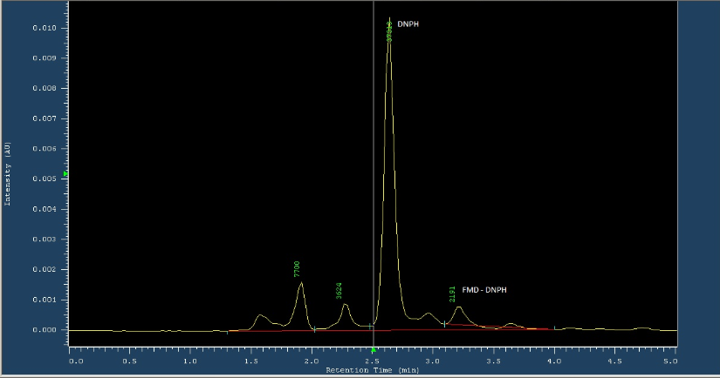

Figure 13 : Chromatogram of formaldehyde content in sample from Temeke market
.
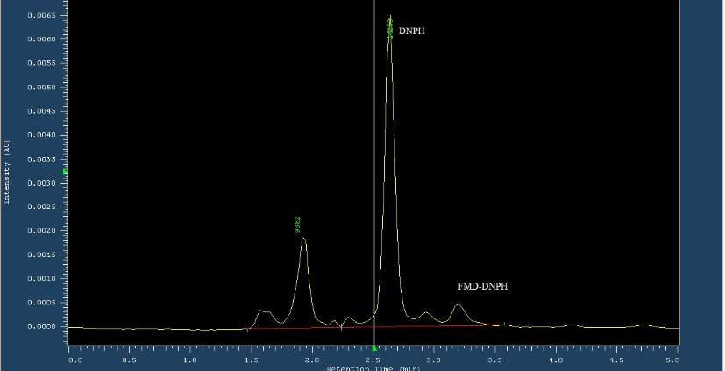
Figure 14: Chromatogram of formaldehyde content in sample from Temeke Street vendors.
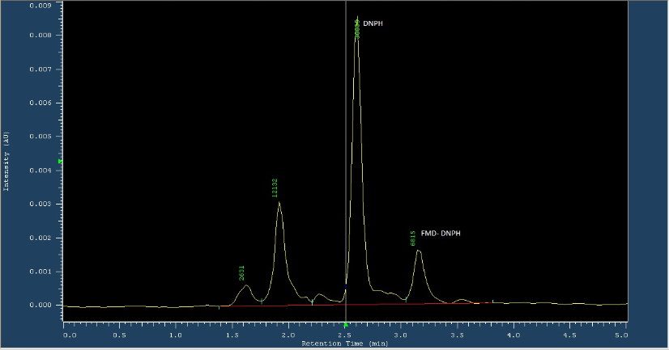
Figure 15: Chromatogram of formaldehyde content in sample from Temeke Supermarket.
3.3.3.6 Formaldehyde content in Mackerel from the districts in Dar es Salaam.
Table 21:Overall content of formaldehyde in Mackerel circulating in Dares salaam.
Name Of District | Market | Supermarket | Streetvendors | Average content
Kinondoni | 1.59 | 19.2371 | 8.8168 | 9.88
kigamboni | 2.03 | 6.20 | 11.13 | 6.45
Ilala | 2.77 | 18.44 | 20.32 | 13.84
Ubungo | 6.65 | 15.18 | 12.94 | 11.59
Temeke | 3.68 | 19.25 | 5.51 | 9.48
Average Content (mg/kg) | 3.34 | 15.66 | 11.74

