The original blots for the figures
Note: For our gel data, the target proteins analyzed by western blot were transferred from SDS-PAGE and the PVDF membrane would be sliced into different strips according to their protein size identified with the loading marker. Then the panel of antibodies targeting these proteins were used for western blot analysis. Our SOP for processing the gel data only collected the pictures with target protein regions instead of the whole gel, so here are the original gels for the data we presented in the manuscript.

Fig. 1B~LC3
hpi | 2 | 4 | 8 | 12
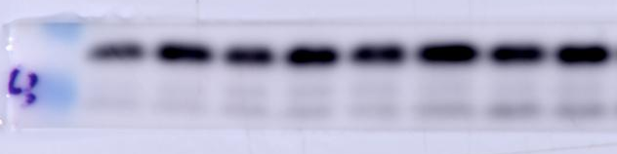
Fig. 1B~β-tubulin
hpi | 2 | 4 | 8 | 12
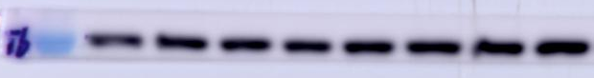
Fig. 1C~LC3
hpi | 16 | 20 | 24 | 28 | 32 | 36
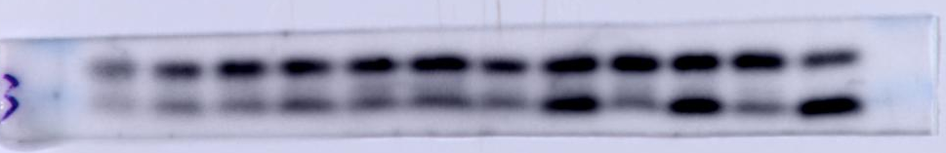
Fig. 1C~CDV-N
hpi | 16 | 20 | 24 | 28 | 32 | 36
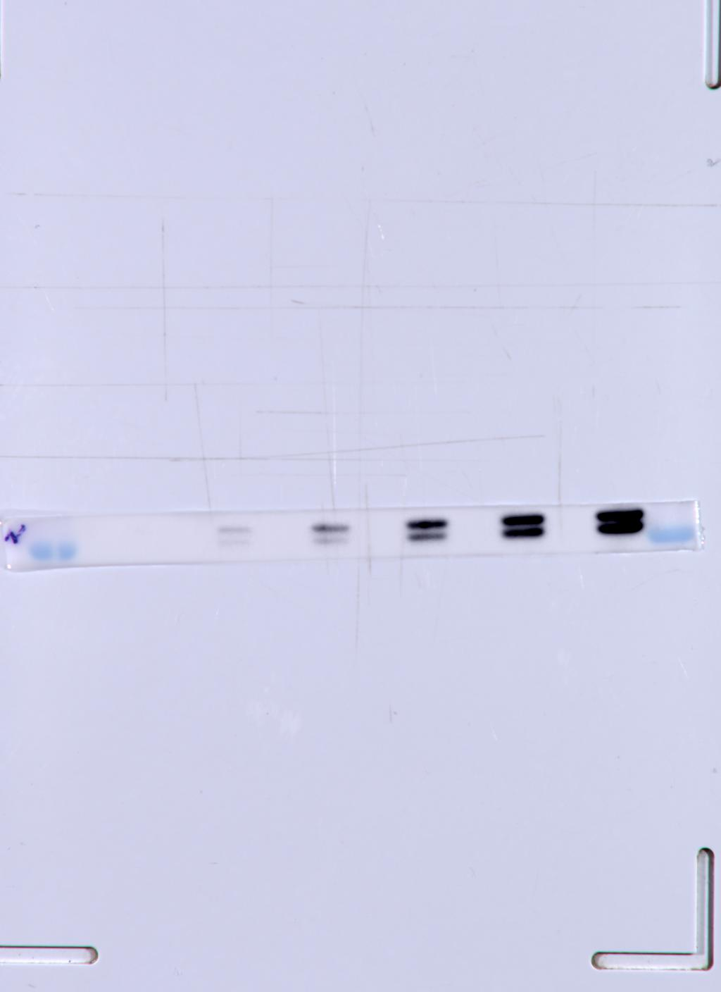
Fig. 1C~β-tubulin
hpi | 16 | 20 | 24 | 28 | 32 | 36
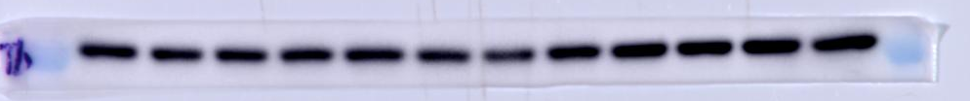

Fig. 2A~p62
hpi | 24 | 28 | 32 | 36 | 40
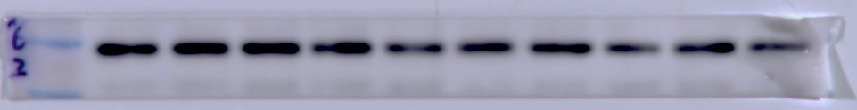
Fig. 2A~CDV-N
hpi | 24 | 28 | 32 | 36 | 40
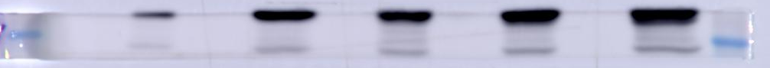

Fig. 2A~β-tubulin
hpi | 24 | 28 | 32 | 36 | 40
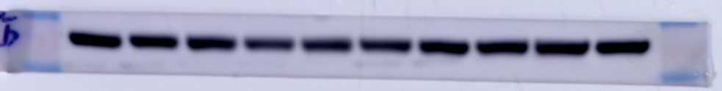
Fig. 2C~CDV-N
hpi | 24 |  |  | 28
 | mock | rapamycin | CDV | mock | rapamycin | CDV
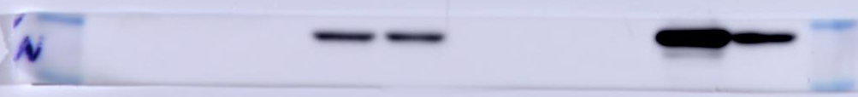
Fig. 2C~LC3
hpi | 24 |  |  | 28
 | mock | rapamycin | CDV | mock | rapamycin | CDV
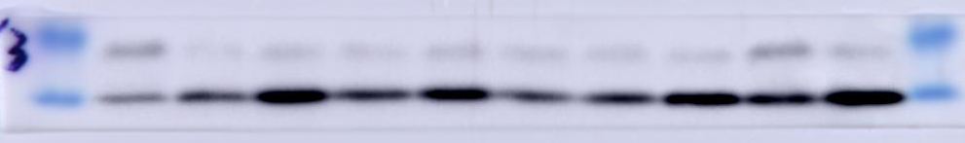
Fig. 2C~p62
hpi | 24 |  |  | 28
 | mock | rapamycin | CDV | mock | rapamycin | CDV
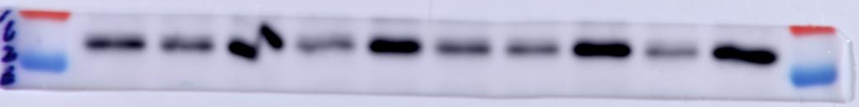
Fig. 2C~β-tubulin
hpi | 24 |  |  | 28
 | mock | rapamycin | CDV | mock | rapamycin | CDV
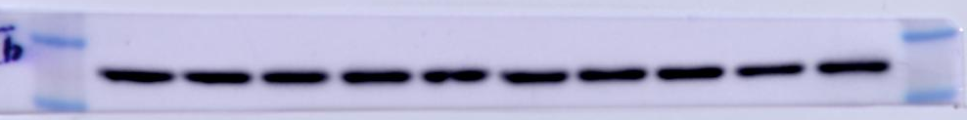

Fig. 3A~CDV-N
hpi | 26 |  | 30
 | - | 200 | - | 200 | 500 | 1000
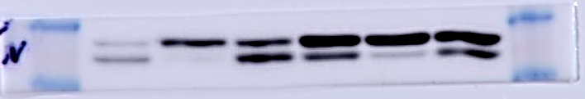
Fig. 3A~LC3
hpi | 26 |  | 30
 | - | 200 | - | 200 | 500 | 1000
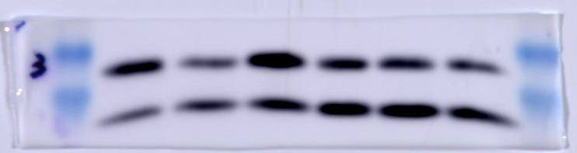

Fig. 3A~p62
hpi | 26 |  | 30
 | - | 200 | - | 200 | 500 | 1000
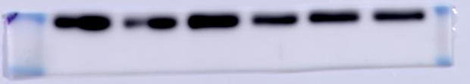
Fig. 3A~β-tubulin
hpi | 26 |  | 30
 | - | 200 | - | 200 | 500 | 1000
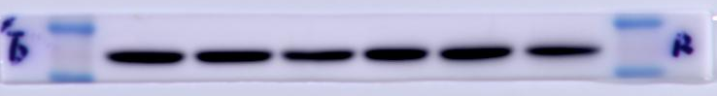

Fig. 4A~CDV-N
hpi | 26 | 30
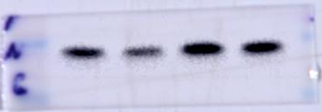
Fig. 4A~p62
hpi | 26 | 30
Fig. 4A~LC3
hpi | 26 | 30
Fig. 4A~β-tubulin
hpi | 26 | 30
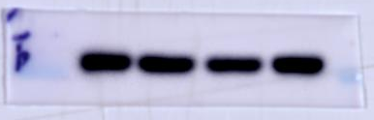
Fig. 4G~CDV-N
hpi | 26 | 30
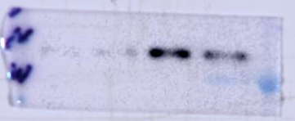

Fig. 4G~p62
hpi | 26 | 30
Fig. 4G~LC3
hpi | 26 | 30
Fig. 4G~β-tubulin
hpi | 26 | 30
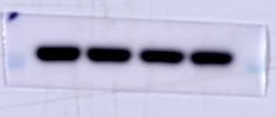

Fig. 5A~ATG5
 | si-  control | si-  ATG5
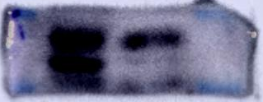
Fig. 5A~β-tubulin
 | si-  control | si-  ATG5
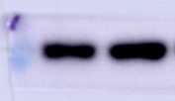
Fig. 5C~CDV-N
hpi | 32 |  | 24 |  | 28 |  | 32
 | si-  control | si-  ATG5 | si-  control | si-  ATG5 | si-  control | si-  ATG5 | si-  control | si-  ATG5
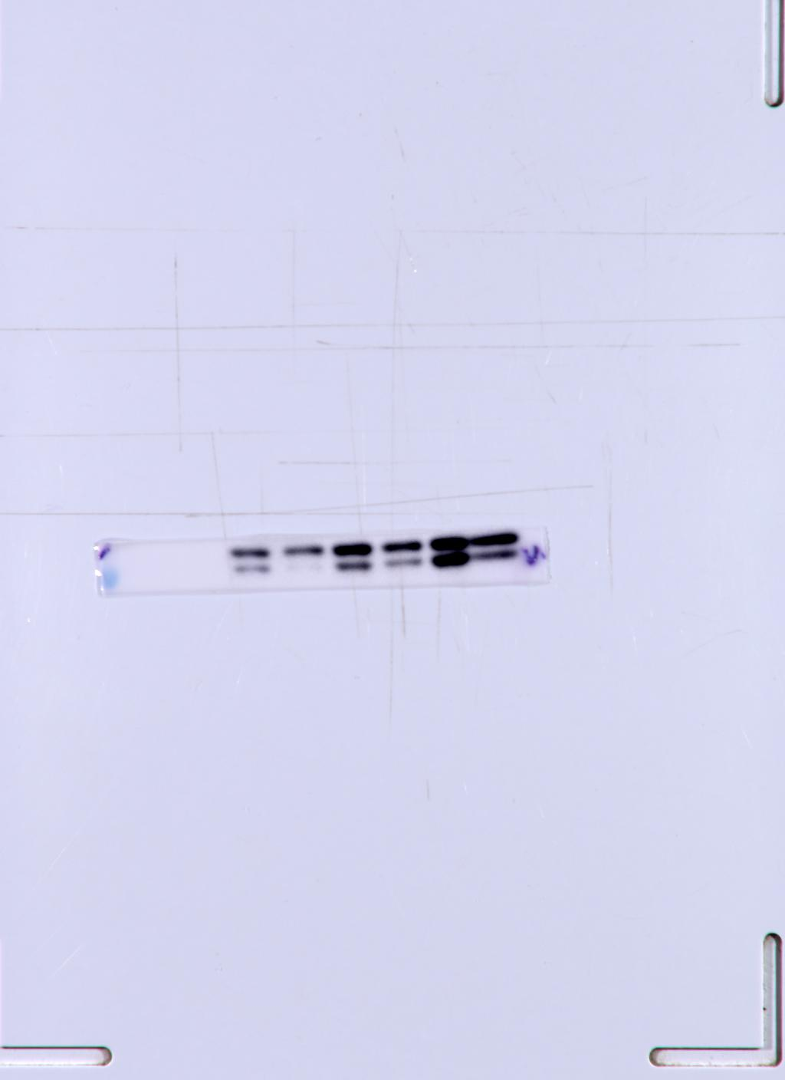
Fig. 5C~LC3
hpi | 32 |  | 24 |  | 28 |  | 32
 | si-  control | si-  ATG5 | si-  control | si-  ATG5 | si-  control | si-  ATG5 | si-  control | si-  ATG5
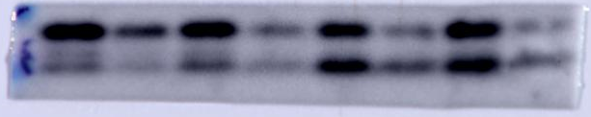
Fig. 5C~p62
hpi | 32 |  | 24 |  | 28 |  | 32
 | si-  control | si-  ATG5 | si-  control | si-  ATG5 | si-  control | si-  ATG5 | si-  control | si-  ATG5
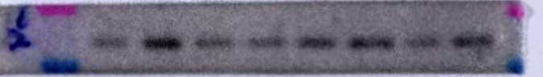
Fig. 5C~β-tubulin
hpi | 32 |  | 24 |  | 28 |  | 32
 | si-  control | si-  ATG5 | si-  control | si-  ATG5 | si-  control | si-  ATG5 | si-  control | si-  ATG5
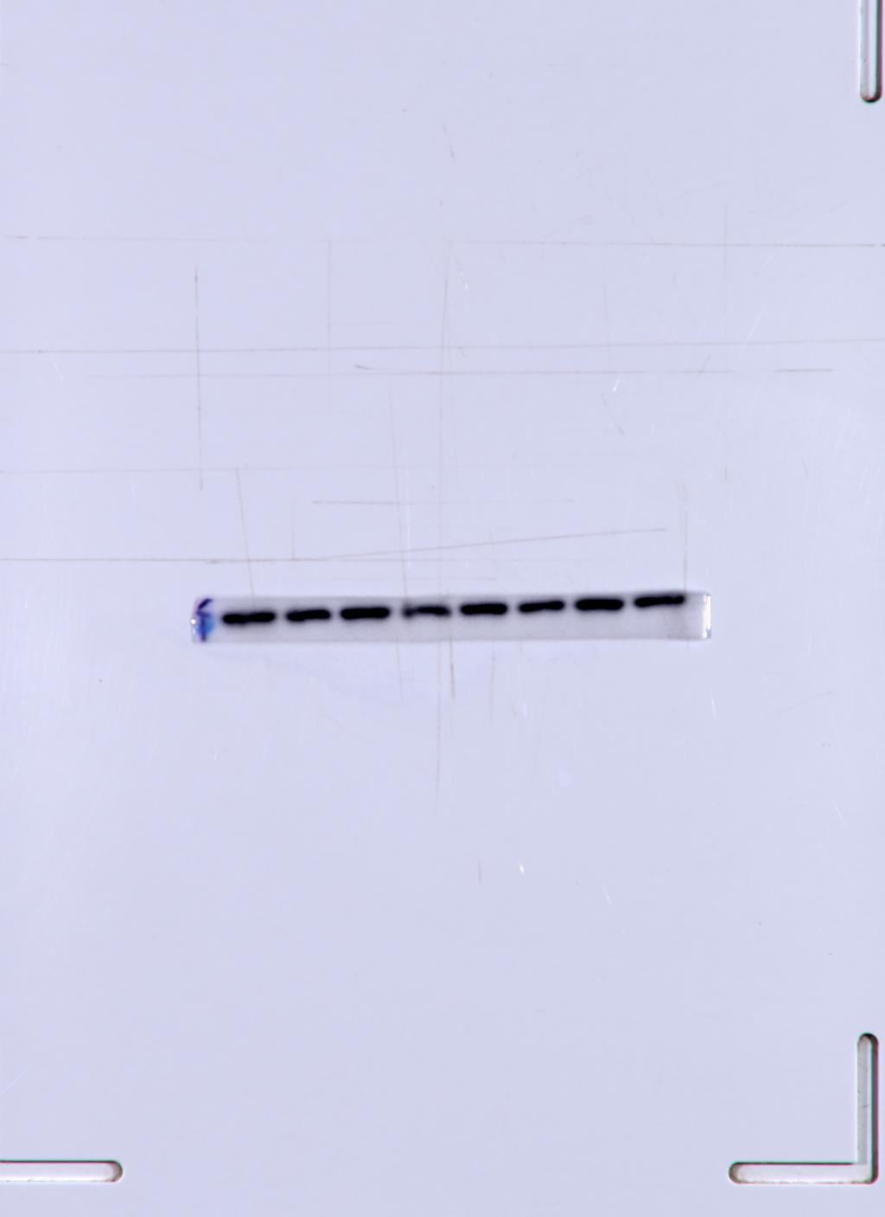

Fig. 6C~LC3
hpi | 28 | 32
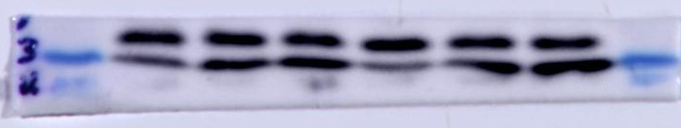
Fig. 6C~β-tubulin
hpi | 28 | 32
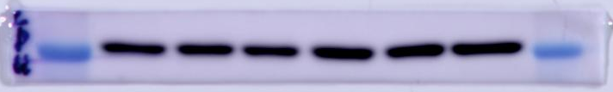
Fig. 6E~Flag
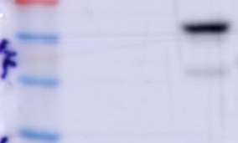
Fig. 6E~β-tubulin
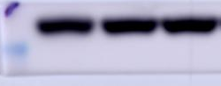

Fig. 6F~p-mTOR
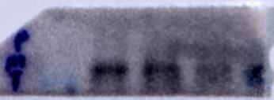
Fig. 6F~mTOR
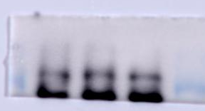
Fig. 6F~p-AKT
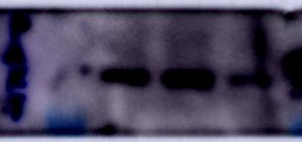
Fig. 6F~AKT
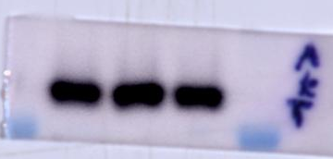
Fig. 6F~p62
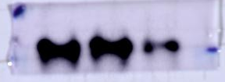
Fig. 6F~LC3
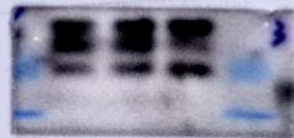
Fig. 6F~β-tubulin
