
Lirong Qian received the Ph.D. degrees in physical electronics from Tianjin University, Tianjin, China, in 2018. He is currently an Assistant Professor with the Tianjin Key Laboratory of Film Electronic and Communication Devices, School of Integrated Circuit Science and Engineering, Tianjin University of Technology, Tianjin, China. His research interests include RF MEMS, microacoustic resonators, filters and sensors.

Zeqin Zhang was born in Zhangjiakou, Hebei province, China, in 1999. He received a BEng degree in Electronic and Information Engineering from Hebei University of Architecture. He is currently working toward the ME degree at Tianjin University of Technology, China. His main research interest is surface acoustic waves torque sensors.

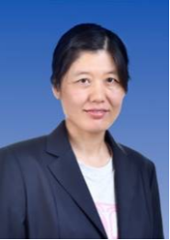
Cuiping Li received her Ph.D. degrees in physical electronics from Tianjin University, Tianjin, China, in 2012. She is currently an associate Professor with the School of Integrated Circuit Science and Engineering, Tianjin University of Technology, Tianjin, China. Her main research interests are in the fields of the surface acoustic wave devices and sensor


Yahui Tian was born in Shandong Province, China, in 1990. She received her B.S degree in Shandong University, China in 2012 and Ph. D degree in the Institute of Acoustics, Chinese Academy of Sciences in 2017. Now she is an associate researcher of the Institute of Acoustics, Chinese Academy of Sciences. She has published more than 40 academic papers. Her current research focuses on phononic crystals and surface acoustic wave devices. She has hosted and participated in many National Key R&D Projects, National Natural Fund Project, National Natural Fund Youth Fund and so on. She has won a classical Chinese Mathematics Artificial Intelligence Science and Technology Award and has been elected to the Beijing Municipal Science and Technology Star.

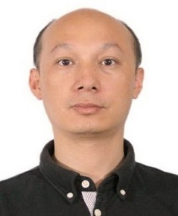
Honglang Li was born in Hubei Province, China, in 1976. He received his B.S degree in microelectronics from Hunan University, China in 1998 and Ph. D degree in Acoustics from the Institute of Acoustics, Chinese Academy of Sciences in 2003. From 2003 to 2005, he joined the Venture Business Laboratory, Chiba University as a post-doctoral fellow. He is currently a Researcher in National Center for Nanoscience and Technology. His research interests include simulation and application of surface acoustic wave filters and sensors of Physical/Chemical/Biological.

Litian Wang was born in Tianjin, China, in 1991. He received his Ph. D degree from Nankai University, Tianjin, China, in 2020. In 2020, he joined Tianjin University of Technology. He is currently an Assistant Professor and Deputy Director of Department with School of Integrated Circuit Science and Engineering, Tianjin University of Technology, Tianjin, China. His current research interests include the microwave passive devices and systems, high-temperature superconducting circuits, RF integrated circuit and sensor

