Supporting Information
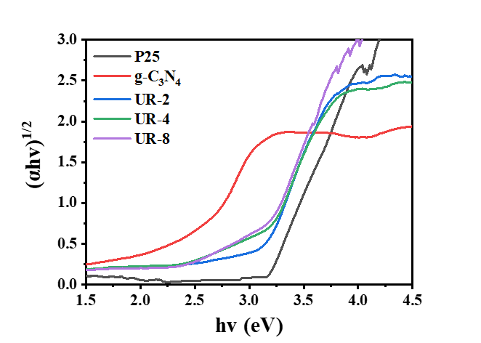
Fig S1. The plots of (ahv)^{1/2} vs. hv of the P25,g-C₃N₄, UR-2, UR-4 and UR-8 nanoparticles
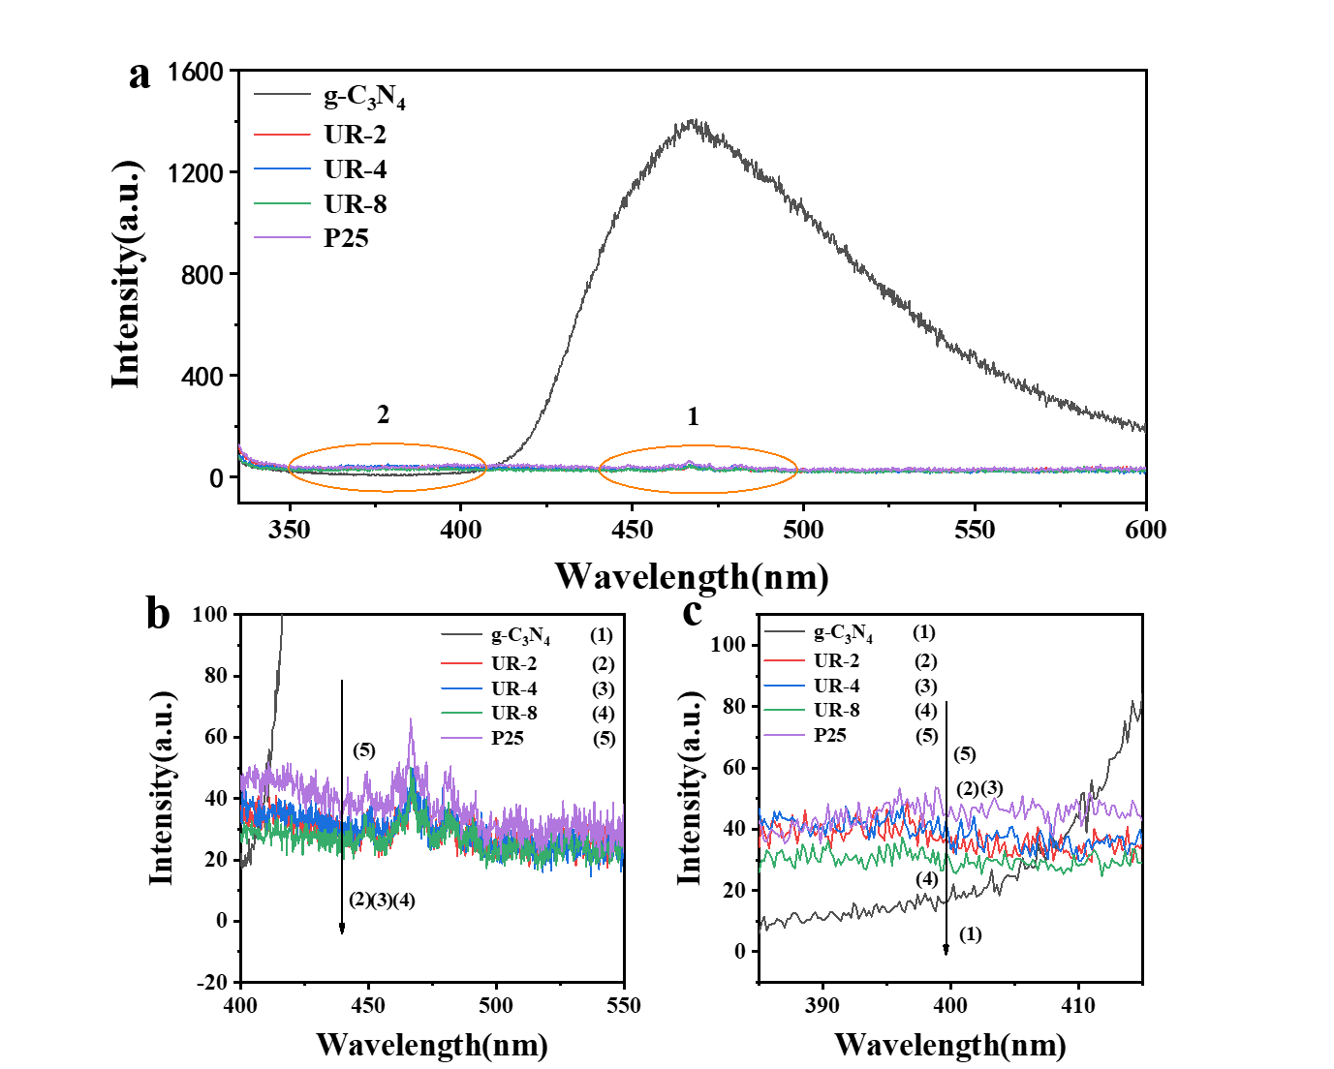
Fig S2. PL spectra (a), the magnified spectra of area1 (b) and area2 (c) of P25, g-C₃N₄, UR-2, UR-4 and UR-8 nanoparticles
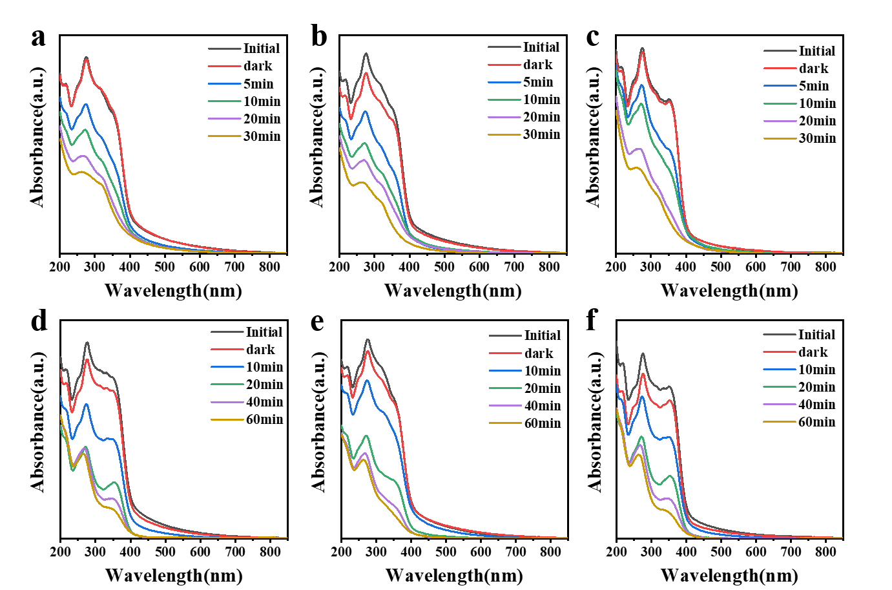
Fig S3. UV-Vis absorption curves of UR-2 (a), UR-4 (b) and UR-8 (c) nanoparticles for TC-HCl under simulated sunlight irradiation; UV-Vis absorption curves of UR-2 (d), UR-4 (e) and UR-8 (f) nanoparticles for TC-HCl under visible light irradiation
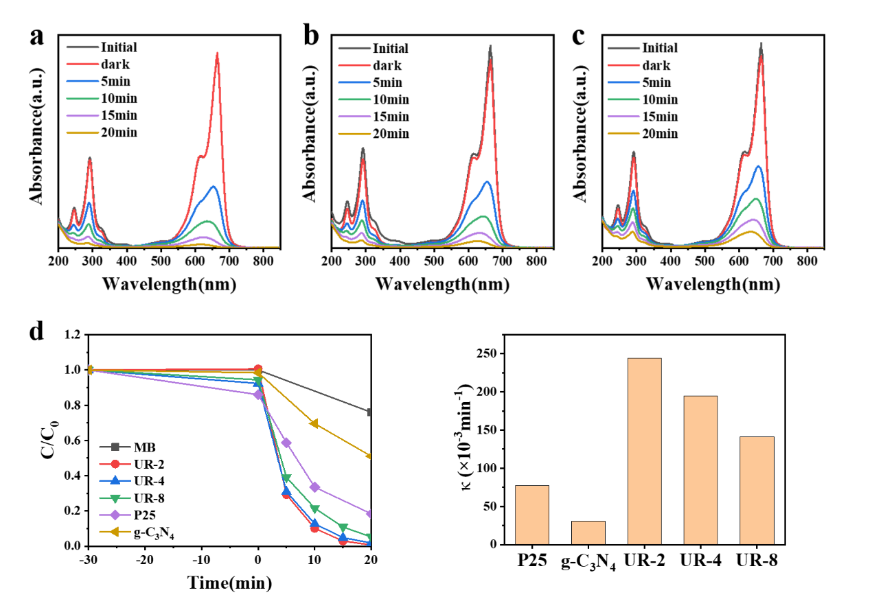
Fig S4. UV-Vis absorption curves of UR-2 (a), UR-4 (b) and UR-8 (c) nanoparticles for MB under simulated sunlight irradiation; Photocatalytic degradation MB curves under simulated sunlight irradiation (d) and reaction rate constant (e)

