Title: Endoscopic papillary balloon dilation can be safely performed in patients with dual antiplatelet therapy: A pilot study
Author list with degrees
Sakue Masuda¹ MD, Ryuhei Jinushi¹ MD, Kazuya Koizumi¹ MD, PhD, Makomo Makazu¹ MD, PhD, Takashi Nishino¹ MD, Kento Shionoya¹ MD, Karen Kimura¹ MD, Chihiro Sumida¹ MD, Jun Kubota¹ MD, Chikamasa Ichita¹ MD, Akiko Sasaki¹ MD, Masahiro Kobayashi¹ MD, Makoto Kako¹ MD, PhD, Haruki Uojima² MD, Ayumu Sugitani³ BSc

Author affiliations
¹Department of Gastroenterology Medicine Center, Shonan Kamakura General Hospital 1370-1 Okamoto, Kamakura, Kanagawa 247-8533, Japan
²Department of Gastroenterology, Internal Medicine, Kitasato University School of Medicine, Kanagawa 252-0375, Japan
³Department of the Institute of Biomedical Research, Sapporo Higashi Tokushukai Hospital, Hokkaido 065-0033, Japan

Corresponding author:
Sakue Masuda, MD
Department of Gastroenterology, Shonan Kamakura General Hospital
1370-1 Okamoto, Kamakura, Kanagawa 247-8533, Japan
E-mail: sakue3939@yahoo.co.jp, sakue.masuda@tokushukai.jp
Tel.: +81-467-46-1717
Fax: +81-467-45-0190
Supple 1.
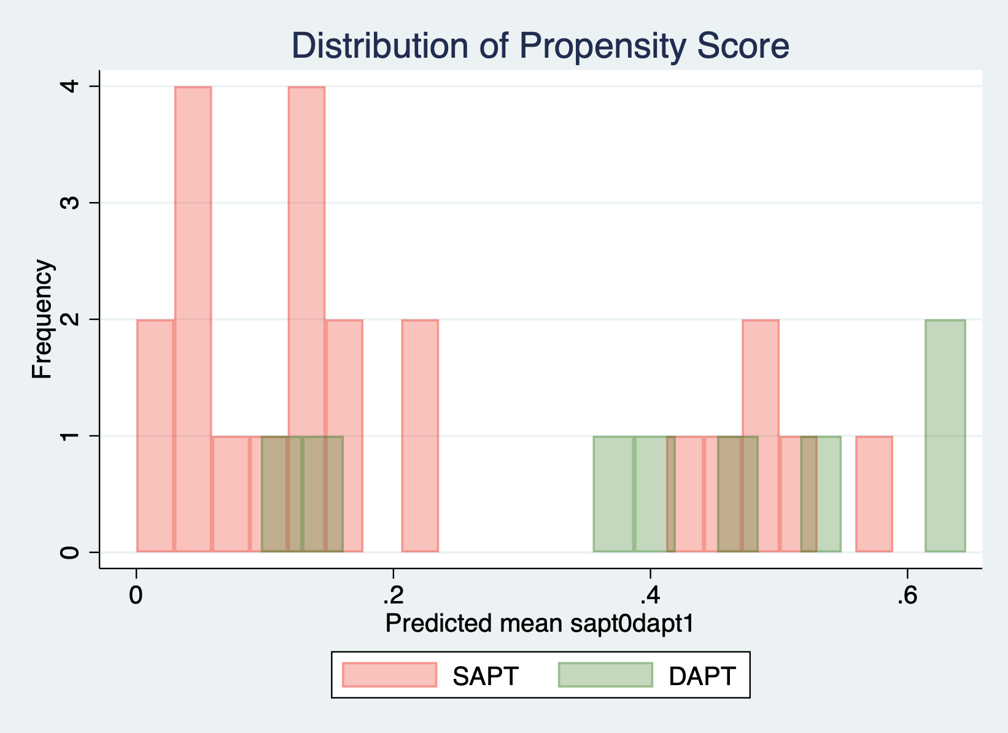
In this study, we attempted to align the background factors of the DAPT and SAPT groups by propensity score matching; however, it was difficult to achieve homogeneous alignment.

DAPT: dual antiplatelet therapy, SAPT: single antiplatelet therapy

