Supporting Information

Predicting the speciation of ionizable antibiotic ciprofloxacin by biochars with varying carbonization degrees

Guowei Shi^{1,2,3}, Yasong Li^{1,2}, Yaci Liu^{1,2}, Lin Wu^{1,2,4,*}
¹ Fujian Provincial Key Laboratory of Water Cycling and Eco-Geological Processes, Xiamen 361021, China
² China Geological Survey & Hebei Province Key Laboratory of Groundwater Contamination and Remediation, Institute of Hydrogeology and Environmental Geology, Chinese Academy of Geological Sciences, Shijiazhuang 050061, China
³ China University of Geosciences (Beijing), Beijing 100083, China
⁴ North China University of Water Resources and Electric Power, Zhengzhou 450046, China

*Corresponding author:
E-mail: wulin_shs@mail.cgs.gov.cn
Tel: +86-311-67598598
Fax: +86-311-67598661

Fig. S1 The proportion of different CIP species at various pH calculated from the MarvinSketch Software

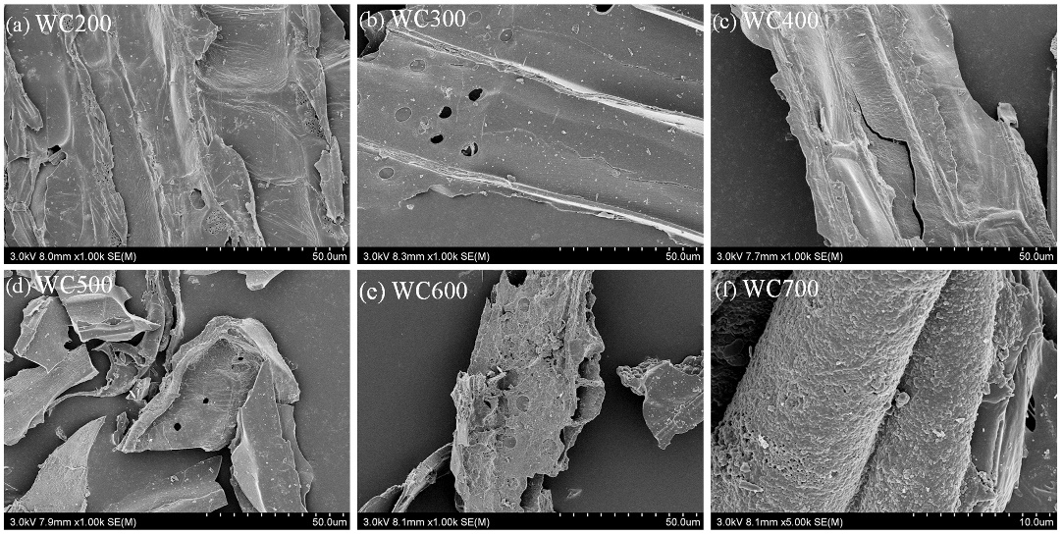
Fig. S2 SEM images of woodchip-derived biochars at 200-700 °C (WC200-WC700)

Fig. S3 Sorption isotherms of woodchip-derived biochars at 200 °C (WC200), 400 °C (WC400) and 600 °C (WC600) for CIP at different temperatures (298-318 K)

Table S1 Sorption isothermal parameters of woodchip-derived biochars at 200 °C (WC200), 400 °C (WC400) and 600 °C (WC600) for CIP at different temperatures (298-318 K)
Sample |  | Langmuir |  |  | Freundlich
Sample | Temperature (K) | q_{m} (mg g⁻¹) | K_{L} (L mg⁻¹) | R² | K_{F} (mg^{(1-N)} L^{N} g⁻¹) | N | R²
WC200 | 298 | 12.2 | 1.03 | 0.958 | 5.55 | 0.270 | 0.911
WC200 | 308 | 12.6 | 1.23 | 0.917 | 6.88 | 0.208 | 0.949
WC200 | 318 | 12.9 | 0.896 | 0.935 | 5.58 | 0.283 | 0.850
WC400 | 298 | 10.1 | 0.316 | 0.813 | 3.74 | 0.275 | 0.835
WC400 | 308 | 12.7 | 0.327 | 0.977 | 4.20 | 0.319 | 0.945
WC400 | 318 | 20.0 | 0.215 | 0.952 | 5.12 | 0.383 | 0.934
WC600 | 298 | 19.6 | 0.093 | 0.950 | 3.40 | 0.455 | 0.957
WC600 | 308 | 20.0 | 0.528 | 0.923 | 7.24 | 0.288 | 0.852
WC600 | 318 | 21.9 | 0.350 | 0.920 | 7.08 | 0.326 | 0.832

Table S2 Thermodynamic parameters of CIP sorption by woodchip-derived biochars at 200 °C (WC200), 400 °C (WC400) and 600 °C (WC600) at different temperatures (298-318 K)
Sample | Temperature (K) | ΔG (kJ mol⁻¹) | ΔH (kJ mol⁻¹) | ΔS (kJ mol⁻¹ K⁻¹)
WC200 | 298 | -1.34 | 4.54 | 0.0190
WC200 | 308 | -1.53 | 4.54 | 0.0190
WC200 | 318 | -1.73 | 4.54 | 0.0190
WC400 | 298 | -0.377 | 19.1 | 0.0650
WC400 | 308 | -0.870 | 19.1 | 0.0650
WC400 | 318 | -1.69 | 19.1 | 0.0650
WC600 | 298 | -0.86 | 20.9 | 0.0740
WC600 | 308 | -2.13 | 20.9 | 0.0740
WC600 | 318 | -2.31 | 20.9 | 0.0740

