Supplemental Table.1
Study | Representativeness | Selection of the nonexposed conhort | Ascertainment of exposure | Demonstration that outcome of interest was not present at start of study | Comparability of cohorts on the basis of the design or analysis | Assessment of outcome | Was follow-up enough for outcomes to occur | Adequacy of follow up of cohorts | Quanty score
Eric Durand 2014 | ★ |  | ★ | ★ | ★ | ★ |  |  | 5
Ichibori 2017 |  | ★ | ★ | ★ | ★ | ★ | ★ | ★ | 7
Mach 2020 |  | ★ | ★ | ★ | ★ | ★ | ★ | ★ | 7
D'Ascenzo 2017 | ★ | ★ | ★ | ★ | ★★ | ★ | ★ | ★ | 9
Kawashima 2020 | ★ | ★ | ★ | ★ | ★ | ★ | ★ | ★ | 8
Butt 2019 | ★ | ★ | ★ | ★ | ★ | ★ | ★ | ★ | 8
Seeger 2017 | ★ | ★ | ★ | ★ | ★ | ★ | ★ | ★ | 8
Geis 2018 | ★ | ★ | ★ | ★ |  |  | ★ | ★ | 6
Jochheim 2019 | ★ | ★ | ★ | ★ | ★ | ★ | ★ | ★ | 7
Didier 2021 | ★ | ★ | ★ | ★ | ★ | ★ | ★ | ★ | 8
Kalogeras 2019 | ★ | ★ | ★ | ★ | ★ | ★ | ★ | ★ | 8
Kosmidou 2019 | ★ | ★ |  | ★ |  | ★ | ★ | ★ | 6
Sherwood 2021 | ★ | ★ | ★ | ★ | ★ | ★ | ★ | ★ | 8
Abdul-Jawad 2016 | ★ | ★ | ★ | ★ | ★ | ★ | ★ | ★ | 8

Supplemental Fig. 1 Quality evaluation of included RCTs

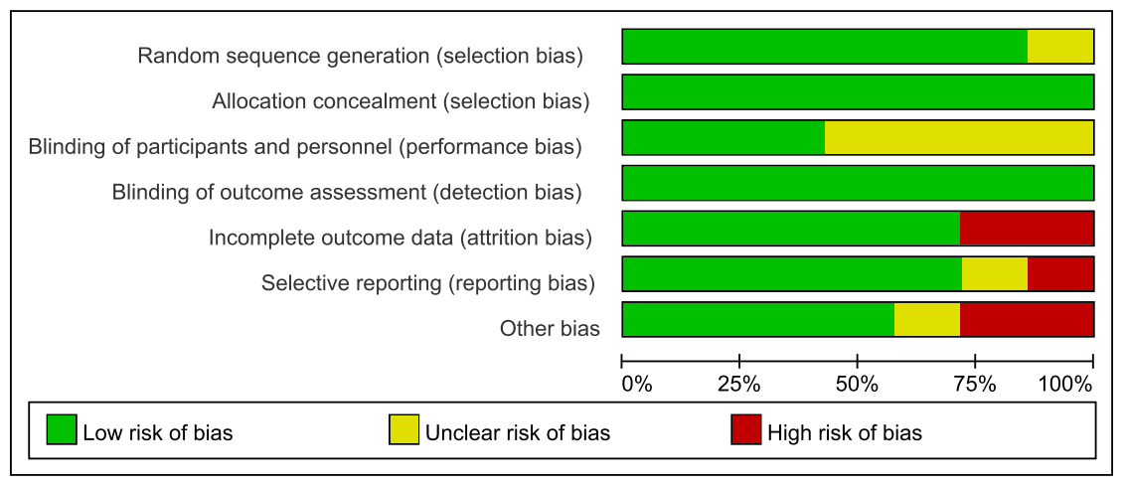

Supplemental Fig. 2 Quality assessment of included RCTs

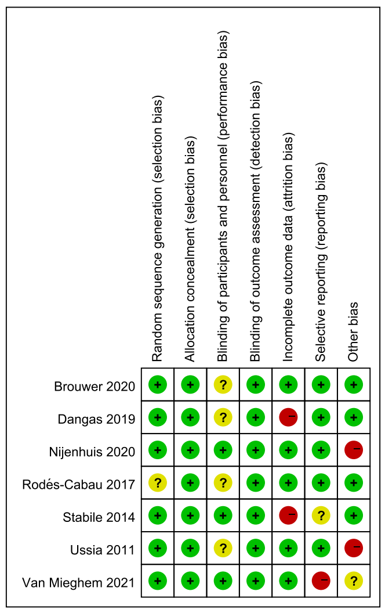

Supplemental Fig. 3A Sensitivity analysis of the all cause death for patients with an indication for oral anticoagulants(VKA vs NOACs)

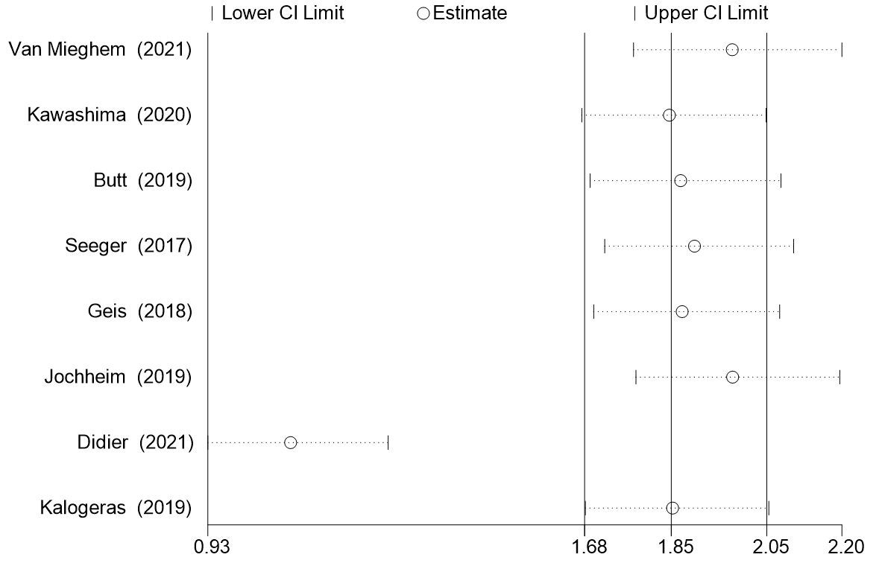

Supplemental Fig. 3B Sensitivity analysis of the all stroke for patients with an indication for oral anticoagulants(VKA vs NOACs)

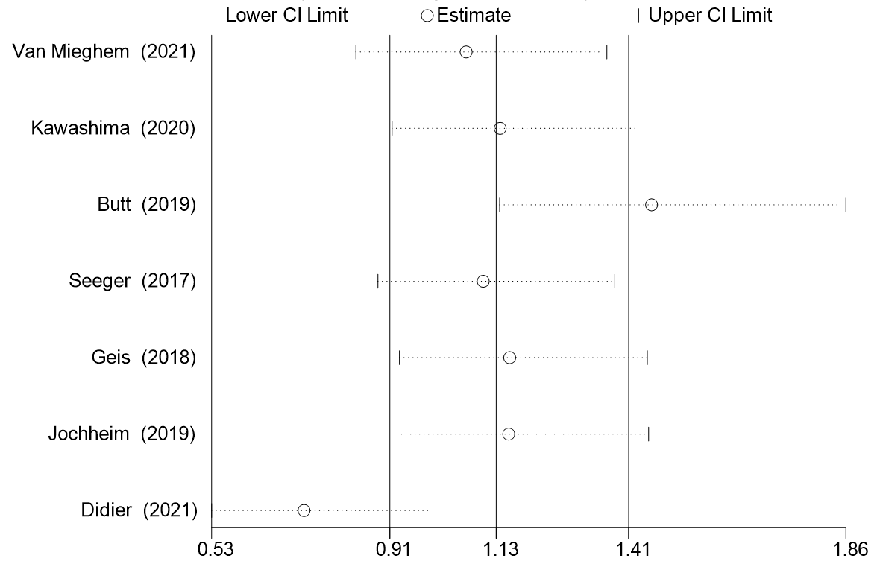

Supplemental Fig. 3C Sensitivity analysis of the all bleeding for patients with an indication for oral anticoagulants(VKA vs NOACs)

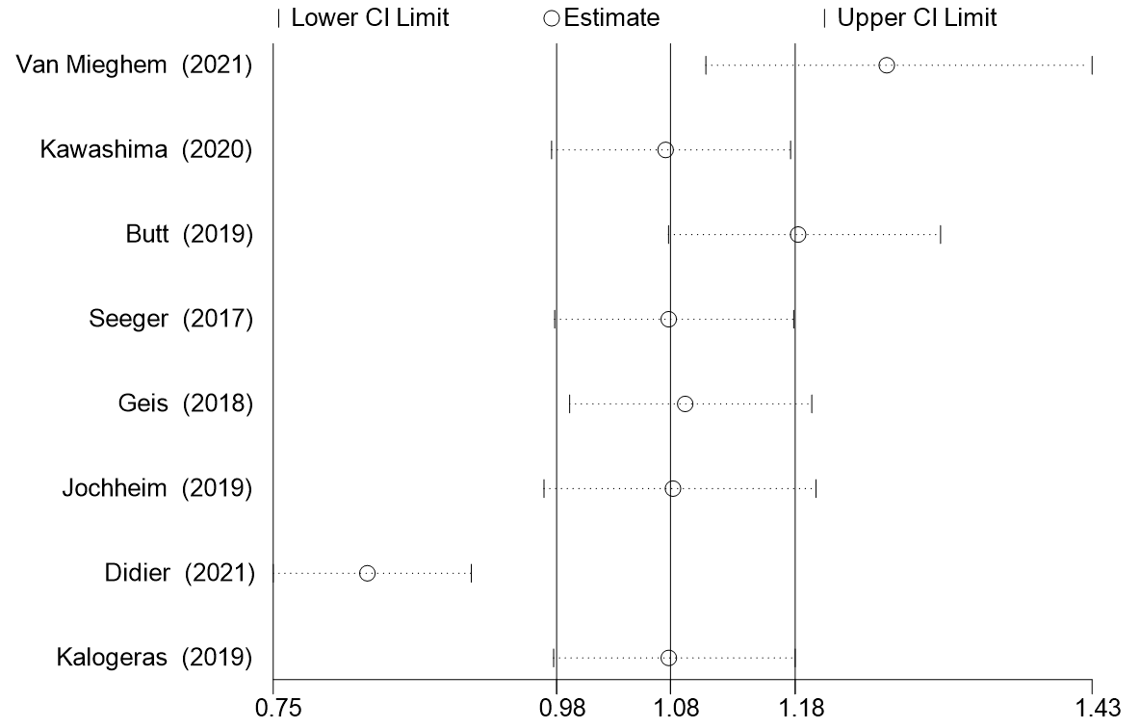

Supplemental Fig. 4A Sensitivity analysis of the all cause death for patients without an indication for oral anticoagulants(SAPT vs DAPT)

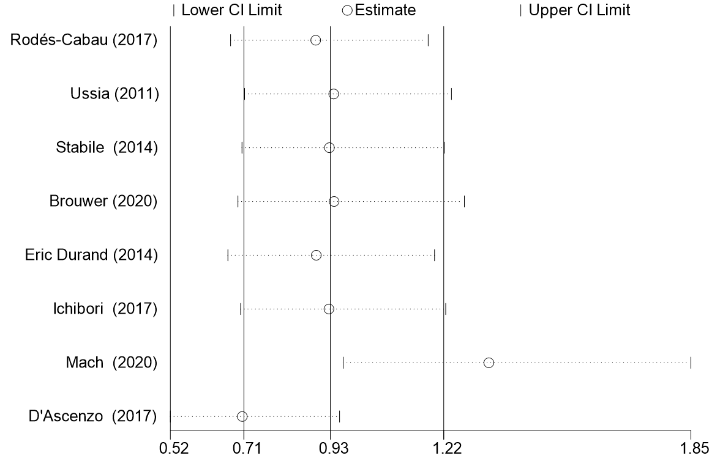

Supplemental Fig. 4B Sensitivity analysis of the all bleeding for patients without an indication for oral anticoagulants(SAPT vs DAPT)

