ADDITIONAL FIILE

In vitro antiplasmodial activity and toxicological profile of extracts, fractions and chemical constituents of leaves and stem bark of Dacryodes edulis (Burseraceae)
By
Kevine Johane Jumeta Dongmo ¹, Mariscal Brice Tchatat Tali ², Yannick Stéphane Fotsing Fongang ^{3,*}, Pierre Leonel K. Tafokeu Taguimjeu ¹, Donald Ulrich Kenou Kagho ¹, Gabin Thierry Bitchagno ⁴, Bruno Ndjakou Lenta ^{5,*}, Fabrice Boyom Fekam ², Norbert Sewald ⁶, Silvère Augustin Ngouela ¹
¹ Department of Organic Chemistry, Faculty of Science, University of Yaoundé I, P.O. Box 812 Yaoundé, Yaoundé, Cameroon (jumetakevine@yahoo.fr; taguimjeuleonel@outlook.fr; dkaghokenou@yahoo.fr)
² Antimicrobial and Biocontrol Agent Unit, Faculty of Science, University of Yaoundé I, P.O. Box 812 Yaoundé, Yaoundé, Cameroon (b.tchatat@yahoo.com; tchatatb7@gmail.com)
³ Department of Chemistry, Higher Teachers’ Training College, The University of Maroua, P.O. Box 55 Maroua, Maroua, Cameroon (fongangfys@yahoo.fr)
⁴ Department of Chemistry, University of Dschang, P.O. Box 67 Dschang, Cameroon (bmgt198716@ymail.com)
⁵ Department of Chemistry, Higher Teacher Training College, University of Yaoundé I, P.O. Box 47 Yaoundé, Yaoundé, Cameroon (lentabruno@yahoo.fr)
⁶ Department of Chemistry, Bielefeld University, P.O. Box 100131, 33501, Bielefeld, Germany (Norbert.sewald@uni-bielefeld.de)

* Corresponding Authors : Yannick Stéphane Fotsing Fongang (fongangfys@yahoo.fr; Orcid number: 0000-0002-9311-9945) and Bruno Ndjakou Lenta (lentabruno@yahoo.fr)
Table of Contents
Figure 1: HR-ESI mass spectrum of 1 3
Figure 2: ¹H NMR spectrum (Pyridin-d₅, 600 MHz) of 1 3
Figure 3: ¹³C NMR spectrum (Pyridin-d₅, 150 MHz) of 1 4
Figure 4: ESI mass spectrum of 2 4
Figure 5: ¹H NMR spectrum (CDCl₃, 600 MHz) of 2 5
Figure 6: ¹³C NMR spectrum (CDCl₃, 150 MHz) of 2 5
Figure 7: ¹H NMR spectrum (Pyridin-d₅, 600 MHz) of 3 6
Figure 8: ¹H NMR spectrum (Pyridin-d₅, 600 MHz) of 4 6
Figure 9: ¹³C NMR spectrum (Pyridin-d₅, 150 MHz) of 4 7
Figure 10: HR-ESI mass spectrum of 5 7
Figure 11: ¹H NMR spectrum (CD₃OD, 600 MHz) of 5 8
Figure 12: ¹³C NMR spectrum (CD₃OD, 150 MHz) of 5 8
Figure 13: ¹H NMR spectrum (CD₃OD, 600 MHz) of 6 9
Figure 14: ¹³C NMR spectrum (CD₃OD, 150 MHz) of 6 9
Figure 15: HR-ESI mass spectrum of 7 10
Figure 16: ¹H NMR spectrum (CDCl₃, 600 MHz) of 7 10
Figure 17: ¹³C NMR spectrum (CDCl₃, 150 MHz) of 7 11
Figure 18: ¹H NMR spectrum (CDCl₃, 600 MHz) of 8 11
Figure 19: ¹³C NMR spectrum (CDCl₃, 150 MHz) of 8 12
Figure 20: HR-ESI mass spectrum of 9 12
Figure 21: ¹H NMR spectrum (CDCl₃, 600 MHz) of 9 13
Figure 22: ¹³C NMR spectrum (CDCl₃, 150 MHz) of 9 13
Figure 23: ¹H NMR spectrum (CD₃OD, 600 MHz) of 10 14
Figure 24: ¹H NMR spectrum (CDCl₃, 600 MHz) of 11 14
Figure 25: ¹³C NMR spectrum (CDCl₃, 150 MHz) of 11 15
Figure 26: ¹H NMR spectrum (CDCl₃, 600 MHz) of 12 15
Figure 27: ¹³C NMR spectrum (CDCl₃, 150 MHz) of 12 16
Figure 28: ¹H NMR spectrum (CDCl₃, 600 MHz) of 13 16
Figure 29: ¹³C NMR spectrum (CDCl₃, 150 MHz) of 13 17
Figure 30: ¹H NMR spectrum (CDCl₃, 600 MHz) of 14 17
Figure 31: ¹³C NMR spectrum (CDCl₃, 150 MHz) of 14 18

Lichexanthone (1)
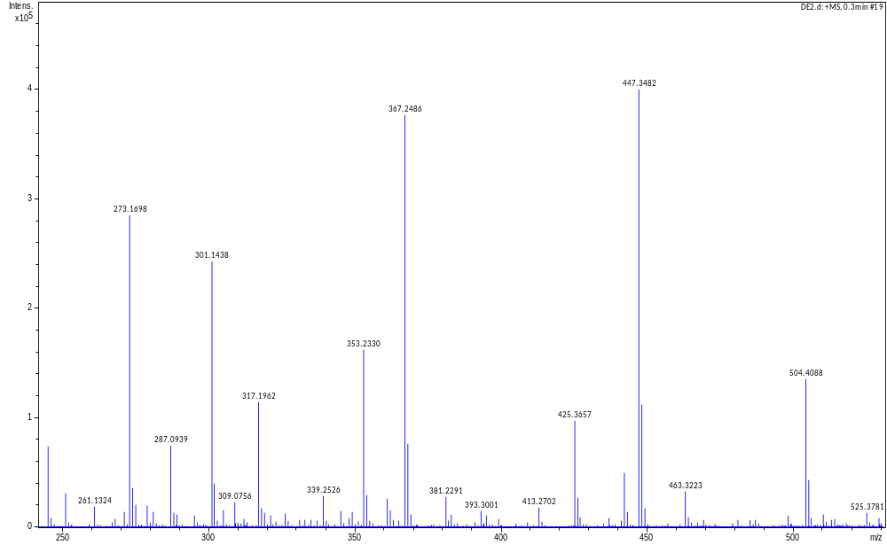

Figure 1: HR-ESI mass spectrum of 1
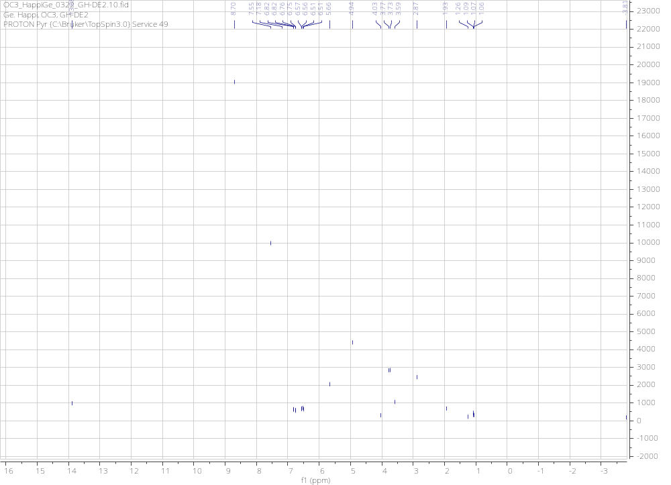

Figure 2: ¹H NMR spectrum (Pyridin-d₅, 600 MHz) of 1

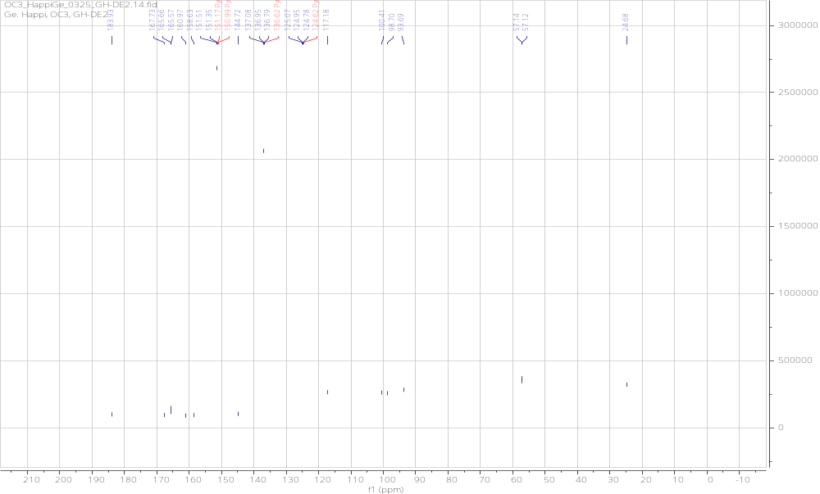

Figure 3: ¹³C NMR spectrum (Pyridin-d₅, 150 MHz) of 1

Griseoxanthone (2)
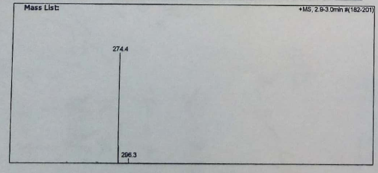

Figure 4: ESI mass spectrum of 2

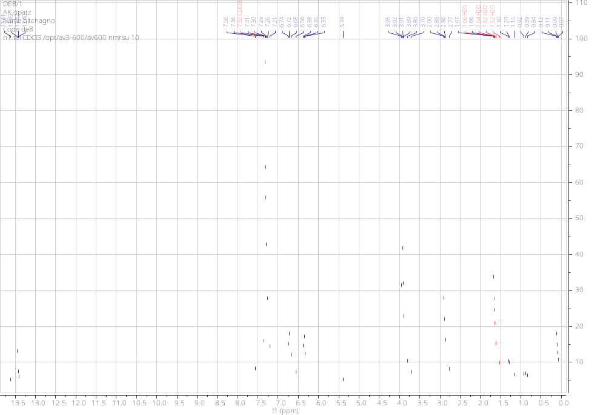

Figure 5: ¹H NMR spectrum (CDCl₃, 600 MHz) of 2

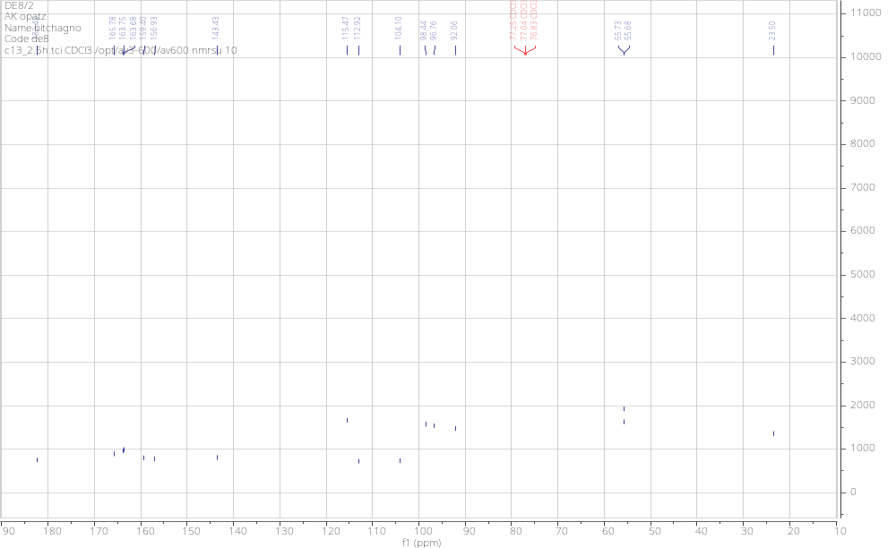

Figure 6: ¹³C NMR spectrum (CDCl₃, 150 MHz) of 2

3-3'-O-dimethylellargic acid (3)

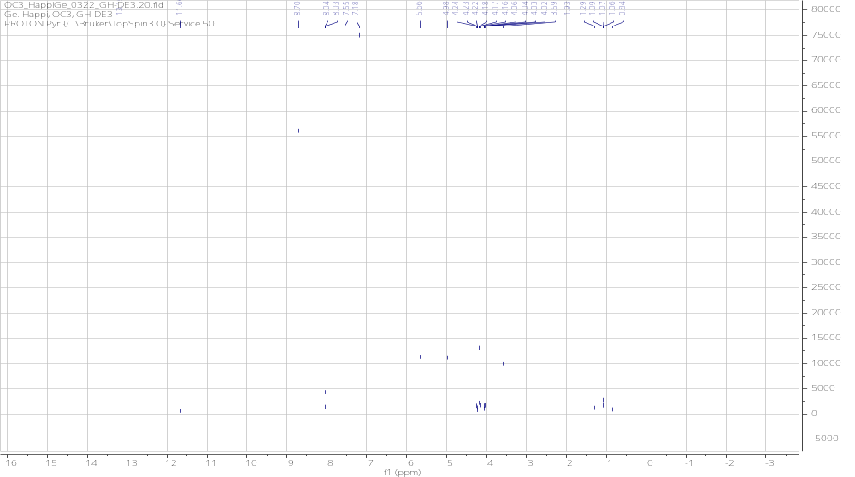

Figure 7: ¹H NMR spectrum (Pyridin-d₅, 600 MHz) of 3
3,3′,4-tri-O-methylellargic (4)
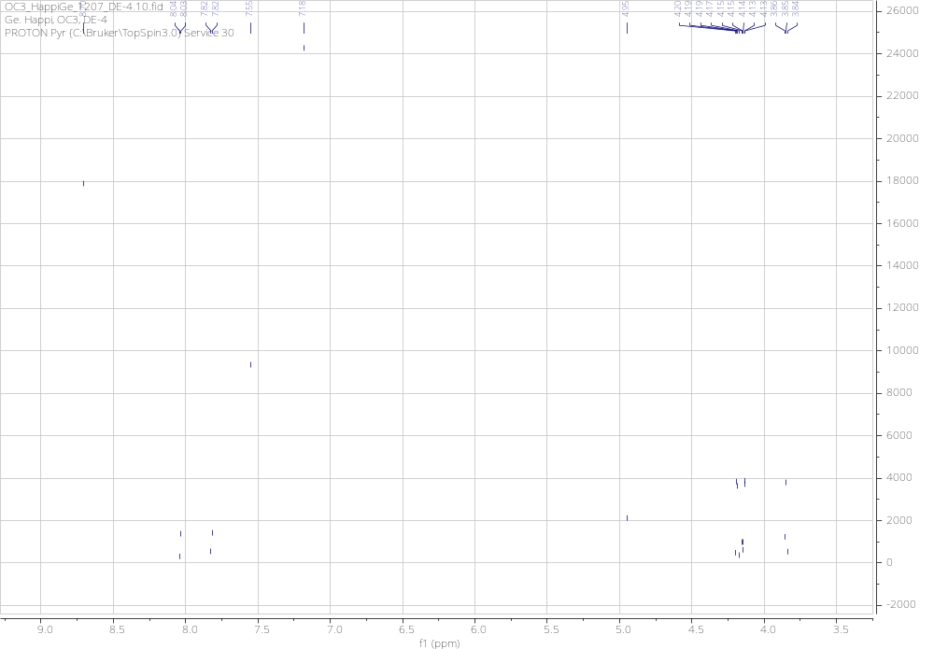

Figure 8: ¹H NMR spectrum (Pyridin-d₅, 600 MHz) of 4

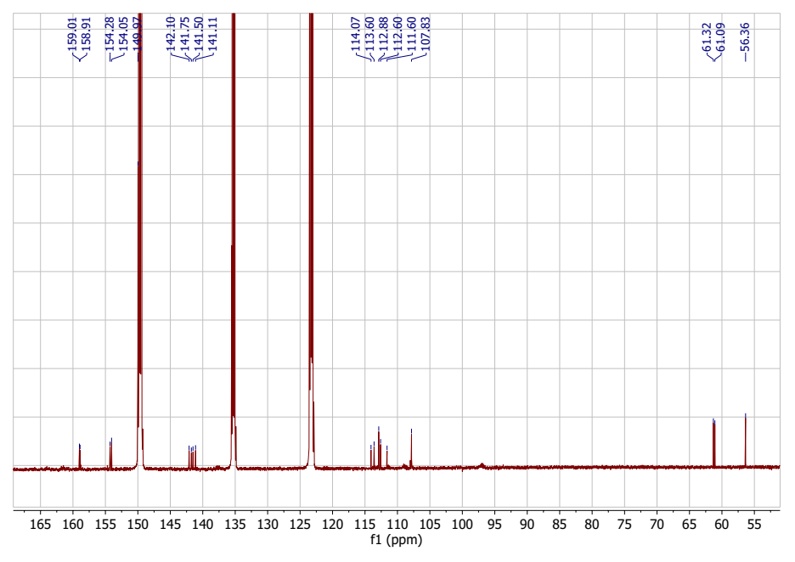

Figure 9: ¹³C NMR spectrum (Pyridin-d₅, 150 MHz) of 4

3,3″-di-O-methylellargic acid 4-O-(3″-galloyl)-β-D-xylopyranoside (5)
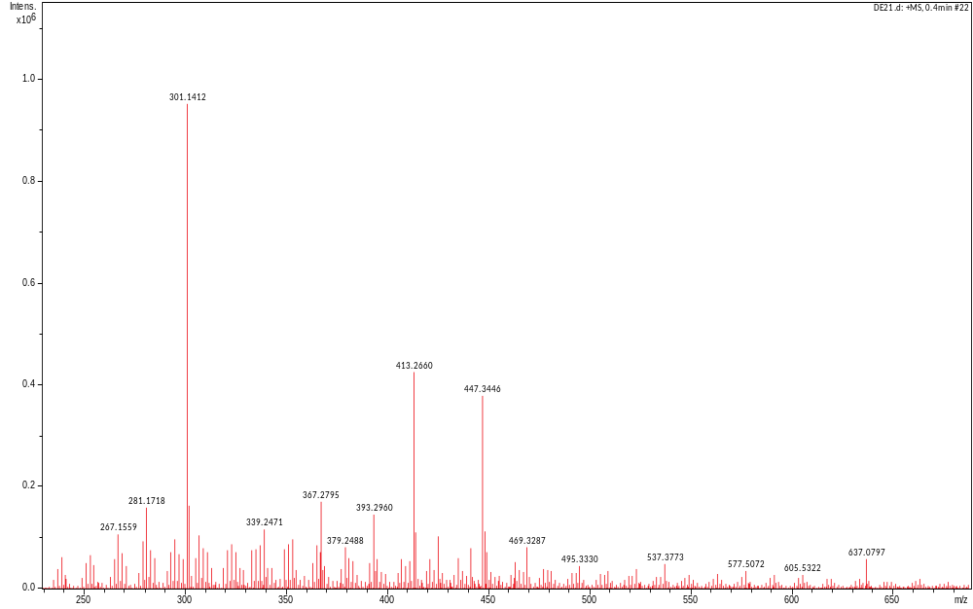

Figure 10: HR-ESI mass spectrum of 5

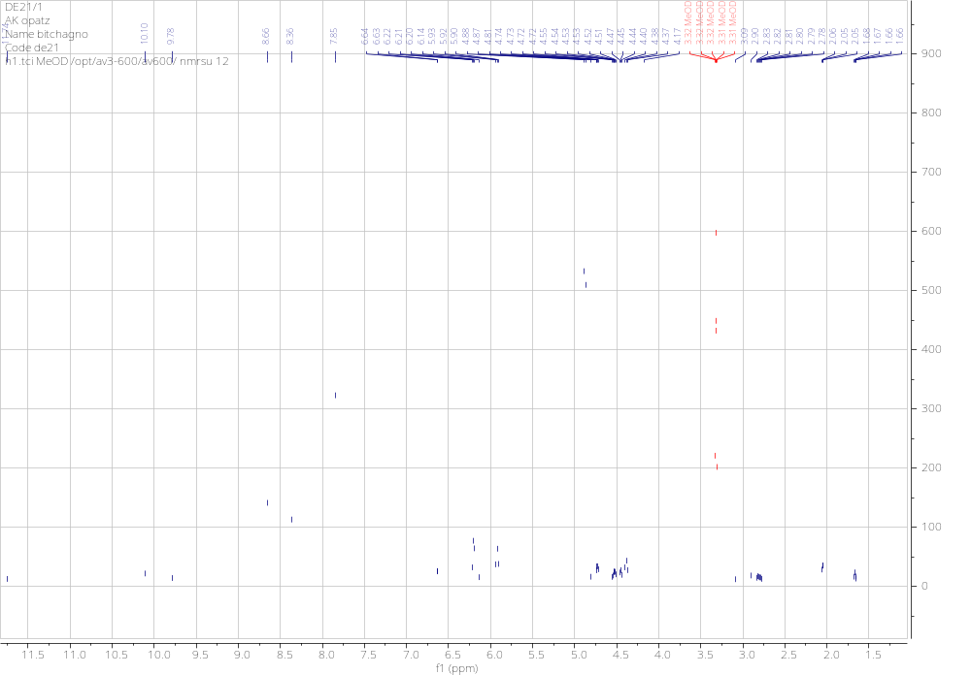

Figure 11: ¹H NMR spectrum (CD₃OD, 600 MHz) of 5
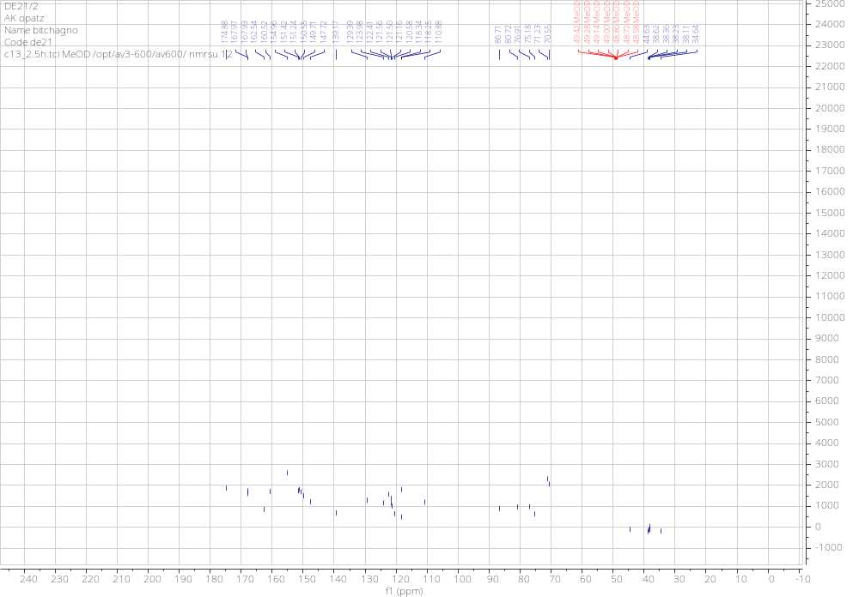

Figure 12: ¹³C NMR spectrum (CD₃OD, 150 MHz) of 5

3,4-dihydroxybenzoïc acid (6)
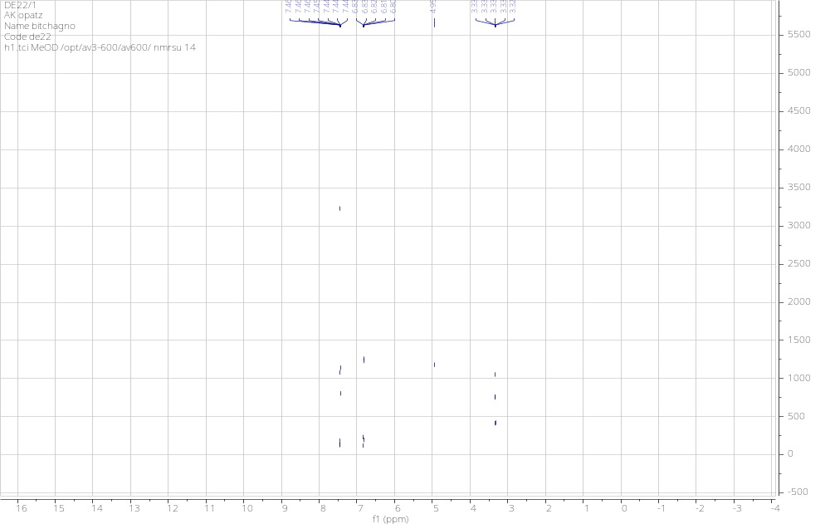

Figure 13: ¹H NMR spectrum (CD₃OD, 600 MHz) of 6

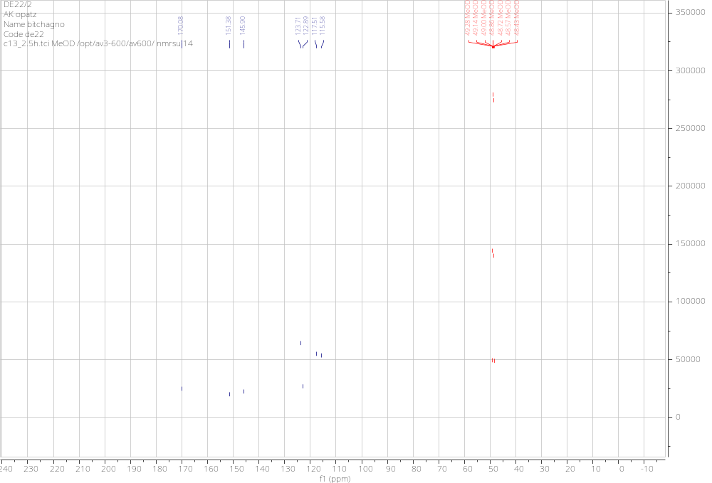

Figure 14: ¹³C NMR spectrum (CD₃OD, 150 MHz) of 6

Confluentic acid (7)
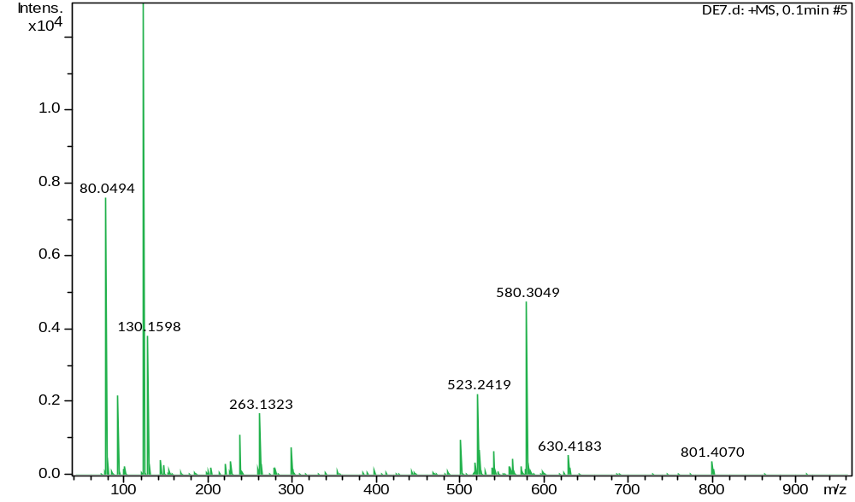

Figure 15: HR-ESI mass spectrum of 7

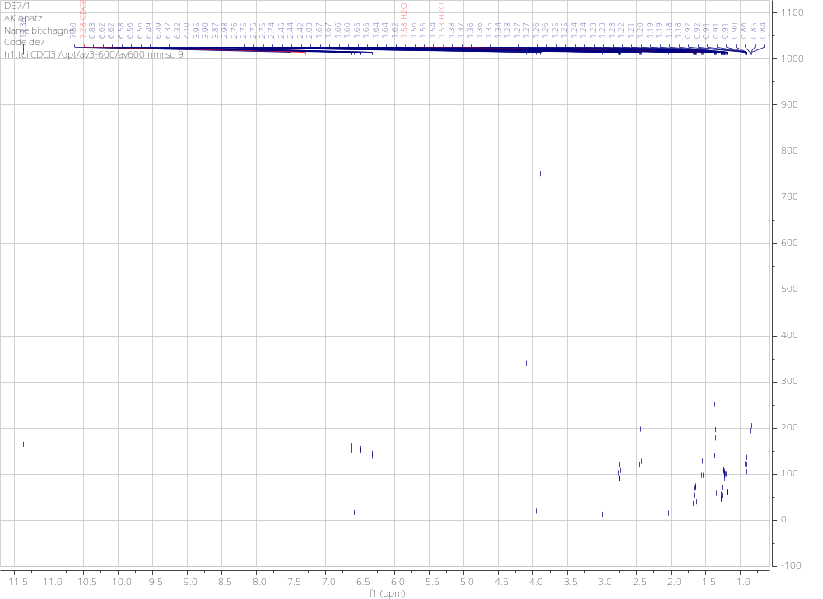

Figure 16: ¹H NMR spectrum (CDCl₃, 600 MHz) of 7

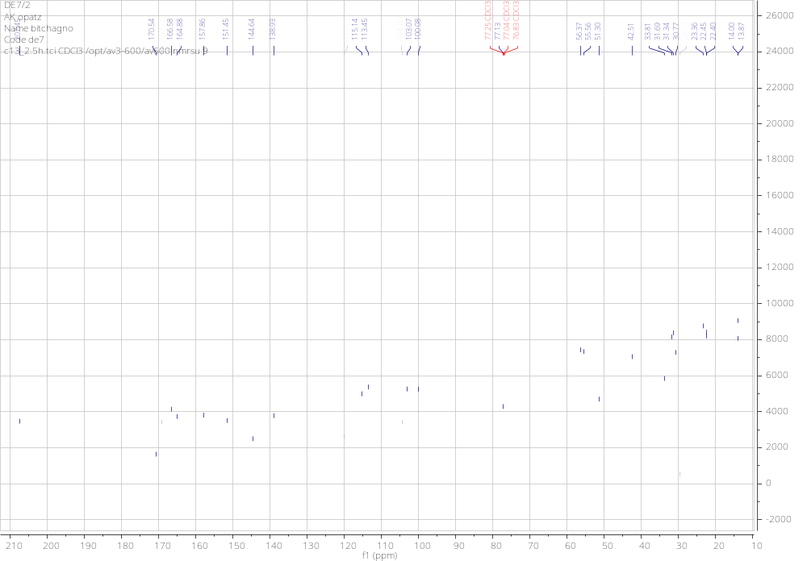
Figure 17: ¹³C NMR spectrum (CDCl₃, 150 MHz) of 7
Glyceryl-1-tetracosanoate (8)
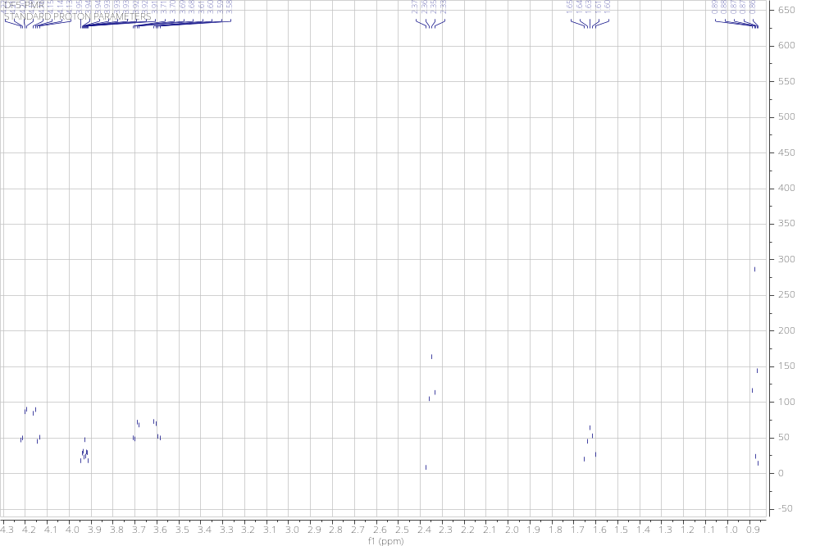

Figure 18: ¹H NMR spectrum (CDCl₃, 600 MHz) of 8

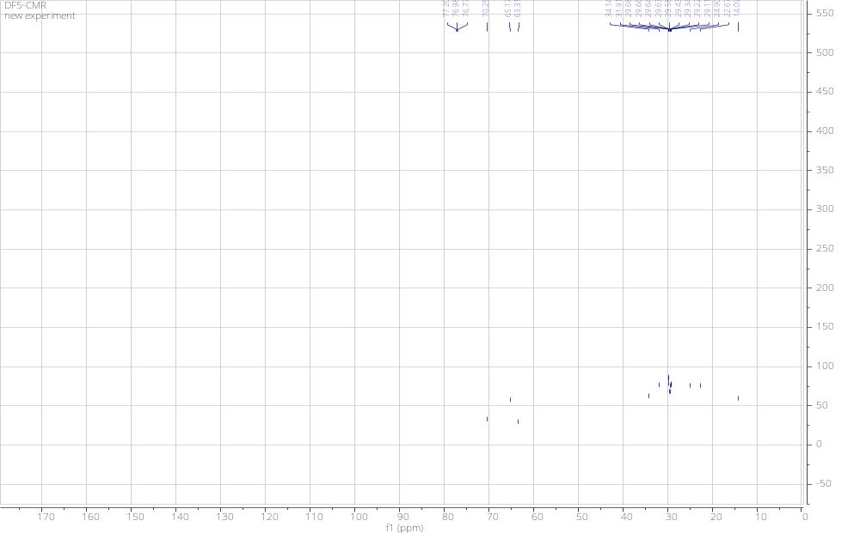

Figure 19: ¹³C NMR spectrum (CDCl₃, 150 MHz) of 8

Auranthiamide acetate (9)
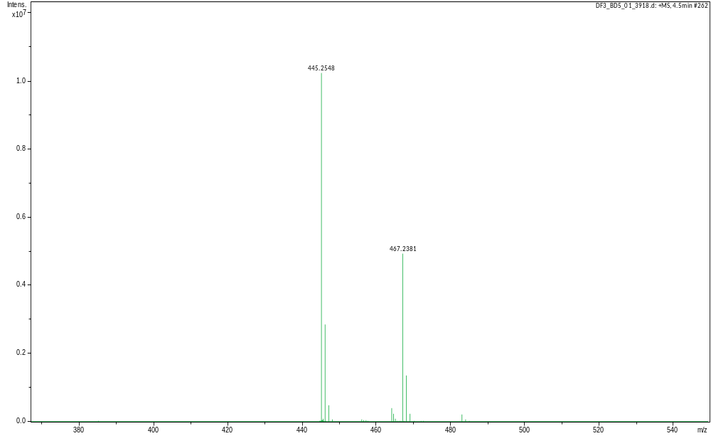

Figure 20: HR-ESI mass spectrum of 9

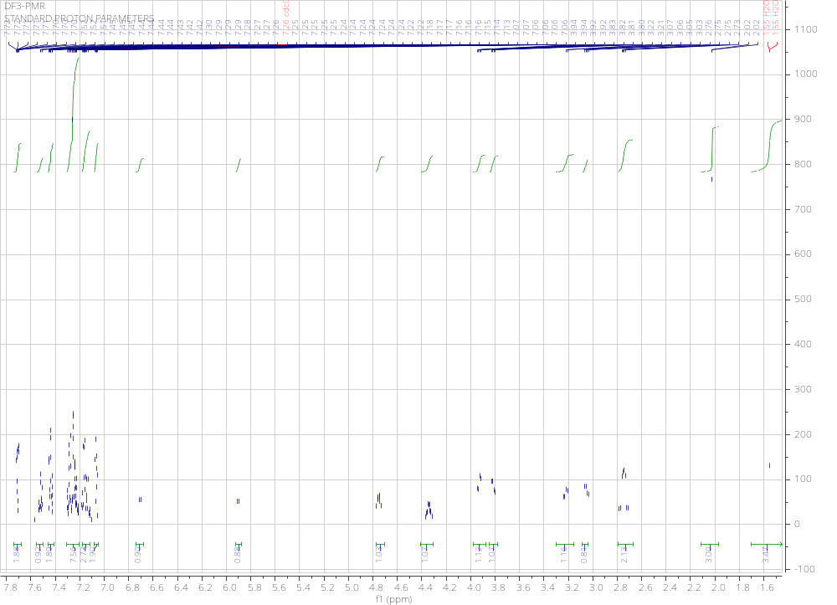

Figure 21: ¹H NMR spectrum (CDCl₃, 600 MHz) of 9

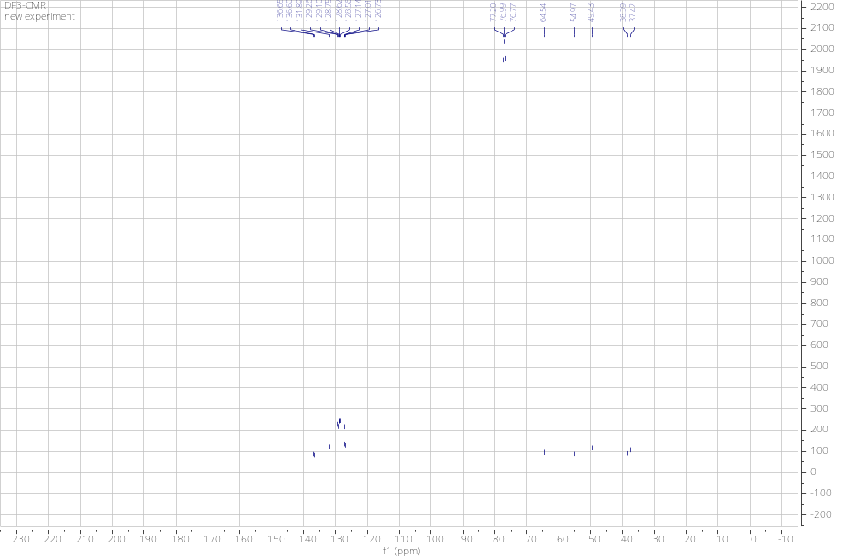

Figure 22: ¹³C NMR spectrum (CDCl₃, 150 MHz) of 9

Ethyl gallate (10)
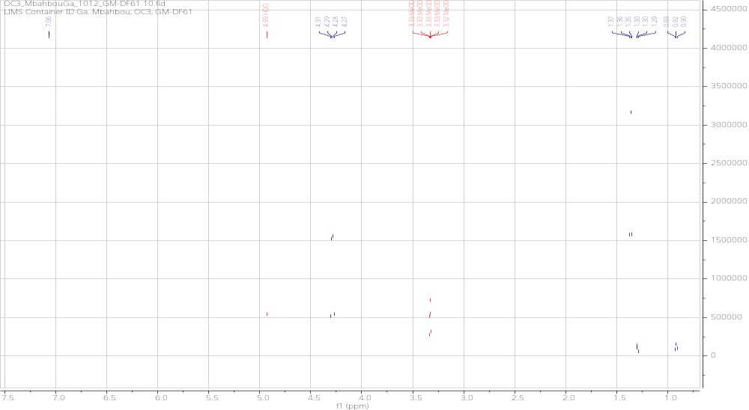

Figure 23: ¹H NMR spectrum (CD₃OD, 600 MHz) of 10
β- amyrinacetate (11)
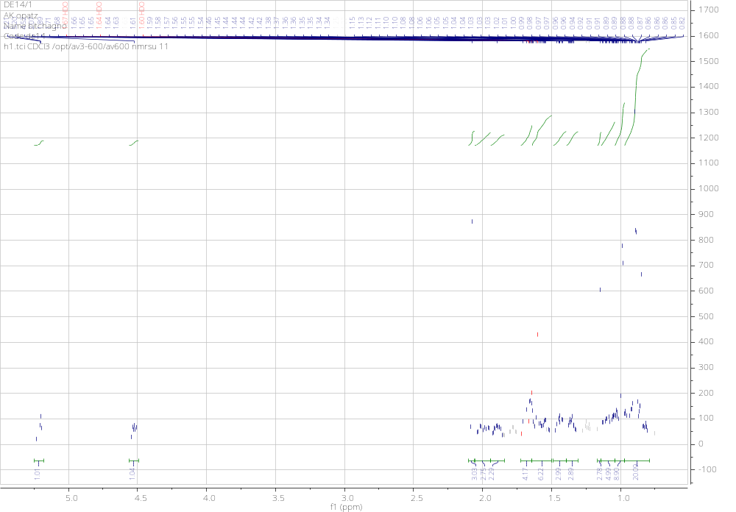

Figure 24: ¹H NMR spectrum (CDCl₃, 600 MHz) of 11

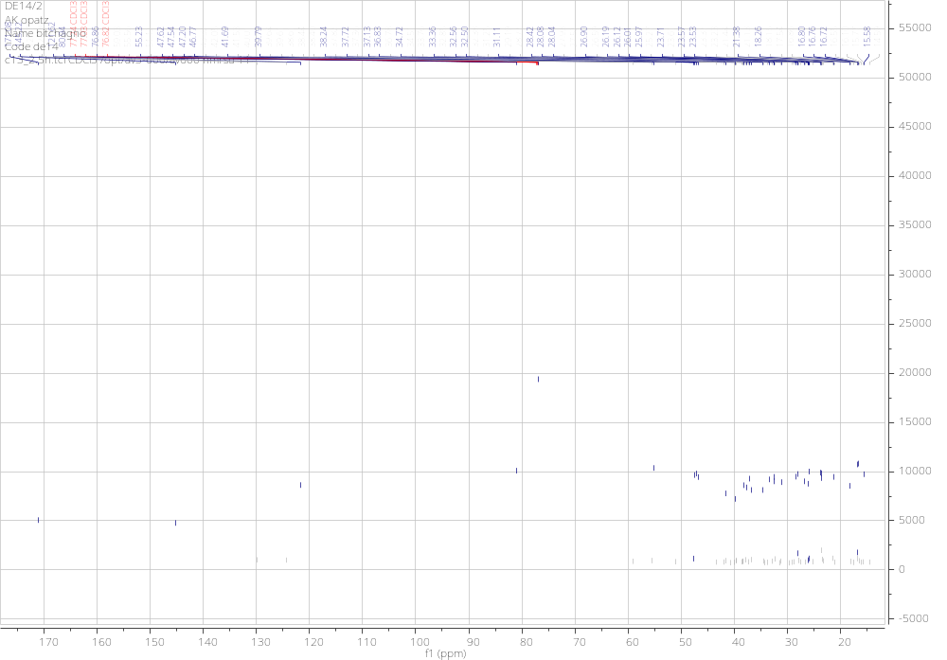

Figure 25: ¹³C NMR spectrum (CDCl₃, 150 MHz) of 11
β- amyrin (12)
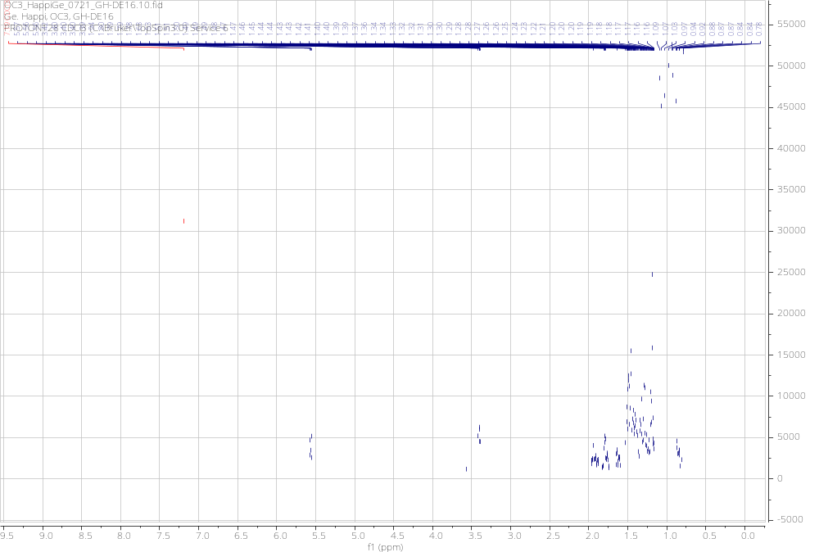

Figure 26: ¹H NMR spectrum (CDCl₃, 600 MHz) of 12

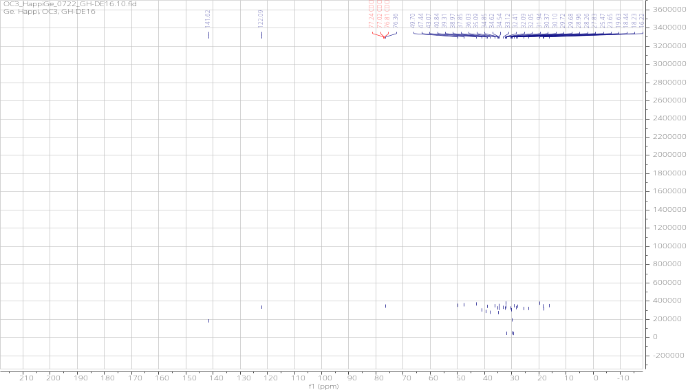

Figure 27: ¹³C NMR spectrum (CDCl₃, 150 MHz) of 12

3-Oxo-7,24Z-tirucalladien-26-oic acid (13)
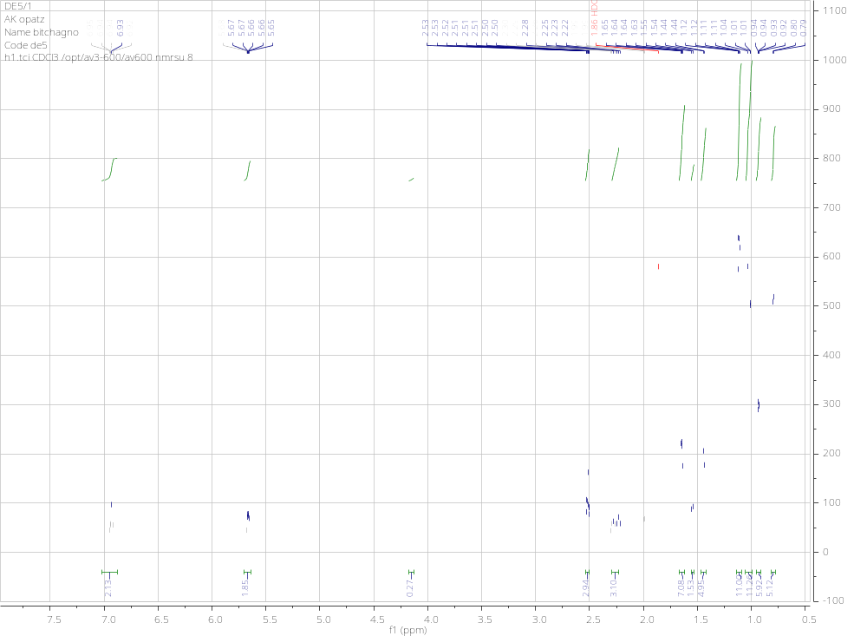

Figure 28: ¹H NMR spectrum (CDCl₃, 600 MHz) of 13

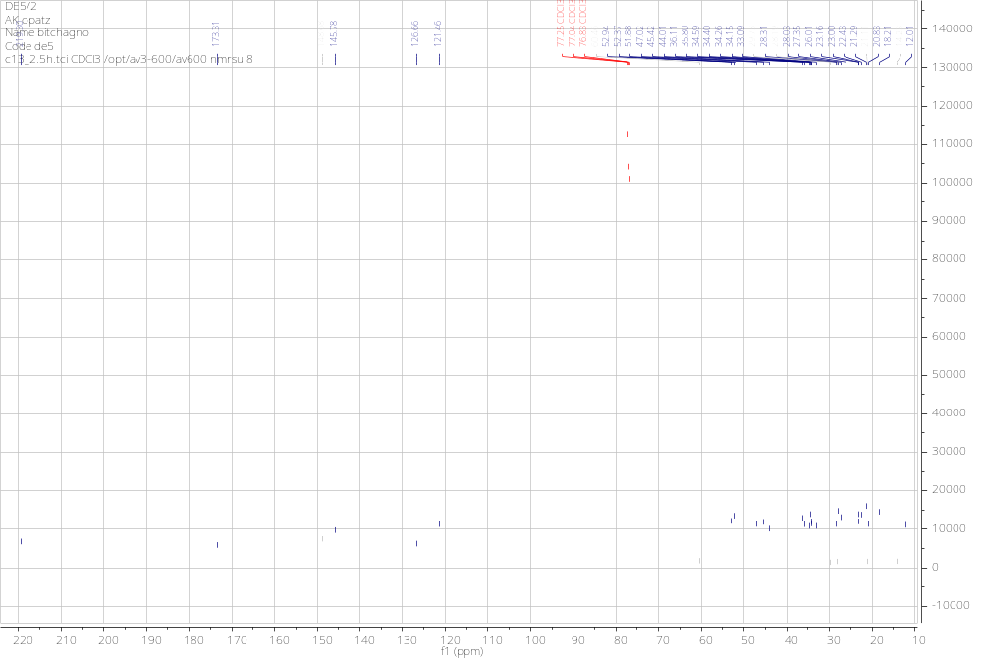

Figure 29: ¹³C NMR spectrum (CDCl₃, 150 MHz) of 13
Mixture of β-and α- amyrin (14)
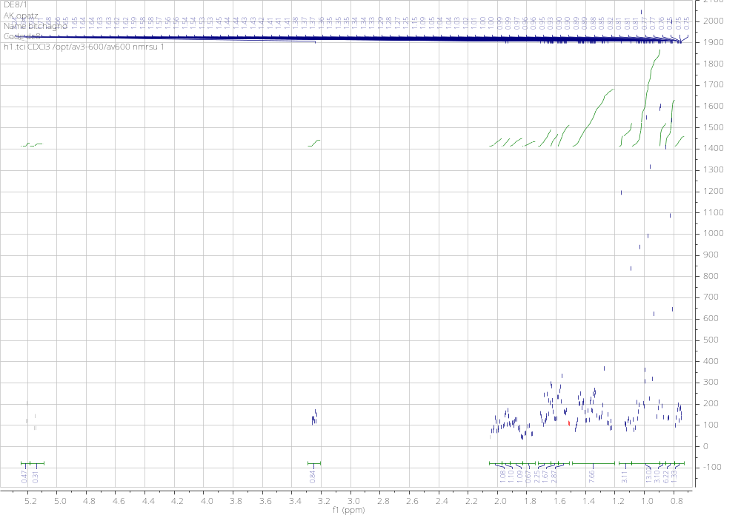

Figure 30: ¹H NMR spectrum (CDCl₃, 600 MHz) of 14

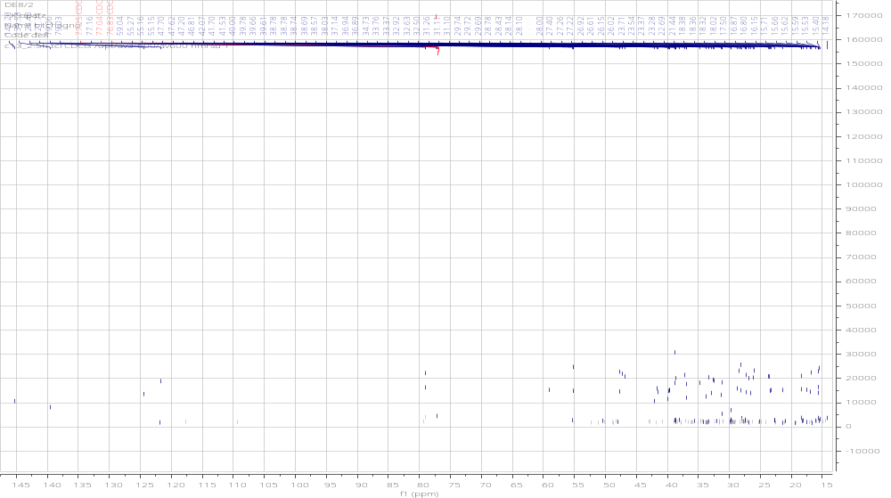

Figure 31: ¹³C NMR spectrum (CDCl₃, 150 MHz) of 14

