Table 3. Weibull Modulus and Characteristic Strength (N) with the respective 90% confidence interval of the different groups.
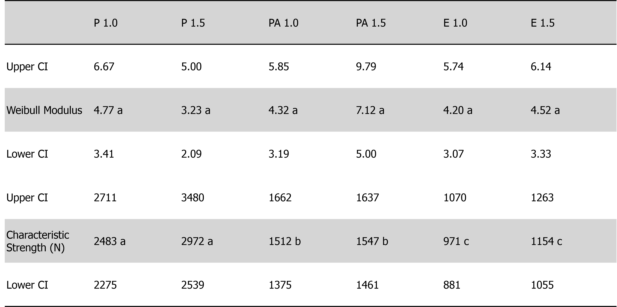
*Different lowercase letters indicate statistically significant difference between groups.

