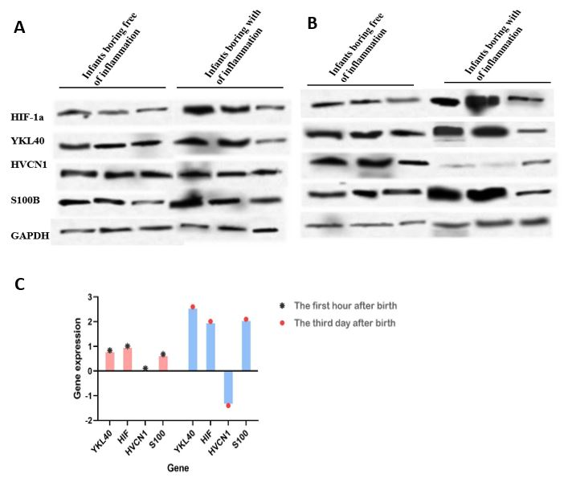
Figure 1: Western blotting results of the expression of HIF-1a (97 kDa), YKL-40 (42 kDa), HVCN1 (28 kDa), S100B (14 kDa), and GAPDH (37 kDa) proteins in infants. There was a significant increase in proteins expression in infants boring infants with inflammation in first day (p = 0.04) (A). There was a significant increase in proteins expression in HIF-1a, YKL-40, S100B while a decrease in proteins expression in HVCN1 in infants boring infants with inflammation after third day of birth (p = 0.02 and 0.01) (B). In the comparison of gene expression on the first day and three days later after birth, which was done by pair t-test, the expression of gene HVCN1 decreased remarkably three days after the birth of infants born with maternal inflammation, while the expression of four other genes showed a considerable increase (P< 0.001) (C).

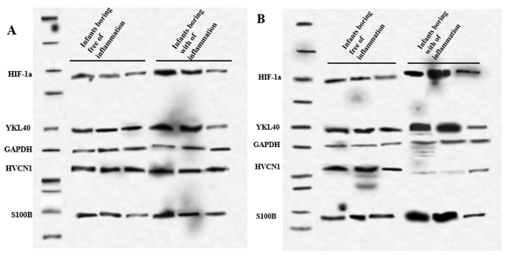

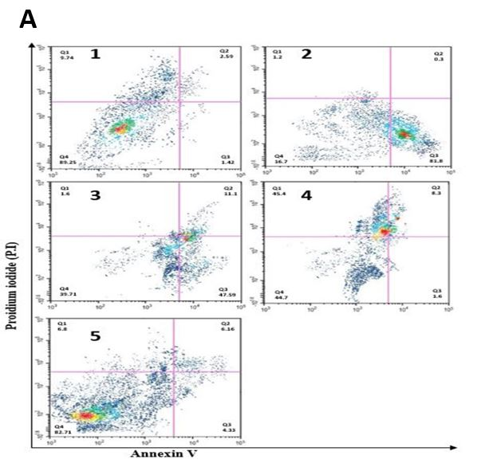
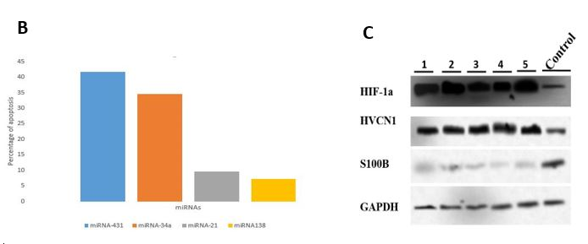
Figure 2: Flow cytometry (FCM) and apoptosis assay after staining with Annexin V-PE and propidium iodide (PI). ABC-TC3973 cells were treated with miRNA431, -34a, -21, -138 for 48 h. Representative scatter plots of PI (y-axis) vs. annexin V (x-axis) (A). A control cell population with unchanged scatter signals (A.1) and an apoptotic cell population after transfecting miRNA-431 and miRNA-34a (A.2 and A.3). Decreased the apoptotic cell population after transfecting miRNA-21 and miRNA-138 (A.4 and A5). Percentage of viable, early apoptotic and late apoptotic cells. Data are presented as the means ± SE of triplicate experiments. *P<0.05, and **P<0.01 vs. control (B). Western blotting results of the expression of HIF-1a (97 kDa), YKL-40 (42 kDa), HVCN1 (28 kDa), S100B (14 kDa), and GAPDH (37 kDa) proteins after transfecting miRNA-138 into Human Oligodendrocyte Progenitor Cells (1), Human Microglia Cells (2), Human Dendritic Cells (3), Human Astrocytes (4), and Human Neural Hindbrain Stem Cells (5) cell lines. The HVCN1and HIF-1a proteins level was increased (P= 0.035 and 0.01, respectively) while the level of S100B protein was decreased (P= 0.046) (C).

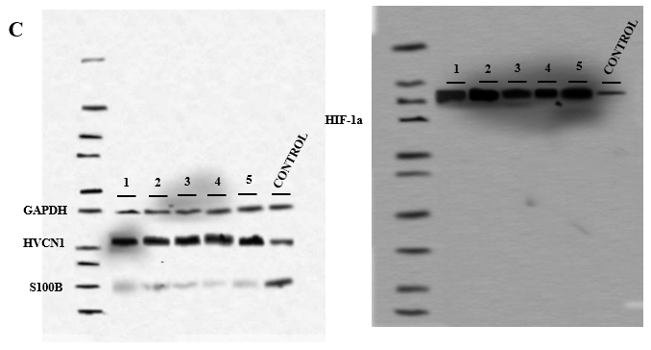

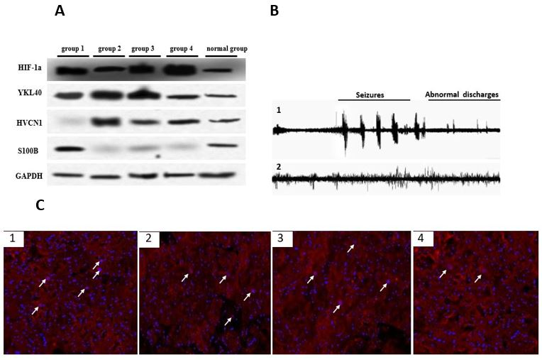
Figure 3: Western blotting records a hypoxia condition (group 1), injection of miR-21-siRNAs-HVCN1 in GC4-targeted nanoparticles (group2), miR-138-siRNAs- HIF-1a in GC4-targeted nanoparticles (group 3), miR-21-siRNAs-HVCN1 and miR-138-siRNAs-HIF-1a together (group4), and normal group. It was seen the decrease of S100B after injecting of miR-21-siRNAs-HVCN1 and miR-138-siRNAs- HIF-1a (p> 0.001). the amount of HVCN1 in group 1 was decreased, while it was increased in group 2 (p=0.015 and 0.024, respectively). The YKL40 level was increased in 1, 2, and 3 groups, whilst there was unchanged in group 4 (p =0.02 and 0.049). The HIF-1a level was increased in 1, 3, and 4 groups, while it remained unchanged in group 2 (p= 0.035 and 0.05). (A). Recording of epilepsy in mice by EEG. It was abnormal discharge and seizure (1) and normal group (2) (B). The IHC results with triple-staining for caspase-3 (red fluorescence), neuronal nuclear marker NeuN (green fluorescence), and nuclear staining (DAPI, blue). It was showed the decrease of apoptosis cells after injecting miR-21-siRNAs-HVCN1 and miR-138-siRNAs-HIF-1a together into mice (4) compared to hypoxia group (1), while a slight decrease was seen after injecting miR-21-siRNAs-HVCN1 (2) and miR-138-siRNAs-HIF-1a (3) individually into mice (C).

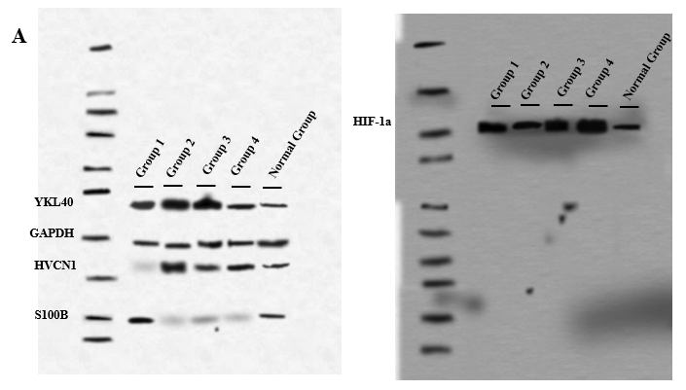
WESTERN BLOTTING LADDER:
