Supplementary Information
Additional file1.Enrollment flow chart
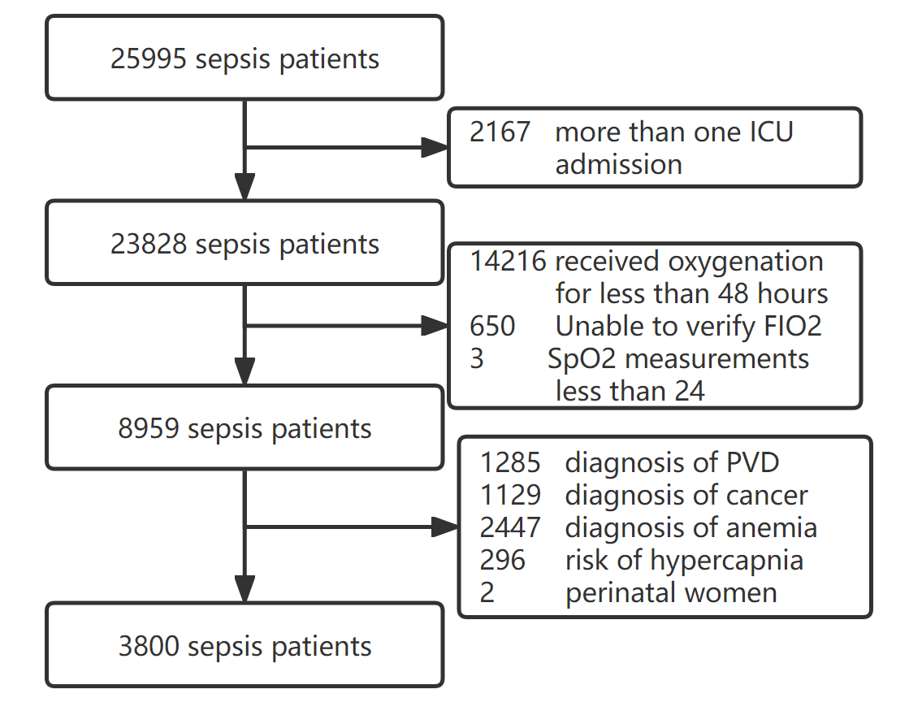
Additional file2. Data preprocessing
1)Missing variables handling
Variables | Missing rate,n(%) | Imputation methods
Gender | 0 | -
Length of hospital stay | 0 | -
In-hospital mortality | 0 | -
Length of ICU stay | 0 | -
ICU mortality | 0 | -
Admission age | 0 | -
Ethnicity | 0 | -
SAPSⅡ | 0 | -
SOFA | 0 | -
Charlson comorbidity index | 0 | -
Oxygenation time | 0 | -
Oxygenation method | 0 | -
TWA-SpO2 | 0 | -
Treatment of vasoactive drugs | 0 | -
CRRT | 0 | -
Hematocrit | 10(0.2%) | PMM
Hemoglobin | 12(0.3%) | PMM
Platelets | 10(0.2%) | PMM
WBC | 10(0.2%) | PMM
Albumin | 1880(49.4%)* | -
Globulin | 3748(98.6)* | -
Aniongap | 15(0.3%) | PMM
Bicarbonate | 10(0.2%) | PMM
BUN | 11(0.2%) | PMM
Calcium | 179(4.7%) | PMM
Chloride | 10(0.2%) | PMM
Creatinine | 9(0.2%) | PMM
Glucose | 19(0.5%) | PMM
Sodium | 10(0.2%) | PMM
Potassium | 11(0.2%) | PMM
Basophils counts | 1188(31.3%)* | -
Eosinophils counts | 1188(31.3%)* | -
Lymphocytes counts | 1188(31.3%)* | -
Monocytes counts | 1188(31.3%)* | -
Neutrophils counts | 1188(31.3%)* | -
D-dimer | 3791(99.7%)* | -
Fibrinogen | 2425(63.8%)* | -
Thrombin | 3791(99.7%)* | -
INR | 161(4.2%) | PMM
PT | 161(4.2%) | PMM
APTT | 177(4.6%) | PMM
ALT | 1376(36.2%)* | -
AST | 1395(36.7%)* | -
ALP | 1377(36.2%)* | -
Bilirunbin | 1405(36.9%)* | -
Direct-bilirunbin | 3610(95.0%)* | -
CK | 2068(54.4%)* | -
CK-MB | 2246(59.1%)* | -
LDH | 2310(60.7%)* | -
Weight | 16(0.4%) | PMM
Height | 785(20.6%)* | -
VAP | 0 | -
Lactate | 798(21.0%)* | -
PH | 406(10.7%)* | -
PO2 | 406(10.7%)* | -
PCO2 | 406(10.7%)* | -
SAPSⅡ:Simplified Acute Physiology ScoreⅡ; SOFA: Sequential Organ Failure Assessment score; TWA-SpO2: time-weighted-average pulse oximetry derived oxygen saturation; CRRT: continuous renal replacement therapy; WBC: White Blood Cell Counts; BUN: blood urea nitrogen; INR: international normalized ratio; PT: Prothrombin time; APTT: activated partial thromboplastin time; ALT: Alanine transaminase; AST: Aspartate aminotransferase; ALP: alkaline phosphatase; CK: Creatine Kinase; CK-MB: creatine kinase isoenzymes; LDH: lactate dehydrogenase; VAP: ventilator-associated pneumonia; PMM: Predictive Mean Matching; *: the missing rate was greater than 10%, and the statistics were excluded.

2)Graph of missing values before multiple interpolation
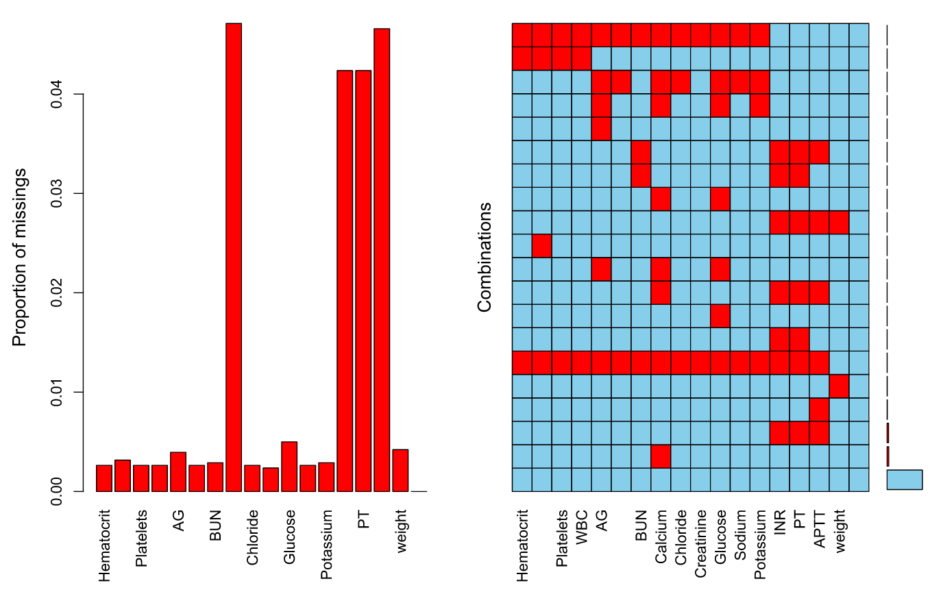There was no obvious relationship between the missing values by visual inspection.

- Outlier Handling
Variables | Q25 | Q75 | Statistical Range | actual range | judgment results of clinical experts
Gender | - | - | - | - | √
Length of hospital stay | 8.2 | 21.25 | (-11.38,40.83 | (2.11,184.90) | √
In-hospital mortality | - | - | - | - | √
Length of ICU stay | 4.38 | 12.83 | (-8.3,25.51) | (1.96,101.73) | √
ICU mortality | - | - | - | - | √
Admission age | 52.22 | 76.66 | (15.56,113.32) | (18.10,97.32) | √
Ethnicity | - | - | - | - | √
SAPSⅡ | 30 | 48 | (3,75) | (6,105) | √
SOFA | 2 | 4 | (-1,7) | (2,14) | √
Charlson comorbidity index | 3 | 6 | (-1.5,10.5) | (0,16) | √
Oxygenation time | 70.81 | 178.01 | (-89.79,338.81) | (48,2174.97) | √
Oxygenation therapy | - | - | - | - | √
TWA-SpO2 | 96 | 98 | (93,101) | (81,100) | √
Treatment of vasoactive drugs | - | - | - | - | √
CRRT | - | - | - | - | √
Hematocrit | 34.30 | 42.20 | (22.45,54.05) | (25.4,64.6) | √
Hemoglobin | 11.3 | 14 | (7.25,18.05) | (9,20.3) | √
Platelets | 128 | 233 | (-29.5,390.5) | (5,1297) | √
WBC | 10.8 | 19.7 | (-2.55,33.05) | (0.8,121) | √
Bicarbonate | 18 | 24 | (9,33) | (2,45) | √
BUN | 15 | 33 | (-13,60) | (2,255) | √
Calcium | 8.1 | 9.0 | (6.75,10.35) | (4.8,27.4) | √
Chloride | 103 | 110 | (92.5,120.5) | (67,155) | √
Creatinine | 0.8 | 1.6 | (-0.4,2.8) | (0.1,19.0) | √
Glucose | 126 | 208 | (3,331) | (41,2275) | √
Sodium | 135 | 140 | (127.5,147.5) | (74,170) | √
Potassium | 4.1 | 5.0 | (1.25,7.85) | (2.6,9.7) | √
INR | 1.1 | 1.5 | (0.5,2.1) | (0.9,21.1) | √
PT | 12.6 | 16.6 | (6.6,22.6) | (9.2,150) | √
APTT | 27.91 | 66.23 | (4.91,66.23) | (16.6,150) | √
VAP | - | - | - | - | √
Potential outliers were found in most variables through statistical analysis, but two experts judged that potential outliers might appear in clinical, so we retained them for further analysis

Additional file3. Logistic and VIF results for in-hospital mortality
Variables | Univariate logistic regression results | VIF | Multivariate logistic regression results
Oxygenation group(SpO2>98%) | 1.446(1.158,1.807) | 1.31 | 1.613(1.264,2.059)
Oxygenation group(SpO2<95%) | 1.816(1.445,2.282) | 1.31 | 1.604(1.230,2.093)
Oxygenation duration | 1.002(1.001,1.002) | 1.06 | 1.001(1.001,1.002)
Oxygenation therapy(NIV/oxygenation) | 2.509(1.521,4.138) | 1.44 | 1.665(0.974,2.846)
Oxygenation therapy(IMV/oxygenation) | 2.221(1.543,3.198) | 1.44 | 2.133(1.417,3.211)
Age | 1.023(1.018,1.029) | 1.69 | 1.009(1.002,1.017)
Ethnicity(White) | 0.710(0.601,0.839) | 1.05 | 0.660(0.551,0.790)
SAPSⅡ | 1.037(1.031,1.043) | 1.37 | 1.025(1.018,1.033)
SOFA | 1.081(1.040,1.124) | 1.22 | 0.996(0.922,1.012)
TWA-FiO2 | 1.022(1.016,1.028) | 1.38 | 1.029(1.021,1.037)
Charlson comorbidity index | 1.183(1.146,1.221) | 1.56 | 1.109(1.063,1.151)
Treatment of vasoactive drugs | 2.182(1.807,2.635) | 1.23 | 1.602(1.289,1.990)
VIF: Variance Inflation Factor; NIV: Non-invasive ventilation; IMV: Invasive Mechanical Ventilation; SAPS Ⅱ: Simplified Acute Physiology Score Ⅱ; SOFA: Sequential Organ Failure Assessment score; TWA-FiO2: time-weighted average-fraction of inspired O2;

