Figures - Appendix A

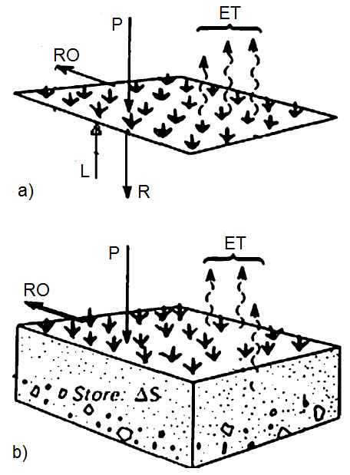
Fig. A1Schematic representation of the water balance components: a) surface between land and atmosphere and b) soil-plant column (Pandžić et al. 2009, according to Oke, 1987)

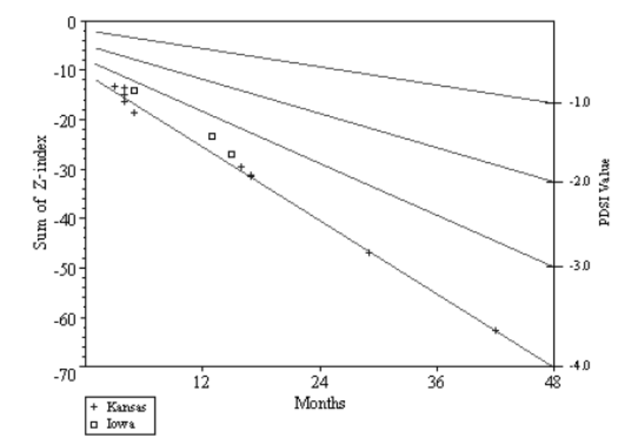
Fig. A2 Accumulated Z-index over the driest intervals varying lengths in Western Kansas (1887-1962) and Central Iowa (1930-1962). The overlying lines represent PDSI values according to the accumulated Z-index (after Palmer (1965) redrawn by Wells (2002))
Figures - Appendix B

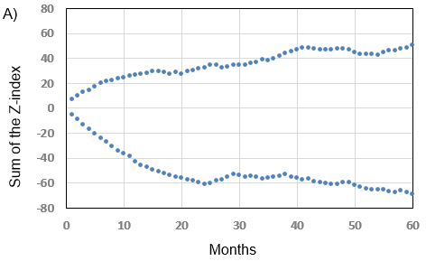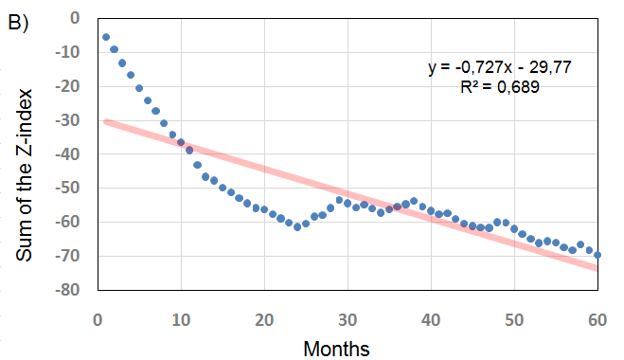
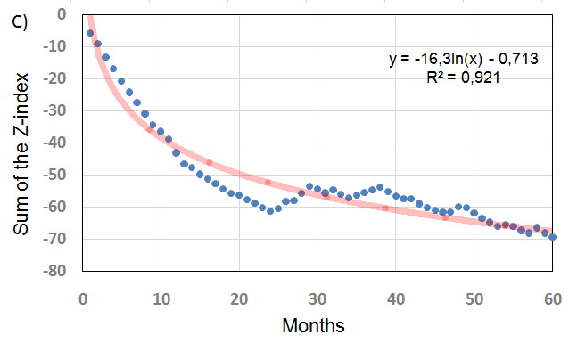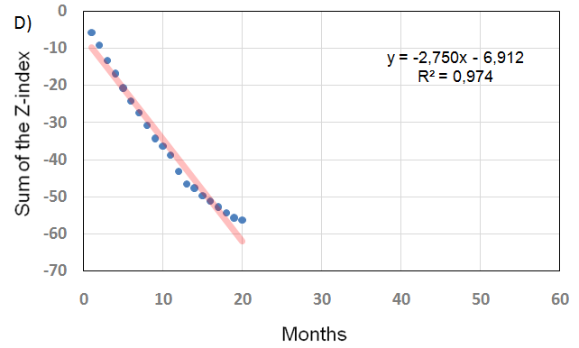
Fig. B1Representation of monthly Z-sums for Zagreb Maksimir Observatory: A) positive and negative sums for the periods from 1 to 60 months, B) linear trend for negative sums for the periods from 1 to 60 months, C) exponential trend for negative sums for the periods from 1 to 60 months and D) linear trend for negative sums for the periods from 1 to 20 months

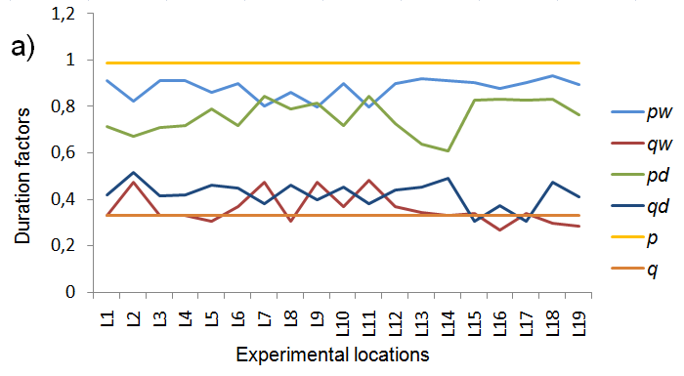
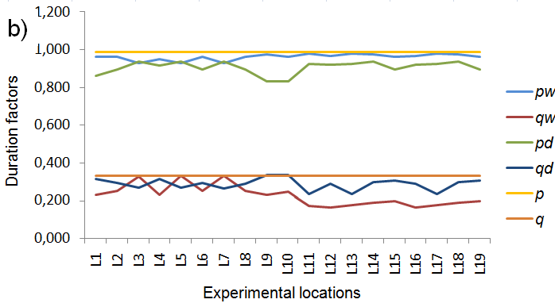
Fig. B2 Palmer (1965) original p=0.987 (upper straight line) and q=1/3 (down straight line) duration factors for calculation of monthly/10-day PDSCI, obtained by climate data for central west of the USA. pw (qw) and pd (qd) duration factors for wet and dry spells, respectively, obtained by climate data for experimental locations in Croatia and used for calculation of: a) monthly scPDSI and b) 10-day scPDSI, for the same locations. pw (pd) are represented by upper polylines while qw (qd) are represented with down polylines

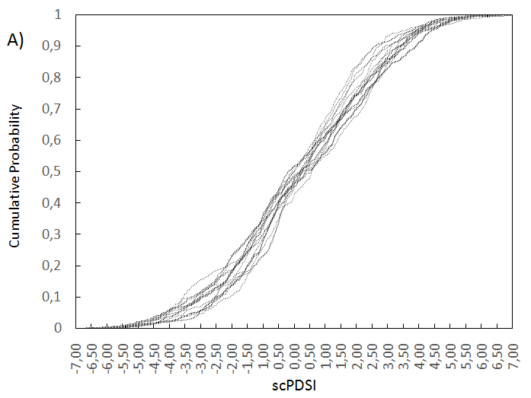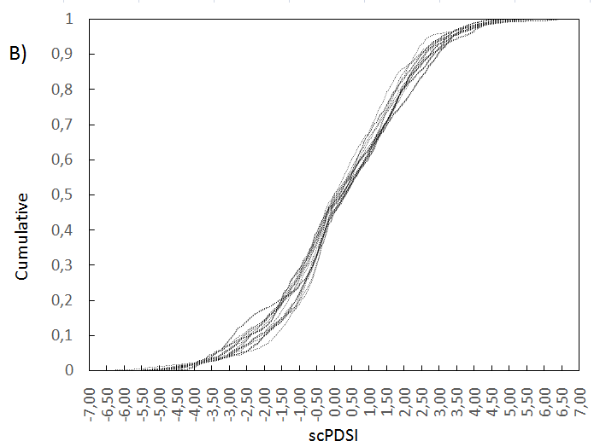
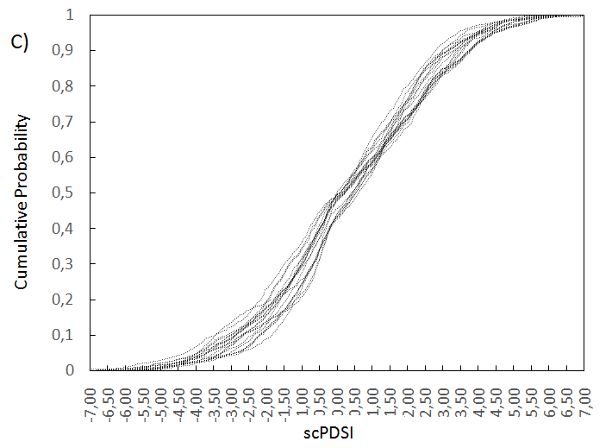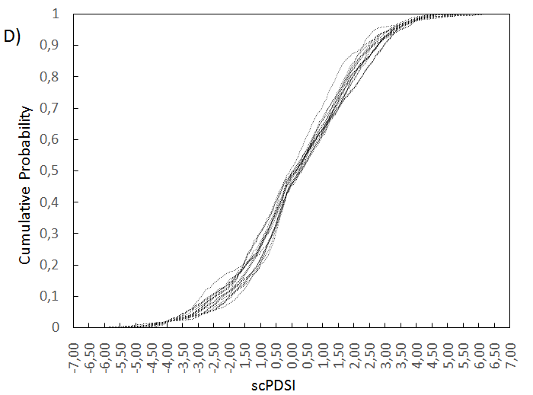
Fig. B3 Cumulative frequency distribution of scPDSI for 19 experimental locations in Croatia: A) monthly scPSI before spatial standardization of Z-index, B) monthly scPDSI after spatial standardization of Z index; C) 10-day scPSI before spatial standardization of Z-index and D) 10-day scPSI after spatial standardization of Z-index

