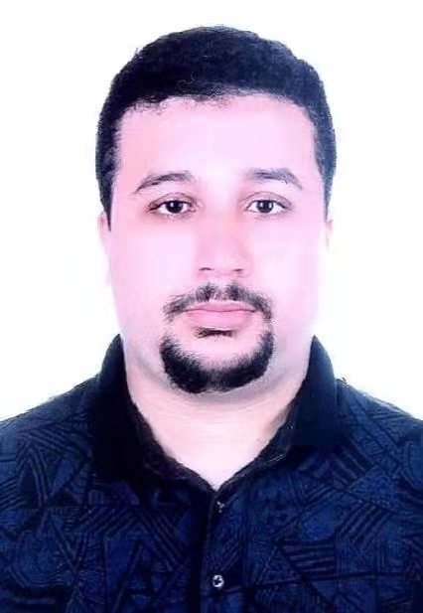
Pr. Dr Zerdoumi Saber At Constantine University, the Author majored in computer science and mathematics.
In addition, he had the highest archival degree in the French educational system.
He has post-doctoral and post-doctoral managerial and teaching expertise in academics, education, management, and quality assurance.
The Author has just been appointed as an Associate Professor at Taylor's University.
He was just acknowledged by WoS/ISI as the best reviewer 1% in the world for the year 2019. Additionally, the author has a patent in industry and academia.

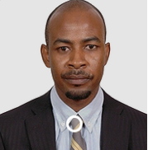
Dr.Ibrahim Abaker Targio Hashem
Faculty of Computer Science and Information Technology, University of Malaya Ibrahim Abaker Targio Hashem (targio@siswa.um.edu.my) is currently a Ph.D. degree candidate in the Department of Computer Systems and Technology, University of Malaya. He received his M.S. degree in computing in 2012 at the same university and his B.E. degree in computer science in 2007, Sudan. He obtained professional certificates from Cisco (CCNP, CCNA, and CCNA Security) and the APMG Group (PRINCE2 Foundation, ITIL v3 Foundation, and OBASHI Foundation). He worked as a tutor at Cisco Academy, University of Malaya. His main research interests include big data, cloud computing, distributed computing, and networking.

