Appendix.
Figure 1. Flow chart of the study population.

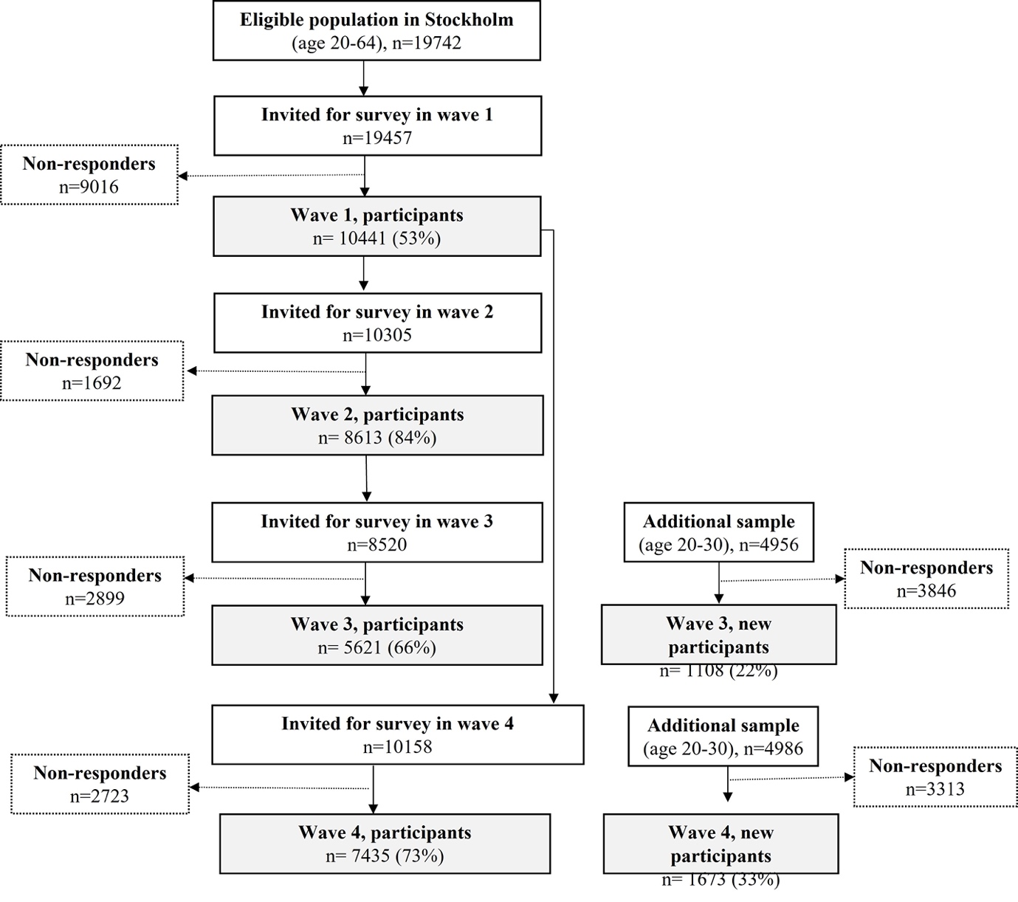

Supplementary table 1. The prevalence of individual depressive symptoms from 2020 to 2021 in total participants and by age and sex
Individual symptoms* | Total |  |  | Male |  |  | Female
Individual symptoms* | No. cases (%) |  | Odds ratio (95% CI)# | No. cases (%) |  | Odds ratio (95% CI)# | No. cases (%) |  | Odds ratio (95% CI)#
Individual symptoms* | 2010 | 2021 | Odds ratio (95% CI)# | 2010 | 2021 | Odds ratio (95% CI)# | 2010 | 2021 | Odds ratio (95% CI)#
1. Sadness
Total | 352 (5.3) | 528 (6.0) | 1.23 (1.06-1.43) | 80 (3.0) | 169 (4.6) | 1.66 (1.24-2.24) | 272 (6.8) | 359 (7.0) | 1.10 (0.92-1.31)
20-29 | 97 (10.3) | 168 (12.5) | 1.20 (0.90-1.60) | 23 (7.2) | 51 (9.3) | 1.19 (0.68-2.05) | 74 (11.8) | 117 (14.7) | 1.20 (0.85-1.68)
30-39 | 54 (5.5) | 59 (7.7) | 1.24 (0.81-1.00) | 10 (2.6) | 17 (6.6) | 2.60 (1.08-6.26) | 44 (7.2) | 42 (8.2) | 0.98 (0.60-1.60)
40-49 | 51 (4.2) | 52 (5.0) | 1.40 (0.91-2.16) | 12 (2.6) | 13 (3.1) | 1.33 (0.55-3.19) | 39 (5.2) | 39 (6.4) | 1.45 (0.88-2.39)
50-59 | 73 (6.1) | 79 (4.5) | 0.78 (0.55-1.11) | 17 (3.6) | 30 (4.1) | 1.30 (0.68-2.50) | 56 (7.8) | 49 (4.8) | 0.63 (0.41-0.96)
60-64 | 33 (4.5) | 33 (4.4) | 0.96 (0.56-1.63) | 7 (2.2) | 10 (3.1) | 1.28 (0.44-3.77) | 26 (6.3) | 23 (5.4) | 0.86 (0.46-1.59)
≥65 | 44 (2.9) | 137 (4.3) | 1.28 (0.86-1.92) | 11 (1.6) | 48 (3.5) | 2.06 (0.96-4.44) | 33 (3.8) | 89 (5.0) | 1.04 (0.65-1.67)
2. Loss of interest
Total | 315 (4.8) | 620 (7.0) | 1.63 (1.41-1.89) | 85 (3.2) | 213 (5.8) | 2.04 (1.54-2.69) | 230 (5.8) | 407 (7.9) | 1.49 (1.25-1.77)
20-29 | 106 (11.3) | 211 (15.7) | 1.48 (1.13-1.94) | 20 (6.3) | 74 (13.5) | 2.41 (1.40-4.13) | 86 (13.8) | 137 (17.2) | 1.24 (0.91-1.70)
30-39 | 47 (4.8) | 72 (9.3) | 1.73 (1.14-2.63) | 15 (4.0) | 25 (9.7) | 2.19 (1.04-4.57) | 32 (5.3) | 47 (9.2) | 1.53 (0.92-2.54)
40-49 | 43 (3.5) | 60 (5.8) | 1.77 (1.14-1.76) | 9 (1.9) | 16 (3.8) | 2.16 (0.88-5.30) | 34 (4.5) | 44 (7.2) | 1.69 (1.01-2.83)
50-59 | 63 (5.3) | 96 (5.5) | 1.13 (0.80-1.61) | 23 (4.9) | 34 (4.6) | 1.22 (0.68-2.19) | 40 (5.6) | 62 (6.1) | 1.15 (0.74-1.78)
60-64 | 19 (2.6) | 23 (3.1) | 1.33 (0.70-2.53) | 6 (1.9) | 8 (2.5) | 1.08 (0.33-3.54) | 13 (3.1) | 15 (3.5) | 1.43 (0.66-3.09)
≥65 | 37 (2.4) | 158 (5.0) | 1.60 (1.04-2.36) | 12 (1.8) | 56 (4.0) | 2.00 (1.02-3.95) | 25 (2.9) | 102 (5.7) | 1.43 (0.86-2.37)
3. Energy loss
Total | 516 (7.8) | 985 (11.2) | 1.61 (1.43-1.80) | 134 (5.1) | 317 (8.6) | 1.90 (1.52-2.36) | 382 (9.6) | 668 (13.0) | 1.50 (1.31-1.73)
20-29 | 134 (14.2) | 261 (19.5) | 1.46 (1.14-1.87) | 23 (7.2) | 82 (15.0) | 2.37 (1.43-3.94) | 111 (17.8) | 179 (22.5) | 1.24 (0.93-1.65)
30-39 | 84 (8.5) | 104 (13.5) | 1.50 (1.07-2.10) | 25 (6.6) | 30 (11.6) | 1.60 (0.85-3.01) | 59 (9.7) | 74 (14.4) | 1.46 (0.98-2.18)
40-49 | 83 (6.8) | 119 (11.5) | 1.98 (1.44-2.74) | 21 (4.5) | 31 (7.4) | 2.22 (1.20-4.10) | 62 (8.2) | 88 (14.3) | 1.91 (1.30-2.80)
50-59 | 98 (8.2) | 159 (9.1) | 1.12 (0.84-1.49) | 27 (5.7) | 45 (6.1) | 0.94 (0.54-1.62) | 71 (9.9) | 114 (11.2) | 1.19 (0.85-1.66)
60-64 | 35 (4.7) | 51 (6.8) | 1.53 (0.96-2.43) | 13 (4.0) | 17 (5.3) | 1.30 (0.58-2.90) | 22 (5.3) | 34 (8.0) | 1.67 (0.94-2.98)
≥65 | 82 (5.3) | 291 (9.2) | 1.31 (0.98-1.75) | 25 (3.7) | 112 (8.0) | 1.75 (1.07-2.88) | 57 (6.6) | 179 (10.0) | 1.12 (0.78-1.61)
4. Low self-esteem, guilt
Total | 664 (10.0) | 1308 (14.8) | 1.83 (1.64-2.03) | 189 (7.2) | 427 (11.6) | 1.89 (1.55-2.31) | 475 (11.9) | 881 (17.1) | 1.81 (1.59-2.05)
20-29 | 202 (21.4) | 446 (33.3) | 1.88 (1.52-2.31) | 42 (13.2) | 150 (27.5) | 2.49 (1.68-3.70) | 160 (25.6) | 296 (37.2) | 1.67 (1.30-2.14)
30-39 | 113 (11.4) | 176 (22.8) | 2.13 (1.61-2.83) | 36 (9.5) | 46 (17.8) | 1.92 (1.14-3.26) | 77 (12.6) | 130 (25.3) | 2.23 (1.59-3.12)
40-49 | 116 (9.5) | 153 (14.8) | 1.58 (1.18-2.10) | 33 (7.1) | 38 (9.0) | 1.18 (0.69-2.04) | 83 (10.9) | 115 (18.7) | 1.79 (1.27-2.52)
50-59 | 110 (9.2) | 208 (11.8) | 1.38 (1.06-1.80) | 36 (7.6) | 73 (9.9) | 1.39 (0.89-2.19) | 74 (10.2) | 135 (13.2) | 1.39 (1.00-1.92)
60-64 | 45 (6.1) | 64 (8.5) | 1.37 (0.90-2.09) | 11 (3.4) | 20 (6.2) | 2.11 (0.95-4.67) | 34 (8.2) | 44 (10.3) | 1.18 (0.71-1.94)
≥65 | 78 (5.0) | 261 (8.2) | 1.32 (0.98-1.78) | 31 (4.5) | 100 (7.2) | 1.26 (0.80-2.00) | 47 (5.4) | 161 (9.0) | 1.39 (0.94-2.06)
5. Suicidal thoughts
Total | 188 (2.8) | 455 (5.2) | 2.06 (1.71-2.47) | 52 (2.0) | 169 (4.6) | 2.63 (1.86-3.71) | 136 (3.4) | 286 (5.6) | 1.85 (1.48-2.31)
20-29 | 65 (6.9) | 144 (10.8) | 1.76 (1.26-2.44) | 11 (3.4) | 50 (9.2) | 2.82 (1.41-5.65) | 54 (8.6) | 94 (11.9) | 1.51 (1.03-2.21)
30-39 | 13 (1.3) | 47 (6.1) | 4.48 (2.33-8.62) | 2 (0.5) | 18 (6.9) | 13.90 (3.06-63.12) | 11 (1.8) | 29 (5.7) | 2.91 (1.38-6.13)
40-49 | 28 (2.3) | 40 (3.9) | 1.72 (1.00-2.95) | 11 (2.4) | 10 (2.4) | 0.86 (0.32-2.30) | 17 (2.2) | 30 (4.9) | 2.36 (1.22-4.56)
50-59 | 38 (3.2) | 73 (4.2) | 1.30 (0.84-1.98) | 13 (2.7) | 32 (4.3) | 1.46 (0.72-2.97) | 25 (3.5) | 41 (4.0) | 1.17 (0.68-2.02)
60-64 | 14 (1.9) | 22 (2.9) | 1.81 (0.89-3.65) | 3 (0.9) | 7 (2.2) | 2.38 (0.57-10.02) | 11 (2.7) | 15 (3.5) | 1.62 (0.72-3.64)
≥65 | 30 (1.9) | 129 (4.1) | 1.67 (1.06-2.63) | 12 (1.8) | 52 (3.7) | 1.90 (0.94-3.84) | 18 (2.1) | 77 (4.3) | 1.55 (0.86-2.80)
6. Cognitive difficulties
Total | 388 (5.8) | 1306 (14.8) | 2.31 (2.91-3.76) | 96 (3.6) | 406 (11.0) | 3.82 (2.98-4.90) | 292 (7.3) | 900 (17.5) | 3.14 (2.71-3.64)
20-29 | 113 (12.0) | 452 (33.7) | 4.10 (3.22-5.23) | 19 (6.0) | 146 (26.7) | 6.04 (3.61-10.12) | 94 (15.0) | 306 (38.5) | 3.66 (2.76-4.84)
30-39 | 55 (5.6) | 176 (22.8) | 4.96 (3.53-6.96) | 14 (3.7) | 50 (19.3) | 6.52 (3.39-12.54) | 41 (6.7) | 126 (24.6) | 4.53 (3.04-6.76)
40-49 | 64 (5.2) | 152 (14.7) | 3.08 (2.21-4.30) | 13 (2.8) | 36 (8.5) | 3.13 (1.57-6.24) | 51 (6.7) | 116 (18.9) | 3.07 (2.09-4.52)
50-59 | 74 (6.2) | 195 (11.1) | 2.00 (1.49-2.70) | 22 (4.6) | 57 (7.7) | 1.63 (0.94-2.84) | 52 (7.2) | 138 (13.5) | 2.16 (1.52-3.08)
60-64 | 28 (3.8) | 64 (8.5) | 2.23 (1.38-3.60) | 10 (3.1) | 17 (5.2) | 1.78 (0.77-4.13) | 18 (4.3) | 47 (11.1) | 2.53 (1.41-4.53)
≥65 | 54 (3.5) | 267 (8.4) | 2.04 (1.46-2.85) | 18 (2.6) | 100 (7.2) | 2.42 (1.35-4.31) | 36 (4.2) | 167 (9.3) | 1.89 (1.25-2.86)
7. Psychomotor disturbance
Total | 647 (9.7) | 1525 (17.3) | 2.22 (2.00-2.46) | 189 (7.2) | 511 (13.9) | 2.32 (1.92-2.81) | 458 (11.5) | 1014 (19.7) | 2.81 (1.92-2.48)
20-29 | 192 (20.3) | 501 (37.4) | 2.42 (1.96-2.98) | 44 (13.8) | 165 (30.2) | 2.66 (1.80-3.91) | 148 (23.7) | 336 (42.3) | 2.34 (1.82-3.01)
30-39 | 106 (10.7) | 190 (24.6) | 2.41 (1.82-3.20) | 40 (10.6) | 54 (20.8) | 1.66 (0.99-2.77) | 66 (10.8) | 136 (26.5) | 2.86 (2.02-4.04)
40-49 | 108 (8.8) | 173 (16.7) | 2.12 (1.59-2.81) | 35 (7.5) | 49 (11.6) | 1.85 (1.12-3.05) | 73 (9.6) | 124 (20.2) | 2.26 (1.60-3.21)
50-59 | 121 (10.1) | 222 (12.6) | 1.40 (1.09-1.80) | 37 (7.8) | 74 (10.0) | 1.31 (0.84-2.05) | 84 (11.6) | 148 (14.5) | 1.43 (1.05-1.94)
60-64 | 46 (6.3) | 78 (10.4) | 1.53 (1.02-2.30) | 14 (4.3) | 30 (9.3) | 2.07 (1.02-4.18) | 32 (7.7) | 48 (11.3) | 1.32 (0.80-2.18)
≥65 | 74 (4.8) | 361 (11.4) | 1.96 (1.46-2.62) | 19 (2.8) | 139 (10.0) | 2.95 (1.71-5.10) | 55 (6.4) | 222 (12.4) | 1.62 (1.15-2.28)
8. Sleeping disturbance
Total | 1064 (16.0) | 2185 (24.7) | 1.79 (1.65-1.95) | 316 (12.0) | 708 (19.2) | 1.81 (1.56-2.10) | 748 (18.7) | 1477 (28.6) | 1.79 (1.62-1.98)
20-29 | 225 (23.8) | 532 (39.7) | 2.12 (1.74-2.59) | 62 (19.4) | 183 (33.5) | 2.17 (1.53-3.07) | 163 (26.1) | 349 (43.9) | 2.10 (1.64-2.69)
30-39 | 134 (13.5) | 226 (29.3) | 2.35 (1.80-3.05) | 37 (9.8) | 68 (26.2) | 2.80 (1.72-4.56) | 97 (15.9) | 158 (30.9) | 2.17 (1.59-2.97)
40-49 | 195 (15.9) | 237 (22.9) | 1.46 (1.15-1.86) | 62 (13.3) | 68 (16.1) | 1.19 (0.78-1.81) | 133 (17.5) | 169 (27.5) | 1.63 (1.22-2.19)
50-59 | 209 (17.5) | 378 (21.5) | 1.38 (1.13-1.69) | 64 (13.5) | 114 (15.4) | 1.17 (0.82-1.68) | 145 (20.1) | 264 (25.9) | 1.48 (1.16-1.89)
60-64 | 96 (13.0) | 148 (19.7) | 1.44 (1.07-1.96) | 26 (8.1) | 51 (15.7) | 1.86 (1.08-3.21) | 70 (16.9) | 97 (22.7) | 1.31 (0.91-1.90)
≥65 | 205 (13.2) | 664 (20.9) | 1.41 (1.16-1.70) | 65 (9.5) | 224 (16.1) | 1.42 (1.01-2.00) | 140 (16.2) | 440 (24.6) | 1.41 (1.12-1.79)
9. Appetite disturbance
Total | 817 (12.3) | 1273 (14.4) | 1.29 (1.16-1.43) | 225 (8.5) | 365 (9.9) | 1.20 (1.00-1.46) | 592 (14.8) | 908 (17.6) | 1.33 (1.18-1.50)
20-29 | 207 (21.9) | 353 (26.3) | 1.36 (1.10-1.69) | 39 (12.2) | 111 (20.3) | 1.76 (1.16-2.68) | 168 (26.9) | 242 (30.4) | 1.22 (0.94-1.57)
30-39 | 135 (13.7) | 128 (16.6) | 1.08 (0.81-1.45) | 34 (9.0) | 28 (10.8) | 1.03 (0.56-1.90) | 101 (16.6) | 100 (19.5) | 1.10 (0.79-1.54)
40-49 | 136 (11.1) | 152 (14.7) | 1.29 (0.97-1.71) | 33 (7.1) | 36 (8.6) | 1.19 (0.69-2.04) | 103 (13.6) | 116 (18.9) | 1.33 (0.95-1.86)
50-59 | 142 (11.9) | 237 (13.5) | 1.20 (0.95-1.53) | 50 (10.5) | 58 (7.8) | 0.75 (0.48-1.16) | 92 (12.7) | 179 (17.5) | 1.51 (1.12-2.02)
60-64 | 66 (9.0) | 86 (11.5) | 1.33 (0.93-1.91) | 24 (7.5) | 23 (7.1) | 0.99 (0.52-1.90) | 42 (10.1) | 63 (14.8) | 1.57 (1.01-2.44)
≥65 | 131 (8.5) | 317 (10.0) | 1.03 (0.80-1.32) | 45 (6.6) | 109 (7.9) | 0.98 (0.64-1.49) | 86 (9.9) | 208 (11.6) | 1.06 (0.78-1.45)
*In total, the number of missing was 51 for symptom 1, 69 for symptom 2, 47 for symptom 3, 33 for symptom 4, 51 for symptom 5, 29 for symptom 6, 28 for symptom 7, 24 for symptom 8, and 27 for symptom 9.
#With the adjustment of age, marital status, employment status, covid infection, and if applicable, sex, GEE model was used for total participants and those aged 65 and above due to repeated participation, and logistic regression was performed for other age groups.

