Analysis of the difference between early-bolting and non-bolting roots of Angelica dahurica based on transcriptome sequencing
Ping Wu, Xiaoyu Wang, Junxai Guo, Songli Zhang, Qingmiao Li* & Qingmao Fang

SUPPLEMENTAL MATERIAL

Table S1：Sutatistics of the annotations for A. dahurica unigenes from nine public databases.
Annotatio database | Annotated number | 300<=length<1000 | length>=1000
COG annotation | 6,259 | 2,000 | 4,259
GO annotation | 22,530 | 10,993 | 11,535
KEGG annotation | 17,895 | 8,036 | 9,859
KOG annotation | 14,693 | 6,646 | 8,047
Pfam annotation | 18,786 | 7,591 | 11,195
Swissprot annotation | 16,996 | 7,161 | 9,835
TrEMBL annotation | 28,022 | 14,205 | 13,817
eggNOG annotation | 22,697 | 10,783 | 11,914
Nr annotation | 28,803 | 14,929 | 13,874
All annotated | 29,401 | 15,466 | 13,933

Table S2:KEGG pathway analysis of A. dahurica transcriptome Unigenes
pathway | pathway_id | Gene_number
Glycolysis / Gluconeogenesis | ko00010 | 239
Citrate cycle (TCA cycle) | ko00020 | 104
Pentose phosphate pathway | ko00030 | 102
Pentose and glucuronate interconversions | ko00040 | 353
Fructose and mannose metabolism | ko00051 | 111
Galactose metabolism | ko00052 | 290
Ascorbate and aldarate metabolism | ko00053 | 254
Fatty acid biosynthesis | ko00061 | 72
Fatty acid elongation | ko00062 | 38
Fatty acid degradation | ko00071 | 97
Synthesis and degradation of ketone bodies | ko00072 | 8
Cutin, suberine and wax biosynthesis | ko00073 | 56
Steroid biosynthesis | ko00100 | 40
Ubiquinone and other terpenoid-quinone biosynthesis | ko00130 | 63
Oxidative phosphorylation | ko00190 | 264
Photosynthesis | ko00195 | 125
Photosynthesis - antenna proteins | ko00196 | 36
Arginine biosynthesis | ko00220 | 54
Purine metabolism | ko00230 | 161
Caffeine metabolism | ko00232 | 5
Pyrimidine metabolism | ko00240 | 91
Alanine, aspartate and glutamate metabolism | ko00250 | 75
Glycine, serine and threonine metabolism | ko00260 | 93
Monobactam biosynthesis | ko00261 | 15
Cysteine and methionine metabolism | ko00270 | 175
Valine, leucine and isoleucine degradation | ko00280 | 84
Valine, leucine and isoleucine biosynthesis | ko00290 | 18
Lysine biosynthesis | ko00300 | 14
Lysine degradation | ko00310 | 68
Arginine and proline metabolism | ko00330 | 89
Histidine metabolism | ko00340 | 39
Tyrosine metabolism | ko00350 | 86
Phenylalanine metabolism | ko00360 | 78
Tryptophan metabolism | ko00380 | 83
Phenylalanine, tyrosine and tryptophan biosynthesis | ko00400 | 69
Benzoxazinoid biosynthesis | ko00402 | 14
beta-Alanine metabolism | ko00410 | 82
Taurine and hypotaurine metabolism | ko00430 | 10
Phosphonate and phosphinate metabolism | ko00440 | 11
Selenocompound metabolism | ko00450 | 30
Cyanoamino acid metabolism | ko00460 | 57
Glutathione metabolism | ko00480 | 107
Starch and sucrose metabolism | ko00500 | 317
N-Glycan biosynthesis | ko00510 | 76
Other glycan degradation | ko00511 | 78
Various types of N-glycan biosynthesis | ko00513 | 58
Other types of O-glycan biosynthesis | ko00514 | 22
Mannose type O-glycan biosynthesis | ko00515 | 4
Amino sugar and nucleotide sugar metabolism | ko00520 | 378
Polyketide sugar unit biosynthesis | ko00523 | 1
Glycosaminoglycan degradation | ko00531 | 51
Glycerolipid metabolism | ko00561 | 149
Inositol phosphate metabolism | ko00562 | 135
Glycosylphosphatidylinositol (GPI)-anchor biosynthesis | ko00563 | 30
Glycerophospholipid metabolism | ko00564 | 152
Ether lipid metabolism | ko00565 | 50
Arachidonic acid metabolism | ko00590 | 41
Linoleic acid metabolism | ko00591 | 36
alpha-Linolenic acid metabolism | ko00592 | 78
Sphingolipid metabolism | ko00600 | 132
Glycosphingolipid biosynthesis - lacto and neolacto series | ko00601 | 3
Glycosphingolipid biosynthesis - globo and isoglobo series | ko00603 | 14
Glycosphingolipid biosynthesis - ganglio series | ko00604 | 38
Pyruvate metabolism | ko00620 | 153
Glyoxylate and dicarboxylate metabolism | ko00630 | 112
Propanoate metabolism | ko00640 | 78
Butanoate metabolism | ko00650 | 31
C5-Branched dibasic acid metabolism | ko00660 | 5
One carbon pool by folate | ko00670 | 23
Carbon fixation in photosynthetic organisms | ko00710 | 120
Thiamine metabolism | ko00730 | 47
Riboflavin metabolism | ko00740 | 31
Vitamin B6 metabolism | ko00750 | 16
Nicotinate and nicotinamide metabolism | ko00760 | 37
Pantothenate and CoA biosynthesis | ko00770 | 58
Biotin metabolism | ko00780 | 18
Lipoic acid metabolism | ko00785 | 5
Folate biosynthesis | ko00790 | 32
Porphyrin and chlorophyll metabolism | ko00860 | 67
Terpenoid backbone biosynthesis | ko00900 | 63
Indole alkaloid biosynthesis | ko00901 | 5
Monoterpenoid biosynthesis | ko00902 | 20
Limonene and pinene degradation | ko00903 | 18
Diterpenoid biosynthesis | ko00904 | 101
Brassinosteroid biosynthesis | ko00905 | 35
Carotenoid biosynthesis | ko00906 | 53
Zeatin biosynthesis | ko00908 | 55
Sesquiterpenoid and triterpenoid biosynthesis | ko00909 | 90
Nitrogen metabolism | ko00910 | 49
Sulfur metabolism | ko00920 | 49
Phenylpropanoid biosynthesis | ko00940 | 202
Flavonoid biosynthesis | ko00941 | 89
Anthocyanin biosynthesis | ko00942 | 13
Isoflavonoid biosynthesis | ko00943 | 18
Flavone and flavonol biosynthesis | ko00944 | 13
Stilbenoid, diarylheptanoid and gingerol biosynthesis | ko00945 | 44
Isoquinoline alkaloid biosynthesis | ko00950 | 59
Tropane, piperidine and pyridine alkaloid biosynthesis | ko00960 | 48
Betalain biosynthesis | ko00965 | 19
Glucosinolate biosynthesis | ko00966 | 8
Aminoacyl-tRNA biosynthesis | ko00970 | 98
Biosynthesis of various secondary metabolites - part 2 | ko00998 | 4
Biosynthesis of unsaturated fatty acids | ko01040 | 52
Carbon metabolism | ko01200 | 437
2-Oxocarboxylic acid metabolism | ko01210 | 77
Fatty acid metabolism | ko01212 | 129
Biosynthesis of amino acids | ko01230 | 346
ABC transporters | ko02010 | 128
Ribosome biogenesis in eukaryotes | ko03008 | 129
Ribosome | ko03010 | 418
RNA transport | ko03013 | 324
mRNA surveillance pathway | ko03015 | 209
RNA degradation | ko03018 | 202
RNA polymerase | ko03020 | 144
Basal transcription factors | ko03022 | 56
DNA replication | ko03030 | 88
Spliceosome | ko03040 | 374
Proteasome | ko03050 | 59
Protein export | ko03060 | 82
Base excision repair | ko03410 | 56
Nucleotide excision repair | ko03420 | 99
Mismatch repair | ko03430 | 79
Homologous recombination | ko03440 | 141
Non-homologous end-joining | ko03450 | 8
MAPK signaling pathway - plant | ko04016 | 401
Phosphatidylinositol signaling system | ko04070 | 125
Plant hormone signal transduction | ko04075 | 496
Ubiquitin mediated proteolysis | ko04120 | 206
Sulfur relay system | ko04122 | 13
SNARE interactions in vesicular transport | ko04130 | 41
Autophagy - other | ko04136 | 48
Protein processing in endoplasmic reticulum | ko04141 | 460
Endocytosis | ko04144 | 311
Phagosome | ko04145 | 114
Peroxisome | ko04146 | 141
Plant-pathogen interaction | ko04626 | 689
Circadian rhythm - plant | ko04712 | 93

Table S3:DEGs associated with early bolting and biosynthesis of coumarin and lignin metabolism.
Number | type | Gene name | Protein name | NB-  FPKM | EB-  FPKM | Regulation
1 | floral organ development | AGL62 | Agamous-like MADS-box protein AGL62 | 0.13 | 29.65 | up
2 | floral organ development | AGL8 | Agamous-like MADS-box protein AGL8 | 13.33 | 37.43 | up
3 | floral organ development | AP1 | Agamous-like MADS-box protein AP1 | 0.98 | 215.62 | up
4 | Genes involved in plant hormone metabolism pathways | ABAH2 | Abscisic acid 8'-hydroxylase | 0 | 2.72 | up
5 | Genes involved in plant hormone metabolism pathways | CKX1 | Cytokinin dehydrogenase 1 | 2.11 | 8.84 | up
6 | Genes involved in plant hormone metabolism pathways | CKX6 | Cytokinin dehydrogenase 6 | 1.26 | 8.04 | up
7 | Genes involved in plant hormone metabolism pathways | CKX7 | Cytokinin dehydrogenase 7 | 0.35 | 3.5 | up
8 | Genes involved in plant hormone metabolism pathways | NCED2 | 9-cis-epoxycarotenoid dioxygenase NCED2, chloroplastic OS=Solanum lycopersicum OX=4081 GN=NCED2 PE=2 SV=1 | 0.31 | 3.9 | up
9 | Genes involved in plant hormone metabolism pathways | AUX6B | Auxin-induced protein AUX | 0 | 4.13 | up
10 | Genes involved in plant hormone metabolism pathways | ERF13 | Ethylene-responsive transcription factor 13 | 18.335 | 2.17 | down
11 | Genes involved in plant hormone metabolism pathways | RAP2-7 | Ethylene-responsive transcription factor RAP2-7 | 18.63 | 2.61 | down
12 | Genes involved in plant hormone metabolism pathways | RAV1 | AP2/ERF and B3 domain-containing transcription factor RAV1 | 18.73 | 0.24 | down
13 | Genes involved in plant hormone metabolism pathways | GASA1 | Gibberellin-regulated protein 1 | 496.3 | 5.24 | down
14 | Genes involved in plant hormone metabolism pathways | GASA11 | Gibberellin-regulated protein 11 | 361 | 68.5 | down
15 | Genes involved in plant hormone metabolism pathways | GASA14 | Gibberellin-regulated protein 14 | 12.8 | 0.31 | down
16 | Genes involved in plant hormone metabolism pathways | GH3.1 | Probable indole-3-acetic acid-amido synthetase GH3.1 | 3.49 | 40.05 | up
17 | Genes involved in plant hormone metabolism pathways | IAA14 | Auxin-responsive protein IAA14 | 20.16 | 2.41 | down
18 | Genes involved in plant hormone metabolism pathways | IAA26 | Auxin-responsive protein IAA26 | 4.35 | 29.93 | up
19 | Genes involved in plant hormone metabolism pathways | IAA27 | Auxin-responsive protein IAA27 | 26.66 | 4.21 | down
20 | Genes involved in plant hormone metabolism pathways | SAU32 | Auxin-responsive protein SAUR32 | 27.5 | 201.6 | up
21 | Genes involved in plant hormone metabolism pathways | SAU36 | Auxin-responsive protein SAUR36 | 6.6 | 107.38 | up
22 | Genes involved in plant hormone metabolism pathways | SAU40 | Auxin-responsive protein SAUR40 | 5.66 | 0.19 | down
23 | Genes involved in plant hormone metabolism pathways | SAU61 | Auxin-responsive protein SAUR61 | 1.27 | 5.77 | up
24 | Genes involved in plant hormone metabolism pathways | SAU67 | Auxin-responsive protein SAUR67 | 0 | 5.24 | up
25 | Genes involved in plant hormone metabolism pathways | SAU72 | Auxin-responsive protein SAUR72 | 2.4 | 17.76 | up
26 | Genes involved in plant hormone metabolism pathways | SAU76 | Auxin-responsive protein SAUR76 | 18.7 | 2.08 | down
27 | Genes involved in plant hormone metabolism pathways | MYC2 | transcription factor MYC2 | 21.75 | 3.38 | down
28 | Genes involved in plant hormone metabolism pathways | MYC3 | Transcription factor MYC3 | 12.33 | 1.45 | down
29 | photoperiodic pathway | CDF2 | Cyclic dof factor 2 | 1.05 | 0.04 | down
30 | photoperiodic pathway | COL13 | Zinc finger protein CONSTANS-LIKE 13 | 41.7 | 12.98 | down
31 | photoperiodic pathway | COL5 | Zinc finger protein CONSTANS-LIKE 5 | 1.28 | 0 | down
32 | photoperiodic pathway | COL7 | Zinc finger protein CONSTANS-LIKE 7 | 13.27 | 75.45 | up
33 | photoperiodic pathway | EFM | Myb family transcription factor EFM | 9.37 | 0.91 | down
34 | photoperiodic pathway | FTIP1 | FT-interacting protein 1 | 6.53 | 1.15 | down
35 | photoperiodic pathway | HD3A | Flowering locus T | 0 | 6.41 | up
36 | photoperiodic pathway | SOC1 | MADS-box protein SOC1 | 0.59 | 29.85 | up
37 | photoperiodic pathway | MIP1A | B-box domain protein 30 | 35.2 | 3.08 | down
38 | photoperiodic pathway | MIP1B | B-box domain protein 31 | 21.74 | 1.2 | down
39 | vernalization pathway | VRN1 | B3 domain-containing transcription factor VRN1 | 0 | 4.73 | up
40 | gibberellin pathway | GA20OX1 | Gibberellin 20 oxidase 1 | 0.12 | 19.37 | up
41 | gibberellin pathway | GA20OX2 | Gibberellin 20 oxidase 2 | 0 | 4.09 | up
42 | gibberellin pathway | GA2OX1 | Gibberellin 2-beta-dioxygenase 1 | 86.95 | 1.27 | down
43 | gibberellin pathway | GA2OX5 | Gibberellin 2-beta-dioxygenase 5 | 0 | 6.42 | up
44 | gibberellin pathway | GA2OX6 | Gibberellin 2-beta-dioxygenase 6 | 4.61 | 1 | down
45 | gibberellin pathway | GAIP | DELLA protein GAIP | 3.85 | 0.47 | down
46 | biosynthesis of coumarin metabolism | 4CL | 4-coumarate--CoA ligase | 8.08 | 0.23 | down
47 | biosynthesis of coumarin metabolism | COMT | Caffeic acid 3-O-methyltransferase | 40.21 | 4.023 | down
48 | biosynthesis of coumarin metabolism | CSE | Caffeoylshikimate esterase | 7.17 | 3.49 | down
49 | biosynthesis of coumarin metabolism | HCT | Shikimate O-hydroxycinnamoyltransferase | 13.38 | 1.54 | down
50 | biosynthesis of lignin metabolism | ABCG22 | ABC transporter G family member 22 | 0.18 | 12.61 | up
51 | biosynthesis of lignin metabolism | ABCG36 | ABC transporter G family member 36 | 11.94 | 58.82 | up
52 | biosynthesis of lignin metabolism | MYB1 | Transcription factor MYB1 | 57.25 | 2.96 | down
53 | biosynthesis of lignin metabolism | MYB63 | Transcription factor MYB63 | 3.17 | 0.26 | down

Table S4：Gene and primers used for the qRT-PCR.
Number | Genes | Primer pairs
1 | actin | F:5'-GATTCCGTTGCCCTGAGGTTCTG -3'
1 | actin | R: 5'-ACCACCACTGAGCACTATGTTTCC-3'
2 | 4CL | F:5'-CAACTCATGGAAGCTGACGAAT-3'
2 | 4CL | R: 5'- ATTCTCGCCATCAACTTGTTGT-3'
3 | HCT | F:5'-CTTAGCTGGTCCCACATTCTTG-3'
3 | HCT | R: 5'-AAGAAGGGAGTTTGCAGGTTTC-3'
4 | CSE | F:5'-CCTAAACCGAAAGCAGGAGAAG-3'
4 | CSE | R: 5'-GAATCCCAAACCATTCCCTCAG-3'
5 | COMT | F:5'-AGTTACATTGCCGACGAAGATG-3'
5 | COMT | R: 5'-CCCTCAAGCAGTGCATCTTTTA-3'
6 | RAP2-7 | F: 5'-CGCACCACAATCTGGACCTTAGC-3'
6 | RAP2-7 | R: 5'-GAGCAGGAGCAAACCTCTCAACC-3'
7 | RAV1 | F: 5'-TCGTGTCGGGTCGGGTTGTG-3'
7 | RAV1 | R: 5'-ACCCCATCTCCCTCGTTCTCTTTC-3'
8 | MYC2 | F:5'-GCCTGCGAATGGGAGAGAAGAAC-3'
8 | MYC2 | R: 5'-ATTAGGCACCACAACACGAAGAGC-3'
9 | COL5 | F: 5'-AGAGAACTGATGGAAATCGGCA-3'
9 | COL5 | R:5'- CGTTATGGCCAACACCAAAGAG-3'

Figure S1： Length distribution of A. dahurica unigenes.
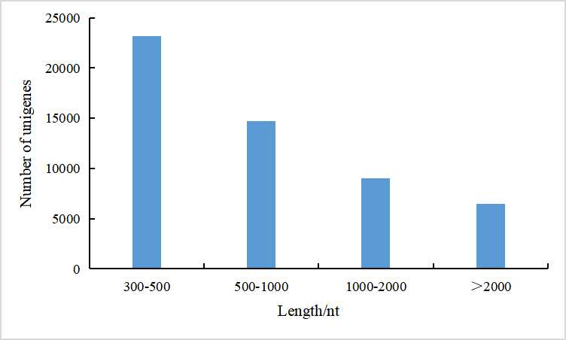

Figure S2:Homologous species distribution (determined using the NR database).
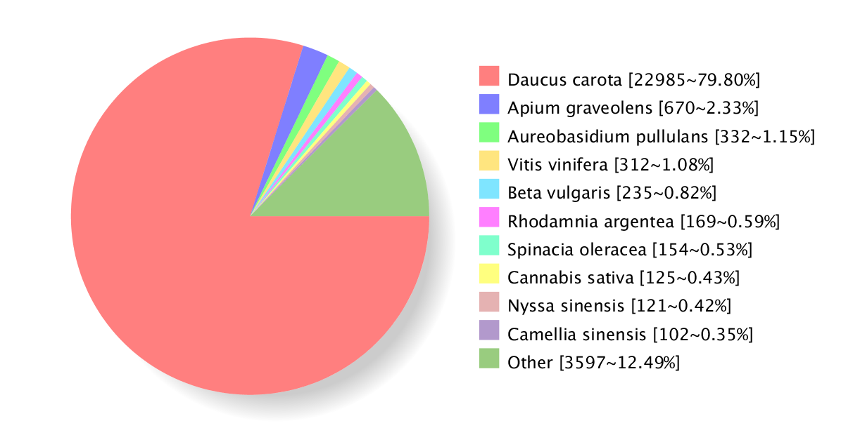:

Figure S3:Functional classification in the COG pathways.
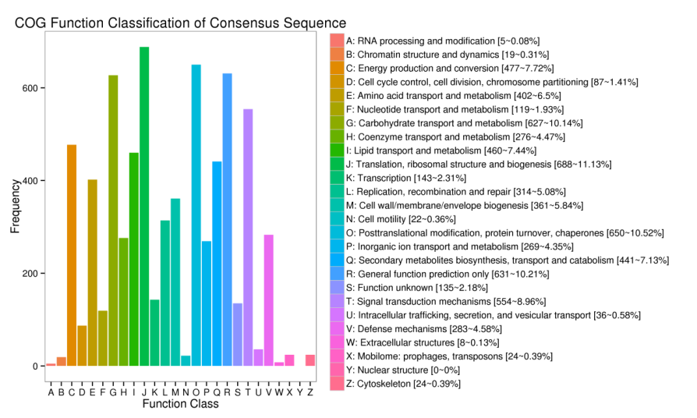

Figure S4: Functional classification in the GO pathways.
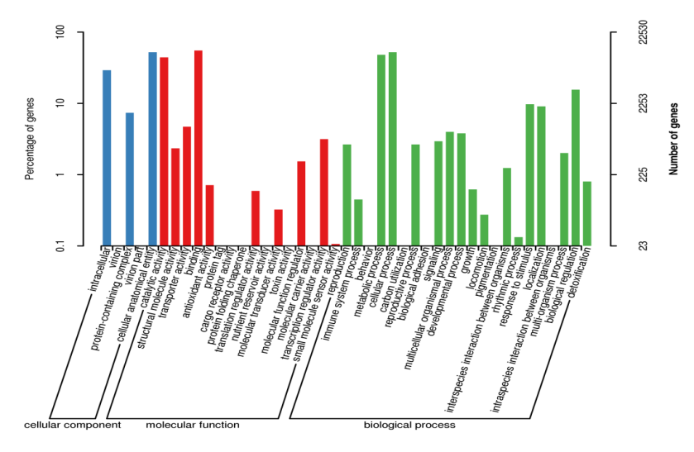

Figure S5: Enriched GO Terms of DEGs generated from the EB and NB group
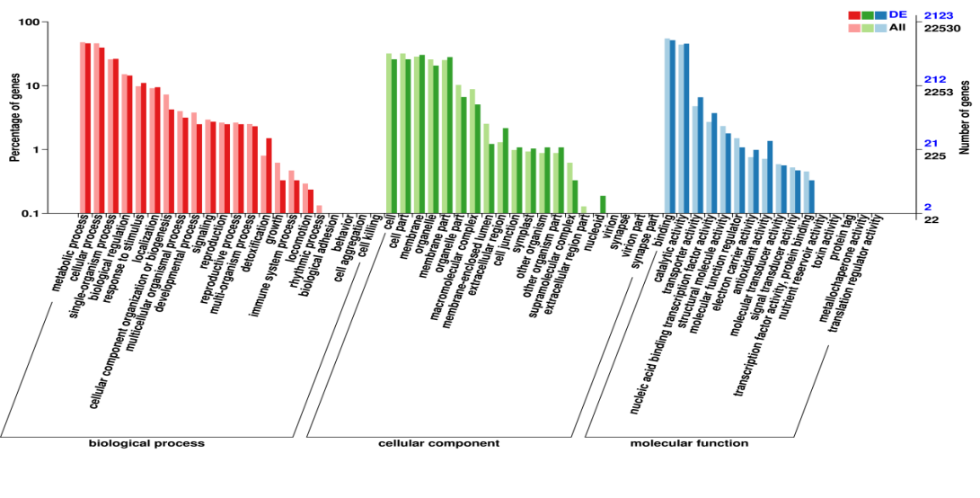

Figure S6:KEGG enrichment of DEGs
