Supplementary Materials

This PDF file includes:

Figs. S1 to S15
Tables S1

Fig.S1. Flow diagram of patient selection criteria.

Fig.S2. Synthesis routes of PGA-covered MoS₂ with different sizes. (A) MoS₂ monolayers with large size (MoS₂-L) were prepared through intercalation method with lithium ions and then broke down to medium (MoS₂-M) and small size (MoS₂-S) with tip sonication. (B) PGA-covered MoS₂ with large size (M-PGA-L), medium size (M-PGA-M) and small size (M-PGA-S) were synthesized through amidation reaction, substitution reaction, and reduction reaction.

Fig.S3. The Nuclear Magnetic Resonance (NMR) spectra of (A) hPG(OMs)_{5%} and (B) hPG(NH₂)_{5%} in D₂O. NMR spectrum confirmed 5% hydroxyls were replaced as methanesulfonyl groups on hPG(OMs)_{5%} and then these methanesulfonyl groups were reduced to amino groups to prepare hPG(NH₂)_{5%}. The signals at 3.4-4.4 ppm and 3.1-3.25 ppm were attributed to the protons of hPG backbone and methyl of methanesulfonyl, respectively.

Fig.S4. The NMR spectra of (A) M-PG(OMs)-M in (CD₃)₂CO and (B) M-PGA-M in D₂O. NMR spectrum confirmed around 50% hydroxyls were replaced as methanesulfonyl groups on M-PG(OMs)-M and then all methanesulfonyl groups were reduced to amino groups to prepare M-PGA-M. The signals at 3.4-4.4 ppm and 3.1-3.25 ppm were attributed to the protons of hPG backbone and methyl of methanesulfonyl, respectively.

Fig.S5. The Fourier Transform Infrared Spectrometer (FTIR) spectra of (A) hPG (N₃)_{5%} and (B) hPG(NH₂)_{5%}. Appearance of a new absorbance band in the IR spectra at 2100 cm⁻¹ for hPG(OMs)_{5%} after reaction with sodium azide confirmed that azaidation of hPG was successfully performed. Reduction of hPG(N₃)_{5%} to hPG(NH₂)_{5%} was substantiated by the disappearance of the azide peak.

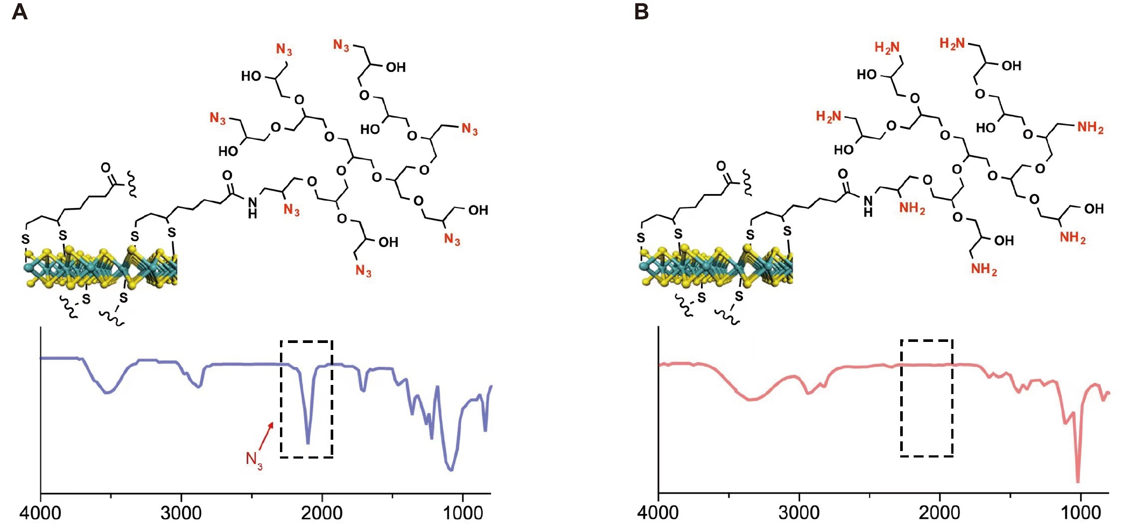
Fig.S6. The FTIR spectra of (A) M-PG(N₃)-M and (B) M-PGA-M. The new absorbance band in the IR spectrum at 2100 cm⁻¹ for M-PG(N₃)-M after reaction with sodium azide confirmed that azaidation of M-PG-M was successfully conducted. The disappearance of azide peak in M-PGA-M indicated the reduction of azide groups to amino groups.

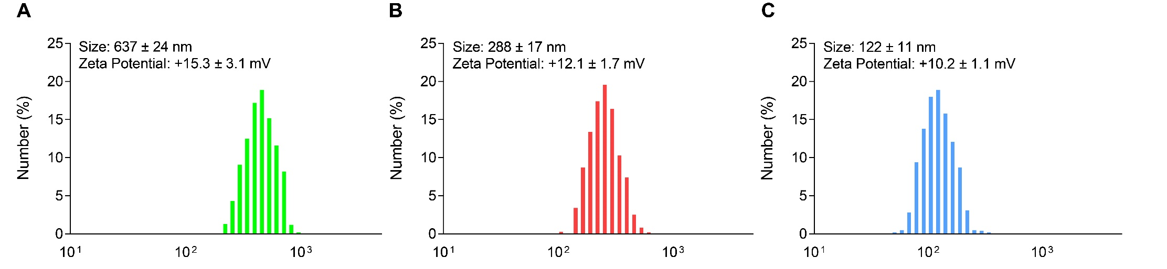
Fig.S7. Zeta potential and DLS data of (A) M-PGA-L, (B) M-PGA-M and (C) M-PGA-S in PBS (pH 7.4).

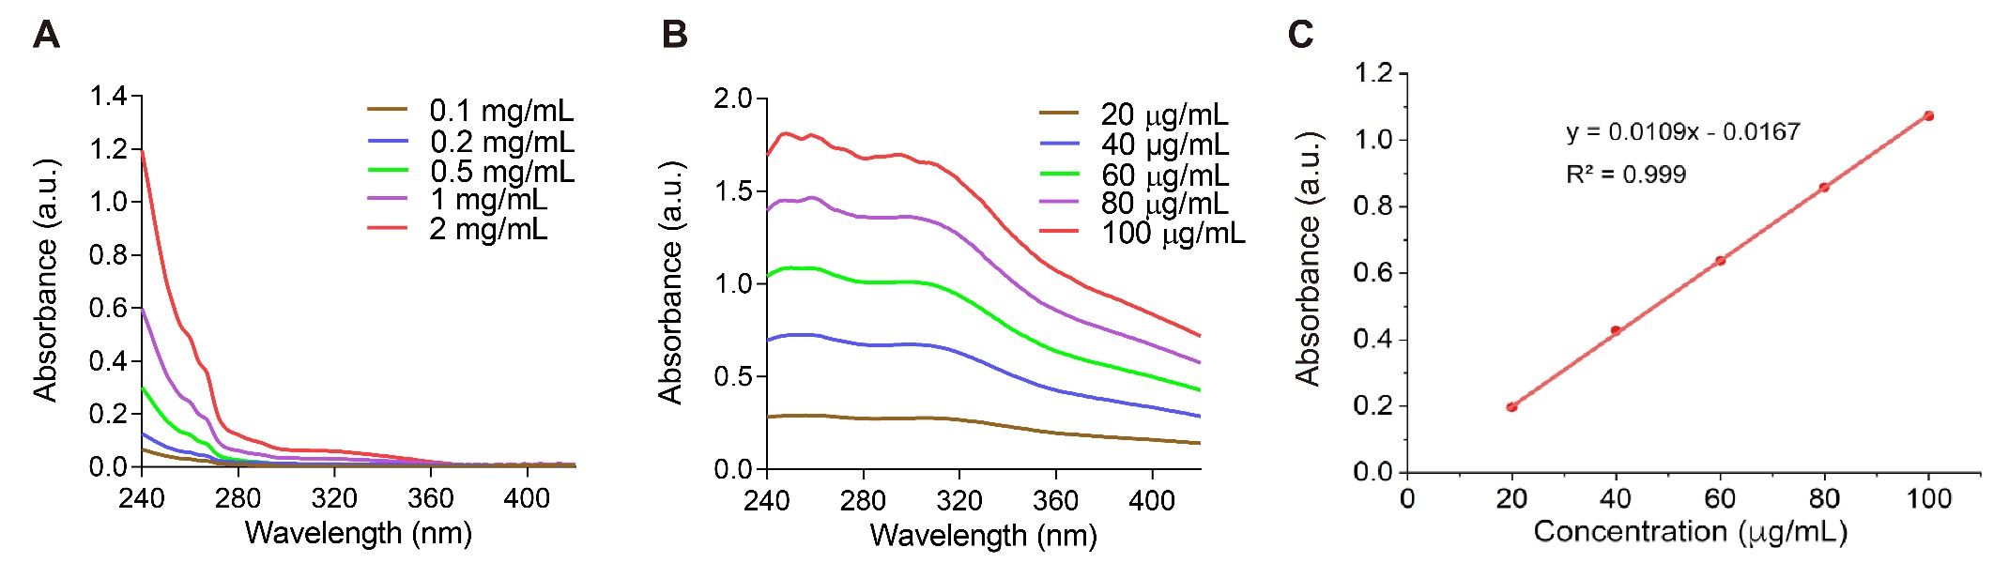
Fig.S8. UV-vis absorption of PGA and MoS₂. (A) The UV-vis absorbance of PGA at a series concentration from 0.1 mg/mL to 2 mg/mL. (B) The UV-vis absorbance of MoS₂ at a series concentration from 20 µg/mL to 100 µg/mL. (C) Standard curve of MoS₂ with absorbance at 360 nm. The data are expressed as the means ± SEM. The absorbance value at 360 nm of M-PGA-L, M-PGA-M and M-PGA-S (200 µg/mL) solutions were 0.432, 0.361 and 0.324, giving MoS₂ concentrations of 41.2 µg/mL, 34.7 µg/mL and 31.3 µg/mL, respectively. The MoS₂ contents of M-PGA-L, M-PGA-M and M-PGA-S was 20.6%, 17.4% and 15.7%, respectively. Therefore, the polymer contents of M-PGA-L, M-PGA-M and M-PGA-S was 79.4%, 82.6% and 84.3%, respectively.

Fig.S9. Biodegradation of MoS₂-L, M-PGA-L, MoS₂-M, M-PGA-M, MoS₂-S and M-PGA-S in PBS (7.4) at 37℃ within 4 weeks. Remaining percent of nanomaterials were calculated by the UV adsorption at 360 nm.

Fig.S10. Dynamic light scattering (DLS) results of M-PGA-M before and after 2 or 4 weeks incubation in PBS (7.4) at 37℃.

Fig.S11. Biocompatibility and cytocompatibility assessment of M-PGA-M or PGA in vitro. (A) Human red blood cells (RBCs) hemolysis test of M-PGA-M and PGA. Insets were digital photographs of hemolysis test for M-PGA-M and PGA at different concentrations. Data shown were representative of three independent experiments. (B to D) Representative images of different human cells before and after incubation with M-PGA-M (100 μg/mL) or PGA (100 μg/mL). Microscope images of RBCs (B). Scale bars: 50μm. Wright-Giemsa staining of neutrophils and platelets suspension (C). Blue arrows and red arrows indicated neutrophils and platelets, respectively. Scale bars: 50 μm. Cytoskeleton staining of HK-2 cells (D). Scale bars: 20 μm.

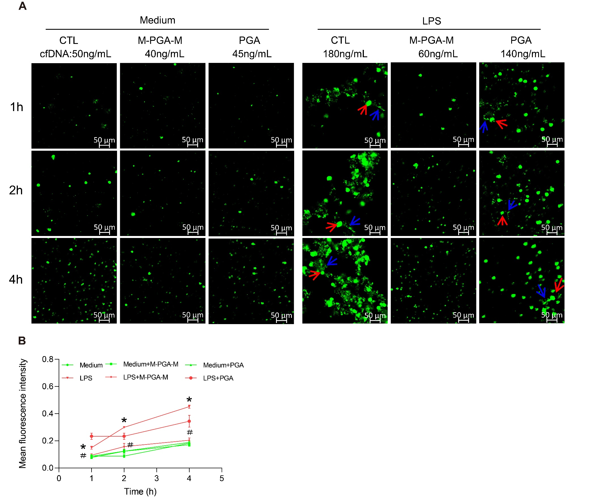
Fig.S12. Effect of M-PGA-M on chromatin decondensation in NETs. (A) Dynamic analyses of chromatin (red arrows) decondensation (blue arrows) by Sytoxgreen staining from different groups. Scale bar: 50 μm. (B) Fluorescence intensity measured by microplate reader from indicated groups in A. Data shown were representative of three independent experiments. Differences were assessed via Kruskal-Wallis and Mann-Whitney U test (*P < 0.05, compared with Medium; ＃P < 0.05, compared with LPS alone or LPS+PGA).

Fig.S13. Inhibition of oxidative stress in the mixture of platelets and neutrophils by M-PGA-M. Platelet-neutrophil mixed cells were stimulated with conditioned medium. (A) Representative ROS fluorescent staining after different treatment conditions. Scale bar: 20 μm. (B) Quantitative data for ROS levels in A. (C to E) MDA, SOD and GSH levels were measured after different treatment conditions. The data are expressed as the means ± SD, categorical variables are presented as numbers (%). All experiments were performed in triplicate (n = 3). Differences were assessed via Kruskal-Wallis and Mann-Whitney U test in B and one-way ANOVA with Tukey’s multiple comparison tests in C-E (*P < 0.05, compared with CTL; ＃P < 0.05, compared with LPS alone or LPS+PGA).

Fig.S14. Blockage of renal oxidative stress by M-PGA-M. Kidney tissues were collected at 24 hours after different treatments. (A) Representative ROS fluorescent staining of kidneys. Scale bar: 20 μm. (B) Quantitative data for ROS levels in A. (C to E) MDA, SOD and GSH levels in kidneys were measured after different treatment conditions. The data were expressed as the means ± SD, categorical variables were presented as numbers (%). Differences were assessed via Kruskal-Wallis and Mann-Whitney U test in B and one-way ANOVA with Tukey’s multiple comparison tests in C-E (*P < 0.05, compared with saline; ＃P < 0.05, compared with LPS).

Fig.S15. Mitigation of LPS-induced multiple organ injury by M-PGA-M. (A to D) Blood samples were collected at 24 hours after different treatments. (A) AST, (B) ALT, (C) CK and (D) CK-MB levels in serum were analyzed. The data were expressed as the means ± SD (n = 6). Differences were assessed via Kruskal-Wallis and Mann-Whitney U test (*P < 0.05, compared with saline; ＃P < 0.05, compared with LPS alone or LPS+PGA).

Table.S1. Values expressed as mean ± SD or number (percent), P < 0.05 were considered statistically significant.

Characteristic | Health (n=47) | AKI (n=46) | P-value
Age (y) | 47.06 ± 16.68 | 52.34 ± 17.33 | 0.146
Sex (Male/Female) | 33/14 | 31/15 | 0.769
Sepsis (%) | － | 30.43 | －
Nephrotic Syndrome (%) | － | 23.91 | －
Lupus Nephritis (%) | － | 21.74 | －
Chemotherapeutic drug associated AKI (%) | － | 15.22 | －
Malignant Hypertension (%) | － | 2.17 | －
Obstructive Nephropathy (%) | － | 2.17 | －
Tsutsugamushi Diseases (%) | － | 2.17 | －
Serum creatinine (μmoI/L) | 69.77 ± 11.81 | 341.09 ± 195.48 | 0.000
cfDNA (ng/mL) | 177.40 ± 50.21 | 362.51 ± 145.89 | 0.000
Neutrophils ( ×10⁹/L ) | － | 7.27 ± 3.99 | －

