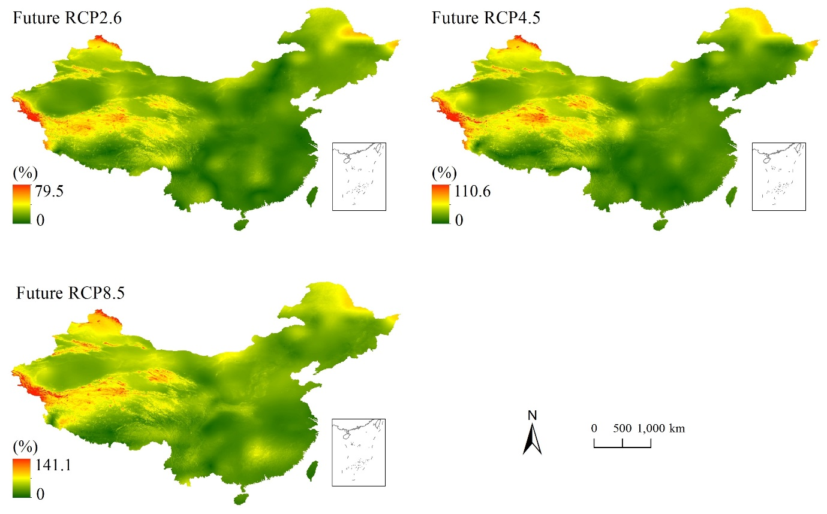
Fig. S1 Spatial patterns of standard errors of future PET changes during the 2018-2100 period, introduced by three GCMs (i.e., BNU-ESM, CESM1-CAM5, and GFDL-ESM2M).
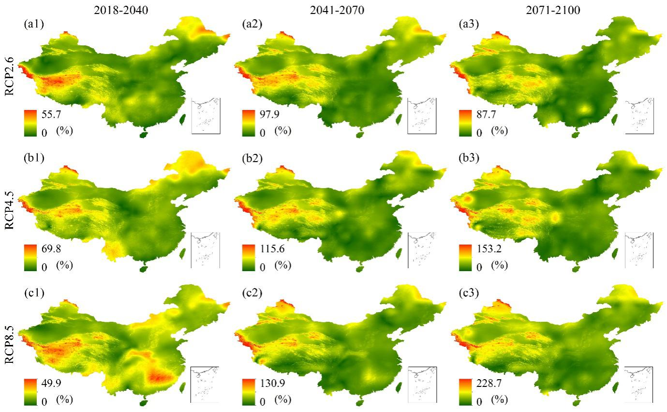
Fig. S2 Spatial patterns of standard errors of future PET changes during the 2018–2040, 2041–2070 and 2071–2100 periods, introduced by three GCMs (i.e., BNU-ESM, CESM1-CAM5, and GFDL-ESM2M).

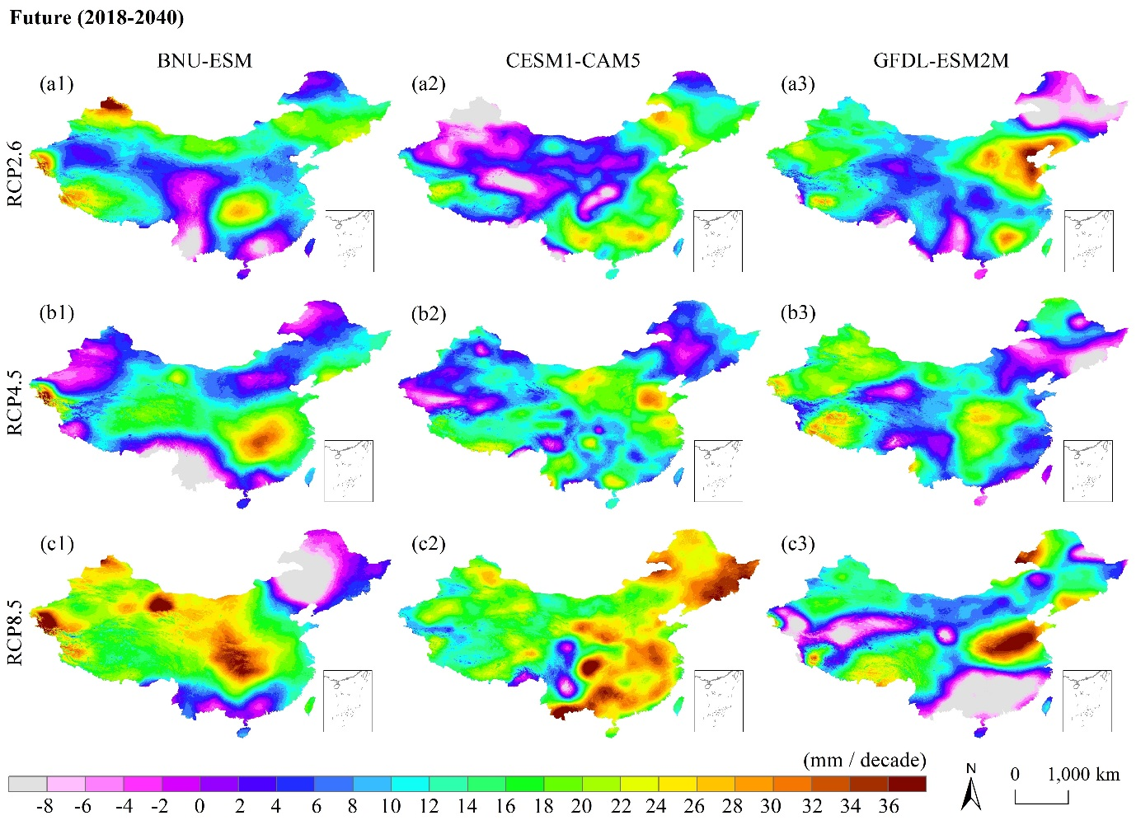
Fig. S3 Spatial patterns of trend magnitude in annual PET variations during beginning-of-century (2018–2040).
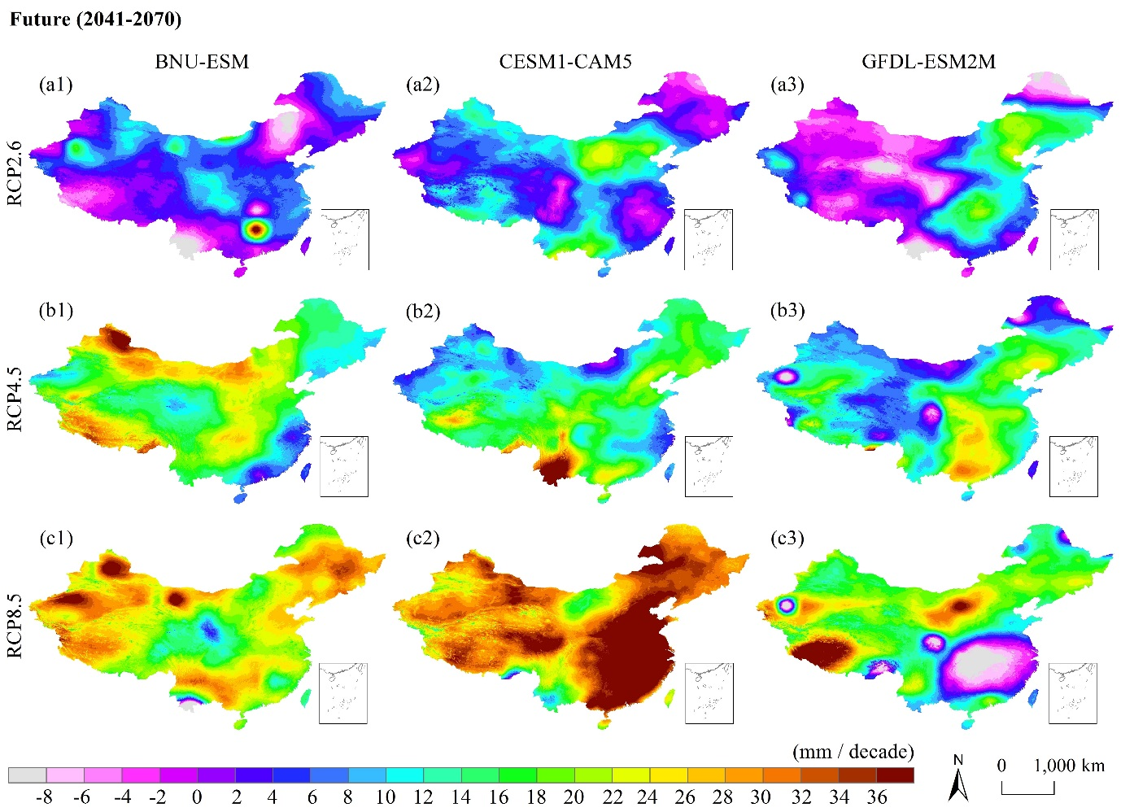
Fig. S4 Spatial patterns of trend magnitude in mid-century annual PET variations during (2041–2070).
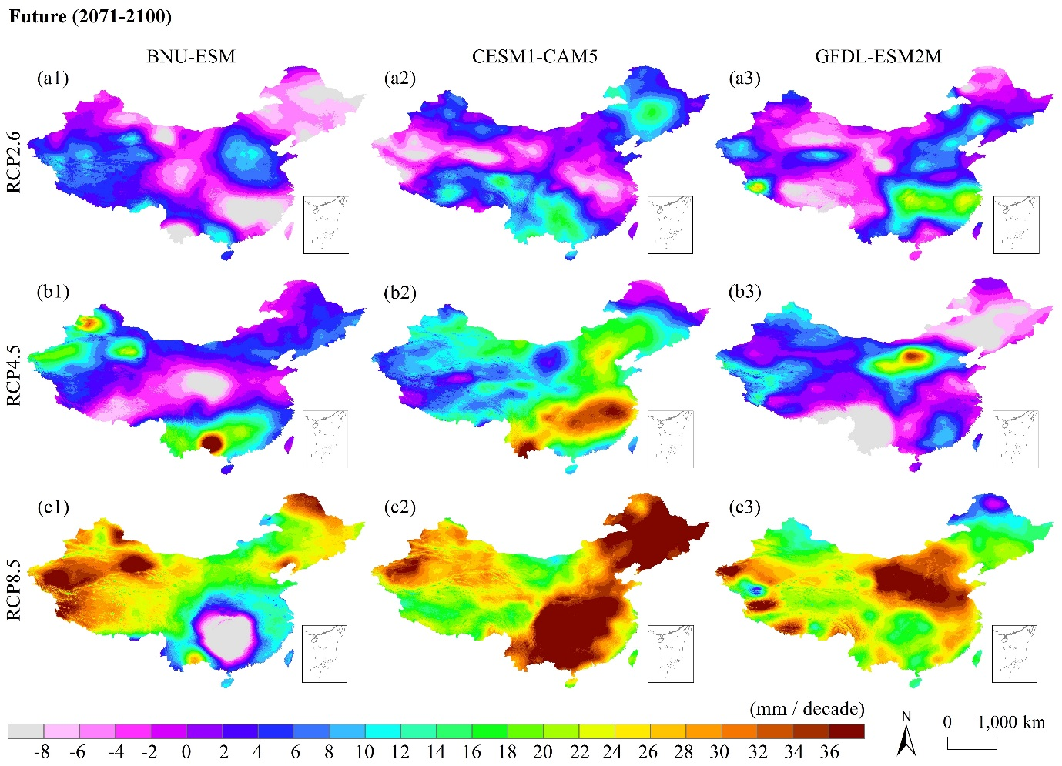
Fig. S5 Spatial patterns of trend magnitude in annual PET variations during the end of the century (2071–2100).
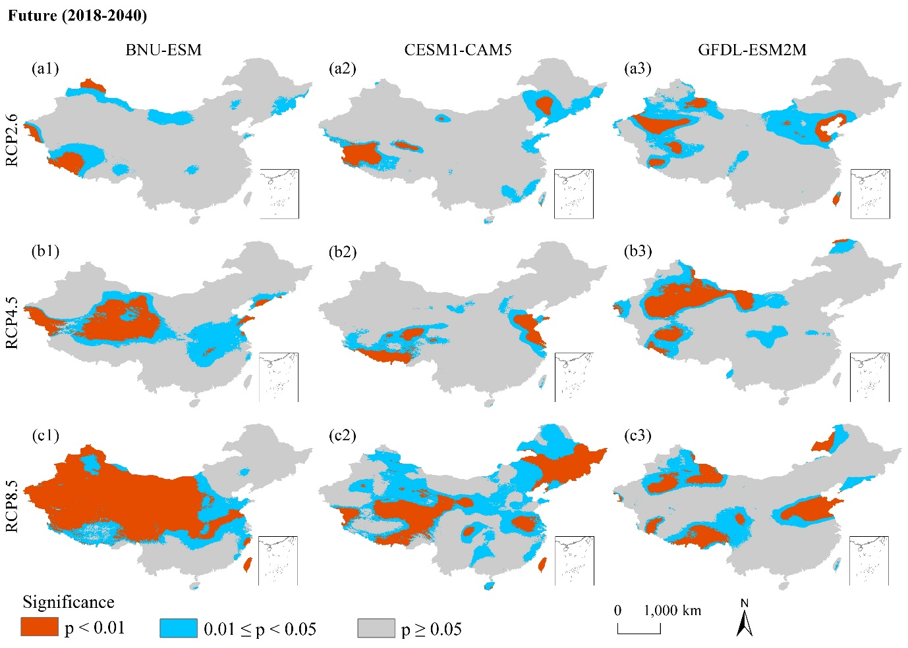
Fig. S6 Spatial patterns of trend significance in annual PET variations at the beginning of the century (2018–2040).
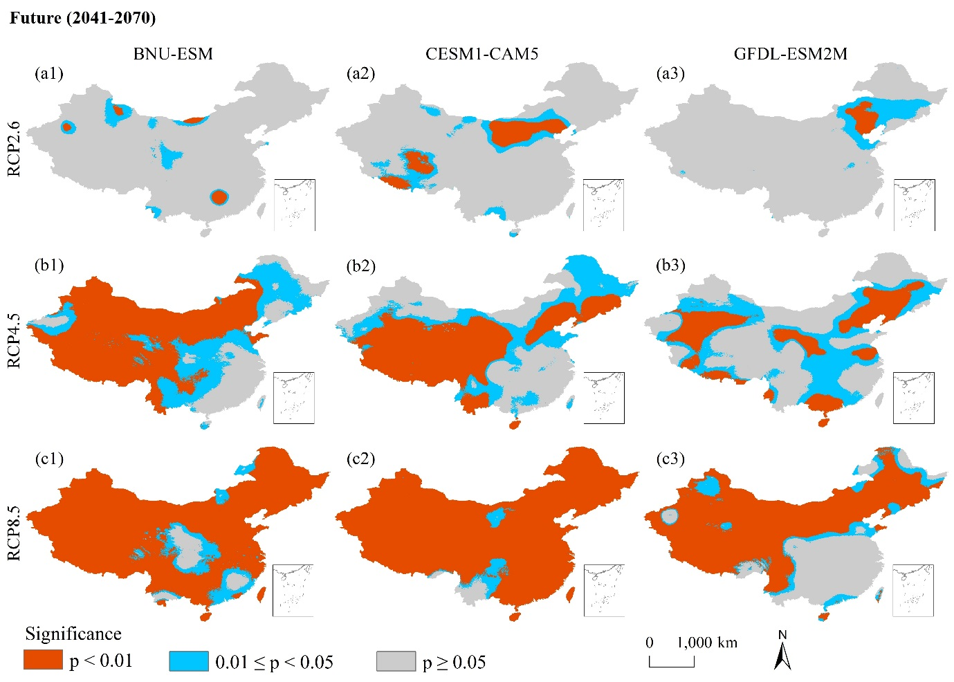
Fig. S7 Spatial patterns of trend significance in annual PET variations during the middle of the century (2041–2070).
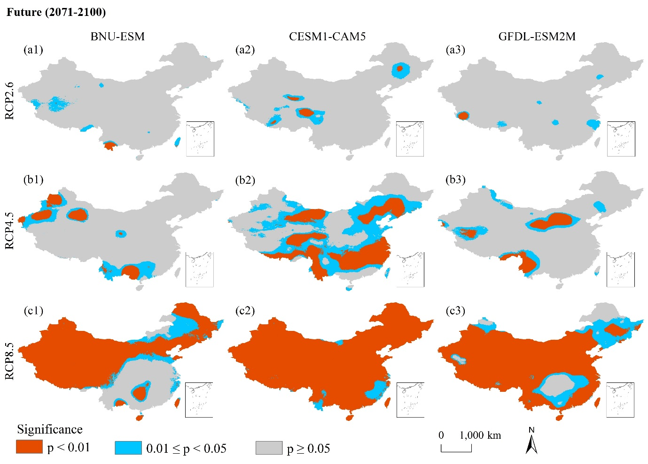
Fig. S8 Spatial patterns of trend significance in annual PET variations during the end of the century (2071–2100).
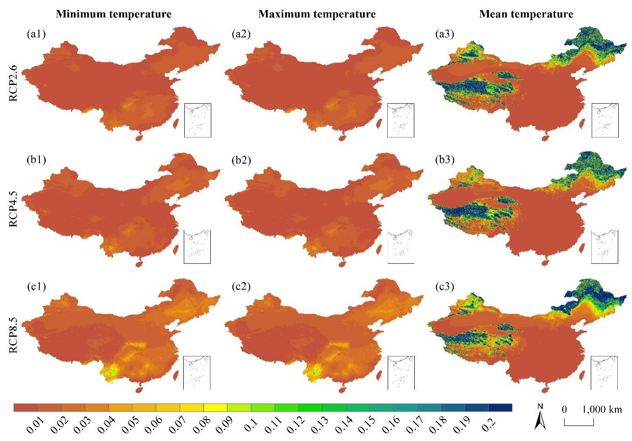
Fig. S9 Spatial patterns of standard errors of sensitivity coefficients of minimum, maximum, and mean temperatures on PET variations during the future period (2018–2100). The pattern under each RCP scenario was the averaged result of three GCMs (i.e., BNU-ESM, CESM1-CAM5, and GFDL-ESM2M).

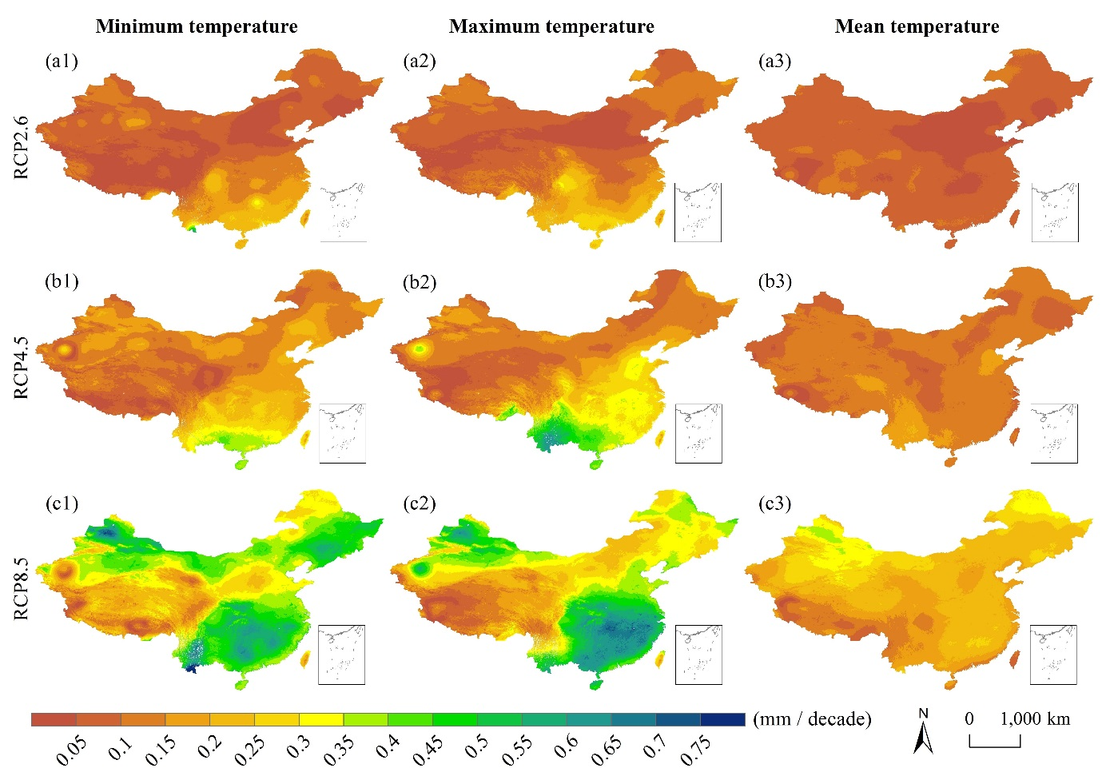
Fig. S10 Spatial patterns of standard errors of contributions of minimum, maximum, and mean temperatures on annual PET variations during the future period (2018–2100). The pattern under each RCP scenario was averaged result of three GCMs (i.e., BNU-ESM, CESM1-CAM5, and GFDL-ESM2M).

Table S1 Spatial characteristics of annual PET trend (mm/decade) in the 2018–2040 period.
 | BNU-ESM |  |  |  |  |  | CESM1-CAM5 |  |  |  |  |  | GFDL-ESM2M
 | RCP2.6 |  | RCP4.5 |  | RCP8.5 |  | RCP2.6 |  | RCP4.5 |  | RCP8.5 |  | RCP2.6 |  | RCP4.5 |  | RCP8.5
 | ↓ | ↑ | ↓ | ↑ | ↓ | ↑ | ↓ | ↑ | ↓ | ↑ | ↓ | ↑ | ↓ | ↑ | ↓ | ↑ | ↓ | ↑
Min | – | 3.34 | 2.89 | 3.90 | 18.81 | 2.22 | 5.74 | 3.33 | 4.80 | 3.09 | – | 2.71 | 18.99 | 1.84 | 5.78 | 4.27 | 8.42 | 2.92
Max | – | 47.47 | 20.24 | 51.19 | 27.12 | 56.59 | 22.66 | 30.02 | 6.69 | 33.21 | – | 46.07 | 22.67 | 43.47 | 5.95 | 32.98 | 30.71 | 45.95
Mean | – | 21.36 | 19.04 | 17.39 | 23.26 | 22.75 | 10.97 | 17.98 | 5.95 | 18.21 | – | 23.28 | 20.56 | 19.03 | 5.87 | 18.68 | 14.97 | 20.46
Std | – | 6.14 | 2.50 | 5.89 | 1.51 | 5.82 | 2.58 | 5.14 | 0.55 | 5.04 | – | 6.28 | 0.72 | 6.71 | 0.05 | 4.13 | 3.60 | 7.28
CV (%) | – | 28.77 | 13.14 | 33.88 | 6.51 | 25.56 | 23.54 | 28.57 | 9.30 | 27.69 | – | 26.99 | 3.50 | 35.26 | 0.84 | 22.10 | 24.06 | 35.60
PA (%) | – | 15.29 | <0.01 | 32.44 | 0.26 | 65.01 | 1.07 | 15.68 | <0.01 | 14.77 | – | 57.37 | <0.01 | 26.22 | <0.01 | 26.43 | 0.07 | 30.98
Note: Min, Max, Mean, Std, CV, and PA represent the minimum, maximum, mean, standard deviation, coefficient of variation, and percent area, respectively. ↓ and ↑ indicate significant decreasing and increasing trends at 95% significance level, respectively. – indicates that the significant trend was not detected at 95% significance level.
Table S2 Spatial characteristics of annual PET trend (mm/decade) in 2041-2070.
 | BNU-ESM |  |  |  |  |  | CESM1-CAM5 |  |  |  |  |  | GFDL-ESM2M
 | RCP2.6 |  | RCP4.5 |  | RCP8.5 |  | RCP2.6 |  | RCP4.5 |  | RCP8.5 |  | RCP2.6 |  | RCP4.5 |  | RCP8.5
 | ↓ | ↑ | ↓ | ↑ | ↓ | ↑ | ↓ | ↑ | ↓ | ↑ | ↓ | ↑ | ↓ | ↑ | ↓ | ↑ | ↓ | ↑
Min | 4.10 | 2.12 | – | 3.02 | 12.60 | 3.24 | – | 2.27 | – | 1.20 | – | 2.21 | 8.20 | 0.90 | 15.38 | 1.83 | 9.75 | 2.76
Max | 14.07 | 41.68 | – | 40.73 | 74.13 | 43.48 | – | 24.36 | – | 53.94 | – | 56.77 | 14.94 | 25.43 | 19.92 | 41.31 | 29.48 | 57.58
Mean | 11.47 | 13.27 | – | 20.25 | 36.21 | 24.33 | – | 14.41 | – | 16.77 | – | 32.20 | 12.68 | 17.19 | 17.47 | 16.76 | 14.32 | 20.49
Std | 0.83 | 6.39 | – | 5.68 | 15.58 | 5.15 | – | 4.61 | – | 6.35 | – | 7.55 | 2.02 | 2.81 | 1.14 | 5.21 | 2.99 | 6.86
CV (%) | 7.26 | 48.17 | – | 28.06 | 43.01 | 21.16 | – | 31.96 | – | 37.86 | – | 23.44 | 15.94 | 16.36 | 6.51 | 31.06 | 20.85 | 33.48
PA (%) | 0.39 | 6.42 | – | 81.26 | 0.27 | 94.20 | – | 17.36 | – | 67.44 | – | 97.57 | 0.01 | 10.12 | <0.01 | 51.23 | 0.06 | 73.07
Note: Min, Max, Mean, Std, CV, and PA represent the minimum, maximum, mean, standard deviation, coefficient of variation, and percent area, respectively. ↓ and ↑ indicate significant decreasing and increasing trends at 95% significance level, respectively. – means that the significant trend was not detected at 95% significance level.
Table S3 Spatial characteristics of annual PET trend (mm/decade) in 2071-2100.
 | BNU-ESM |  |  |  |  |  | CESM1-CAM5 |  |  |  |  |  | GFDL-ESM2M
 | RCP2.6 |  | RCP4.5 |  | RCP8.5 |  | RCP2.6 |  | RCP4.5 |  | RCP8.5 |  | RCP2.6 |  | RCP4.5 |  | RCP8.5
 | ↓ | ↑ | ↓ | ↑ | ↓ | ↑ | ↓ | ↑ | ↓ | ↑ | ↓ | ↑ | ↓ | ↑ | ↓ | ↑ | ↓ | ↑
Min | 4.35 | 2.64 | 3.30 | 2.44 | 13.41 | 3.10 | 4.30 | 3.17 | – | 1.52 | – | 2.13 | 3.22 | 5.69 | 4.96 | 4.59 | – | 2.58
Max | 93.47 | 14.05 | 15.22 | 59.86 | 55.08 | 49.87 | 13.17 | 19.44 | – | 45.20 | – | 52.35 | 18.38 | 29.03 | 39.41 | 37.21 | – | 48.71
Mean | 24.95 | 8.14 | 11.59 | 18.44 | 29.49 | 25.32 | 9.45 | 11.55 | – | 18.23 | – | 29.90 | 9.32 | 18.79 | 20.06 | 14.71 | – | 24.72
Std | 19.94 | 1.60 | 1.72 | 7.85 | 8.60 | 6.32 | 1.54 | 2.56 | – | 7.70 | – | 8.82 | 3.40 | 4.06 | 6.89 | 6.57 | – | 6.87
CV (%) | 79.94 | 19.70 | 14.85 | 42.56 | 29.17 | 24.98 | 16.33 | 22.15 | – | 42.25 | – | 29.51 | 36.48 | 21.62 | 34.37 | 44.66 | – | 27.78
PA (%) | 1.29 | 2.64 | 0.66 | 15.61 | 2.54 | 72.07 | 1.13 | 6.21 | – | 57.26 | – | 99.98 | 0.47 | 2.21 | 5.50 | 10.73 | – | 89.17
Note: Min, Max, Mean, Std, CV, and PA represent the minimum, maximum, mean, standard deviation, coefficient of variation, and percent area, respectively. ↓ and ↑ indicate significant decreasing and increasing trends at 95% significance level, respectively. – means that the significant trend was not detected at 95% significance level.

