Supporting Information
Biomacromolecule Supported N-heterocyclic Carbene-Palladium(II) as a Novel Catalyst for Suzuki-Miyaura and Mizoroki-Heck Cross-Coupling Reactions

Arnet Maria Antonyª, Masira Imtiyaz Chamanmalikª, Vishal Kandathilª, Harini G. Sampatkumarª, B. S. Sasidhar^{b}, C. V. Yelamaggad^{c}, Siddappa A. Patilª*

ªCentre for Nano and Material Sciences, Jain University, Jain Global Campus, Kanakapura, Ramanagaram, Bangalore 562112, India.
^{b}Organic Chemistry Section, Chemical Sciences & Technology Division, National Institute for Interdisciplinary Science and Technology (CSIR), Thiruvananthapuram 695019, Kerala, India.
^{c}Centre for Nano and Soft Matter Sciences, Survey No. 7, Shivanapura, Bangalore 562162, India

Corresponding author: Prof. Siddappa A. Patil
E-mail: p.siddappa@jainuniversity.ac.in / patilsiddappa@gmail.com

Table of contents

- ¹H NMR spectrum of NHC precursor --------------------------------------------------------------- 03
- FT-IR spectrum of NHC precursor ------------------------------------------------------------------- 03
- GC-MS spectrum of NHC precursor ----------------------------------------------------------------- 04
- ¹H NMR spectrum of Suzuki-Miyaura cross-coupled products ---------------------------------- 04
- ¹H NMR spectrum of Mizoroki-Heck cross-coupled products ----------------------------------- 12
- Plausible mechanism for Suzuki-Miyaura cross-coupling reaction ------------------------------ 15
- Plausible mechanism for Mizoroki-Heck cross-coupling reaction ------------------------------- 16
- References ----------------------------------------------------------------------------------------------- 16

Fig. S1. ¹H NMR spectrum of NHC precursor.
Fig. S2. FT-IR spectrum of NHC precursor (Antony et al. 2021; Kandathil et al. 2017).
Fig. S3. GC-MS spectrum of NHC precursor.
¹H NMR spectra of Suzuki-Miyaura cross-coupled products.

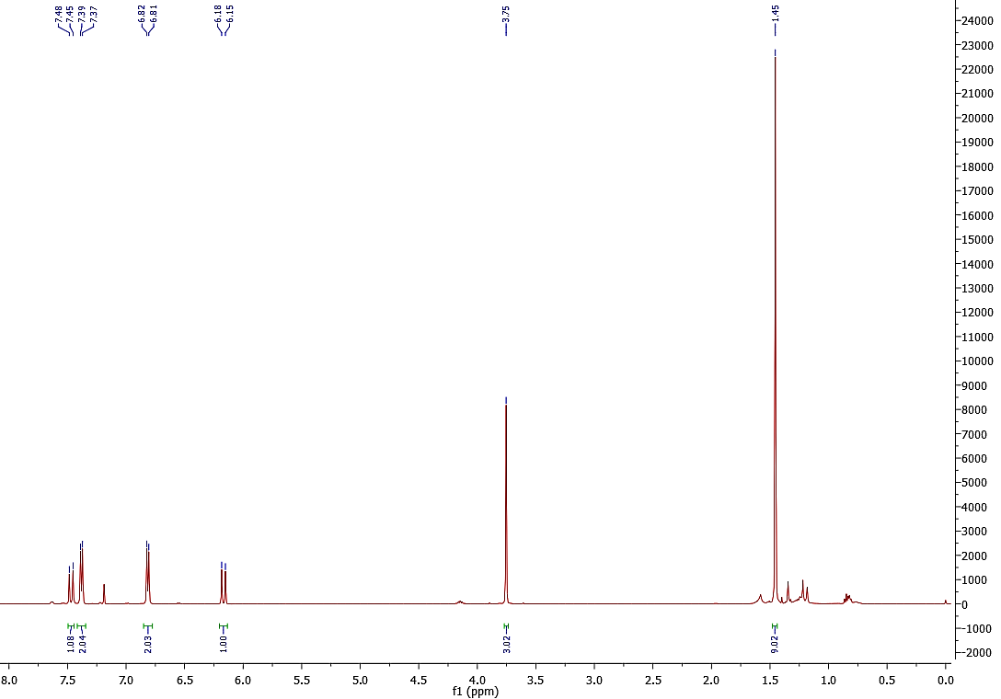
¹H NMR spectrum of Mizoroki-Heck cross-coupled products

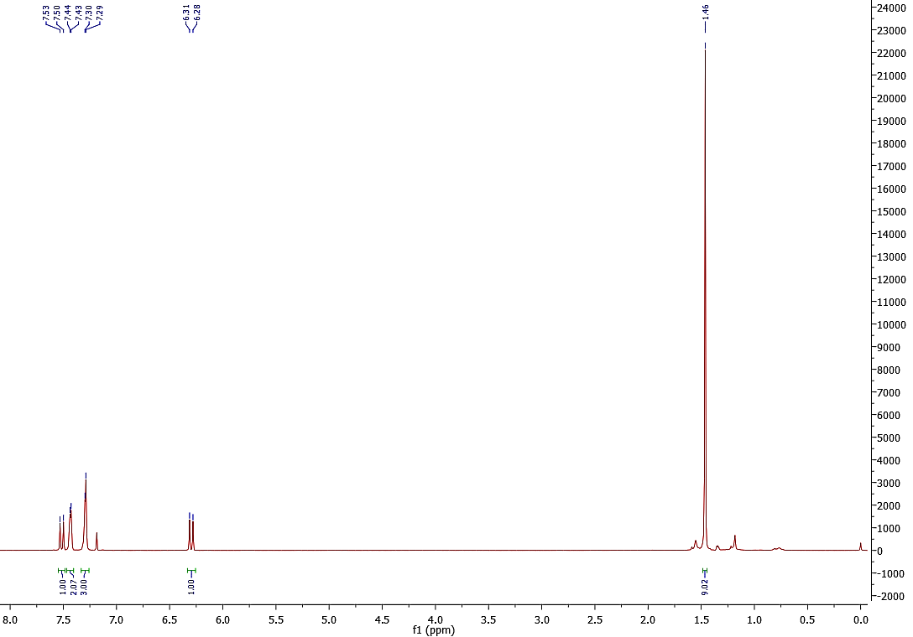

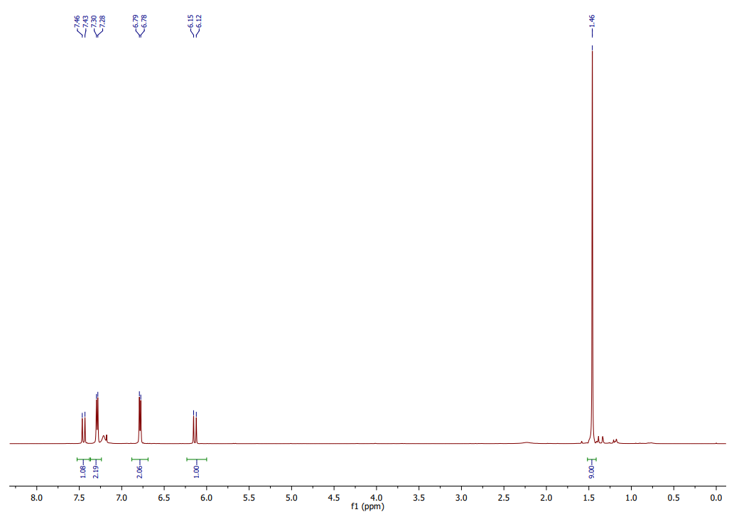
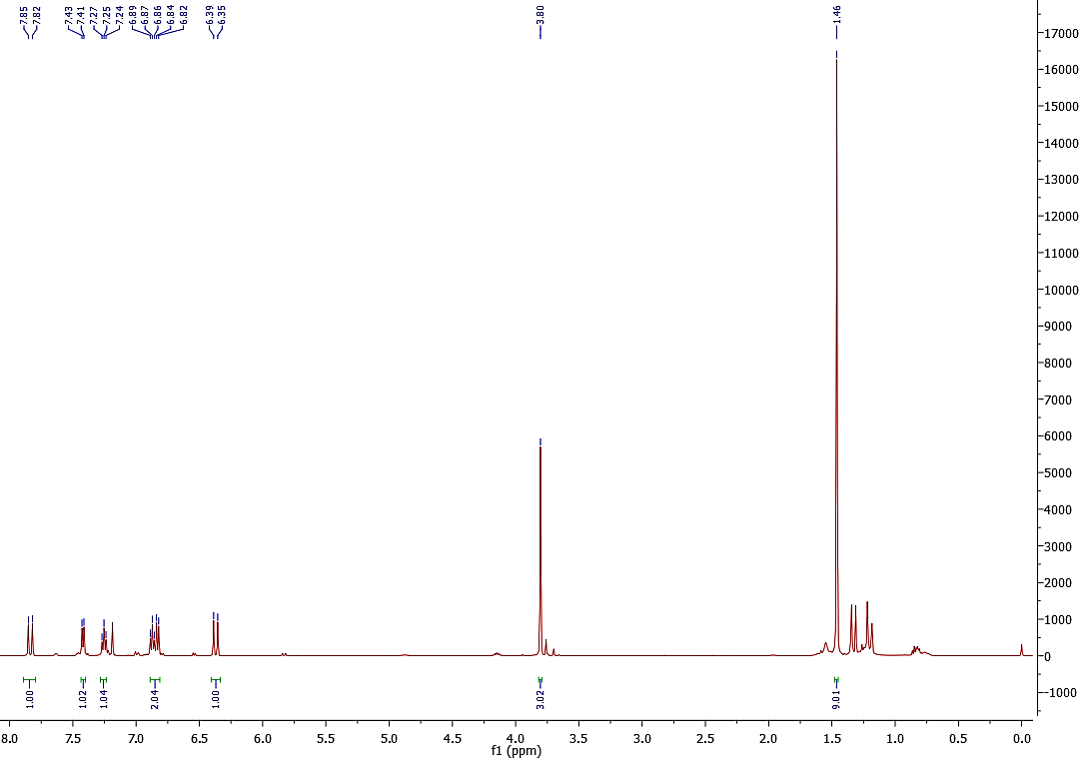
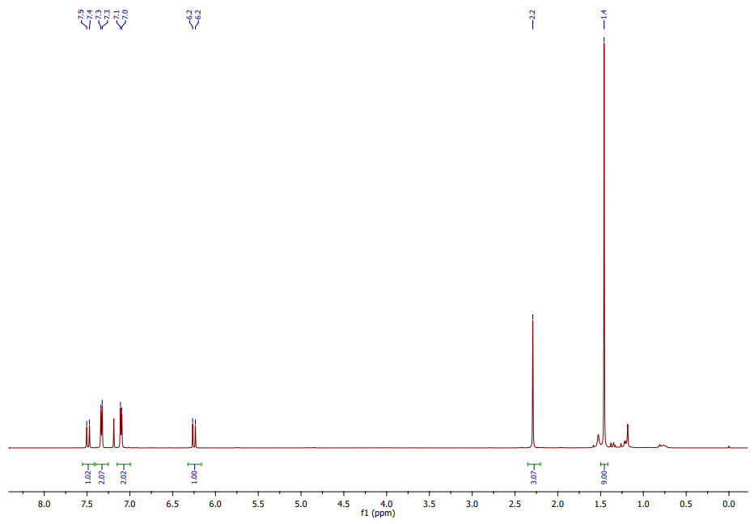
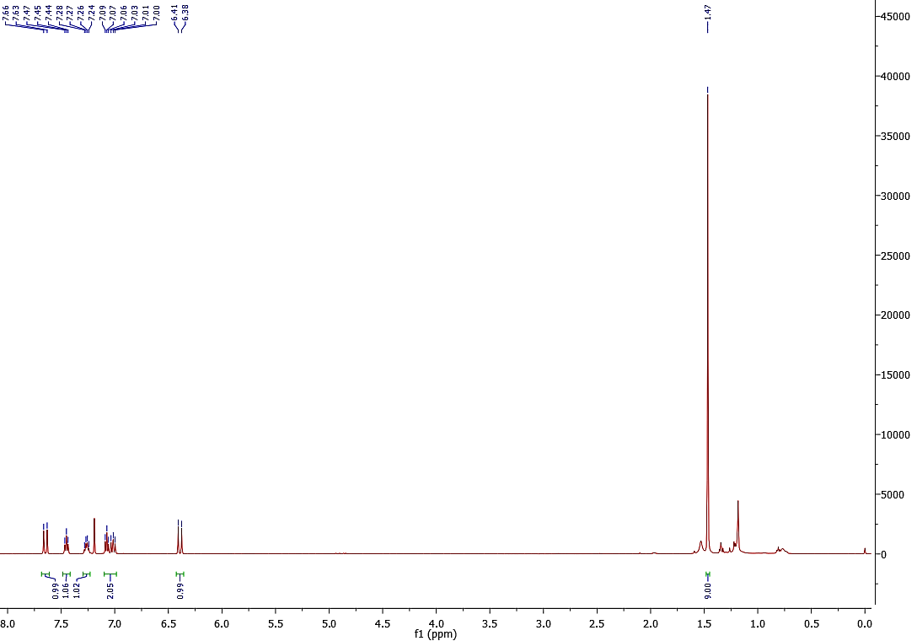
Scheme S1. Plausible mechanism for Suzuki-Miyaura cross-coupling in the presence of Cellu@NHC-Pd heterogeneous catalyst (Sampatkumar et al. 2022).

Scheme S2. Plausible mechanism for Mizoroki-Heck cross-coupling in the presence of Cellu@NHC-Pd heterogeneous catalyst (Beletskaya and Cheprakov 2000; Kumar et al. 2012).

References
Antony, A.M., Kandathil, V., Kempasiddaiah, M., Sasidhar, B., Patil, S.A., Patil, S.A., 2021. Hexagonal Boron Nitride Supported N-Heterocyclic Carbene-Palladium (II): A New, Efficient and Recyclable Heterogeneous Catalyst for Suzuki–Miyaura Cross-Coupling Reaction. Catal Letters 151, 1293-1308. https://doi.org/10.1007/s10562-020-03401-x
Beletskaya, I.P., Cheprakov, A.V., 2000. The Heck reaction as a sharpening stone of palladium catalysis. Chem. Rev. 100, 3009-3066. https://doi.org/10.1021/cr9903048
Kandathil, V., Fahlman, B.D., Sasidhar, B., Patil, S.A., Patil, S.A., 2017. A convenient, efficient and reusable N-heterocyclic carbene-palladium (ii) based catalyst supported on magnetite for Suzuki–Miyaura and Mizoroki–Heck cross-coupling reactions. New J. Chem. 41, 9531-9545. https://doi.org/10.1039/C7NJ01876B
Kumar, A., Rao, G.K., Singh, A.K., 2012. Organochalcogen ligands and their palladium (II) complexes: synthesis to catalytic activity for Heck coupling. RSC Adv. 2, 12552-12574. https://doi.org/10.1039/C2RA20508D
Sampatkumar, H.G., Antony, A.M., Trivedi, M., Sharma, M., Ghate, M., Baidya, M., Dateer, R.B., Patil, S.A., 2022. In situ biosynthesis of palladium nanoparticles on banana leaves extract-coated graphitic carbon nitride: An efficient and reusable heterogeneous catalyst for organic transformations and antimicrobial agent. Biomass Convers. Biorefin., 1-22. https://doi.org/10.1007/s13399-022-03222-5

