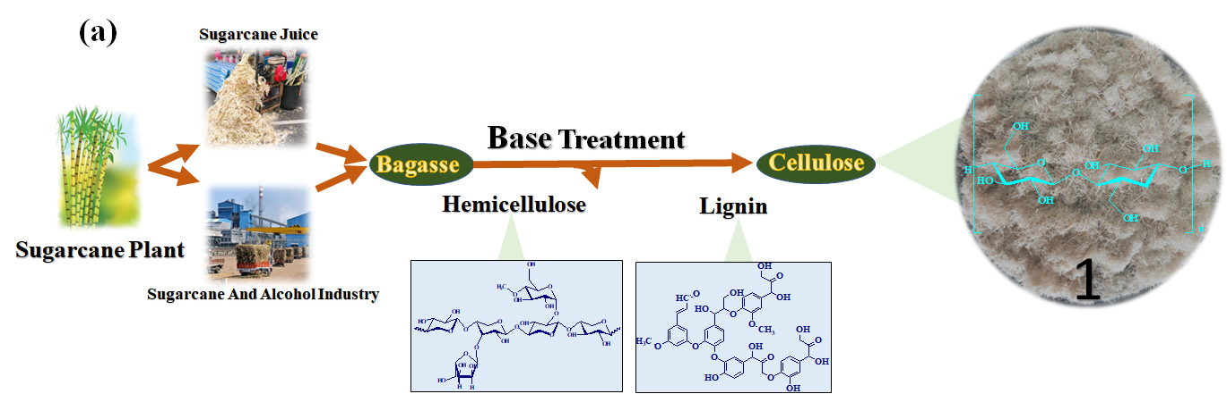
Scheme 1 (a) Extraction of cellulose from agriculture waste sugarcane bagasse and (b) synthetic scheme for the preparation of cellulose tethered N-heterocyclic carbene-palladium(II) complex as heterogeneous catalyst (Cellu@NHC-Pd).

Table 1 Optimization of reaction conditions for Suzuki–Miyaura cross-coupling reaction of 4-iodoanisole with phenylboronic acid in the presence of the Cellu@NHC-Pd heterogeneous catalystª
Entry | Base | Solvent | Temp. (° C) | Pd (mol%) | Time (min) | Yield (%)^{b}
1 | NaOH | EtOH: H₂O | RT | 2.22 | 30 | 90
2 | KOH | EtOH: H₂O | RT | 2.22 | 60 | 95
3 | Cs₂CO₃ | EtOH: H₂O | RT | 2.22 | 30 | 90
4 | Na₂CO₃ | EtOH: H₂O | RT | 2.22 | 60 | 90
5 | KF | EtOH: H₂O | RT | 2.22 | 45 | 30
6 | Na₃PO₄.12H₂O | EtOH: H₂O | RT | 2.22 | 30 | 70
7 | K₂CO₃ | H₂O | RT | 2.22 | 90 | 60
8 | K₂CO₃ | EtOH | RT | 2.22 | 30 | Trace
9 | K₂CO₃ | DMF | RT | 2.22 | 60 | Trace
10 | K₂CO₃ | Acetonitrile | RT | 2.22 | 60 | Trace
11 | K₂CO₃ | Toluene | RT | 2.22 | 60 | Trace
12 | K₂CO₃ | 1,4-Dioxane | RT | 2.22 | 60 | Trace
13 | K₂CO₃ | THF | RT | 2.22 | 60 | Trace
14 | K₂CO₃ | EtOH: H₂O | 50 | 2.22 | 30 | 95
15 | K₂CO₃ | EtOH: H₂O | 40 | 2.22 | 30 | 95
16 | K₂CO₃ | EtOH: H₂O | RT | 2.22 | 15 | 90
17 | K₂CO₃ | EtOH: H₂O | RT | 2.22 | 30 | 95
18 | K₂CO₃ | EtOH: H₂O | RT | 2.22 | 45 | 95
19 | K₂CO₃ | EtOH: H₂O | RT | 1.67 | 30 | 90
20 | K₂CO₃ | EtOH: H₂O | RT | 2.00 | 30 | 93
21 | K₂CO₃ | EtOH: H₂O | RT | 2.78 | 30 | 90
ªReaction conditions: 4-iodoanisole (1.0 equiv.), phenylboronic acid (1.1 equiv.), Cellu@NHC-Pd (1.67-2.78 mol% Pd with respect to aryl halide), base (2.5 equiv.) and solvent (6 mL) in air.
^{b}Isolated yield after separation by column chromatography.

Table 2 Suzuki–Miyaura cross-coupling reactions of different aryl halides with aryl boronic acids in the presence of Cellu@NHC-Pd heterogeneous catalystª
Entry | Aryl halide | Product | Time (min) | Yield^{b}  (%)
1 |  |  | 45 | 80
2 |  |  | 30 | 95
3 |  |  | 60 | 80
4 |  |  | 60 | 90
5 |  |  | 2.5^{c} | 40
6 |  |  | 30 | 95
7 |  |  | 30 | 95
8 |  |  | 60 | 85
9 |  |  | 3^{c} | 85
10 |  |  | 45 | 95
11 |  |  | 45 | 90
12 |  |  | 45 | 90
13 |  |  | 45 | 90
14 |  |  | 45 | 90
15 |  |  | 60 | 95
16 |  |  | 2.5^{c} | 80
17 |  |  | 75 | 80
18 |  |  | 4^{c} | 60
19 |  |  | 2.5^{c} | 80
20 |  |  | 4^{c} | 60
21 |  |  | 90 | 95
22 |  |  | 45 | 99
23 |  |  | 60 | 95
ªReaction condition: Aryl halide (1 equiv), arylboronic acid (1.1 equiv), Cellu@NHC-Pd heterogeneous catalyst (2.22 mol% Pd with respect to aryl halide), K₂CO₃ (2.5 equiv) and EtOH:H₂O (1:1, 6 mL) in air at room temperature.
^{b}Isolated yield after separation by column chromatography.
^{c}Time in hours.

Table 3 Optimization of reaction conditions for Mizoroki-Heck cross-coupling reaction of 4-iodoanisole with tert-butylacrylate in the presence of Cellu@NHC-Pd heterogeneous catalystª
Entry | Base | Solvent | Temp. (° C) | Pd (mol%) | Time (min) | Yield (%)^{b}
1 | Na₂CO₃ | EtOH:H₂O | 60 | 2.22 | 3 | 60
2 | KOH | EtOH:H₂O | 60 | 2.22 | 4 | 40
3 | NaOH | EtOH:H₂O | 60 | 2.22 | 3 | 35
4 | CS₂CO₃ | EtOH:H₂O | 60 | 2.22 | 3 | 40
5 | KF | EtOH:H₂O | 60 | 2.22 | 2 | Trace
6 | K₂CO₃ | H₂O | 60 | 2.22 | 2 | Trace
7 | K₂CO₃ | EtOH | 60 | 2.22 | 2 | 10
8 | K₂CO₃ | Acetonitrile | 60 | 2.22 | 3 | Trace
9 | K₂CO₃ | DMF | 60 | 2.22 | 3 | 10
10 | K₂CO₃ | THF | 60 | 2.22 | 3 | Trace
11 | K₂CO₃ | Toluene | 60 | 2.22 | 3 | Trace
12 | K₂CO₃ | 1,4-Dioxane | 60 | 2.22 | 4 | 40
13 | K₂CO₃ | EtOH:H₂O | RT | 2.22 | 2 | Trace
14 | K₂CO₃ | EtOH:H₂O | 50 | 2.22 | 3 | 60
15 | K₂CO₃ | EtOH:H₂O | 70 | 2.22 | 6 | 80
16 | K₂CO₃ | EtOH:H₂O | 60 | 2.22 | 1 | 20
17 | K₂CO₃ | EtOH:H₂O | 60 | 2.22 | 2 | 60
18 | K₂CO₃ | EtOH:H₂O | 60 | 2.22 | 3 | 80
19 | K₂CO₃ | EtOH:H₂O | 60 | 2.22 | 4 | 80
20 | K₂CO₃ | EtOH:H₂O | 60 | 1.67 | 4 | 50
21 | K₂CO₃ | EtOH:H₂O | 60 | 2.00 | 4 | 47
22 | K₂CO₃ | EtOH:H₂O | 60 | 2.45 | 4 | 70
23 | K₂CO₃ | EtOH:H₂O | 60 | 2.78 | 4 | 50
ªReaction conditions: 4-iodoanisole (1.0 equiv.), tert-butylacrylate (1.1 equiv.), Cellu@NHC-Pd (1.67-2.78 mol% Pd with respect to aryl halide), base (2.5 equiv.) and solvent (6 mL) in air.
^{b}Isolated yield after separation by column chromatography.

Table 4 Mizoroki-Heck cross-coupling reactions of different aryl halides with tert-butylacrylate in the presence of Cellu@NHC-Pd heterogeneous catalystª
Entry | Aryl halide | Product | Time (h) | Yield (%)
1 |  |  | 3 | 80
2 |  |  | 4 | 70
3 |  |  | 3 | 95
4 |  |  | 2 | Trace
5 |  |  | 4 | 65
6 |  |  | 8 | Trace
7 |  |  | 4 | 65
8 |  |  | 3 | 85
9 |  |  | 2 | 95
10 |  |  | 8 | Trace
ªReaction condition: aryl iodide (1 equiv), tert-butylacrylate (1.2 equiv), Cellu@NHC-Pd heterogeneous catalyst (2.22 mol% Pd with respect to aryl iodide), K₂CO₃ (2.5 equiv) and EtOH:H₂O (1:1, 5 mL) in air at 60 °C.
^{b}Isolated yield after separation by column chromatography.

