Local Chemical Enhancement and Gating of Coordinated Organic Ionic-Electronic Transport
Tamanna Khan¹, Terry McAfee^{2,3*}, Thomas Ferron^{2*}, Awwad Alotaibi^{1*}, Brian A. Collins^{1,2*}
¹ Department of Materials Engineering, Washington State University; Pullman, WA, USA
² Department of Physics, Washington State University; Pullman, WA, USA
³ Lawrence Berkeley National Laboratory, Berkeley, CA, USA

Supplementary information

Section S1: Water Contact Angle (WCA) Measurements:
Contact angles are measured using a drop of water on the target surfaces. Then an image is acquired from the side with a camera just after the drop has stopped dispersing on the substrate’s surface and angle is measured with the help of an image protractor. For the UV ozone exposure experiment, the WCA is measured each time after exposure.
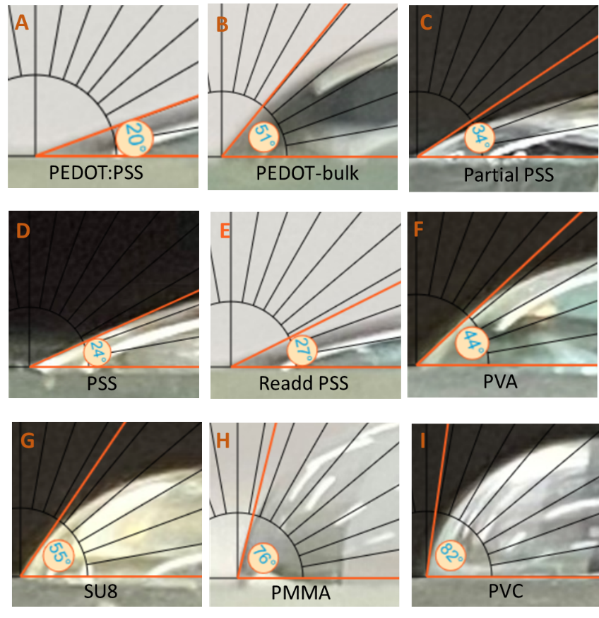
Fig. S1: Water Contact Angles (WCA) Measurements: WCA with a drop of DI-water on the surface of PEDOT:PSS film when (A) PSS is not removed (unsonicated), (B) PSS is fully removed (sonicated before film crosslinking), (C) PSS is partially removed, (D) PSS with GOPS and (E) PSS is readded after removing it. A, C, and E show similar results are expected. WCA on (F) PVA, (G) SU8, (H) PMMA, and (I) PVC.
Section S2: Variable angle spectroscopic ellipsometry (VASE) measurements and analyses:
For modeling the optical constants of PEDOT-rich bulk, we spincast the PEDOT:PSS on both native oxide Si wafer (DOT_nat) and thermally grown oxide (500nm) on Si wafer (DOT_thrm) at 1000 rpm for 1 min. On these films we eliminate the PSS-top layer by sonicating the films in water for 1 min prior to the soft bake step. The optical constants for the PEDOT-rich bulk are developed by fitting a uniaxial B-spline model simultaneously to both DOT_nat and DOT_thrm measurements (Fig. S2A-B) as accomplished previously on other thin films with tensor optical properties ^{30,31}. The resultant optical model from this fit is shown in Fig. S2C. For the PSS optical model, PSS is mixed with 0.14% of GOPS (to mimic the ratios in PEDOT:PSS solutions) before spincasting on native oxide Si wafer with 800 rpm for 1 min (PSS_nat). An isotropic B-spline model suffices to fit to VASE measurements on this sample to create the optical model (Fig. S2D-E).
To characterize the bilayer geometry, pristine PEDOT:PSS films are fit (Fig. 1B) using the optical models separately developed above for PEDOT-rich bulk and PSS allowing only two open parameters: thickness of these two channels. Thicker films (DOT_thick) are fabricated by two spincasting cycles as described in the methods while thinner films (DOT_thin) only uses one spincasting cycle. Both films are spincast on native oxide Si substrate with 2000 rpm for 1 min. The resulting fit for the thinner sample is shown Fig. S2F. All fit parameters are shown in Table S1.
Alternative models are fit to DOT_thick and DOT_thin sample’s VASE data to challenge the result of a PSS top layer which are shown in Fig. . Fig. S3A and Fig. S3C shows VASE analyses of DOT_thick and DOT_thin samples fitted to the same bilayer model except using an isotropic optical model of the PEDOT-rich bulk. The isotropic optical models for the PEDOT-rich bulk are shown in Fig. S3B and Fig. S3D, respectively. These fits are significantly than the uniaxial model despite having significantly more fit parameters. Also, the optical models do not resemble absorbance data. This highlights the necessity to generate uniaxial optical models for conjugated polymer thin films. Fig. S3E is of the bilayer reversed with the PSS-rich layer below the PEDOT-rich layer and Fig. S3F is of a single PEDOT-rich layer and no PSS-rich layer. All parameters are shown in Table S1. The MSE for both alternative models are significantly higher than that for the primary model where the PSS-rich layer is on top. In particular, the reversed bilayer required an unphysical negative thickness of the PEDOT-rich bulk.

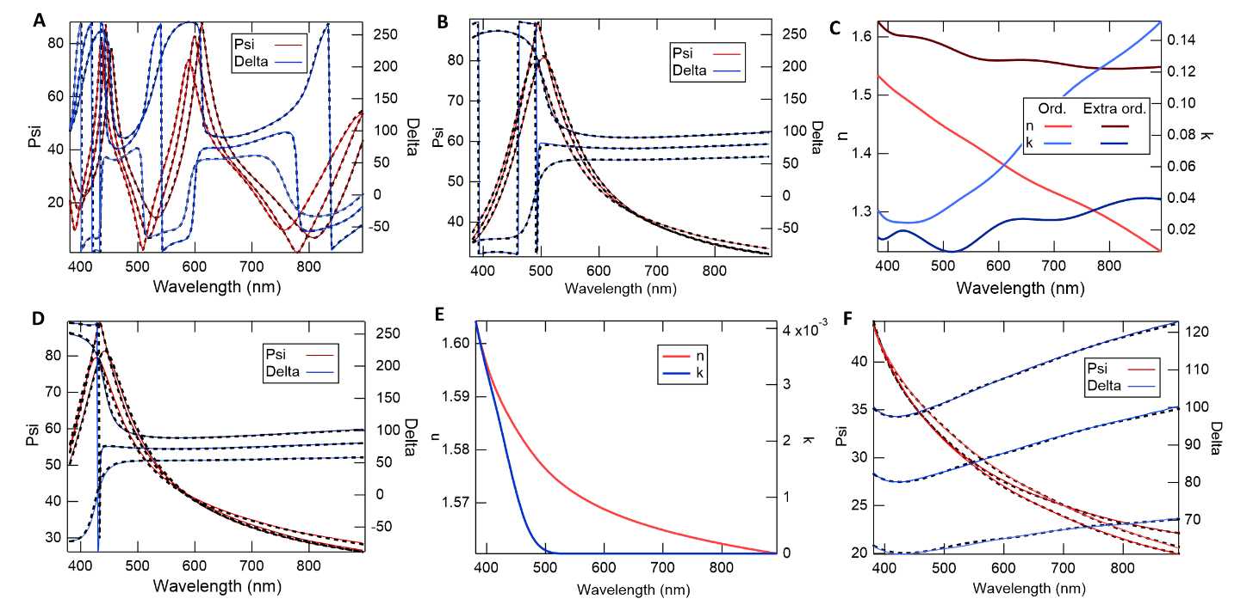
Fig. S2: VASE Models of PEDOT Bulk and PSS: VASE measurements of PEDOT-rich bulk (washed via sonication) films on two different Si substrates with: (A) thermally grown oxide and (B) native oxide. (C) The optical constants, n (real) and k (imaginary), from a (dark red and blue) and b (light red and blue). VASE data for (D) PSS with GOPS with optical constants in e. The PSS solution is prepared by diluting with DI-water in the ratio of 1:10 and mixing 0.14 vol.% of GOPS. (F) Fitting of unsonicated PEDOT:PSS film using optical constants from C and E where the film is spin cast once on native oxide Si substrate that shows thinner film than twice spin coated film (see Table S1 for details). All SE measurements are taken at three different angles, 65ᴼ, 70ᴼ, and 75ᴼ to get the average thickness. The solid lines represent the data where the black dotted lines are the model fitting for the data.

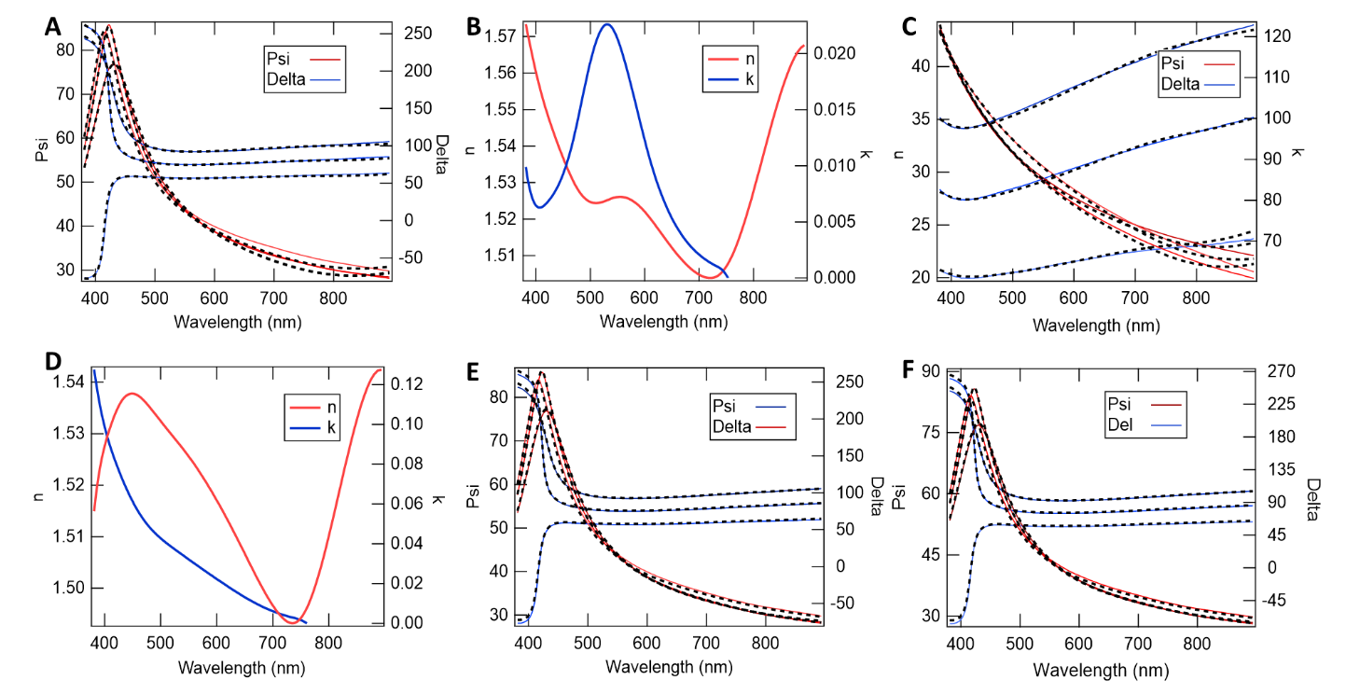
Fig. S3: Failed Attempts: Fitting the as cast PEDOT:PSS film using PSS model atop B-Spline when the solution is spin coated (A) twice and (C) once whose optical constants are in B and D, respectively. Fitting the as cast film (spin coated twice) by (E) reversing the order of model with the PEDOT-rich layer atop a PSS-rich layer and (F) using only PEDOT-rich bulk model. The solid lines represent data and dashed lines are the fitting models.
Table S1: Model fitting parameters of VASE measurements for different samples. (The highlighted fit is described in the main text.)
Parameters  Substrates | Thickness (nm) |  |  | E inf | IR Amp | MSE | Angle offset
DOT_nat (Uniaxial B-spline model) | 111.2 ± 0.2 |  |  | 1.40 ± 0.03 | 1.92 ± 0.04 | 6.6 | -0.43 ± 0.05
DOT_thrm (Uniaxial B-spline model) | 119.2± 0.2 |  |  | 1.40 ± 0.12 | 0.39 ± 0.17 | 6.6 | -0.43 ± 0.05
PSS_nat (B-spline) | 81.7 ± 0.4 |  |  | 1.31 ± 0.03 | 0.03 ± 0.08 | 14.0 | -0.05 ± 0.09
DOT_thick (uniaxial & B-Spline) | PSS |  | 6.1 ± 0.4 | N/A | N/A | 12.6 | -0.14 ± 0.020
DOT_thick (uniaxial & B-Spline) | Bulk |  | 82.0 ± 0.4
DOT_thin (uniaxial & B-Spline) | PSS |  | 8.1 ± 0.2 | N/A | 1.92 ± 0.04 | 2.7 | -0.07 ± 0.004
DOT_thin (uniaxial & B-Spline) | Bulk |  | 44.0 ± 0.2
DOT_thick (Flipping the uniaixal and Bspline model) | Bulk |  | -1.0 ± 2.6 | N/A | N/A | 17.5 | -0.14 ± 0.02
DOT_thick (Flipping the uniaixal and Bspline model) | PSS |  | 90.5 ± 2.6
DOT_thick (using only uniaxial model) | 89.5 ± 0.02 |  |  | N/A | N/A | 17.6 | -0.14 ± 0.02
DOT_thin (B-Spline) | PSS | 8.40 ± 2.3 |  | N/A | 1.70±0.10 | 6.6 | 0.56 ± 0.100
DOT_thin (B-Spline) | Bulk | 47.8 ± 2.3
DOT_thick (B-Spline) | PSS | 7.5 ± 17.1 |  | N/A | 1.60±0.40 | 18.9 | -0.20±0.100
DOT_thick (B-Spline) | Bulk | 76.2±18.5
Section S3: Conversion from Optical Density to Extinction Coefficient:
UV-vis spectroscopy characteristics on PEDOT:PSS film are measured to compare the optical constants from VASE. In UV vis spectroscopy the absorbance is calculated through the Beer-Lambert Law given by
$$\frac{I\left(λ\right)}{I_{0}\left(λ\right)}=\log\left(-αd\right)$$
Or, $I(λ)=I_{0}(λ) e^{-αd}$
where 𝐼(𝜆) is the intensity measured through the active layer, 𝐼₀(𝜆) is the measurement of direct beam through a substrate without any active layer, 𝛼 is the film attenuation coefficient, and $d$ is the film thickness. It does not change the physical attributes of the measurement. Further the optical density (OD) is converted to imaginary refractive index $k$.
The OD is defined by the following equation:
$$OD_{10}(λ)=\log_{10}{\frac{I_{0}(λ)}{I(λ)}}$$
Therefore, combining the last two equations,
$$OD \left(λ\right)=α\left(λ\right)\frac{d}{\ln{10}}$$
The absorption coefficient is related to the imaginary refractive index, $α=\frac{4π}{λ}k$. From this relationship, we get
$$OD \left(λ\right) =\frac{4πd}{λ\ln{10}}k\left(λ\right)$$
$\text{Therefore,} k\left(λ\right)=OD\left(λ\right)∙ λ∙\frac{ln10}{4πd}$
The above equation is used to convert the OD from UV vis to k.
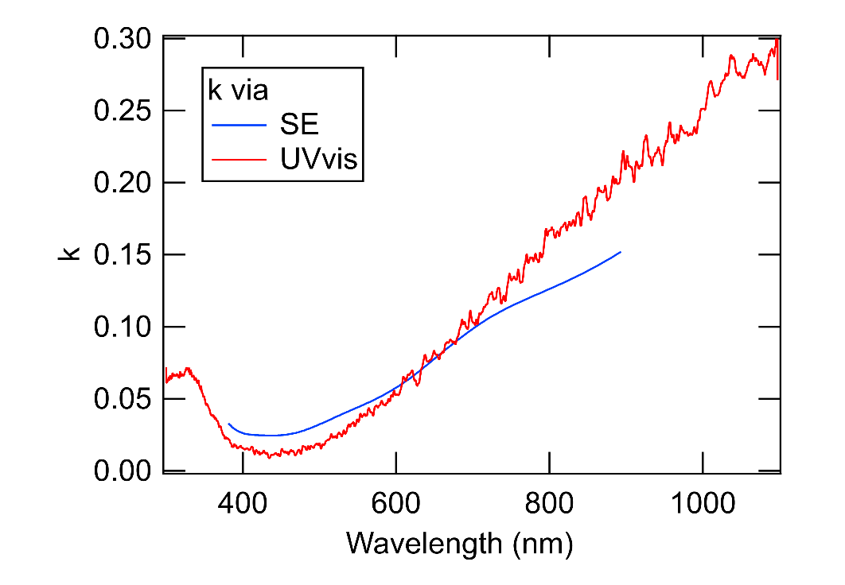
Fig. S4: Comparison of Optical Constant (k): The blue trace represents the measurement from VASE measurements and the red is from UV-vis spectroscopy of PEDOT- rich bulk. Identical method as VASE measurements is used to make film for UV-vis spectroscopy measurements.
Section S4: Equation Derivation for Ion Mobility:
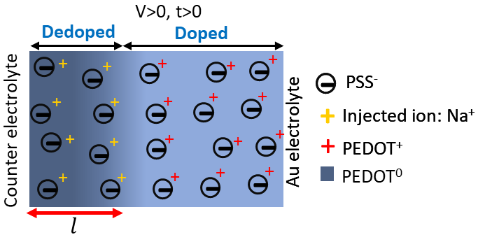
Fig. S5: Film Charge Distribution: Partially (de)doped film when voltage, V is applied. The drift length, $l$ is the distance between the electrolyte/conducting polymer interface to the (de)doped part.
The velocity ($u$) of the ion can be determined from the ion mobility, $μ$ times the electric field, $E$:
$u=μ∙E$
Rearranging, $μ= \frac{u∙l}{V}=\frac{\frac{dl}{dt} l}{V}$
Integrating, $\int{l dx=} \int{μ∙V dt }$
Therefore, $l^{2}=2∙μ∙ V∙t (1)$
where $t$ is the time.
Section S5: Conductivity Measurements:
We have measured the ion conductivity $σ_{ion}=eμp$ of the dedoped film simultaneous to the optical measurement. The film can be considered as two resistors in a series where the $R_{l}$ and $R_{c}$ corresponds to the dedoped and still doped part. A few assumptions are made in this model: The ion mobility is lower than the hole mobility and there is enough electrolyte to neglect ion depletion.
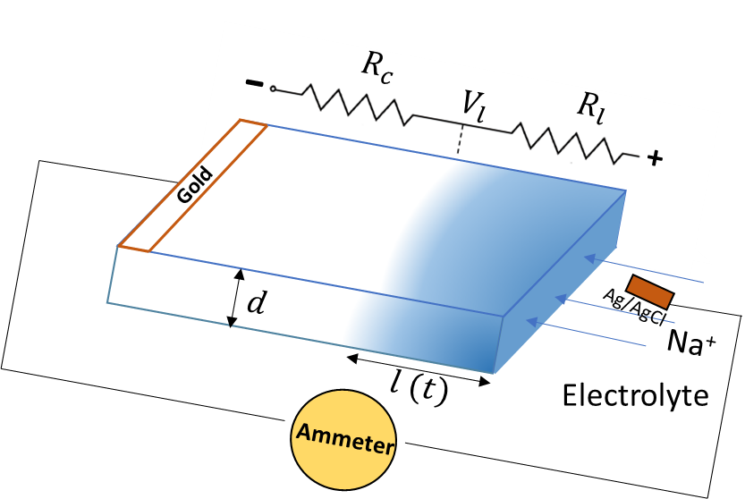
Fig. S6: DC Current Measurement Setup: Schematic of a dedoped film while voltage is applying with equivalent circuit diagram.
When voltage is applied the ions inject into the film from the electrolyte, they increase $p$ in the PEDOT-channel, which allows for increased conductivity of the channel. To measure $p$ we need to measure the current$I$ vs voltage. We start with the Ohms law stated below:
$$I=VG$$
where $G$ is the conductance.
Again, $σ_{ion}$ is related to the $G$ through the length and area, $A$ of the channel as follows:
$$I=\frac{VσA}{l}$$
Now replacing$x$ from equation $l^{2}=2μVt$ gives,
$$I= epA\sqrt{\frac{Vμ}{2t}} (3)$$
Solving for desired ion density, we get
$$p=\frac{I}{eA}\sqrt{\frac{2t}{Vμ}} (4)$$
Taking the derivative of equation 3, we get,
$$\frac{dI}{dt}= \frac{epA\sqrt{V}}{4t} \sqrt{μ} (5)$$
The above equation shows that AC current is proportional to the square root of ion mobility.
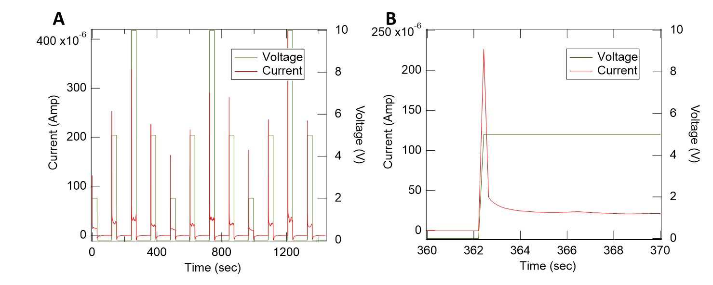
Fig. S7: DC Current Measurement: (A) Current vs time graph for twelve dedoping/redoping cycles and (B) zoomed in version of a dedoping cycle from electrical measurements of a mixed conduction device with PVA encapsulation layer. The green and red traces represent the voltage and current, respectively.

Fig. S7 depicts the automated ECMF experiment. Fig. S7a current vs time graph of 12 cycles of dedoping/redoping where the dedoping is hold for half a minute and the redoping was hold for four times longer to return all the ions back to the electrolyte. The current spikes up in the beginning of time for each cycle of doping which can be seen clearly in Fig. S7b which is a zoomed to show beginning few seconds of dedoping cycle while 5V is applied across the device. According to the two-resistor model, at $t=0$, the dominant resistor is $R_{c}$ because there is no $R_{l}$ yet (no ion injection). Therefore, at that instant of time the current is dominated by the hole transport. After that, as ions enters into the film, $R_{l }$gets bigger and eventually becomes the dominant resistance. Therefore, the current declines back down in nominal level. Afterward, during the removal of bias the current spikes down again while redoing and shows negative value which eventually comes back to zero current (Fig. S7a).

Section S6: Solubility analysis of the barrier materials:
Table S2: δ for different coating materials and water: ^{32–35}
Material | δ_{d}  (MPa^{1/2}) | δ_{p}  (MPa^{1/2}) | δ_{h}  (MPa^{1/2}) | R₀  (MPa^{1/2}) | RED
PVC | 20.90 | 11.30 | 9.60 | 13.70 | 2.25
PMMA | 17.70 | 6.70 | 6.20 | 8.59 | 3.02
SU8 | 18.10 | 11.40 | 9.00 | 9.10 | 3.27
PVA | 18.20 | 7.50 | 8.30 | 3.50 | 7.70
Water | 6.00 | 15.30 | 16.70

A solubility analysis for measuring the hydrophobicity of the encapsulating layer is obtained from relative energy density (RED) using Hansen solubility parameters (HSPs) which are the extension of the Hildebrand solubility parameter, δ. δ defines as the square root of the ratio of cohesive energy to the molar volume of the liquid. δ is well characterized by three cohesive components: dispersion force component (δ_{d}), polar force component (δ_{p}), and hydrogen bonding component (δ_{h}). These three Hansen parameters are needed for a certain material to define the cohesive energy density. By considering each Hansen parameter as one of the three coordinates, a 3D spherical area of solubility is fabricated where the radius is called the interaction radius (R₀). The value of δ_{d}, δ_{p}, and δ_{h} for different components are given in table 1. The distance between two substances 1 and 2, is defined as R_{a}:
R_{a}² = 4 (δ_{d1} - δ_{d2})² + (δ_{h1} – δ_{h2})² + (δ_{p1} – δ_{p2})²
The smaller the value of R_{a}, the solvents are more likely to dissolve into each other. The preferred quantity to define the solubility is termed relative energy density (RED= R_{a} /R₀). As the RED value increases the hydrophobicity also increases. Therefore, using the values from SI Table 3, the calculated RED values show that the hydrophobicity of coating materials increases as PVA<SU8<PMMA<PVC.

Section S7: Transient of Polymer Mediated Transport vs Dewetted Films:
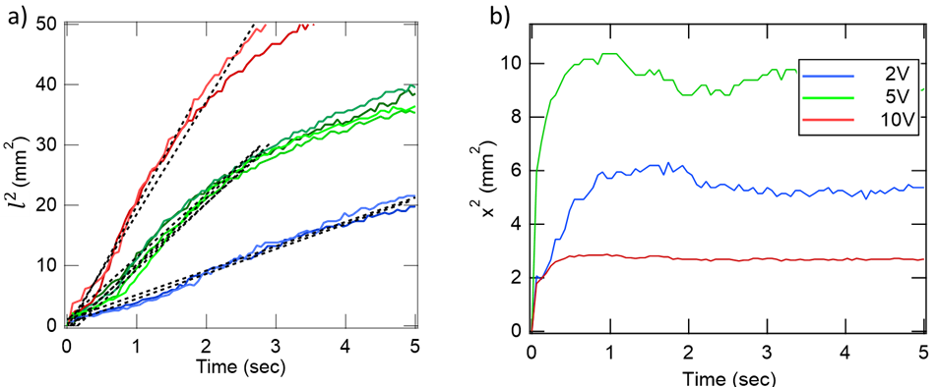
Fig. S8: Comparison between transients of Non-dewetted and Deweeted Film: The transient of dedoping cycles when the film is a) not dewetted and b) dewetted.

Section S8: Swelling Experiments:
The high mobility of Na ions in PEDOT:PSS demands investigation for possible mechanism. Dedoping the film makes it hydrated which causes the swelling of the film. However, too much swelling could result in dewetting of the film meaning the encapsulation loses contact with the film. Therefore, the water as well as the ions from the electrolyte rush into the film as soon as the voltage is applied and causing mobility to be very high.
Previously published report showed that an uncrosslinked (without GOPS), unwashed film swells around 155% after wetting and a crosslinked film via 1% GOPS swells around 35% ¹⁶. All our PEDOT:PSS films are made with 0.14% GOPS. Now, to measure the thickness of the PEDOT:PSS, devices with and without water rinsing using a PVA (most hydrophilic) and PVC (most hydrophobic) encapsulation layers are made. VASE measurements are taken on these devices before and after dedoping with NaCl electrolyte via ECMF experiment.
Because of the presence of the water in the film we cannot use the optical constants of PEDOT-bulk and pure PSS for measuring the thickness of the swelled channel. Therefore, we first model the optical constants for PVA and PVC. To do that we spincast PVA and PVC on native oxide Si wafer and the VASE measurements are fitted to a B-Spline.
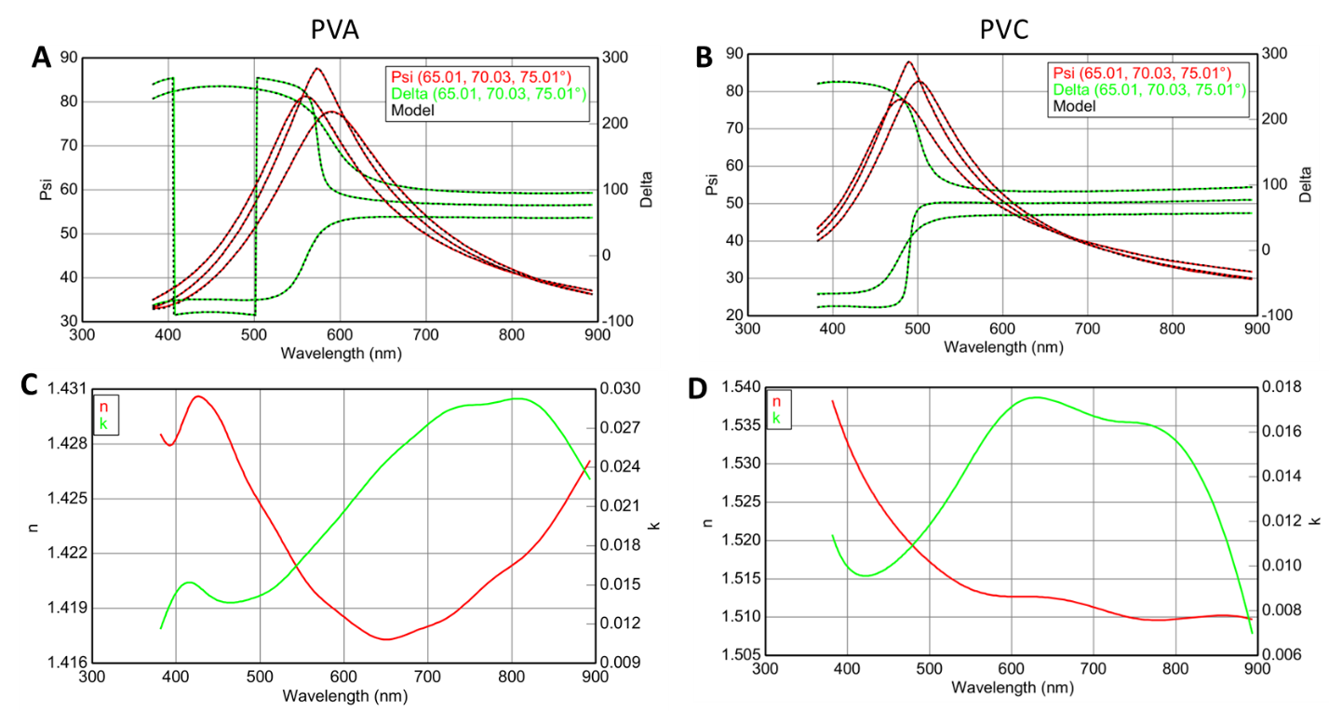
Fig. S9: Optical Constants of Encapsulation: VASE Measurement of (A) PVA and (B) PVC with optical constant in C and D, respectively. The thickness of PVA and PVC is 134.07nm (MSE= 2.92) and 101.22nm (MES= 1.92), respectively.
To measure the thickness of the swelled film a uniaxial B-Spline model is used with the optical constant of PVA or PVC atop. The thickness of the encapsulation layer and the channel are open to vary. Some of the example graphs are shown below with the optical constants from the PVA coated device:

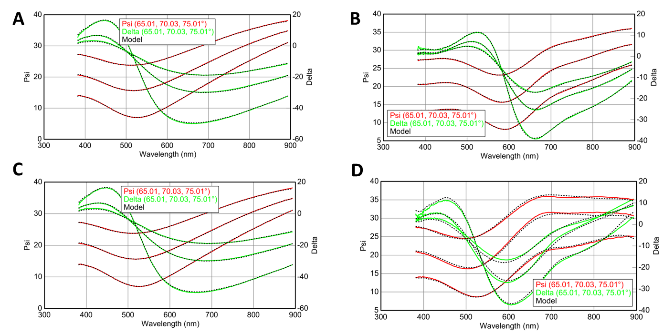
Fig. S10: Thickness Measurements of Swelled Film: The VASE measurements of the film on the PVC coated devices when (A) dry and (B) swelled with PSS, (C) dry and (D) wet without PSS present in the device on glass substrate. All fitting parameters are shown in Table S3.

Table S3: Parameters from VASE for swelling experiments
Sample Condition | Parameter  Dedoping  Trial number | Thickness of encapsulation (nm) | Channel thickness (nm) | MSE
With PSS | 0th | 134.68 | 89.88 | 2.84
With PSS | 7th | 133.41 | 166.30 | 2.12
W/o PSS | 0th | 132.77 | 79.87 | 2.73
W/o PSS | 7th | 134.52 | 146.11 | 10.37

Table S4: Thickness of swelled bulk and interfacial channel
Encapsulation Layer | Sample Condition | Dedoping trial number | Thickness of channel, $t$ (nm) | Bulk swelling, $S_{bulk}$ (%) | PSS swelling, $S_{PSS}$ (%)
PVA | With PSS | 0th | 89.88 | 84.82 | 101.70
PVA | With PSS | 7th | 166.30 | 84.82 | 101.70
PVA | W/oPSS | 0th | 79.87 | 82.93 | 101.70
PVA | W/oPSS | 7th | 146.11 | 82.93 | 101.70
PVC | With PSS | 0th | 86.09 | 81.75 | 83.07
PVC | With PSS | 7th | 156.47 | 81.75 | 83.07
PVC | W/o PSS | 0th | 81.60 | 81.68 | 83.07
PVC | W/o PSS | 7th | 148.25 | 81.68 | 83.07

Here, $S_{bulk}=$ $\frac{t^{7th}-t^{0th} }{t^{0th} }X 100\%$ and $S_{PSS}= \frac{(t_{PSS}^{7th}-t_{w/oPSS}^{7th}) -( t_{PSS}^{0th}-t_{w/oPSS}^{0th})}{t_{PSS}^{0th}-t_{w/oPSS}^{0th}}X100\%$
Comparing the Density of Anion (S0₃⁻) to Na⁺:
We have calculated the number density of sulfonate anions in pure dry PSS, hydrated/swollen PSS, PSS in bulk PEDOT:PSS, and PEDOT:PSS crystal to see how resonable is the Na ion density ($p$) we calculated in Fig. 1H.
Molecular weight of a PSS monomer, $M=206.2 \frac{g}{mol}$
Mass density of PSS, $ρ=0.8019\frac{g}{cm^{3}} ADDIN ZOTERO_ITEM CSL_CITATION \{"citationID":"kBgGsREa","properties":\{"formattedCitation":"\backslash \backslash super 36\backslash \backslash nosupersub\{\}","plainCitation":"36","noteIndex":0\},"citationItems":[\{"id":"tubK7RGe/xOmev8EP","uris":["http://zotero.org/users/7436350/items/BHRIUJCD"],"itemData":\{"id":873,"type":"webpage","abstract":"Poly(sodium 4-styrenesulfonate) (PSS) | Poly (sodium 4-styrenesulfonate) (PSS) a cation exchange polyelectrolyte | Reduction of graphite oxide in the presence of PSS has been reported for the synthesis of polymer-coated graphitic nanoplatelets | Buy chemicals and reagents online from Sigma Aldrich","language":"en","title":"Poly(sodium 4-styrenesulfonate) average Mw 70,000, powder 25704-18-1","URL":"http://www.sigmaaldrich.com/","accessed":\{"date-parts":[["2022",8,18]]\}\}\}],"schema":"https://github.com/citation-style-language/schema/raw/master/csl-citation.json"\}$³⁶

Number density of dry PSS:
$$n_{PSS}=\frac{ρ}{M}=0.8019\left[\frac{g}{cm^{3}}\right]∙\frac{1}{206.2}\left[\frac{mol}{g}\right]∙6.023X{10}^{23}\left[\frac{monomer}{mol}\right]$$
Therefore,
$$n_{PSS}=2.34×{10}^{21} monomers/cm^{-3}$$

Swelling causes $n_{PSS}$ to reduce. We have measured ~102% swelling. Therefore,
$n_{PSS}^{Swell}=1.16×{10}^{21}/cm^{3}$

In PEDOT:PSS average blend (1:2.5 w/w) we have measured 83% swelling resulting in
$n_{PSS}^{Blend}=\frac{2.5}{3.5}∙\frac{100}{183} n_{PSS}=9.1×{10}^{20}/cm^{3}$

In a (dry) PEDOT:PSS crystal there is reported 1 PSS to every 4 PEDOT ^{16,37}. Therefore,
$$n_{PSS}^{xtl}=\frac{n_{PSS}}{5}=4.7×{10}^{20}/cm^{3}$$

Section S9: Effect of UV ozone on PMMA coating devices:
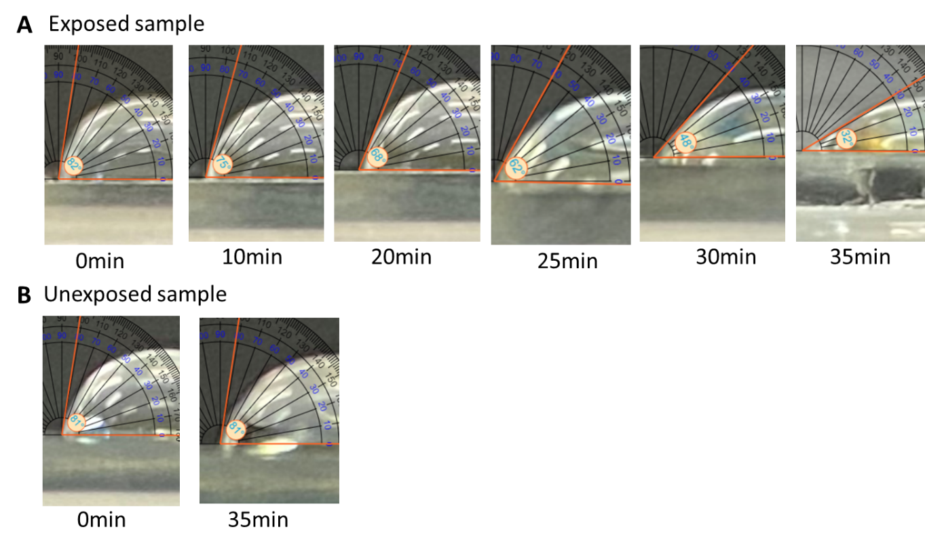
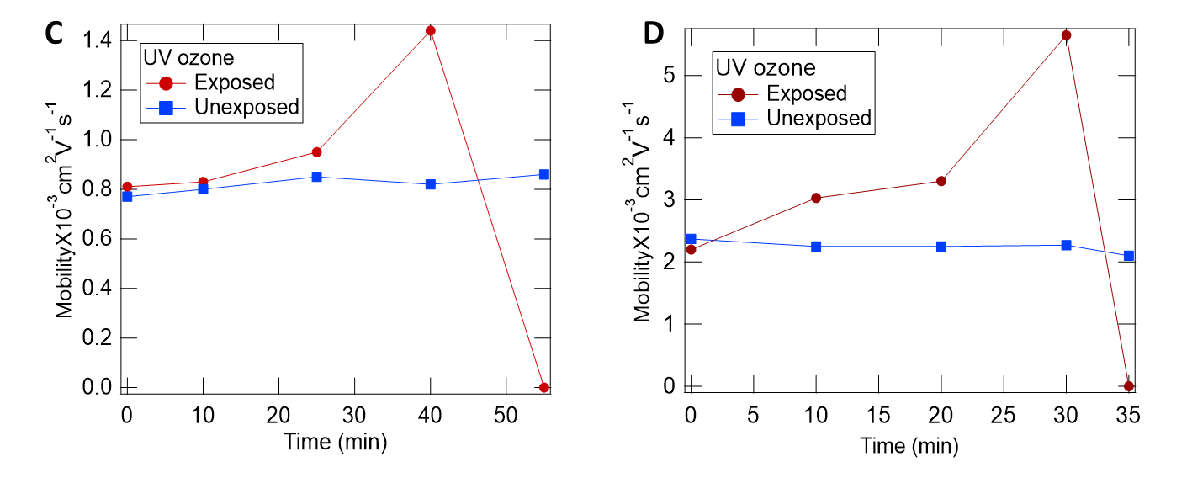
Fig. S11: UV Exposure on Device with PMMA on Top: WCA of PMMA when the device is (A) exposed via UV ozone and (B) unexposed up to 35 mins. Both WCA and MFE are done on the same devices. Mobility measurement on two separate devices showing in C and D. This shows the same trend as in Fig. 3B.

Section S10: Electrical Measurement of Mixed Conduction Devices with PMMA encapsulation:
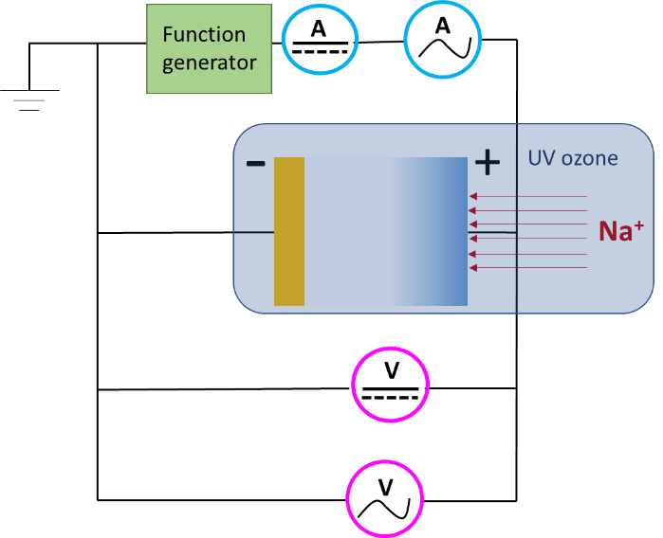
Fig. S12: Experimental Setup for AC Current Measurements: Schematic of setup for AC current measurement over time while dedoping the device with 5V with UV ozone. A function generator is used to provide the DC voltage. The four multi meters show the measured electrical signal.
Section S11: Solvent testing:
It is important that the solvents we use to dissolve the encapsulation materials do not affect the PSS interfacial layer in the film. To see if these solvents affect the PSS interfacial layer, VASE measurements are performed on the PEDOT:PSS sample with and without the solvents atop. A PEDOT:PSS film is made (same procedure as described in methods) on native oxide Si substate with dimension of ~3”X3”. First a measurement via VASE is taken to determine the thickness of the PEDOT and PSS interfacial channel (Fig. S13A and Table S5). Then this film is cleaved into three parts to make three samples. Each of the sample is spin coated with three of the solvents i.e., chloroform, toluene, and THF, with 500 rpm for 1 min on top of PEDOT:PSS film. Cutting three samples from one gives more control over the thickness and reduces the uncertainty. Afterward, the thickness of the PEDOT and PSS interfacial layer are measured from three of the samples (Fig. S13B-D). The resulting VASE data shown in Table S5 represents the thickness of PSS interfacial channel remains essentially identical with and without the solvent Chloroform and Toluene which are used to dissolve PVA and PMMA, respectively. Therefore, these two solvents do not affect the PSS interfacial channel and several nm of PSS interfacial is available to transport the ion through them. However, solvent for PVC, THF, reduces the PSS thickness to less than half a nm which could mean that PSS interfacial channel is dissolved in PVC. Therefore, no PSS interfacial channel is available for ions to move. To solve this problem, another solvent, Cyclohexanone, is used. The thickness of PSS interfacial channel without and with Cyclohexanone is again measured (Fig. S13E-F) which confirms that the presence of PSS channel is present on the top of the PEDOT:PSS film.
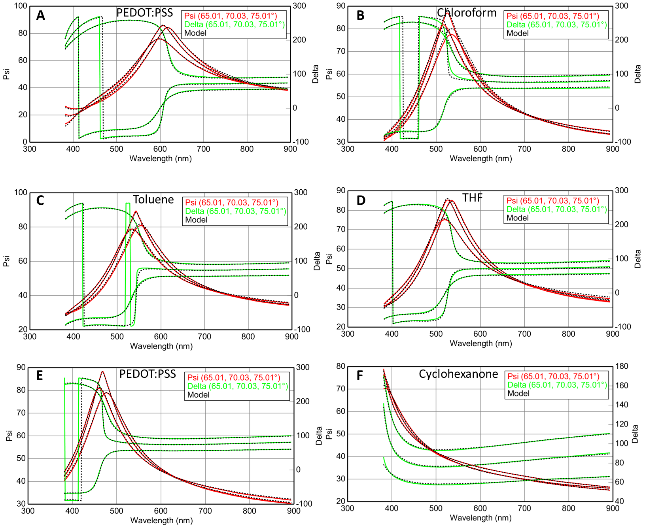
Fig. S13: PSS Thickness Measurement with Solvents: Thickness measurement of A) pure PEDOT:PSS, PEDOT:PSS coated with B) Chloroform, C) Toluene, D) THF. Thickness measurement of E) pure PEDOT:PSS film and F) coated with Cyclohexanone.

Table S5: Thickness of PEDOT:PSS Film with and w/out Solvent Using VASE

