Supporting information
Site Specific N- and O-glycosylation mapping of the Spike Proteins of SARS-CoV-2 Variants of Concern
Asif Shajahan¹#, Lauren E. Pepi², Bhoj Kumar², Nathan Murray², Parastoo Azadi²*
¹Vaccine Production Program, Vaccine Research Center, National Institutes of Health, 9 W Watkins Mill Rd, Gaithersburg, MD 20877, USA; ²Complex Carbohydrate Research Center, University of Georgia, Athens, GA 30602, USA
*Correspondence Author, #Co-correspondence Author.
E-mail address: asif.shajahan@nih.gov (Asif Shajahan), lauren.pepi@uga.edu (Lauren E. Pepi), bhoj.Kumar@uga.edu (Bhoj Kumar), nathan.murray@uga.edu (Nathan Murray), cheiss@ccrc.uga.edu (Christian Heiss), azadi@ccrc.uga.edu (Parastoo Azadi).

Table of Contents
Content | Figure Number
SDS-polyacrylamide gel of spike variants | S1
Experimental Design | S2
Glycoform distribution at site N17 | S3
Glycoform distribution at site N61 | S4
Glycoform distribution at site N74 | S5
Glycoform distribution at site N122 | S6
Glycoform distribution at site N149 | S7
Glycoform distribution at site N165 | S8
Glycoform distribution at site N234 | S9
Glycoform distribution at site N282 | S10
Glycoform distribution at site N331 | S11
Glycoform distribution at site N343 | S12
Glycoform distribution at site N603 | S13
Glycoform distribution at site N616 | S14
Glycoform distribution at site N657 | S15
Glycoform distribution at site N709 | S16
Glycoform distribution at site N717 | S17
Glycoform distribution at site N801 | S18
Glycoform distribution at site N1074 | S19
Glycoform distribution at site N1098 | S20
Glycoform distribution at site N1134 | S21
Glycoform distribution at site N1158 | S22
Glycoform distribution at site N1173 | S23
Content | Figure Number
Glycoform distribution at site N1194 | S24
Glycoform distribution at site T323 | S25
PCA and heat map of site N17 and N61 | S26
PCA and heat map of site N74 and N122 | S27
PCA and heat map of site N149 and N165 | S28
PCA and heat map of site N234 and N282 | S29
PCA and heat map of site N331 and N343 | S30
PCA and heat map of site N603 and N616 | S31
PCA and heat map of site N657 and N709 | S32
PCA and heat map of site N717 and N801 | S33
PCA and heat map of site N1074 and N1098 | S34
PCA and heat map of site N1134 and N1158 | S35
PCA and heat map of site N1173 and N1194 | S36
Distribution of N-glycan types across the variants – determined by N-glycomics | S37
ESI-MS spectrum of N-glycans – WT spike protein. | S38
ESI-MS spectrum of N-glycans - alpha variant spike protein. | S39
ESI-MS spectrum of N-glycans - beta variant spike protein. | S40
ESI-MS spectrum of N-glycans - gamma variant spike protein. | S41
ESI-MS spectrum of N-glycans - delta variant spike protein. | S42
ESI-MS spectrum of N-glycans - omicron variant spike protein. | S43
Sialic Acid Linkage Analysis | S44
Sialic linkages on N-glycans - spike protein of variants | Table S1
LC solvent gradient for glycoproteomics | Table S2
LC solvent gradient for glycomics | Table S3

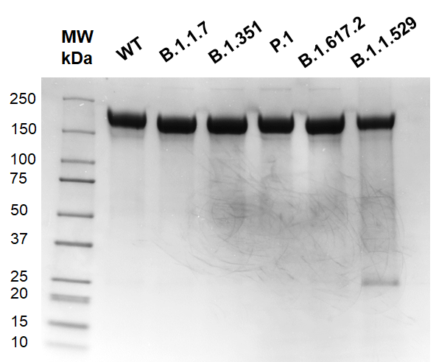
Figure S 1: Coomassie stained SDS-polyacrylamide gel of recombinantly expressed spike proteins of SARS-CoV-2 Wuhan-Hu-1 and VOCs (Wuhan-Hu-1/WT, VOCs- alpha/B.1.1.7, beta/B.1.351, gamma/P.1, delta/B.1.617.2, and omicron B.1.1.529) expressed under identical conditions showing similar purity and migration profile.

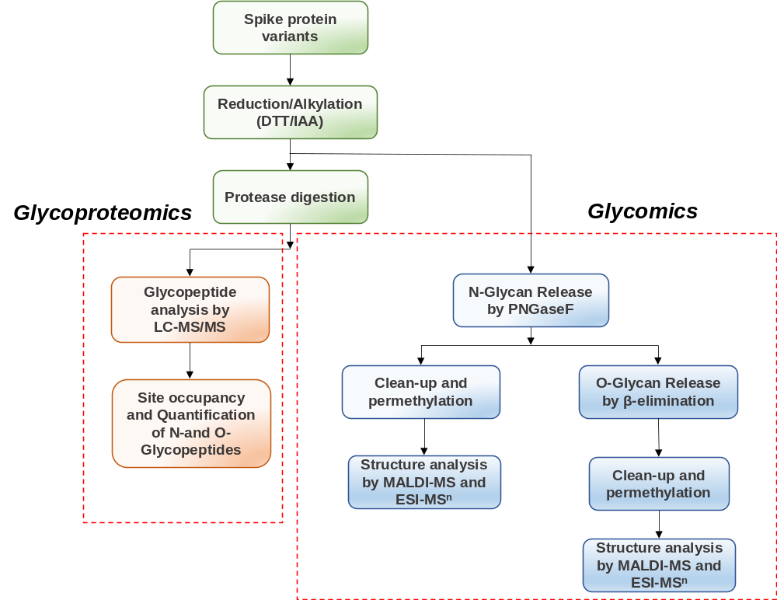
Figure S 2: Glycoproteomics and glycomics workflow followed for the quantitative and qualitative profiling of N-and O-glycosylation on the S protein of SARS-CoV-2 Wuhan-Hu-1 and VOCs.

Figure S 3: Relative abundances of N-glycans at site N17 across the variants. N20 in the case of P.1 (Gamma variant).

Figure S 4: Relative abundances of N-glycans at site N61 across the variants.

Figure S 5: Relative abundances of N-glycans at site N74 across the variants.

Figure S 6: Relative abundances of N-glycans at site N122 across the variants.

Figure S 7: Relative abundances of N-glycans at site N149 across the variants.

Figure S 8: Relative abundances of N-glycans at site N165 across the variants.

Figure S 9: Relative abundances of N-glycans at site N234 across the variants.

Figure S 10: Relative abundances of N-glycans at site N282 across the variants.

Figure S 11: Relative abundances of N-glycans at site N331 across the variants.

Figure S 12: Relative abundances of N-glycans at site N343 across the variants.

Figure S 13: Relative abundances of N-glycans at site N603 across the variants.

Figure S 14: Relative abundances of N-glycans at site N616 across the variants.

Figure S 15: Relative abundances of N-glycans at site N657 across the variants.

Figure S 16: Relative abundances of N-glycans at site N709 across the variants.

Figure S 17: Relative abundances of N-glycans at site N717 across the variants.

Figure S 18: Relative abundances of N-glycans at site N801 across the variants.

Figure S 19: Relative abundances of N-glycans at site N1074 across the variants.

Figure S 20: Relative abundances of N-glycans at site N1098 across the variants.

Figure S 21: Relative abundances of N-glycans at site N1134 across the variants.

Figure S 22: Relative abundances of N-glycans at site N1158 across the variants.

Figure S 23: Relative abundances of N-glycans at site N1173 across the variants.

Figure S 24: Relative abundances of N-glycans at site N1194 across the variants.

Figure S 25: Relative abundances of O-glycans at site T323 across the variants.

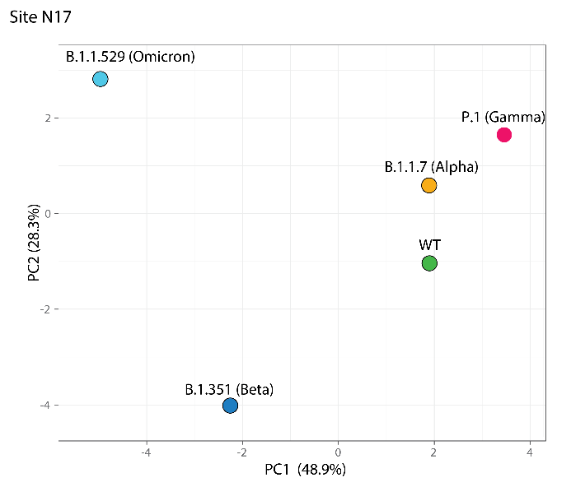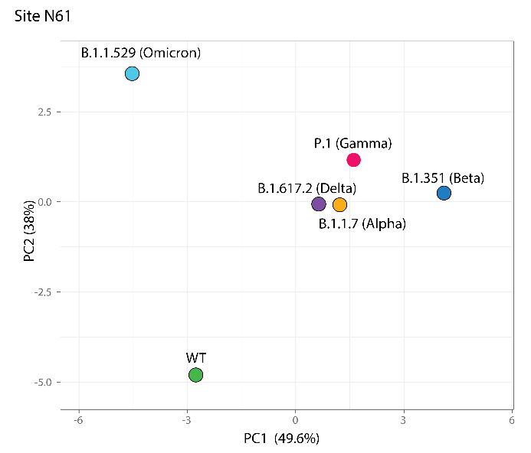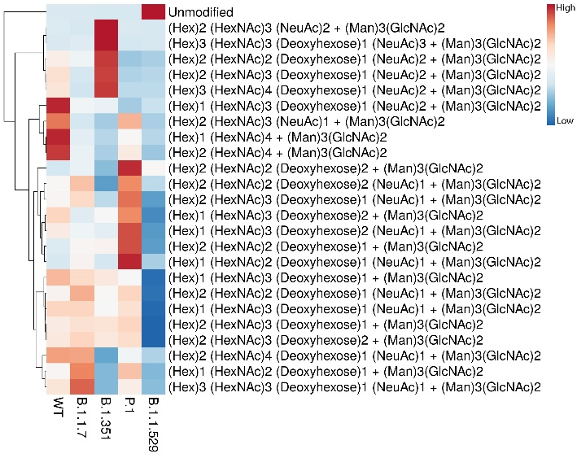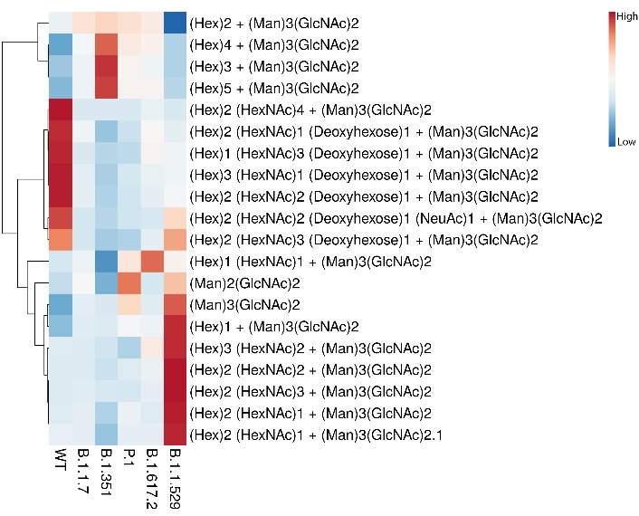
Figure S 26: PCA and Heat map comparison of N-glycans at site N17 (N20 in the case of P.1, Gamma) and N61 of variants.

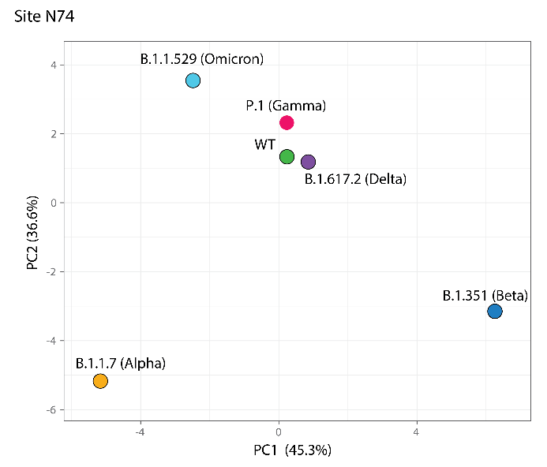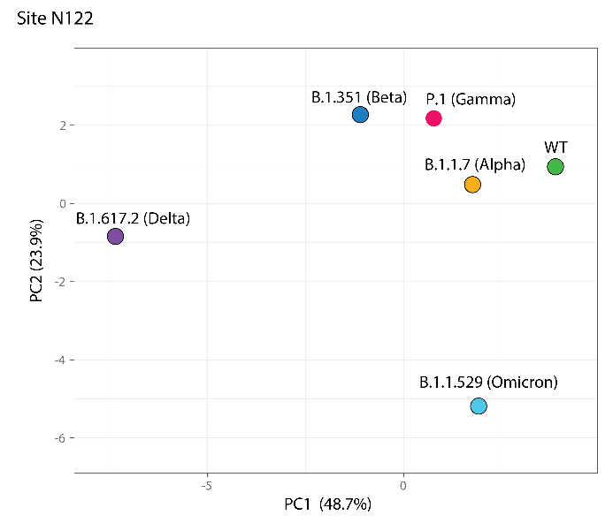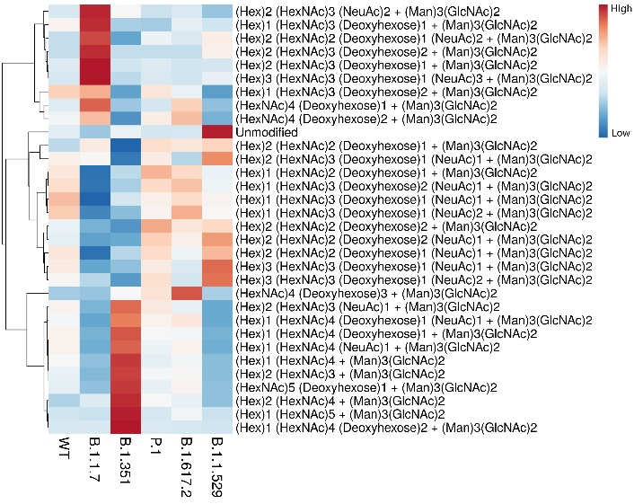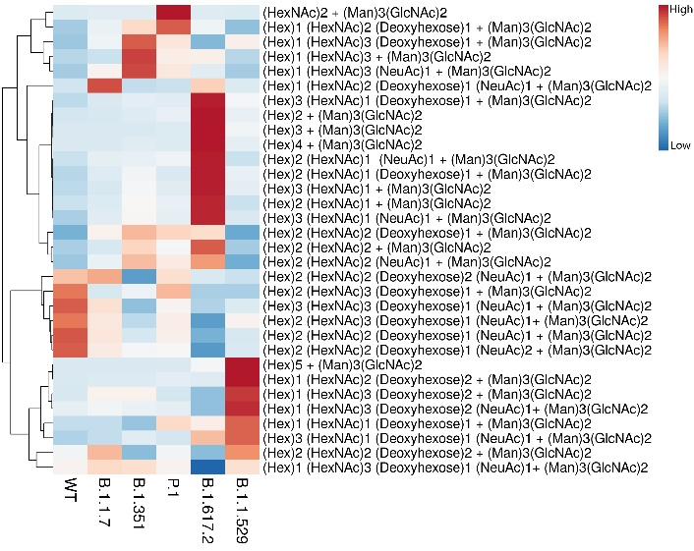
Figure S 27: PCA and Heat map comparison of N-glycans at site N74 and N122 of variants.

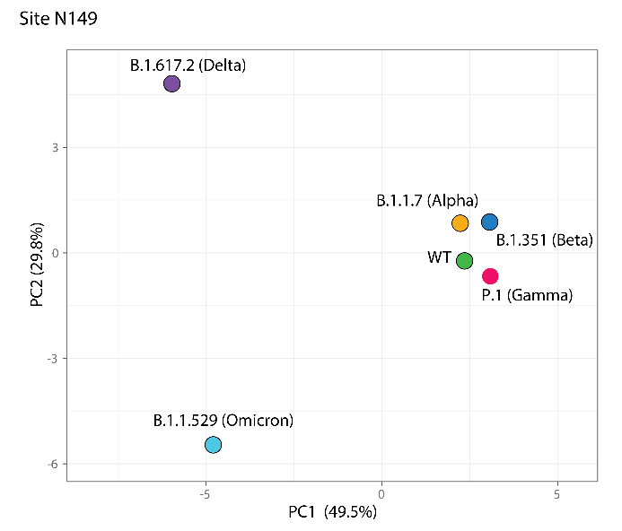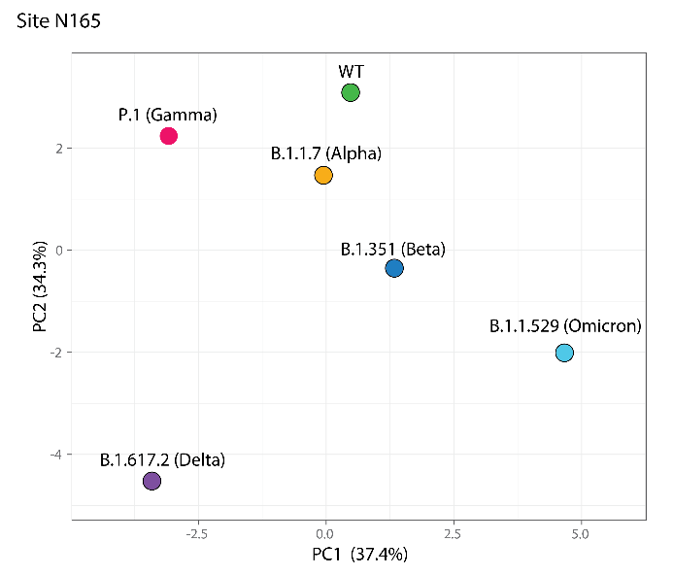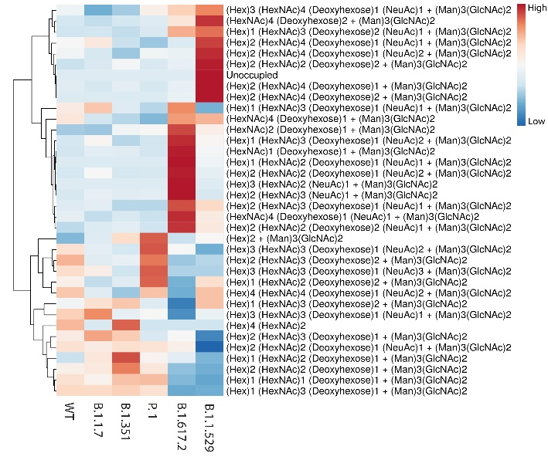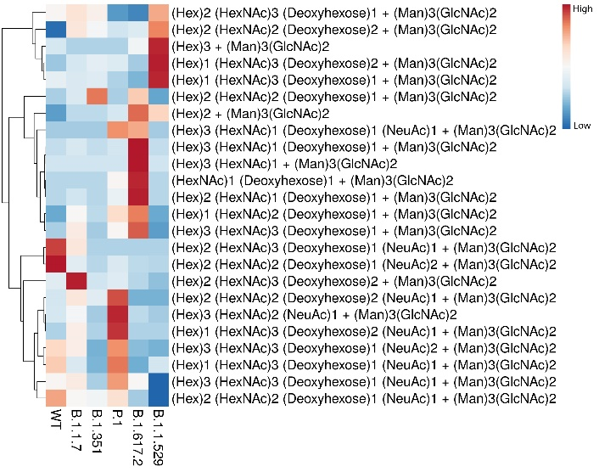
Figure S 28: PCA and Heat map comparison of N-glycans at site N149 and N165 of variants.

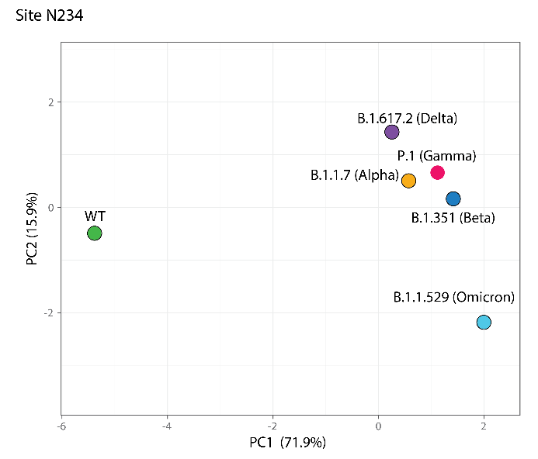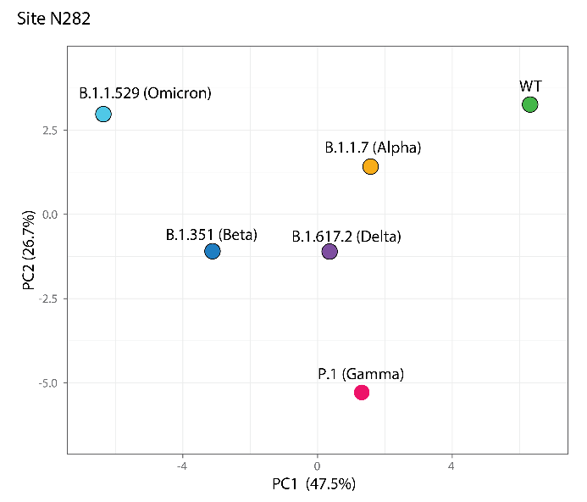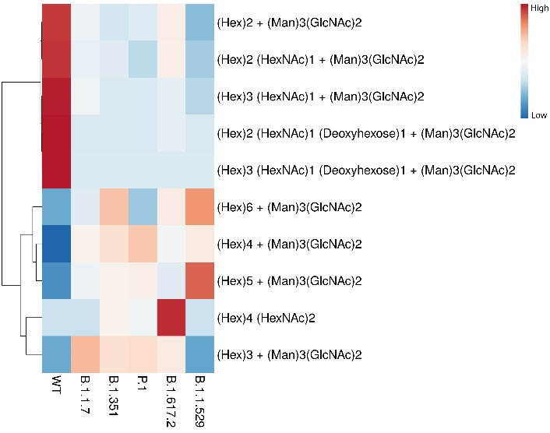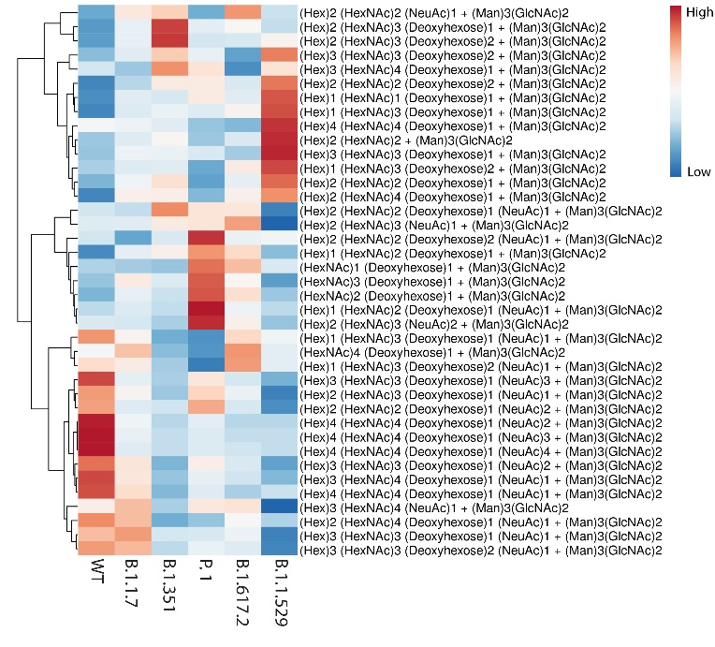
Figure S 29: PCA and Heat map comparison of N-glycans at site N234 and N282 of variants.

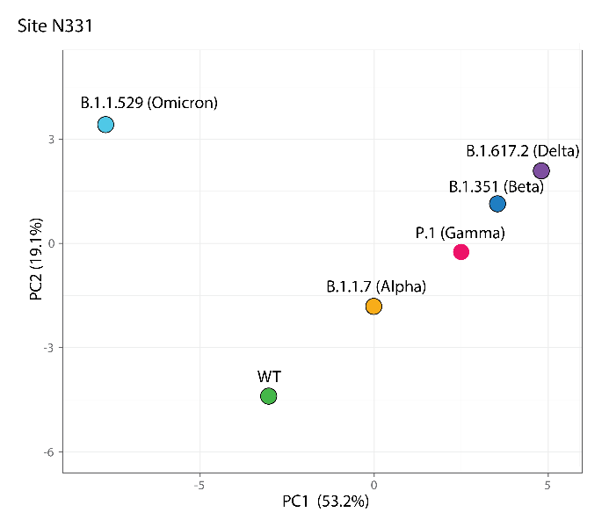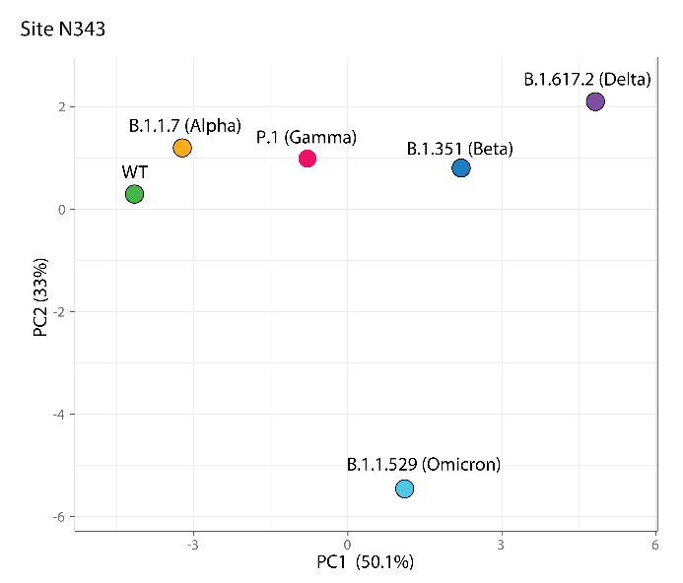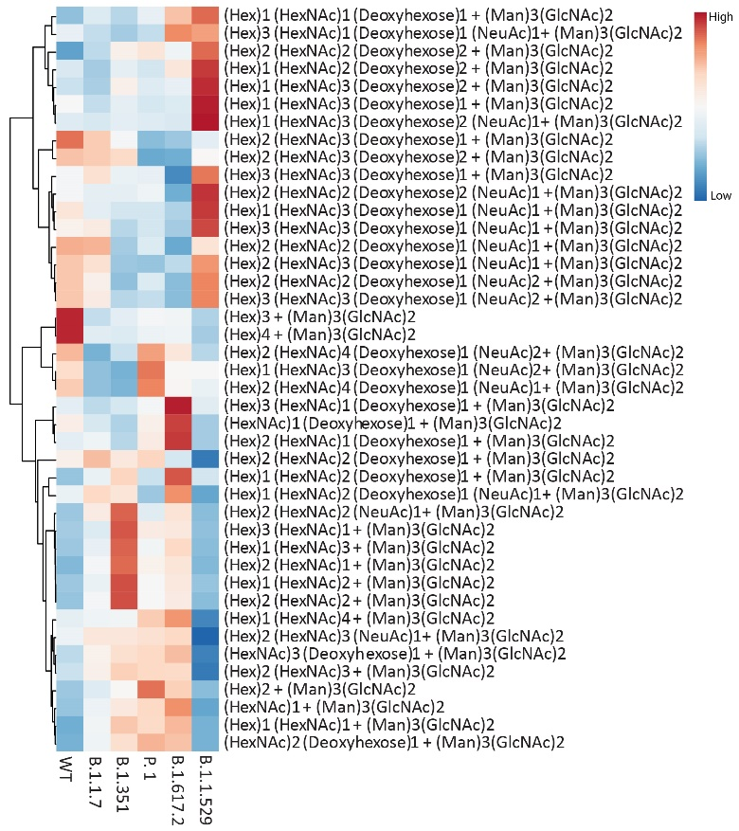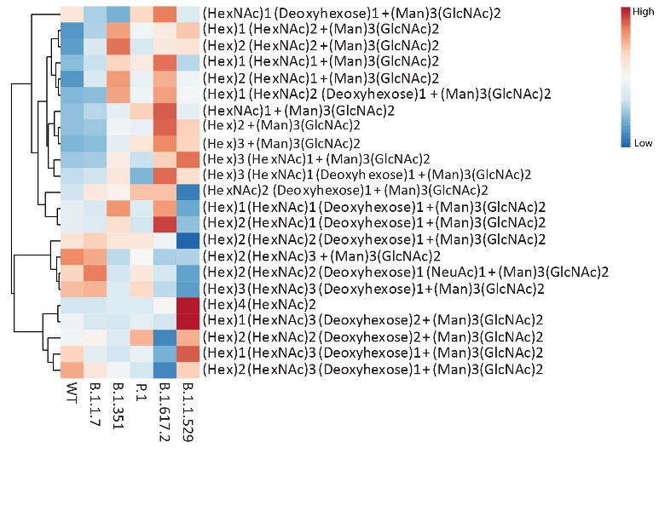
Figure S 30: PCA and Heat map comparison of N-glycans at site N331 and N343 of variants.

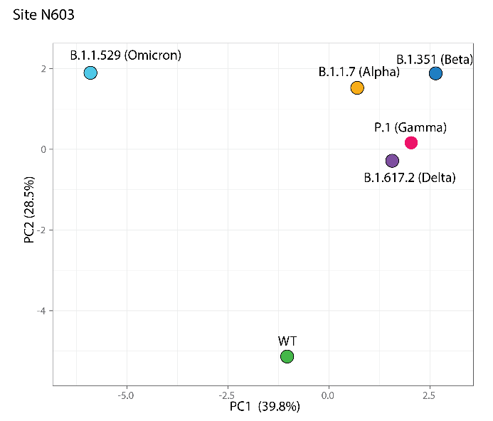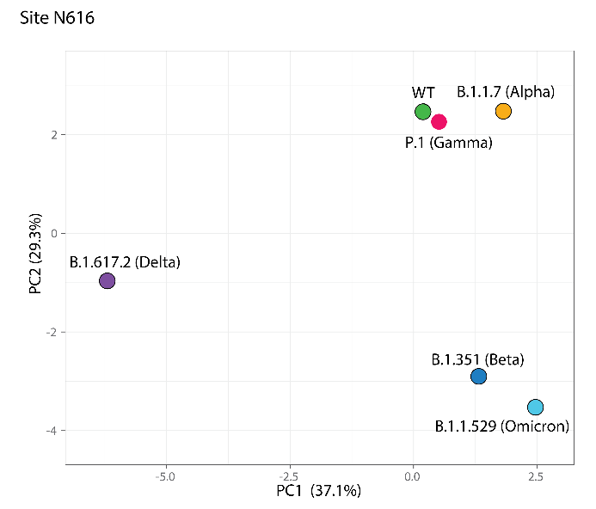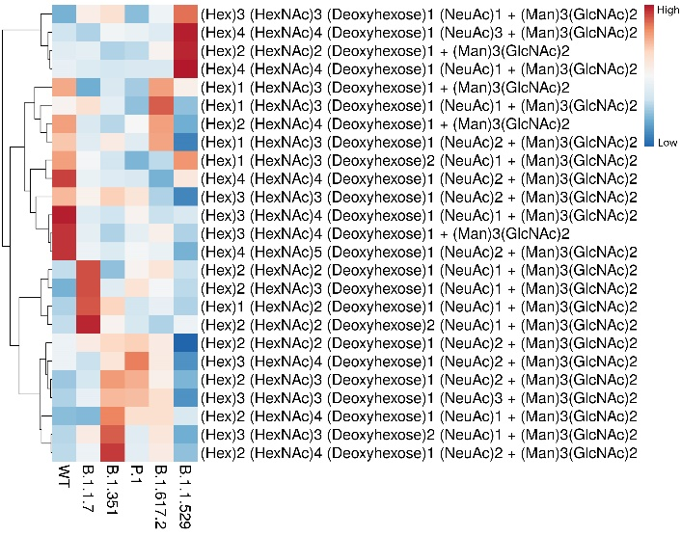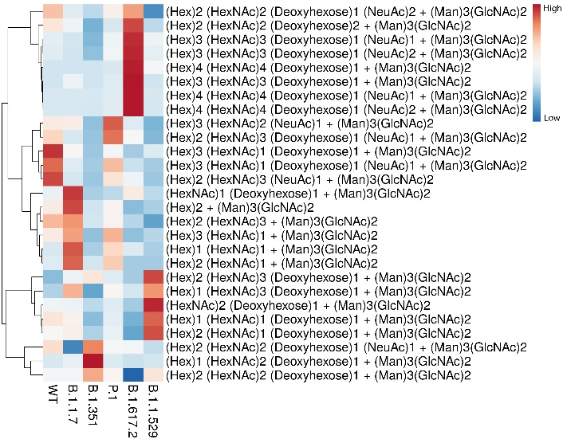
Figure S 31: PCA and Heat map comparison of N-glycans at site N603 and N616 of variants.

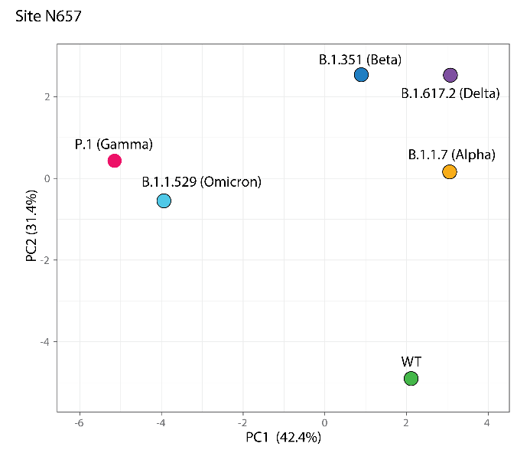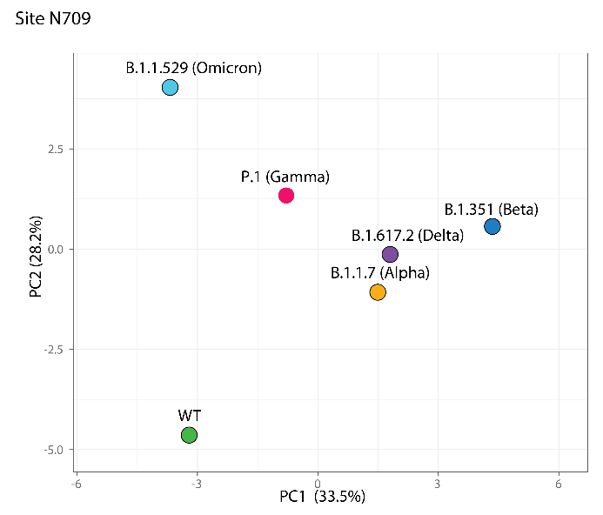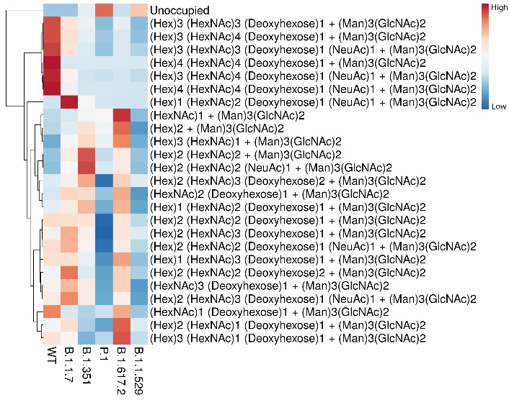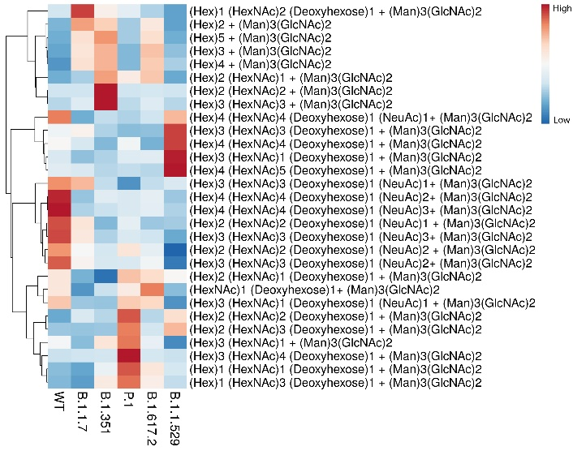
Figure S 32: PCA and Heat map comparison of N-glycans at site N657 and N709 of variants.

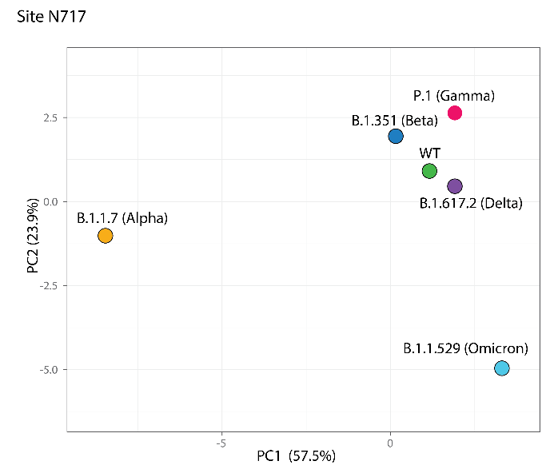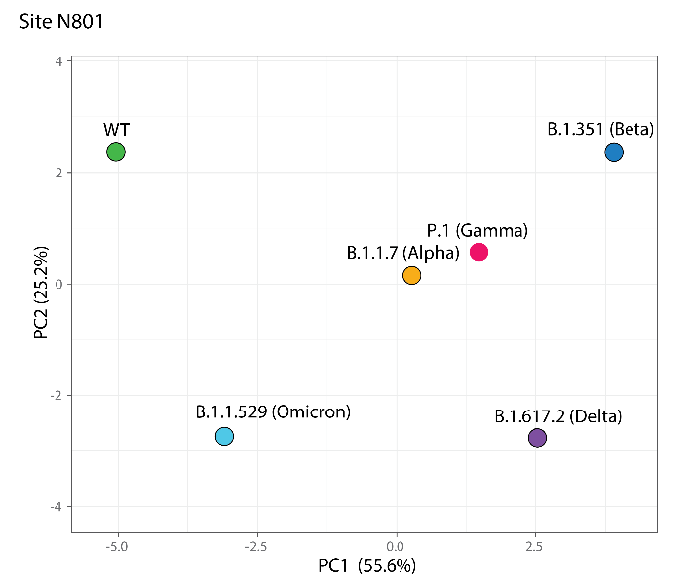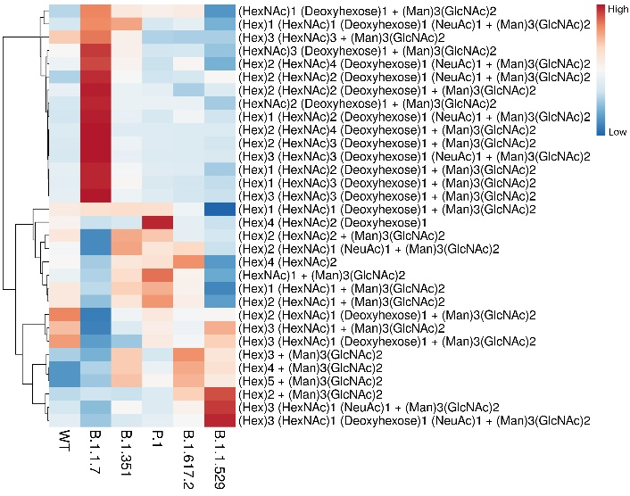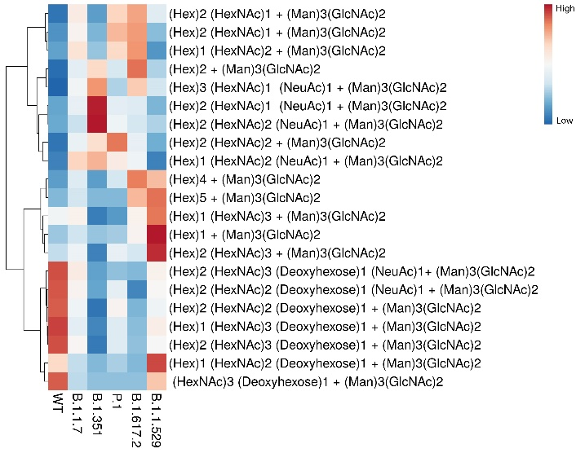
Figure S 33: PCA and Heat map comparison of N-glycans at site N717 and N801 of variants.

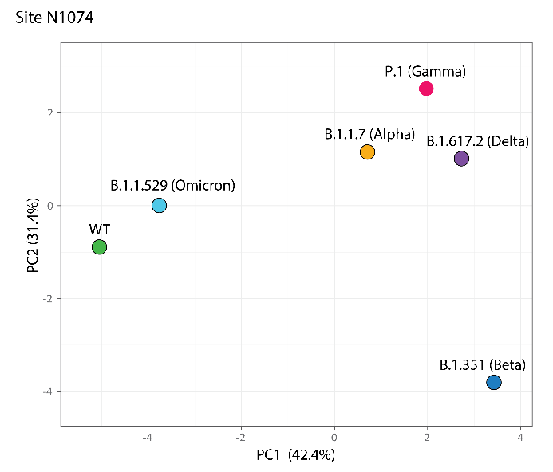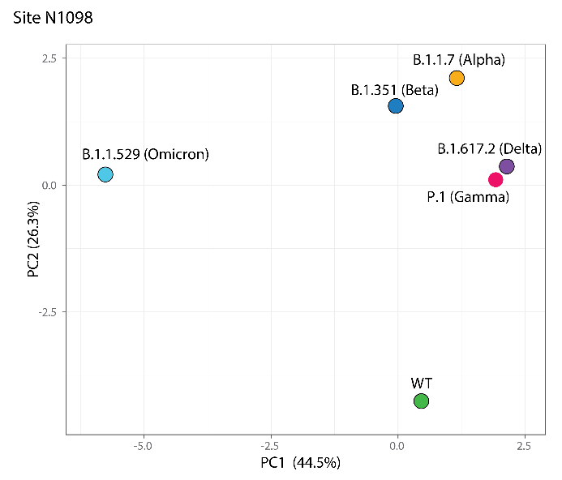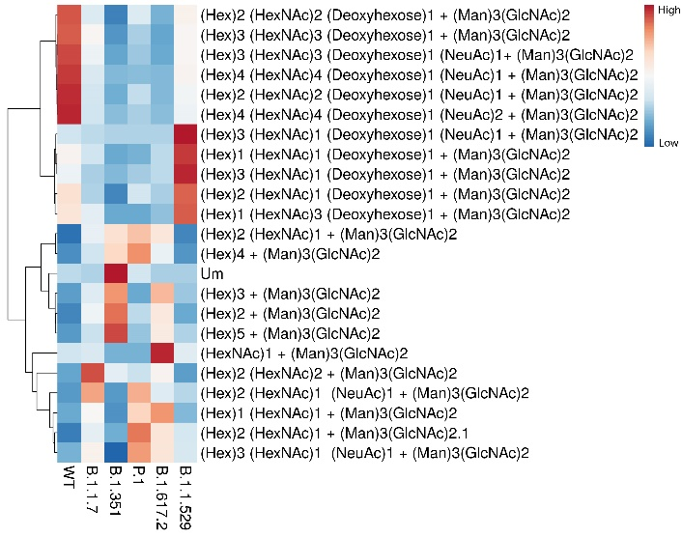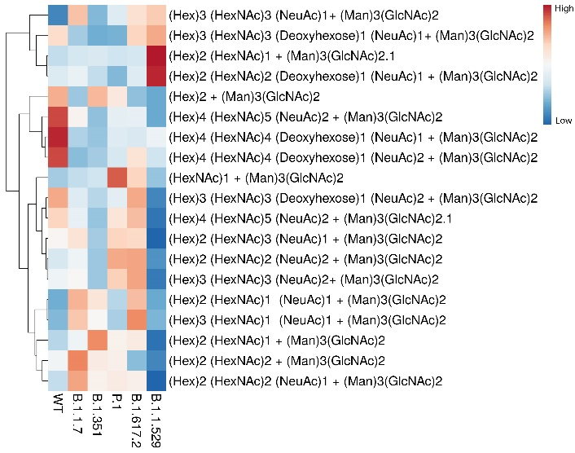
Figure S 34: PCA and Heat map comparison of N-glycans at site N1074 and N1098 of variants.

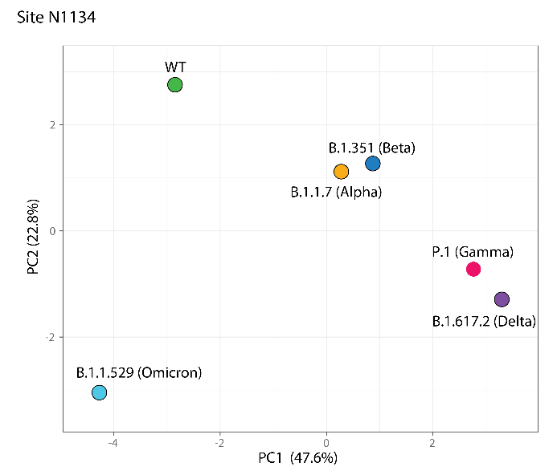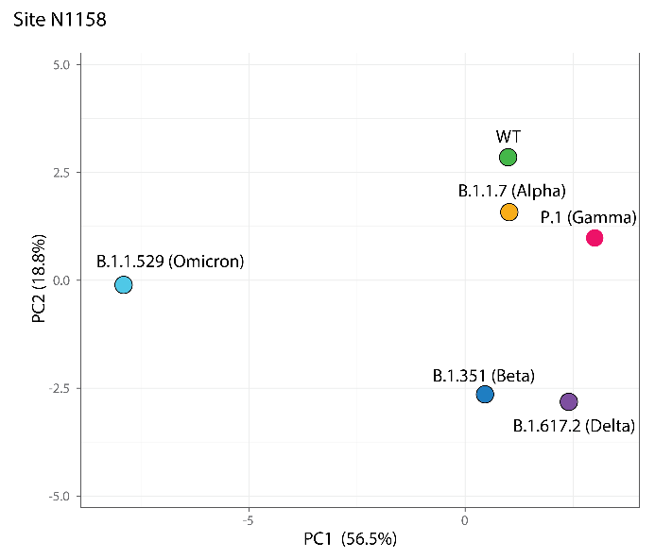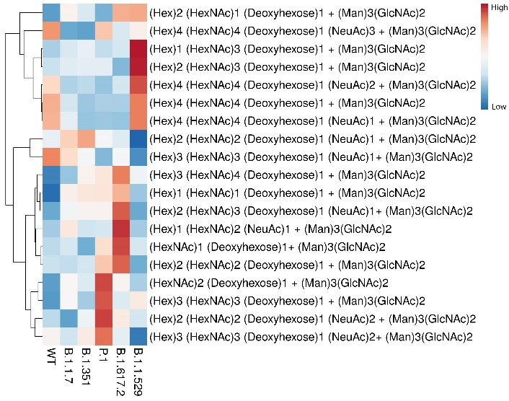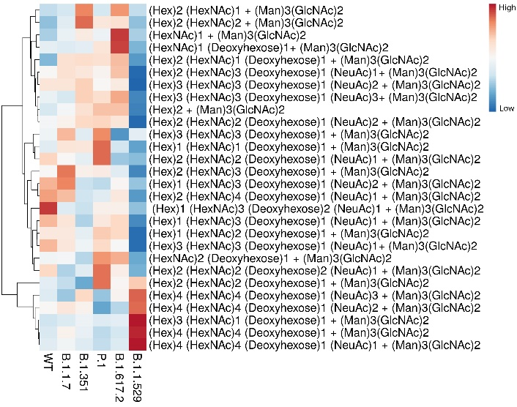
Figure S 35: PCA and Heat map comparison of N-glycans at site N1134 and N1158 of variants.

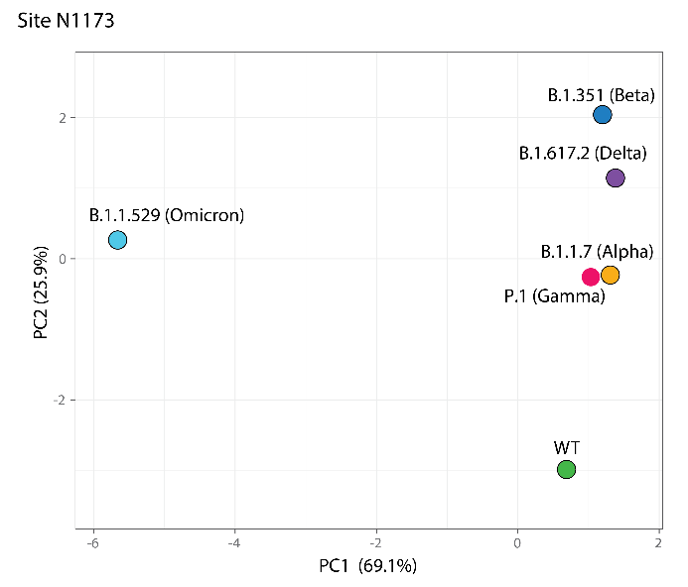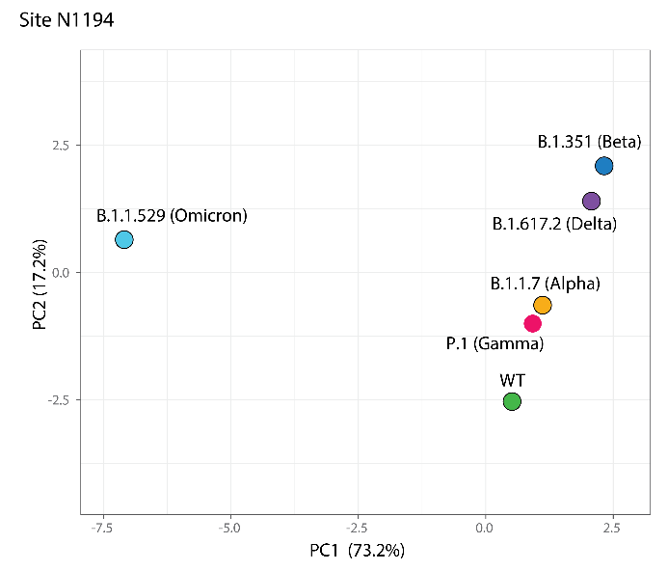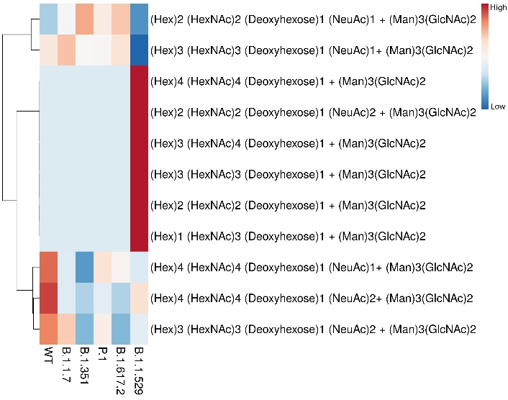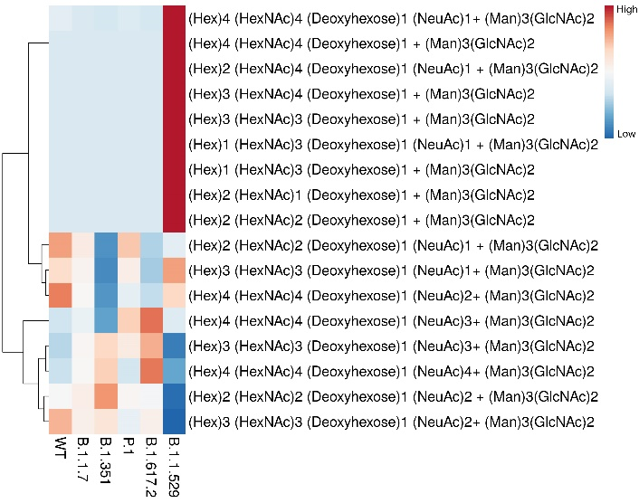
Figure S 36: PCA and Heat map comparison of N-glycans at site N1173 and N1194 of variants.

Figure S 37: Distribution of N-glycan types across the variants based on N-glycomics results. Data was collected in duplicate, and error bars represent the standard deviation.

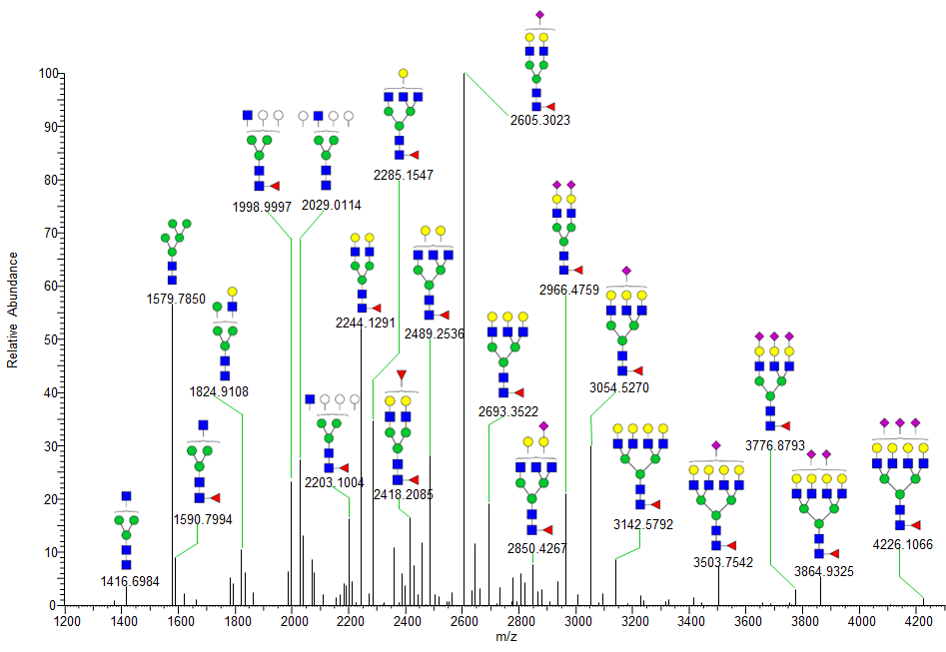
Figure S 38: Deconvoluted ESI-MS spectrum of permethylated N-glycans released from WT (Wuhan-Hu-1) spike protein.
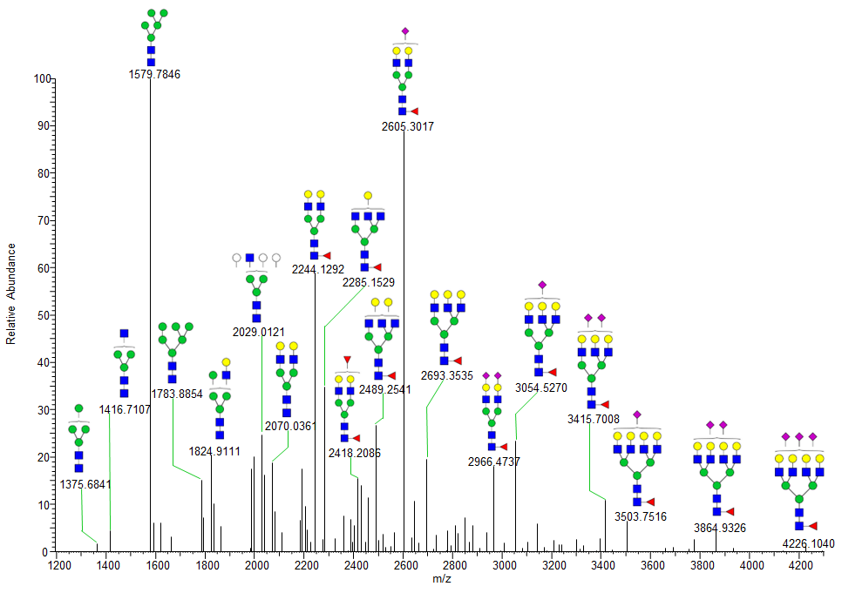
Figure S 39: Deconvoluted ESI-MS spectrum of permethylated N-glycans released from alpha (B.1.1.7) variant spike protein.
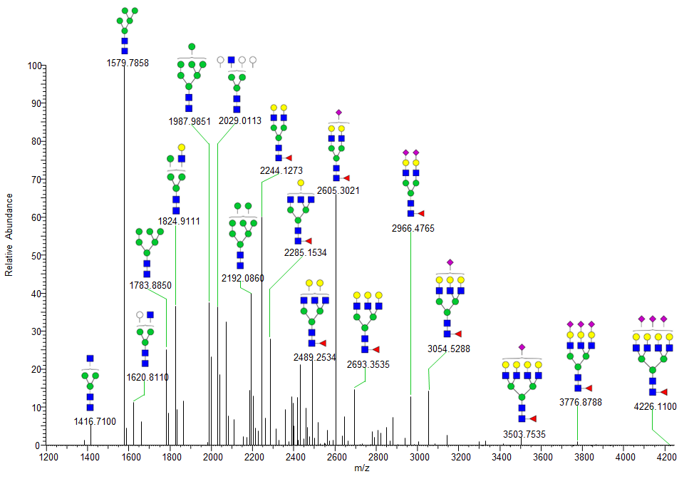
Figure S 40: Deconvoluted ESI-MS spectrum of permethylated N-glycans released from beta (B.1.351) variant spike protein.
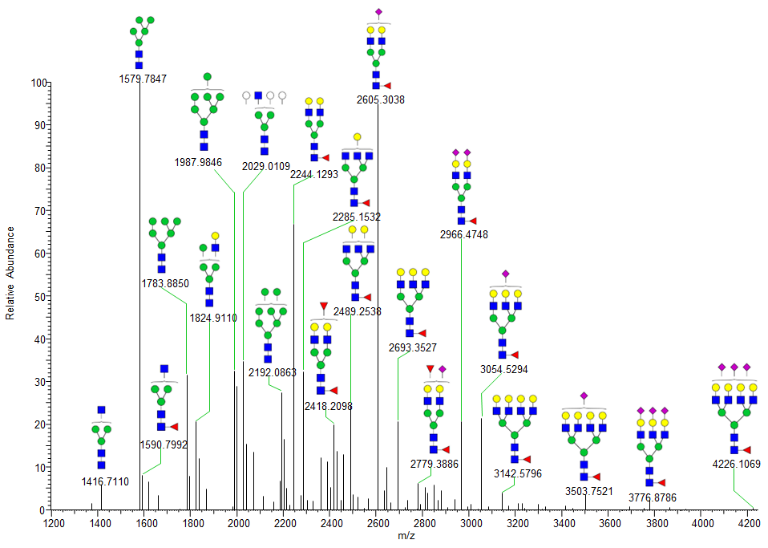
Figure S 41: Deconvoluted ESI-MS spectrum of permethylated N-glycans released from gamma (P.1) variant spike protein.

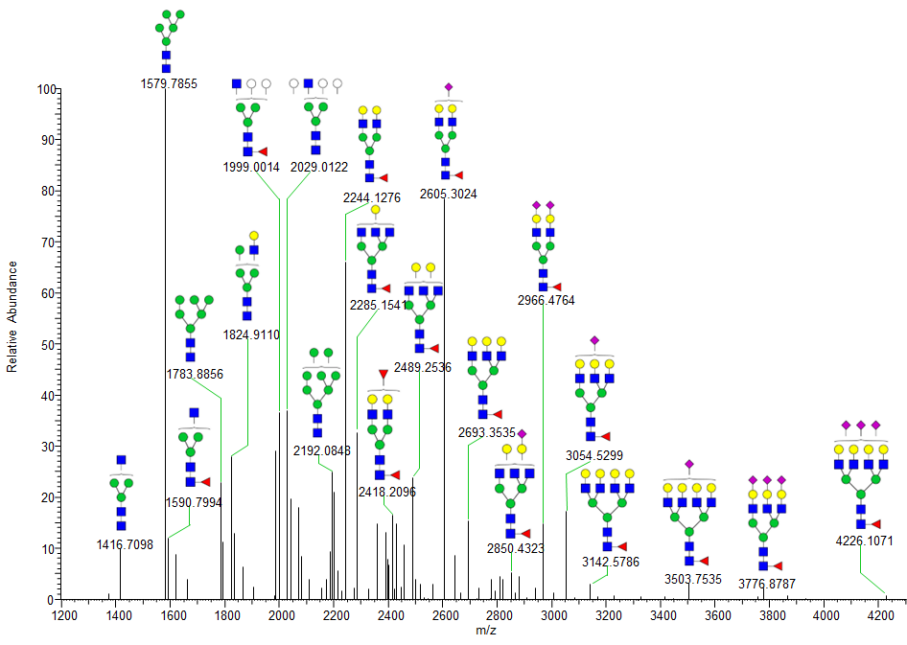
Figure S 42: Deconvoluted ESI-MS spectrum of permethylated N-glycans released from delta (B.1.617.2) variant spike protein.
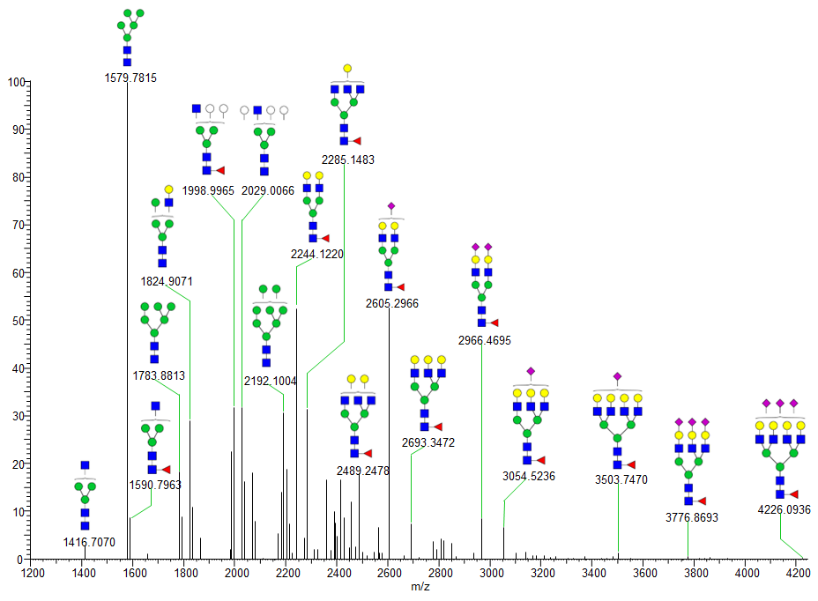
Figure S 43: Deconvoluted ESI-MS spectrum of permethylated N-glycans released from omicron (B.1.1.529) variant spike protein.
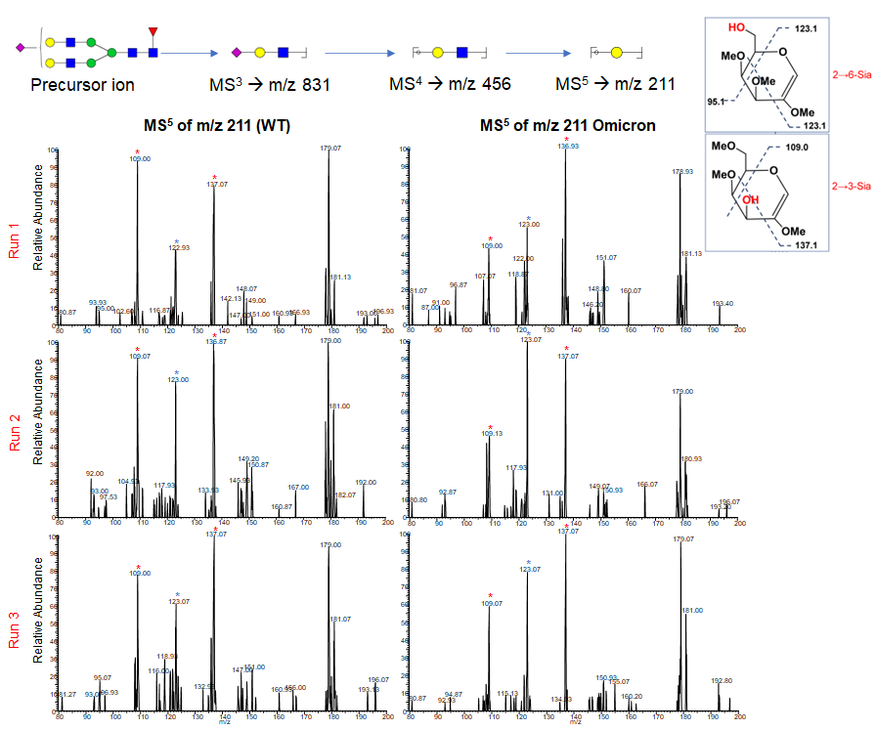
Figure S 44: Sialic acid linkage comparison on N-glycans released from Wuhan-Hu-1 (WT) SARS-CoV-2 and Omicron by ESI-MS^{n} of permethylated glycans (M+Li) showed the presence of both 2,3 and 2,6 linked sialic acid in both WT and Omicron but slightly increased levels of 2,6 linked sialic acid in Omicron variant. Fragment ions at m/z 109 (*) and 137 (*) are diagnostic for 2,3 linkage. Fragment ion at m/z 123 (*) is diagnostic for 2,6 linkage.
Table S1: Sialic linkage observed across the N-glycans released from spike protein of variants – determined by ESI-MSn
Structure (Precursor) | WT | B.1.1.7 | B.1.351 | P.1 | B.1.617.2 | B.1.1.529
2390 (m/z 796, z=3) | Not detected | Not detected | Not detected | Not detected | Not detected | α2,3 > α2,6
2431 (m/z 809, z=3) | α2,3 > α2,6 | Not detected | α2,3 > α2,6 | α2,3 > α2,6 | α2,3 > α2,6 | α2,3 = α2,6
2605 (m/z 867, z=3) | α2,3 > α2,6 | α2,3 > α2,6 | α2,3 > α2,6 | α2,3 > α2,6 | α2,3 > α2,6 | α2,3 = α2,6
2646 (m/z 881, z=3) | Not detected | α2,3 > α2,6 | Not detected | Not detected | Not detected | Not detected
2779 (m/z 925, z=3) | Not detected | Not detected | Not detected | Not detected | Not detected | α2,3 > α2,6
2880 (m/z 959, z=3) | Not detected | Not detected | α2,3 > α2,6 | Not detected | Not detected | Not detected
2966 (m/z 988, z=3) | α2,3 > α2,6 | α2,3 > α2,6 | α2,3 > α2,6 | α2,3 > α2,6 | α2,3 = α2,6 | α2,3 = α2,6
3054 (m/z 1017, z=3) | α2,3 > α2,6 | α2,3 > α2,6 | α2,3 > α2,6 | α2,3 = α2,6 | α2,3 > α2,6 | Not detected
3415 (m/z 1137, z=3) | α2,3 = α2,6 | α2,3 > α2,6 | Not detected | α2,3 > α2,6 | α2,3 > α2,6 | Not detected
Table S2. LC solvent gradient used for glycoproteomics data. Solvent A is 0.1% formic acid, and solvent B is 80% acetonitrile with 0.1% formic acid.
Time | Flow (uL/ min) | %B | Curve
0.00 | 0.300 | 4.0 | 5
3.00 | 0.300 | 4.0 | 5
155.00 | 0.300 | 40.0 | 5
156.00 | 0.300 | 90.0 | 5
167.00 | 0.300 | 90.0 | 5
167.50 | 0.300 | 4.0 | 5
180.00 | 0.300 | 4.0 | 5

Table S3. LC solvent gradient used for glycomics data. Solvent A is 2% acetonitrile and 0.1% formic acid with 1 mM NaOAc, and solvent B is 80% acetonitrile with 0.1% formic acid and 1 mM NaOAc.
Time | Flow (uL/ min) | %B | Curve
0.00 | 0.300 | 5.0 | 5
3.00 | 0.300 | 40.0 | 5
30.00 | 0.300 | 60.0 | 5
50.00 | 0.300 | 85.0 | 5
60.00 | 0.300 | 99.0 | 5
65.00 | 0.300 | 99.0 | 5
68.00 | 0.300 | 20.0 | 5
72.00 | 0.300 | 5.0 | 5

