APPENDIX 1 – DASS 21 SCORING
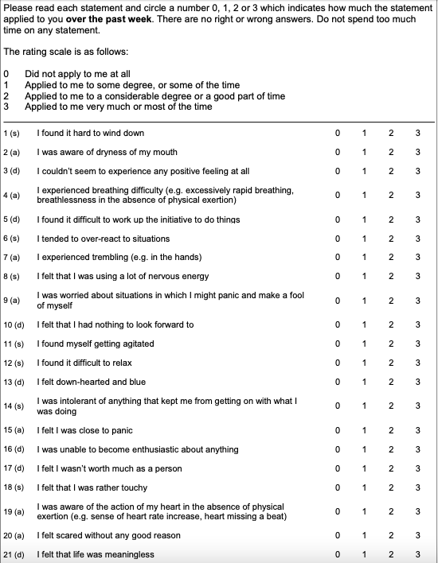

APPENDIX 2 – EPIDEMIOLOGICAL QUESTIONNAIRE - STUDENTS
