Annex – Supplementary material
Annex 1. Evolution of granted credits to the overall agricultural (blue) and cattle (orange) sectors in Colombia between 2011 and 2021

Annex 2. Credit behavior according to source 2011-2020 (in USD). The closing US dollar exchange rate for the years 2011-2020 was used [57]
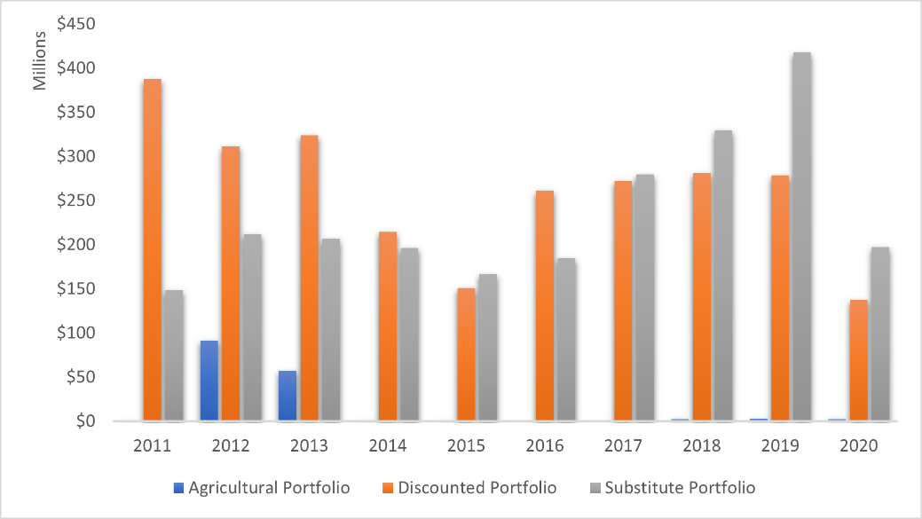

Annex 3. Summary of the descriptive statistics for the dependent variable cattle production
Dependent variable: Cattle production (herd size)
Variable |  | Mean | Std.Dev. | Min | Max | Obs
Cattle herd size (heads) | overall | 734109 | 715503 | 624 | 3179947 | N = 330
 | between |  | 689703.8 | 946.2 | 2756484 | n = 33
 | within |  | 221959.6 | -747518.2 | 2441752 | T = 10
Number of agricultural credits | overall | 10274.54 | 11761.19 | 3 | 56585 | N = 330
 | between |  | 11128.62 | 11.7 | 34356.7 | n = 33
 | within |  | 4226.966 | -1655.658 | 34795.34 | T = 10
Total credit value agricultural credits | overall | 361788.6 | 637244 | 54 | 4664243 | N = 330
 | between |  | 508127.8 | 389.3 | 1943949 | n = 33
 | within |  | 393635.7 | -1296224 | 3082082 | T = 10
Number of cattle credits | overall | 806.6711 | 1530.955 | 1 | 9150 | N = 330
 | between |  | 1453.524 | 1 | 5602.5 | n = 33
 | within |  | 446.4281 | -1237.829 | 4354.171 | T = 10
Total credit value cattle credits | overall | 37411.65 | 87818.4 | 0 | 607620 | N = 330
 | between |  | 68675.95 | 0 | 286627.9 | n = 33
 | within |  | 55899.05 | -164701.7 | 411107.3 | T = 10
Coca (hectares) | overall | 2927.536 | 7216.498 | 0 | 45735 | N = 330
 | between |  | 5598.307 | 0 | 26015.7 | n = 33
 | within |  | 4646.951 | -23088.16 | 32928.54 | T = 10
Agricultural land use | overall | 92755.75 | 101685.6 | 0 | 502270 | N = 330
 | between |  | 86651.19 | 0 | 307897 | n = 33
 | within |  | 55108.44 | -215141.2 | 300544.6 | T = 10
Cattle land use | overall | 928954.8 | 1147273 | 0 | 4870717 | N = 330
 | between |  | 980871.7 | 0 | 4225953 | n = 33
 | within |  | 616802.2 | -3296998 | 3776125 | T = 10
Agricultural  Bank of Colombia offices (#) | overall | 23.93939 | 23.40984 | 1 | 103 | N = 330
 | between |  | 22.65869 | 1 | 103 | n = 33
 | within |  | 6.974901 | -41.76061 | 70.73939 | T = 10
% Rurality | overall | 0.3349811 | 0.1592033 | 0.0020974 | 0.7891356 | N = 330
 | between |  | 0.1592333 | 0.0021471 | 0.6598116 | n = 33
 | within |  | 0.0261541 | 0.1758022 | 0.5240153 | T = 10
Variable |  | Mean | Std.Dev. | Min | Max | Obs
Note: Overall represents the total data set, between represents between units (departments), and within represents over time (years). Source: own elaboration
Annex 4. Summary of the descriptive statistics for the dependent variable annual deforestation rate
Dependent variable: Annual deforestation rate
Variable |  | Mean | Std.Dev. | Min | Max | Obs
Annual deforestation rate | overall | -0.381435 | 0.3691843 | -1.77 | 0 | N = 231
 | between |  | 0.3051749 | -1.154286 | -0.0171429 | n = 33
 | within |  | 0.208621 | -1.172864 | 0.5371365 | T = 7
Cattle herd size (heads) | overall | 710230.3 | 690769.6 | 735 | 3038779 | N = 231
 | between |  | 629207.6 | 935 | 2665661 | n = 33
 | within |  | 302635.7 | -421491.8 | 2148108 | T = 7
Agricultural land use | overall | 99899.81 | 97888.42 | 0 | 502270 | N = 231
 | between |  | 92740.11 | 0 | 327509.1 | n = 33
 | within |  | 34724.37 | -47236.33 | 299674.7 | T = 7
Cattle land use | overall | 1031991 | 1165220 | 0 | 4870717 | N = 231
 | between |  | 1092809 | 0 | 4701065 | n = 33
 | within |  | 441204.7 | -864969.7 | 3772876 | T = 7
Number of agricultural credits | overall | 9474.827 | 10688.52 | 3 | 42261 | N = 231
 | between |  | 10292.63 | 9.428571 | 31655.57 | n = 33
 | within |  | 3327.128 | 476.2554 | 21335.26 | T = 7
Total credit value agricultural credits | overall | 305007.3 | 467088.6 | 54 | 2979711 | N = 231
 | between |  | 410637 | 251.7143 | 1592376 | n = 33
 | within |  | 232266.9 | -663557 | 1848578 | T = 7
Number of cattle credits | overall | 754.3714 | 1409.381 | 1 | 6022 | N = 231
 | between |  | 1367.306 | 1 | 5208.286 | n = 33
 | within |  | 284.3644 | -864.4857 | 2065.943 | T = 7
Total credit value cattle credits | overall | 29901.82 | 64806.24 | 0 | 431717 | N = 231
 | between |  | 54475.97 | 0 | 258155.9 | n = 33
 | within |  | 36188.86 | -115755 | 304617.5 | T = 7
% Rurality | overall | 0.3334331 | 0.1564265 | 0.0021193 | 0.6933935 | N = 231
 | between |  | 0.1575011 | 0.0021526 | 0.6556402 | n = 33
 | within |  | 0.0176004 | 0.2279433 | 0.4509327 | T = 7
Coca (hectares) | overall | 3237.433 | 7450.743 | 0 | 45735 | N = 231
 | between |  | 6512.503 | 0 | 28745 | n = 33
 | within |  | 3769.256 | -14774.57 | 20263.43 | T = 7
Note: Overall represents the total data set, between represents between units (departments), and within represents over time (years). Source: own elaboration
Annex 5. Table of correlations
Independent variables | Cattle herd size (heads) | Independent variables | Annual deforestation rate
Cattle herd size (heads) | 1 | Annual deforestation rate | 1
Number of agricultural credits | 0.2897 | Cattle herd size (heads) | -0.3168
Total credit value agricultural credits | 0.2323 | Agricultural land use | -0.0515
Number of cattle credits | 0.162 | Cattle land use | -0.2164
Total credit value cattle credits | 0.285 | Number of agricultural credits | 0.0804
Coca (hectares) | -0.0219 | Total credit value agricultural credits | 0.0792
Agricultural land use | 0.4348 | Number of cattle credits | 0.1151
Cattle land use | 0.5575 | Total credit value cattle credits | 0.0058
Agricultural  Bank of Colombia offices (#) | 0.4926 | % Rurality | 0.1642
% Rurality | -0.1275 | Coca (hectares) | -0.1392

Annex 6. Estimation of panel data with fixed and random effects, Hausman test for cattle production
Variables | (b)  fixed effects | (B)  random effects | (b-B)  Difference | sqrt(diag(V_b-V_B))  S.E.
Number of agricultural credits | 11.11745 | 13.45947 | -2.34203 | 0.7015996
Total credit value agricultural credits | -0.1041952 | -0.1159693 | 0.0117741 | .
Number of cattle credits | 12.63566 | -11.81668 | 24.45235 | 15.05666
Total credit value cattle credits | 1.000176 | 1.204693 | -0.2045175 | .
Coca (hectares) | 1.783118 | -0.7765618 | 2.55968 | .
Agricultural land use | 0.2565308 | 0.2725283 | -0.0159976 | .
Cattle land use | -0.0481199 | 0.0014753 | -0.0495952 | .
Agricultural  Bank of Colombia offices (#) | 749.8411 | 3961.136 | -3211.295 | 715.6141
% Rurality | 1730357 | -254023.2 | 1984380 | 690051.9
 | b = consistent under Ho and Ha; obtained from xtreg
 | B = inconsistent under Ha, efficient under Ho; obtained from xtreg
 | Test: Ho: difference in coefficients not systematic
 | chi2(2) = (b-B)'[(V_b-V_B)^(-1)](b-B)
 | = | 21.46
 | Prob>chi2 = 0.0000
Annex 7. Estimation of panel data with fixed and random effects, Hausman test
Variables | (b)  fixed effects | (B)  random effects | (b-B)  Difference | sqrt(diag(V_b-V_B))  S.E.
Herd size (cattle heads) | -2.35E-08 | -9.33E-08 | 6.98E-08 | 3.25E-08
Agricultural land use | -4.12E-08 | 1.04E-07 | -1.46E-07 | 0.000000335
Cattle land use | -1.55E-08 | -5.21E-08 | 3.65E-08 | 2.59E-08
Number of agricultural credits | -3.95E-07 | -8.45E-07 | 0.00000045 | 0.00000456
Total credit value agricultural credits | 6.04E-08 | 1.44E-07 | -8.31E-08 | 6.43E-08
Number of cattle credits | 0.0000302 | 0.0000452 | -0.000015 | 0.0000526
Total credit value cattle credits | -4.55E-07 | -5.61E-07 | 1.06E-07 | 0.00000028
% Rurality | -1.798868 | 0.5812401 | -2.380108 | 1.631719
Coca (hectares) | -0.00000639 | -0.00000847 | 0.00000208 | 0.00000342
 | b = consistent under Ho and Ha; obtained from xtreg
 | B = inconsistent under Ha, efficient under Ho; obtained from xtreg
 | Test: Ho: difference in coefficients not systematic
 | chi2(2) = (b-B)'[(V_b-V_B)^(-1)](b-B)
 |  | = | 2.13
 |  | Prob>chi2 | 0.1447
Annex 8. Moran scatterplot for cattle production
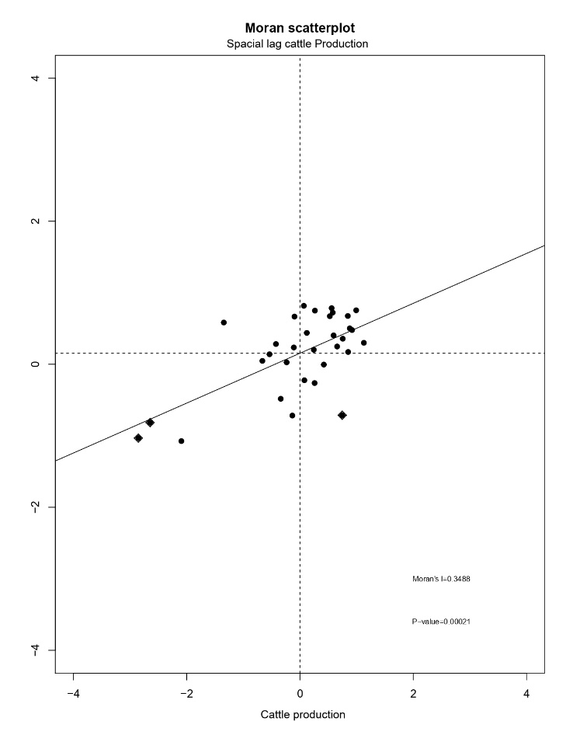
Annex 9. Moran map of cattle production
