A
Supplementary Figure 1
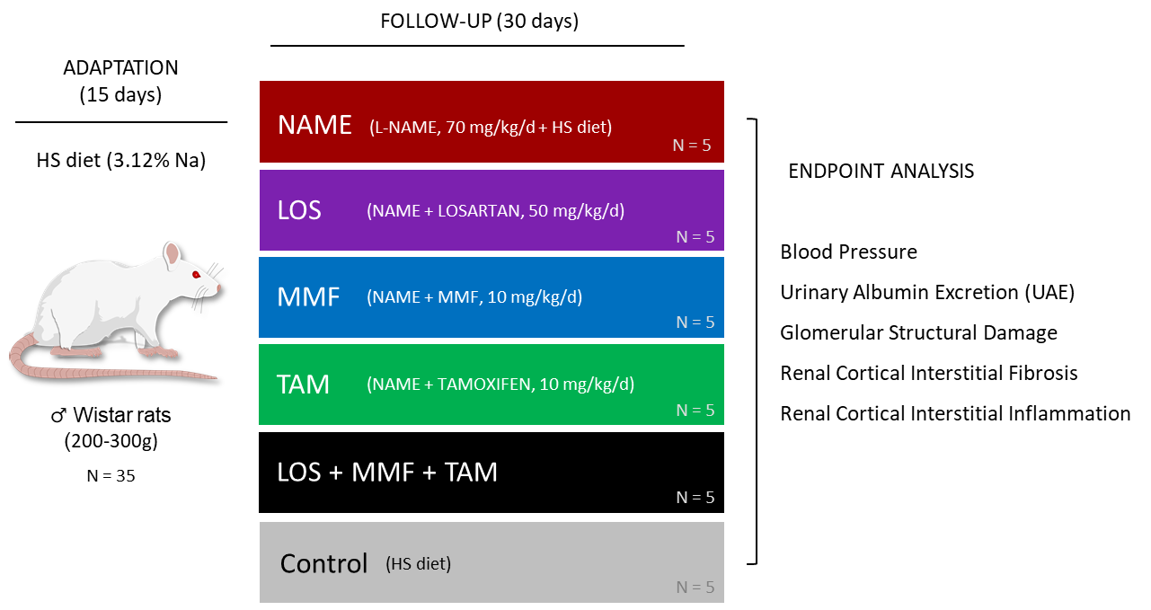

B
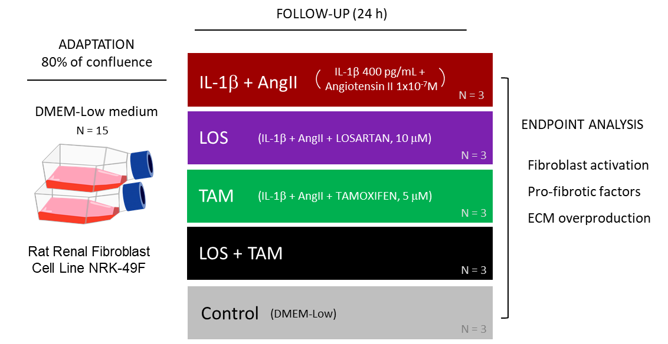

Supplementary Figure 1. Illustrative flow-chart depicting the in vivo (A) and in vitro (B) study protocols

