Trophic ecology of Octopus vulgaris paralarvae along the Iberian Canary current eastern boundary upwelling system

Supplementary Material

The analyses shown in this study were done based on the filtered reads that are available in the excel supporting file named “Octopus vulgaris filtered reads”

Table S1. Summary of the prey reads detected in Octopus vulgaris paralarvae collected in three sites along the ICC upwelling system (Ría de Vigo, Northwest Iberian Peninsula and Cape Ghir, Morocco). The details of the samples where the paralarvae were collected are shown at the top table: location (C, coast; C~O, samples collected in the upwelling filament and its periphery; and O, ocean); strata (S, surface; M, 100 m; DSL, Deep scattering layer ~ 500 m); Day/Night (D/N); Paralarvae, that indicates the number of paralarvae analysed from each sample, with superscripts showing the number of paralarvae where no prey DNA was detected; Sucker and Prey count, indicates the range of suckers present in the paralarvae as well as the total prey detected in the different groups. Within the prey table, the number of detections on different O. vulgaris paralarvae is shown (count), together with the total number of reads detected (reads) and their homology with public sequences (%). Colours represent prey detected in the coastal area (green), in the ocean (blue) or in both environments (light red).
Table S2. Relative abundance of the zooplankton groups at the stations where the diet of Octopus vulgaris paralarvae was analysed. Abbreviations as in Suppl. table S1. Station # as shown in Fig. 7.

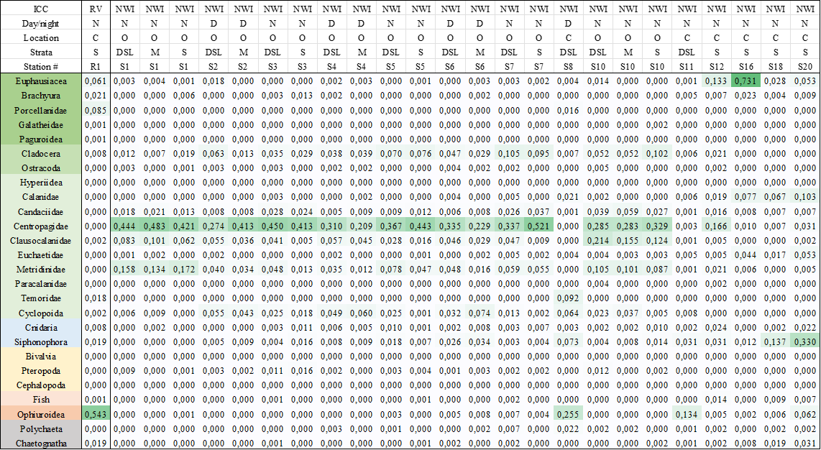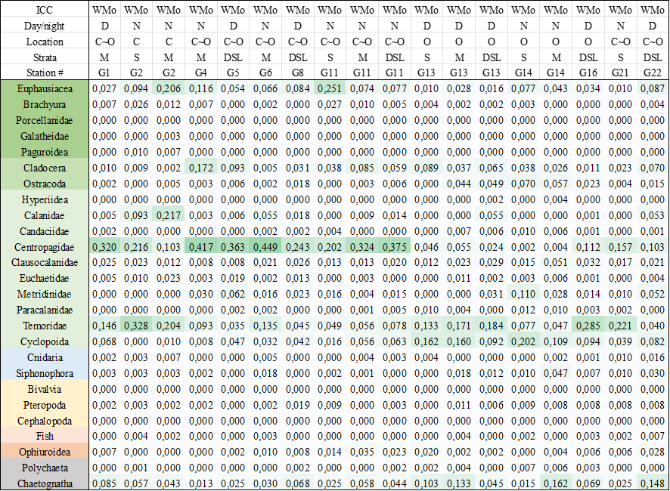
Table S3. Linear indices of food selection obtained for the different prey groups detected in Octopus vulgaris paralarvae collected in three sites along the ICC upwelling system: Ría de Vigo (RV), Northwest Iberian Peninsula (NWI) and West Morocco (WMo). The paralarvae are ordered by location (Loc: C, coast; C~O, samples collected in the upwelling filament and its periphery; and O, ocean) and sucker number (Suc). Prey groups are abbreviated as follows: Euph, euphausiids; Brac, brachyura/crab larvae; Porc, porcellanid larvae; Gala, galatheid larvae; Pagu, pagurid larvae (hermit crabs); Clad, cladocerans; Ostr, ostracods; Hype, Hyperiid amphipods; Cala, Calanidae; Cent, Centropagidae; Clau, Clausocalanidae; Euch, Euchaetidae; Metr, Metrididae; Para, Paracalanidae; Temo, Temoridae; Cycl, Cyclopoida; Cnid, cnidarians; Siph, siphonophores; Biva, bivalves; Pter; pteropods; Ceph, cephalopods; Fish, fish larvae and eggs; Ophi, ophiuroids; Poly, polychaetes; Chae, chaetognaths.
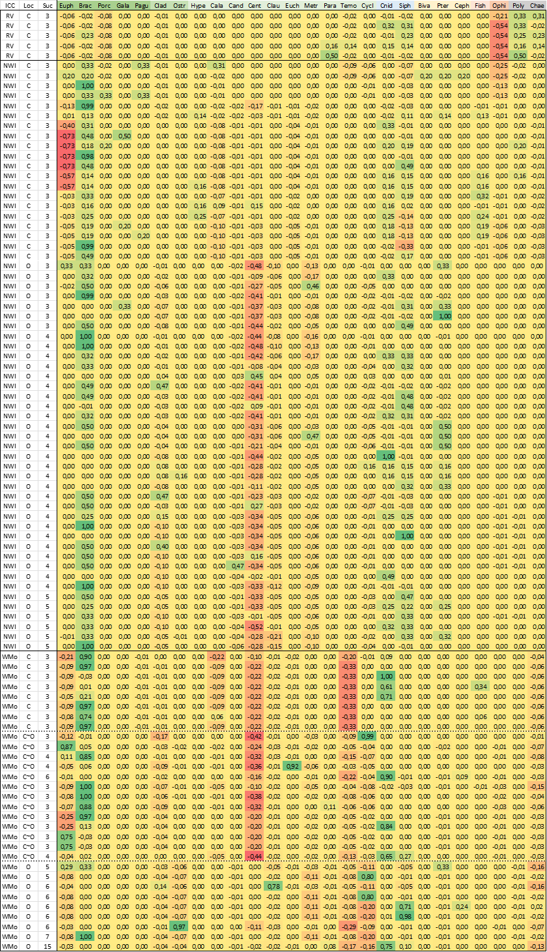
Table S4. Primers used in this study. In italics: Illumina adapter sequence; I: inosine modification; bold: 8 bp index sequence for multiplexing

Primer name | Primer sequence (5’-to-3’)
NICO-F | TCGTCGGCAGCGTCAGATGTGTATAAGAGACAGGGIACIGGITGAACWGTITAYCCHCC
NICO-R | GTCTCGTGGGCTCGGAGATGTGTATAAGAGACAGTAIACTTCIGGRTGICCRAARAAYCA
Amplicon_IDX-N701_1 | CAAGCAGAAGACGGCATACGAGATTCGCCTTAGTCTCGTGGGCTCGG
Amplicon_IDX-N702_2 | CAAGCAGAAGACGGCATACGAGATCTAGTACGGTCTCGTGGGCTCGG
Amplicon_IDX-N703_3 | CAAGCAGAAGACGGCATACGAGATTTCTGCCTGTCTCGTGGGCTCGG
Amplicon_IDX-N704_4 | CAAGCAGAAGACGGCATACGAGATGCTCAGGAGTCTCGTGGGCTCGG
Amplicon_IDX-N705_5 | CAAGCAGAAGACGGCATACGAGATAGGAGTCCGTCTCGTGGGCTCGG
Amplicon_IDX-N706_6 | CAAGCAGAAGACGGCATACGAGATCATGCCTAGTCTCGTGGGCTCGG
Amplicon_IDX-N707_7 | CAAGCAGAAGACGGCATACGAGATGTAGAGAGGTCTCGTGGGCTCGG
Amplicon_IDX-N710_8 | CAAGCAGAAGACGGCATACGAGATCAGCCTCGGTCTCGTGGGCTCGG
Amplicon_IDX-N711_9 | CAAGCAGAAGACGGCATACGAGATTGCCTCTTGTCTCGTGGGCTCGG
Amplicon_IDX-N712_10 | CAAGCAGAAGACGGCATACGAGATTCCTCTACGTCTCGTGGGCTCGG
Amplicon_IDX-N714_11 | CAAGCAGAAGACGGCATACGAGATTCATGAGCGTCTCGTGGGCTCGG
Amplicon_IDX-N715_12 | CAAGCAGAAGACGGCATACGAGATCCTGAGATGTCTCGTGGGCTCGG
Amplicon_IDX-N716_13 | CAAGCAGAAGACGGCATACGAGATTAGCGAGTGTCTCGTGGGCTCGG
Amplicon_IDX-S502_A | AATGATACGGCGACCACCGAGATCTACACCTCTCTATTCGTCGGCAGCGTC
Amplicon_IDX-S503_B | AATGATACGGCGACCACCGAGATCTACACTATCCTCTTCGTCGGCAGCGTC
Amplicon_IDX-S505_C | AATGATACGGCGACCACCGAGATCTACACGTAAGGAGTCGTCGGCAGCGTC
Amplicon_IDX-S506_D | AATGATACGGCGACCACCGAGATCTACACACTGCATATCGTCGGCAGCGTC
Amplicon_IDX-S507_E | AATGATACGGCGACCACCGAGATCTACACAAGGAGTATCGTCGGCAGCGTC
Amplicon_IDX-S508_F | AATGATACGGCGACCACCGAGATCTACACCTAAGCCTTCGTCGGCAGCGTC
Amplicon_IDX-S510_G | AATGATACGGCGACCACCGAGATCTACACCGTCTAATTCGTCGGCAGCGTC
Amplicon_IDX-S511_H | AATGATACGGCGACCACCGAGATCTACACTCTCTCCGTCGTCGGCAGCGTC

