Supplementary Information for

Rising ecosystem water demand exacerbates the lengthening of tropical dry seasons
Hao Xu¹, Xu Lian¹, Ingrid J. Slette^{2,3}, Hui Yang⁴,
Yuan Zhang⁵, Anping Chen², Shilong Piao^{1,6,7,*}

¹Sino-French Institute for Earth System Science, College of Urban and Environmental Sciences, Peking University, Beijing 100871, China.
²Department of Biology, Colorado State University, Fort Collins, CO, 80523, USA.
³Graduate Degree Program in Ecology, Colorado State University, Fort Collins, CO, 80523, USA.
⁴Department of Biogeochemical Integration, Max Planck Institute for Biogeochemistry, 07745 Jena, Germany
⁵Laboratoire des Sciences du Climat et de l’Environnement, CEA CNRS UVSQ, Gif-sur-Yvette 91191, France.
⁶Key Laboratory of Alpine Ecology and Biodiversity, Institute of Tibetan Plateau Research, Chinese Academy of Sciences, Beijing 100085, China.
⁷Center for Excellence in Tibetan Earth Science, Chinese Academy of Sciences, Beijing 100085, China.

Table 1. Precipitation and Evaporation Datasets in this study. All P datasets were interpolated to a common 0.25° grid. All datasets that don’t cover the longer validation period (1979-2018) are the marked with an asterisk: TRMM Multi-satellite Precipitation Analysis (TMPA) 3b42datasets, only covering the period from 1998 to near present, CHIRPS, PGF and GLEAM lack one or two years at the end of the 1979-2018 timeline.
Datasets | Description | Period Used | Resolution |  | Reference
Datasets | Description | Period Used | spatial | temporal | Reference
Precipitation
TRMM 3B42* | the Tropical Rainfall Measuring Mission, merged from microwave and infrared satellite data, adjusted to local gauge data | 1998-2018 | 0.25° × 0.25° | daily | Huffman et al. (2007)
CHIRPS v2.0* | the Climate Hazards Group Infrared Precipitation with Stations, interpolated gauge observations combined with satellite data | 1981-2018 | 0.25° × 0.25° | daily | Funk et al. (2014)
GPCC v2018* | the Global Precipitation Climatology Centre, interpolated gauge observations | 1982-2016 | 1.0° × 1.0° | daily | Ziese et al. (2018)
CPC-U | Climate Prediction Center Unified gauge-based analysis, interpolated gauge observations combined with satellite data | 1979-2018 | 0.50° × 0.50° | daily | Chen et al. (2008)
ERA-interm | global atmospheric reanalysis produced by the ECMWF Forecast System | 1979-2018 | 0.25° × 0.25° | daily | Dee et al. (2011)
PGF* | Princeton Global Forcings, by combining a suite of global observation-based datasets with the (NCEP–NCAR) reanalysis CRU, SRB/UMD, TRMM and NCEP/NCAR | 1979-2016 | 0.25° × 0.25° | daily | Sheffield et al. (2006)
MERRA-2* | The Modern-Era Retrospective Analysis for Research and Applications, version 2, atmospheric reanalysis of the modern satellite era | 1980-2018 | 0.625° × 0.5° | daily | Gelaro et al. (2017)
Evaporation
GLEAM v3.3a* | the Global Land Evaporation Amsterdam Mode, based on reanalysis net radiation and air temperature, satellite and gauged-based variables | 1980-2018 | 0.25° × 0.25° | daily | Miralles et al. (2011)

Table 2. Regionally aggregated linear trends of DSL and Water Deficit. The DSL and Water Deficit of four regions (southern Amazon, northern and southern central Africa, southwestern Africa) of each precipitation dataset are first spatially averaged, and their linear trends are assessed by the ordinary least squares linear regression for the period 19822-2016 (See Methods). Central Africa is divided into two parts (northern and southern), because their dry seasons are different (northern: DJF; southern: JJA) and thus cannot be regionally averaged. The statistical significance level (P value) was determined by the two-tailed Student’s t-test and Mann–Kendall trend test. Significant (P < 0.05) changes are bold and insignificant changes are gray.
Regions | Datasets | DSL change (d decade⁻¹) |  |  | WD change (mm decade⁻¹)
Regions | Datasets | P < Ep | P < E | P < P | P < Ep | P < E | P < P
southern Amazon  (15°S-5°S; 60°W-50°W) | CHIRPs | 2.82 | 1.29 | 0.28 | 43.52 | 0.91 | 8.17
southern Amazon  (15°S-5°S; 60°W-50°W) | CPC-U | 10.36 | 11.24 | 9.66 | 66.39 | 23.55 | 46.30
southern Amazon  (15°S-5°S; 60°W-50°W) | ERA-I | 8.53 | 8.83 | 3.30 | 63.00 | 15.86 | 43.59
southern Amazon  (15°S-5°S; 60°W-50°W) | PGF | 4.60 | 3.61 | 1.95 | 52.80 | 7.19 | 19.48
southern Amazon  (15°S-5°S; 60°W-50°W) | GPCC | 5.45 | 3.73 | 2.91 | 51.89 | 9.27 | 21.40
southern Amazon  (15°S-5°S; 60°W-50°W) | MERRA-2 | 10.55 | 11.88 | 10.45 | 66.85 | 23.55 | 47.01
northern central Africa  (0°N-10°N; 0°E-30°E) | CHIRPs | 2.95 | -2.42 | -1.31 | 18.44 | -1.61 | -3.53
northern central Africa  (0°N-10°N; 0°E-30°E) | CPC-U | 12.10 | 8.41 | 8.34 | 64.11 | 25.85 | 22.85
northern central Africa  (0°N-10°N; 0°E-30°E) | ERA-I | 13.55 | 11.63 | 15.82 | 63.18 | 22.49 | 51.13
northern central Africa  (0°N-10°N; 0°E-30°E) | PGF | 4.78 | -0.22 | 0.83 | 22.77 | -3.14 | -0.84
northern central Africa  (0°N-10°N; 0°E-30°E) | GPCC | 1.44 | -1.83 | -2.01 | 17.23 | -6.49 | -9.62
northern central Africa  (0°N-10°N; 0°E-30°E) | MERRA-2 | 8.50 | 5.37 | 6.27 | 40.26 | 13.05 | 21.68
southern central Africa  (2°S-12°S; 20°E-30°E) | CHIRPs | 1.33 | 1.80 | 0.34 | 8.13 | 2.76 | -0.12
southern central Africa  (2°S-12°S; 20°E-30°E) | CPC-U | 14.44 | 15.90 | 11.20 | 49.95 | 50.91 | 23.11
southern central Africa  (2°S-12°S; 20°E-30°E) | ERA-I | 5.12 | 6.51 | 7.47 | 19.88 | 13.25 | 30.26
southern central Africa  (2°S-12°S; 20°E-30°E) | PGF | -0.45 | -1.45 | -0.54 | -1.26 | -3.27 | -9.48
southern central Africa  (2°S-12°S; 20°E-30°E) | GPCC | -0.73 | -0.87 | -3.16 | 6.68 | 2.01 | -4.68
southern central Africa  (2°S-12°S; 20°E-30°E) | MERRA-2 | 9.77 | 10.69 | 10.99 | 29.20 | 22.57 | 26.15
southwestern Africa  (23°S-12°S; 15°E-28°E) | CHIRPs | -7.09 | 9.51 | -2.20 | -16.92 | 26.00 | 2.40
southwestern Africa  (23°S-12°S; 15°E-28°E) | CPC-U | 5.12 | 13.67 | 1.67 | 18.06 | 38.69 | 7.89
southwestern Africa  (23°S-12°S; 15°E-28°E) | ERA-I | -10.24 | 9.18 | -3.85 | -20.00 | 22.95 | 4.20
southwestern Africa  (23°S-12°S; 15°E-28°E) | PGF | -10.80 | 2.55 | -5.11 | -34.33 | 20.49 | -3.48
southwestern Africa  (23°S-12°S; 15°E-28°E) | GPCC | -7.00 | 8.44 | -2.24 | -16.32 | 27.90 | 2.87
southwestern Africa  (23°S-12°S; 15°E-28°E) | MERRA-2 | -0.60 | 13.98 | 0.11 | 3.78 | 32.70 | 8.11

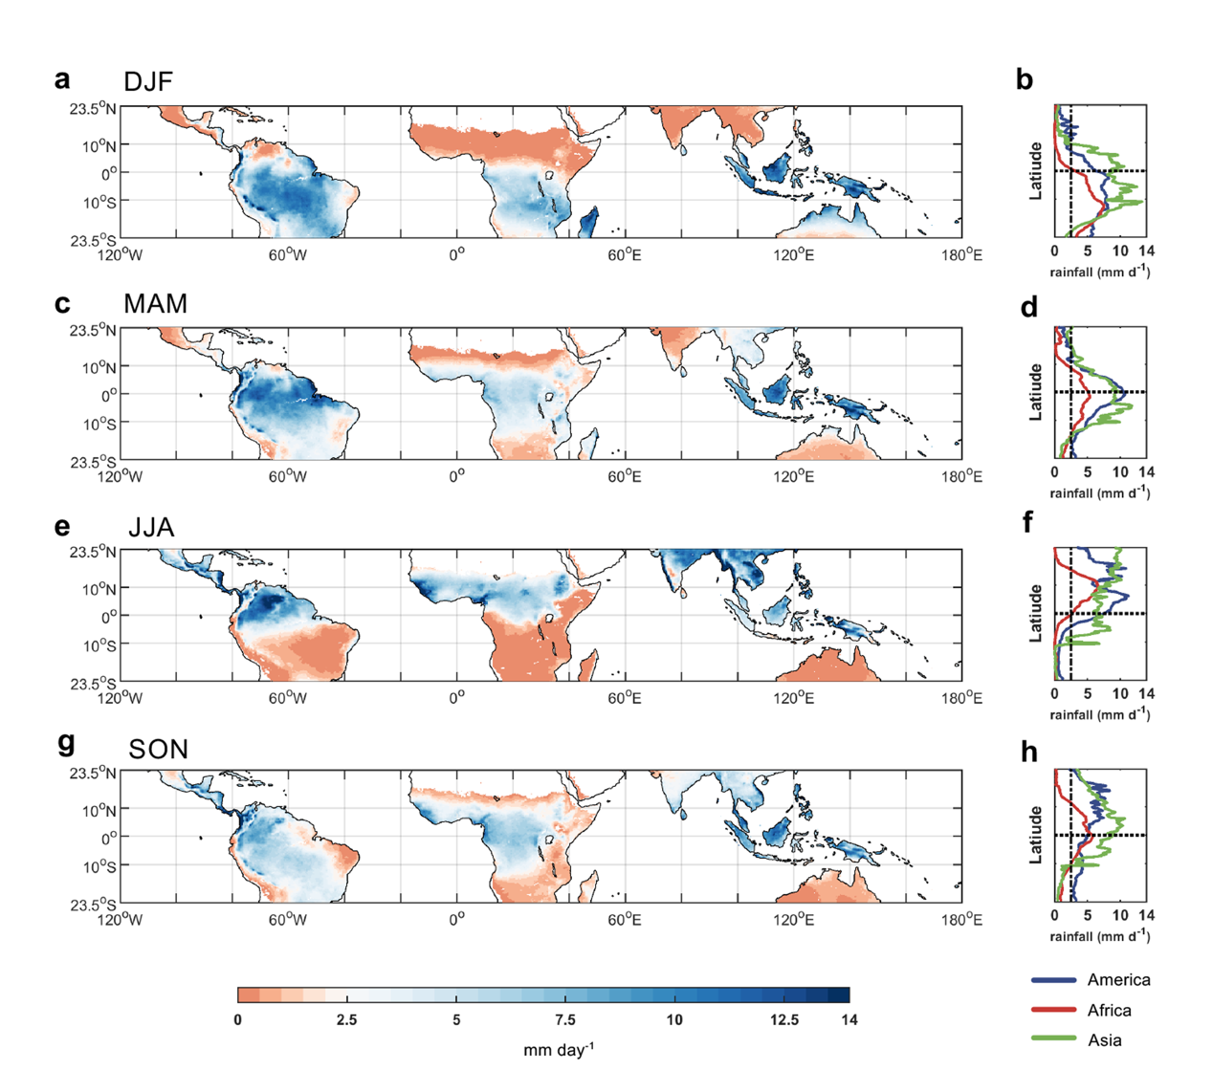
Supplementary Figure 1. Seasonal movement of tropical rain belt. Mean rainfall rate during (a-b) December-January-February (DJF), (c-d) March-April-May (MAM), (e-f) June-July-August (JJA) and (g-h) September-October-November (SON), according to CHIRPS (1981-2018). In the figures on the right, the horizontal dashed line marks 0° latitude, and the vertical dashed line marks the rainfall rate of 2.5 mm day⁻¹, which is usually used as the threshold to define the tropical rain belt (Jiang et al., 2019).
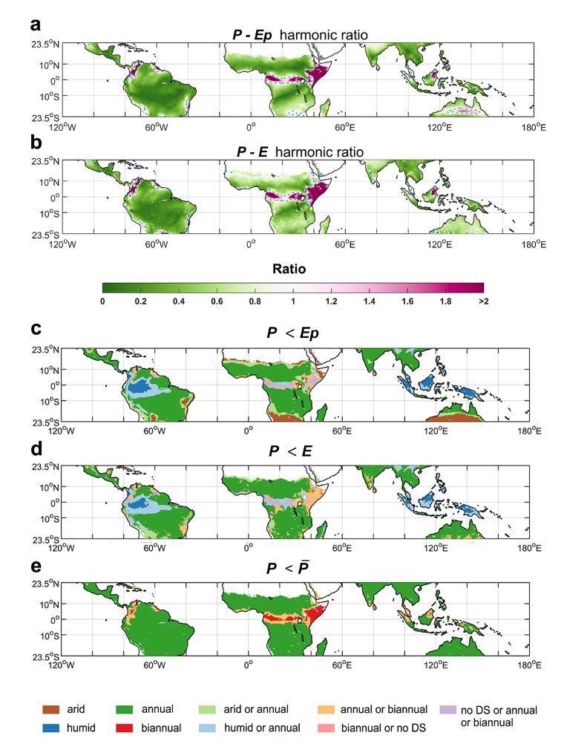
Supplementary Figure 2. P < Ep and P < E occurrence (a, b) and number of dry seasons per year (c, d, e) across precipitation datasets. a-b, The mean ratio of P - Ep, P - E amplitudes of the harmonics at frequencies of two and one cycles per year via Fourier Analysis of whole daily time series (1979-2018) for each grid box based on the seven precipitation datasets. The blue dashed line marks the boundaries of the area with ratio of 1.0.

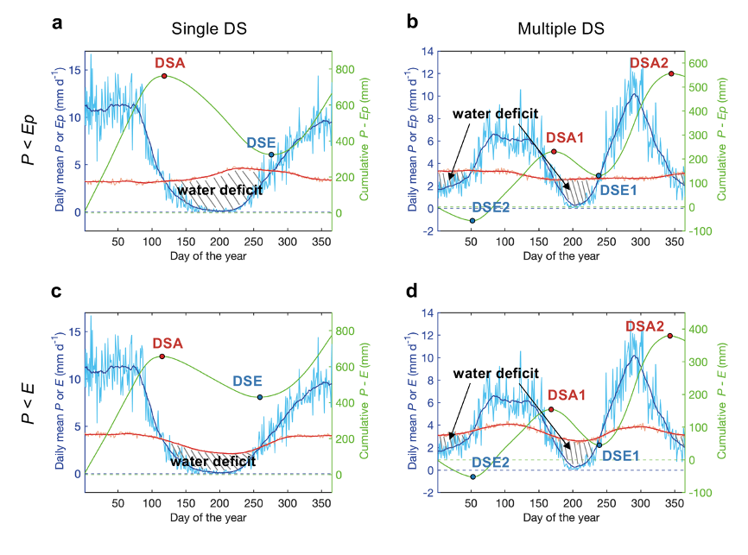
Supplementary Figure 3. Dry seasons, defined as P < Ep (a, b) and P < E (c, d). Daily mean rainfall (light blue) for each day of the year, smoothed using a 30-day running windows (dark blue line), the climatological Ep or E (red line) and cumulative value (green line) for the grid box centered at 11.125°S, 57.875°W (left, point 1 in Fig. 1a) and 1.375°N, 12.875°E (right, point 2 in Fig. 1a) according to the daily CHIRPS dataset for the period 1981-2018 (see Eq. 1 and Eq. 2). Blue dots mark the arrival of dry seasons and red dots mark the end of dry seasons. The solid black shaded area represents the water deficit. The longest dry season and the longest wet season are assumed to be the seasons of interest for regions with multiple dry and wet seasons per year (b, d).
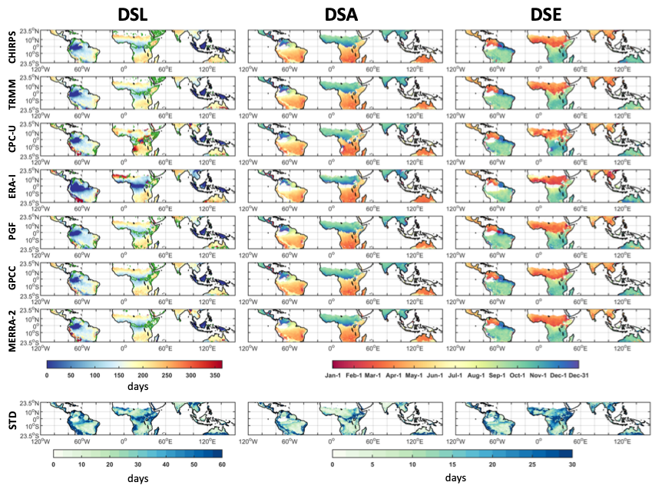
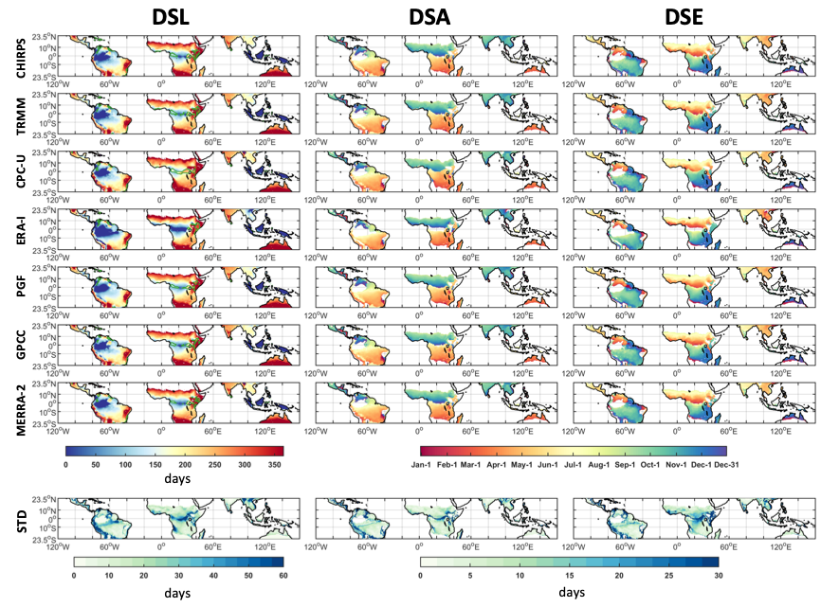
b
a
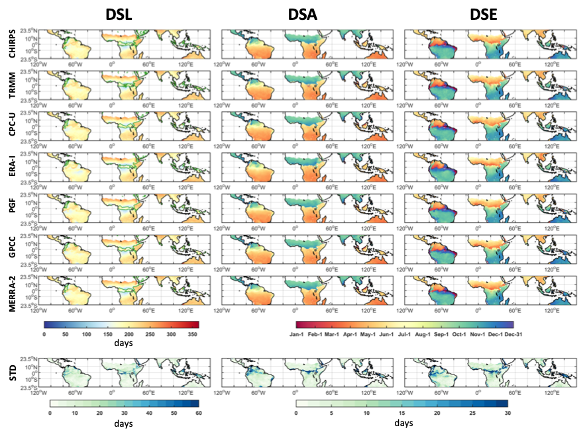
Supplementary Figure 4. Dry season length, arrival, and end, when defined as P < Ep (a), P < E (b) and P < $\overline{P}$ (c), for each precipitation dataset. The green line indicates the boundary of the region with two dry season per year. For this region, characteristics of the austral summer dry season (June, July, August) are shown. Results from ERA-interm is included in the STD calculation.
c
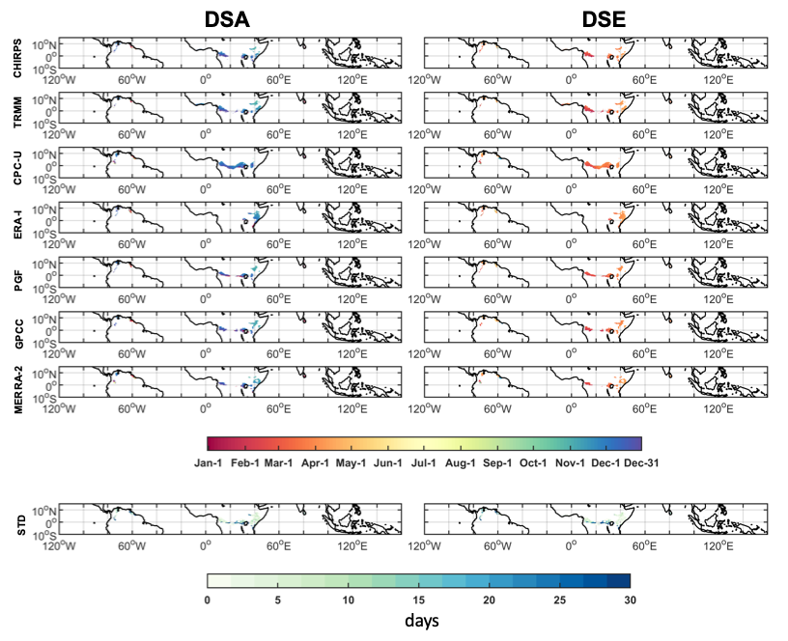
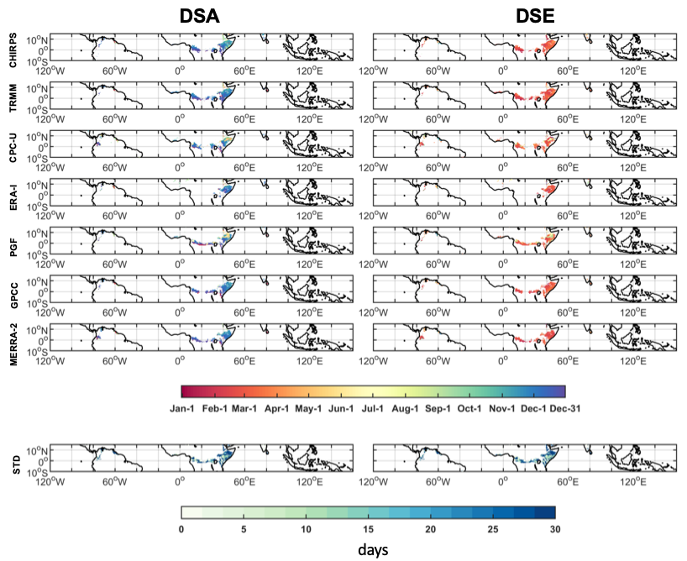
a
b
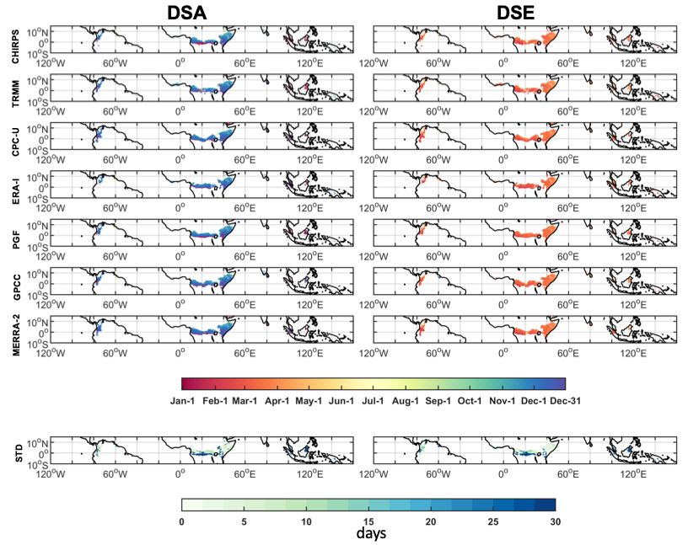
Supplementary Figure 5. Dry season length, arrival, and end, when defined as P < Ep (a), P < E (b) and P < $\overline{P}$ (c), for each precipitation dataset. Characteristics of the austral winter dry season (December, January, February) are shown, for regions with multiple dry seasons per year.
c

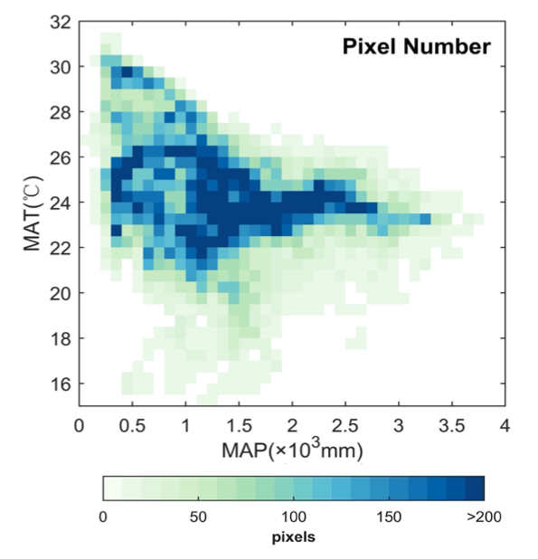
Supplementary Figure 6. Pixels distribution for each MAT and MAP interval shown in Figure 3a.

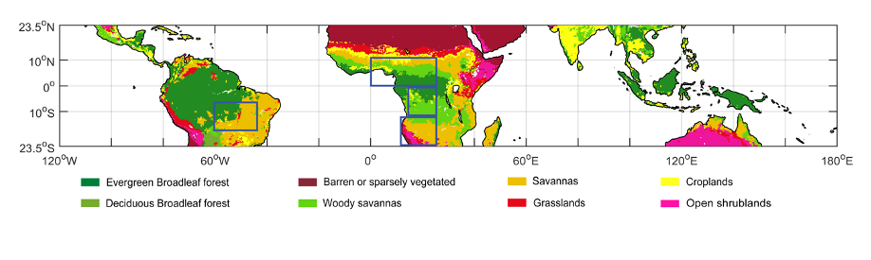
Supplementary Figure 7. Dominant vegetation types in the tropics, from MODIS landcover product MCD12C1. Regions of interest (in Supplementary Table2-3) are indicated by blue rectangles: southern Amazonia, northern central Africa, southern central Africa and southeastern Africa. We excluded sparsely-vegetated and water-dominated pixels from our research.

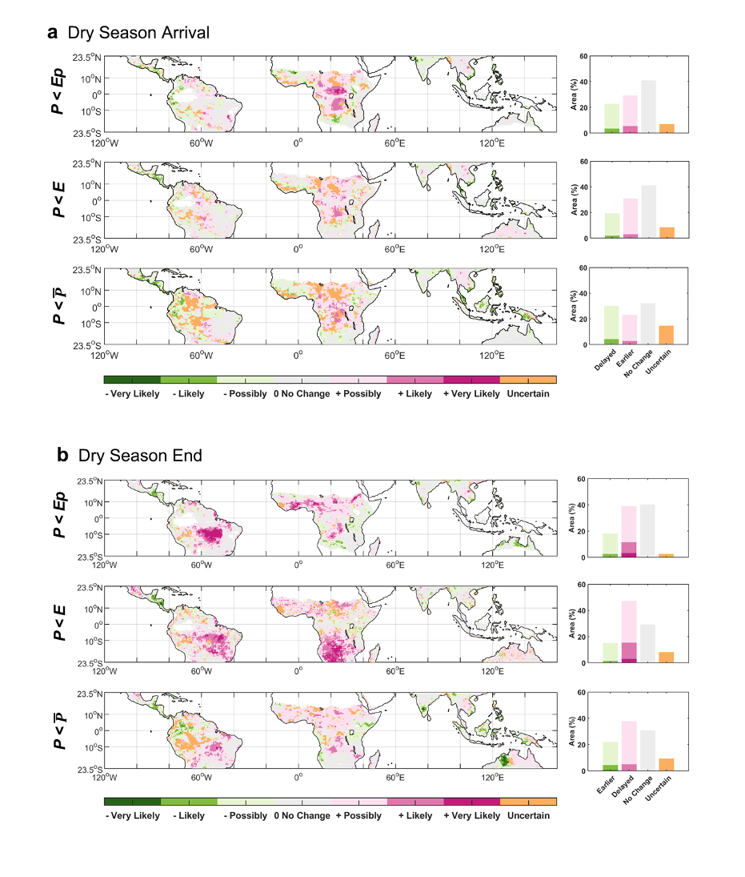
Supplementary Figure 8. Consistency of linear trends in DSA and DSE, among six datasets and under three different definitions over the same period, 1982-2016. The confidence level of wetting (green) or drying (pink) trends was assessed as the variation among the six datasets, under the same definition. For grids experiencing two dry seasons, only the changes for the longer one are shown. The histogram shows the percent area with wetting, drying, or uncertain trends.
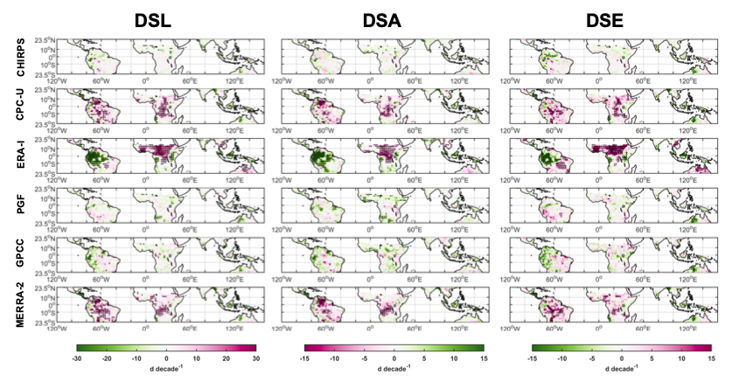
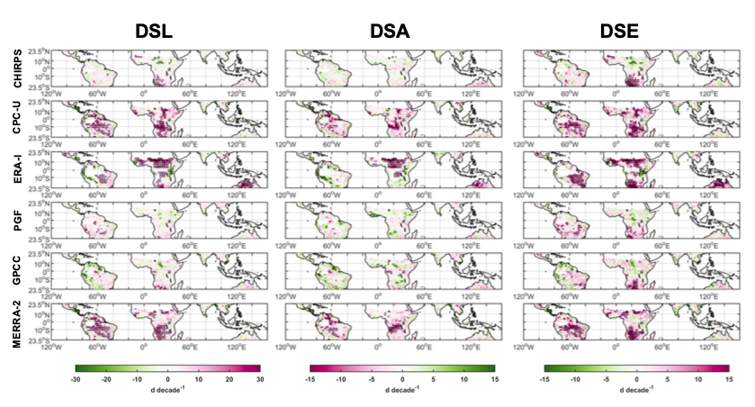
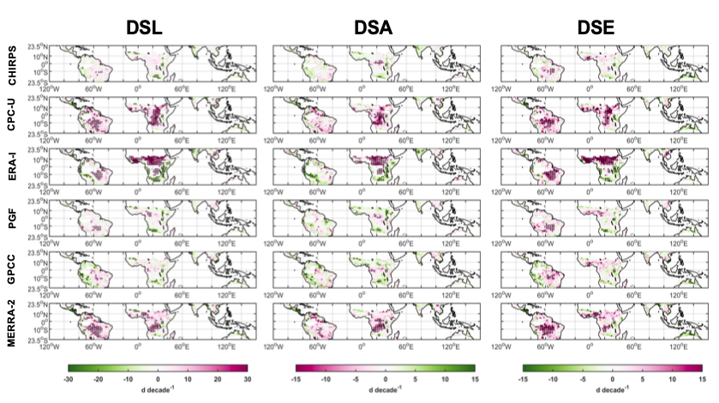
c
b
a
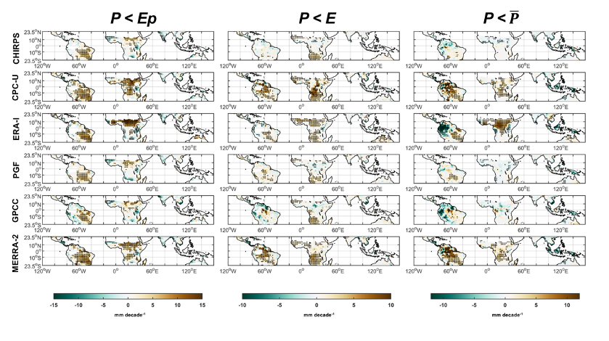
Supplementary Figure 9. Trends in DSL, DSA, DSE (a-c) under the definitions P < Ep, P < E, P < $\overline{P}$, respectively, and Water Deficit (d), under each definition, and for each precipitation dataset. For grids experiencing two dry seasons, only the changes for the longer one are shown.
d

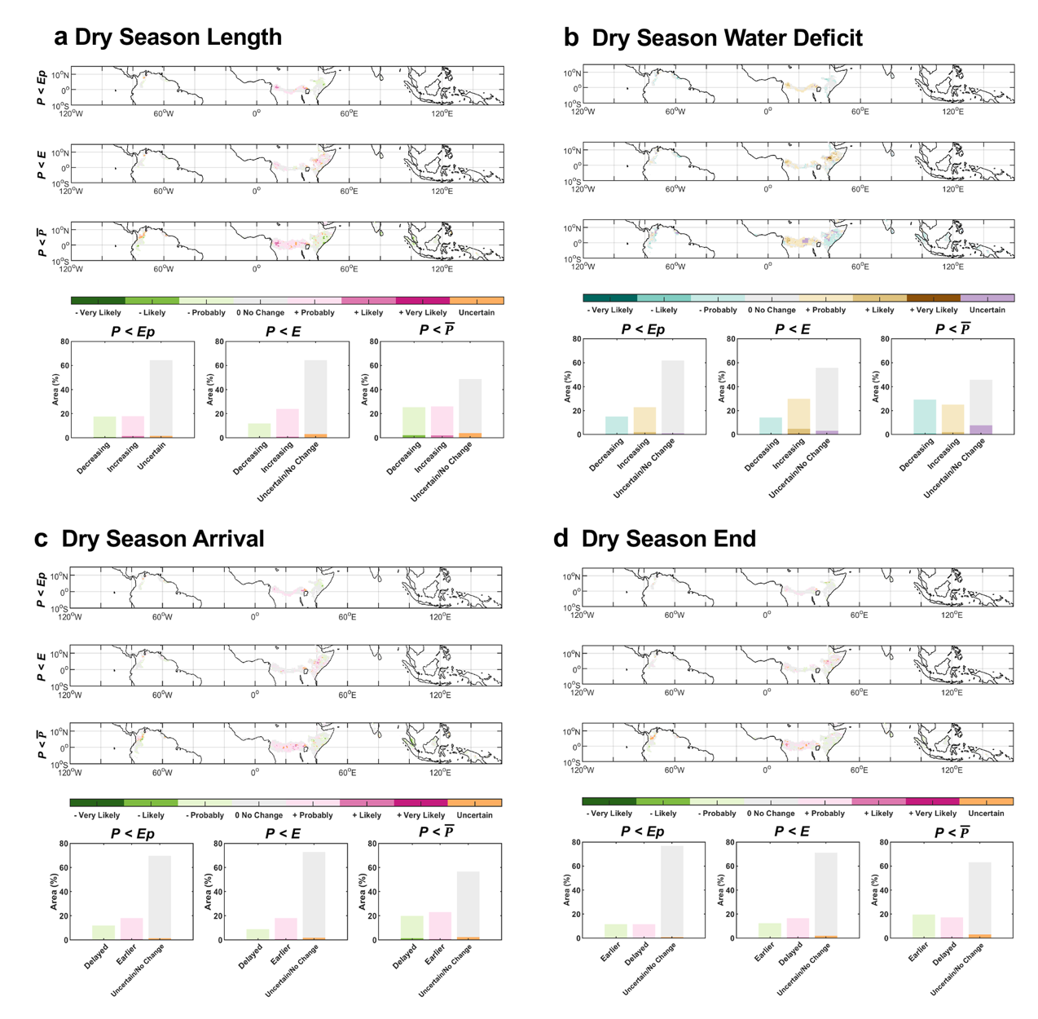
Supplementary Figure 10. Consistency of trends of DSL, DSA, DSE (a-c) and Water Deficit (d), for the shorter dry season (in regions with multiple dry seasons per year).
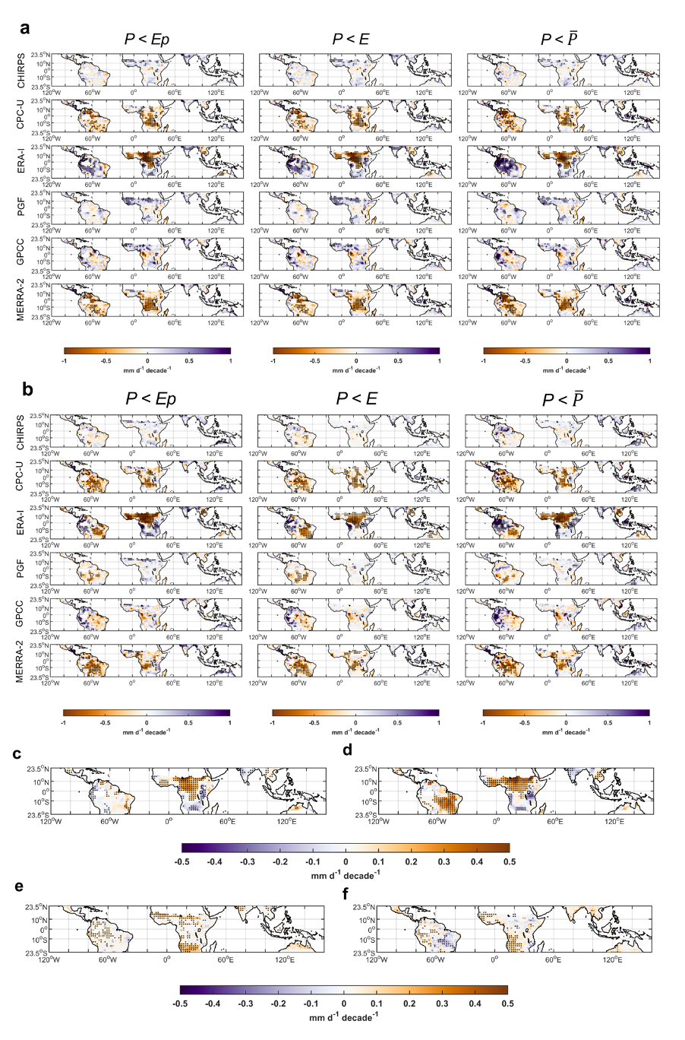
Supplementary Figure 11. Contribution of changes in P, Ep and E to the dry season trend. Linear trends of P during DSA_3month (a) and DSE_3month (b), defined as three consecutive months centered at the DSA/DSE date, from 6 datasets under the same definition, and linear trends of Ep and E during DSA_3month (c, e) and DSE_3month (d, f), for the P < Ep and P < E dry season respectively, over the same period 1982-2016. For grids experiencing two dry seasons per year, only the changes for the longer one are shown.

Supplementary Reference
Chen, M. Y. et al. Assessing objective techniques for gauge-based analyses of global daily precipitation. J. Geophys. Res. Atmos. 113, D04110 (2008).
Dee, D. P. et al. The ERA-Interim reanalysis: configuration and performance of the data assimilation system. Q. J. R. Meteorolog. Soc. 137, 553-597 (2011).
Dunning, C. M., Black, E. C. L. & Allan, R. P. The onset and cessation of seasonal rainfall over Africa. J. Geophys. Res. Atmos. 121, 11405-11424 (2016).
Friedl, M. A. et al. MODIS Collection 5 global land cover: Algorithm refinements and characterization of new datasets. Remote Sens. Environ. 114, 168-182 (2010).
Funk, C. et al. The climate hazards infrared precipitation with stations-a new environmental record for monitoring extremes. Sci. Data 2, 150066 (2015).
Huffman, G. J. et al. The TRMM multisatellite precipitation analysis (TMPA): Quasi-global, multiyear, combined-sensor precipitation estimates at fine scales. J. Hydrometeorol. 8, 38-55 (2007).
Jiang, Y. et al. Widespread increase of boreal summer dry season length over the Congo rainforest. Nat. Clim. Change 9, 617-622 (2019).
Martens, B. et al. GLEAM v3: satellite-based land evaporation and root-zone soil moisture. Geosci. Model Dev. 10, 1903-1925 (2017).
Sheffield, J., Goteti, G. & Wood, E. F. Development of a 50-year high-resolution global dataset of meteorological forcings for land surface modeling. J. Clim. 19, 3088-3111 (2006).
Ziese, M et al. GPCC Full Data Daily Version.2018 at 1.0°: Daily Land-Surface Precipitation from Rain-Gauges built on GTS-based and Historic Data. (GPCC, 2018) http://dx.doi.org/10.5676/DWD_GPCC/FD_D_V2018_100

