Revealing the effects of high Al loading incorporation in the SBA-15 silica mesoporous material

Jorge Gajardo^{a,1}, Julio Colmenares-Zerpa^{a,b,1}, A.F. Peixoto^{c}, D.S.A. Silva^{d}, J.A. Silva^{d},
F. Gispert-Guirado^{e}, J. Llorca^{f}, E.A.Urquieta-Gonzalez^{d, g}, J.B.O. Santos^{d}, J. Szanyi^{h},
C. Sepúlvedaª, M.G. Álvarez^{i,*}, R.J. Chimentão^{a,*}
ª Laboratorio de Investigación de Procesos Catalíticos y Adsorción (LIPROCAD), Departamento de Fisicoquímica, Facultad de Ciencias Químicas, Universidad de Concepción,
Concepción, Casilla 160-C, Chile.
^{b} Laboratorio de Cinética y Catálisis, Facultad de Ciencias, Universidad de Los Andes,
Mérida 5101, Venezuela.
^{c} LAQV-REQUIMTE, Departamento de Química e Bioquímica, Faculdade de Ciências da Universidade do Porto, Rua do Campo Alegre, 4169-007 Porto, Portugal.
^{d} Departamento de Engenharia Química, Universidade Federal de São Carlos, São Carlos, Brasil.
^{e} Servei de Recursos Científics, Universitat Rovira i Virgili, Tarragona 43007, Spain.
^{f} Institute of Energy Technologies, Department of Chemical Engineering and Barcelona Research Center in Multiscale Science and Engineering, Universitat Politècnica de Catalunya, EEBE, Eduard Maistany 10-14, 08019 Barcelona, Spain.
^{g} Research Center on Advanced Materials and Energy, Federal University of São Carlos, C. Postal 676, CEP, 13565-905, São Carlos, SP, Brasil.
^{h} Institute for Integrated Catalysis, Pacific Northwest National Laboratory, Richland, WA 99352, USA.
^{i} GIR-QUESCAT. Departamento de Química Inorgánica. Facultad de Ciencias Químicas. Universidad de Salamanca. Spain. https://ror.org/02f40zc51.

¹ These authors contributed equally to this work.
* Corresponding authors: mgalvarez@usal.es; rchimenton@udec.cl

Scheme 1. Methodology adopted in the synthesis of materials.
Table S1. Chemical composition determined by EDX and XPS techniques of the samples prepared using “pH-adjusting” method.
Sample | Chemical composition
Sample | XPS (at. %) |  |  |  | EDX (at. %)
Sample | Si 2p | Al 2p | O 1s | C 1s | Si | Al | O | C
SBA-15 | 30.4 | n.a. | 66.1 | 3.2 | n.d. | n.d. | n.d. | n.d.
SBA-15 SiAl 15 | 29.8 | 2.6 | 63.3 | 4.3 | 24.61 | 1.63 | 63.08 | 6.65
SBA-15 SiAl 10 | 29.1 | 3.1 | 63.6 | 4.2 | 22.26 | 2.22 | 66.36 | 6.94
SBA-15 SiAl 2 | 21.4 | 10.3 | 60.8 | 7.5 | 19.32 | 9.25 | 65.86 | 6.80
n.d. = not determined, n.a. = not applicable.

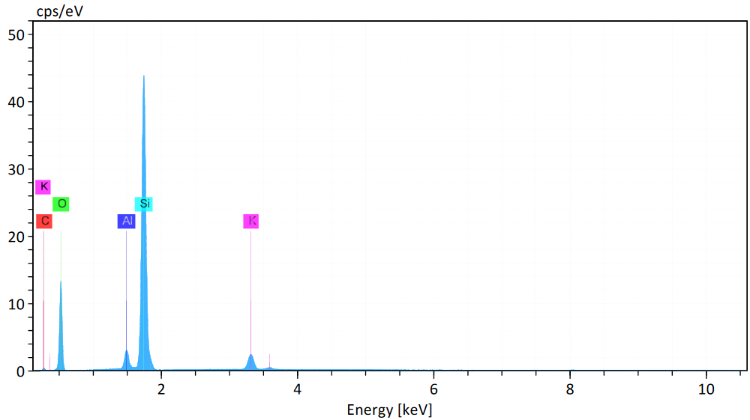 | (A)
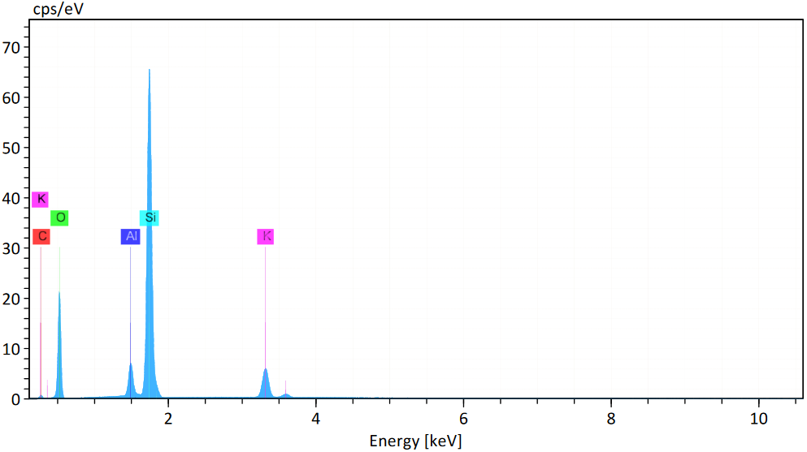 | (B)
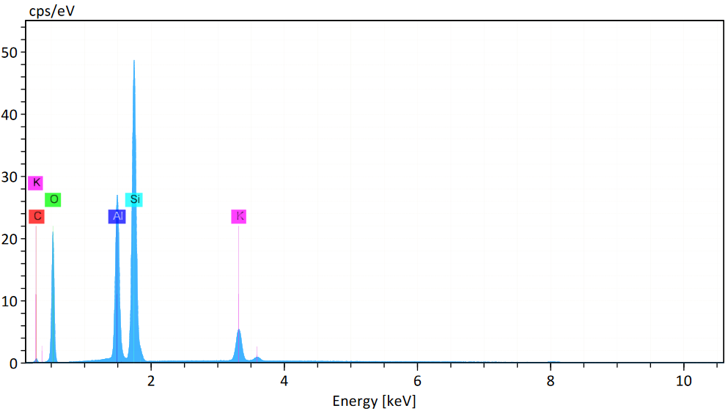 | (C)

Fig. S1. EDX spectrum of Al-containing mesoporous SBA-15: (A) SBA-15 SiAl 15; (B) SBA-15 SiAl 10, and (C) SBA-15 SiAl 2.

(A)
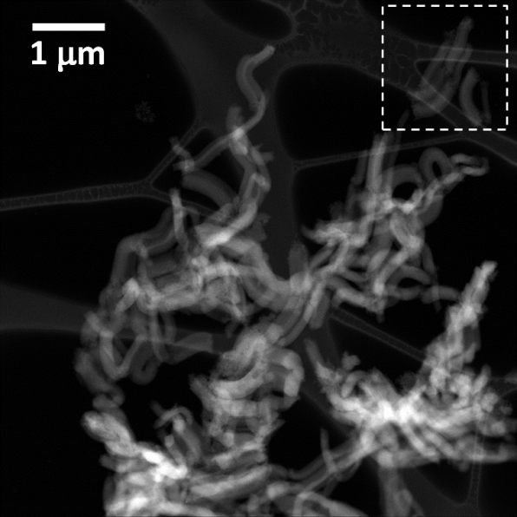  (1) | 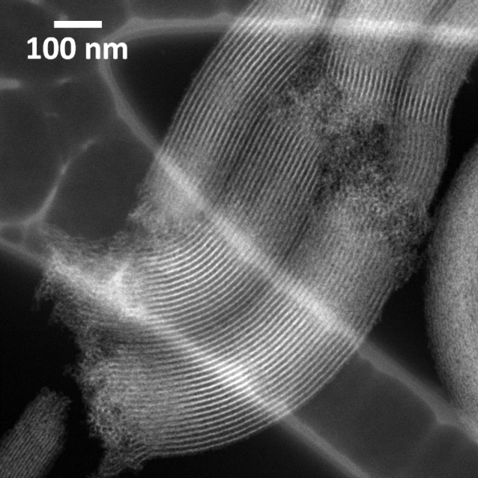  (2)
(B)
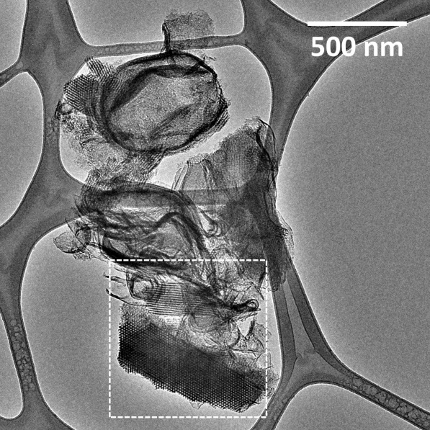  (1) | 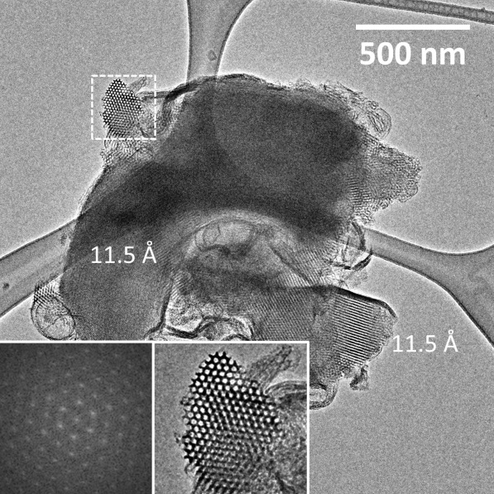  (2)

(C)
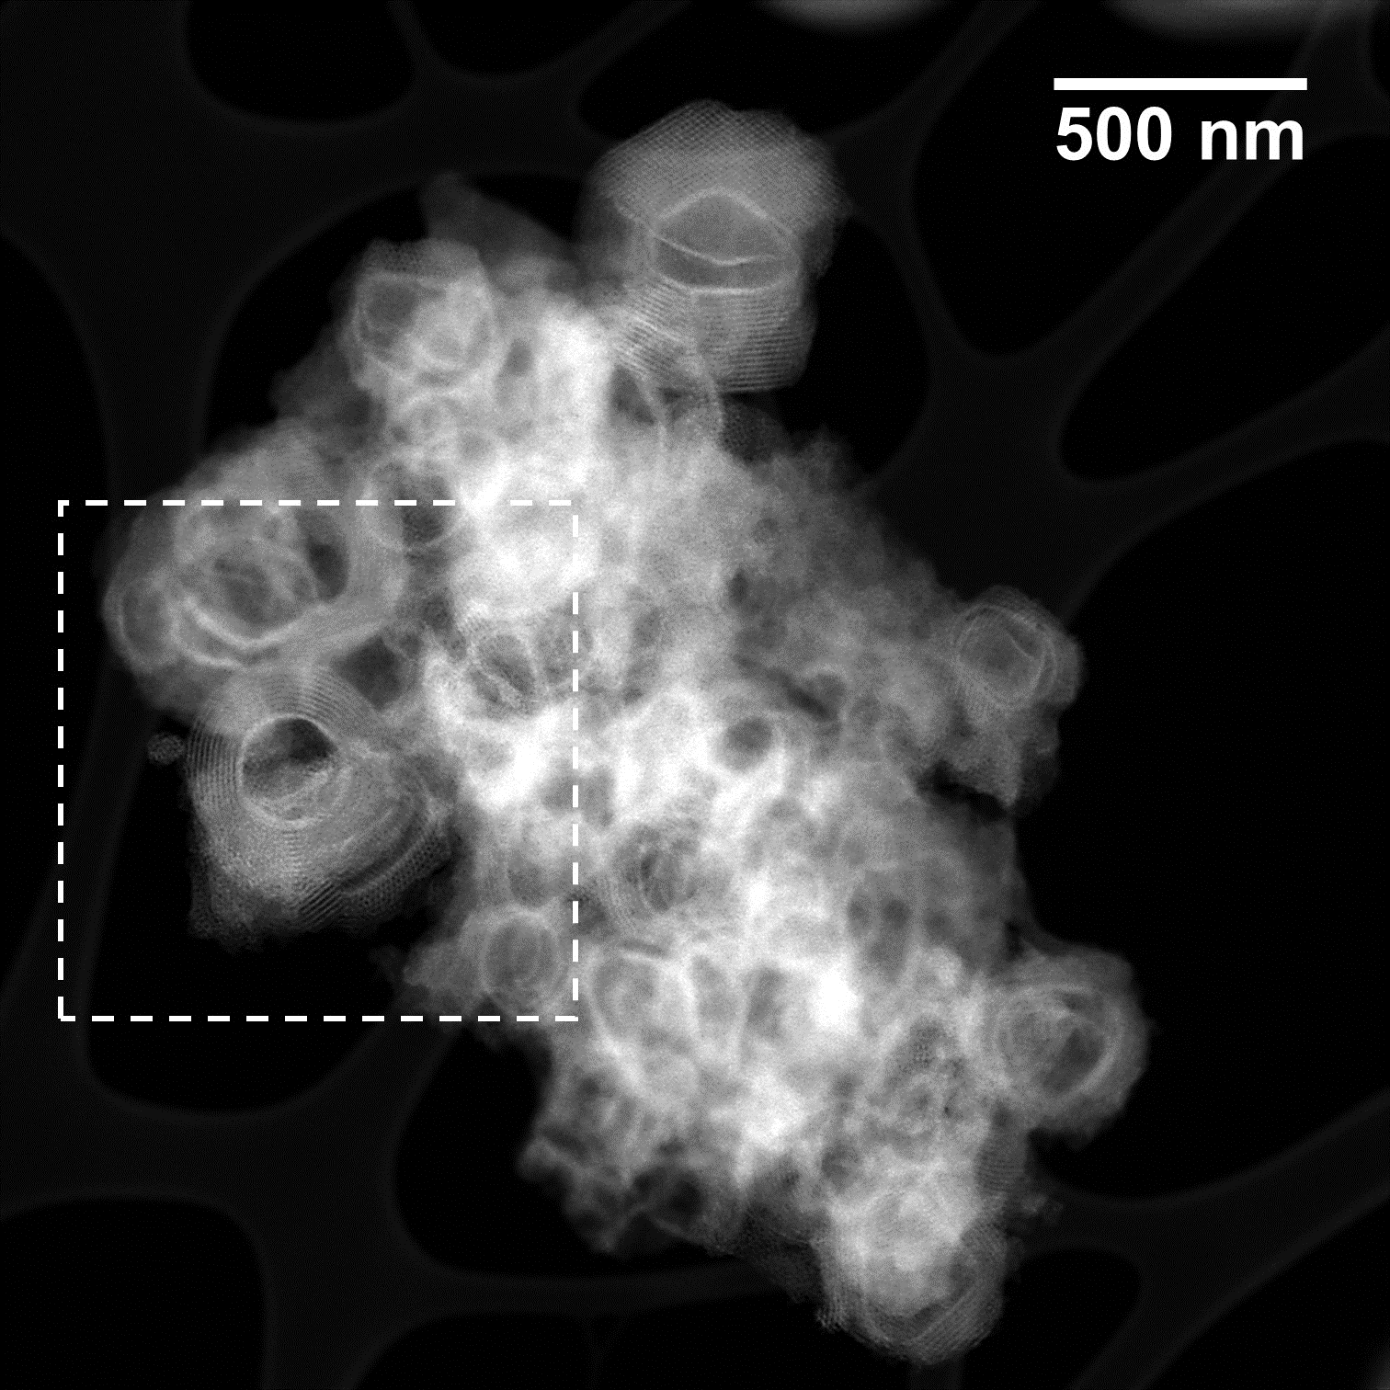  (1) | 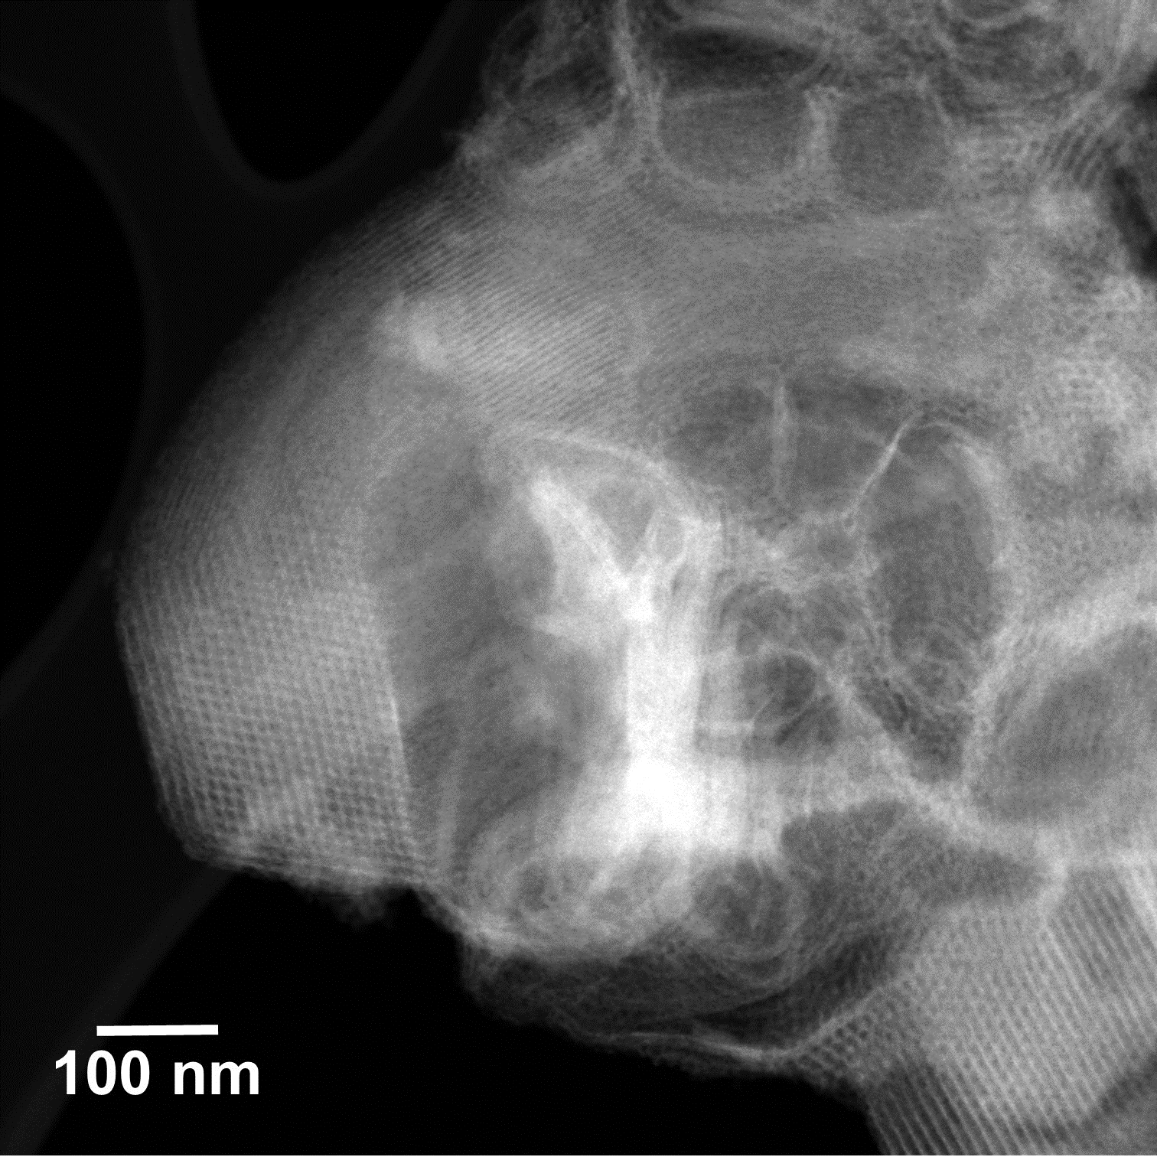  (2)

Fig. S2. Complementary HRTEM images of the samples: (A) SBA-15, (B) SBA-15 SiAl 10, and (C) SBA-15 SiAl 2.

Fig. S3. NH₃-TPD curves of the materials.

Fig. S4. Overall XPS spectrum of the materials.

