Supplementary Material

Supplementary Figures
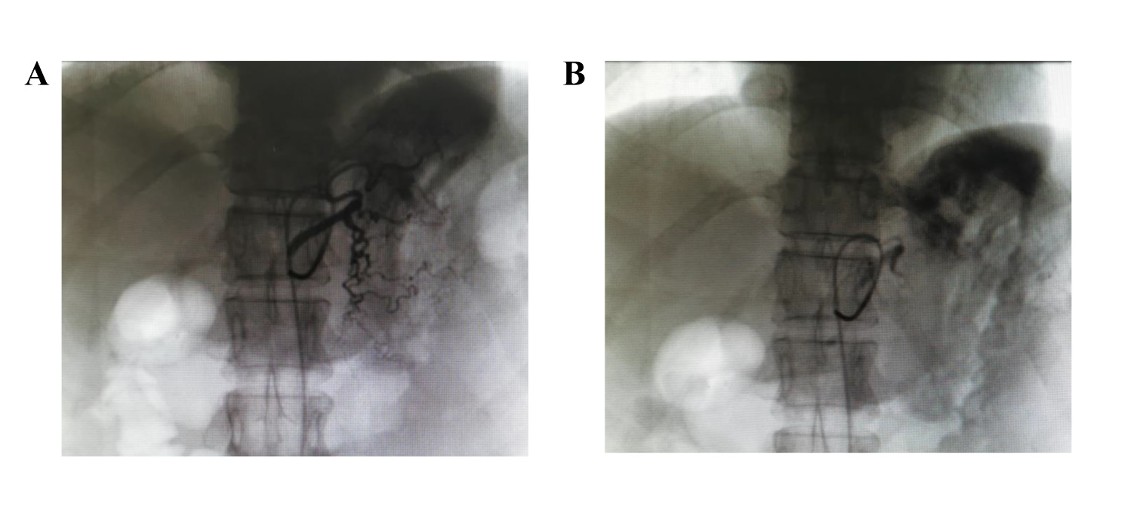
Supplementary Figure 1. The procedures of arterial chemoembolization for LAGC. a: Contrast medium was injected into left gastric artery to reveal tumor blood supply; b: Lipiodol mixed with oxaliplatin were injected to embolize tumor feeding arteries after completing arterial chemotherapy.
Supplementary Figure 2. ROC analysis of NLR and PLR

