Supplementary

The 24 task activation masks for determining appropriate number of the clustering were collected from the result of “Term-based meta-analyses” provided by neurosynth (https://neurosynth.org/analyses/terms/). The terms were attention, auditory, choise, conflict, decision, emotional, episodic memory, executive, impulsivity, inhibition, integration, language, learning, motor, pain, perception, reward, self referential, semantic, sensory, theory of mind, valence, visual, and working memory.

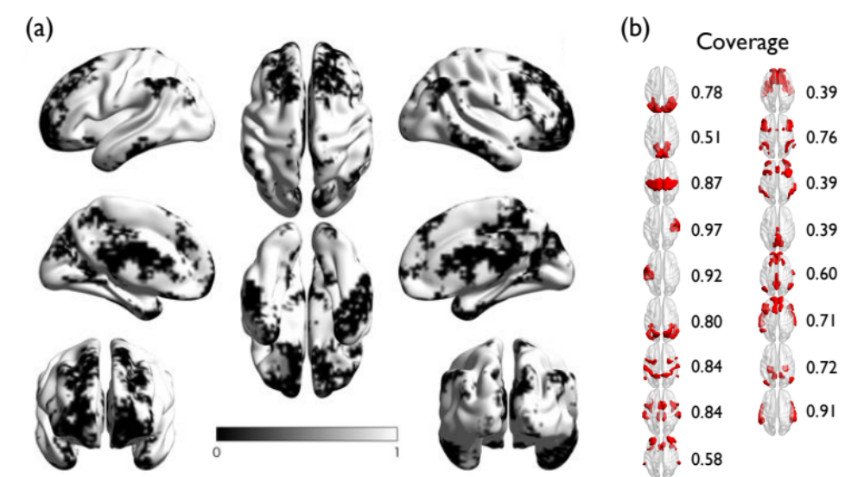

Figure S1. (a) The areas overlapping with any of task activation masks provided by neurosynth (Yarkoni et al. 2011). The areas where do not have any overlap are colored black. (b) The coverage of the networks of Yeo et al. (2011).

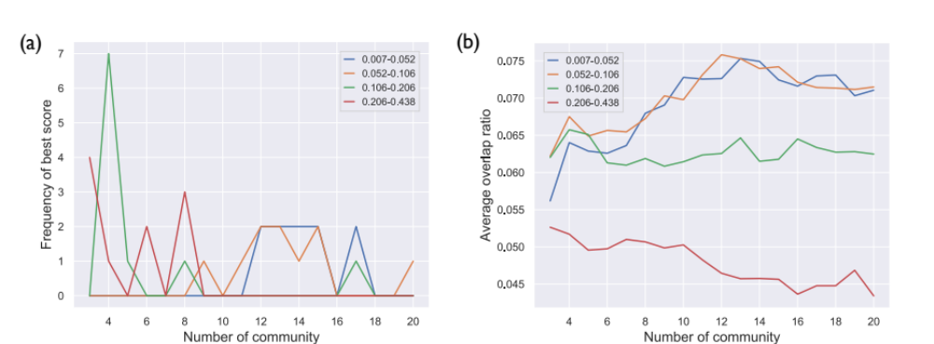
Figure S2. (a) The frequency of being the best overlap score for each cluster number and each frequency-band. (b) Averages of overlap scores across thresholds for each cluster number and each frequency-band.

Figure S3. Network structures for each frequency-band and Yeo et al. (2011). The line width reflects the overlap ratio between networks.

