Supplementary Information for:

A unified framework to enable streamlined RNA-seq analysis for non-model organisms

Peng Liu^{1,2}*, Jessica Ewald¹*, Elena Legrand¹, Yeon Seon Jeon¹, Jonathan Sangiovanni¹, Orcun Hacariz¹, Zhiqiang Pang¹, Guangyan Zhou¹, Jessica A. Head¹, Niladri Basu¹, Jianguo Xia¹

¹ Faculty of Agricultural and Environmental Sciences, McGill University, Ste-Anne-de-Bellevue, Canada

² National Wildlife Research Centre, Environment and Climate Change Canada, Ottawa, Canada

* These authors contributed equally to the work.

Correspondence:
Email: jeff.xia@mcgill.ca (J.X.)
Tel.: +1-(514) 398-8668 (J.X.)

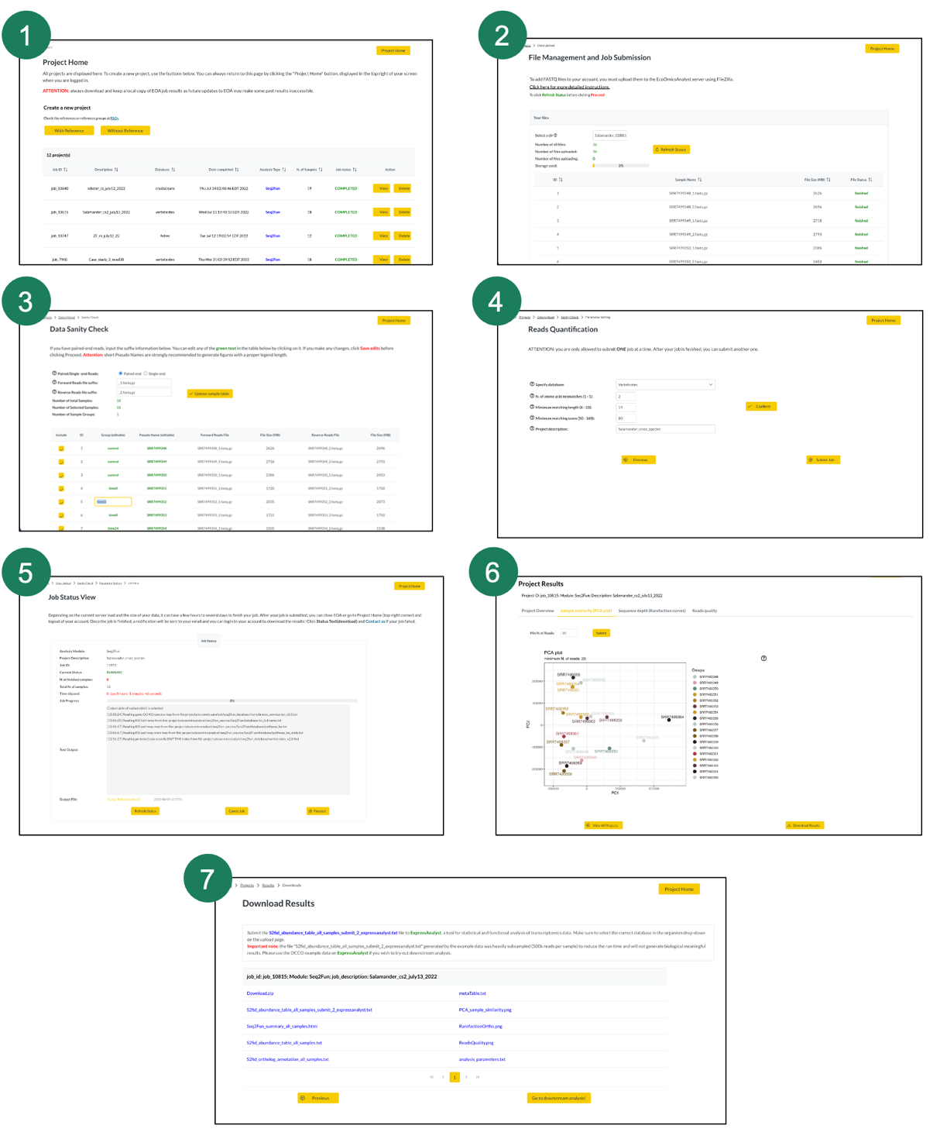

Figure S1. Overview of EcoOmicsAnalyst interface for the main steps in a typical Seq2Fun project workflow, including initiation of a project from the Project Home (1), selection and grouping of samples from the home directory (2), annotation of samples with short names and experimental factors (3), selection of quantification database and parameters (4), job status view (5), view of project results via PCA, rarefaction curves, reads quality filters, and summary table (6), and the final results download page (7).
Overview
Several datasets were used to develop, build, test, and update EcoOmicsAnalyst, ExpressAnalyst, and EcoOmicsDB. Here, we analyze two RNA-seq datasets from zebrafish (Danio rerio) and American lobster (Homarus americanus), organisms with reference transcriptomes, with both Kallisto and Seq2Fun. The results are compared to show that Seq2Fun still recovers overall trends after changing the ortholog protein database that was evaluated in the original publication (Liu, Ewald et al., 2021). In both case studies, resulting counts tables were uploaded to ExpressAnalyst to perform downstream filtering, normalization, statistical analysis, and functional analysis. Note that American lobster does not have any publicly available pathway libraries for the current version of the reference genome, so functional analysis could not be performed for the American lobster Kallisto dataset.

Methods
Zebrafish RNA-seq data were obtained from NCBI’s Sequence Read Archive (SRA) with sample accessions SRR13332314 – SRR13332325. Files were downloaded and converted to FASTQ format using the NCBI SRA ToolKit (version 2.11.3) before being uploaded to EcoOmicsAnalyst. Lobster RNA-seq data are previously unpublished, and collected by us. Briefly, stage I lobster larvae were exposed for 24hrs to four doses of WAF (10%, 19%, 37% and 72%) a positive control (1-methylnaphthalene, at 0.3 mg/L corresponding to the estimated concentration of EC20) or a negative control (0.22 µm filtered seawater). Due to the lack of effects reported on survival, molting and respiration after WAF exposures, only the highest dose of WAF (72% WAF) was considered for transcriptomics analysis. RNA extraction of whole larvae exposed to 72% WAF (n = 7), methylnaphthalene (n = 6) and filtered seawater (n = 6) was performed using Trizol. The transcriptomes were sequenced using Novaseq Illumina at 28M reads per library. FASTQ files were downloaded from the Genome Quebec portal and uploaded to EcoOmicsAnalyst.

For the Kallisto workflow, zebrafish samples were aligned to the GRCz11 Danio rerio genome assembly (accession: GCA_000002035.4) and lobster samples were uploaded to the GMGI_Hamer_2.0 Homarus americanus genome assembly (accession: GCA_018991925.1). The minimum quality score parameter was set to 25. For the Seq2Fun workflow, zebrafish samples were aligned to a customized version of the “Fishes” database that had zebrafish sequences removed, and lobster samples were aligned to the ‘Crustaceans’ database. The Seq2Fun parameters were set as “maximum number of mismatches” = 2, “minimum matching length” = 19, and “minimum matching BLOSUM62 score” = 80. The zebrafish sequences were removed to better demonstrate how mapping to pooled sequences from many other species compares to mapping to a reference transcriptome. This customized database is available for download in the Seq2Fun website (www.seq2fun.ca) under the “Database” tab.

Both count tables (Kallisto and Seq2Fun) were uploaded to ExpressAnalyst for analysis. The appropriate organisms and IDs were selected, data type was set to RNA-seq, and the gene summary method was set to “sum”. Data were filtered to remove those with low abundance and low variation by setting the variance filter to 15 and the abundance filter to 4. Data were normalized using the “Log2 counts per million” option based on the limma voom R package followed by differential analysis with the limma R package. Each treatment group was compared to the control group using the “specific comparison” option. Genes were defined as differentially expressed if their false discovery rate (FDR) adjusted p-values were less than 0.05 and the absolute log fold changes greater than 1.5. For each contrast, the list of DEGs was analyzed for enriched KEGG pathways using the “ORA Networks” tool. A pathway was defined as significantly enriched if the FDR-adjusted p-value was less than 0.05 and there were at least five DEGs in the gene set.

Results
Case study #1: Zebrafish
The zebrafish RNA-seq data were collected as part of a previously published study that investigated the toxicity of perfluorooctane sulfonate (PFOS) compared to sodium p-perfluorous nonenoxybenzene sulfonate (OBS), a popular PFOS alternative (Huang et al., 2021). Three groups of zebrafish embryos were exposed to 20 mg/L PFOS, 20 mg/L OBS, and 30 mg/L OBS, in addition to a fourth unexposed control group, starting at six hours post fertilization. RNA-seq profiles were measured in whole embryos at four days post fertilization. Raw FASTQ files were downloaded from NCBI’s Gene Expression Omnibus (GEO) at accession GSE164074. The original study found that while immune-related genes and pathways were impacted by both OBS and PFOS exposure, a higher number were dysregulated to a higher degree by PFOS. This supports their overall conclusion that while PFOS and OBS have a similar mechanism, PFOS is more toxic, likely because it is more bioaccumulative (Tu et al., 2019).

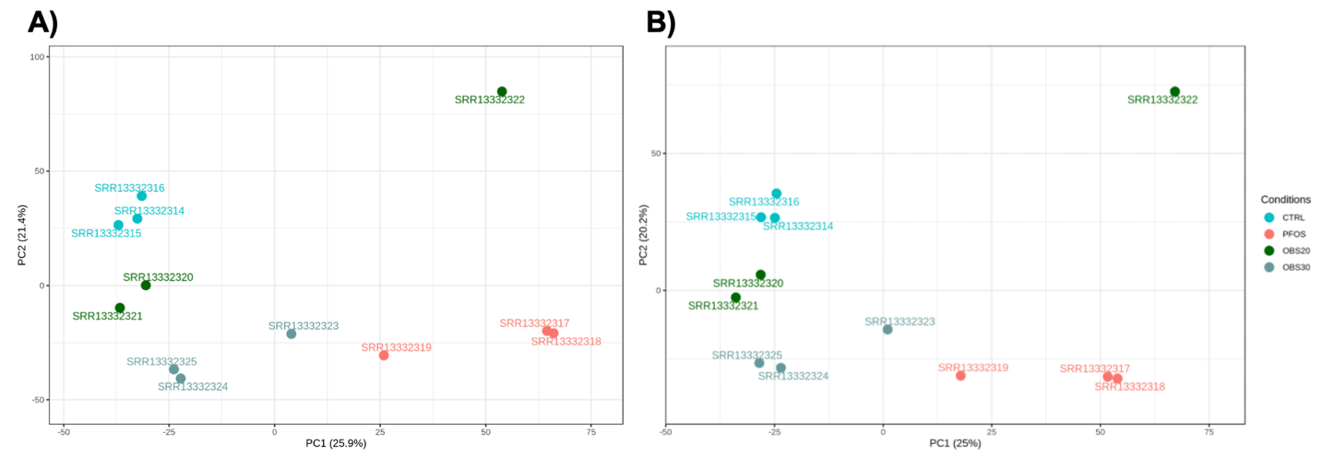

Figure S2: PCA of normalized zebrafish counts tables for a) Kallisto and b) Seq2Fun. This plot was generated by ExpressAnalyst.

Visual inspection of PCA plots of the normalized counts (Figure S2) shows that both Seq2Fun and Kallisto captured the same variability structure among the samples, even though Kallisto mapped a higher percentage of reads (78% vs. 53%) to a higher number of features (52 518 vs. 17 186) (Table S1). The higher number of reads is expected since Kallisto is quantifying multiple transcript isoforms for each coding transcript, as well as non-coding transcripts, while Seq2Fun is quantifying orthologs that do not distinguish isoforms and only include protein-coding sequences. The number of DEGs for each exposed vs. control group has the same pattern between Kallisto and Seq2Fun (PFOS > OBS30 > OBS20), with a slightly higher number in each contrast for Kallisto (Table S1).

Table S1. Results from zebrafish DEA and GSA. Tables of the full differential expression and pathway results are in the SI_cs1_zebrasfish.xlsx supplementary file.

 | Kallisto |  |  | Seq2Fun
# Features quantified | 41 345 |  |  | 17 186
Reads mapping | 77.49% |  |  | 53.12%
 | OBS20 | OBS30 | PFOS | OBS20 | OBS30 | PFOS
DEGs | 106 | 430 | 669 | 59 | 259 | 450
KEGG | 2 | 1 | 1 | 1 | 4 | 10

Directly comparing the DEGs across Kallisto and Seq2Fun is challenging because of a lack of mapping between zebrafish transcripts and ortholog groups, however a cursory examination of the results shows that the top DEGs are very similar across the two software. For example, in the PFOS vs. CTRL results, the symbols “mmp9” (Entrez = 406397; Seq2Fun = s2f_0000105026), “ahsg2” (Entrez = 567406; Seq2Fun = s2f_0008962001), and “pth1a/PTH” (Entrez = 405886; Seq2Fun = s2f_0011129001) are among the top DEGs for each software, and the quantified log2FC values are nearly the same (mmp9 = 3.81, 3.78; ahsg1 = -4.64, -6.01; pth1a = 5.44, 4.57 for Kallisto and Seq2Fun respectively). The number of significant pathways is more variable between the Kallisto and Seq2Fun results, however the biological themes of the top enriched pathways are quite similar for given contrasts. For example, for both software the PFOS vs. CTRL pathways are largely related to cellular signaling and the OBS30 vs. CTRL pathways are mostly related to lipid metabolism, lipid transport, and steroid biosynthesis (see SI_cs1_zebrafish.xlsx).

Differences in the specific pathways flagged as enriched across the two software are expected because the Seq2Fun ortholog groups are more densely annotated than most transcriptomes. Overrepresentation analysis is very dependent on the total number of measured genes and on the number of genes in individual pathways. Thus, even if the lists of DEGs are very similar across two analyses, the specific pathways that get flagged as enriched can vary if there are substantial differences in annotation densities, as in the case for the Kallisto and Seq2Fun analyses. This explains many of the differences in the specific pathways that were flagged as enriched between the two analysis pipelines.

Case study #2: Lobster
The American lobster RNA-seq profiles were collected as part of a study that investigated the biological impacts of exposure to heavy crude oil. One group was exposed to a water accommodated fraction (WAF) of oil at 72% concentration (WAF_72; n = 7), another to 0.39 mg/L of the polycyclic aromatic hydrocarbon (PAH) 1-methynaphthalene (positive control; n = 6), and a third group was unexposed (control; n = 6). These are new, unpublished data collected by the authors of this paper.

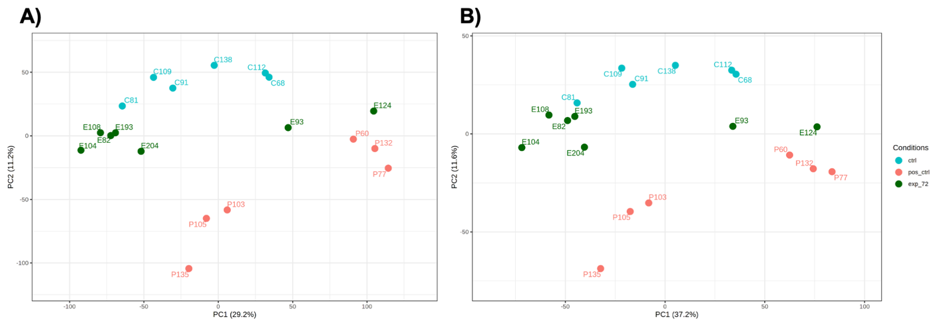

Figure S3: PCA of normalized lobster counts tables for a) Kallisto and b) Seq2Fun. This plot was generated by ExpressAnalyst.

The patterns with the lobster data are very similar to those with the zebrafish data. PCA plots of the normalized counts data show the same variance structure for both quantification methods (Figure S3), even though more features were quantified by Kallisto and Kallisto had a higher reads and gene mapping rate (Table S2). The pattern of DEGs for each contrast is also similar between Kallisto and Seq2Fun, with the positive control group having many more DEGs than the 72% WAF group. While the number of DEGs for each group is higher for Kallisto, the ratio between the two contrasts is very similar across both quantification methods.

Table S2. Results from lobster DEA and GSA. Tables of the full differential expression and pathway results are in the SI_cs2_lobster.xlsx supplementary file.

 | Kallisto |  | Seq2Fun
# Features quantified | 36 925 |  | 10 332
Reads mapping | 71.71% |  | 29.13%
 | Pos. ctrl | WAF 72% | Pos. ctrl | WAF 72%
DEGs | 908 | 50 | 286 | 13
KEGG | NA | NA | 7 | 0

Overall, these case studies show that Kallisto and Seq2Fun give very similar results in terms of relationships between samples, as shown by PCA plots and the relative number of DEGs for different experimental groups. While the number of pathways highlighted by overrepresentation analysis is less consistent, the functional interpretation is quite similar. The lobster analysis shows one advantage of Seq2Fun for recently published genomes - no publicly available gene set libraries exist for the American lobster transcriptome; however, we are still able to easily perform functional analysis of the Seq2Fun results (Table S2).

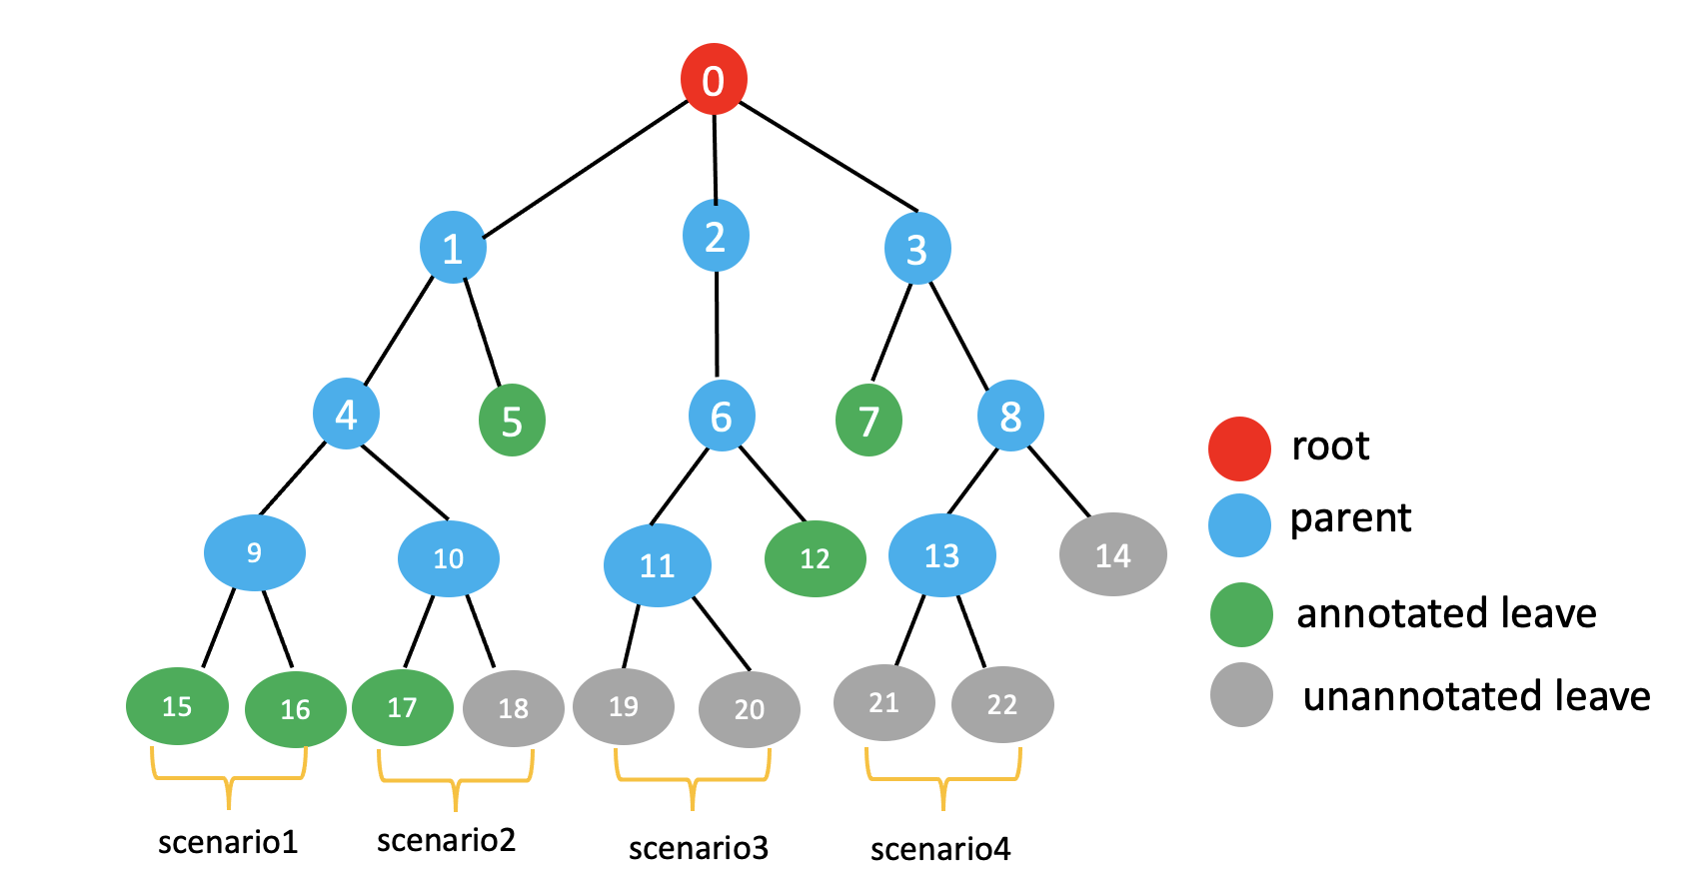Figure S4. Generalized phylogenetic tree based read searching and annotation. For each ortholog group, a phylogenetic tree is built. For each hit read, there will be four generalized scenarios. If a read hits to annotated (with gene features of symbol, KO, GO) leaves, this read will be annotated with the gene features of highest frequency (scenario 1 and 2). If a read hits to leaves without annotation, the annotation will be assigned to its parent who has an annotated sibling (node 12) for scenario3 or its great-grand parent who has an annotated sibling (node 7) for scenario4, or to its ancestor which has an annotated sibling. This searching and annotation strategy will maximize annotation resolution and reduce the false negative annotation at the same time.

Proposed future work
The current Seq2Fun algorithm (version 2.0) is based on a translated nucleotide to peptide search, which is extremely efficient at overcoming large evolutionary distances between query and target organisms in the database. However, this approach cannot quantify non-coding genes or distinguish gene isoforms. In the future, we will develop a tiered search strategy by first conducting DNA-to-DNA search for each read, then a DNA-to-protein (translated) search if the read fails. This novel strategy will not only enable Seq2Fun to quantify the whole transcriptome including non-coding sequences but will also have a higher resolution of features without compromising the ability to overcome long evolutionary distance.

Defining the ortholog group size involves a trade-off between achieving gene-level resolution and achieving a high rate of functional annotation. Perfect gene-level resolution would result any organism contributing only one protein sequence to a given ortholog group. However, tuning the ortholog definition parameters to achieve this creates small ortholog groups with few sequences from well-annotated species, resulting in many ortholog groups with no informative symbols, descriptions, or pathway annotations. In the future, we will employ a new functional annotation strategy where, in cases where the ortholog has no informative functional information, annotations will be pulled from the next closest ortholog group according to phylogenetic relationships (Figure S4). If no annotations are found there either, the search will continue to the next closest ortholog group until an annotation is found. This new strategy will allow us to maximize gene-level resolution while also obtaining the most informative ortholog annotations. This approach is like the functional assignment for marker genes employed by the popular PICRUST method (Langille, Zaneveld et al. 2013).

References

Huang, J., Wang, Q., Liu, S., Zhang, M., Liu, Y., Sun, L., Wu, Y., Tu, W. 2021. Crosstalk between histological alterations, oxidative stress and immune aberrations of the emerging PFOS alternative OBS in developing zebrafish. Science of the Total Environment, 774, 145443.

Langille, M. G., J. Zaneveld, J. G. Caporaso, D. McDonald, D. Knights, J. A. Reyes, J. C. Clemente, D. E. Burkepile, R. L. Vega Thurber and R. Knight (2013). "Predictive functional profiling of microbial communities using 16S rRNA marker gene sequences." Nature biotechnology 31(9): 814-821.

Liu, P., J. Ewald, J. H. Galvez, J. Head, D. Crump, G. Bourque, N. Basu and J. Xia (2021). "Ultrafast functional profiling of RNA-seq data for nonmodel organisms." Genome research 31(4): 713-720.

Tu, W., Martinez, R., Navarro-Martin, L., Kostyniuk, D. J., Hum, C., Huang, J., et al. 2019. Bioconcentration and metabolic effects of emerging PFOS alternatives in developing zebrafish. Environmental Science and Technology, 53(22), 13427-13439.

