Supporting Information for
Composite Phase Change Materials Embedded into Cellulose/Polyacrylamide/Graphene Nanosheets/silver Nanowire Hybrid Aerogels Simultaneously with Effective Thermal Management and Anisotropic Electromagnetic Interference Shielding
Changmei Wu^{1,2}, Lingjun Zeng^{1,2}, Guojun Chang^{1,2}, Ying Zhou^{1,3}, Kang Yan^{1,2},
Lan Xie^{1,2,3*}, Bai Xue^{1,2,3*}, Qiang Zheng⁴
1. State Key Laboratory of Public Big Data, Guizhou University, Guiyang 550025, China.
2. Department of Polymer Materials and Engineering, College of Materials and Metallurgy, Guizhou University, Guiyang 550025, China.
3. National Engineering Research Center for Compounding and Modification of Polymer Materials; National and Local Joint Engineering Research Center for Functional Polymer Membrane Materials and Membrane Processes, Guiyang 550014, China.
4. Department of Polymer Science and Engineering, Zhejiang University, Hangzhou 310027, China.
* Correspondence authors: L.X. (mm.lanxie@gzu.edu.cn) and B.X. (bxue@gzu.edu.cn).

The number of pages: 15
The number of figures: 9
The number of tables: 4

S1 Experimental section
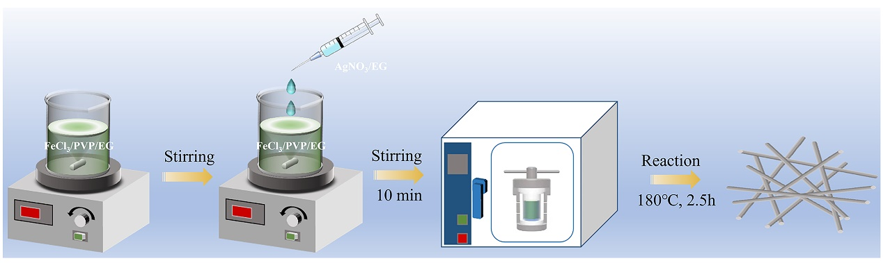
Fig. S1. Schematic route for the synthesis of AgNWs.

S2 Results and discussions

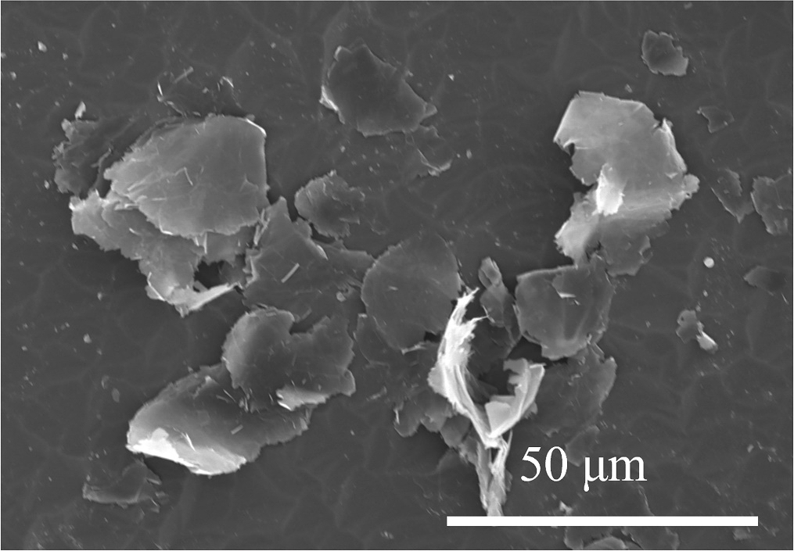
Fig. S2. SEM image of GNPs.
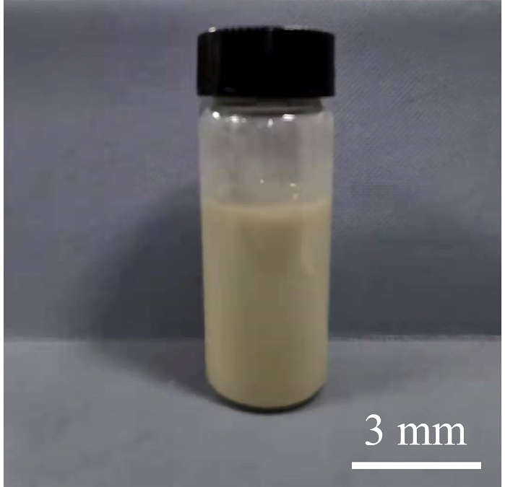
Fig. S3. The digital photo of the synthesized AgNW dispersions

Fig. S4. Porous size distribution of (a) CNF/PAM hybrid aerogels, (b) CPA6 hybrid aerogels, (c) CPG2A6 hybrid aerogels, and (d) CPG6A6 hybrid aerogels.

Fig. S5. (a) XRD curves of PAM, AgNWs, and GNPs. (b) XRD curves of CNFs, CNF/PAM hybrid aerogels, and CPG6A6 hybrid aerogels. (C) FTIR spectra of PAM, AgNWs, and GNPs. (d) FTIR spectra of CNFs, CNF/PAM hybrid aerogels, and CPG6A6 hybrid aerogels.
S2.1 Attribution of XRD diffraction peaks of CPGxAy hybrid aerogels
According to XRD curves (Fig. S5a), it is clearly seen that PAM exhibit an obvious diffraction peak at 21.1º, corresponding to its crystal phase. For AgNWs, five diffraction peaks situated at 81.6º, 77.3º, 64.5º, 44.2º and 37.9º are attributed to (222), (311), (220), (200), and (111) crystal planes of FCC silver, respectively [1]. Typically, the strong peak is located at 26.2º in GNP XRD curve, due to the (002) lattice plane of GNP crystals [2]. In addition, the diffraction peaks of CNF aerogels are observed at 15.7º and 22.8º, belonging to (110) and (020) planes of CNF crystalline structures (Fig. S5b) [3]. Furthermore, two obvious diffraction peaks for CNF/PAM hybrid aerogels in consistence with the crystal structures of CNFs and PAM are discovered at 15.9° and 22.8° in XRD pattern, suggesting that the introduction of PAM exhibits little effect on the crystal structures of CNF aerogels. The intensity is visually elevated, which can be ascribed to the overlapping diffraction peaks of CNFs and PAM. However, the characteristic peaks of CNFs and PAM can not be traced in the XRD curve of CPG6A6 aerogel, because of the relatively low content of CNFs and PAM in CPG6A6 hybrid aerogel. Moreover, the peak position of GNPs and AgNWs in CPG6A6 hybrid aerogel is shifted towards the higher angle than that of neat GNPs and AgNWs, which can be attributed to the hydrogen bonding among CNFs, PAM, GNPs and AgNWs.
S2.2 Attribution of FTIR diffraction peaks of CPGxAy hybrid aerogels
As shown in FTIR spectra (Fig. S5c and d), Pure PAM possess six characteristic absorption peaks at 3424, 3204, 2935, 1666, 1453 and 1123 cm⁻¹, corresponding to the free –NH₂ vibration, associated –NH₂ vibration, –CH₂– asymmetric stretching mode, stretching vibration of –C=O, deformation vibration of –CH₂–, and C–H stretching mode, respectively (Fig. 4c) [4]. For AgNWs, the band at 1634 cm⁻¹ is ascribed to the stretching vibration of C=O groups in PVP on the AgNW surface [5]. The characteristic peaks for GNPs are displayed at 3454, 1641, and 1086 cm⁻¹, which is ascribed to the −OH, C=C and C-O stretching vibrations, respectively, as well as another peak at 1384 cm⁻¹ belonged to the C-H bending mode [6,7], this can be contributed to a great quantity of functional groups or dispersant existed on the edges of purchased GNPs, which is beneficial for the dispersive capacity. According to Fig. S5d, CNF aerogel exhibits five chemical signature peaks situated at 3405, 2918, 1666, 1421, and 1060 cm⁻¹, assigned to the O–H, C–H, and –COO– stretching vibrations, and C–H and –CH₂ bending vibrations, respectively [8,9]. Moreover, the characteristic absorption peaks for CNF/PAM hybrid aerogel comply with those of CNF aerogels without new characteristic peaks, indicating only the physical interaction between CNFs and PAM. After introducing AgNWs and GNPs, the as-prepared CPG6A6 hybrid aerogel presents no new characteristic peak, illuminating the extremely feeble chemical interaction with CNFs whether AgNWs or GNPs. Natheless, some absorption peaks slightly blue-shifted, signifying the strong physical interaction among the components, such as hydrogen bond, Van der Walls’ force.
Fig. S6. (a) XRD patterns and (b) FTIR spectra of pure PEG, PEG@CNF/PAM, PEG@CPA6, and PEG@CPG6A6 ss-CPCMs.
S2.3 Contribution of XRD diffraction peaks of PEG@CPGxAy ss-CPCMs
As exhibited in Fig. S6(a), neat PEG exhibits two typical diffraction bands at 19.1° and 23.3°, which are attributed to the (120) and (032) crystal planes, respectively [10]. It is worth noting that all the representative PEG@CPGxAy ss-CPCM samples display both the diffraction peaks of pure PEG, suggesting that the encapsulation process had nearly no impact on the crystalline structures of PEG. Moreover, the intensity of XRD peaks at 19.1° and 23.3° for PEG@CPGxAy ss-CPCMs become slightly weaker, compared with that of pristine PEG. The possible reason is that CPGxAy hybrid aerogel skeletons restrict the movement of long PEG chains in the crystallizing course [11].
S2.3 Contribution of FTIR diffraction peaks of PEG@CPGxAy ss-CPCMs
In the FTIR (Fig. S6b) spectrum of PEG, three broad characteristic absorption peaks are observed at 3442, 2890, and 1110 cm⁻¹, owing to the stretching mode of O–H, –CH₂–, and C–O groups, respectively [12]. Meanwhile, the absorption bands located at 1466 and 1341 cm⁻¹ are assigned to the C-H bending mode, and the other two bands situated at 964 and 842 cm⁻¹ are ascribed to the C-C stretching vibration [13]. Comparing pure PEG and PEG@CPGxAy ss-CPCMs, it can be seen that all the featured absorption bands of PEG emerge in the FTIR spectra of PEG@CPGxAy ss-CPCMs. What’s more, no new absorption bands are viewed in the FTIR spectra of PEG@CPGxAy ss-CPCMs, and only slight shift is achieved for O–H and –CH₂– stretching vibration peaks, which suggests that there are hydrogen bonds between PEG and CPGxAy hybrid aerogels rather than the chemical bonds [14].
Fig. S7. TG thermograms of PEG@CPG6A6 ss-CPCMs before and after 50/100 thermal cycles.

Fig. S8. The thermal conductivity of PEG@CPG1, PEG@CPG2, PEG@CPG4, and PEG@CPG6 ss-CPCMs.
Fig. S9. The volume conductivity of PEG@CPGxAy ss-CPCMs as indicated in the graph.

Table S1. The theoretical concentration of each component in CPGxAy mixed liquid.
Sample | CNFs (mg/ml) | PAM  (mg/ml) | GNPs (mg/ml) | AgNWs  (mg/ml)
CNF aerogels | 6.41 | - | - | -
CNF/PAM aerogels | 6.41 | 3.205 | - | -
CNF/GNP-6 aerogels | 6.41 | - | 19.23 | -
CPG1 aerogels | 6.41 | 3.205 | 3.205
CPG2 aerogels | 6.41 | 3.205 | 6.41
CPG4aerogels | 6.41 | 3.205 | 12.82 | -
CPG6 aerogels | 6.41 | 3.205 | 19.23 | -
CPA6 aerogels | 6.41 | 3.205 | - | 19.23
CPG1A6 aerogels | 6.41 | 3.205 | 3.205 | 19.23
CPG2A6 aerogels | 6.41 | 3.205 | 6.41 | 19.23
CPG4A6 aerogels | 6.41 | 3.205 | 12.82 | 19.23
CPG6A6 aerogels | 6.41 | 3.205 | 19.23 | 19.23

Table S2. The loading fraction of PEG in PEG@CPGxAy ss-CPCMs
Sample | Loading fraction of PEG (wt%) | Melting enthalpy efficiency (%) | Crystallization enthalpy efficiency (%)
PEG@CNF/PAM | 98.64 | 98.86 | 99.02
PEG@CPA6 | 96.26 | 96.95 | 96.92
PEG@CPG1A6 | 95.84 | 96.06 | 96.03
PEG@CPG2A6 | 95.10 | 95.52 | 95.6
PEG@CPG4A6 | 94.58 | 94.52 | 94.39
PEG@CPG6A6 | 93.67 | 93.47 | 93.08

Table S3. TG properties of PEG and PEG@CPGxAy ss-CPCMs.
Sample | T_{-5wt%} (°C) | T_{max} (°C) | Char yield at 800 °C (wt%)
PEG | 374.32 | 411.79 | 3.44
PEG@CNF/PAM | 376.81 | 414.28 | 3.99
PEG@CPA6 | 379.33 | 416.71 | 6.42
PEG@CPG1A6 | 381.82 | 416.77 | 7.16
PEG@CPG2A6 | 381.83 | 416.78 | 7.56
PEG@CPG4A6 | 382.82 | 416.80 | 8.41
PEG@CPG6A6 | 386.84 | 416.83 | 8.93

Table S4. Comparison of the thermal conductivity enhancement and melting enthalpy efficiency of the prepared PEG/CPGxAy ss-CPCMs with those of some other reported ss-CPCMs.
Composition of ss-CPCMs | Filler | Filler content (wt%) | Thermal conductivity (W/m⋅K) | Thermal conductivity  enhancement (%) | Melting enthalpy efficiency （%） | References
AgNWA-PEG | AgNWs | 19.3 | 0.35 | 128.57 | - | [15]
rGOF-SPU | Graphite | 0.8 | 0.44 | 63.96 | - | [16]
GAF-PW | GO | 12 | 0.32 | 18.52 | - | [17]
PDA@BP/PEG-PU | BP | 1.2 | 0.46 | 73.86 | 69.83 | [18]
Ti3C2Tx@PDA /PCMs | Ti3C2Tx | 2 | 0.476 | 77.07 | 68.75 | [19]
PEG/MDI/GO | GO | 9 | 0.48 | 41.42 | - | [20]
PEG/KF/BN-OH | BN-OH | 10 | 0.68 | 181.48 | 86.94 | [21]
P-SAL@Mxene | Mxene | 20 | 0.48 | 37.68 | 76.79 | [22]
PP/CNTs/Fe3O4/PW | CNTs/Fe3O4 | 6.6/4 | 0.64 | 236.84 | 50.59 | [23]
PEG/HGA | GO/GNP | 0.45 /1.8 | 1.43 | 361.29 | 103.45 | [6]
PEG@CPG4A6 | GNP/AgNW | 1.35/2.19 | 0.69 | 143.32 | 94.52 | This work
PEG@CPG6A6 | GNP/AgNW | 2.19/2.19 | 0.84 | 195.21 | 93.47 | This work

References
[1] Gao D, Guo S, Zhou Y, Lyu B, Ma J, Zhao P, et al. (2022). Hydrophobic, flexible electromagnetic interference shielding films derived from hydrolysate of waste leather scraps. J Colloid Interface Sci 613:396-405.
[2] Atinafu DG, Yun BY, Kang Y, Wi S, Kim S (2021). Three-dimensional hybrid carbon nanocomposite-based intelligent composite phase change material with leakage resistance, low electrical resistivity, and high latent heat.J Ind Eng Chem 98:435-43.
[3] Duan H, He P, Zhu H, Yang Y, Zhao G, Liu Y (2021). Constructing 3D carbon-metal hybrid conductive network in polymer for ultra-efficient electromagnetic interference shielding. Compos Part B-Eng 212:108690.
[4] Tang Q, Wu J, Sun H, Lin J, Fan S, Hu D (2008). Polyaniline/polyacrylamide conducting composite hydrogel with a porous structure. Carbohyd Polym 74(2):215-9.
[5] Ma Z, Kang S, Ma J, Shao L, Zhang Y, Liu C, et al. (2020). Ultraflexible and Mechanically Strong Double-Layered Aramid Nanofiber-Ti3C2Tx MXene/Silver Nanowire Nanocomposite Papers for High-Performance Electromagnetic Interference Shielding. ACS Nano 14(7):8368-82.
[6] Yang J, Qi G-Q, Liu Y, Bao R-Y, Liu Z-Y, Yang W, et al. (2016). Hybrid graphene aerogels/phase change material composites: Thermal conductivity, shape-stabilization and light-to-thermal energy storage. Carbon 100:693-702.
[7] Yu Z, Dai T, Yuan S, Zou H, Liu P (2020). Electromagnetic Interference Shielding Performance of Anisotropic Polyimide/Graphene Composite Aerogels. ACS Appl Mater Interfaces 12(27):30990-1001.
[8] Xue F, Jin XZ, Wang WY, Qi XD, Yang JH, Wang Y (2020). Melamine foam and cellulose nanofiber co-mediated assembly of graphene nanoplatelets to construct three-dimensional networks towards advanced phase change materials. Nanoscale 12(6):4005-17.
[9] Xu J, Tan Y, Du X, Du Z, Cheng X, Wang H (2020). Cellulose nanofibril/polypyrrole hybrid aerogel supported form-stable phase change composites with superior energy storage density and improved photothermal conversion efficiency. Cellu 27(16):9547-58.
[10] Abdalkarim SYH, Yu H, Wang C, Chen Y, Zou Z, Han L, et al. (2019). Thermo and light-responsive phase change nanofibers with high energy storage efficiency for energy storage and thermally regulated on–off drug release devices. Chem Eng J 375:121979.
[11] Mo Z, Mo P, Yi M, Hu Z, Tan G, Selim MS, et al. (2021). Ti3C2Tx@Polyvinyl alcohol foam-Supported Phase Change Materials with Simultaneous Enhanced Thermal Conductivity and Solar-Thermal Conversion Performance. Sol Energ Mat Sol C 219:110813.
[12] Liu L, Zou X, Wang Y, Zhou W, Shi J, Ye Y, et al. (2021). Phase change and aerogel dual functionalized composites materials with double network structure through one-step preparation of polyacrylamide/calcium alginate/polyethylene glycol. Polymer 223:123710.
[13] Atinafu DG, Chang SJ, Kim K-H, Dong W, Kim S (2020). A novel enhancement of shape/thermal stability and energy-storage capacity of phase change materials through the formation of composites with 3D porous (3,6)-connected metal–organic framework. Chem Eng J 389:124430.
[14] Shao Y-w, Hu W-w, Gao M-h, Xiao Y-y, Huang T, Zhang N, et al. (2021). Flexible MXene-coated melamine foam based phase change material composites for integrated solar-thermal energy conversion/storage, shape memory and thermal therapy functions. Compos Part A-Appl S 143: 106291.
[15] Zhang L, Liu X, Deb A, Feng G (2019). Ice-Templating Synthesis of Hierarchical and Anisotropic Silver-Nanowire-Fabric Aerogel and Its Application for Enhancing Thermal Energy Storage Composites. ACS Sust Chem Eng 7(24):19910-7.
[16] Zhang C, Shi Z, Li A, Zhang YF (2020). RGO-Coated Polyurethane Foam/Segmented Polyurethane Composites as Solid-Solid Phase Change Thermal Interface Material. Polymers (Basel) 12(12):3004.
[17] Sun K, Dong H, Kou Y, Yang H, Liu H, Li Y, et al. (2021). Flexible graphene aerogel-based phase change film for solar-thermal energy conversion and storage in personal thermal management applications. Chem Eng J 419:129637.
[18] Du X, Qiu J, Deng S, Du Z, Cheng X, Wang H (2021). Flame-retardant and solid-solid phase change composites based on dopamine-decorated BP nanosheets/Polyurethane for efficient solar-to-thermal energy storage. Renew Energ 164:1-10.
[19] Du X, Qiu J, Deng S, Du Z, Cheng X, Wang H (2020). Ti3C2Tx@PDA-Integrated Polyurethane Phase Change Composites with Superior Solar-Thermal Conversion Efficiency and Improved Thermal Conductivity. ACS Sust Chem Eng 8(14):5799-806.
[20] Xia Y, Zhang H, Huang P, Huang C, Xu F, Zou Y, et al. (2019). Graphene-oxide-induced lamellar structures used to fabricate novel composite solid-solid phase change materials for thermal energy storage. Chem Eng J 362:909-20.
[21] Zhang Q, Chen B, Wu K, Nan B, Lu M, Lu M (2021). PEG-filled kapok fiber/sodium alginate aerogel loaded phase change composite material with high thermal conductivity and excellent shape stability. Compos Part A-Appl S 143:106279.
[22] Luo Y, Xie Y, Jiang H, Chen Y, Zhang L, Sheng X, et al. (2021). Flame-retardant and form-stable phase change composites based on MXene with high thermostability and thermal conductivity for thermal energy storage. Chem Eng J 420:130466.
[23] Li X, Sheng M, Gong S, Wu H, Chen X, Lu X, et al. (2022). Flexible and multifunctional phase change composites featuring high-efficiency electromagnetic interference shielding and thermal management for use in electronic devices. Chem Eng J 430:132928.

