Supplementary Information

Heieck et al.,

Metabolic stress constrains sustainable fermentative production of L-cysteine in Escherichia coli by accelerating transposition of genetic mobile elements in synthetic constructs

Supplementary Table 1. Oligo sequences used for assembly of plasmids pCYS_i and pCYS_m
Primer name | DNA sequence (5’->3’) | Associated assembled plasmid
Fragment 1_fw | CCGGAGCTCCCGCTTGACGCTGCGTAAGGTTTTTGTAATTTTACAGGCTACCTAGCACTTCGGTTTTATTTTAGGAGAACTTTAATGTCGTGTGAAGAACTGGAA | pCYS_i
Fragment 1_rev | TCATCACCTCGAGTTACGTATTAATCCATTGATGGCTTTCGCTGTCTGG | pCYS_i
Fragment 2_fw | ATACTCGAGGGAAAAAGATGAAATTCAGAGGCG | pCYS_i
Fragment 2_rev | AATGGATCCGGCTTATTAACTTCCCACC | pCYS_i
Fragment 3_fw | TGGGGATCCGCTTATGTTAAGTACAGTCACACTACATGCAAATGATCAAAGGC | pCYS_i
Fragment 3_rev | GGAGCCTTAATTAAGGCGTCAGATCATTTCACAATGGT | pCYS_i
Fragment 4_fw | AGTAGTTTAATTAAGAGTCCTGGCTAACCCACAAGAAGGTTTCAAATGGCAAAGGTATCGCTG | pCYS_i
Fragment 4_rev | ATATCGCCATGGCTGGAGTACTTAGTCAGAATACTT | pCYS_i
Pfic_fw | CCTGAGGCTGCAGCTGCCGTAATGATTT | pCYS_m
Pfic_rev | TTCTAATGTACTCATATGTTGATGCCTCCCTGAACGT | pCYS_m
cysM_fw | CAACATATGAGTACATTAGAACAAACAATAGGCAATACGCCTCTGGTGA | pCYS_m
cysM_rev | GGGAGAGCCTGAGCAAACTGGCCTCAGGTTTAAAAGATAAAAAACGCCCGGCGGCAACCGAGCGTTCTTAAGCCGC | pCYS_m

Supplementary Table 2. Average number of generations after each passage of the simulated fermentation of W3110 and MDS42 with integrated pCYS, pCYS_i and pCYS_m. Each strain was cultivated in biological triplicates.
W3110
 | pCYS |  | pCYS_i |  | pCYS_m
Time [h] | Accumulated generations | STD | Accumulated generations | STD | Accumulated generations | STD
Preculture (0) | 2.67 | 0.08 | 4.50 | 0.14 | 3.83 | 0.07
10 | 8.60 | 0.14 | 9.53 | 0.05 | 9.57 | 0.003
20 | 14.37 | 0.21 | 14.84 | 0.13 | 14.61 | 0.05
30 | 20.16 | 0.21 | 20.13 | 0.24 | 19.65 | 0.05
40 | 26.13 | 0.25 | 25.33 | 0.32 | 24.63 | 0.03
50 | 32.23 | 0.31 | 30.66 | 0.43 | 29.68 | 0.05
60 | 38.53 | 0.33 | 35.79 | 0.47 | 34.65 | 0.02
70 | 45.12 | 0.35 | 41.11 | 0.58 | 39.77 | 0.04
80 | 51.71 | 0.37 | 46.42 | 0.70 | 45.13 | 0.21
90 | 58.25 | 0.43 | 51.82 | 0.77 | 51.07 | 0.62
100 | 64.69 | 0.42 | 57.40 | 0.90 | 57.48 | 0.65
110 | - | - | 63.52 | 0.97 | 64.10 | 0.62
MDS42
Preculture (0) | 2.70 | 0.30 | 5.21 | 0.08 | 5.64 | 0.14
5 | 6.85 | 0.42 | 8.75 | 0 | 9.26 | 0.01
10 | 11.05 | 0.42 | 12.88 | 0.04 | 13.29 | 0.15
15 | 14.93 | 0.86 | 17.09 | 0.07 | 16.84 | 0.41
20 | 18.74 | 1.22 | 20.75 | 0.09 | 21.19 | 0.32
25 | 22.60 | 1.62 | 25.04 | 0.12 | 25.24 | 0.39
30 | 26.40 | 1.98 | 29.26 | 0.11 | 29.41 | 0.39
35 | 30.35 | 2.33 | 33.37 | 0.10 | 33.54 | 0.37
40 | 34.32 | 2.64 | 37.48 | 0.11 | 37.27 | 0.34
45 | 38.29 | 2.93 | 41.73 | 0.08 | 41.29 | 0.42
50 | 42.66 | 3.15 | 46.14 | 0.14 | 45.45 | 0.41
55 | 47.05 | 3.28 | 50.34 | 0.16 | 49.59 | 0.43
60 | 51.39 | 3.36 | 54.35 | 0.26 | 53.42 | 0.40
65 | 55.63 | 3.38 | 58.56 | 0.20 | 57.83 | 0.31
70 | 60.63 | 3.37 | 62.81 | 0.19 | 62.31 | 0.21

Supplementary Note 1: Spectrophotometric protocol for L-Cysteine determination adapted from Gaitonde (1).
While the supernatant was transferred directly to a new 1.5 ml reaction tube, the pellet was incubated with 1 ml of mixture 1 (composition below) and shaken for 2 h in a Thermomix (Eppendorf) with 1.000 rpm at 70°C. Samples were then centrifuged at 14,000 x g for 5 min and the supernatant transferred to a new 1.5 ml reaction tube. 100 µl of both reaction mixtures (supernatant and pellet) were incubated with 385 µl of Tris-HCl buffer (pH 8) and 30 µl of a freshly prepared 0.1 M solution of dithiothreitol (DTT) in 2.0 ml reaction tubes. This mixture was incubated for 10 min at room temperature to reduce potential disulphide bonds. Then, 500 µl of ninhydrin reagent (composition below) was added to the mixture and heated at 100°C for 10 min. In order to stabilize the pink product, 1 ml of 95% EtOH was added and cooled on ice. Finally, the absorbance was measured at 560 nm. A sample with minimal medium subjected to the same procedure was used as a blank. Additionally, ninhydrin assays of W3110 and MDS42 cultured in minimal medium with transformed empty vectors were performed. These negative controls showed no absorption at all. A calibration curve of the A560 absorbance as a function of different L-cysteine concentrations was performed with L-cysteine (98.5%) (Sigma) (see below).
Mixture 1 (Storage at room temperature)
Compound | Volume [ml]
Phosphoric acid [85%] | 15.25
Sulphuric acid [96%] | 1.53
H₂O_{dd.} | 83.22

Ninhydrin reagent (Storage at 4°C for up to 2 weeks)
Compound | Amount
Ninhydrin | 1.25 g
Hydrochloride acid | 20 ml
Acetic acid | 80 ml

Calibration curve of the A560 absorbance as a function of different L-cysteine concentrations performed with L-cysteine (98.5%) from Sigma. Concentrations from 0.02 g/L to 1.0 g/L were measured. The function y = 1.0139x + 0.1607 of the according trend line was used to calculate L-cysteine concentrations.
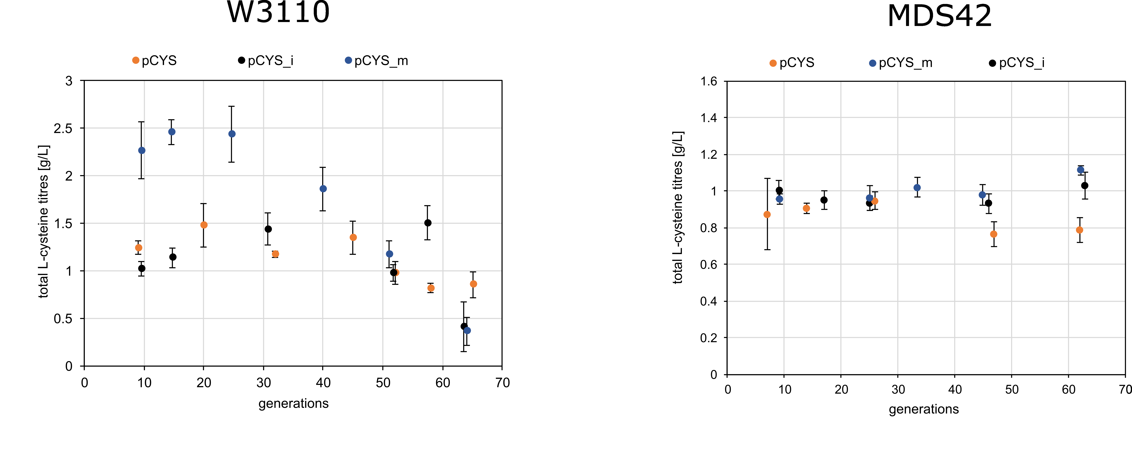Supplementary figure 1: Plots of total L-cysteine titres in g/L. Cultivation and subsequent L-cysteine titre measurements was carried out in biological triplicates of W3110 and MDS42 with the three different plasmids pCYS, pCYS_i and pCYS_m.

Supplementary table 3: Mapping statistics overview. For each sample, the following statistics are provided: Reads mapped: the total number of reads mapped to the reference genome. Unique: number of uniquely mapped reads, i.e. read can only be mapped to one reference locus. Reference covered: reference bases covered by at least one read. Mean read coverage: average read coverage of the reference sequence. HGP: high generation population, LGP: low generation population.
Sample | Reads mapped [Mio] | Unique [Mio] | Reference covered [Mb]
W3110_pCYS_HGP | 15.74 (98.6%) | 15.43 (96.6%) | 4.35 (93.7%)
W3110_pCYS_LGP | 17.48 (97.5%) | 17.16 (95.7%) | 4.26 (91.8%)
MDS42_pCYS_HGP | 12.52 (98.2%) | 12.35 (96.9%) | 3.54 (76.3%)
MDS42_pCYS_LGP | 21.15 (98.1%) | 20.73 (96.1%) | 2.63 (78.2%)
W3110_pCYS_i_HGP | 63.00 (98.0%) | 62.31 (96.9%) | 4.61 (99.2%)
W3110_pCYS_i_LGP | 38.42 (97.1%) | 37.97 (96.0%) | 4.56 (98.3%)
MDS42_pCYS_i_HGP | 52.81 (98.3%) | 52.30 (97.3%) | 3.93 (84.6%)
MDS42_pCYS_i_LGP | 32.11 (98.5%) | 31.88 (97.8%) | 3.89 (83.7%)
W3110_pCYS_m_HGP | 13.74 (98.5%) | 13.62 (97.7%) | 4.59 (99.1%)
W3110_pCYS_m_LGP | 10.93 (97.3%) | 10.84 (96.5%) | 4.35 (97.4%)
MDS42_pCYS_m_HGP | 12.75 (98.4%) | 12.64 (97.6%) | 3.89 (84%)
MDS42_pCYS_m_LGP | 13.14 (97.9%) | 13.05 (97.3%) | 3.76 (83.3%)

Supplementary table 4: Expression profiling statistics. For each sample, the following statistics are provided: Effective library size: The total number of reads mapped to reference features. Normalized library size: The total number of reads mapped to reference features normalized by the associated normalization factor, which can be derived by dividing the normalized library size by the effective library size. No feature: The number of reads mapping to the reference sequence that could not be assigned to any annotated feature, i.e. mapping positions and feature positions do not overlap. Filtered: The number of reads that were filtered due to insufficient mapping quality or ambiguous mapping location. These reads were ignored for read counting.
Sample | Effective Library Size | Normalized Library Size | No Feature | Filtered
W3110_pCYS_HGP | 14,252,994 | 14,476,778.3 | 1,165,261 | 538,202
W3110_pCYS_LGP | 15,767,859 | 17,145,605.9 | 1,379,155 | 776,008
MDS42_pCYS_HGP | 10,911,912 | 11,159,581.3 | 1,433,356 | 390,282
MDS42_pCYS_LGP | 18,559,438 | 17,419,716.3 | 2,160,469 | 832,562
W3110_pCYS_i_HGP | 28,130,536 | 27,532,366.2 | 2,882,373 | 1,119,315
W3110_pCYS_i_LGP | 16,502,506 | 18,445,755.2 | 2,402,562 | 869,322
MDS42_pCYS_i_HGP | 23,361,202 | 21,780,445.7 | 2,574,658 | 915,004
MDS42_pCYS_i_LGP | 14,731,777 | 13,971,444.8 | 981,102 | 571,985
W3110_pCYS_m_HGP | 18,597,401 | 18,489,582 | 1,065,231 | 481,982
W3110_pCYS_m_LGP | 18,351,569 | 18,154,799 | 995,471 | 571,451
MDS42_pCYS_m_HGP | 17,581,965 | 17,281,118 | 1,921,667 | 581,949
MDS42_pCYS_m_LGP | 16,411,682 | 15,984,381 | 1,763,955 | 739,814

Supplementary table 5: Table showing accession numbers, gene names, features, logarithmic fold changes (logFC) and p-values of all differentially expressed genes (DEGs) of W3310_pCYS with p-values <0.05. LogFC and logCPM were calculated by dividing values of the later generation population (LGP) by values of the early generation population (EGP). *: Genes were excluded because they did not fall within the FC range of the metabolic cluster.
Accession | Gene | Feature | LogFC | P-Value
b4205 | ytfA | biofilm formation | 6.31 | 0.0004
b3110 | cyuP | l-cysteine degradation | 5.12 | 0.001
b1505 | ydeT | biofilm formation | 5.07 | 0.001
b1556 | essQ | unknown function | 5.12 | 0.002
b1504 | YdeS | biofilm formation | 5.02 | 0.003
b4293 | FecI | iron starvation | 4.28 | 0.003
b1503 | ydeR | biofilm formation | 4.95 | 0.003
b4002 | ZraP | biofilm formation | 4.25 | 0.004
b1560 | YdfU | unknown function | 4.23 | 0.004
b4470 | CyuA | l-cysteine degradation | 4.11 | 0.004
b4277 | yjgZ | insertion sequence element | 5.05 | 0.004
b1038 | csgF | curli secretion | -4.15 | 0.004
b3558 | insK | insertion sequence element | 4.05 | 0.005
b0585 | fes | iron starvation | 4.04 | 0.005
b4292 | fecR | iron starvation | 4.00 | 0.005
b0584 | fepA | iron starvation | 3.98 | 0.005
b0590 | fepD | iron starvation | 3.99 | 0.005
b4567 | yjjZ | unknown function | 4.20 | 0.005
b0691 | ybfG | biofilm formation | 7.66 | 0.006
b1309 | ycjM | alternative sugar utilizing pathway | 4.36 | 0.007
b4011 | yjaA | biofilm formation | 3.87 | 0.007
b1502 | ydeQ | biofilm formation | 4.05 | 0.007
b2229 | yfaT | unknown function | 4.40 | 0.007
b0587 | fepE | iron starvation | 7.53 | 0.007
b0236 | prfH | unknown function | 4.30 | 0.008
b2298 | yfcC | unknown function | 3.65 | 0.010
b0589 | fepG | iron starvation | 3.61 | 0.010
b1554 | rrrQ | unknown function | 3.73 | 0.011
b0986 | gfC | unknown function | 3.72 | 0.011
b1039 | csgE | curli secretion | -3.53 | 0.012
b1600 | mdtJ | multidrug efflux | 3.55 | 0.013
b0583 | entD | iron starvation | 3.46 | 0.013
b2221 | atoD | acetyl-coA metabolic process | -3.56 | 0.014
b3557 | insJ | Insertion sequence element | 3.34 | 0.016
b1553 | rzpQ | unknown function | 3.55 | 0.017
b1496 | yddA | iron starvation | 3.81 | 0.017
b1037 | csgG | curli secretion | -3.25 | 0.018
b1599 | mdtl | multidrug efflux | 3.32 | 0.019
b1466 | narW | nitrate assimilation | -3.27 | 0.019
b3800 | aslB | L-cysteine degradation | 3.20 | 0.020
b0985 | gfcC | biofilm formation | 3.29 | 0.020
b2155 | cirA | iron starvation | 3.18 | 0.020
b0591 | entS | iron starvation | 3.15 | 0.022
b3158 | ubiU | ubiquinone biosynthesis | 3.15 | 0.022
b0894 | dmsA | anaerobic respiration | 3.07 | 0.024
b0549 | ybcO | unknown function | 3.67 | 0.024
b1492 | gadC | acid resistance | -3.05 | 0.025
b3708 | tnaA | tryptophanases | -3.06 | 0.025
b3060 | ttdR | transcriptional regulator | 3.15 | 0.025
b0575 | cusA | copper/silver export | 3.04 | 0.025
b2343 | yfcZ | unknown function | 3.02 | 0.026
b1493 | gadB | acid resistance | -3.00 | 0.028
b1040 | csgD | curli secretion | -2.98 | 0.028
b4183 | yjkK | unknown function | 3.21 | 0.029
b2339 | yfcV | biofilm formation | 3.48 | 0.029
b2997 | hybO | anaerobic respiration | 2.94 | 0.030
b2534 | yfhR | unknown function | 3.12 | 0.032
b0547 | ybcN | mismatch repair | 3.17 | 0.032
b0593 | entC | iron starvation | 2.90 | 0.032
b0984 | gfcD | unknown function | 2.92 | 0.033
b3408 | feoA | iron starvation | 2.89 | 0.033
b4511 | ybdZ | iron starvation | 3.07 | 0.033
b2222 | atoA | acetyl-coA metabolic process | -3.00 | 0.034
b1409 | ynbB | biofilm formation | 3.10 | 0.035
b1674 | ydhY | iron starvation | 3.02 | 0.036
b1468 | narZ | nitrate assimilation | -2.81 | 0.037
b3654 | xanP | xanthine transport | 2.81 | 0.037
b0913 | ycal | unknown function | 2.80 | 0.038
b0836 | bssR | biofilm formation | 2.79 | 0.038
b1469 | narU | nitrate assimilation | -2.79 | 0.039
b2172 | yeiQ | unknown function | 2.78 | 0.039
b3020 | ygiS | unknown function | 2.77 | 0.039
b1121 | ycfZ | unknown function | 4.17 | 0.040
b0550 | rusA | mismatch repair | 2.98 | 0.042
b1161 | ycgX | unknown function | 3.42 | 0.043
b4367 | fhuF | iron starvation | 2.72 | 0.043
b0375 | iprA | mismatch repair | 4.08 | 0.046
b0574 | cusB | copper/silver export | 2.68 | 0.046
b1541 | ydfZ | unknown function | 2.71 | 0.046
b1467 | narY | nitrate reductase | -2.67 | 0.047
b4314 | fimA* | biofilm formation | -2.63 | 0.049

Supplementary table 6: Table showing accession numbers, gene names, features, logarithmic fold changes (logFC) and p-values of all differentially expressed genes (DEGs) of MDS42_pCYS with p-values <0.05. LogFC and logCPM were calculated by dividing values of the later generation population (LGP) by values of the early generation population (EGP).
Accession | Gene | Feature | LogFC | P-Value
b4035 | malK | maltose transport | -4.54 | 0.0005
b4036 | lamB | maltose transport | -4.03 | 0.0013
b1224 | narG | nitrate assimilation | 3.86 | 0.0019
b1225 | narH | nitrate assimilation | 3.78 | 0.0022
b1223 | narK | nitrate assimilation | 3.74 | 0.0025
b3060 | ttdR | transcriptional regulator | 3.56 | 0.0043
b1226 | narJ | nitrate assimilation | 3.40 | 0.0052
b4034 | malE | maltose transport | -3.34 | 0.0064
b1227 | narI | nitrate assimilation | 3.30 | 0.0065
b4037 | malM | maltose transport | -3.00 | 0.0127
b4242 | mgtA | Mg2+ transport | -2.96 | 0.0131
b4032 | malG | maltose transport | -3.01 | 0.0133
b1750 | zdjX | unknown function | 3.00 | 0.0145
b1436 | yncJ | unknown function | -3.87 | 0.0193
b0894 | dmsA | anaerobic respiration | 2.65 | 0.0243
b4702 | mgtL | Mg2+ transport | -3.13 | 0.0254
b4033 | malF | maltose transport | -2.70 | 0.0259
b3366 | nirD | nitrate assimilation | 2.59 | 0.0274
b2111 | yehD | biofilm formation | 3.12 | 0.0279
b2298 | yfcC | unknown function | 2.56 | 0.0303
b2243 | glpC | anaerobic respiration | 2.53 | 0.0307
b3367 | nirC | nitrate assimilation | 2.50 | 0.0329
b0836 | bssR | biofilm formation | 2.44 | 0.0368
b3158 | ubiU | ubiquinone biosynthesis | 2.45 | 0.0375
b3960 | argH | L-arginine biosynthesis | 2.43 | 0.0375
b1826 | mgrB | Mg2+ transport | -2.51 | 0.0395
b1748 | astC | L-arginine degradation | -2.37 | 0.0426
b3365 | nirB | nitrate assimilation | 2.36 | 0.0429
b2242 | glpB | anaerobic respiration | 2.36 | 0.0430
b1182 | hlyE | heolysin | 2.67 | 0.0435
b0895 | dmsB | anaerobic respiration | 2.35 | 0.0438
b3508 | yhiD | unknown function | 2.52 | 0.0448
b1608 | rstA | unknown function | -2.34 | 0.0451
b1751 | ydjy | unknown function | 2.30 | 0.0498

Supplementary table 7: Table showing accession numbers, gene names, features, logarithmic fold changes (logFC) and p-values of all differentially expressed genes (DEGs) of W3110_pCYS_i with p-values <0.05. LogFC and logCPM were calculated by dividing values of the later generation population (LGP) by values of the early generation population (EGP).
Accession | Gene | Feature | LogFC | P-Value
b0365 | tauA | sulfur/L-cysteine starvation | -10.82 | 4.37E-07
b0366 | tauB | sulfur/L-cysteine starvation | -10.57 | 6.44E-07
b0367 | tauC | sulfur/L-cysteine starvation | -9.97 | 1.60E-06
b0368 | tauD | sulfur/L-cysteine starvation | -8.97 | 7.24E-06
b0937 | ssuE | sulfur/L-cysteine starvation | -8.61 | 2.22E-05
b3917 | sbP | sulfur/L-cysteine starvation | -7.98 | 3.27E-05
b0935 | ssUD | sulfur/L-cysteine starvation | -7.91 | 3.94E-05
b0936 | ssuA | sulfur/L-cysteine starvation | -7.36 | 9.94E-05
b0934 | ssuC | sulfur/L-cysteine starvation | -6.63 | 2.81E-04
b2752 | cysD | sulfur/L-cysteine starvation | -6.56 | 2.92E-04
b2750 | cysC | sulfur/L-cysteine starvation | -6.54 | 3.01E-04
b2751 | cysN | sulfur/L-cysteine starvation | -6.24 | 4.68E-04
b2422 | cysA | sulfur/L-cysteine starvation | -5.51 | 1.43E-03
b0933 | ssUB | sulfur/L-cysteine starvation | -5.37 | 1.81E-03
b2763 | cysI | sulfur/L-cysteine starvation | -5.16 | 2.40E-03
b2424 | cysU | sulfur/L-cysteine starvation | -5.16 | 2.47E-03
b2423 | cysW | sulfur/L-cysteine starvation | -5.07 | 2.80E-03
b4721 | ytiD | unknown function | -5.99 | 3.16E-03
b2762 | cysH | sulfur/L-cysteine starvation | -4.95 | 3.29E-03
b2764 | cysJ | sulfur/L-cysteine starvation | -4.70 | 4.77E-03
b1492 | gadC | acid resistance | -4.42 | 7.18E-03
b1493 | gadB | acid resistance | -4.15 | 1.07E-02
b4518 | ymdF | unknown function | -4.09 | 1.17E-02
b3517 | gadA | acid resistance | -4.01 | 1.29E-02
b2425 | cysP | sulfur/L-cysteine starvation | -3.98 | 1.38E-02
b1038 | csgF | curli secretion | -3.98 | 1.38E-02
b1039 | csgE | curli secretion | -3.87 | 1.61E-02
b1467 | narY | nitrate assimilation | -3.77 | 1.84E-02
b0897 | ysaC | unknown function | -3.73 | 1.94E-02
b3477 | nikB | nickel transport | 3.75 | 1.97E-02
b1489 | dosP | oxygen-sensing | -3.72 | 1.98E-02
b3491 | yhiM | unknown function | -3.72 | 1.99E-02
b2379 | alaC | L-alanine biosynthesis | -3.71 | 2.00E-02
b3555 | yiaG | unknown function | -3.69 | 2.04E-02
b0753 | ybgS | unknown function | -3.64 | 2.19E-02
b0775 | bioB | biotin biosynthesis | 3.67 | 2.23E-02
b1466 | narW | nitrate assimilation | -3.63 | 2.32E-02
b2414 | cysK | L-cysteine /precursor biosynthesis | -3.58 | 2.37E-02
b1287 | yciW | hyperosmotic stress | -3.58 | 2.40E-02
b3073 | patA | nitrogen limitation indicator | -3.56 | 2.45E-02
b1465 | narV | nitrate assimilation | -3.57 | 2.48E-02
b1040 | csgD | curli secretion | -3.55 | 2.51E-02
b2427 | murR | muramic acid regulator | -3.56 | 2.51E-02
b4187 | aidB | cellular response to DNA damage | -3.51 | 2.64E-02
b1468 | narZ | nitrate assimilation | -3.48 | 2.74E-02
b1469 | narU | nitrate assimilation | -3.45 | 2.90E-02
b2241 | glpA | anaerobic respiration | 3.43 | 3.01E-02
b1259 | yciG | acid resistance | -3.44 | 3.15E-02
b3510 | hdeA | acid resistance | -3.36 | 3.24E-02
b0553 | nmpC | unknown function | 3.31 | 3.53E-02
b2749 | ygbE | unknown function | -3.29 | 3.60E-02
b3511 | hdeD | acid resistance | -3.25 | 3.77E-02
b3478 | nikZ | nickel transport | 3.23 | 4.01E-02
b0774 | bioA | biotin biosynthesis | 3.21 | 4.18E-02
b2013 | tsuA | sulfur/L-cysteine starvation | -3.17 | 4.21E-02
b1732 | katE | hyperosmotic stress | -3.16 | 4.25E-02
b2012 | ysuB | sulfur/L-cysteine starvation | -3.16 | 4.26E-02
b0776 | bioF | biotin biosynthesis | 3.16 | 4.44E-02
b4376 | osmY | hyperosmotic stress | -3.12 | 4.49E-02
b1137 | ymfD | unknown function | 3.40 | 4.52E-02
b2465 | tktB | L-cysteine /precursor biosynthesis | -3.11 | 4.53E-02
b4568 | ytjA | unknown function | -3.10 | 4.58E-02
b1037 | csgG | curli secretion | -3.10 | 4.60E-02
b3514 | mdtF | multidrug efflux | -3.08 | 4.75E-02
b3661 | nlpA | methionine transport | -3.05 | 4.89E-02

Supplementary table 8: Table showing accession numbers, gene names, features, logarithmic fold changes (logFC) and p-values of all differentially expressed genes (DEGs) of MDS42_pCYS_i with p-values <0.05. LogFC and logCPM were calculated by dividing values of the later generation population (LGP) by values of the early generation population (EGP).
Accession | Gene | Feature | LogFC | P-Value
b0936 | ssuA | sulfur-/L-Cysteine starvation | -4.48 | 0.0068
b0937 | ssuE | sulfur-/L-Cysteine starvation | -4.43 | 0.0075
b3603 | lldP | cellular response to DNA damage | 4.35 | 0.0081
b3917 | sbp | sulfur-/L-Cysteine starvation | -4.33 | 0.0082
b0934 | ssuC | sulfur-/L-Cysteine starvation | -4.20 | 0.0101
b0935 | ssuD | sulfur-/L-Cysteine starvation | -4.06 | 0.0122
b2752 | cysD | sulfur-/L-Cysteine starvation | -4.03 | 0.0128
b3604 | lldR | cellular response to DNA damage | 4.03 | 0.0130
b3605 | lldD | cellular response to DNA damage | 3.99 | 0.0134
b2751 | cysN | sulfur-/L-Cysteine starvation | -3.78 | 0.0180
b2764 | cysJ | sulfur-/L-Cysteine starvation | -3.77 | 0.0184
b2763 | cysI | sulfur-/L-Cysteine starvation | -3.64 | 0.0219
b2750 | cysC | sulfur-/L-Cysteine starvation | -3.62 | 0.0226
b2425 | cysP | sulfur-/L-Cysteine starvation | -3.56 | 0.0250
b2013 | tsuA | sulfur-/L-Cysteine starvation | -3.55 | 0.0253
b2012 | tsuB | sulfur-/L-Cysteine starvation | -3.52 | 0.0264
b2422 | cysA | sulfur-/L-Cysteine starvation | -3.43 | 0.0294
b2762 | cysH | sulfur-/L-Cysteine starvation | -3.42 | 0.0300
b0933 | ssuB | sulfur-/L-Cysteine starvation | -3.37 | 0.0321
b2424 | cysU | sulfur-/L-Cysteine starvation | -3.27 | 0.0372
b2423 | cysW | sulfur-/L-Cysteine starvation | -3.22 | 0.0397
b1729 | tcyP | sulfur-/L-Cysteine starvation | -3.20 | 0.0401
b1287 | yciW | sulfur-/L-Cysteine starvation | -3.12 | 0.0447
Supplementary table 9: Table showing accession numbers, gene names, features, logarithmic fold changes (logFC) and p-values of all differentially expressed genes (DEGs) of W3110_pCYS_m with p-values <0.05. LogFC and logCPM were calculated by dividing values of the later generation population (LGP) by values of the early generation population (EGP).
Accession | Gene | Feature | logFC | P-Value
b0366 | tauB | sulfur-/ L-cysteine starvation | -5.821272583 | 2.98E-05
b0367 | tauC | sulfur-/ L-cysteine starvation | -5.082104853 | 0.000155955
b0365 | tauA | sulfur-/ L-cysteine starvation | -4.903006691 | 0.000213135
b0936 | ssuA | sulfur-/ L-cysteine starvation | -4.784398761 | 0.000363555
b0935 | ssuD | sulfur-/ L-cysteine starvation | -4.424511323 | 0.00064772
b1493 | gadB | acid resistance | -4.393691919 | 0.000650756
b4470 | cyuA | l-Cysteine degradation | 4.20665212 | 0.00099003
b1492 | gadC | acid resistance | -4.200031995 | 0.001002402
b0937 | ssuE | sulfur-/ L-cysteine starvation | -4.304585235 | 0.001055832
b0368 | tauD | sulfur-/ L-cysteine starvation | -4.130291126 | 0.00123138
b0450 | glnK | nitrogen starvation | -3.950577269 | 0.001776567
b3707 | tnaC | transcriptional attenuation | -4.18533155 | 0.002304927
b0934 | ssuC | sulfur-/ L-cysteine starvation | -3.810239622 | 0.002799372
b0451 | amtB | nitrogen starvation | -3.678782354 | 0.003164359
b1489 | dosP | oxygen sensing | -3.693422741 | 0.003226504
b3708 | tnaA | tryptophanases | -3.633665908 | 0.003575459
b2750 | cysC | sulfur-/ L-cysteine starvation | -3.599451267 | 0.003912051
b2298 | yfcC | unknown function | 3.592554082 | 0.004078273
b1488 | ddpX | nitrogen starvation | -3.623180338 | 0.004573246
b1748 | astC | L-arginine catabolysis | -3.518503904 | 0.004670165
b1988 | nac | nitrogen starvation | -3.434444053 | 0.005431418
b3917 | sbp | sulfur-/ L-cysteine starvation | -3.435172087 | 0.005444333
b1467 | narY | nitrate assimilation | -3.438555719 | 0.005601404
b3511 | hdeD | acid resistance | -3.361747128 | 0.006279399
b1466 | narW | nitrate assimilation | -3.391764903 | 0.006610653
b1747 | astA | L-arginine catabolysis | -3.327739224 | 0.006992027
b1012 | rutA | pyrimidin degradation | -3.421121875 | 0.007184279
b1182 | hlyE | hemolysis | 3.512051653 | 0.00775016
b3517 | gadA | acid resistance | -3.221148839 | 0.008425411
b2751 | cysN | sulfur-/ L-cysteine starvation | -3.206799828 | 0.008634876
b1468 | narZ | nitrate assimilation | -3.147760624 | 0.009868409
b4314 | fimA | cell adhesion | -3.006357837 | 0.013196354
b3671 | ilvB | BCAA biosynthesis | -2.994222798 | 0.013343519
b2763 | cysI | sulfur-/ L-cysteine starvation | -2.980844596 | 0.013714836
b3509 | hdeB | acid resistance | -2.947653324 | 0.014698199
b3268 | yhdW | unknown function | -2.936914268 | 0.015223895
b1038 | csgF | curli secretion | -2.979648511 | 0.015299404
b1487 | ddpA | nitrogen starvation | -2.921872385 | 0.01666648
b1541 | ydfZ | unknown function | 2.904012063 | 0.016843664
b1465 | narV | nitrate assimilation | -2.889579459 | 0.017708658
b3514 | mdtF | multidrug efflux | -2.848462657 | 0.018047176
b3110 | cyuP | l-Cysteine degradation | 2.821287725 | 0.018927267
b1987 | cbI | sulfur-/ L-cysteine starvation | -2.823628515 | 0.019316605
b1746 | astD | L-arginine catabolysis | -2.817034764 | 0.019391912
b2111 | yehD | biofilm formation | 3.261253189 | 0.019492368
b3510 | hdeA | acid resistance | -2.791811406 | 0.020018914
b2422 | cysA | sulfur-/ L-cysteine starvation | -2.773039444 | 0.020788403
b0992 | yccM | unknown function | 2.841407281 | 0.02087771
b2752 | cysD | sulfur-/ L-cysteine starvation | -2.728603797 | 0.02271106
b4072 | nrfC | anaerobic respiration | 2.933523439 | 0.022806289
b2343 | yfcZ | unknown function | 2.714277519 | 0.023304408
b4070 | nrfA | anaerobic respiration | 2.73552111 | 0.023744641
b2423 | cysW | sulfur-/ L-cysteine starvation | -2.71382996 | 0.023758522
b0933 | ssuB | sulfur-/ L-cysteine starvation | -2.726988746 | 0.024362651
b0896 | dmsC | anaerobic respiration | 2.659026564 | 0.026118345
b2110 | yehC | biofilm formation | 3.86463591 | 0.026778193
b4116 | adiY | transcriptional activation | 2.619087737 | 0.028356012
b1745 | astB | L-arginine catabolysis | -2.625927022 | 0.028460359
b1224 | narG | nitrate assimilation | -2.598496723 | 0.029222593
b3158 | ubiU | ubiquinone biosynthesis | 2.611203373 | 0.029286652
b2310 | argT | nitrogen starvation | -2.581918264 | 0.030323738
b2764 | cysJ | sulfur-/ L-cysteine starvation | -2.569263788 | 0.030819373
b3670 | ilvN | BCAA biosynthesis | -2.56428254 | 0.031168241
b1443 | ydcV | unknown function | -2.590221267 | 0.031564249
b3269 | ydhX | unknown function | -2.595507339 | 0.032143511
b1674 | ydhY | unknown function | 2.640124724 | 0.032660893
b0895 | dmsB | anaerobic respiration | 2.538107989 | 0.033062582
b2203 | napB | anaerobic respiration | 2.590548108 | 0.03328397
b1490 | dosC | oxygen sensing | -2.534568305 | 0.033441933
b4245 | pyrB | pyrimidin degradation | -2.524023685 | 0.033568073
b3369 | yhfL | unknown function | 3.100367778 | 0.033702782
b1011 | rutB | pyrimidin degradation | -2.696697026 | 0.034889092
b2345 | yfdF | unknown function | 3.18686013 | 0.03551058
b2208 | napF | anaerobic respiration | 2.536604392 | 0.035939355
b0991 | ymcE | unknown function | 3.068757409 | 0.036027242
b3073 | patA | l-lysin degradation | -2.459327192 | 0.03821933
b1731 | cedA | cell division regulation | 2.681966451 | 0.038563357
b2292 | yfbS | unknown function | 2.451566606 | 0.038713109
b2996 | hybA | anaerobic respiration | 2.459889195 | 0.038806123
b0990 | cspG | cold shock response | 2.50706977 | 0.03895797
b0894 | dmsA | anaerobic respiration | 2.444091285 | 0.039041251
b1287 | yciW | hyperosmotic stress | -2.448737859 | 0.039274106
b2676 | nrdF | pyrimidin degradation | -2.493438134 | 0.03953287
b1675 | fumA | anaerobic respiration | 2.545337693 | 0.039793075
b1025 | dgcT | biofilm formation | 2.549287518 | 0.039812429
b1441 | ydcT | unknown function | -2.474246634 | 0.040116258
b3709 | tnaB | tryptophanases | -2.607284958 | 0.040244207
b2201 | ccmA | cytochrome c maturation | 2.44516171 | 0.040712435
b2727 | hypB | protein maturation | 2.423184881 | 0.041180646
b4244 | pyrI | pyrimidin degradation | -2.40898976 | 0.041669821
b0621 | dcuC | succinat efflux | 2.422663786 | 0.041722113
b2202 | napC | anaerobic respiration | 2.422513419 | 0.041909772
b0036 | caiD | L-carnitine degradation | 2.512422952 | 0.043274337
b2997 | hybO | anaerobic respiration | 2.38619037 | 0.043938516
b4606 | ypfM | unknown function | 2.496316042 | 0.044010761
b1014 | putA | L-proline degradation | -2.371242798 | 0.044714409
b2749 | ygbE | unknown function | -2.397245869 | 0.045600936
b3508 | yhiD | unknown function | -2.371373692 | 0.046274455
b3513 | gadW | acid resistance | -2.354682174 | 0.046389608
b4713 | agrB | small regulatory RNA | 2.899398595 | 0.047659431
b0618 | citC | citrate lyase | 2.786062243 | 0.047944746
b1039 | csgE | curli secretion | -2.386568791 | 0.047956706
b4517 | gnsA | unknown function | 2.435844309 | 0.048711147
b1744 | astE | L-arginine catabolysis | -2.36011251 | 0.049168527
b2150 | mglB | chemotaxis | -2.348907891 | 0.049424165

Supplementary table 10: Table showing accession numbers, gene names, features, logarithmic fold changes (logFC) and p-values of all differentially expressed genes (DEGs) of MDS42_pCYS_m with p-values <0.05. LogFC and logCPM were calculated by dividing values of the later generation population (LGP) by values of the early generation population (EGP).
Accession | Gene | Feature | logFC | P-Value
gene-b4668 | ibsB | unknown function | -2.17 | 0.022
gene-b3643 | rph | rRNA 3'-end and tRNA processing | -4.98 | 0.027
gene-b1539 | ydfG | uracil catabolism | 3.04 | 0.028
gene-b1137 | ymfD | unknown function | 2.14 | 0.028
gene-b2848 | yqeJ | unknown function | 1.37 | 0.038
gene-b0150 | yceK | iron starvation | 4.59 | 0.039
gene-b2724 | hycB | glucose catabolism | -1.33 | 0.039
gene-b2481 | hyfA | alternative sugar utilizing pathways | 1.22 | 0.043
gene-b3900 | frvA | glucose catabolism | -1.40 | 0.044
gene-b4268 | idnK | alternative sugar utilizing pathways | 1.12 | 0.047
gene-b0532 | sfmD | pilus organization | -1.13 | 0.047
gene-b0040 | caiT | nitrogen starvation | -1.13 | 0.048
gene-b4181 | yjfl | unknown function | 1.24 | 0.048
gene-b4254 | argI | nitrogen starvation | -1.02 | 0.049

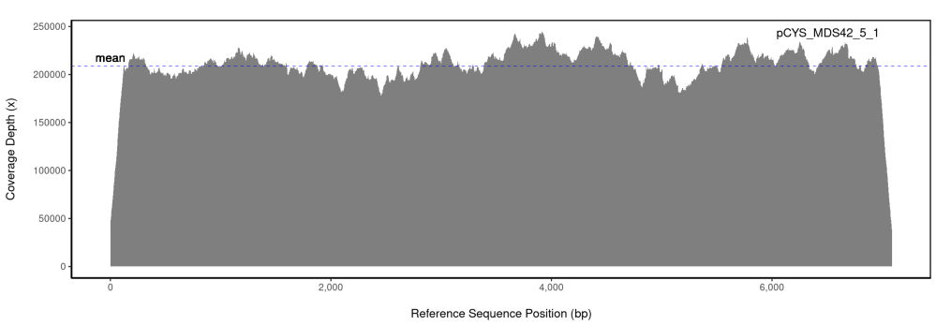
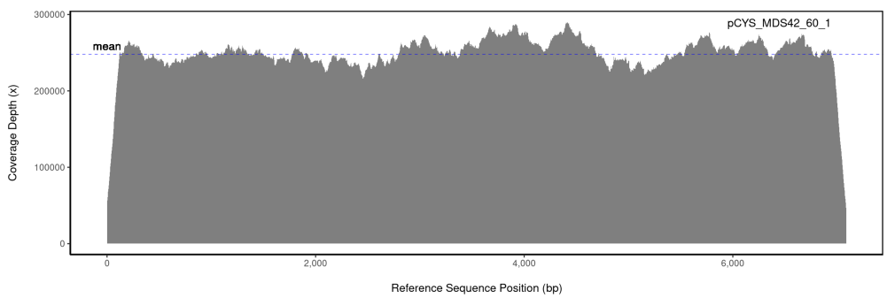
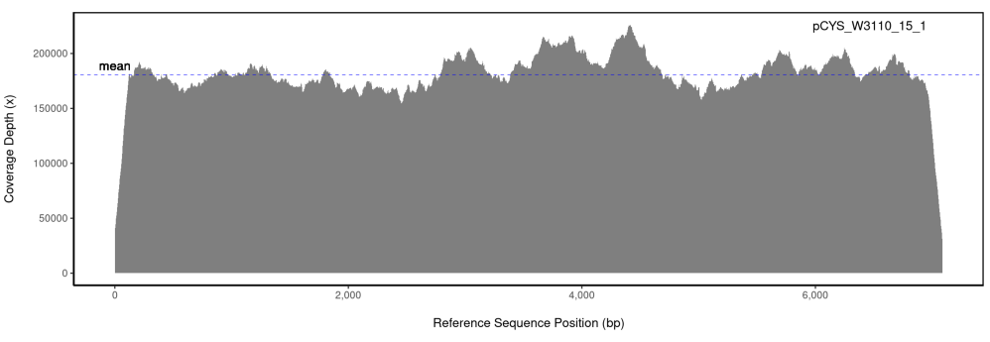
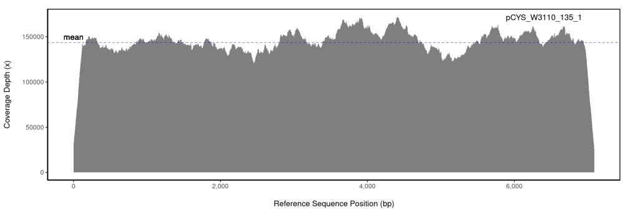
Supplementary figure 2: Per base coverage depths (x) of sequenced pCYS extracted from early and late generation populations (EGPs and LGPs) of E. coli W3110 and MDS42. Sequencing was conducted with Illumina Novaseq paired end 2x150bp.
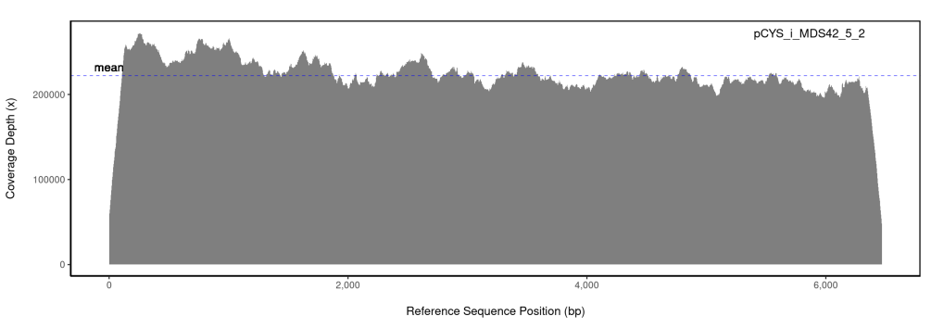
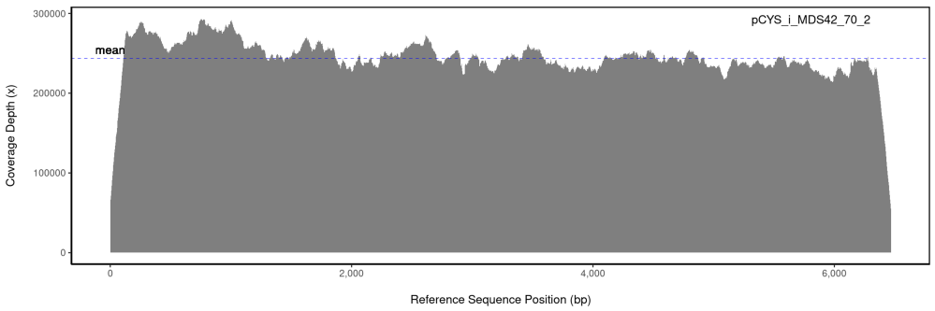
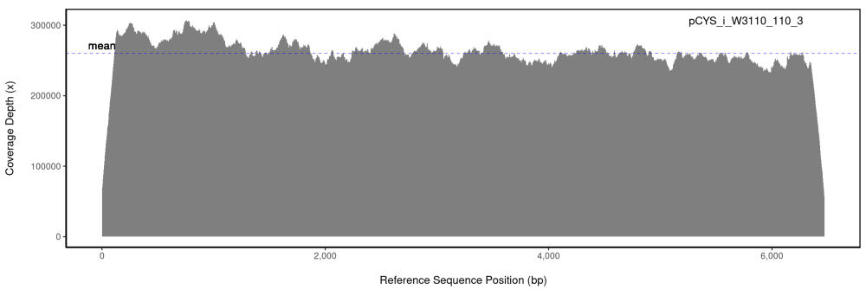
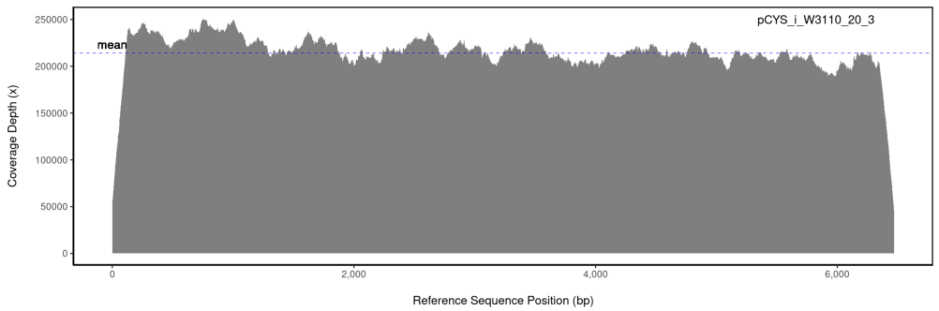
Supplementary figure 3: Per base coverage depths (x) of sequenced pCYS_i extracted from early and late generation populations (EGPs and LGPs) of E. coli W3110 and MDS42. Sequencing was conducted with Illumina Novaseq paired end 2x150bp.
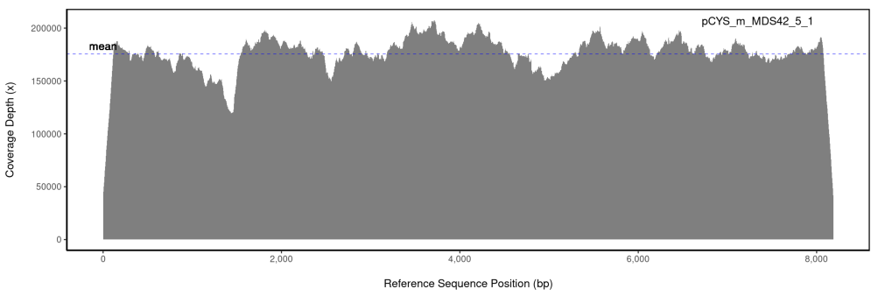
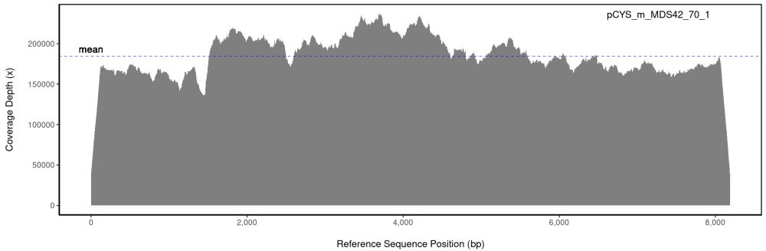
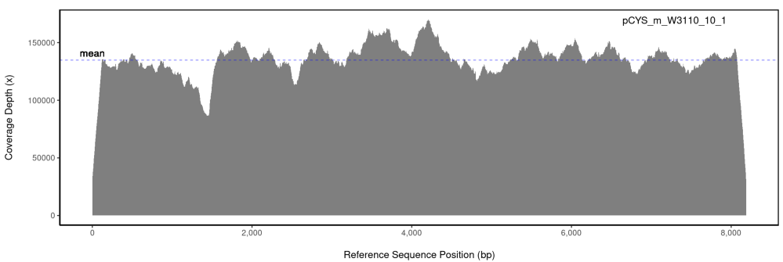
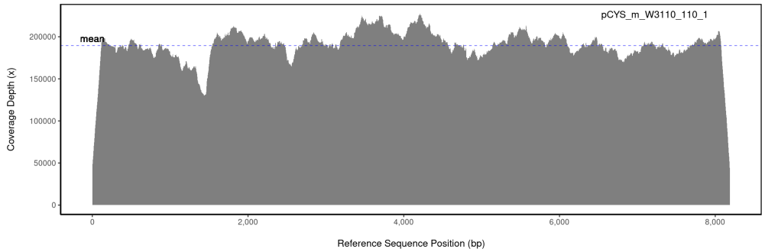
Supplementary figure 4: Per base coverage depths (x) of sequenced pCYS_m extracted from early and late generation populations (EGPs and LGPs) of E. coli W3110 and MDS42. Sequencing was conducted with Illumina Novaseq paired end 2x150bp.

1. Gaitonde, M.K., A spectrophotometric method for the direct determination of Cysteine in the presence of other naturally occuring amino acids. Biochem. J., 1967. 104: p. 627-633.

