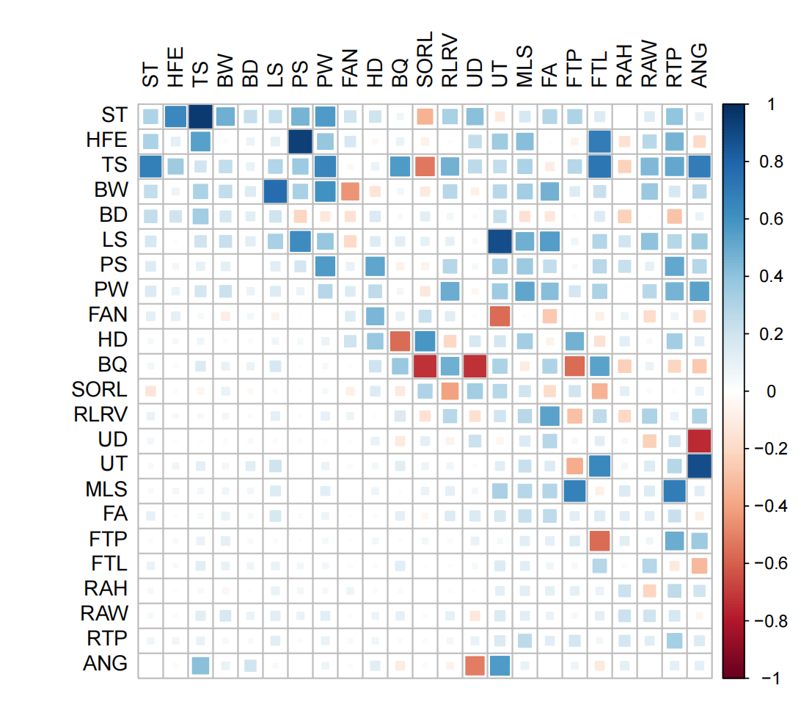
Additional file 2: Figure S1. Genetic and phenotypic correlations among conformation traits

