Supporting Information

Amorphization boost multi-ion storage for high-performance aqueous batteries
Bowen Jin^{1,2}, Yuanhui Liu^{1,2}, Junya Cui¹, Shimeng Zhang¹, Yu Wu¹, Annan Xu¹, Ming Xu¹, and Mingfei Shao^{1,}*
¹ State Key Laboratory of Chemical Resource Engineering, Beijing University of Chemical Technology, Beijing 100029, China
² These authors contribute equally to this work
*Corresponding author E-mail address: shaomf@mail.buct.edu.cn

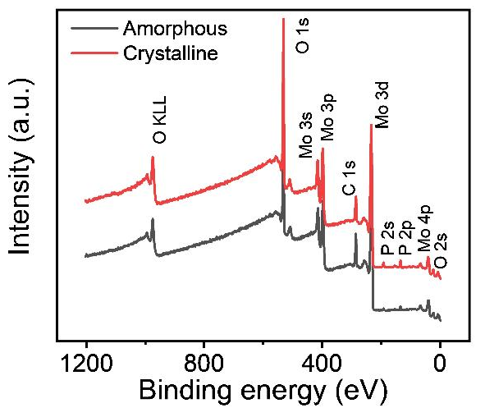
Figure S1. X-ray photoelectron wide spectra of A-MoO_{x} and C-MoO_{x}.

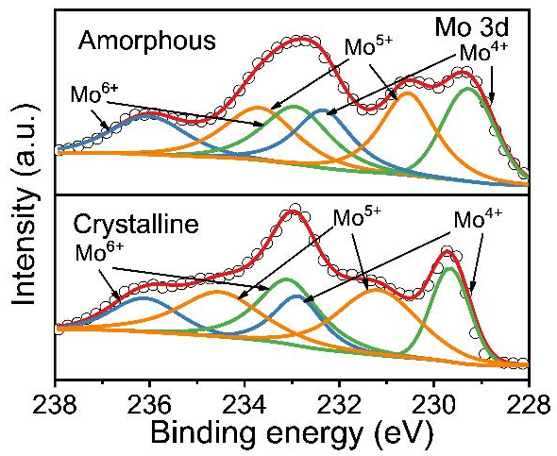
Figure S2. X-ray photoelectron spectra displaying the Mo 3d binding energy region for A-MoO_{x} and C-MoO_{x}.
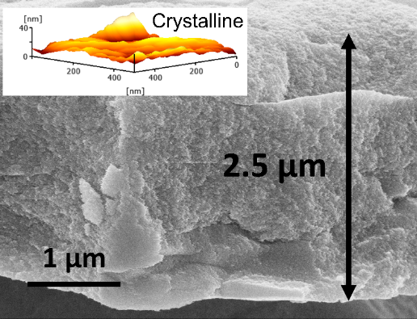
Figure S3. Typical cross-section SEM image of C-MoO_{x} (inset: corresponding atomic force microscope image of top-view).

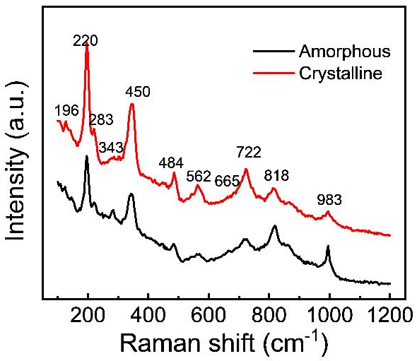
Figure S4. Raman spectroscopy spectra of A-MoO_{x} and C-MoO_{x}.

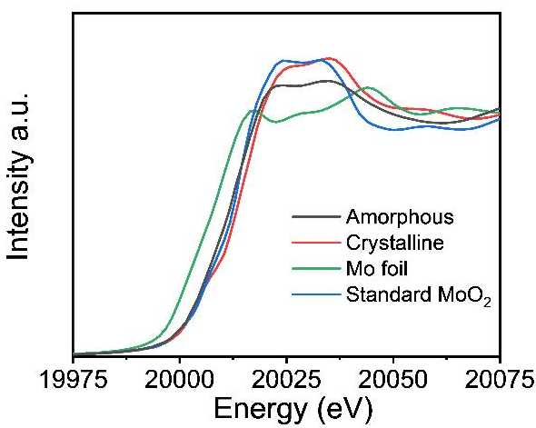
Figure S5. normalized Mo K-edge X-ray absorption near-edge structure (XANES) spectra
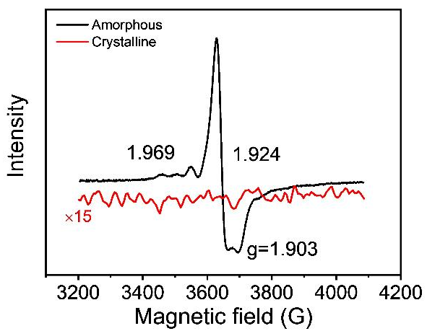
Figure S6. EPR spectra of A-MoO_{x} and C-MoO_{x}.

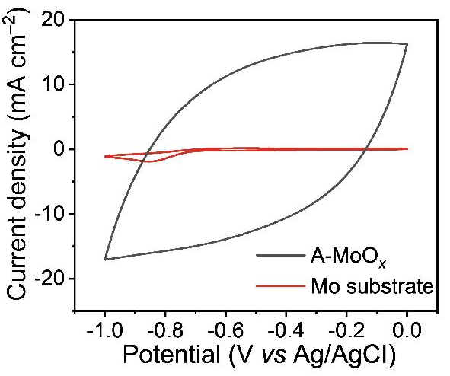
Figure S7. CV curves of A-MoO_{x} and Mo substrate at scan rate of 100 mV s^{‒1}.

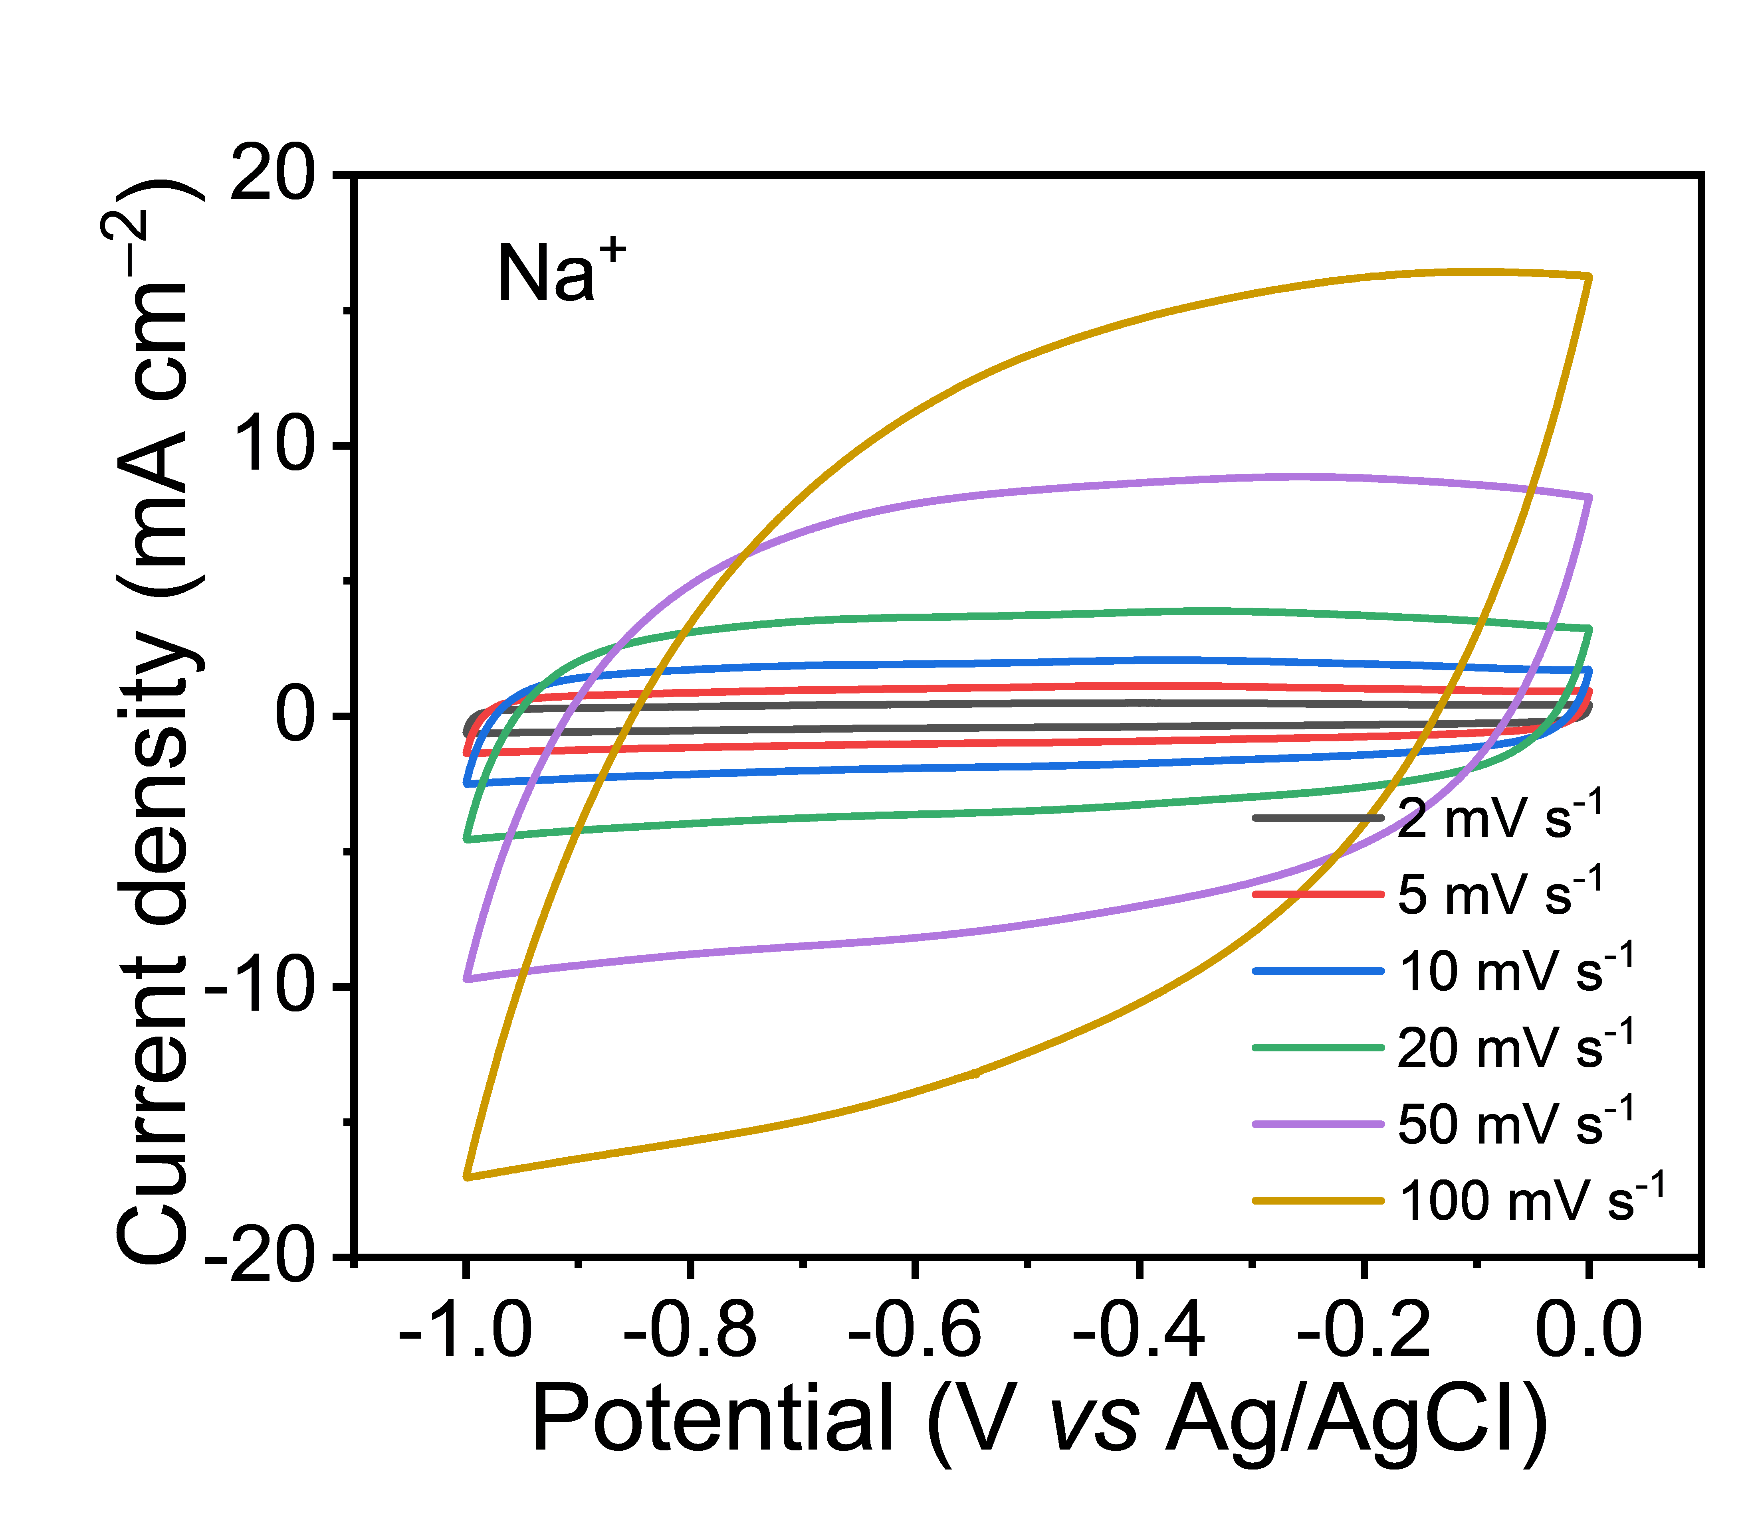
Figure S8. CV curves of A-MoO_{x} at various scan rate in Na⁺ electrolyte.
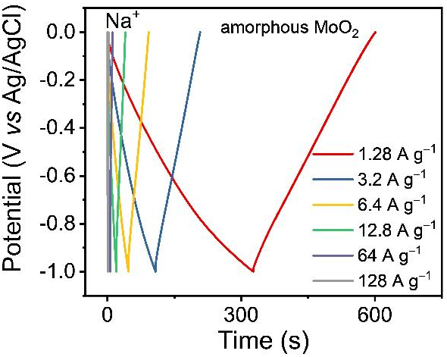
Figure S9. GCD curves of A-MoO_{x} at various discharging rate in Na⁺ electrolyte.

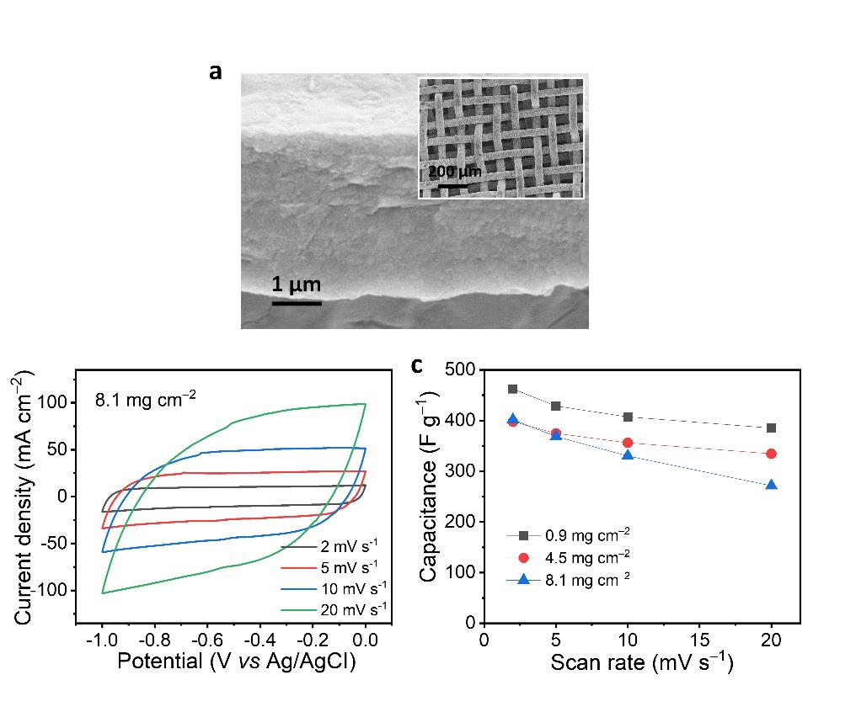
Figure S10. a, SEM image of A-MoO_{x} in Mo net. b, CV curves of A-MoO_{x} in Mo net at various scan rate. c, specific and areal capacitances of A-MoO_{x} in Mo net with different mass loading.

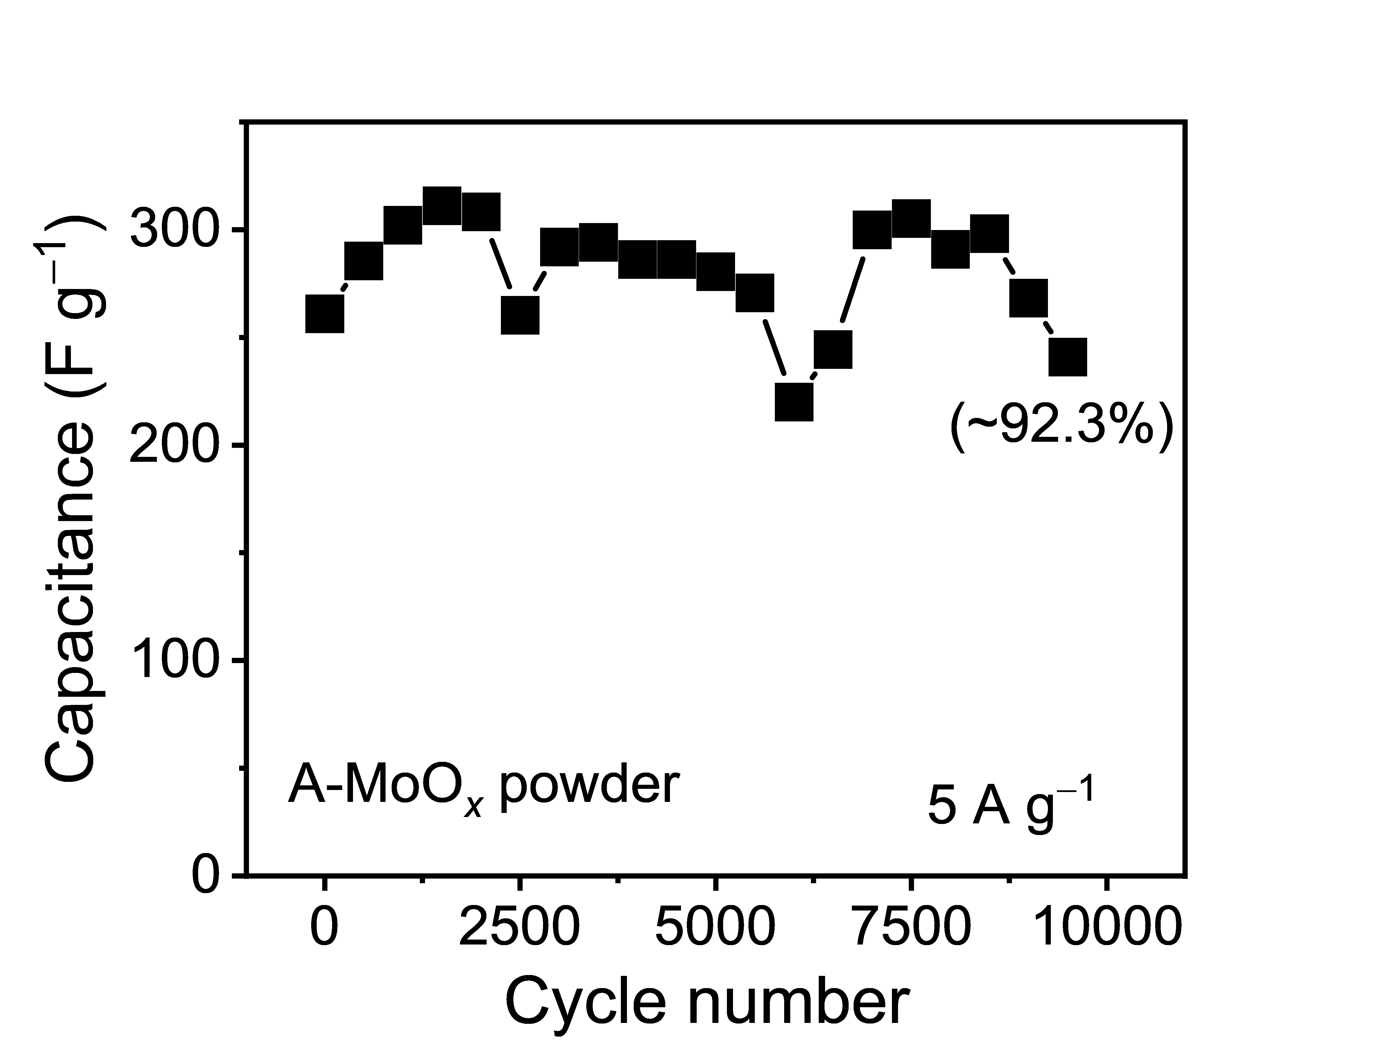
Figure S11. The cycling performance of A-MoO_{x} powder with carbon black and PVDF in Na⁺ solution.

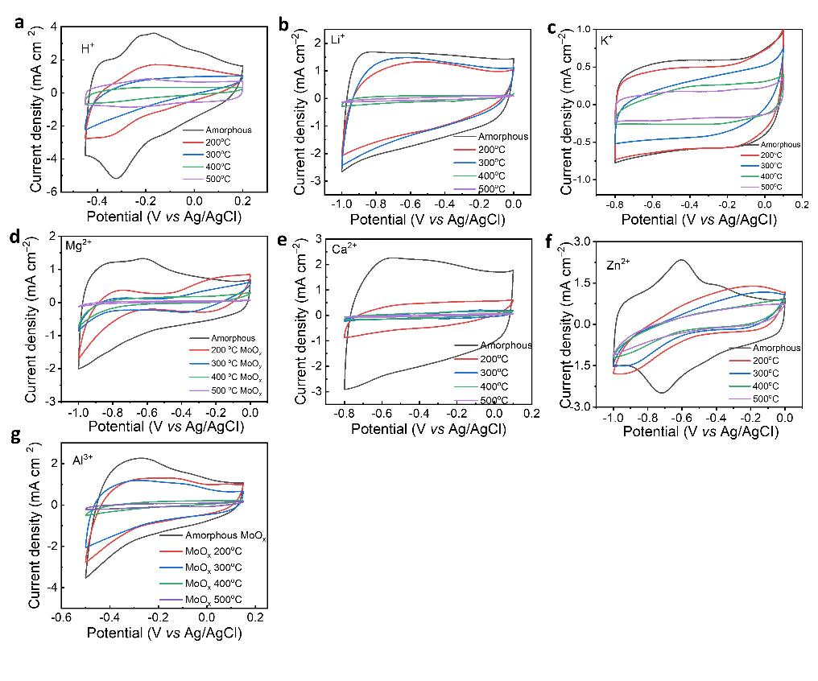
Figure S12. CV curves of A-MoO_{x} and C-MoO_{x} in various electrolyte: (a) H⁺; (b) Li⁺; (c) K⁺; (d) Mg²⁺; (e) Ca²⁺; (f) Zn²⁺; (g) Al³⁺.

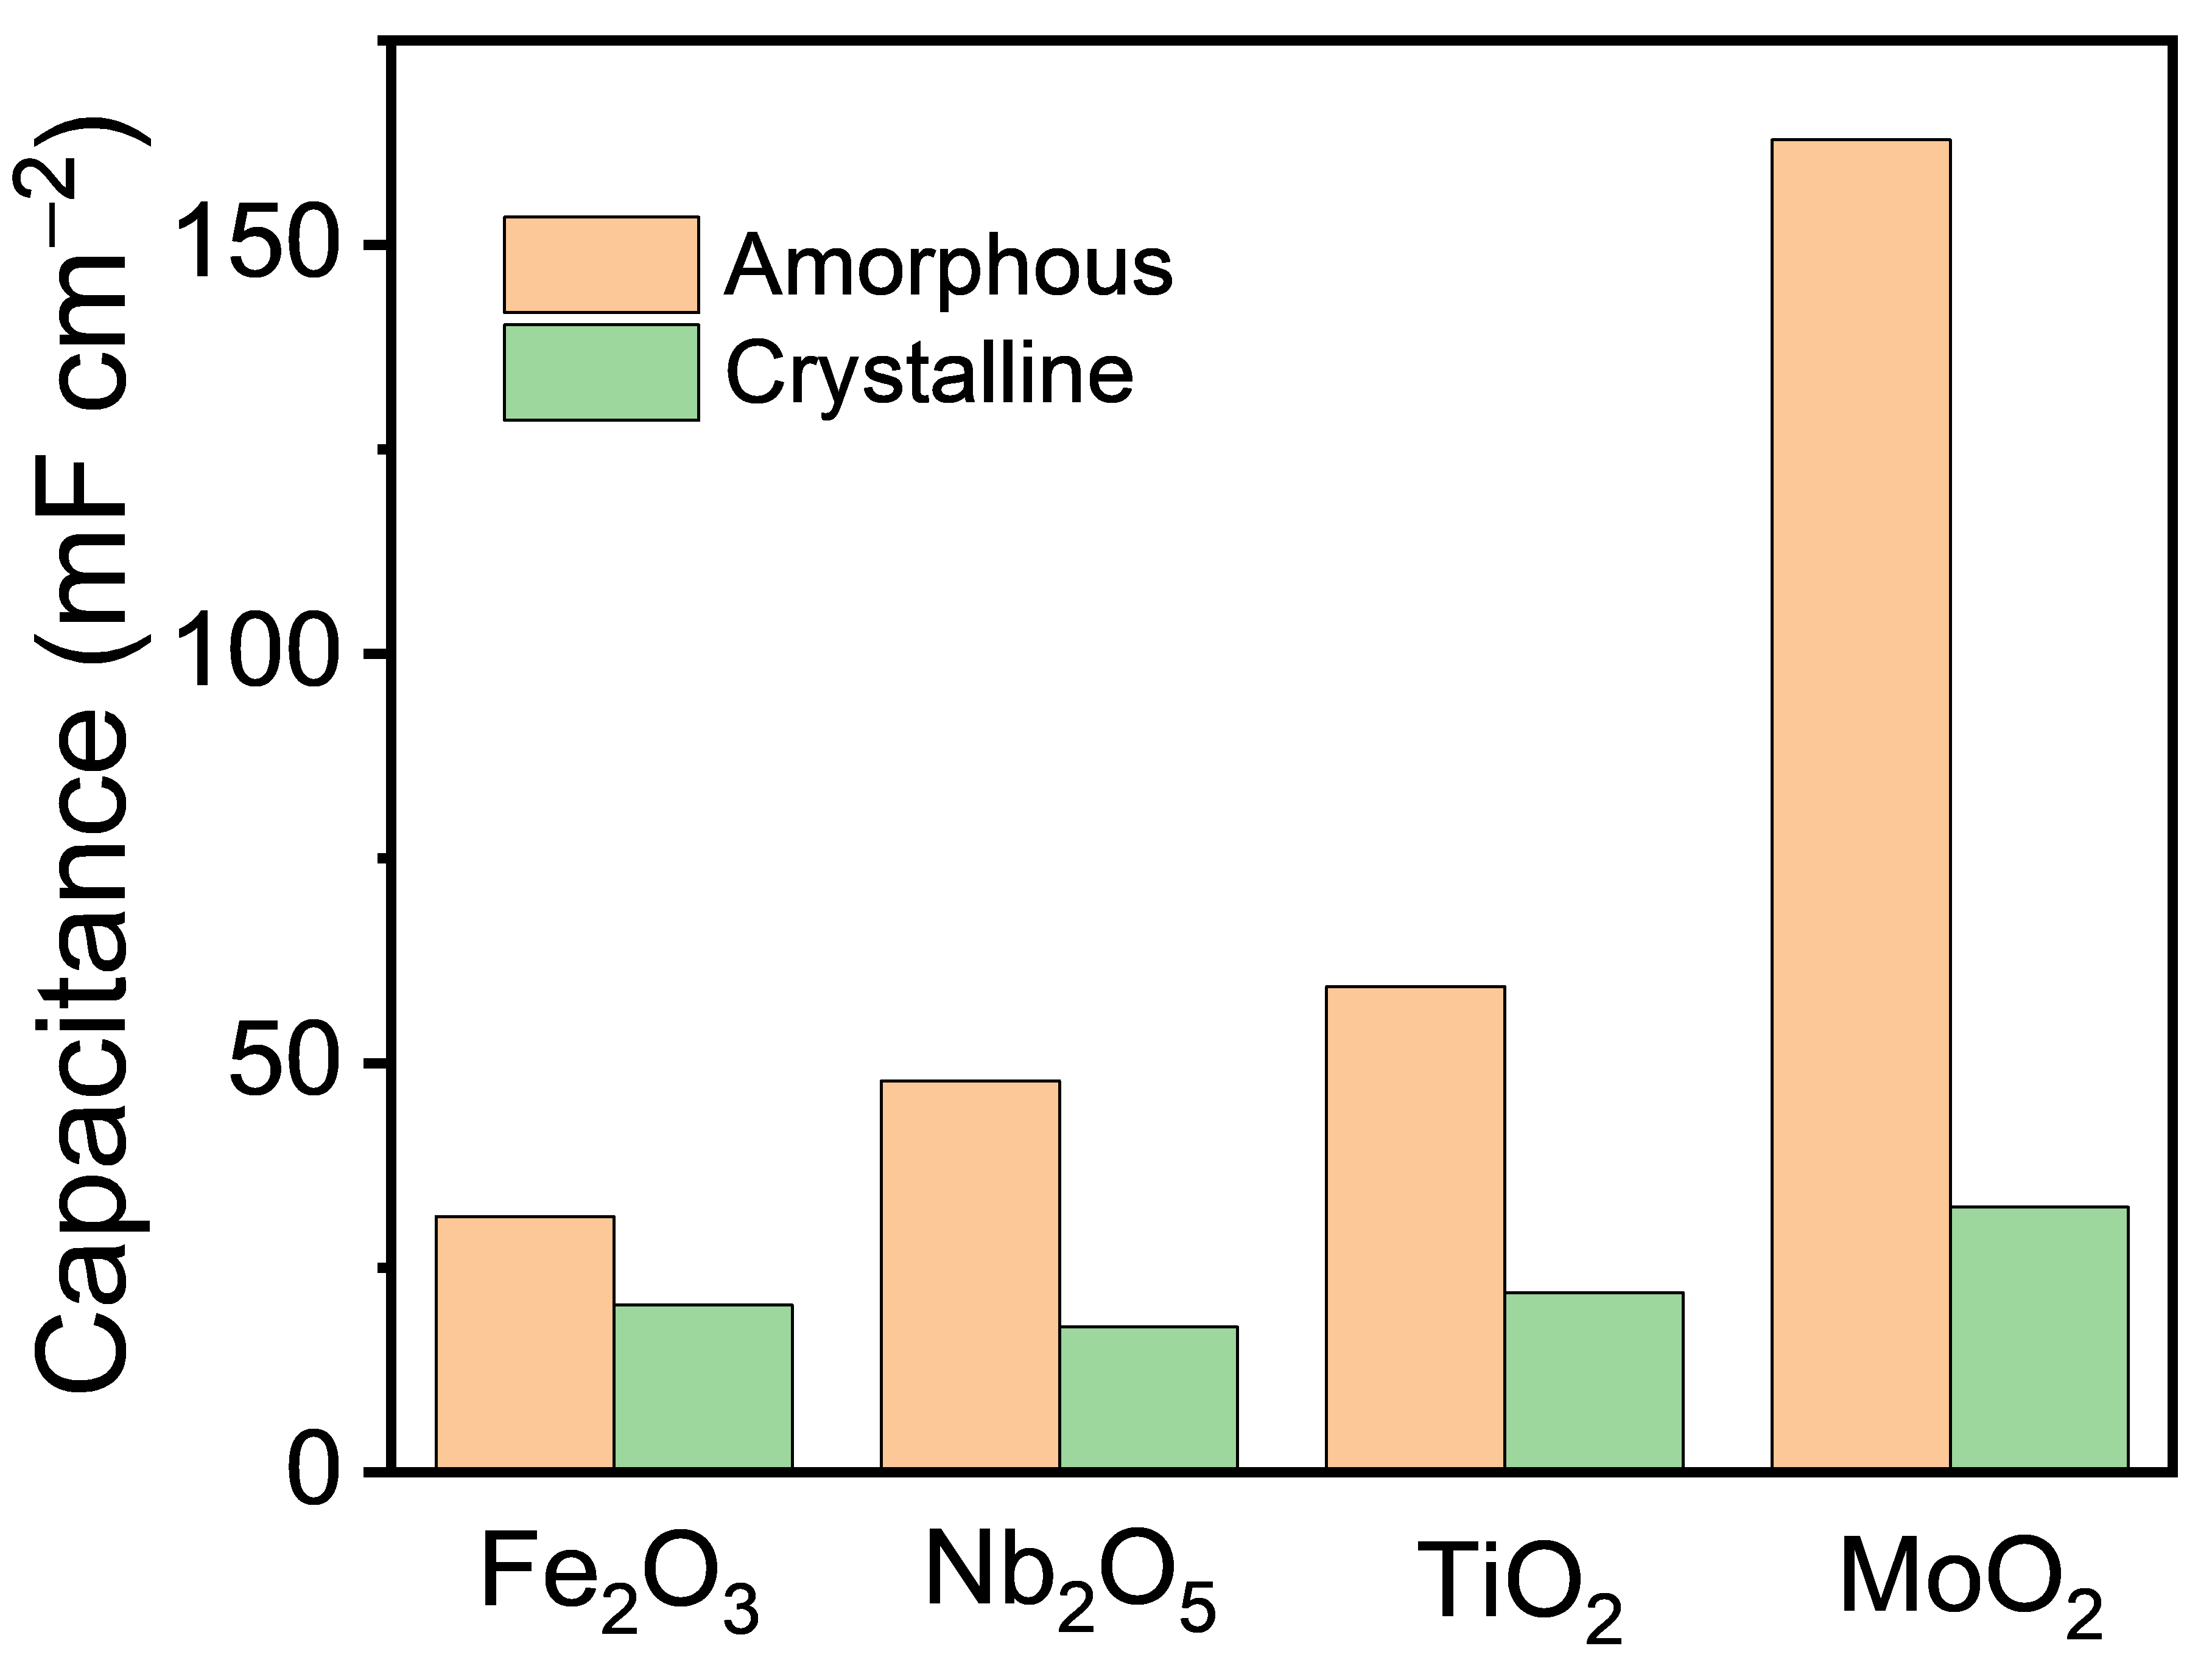
Figure S13. The capacitance of amorphous and crystalline metal oxides
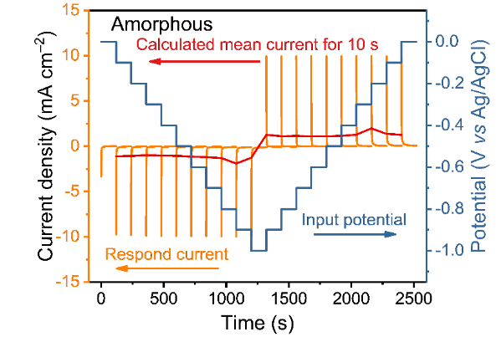
Figure S14. MUSCA test of applied potential and current density responds vs. times in Na⁺ electrolyte. The red line is an example of calculated mean current density for first 10 seconds.

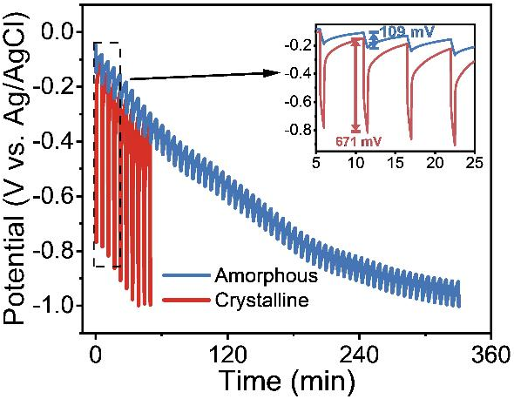
Figure S15. GITT profiles at 0.15 A g⁻¹ of the A-MoO_{x} and C-MoO_{x} (inset: the high magnifications profiles at initial steps).

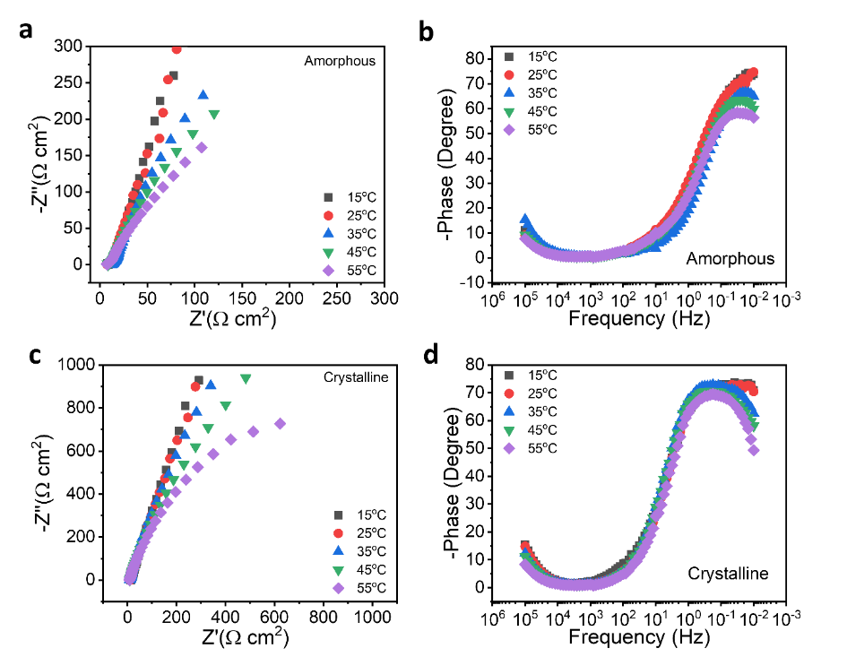
Figure S16. Electrochemical impedance of A-MoO_{x} and C-MoO_{x} measured at different temperature a, Nyquist plots of A-MoO_{x}; b, Bode plots of A-MoO_{x}; c, Nyquist plots of C-MoO_{x}; d, Bode plots of C-MoO_{x.}
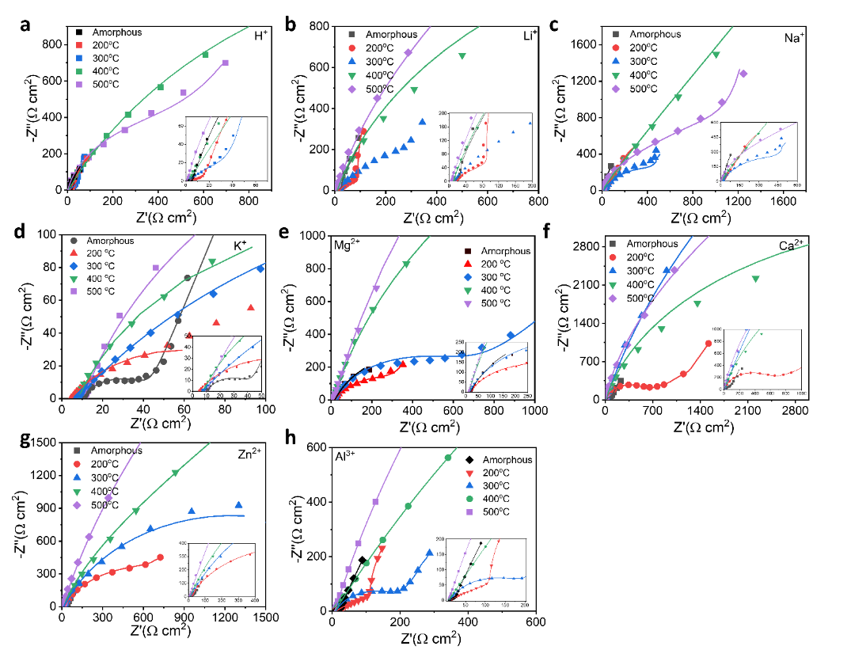
Figure S17. The Nyquist plots of A-MoO_{x} and C-MoO_{x} in various electrolyte: (a) H⁺; (b) Li⁺; (c) K⁺; (d) Mg²⁺; (e) Ca²⁺; (f) Zn²⁺; (g) Al³⁺. (Nyquist plots zooming on at high frequency).

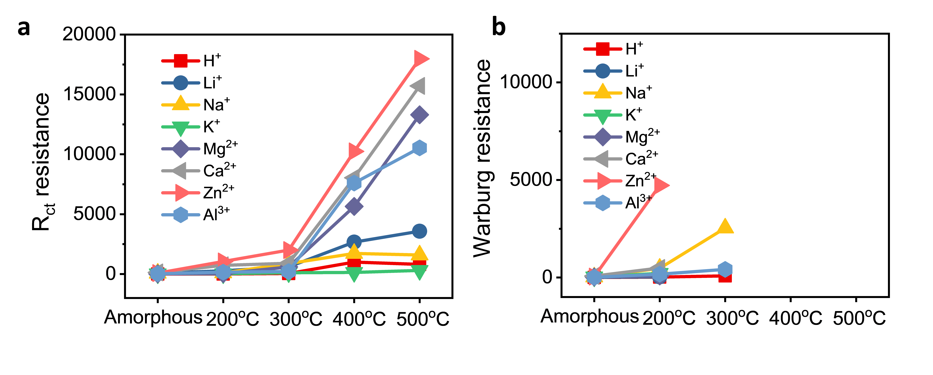
Figure S18. EIS simulation of A-MoO_{x} and C-MoO_{x} in various electrolyte: (a) R_{ct} resistances; (b) Warburg resistances.

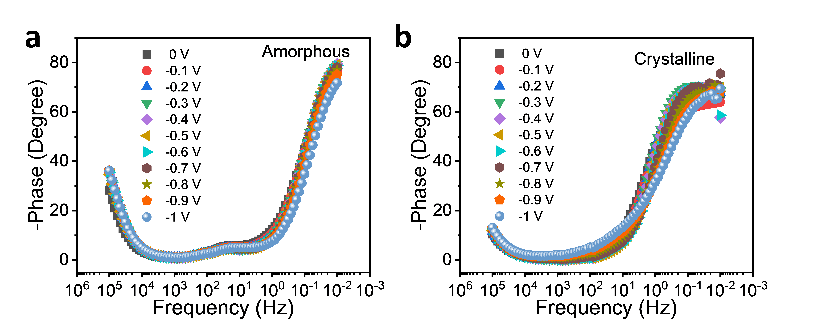
Figure S19. The Bode plots of A-MoO_{x} and C-MoO_{x} in various electrolyte: (a) H⁺; (b) Li⁺; (c) K⁺; (d) Mg²⁺; (e) Ca²⁺; (f) Zn²⁺; (g) Al³⁺. (Nyquist plots zooming on at high frequency)

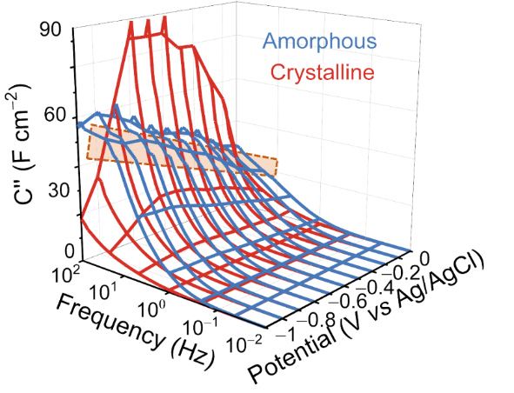
Figure S20. The 3D Bode plot representations of the imaginary areal normalized capacitance (C’’) vs. frequency vs. potential for A-MoO_{x} and C-MoO_{x} in Na⁺.

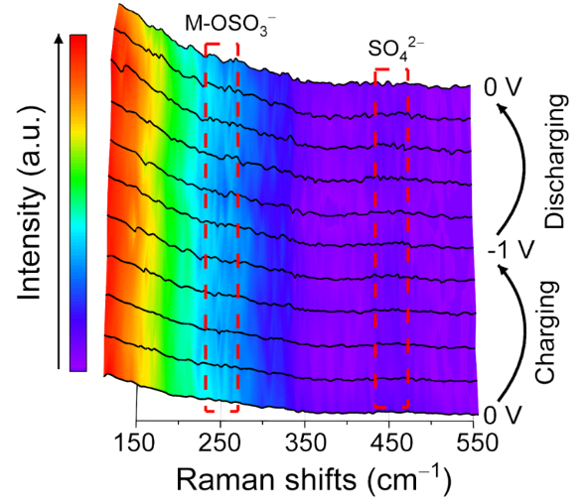
Figure S21. In-situ Raman shift of C-MoO_{x} during cycling.
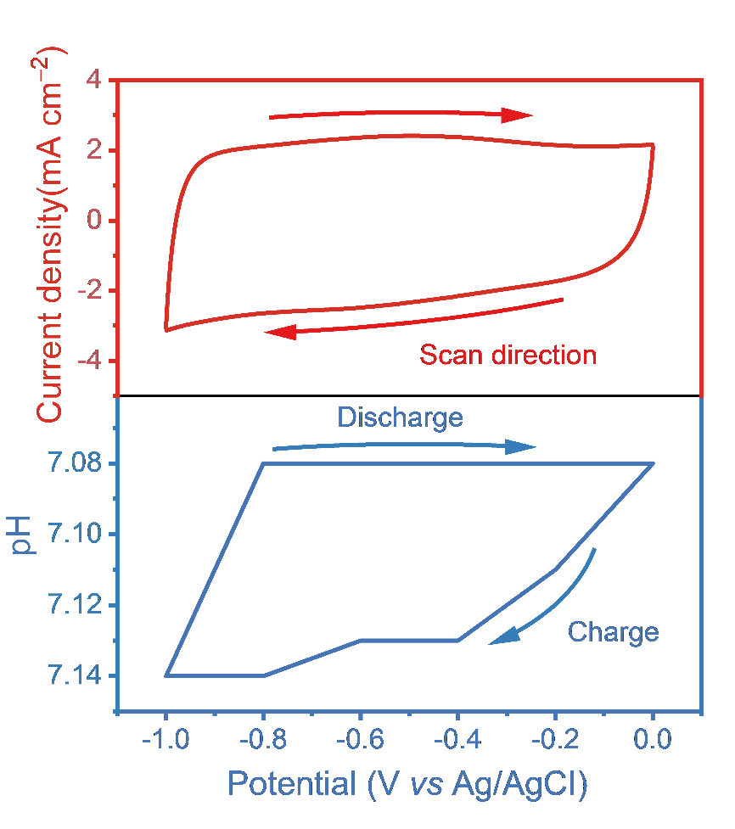
Figure S22. Operando pH changes during charging/discharging process via CV measurement.

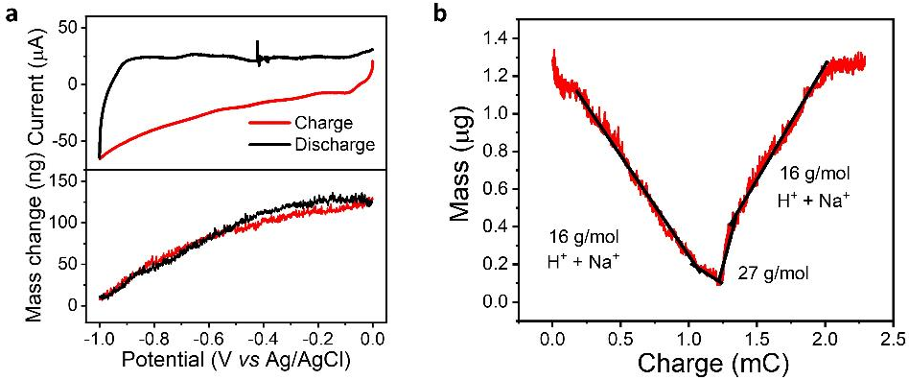
Figure S23. Operando EQCM measurement of A-MoO_{x} during intercalation and deintercalation process (a) CV measurement and corresponding mass changes; (b) the mass changes of A-MoO_{x} vs charging transport.
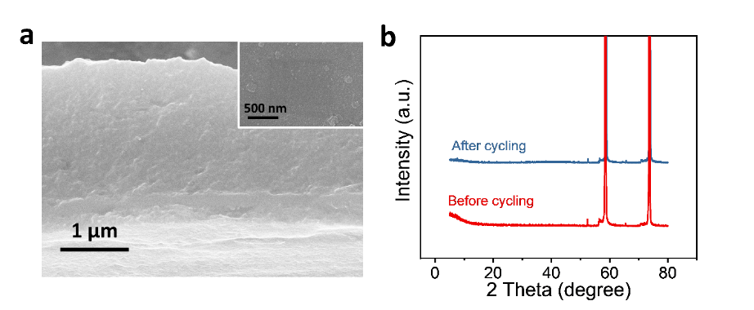
Figure S24. (a) SEM and (b) XRD pattern of A-MoO_{x} before and after cycling test.

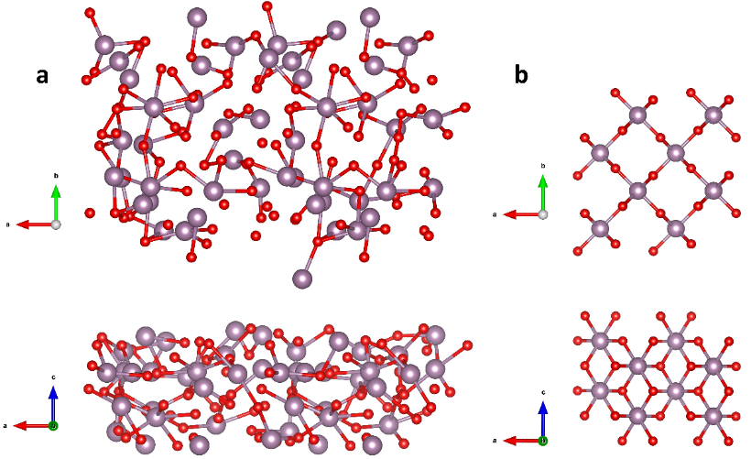
Figure S25. Structural models for the MoO_{x}: (a) A-MoO_{x}; (b) C-MoO_{x}.
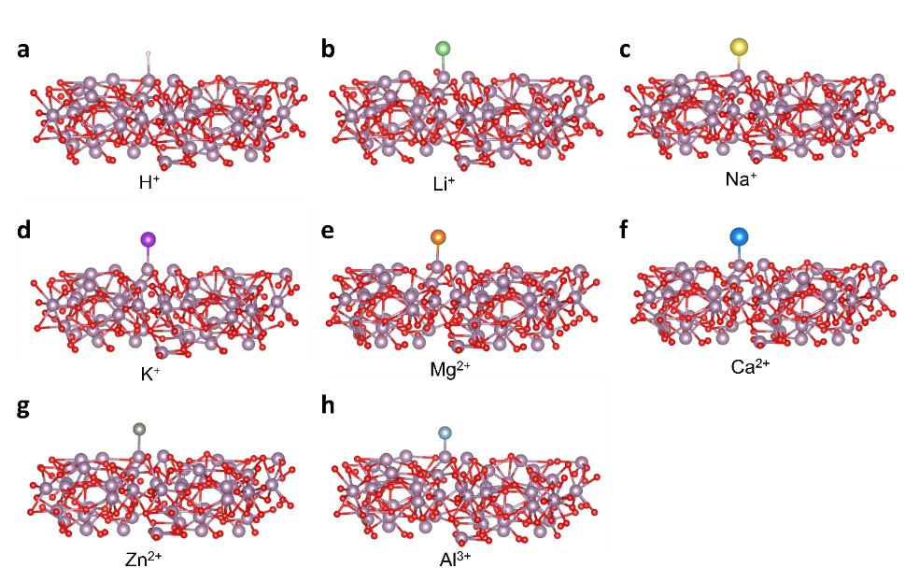
Figure S26. Optimized structures of the cation adsorbed on A-MoO_{x}: (a) H⁺; (b) Li⁺; (c) K⁺; (d) Mg²⁺; (e) Ca²⁺; (f) Zn²⁺; (g) Al³⁺.

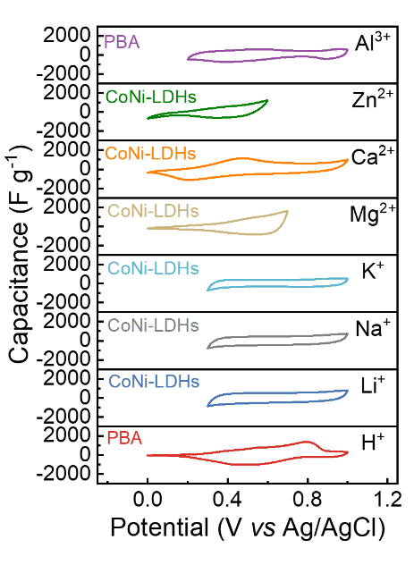
Figure S27. CV curves of aqueous battery cathodes in various electrolyte.
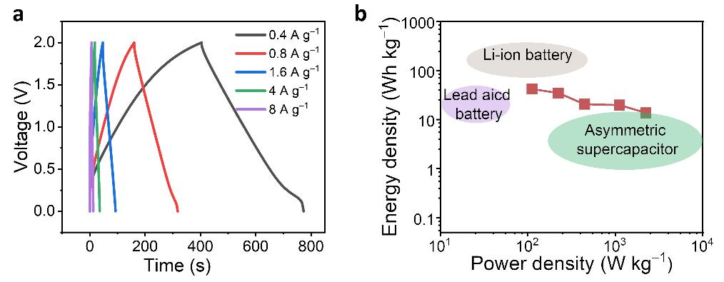
Figure S28. (a) the GCD curves and (b) the energy density /power density of pouch cell.

Table S1 Curve-fitting results of Mo K-edge EXAFS spectra for A-MoO_{x} and C-MoO_{x}.
Sample | Shell | Nª | R(Å)^{b} | σ²(Å²)^{c} | ΔE₀(eV)^{d} | R factor
A-MoO_{x} | Mo-O | 1.4 | 2.0259 | 0.0050 | 7.26 | 0.0373
A-MoO_{x} | Mo-O | 1.4 | 2.1499 | 0.0041 | 7.26 | 0.0373
C-MoO_{x} | Mo-O | 1.2 | 1.9153 | 0.0005 | 4.84 | 0.0354
C-MoO_{x} | Mo-O | 2.3 | 2.0381 | 0.0017 | 4.84 | 0.0354

ªCN, coordination number; ^{b}R, distance between absorber and backscatter atoms; ^{c}σ², Debye-Waller factor to account for both thermal and structural disorders; ^{d}ΔE₀, inner potential correction; R factor indicates the goodness of the fit. S0² was fixed to 0.74, according to the experimental EXAFS fit of Mo foil by fixing CN as the known crystallographic value. Fitting range: 3.0 ≤ k (/Å) ≤ 12 and 1.5 ≤ R (Å) ≤ 3.0 (Mo foil); 3.0 ≤ k (/Å) ≤ 10.0 and 1.1 ≤ R (Å) ≤ ~3.5 (Sample Mo).

Table S2 charge transfer resistance fitting results of A-MoO_{x} and C-MoO_{x} via EIS.
 | H⁺ | Li⁺ | Na⁺ | Ca²⁺ | Zn²⁺ | Al³⁺
Amorphous | 3.2 | 67 | 69 | 134 | 81 | 21
200 ºC | 5.7 | 271 | 95 | 725 | 1053 | 163
300 ºC | 46.7 | 600 | 877 | 21936 | 5064 | 213
400 ºC | 1000 | 2666 | 1724 | 8041 | 10246 | 7600
500 ºC | 805 | 3579 | 1595 | 15713 | 17978 | 10538

Table S3 Warburg resistances fitting results of A-MoO_{x} and C-MoO_{x} via EIS.
 | H⁺ | Li⁺ | Na⁺ | Ca²⁺ | Zn²⁺ | Al³⁺
Amorphous | 6.2 | 22 | 18 | 20 | 19 | 21
200 ºC | 23 | 89 | 2500 | 13 | 3124 | 172
300 ºC | 84 | 874 | \ | \ | \ | 1296
The Warburg resistances C-MoO_{x} 400 ºC 500 ºC are not reflected in the frequency range of 100 kHz to 10 mHz.

Reference
- Henkelman, G.; Uberuaga, B. P.; Jonsson, H. J. Chem. Phys. 2000, 113, 9901.
- Kresse, G.; Furthmüller, J. Efficient Iterative Schemes for Ab Initio Total-Energy Calculations Using a Plane-Wave Basis Set. Phys. Rev. B 1996, 54, 11169−11186.
- Perdew, J. P.; Burke, K.; Ernzerhof, M. Generalized Gradient Approximation Made Simple. Phys. Rev. Lett. 1996, 77, 3865−3868.
- Kresse, G.; Joubert, D. From Ultrasoft Pseudopotentials to the Projector Augmented-Wave Method. Phys. Rev. B 1999, 59, 1758-1775.
- Blöchl, P. E. Projector Augmented-Wave Method. Phys. Rev. B 1994, 50, 17953−17979.
- Grimme, S.; Antony, J.; Ehrlich, S.; Krieg, H. J. Chem. Phys. 2010, 132, 154104.
- Henkelman, G.; Uberuaga, B. P.; Jonsson, H. J. Chem. Phys. 2000

