Online only supplemental material

Table 1: Stakeholder participation across Delphi rounds in gastroschisis core outcomes set development project
Table 2: Stakeholder participation across Delphi rounds in neonatal core outcomes set development project
Figure 1: Comparison of mean and median scores for outcomes across both Delphi projects
Figure 2: Comparison of ranked mean and ranked median scores for outcomes across both Delphi projects
Figure 3: Comparison of ranked mean and ranked rates of exceedance for outcomes across both Delphi projects
Figure 4: Comparison of ranked rates of exceedance and ranked median scores for outcomes across both Delphi projects
Table 3: Outcomes ranked highest by different summary statistics in final round of gastroschisis core outcomes set development
Table 4: Outcomes ranked highest by different summary statistics in final round of neonatal core outcomes set development

Table 1 Stakeholder participation across Delphi rounds in gastroschisis core outcomes set development project
Stakeholder Group | Round 1 |  | Round 2 |  | Round 3
Stakeholder Group | Started | Completed | Started | Completed | Started | Completed
Neonatal panel | 58 | 52 | 47 | 47 | 43 | 43
Non-neonatal panel | 8 | 8 | 7 | 7 | 6 | 6
Personal experience panel | 98 | 42 | 31 | 31 | 22 | 22
Total | 164 | 102 | 85 | 85 | 71 | 71

The three Delphi survey panels included stakeholders from the following groups:
Neonatal panel: Paediatric surgeons. Neonatologists. Fetal medicine specialists. Specialist nurses. Specialist paediatric surgical nurses.
Non-neonatal panel: Paediatricians. Researchers. Dietitians.
Personal experience panel: People born with gastroschisis. Parents of children born with gastroschisis.
Table 2 Stakeholder participation across Delphi rounds in gastroschisis core outcomes set development project
Stakeholder Group | Round 1 |  | Round 2 |  | Round 3
Stakeholder Group | Started | Completed | Started | Completed | Started | Completed
Parents and Patients | 244 | 111 | 84 | 61 | 61 | 53
Neonatal nurses and allied professionals | 53 | 44 | 39 | 38 | 34 | 33
Doctors | 83 | 74 | 71 | 62 | 67 | 59
Neonatal researchers | 34 | 31 | 29 | 26 | 29 | 28
Total | 414 | 260 | 223 | 187 | 191 | 173

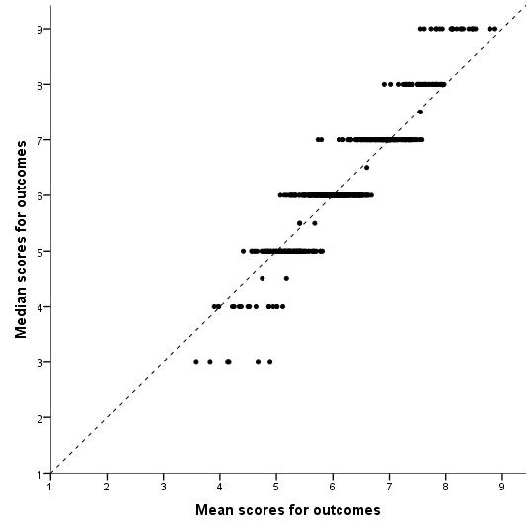
Figure 1 Comparison of mean and median scores for outcomes across both Delphi projects
Mean and median calculated for each outcome within individual rounds of the two Delphi projects
The dashed line is the line of equality
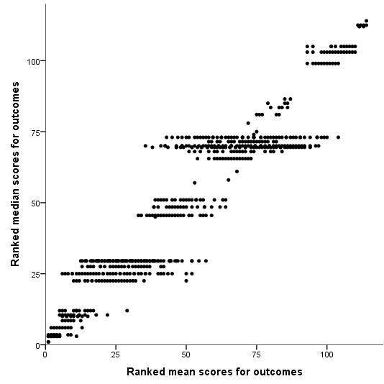
Figure 2 Comparison of ranked mean and ranked median scores for outcomes across both Delphi projects
Mean and median calculated for each outcome and then ranked within individual rounds of the two Delphi projects

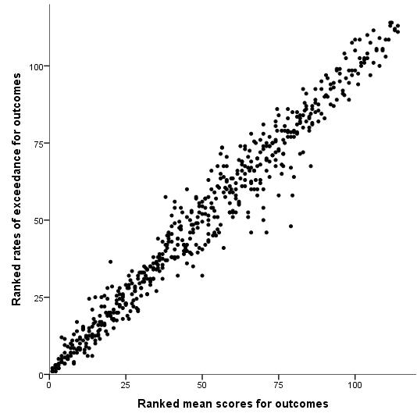
Figure 3 Comparison of ranked mean and ranked rates of exceedance for outcomes across both Delphi projects
Mean and rate of exceedance calculated for each outcome and then ranked within individual rounds of the two Delphi projects

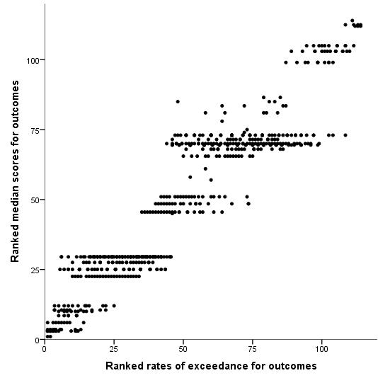
Figure 4 Comparison of ranked rates of exceedance and ranked median scores for outcomes across both Delphi projects
Median and rate of exceedance calculated for each outcome and then ranked within individual rounds of the two Delphi projects
Table 3 Outcomes ranked highest by different summary statistics in final round of gastroschisis core outcomes set development

 | Summary statistic
 | Mean | Median | Rate of Exceedance
1 | Mortality | Mortality | Quality of life for the child
2 | Quality of life for the child | Quality of life for the child | Mortality
3 | Short bowel syndrome | Short bowel syndrome | Liver disease
4 | Small bowel transplant | Small bowel transplant | Home parenteral nutrition
5 | Liver disease | Liver transplantation | Short bowel syndrome
6 | Abdominal compartment syndrome |  | Abdominal compartment syndrome
7 | Bowel ischaemia |  | Bowel ischaemia
8 | Home parenteral nutrition |  | Home total parenteral nutrition

Top 8 outcomes listed to match size of final core outcomes set
Fewer than 8 outcomes listed by ranked median due to tie of median score outside top 8

Table 4 Outcomes ranked highest by different summary statistics in final round of neonatal core outcomes set development

 | Summary statistic
 | Mean | Median | Rate of Exceedance
1 | Survival | Survival | Survival
2 | Necrotising enterocolitis | Necrotising enterocolitis | Sepsis
3 | Sepsis | Sepsis | Necrotising enterocolitis
4 | Brain injury on imaging | Brain injury on imaging | Brain injury on imaging
5 | Medical errors | Medical errors | Retinopathy of Prematurity
6 | Retinopathy of Prematurity | Retinopathy of Prematurity | General gross motor ability
7 | Visual impairment | Visual impairment | General cognitive ability
8 | Quality of life | Quality of life | Ability to walk
9 | Pain | Pain | Medical errors
10 | Hearing impairment | Hearing impairment | Quality of life
11 | Ability to walk | Ability to walk | Visual impairment
12 | General cognitive ability | General cognitive ability | Hearing impairment
 |  | Suffering
 |  | Parental bonding with their baby
Top 12 outcomes listed to match size of final core outcomes set
More than 12 outcomes listed by ranked median due to tie of median score in top 12

