Extended Data Figures
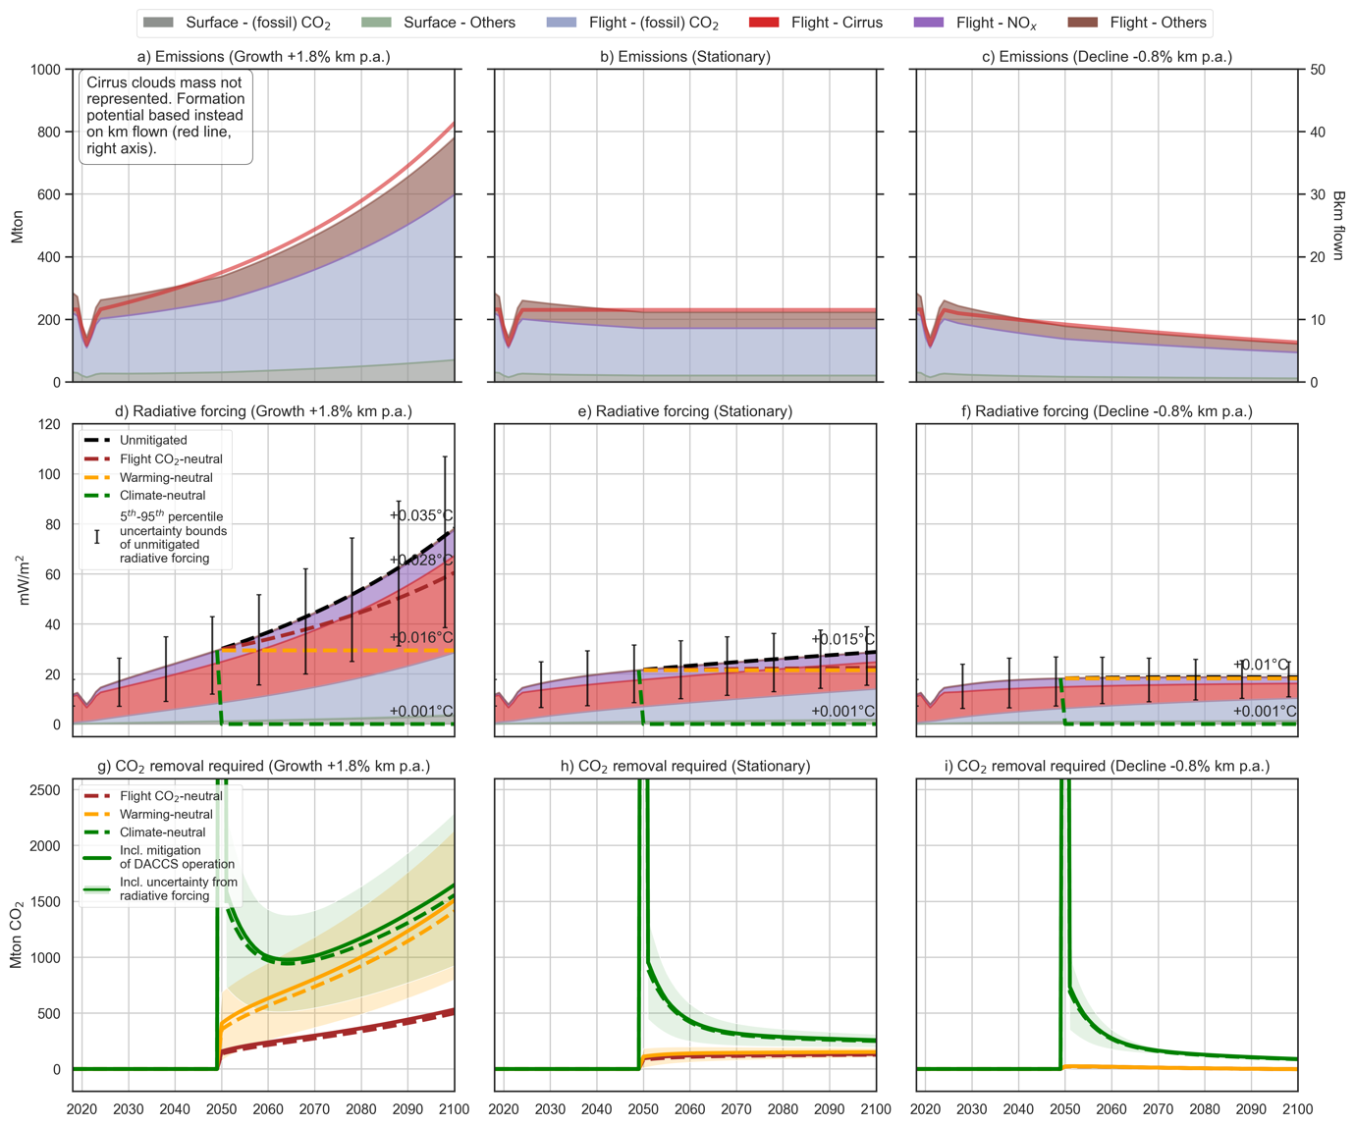
Fig. E.1: European aviation fleet activity for the period 2018-2100 relying on jet fuel and CDR performed via DACCS to meet the mitigation scope, for the three air-traffic demand trajectories, under the 2° C climate scenario. Top row: amount of climate forcers emitted (left y axis) and of kilometers flown (right y axis); middle row: RF of climate forcers and forcing trajectories for the mitigation scopes considered (note: the additional RF caused by DACCS is calculated iteratively and included in the total RF, see Supplementary Information); bottom row: CDR requirement (with and without additional removal needed to mitigate DACCS operations) to meet a given mitigation scope over the 2050-2100 period. Error bars represent the uncertainty around the radiative efficiency of flight SLCF emissions.
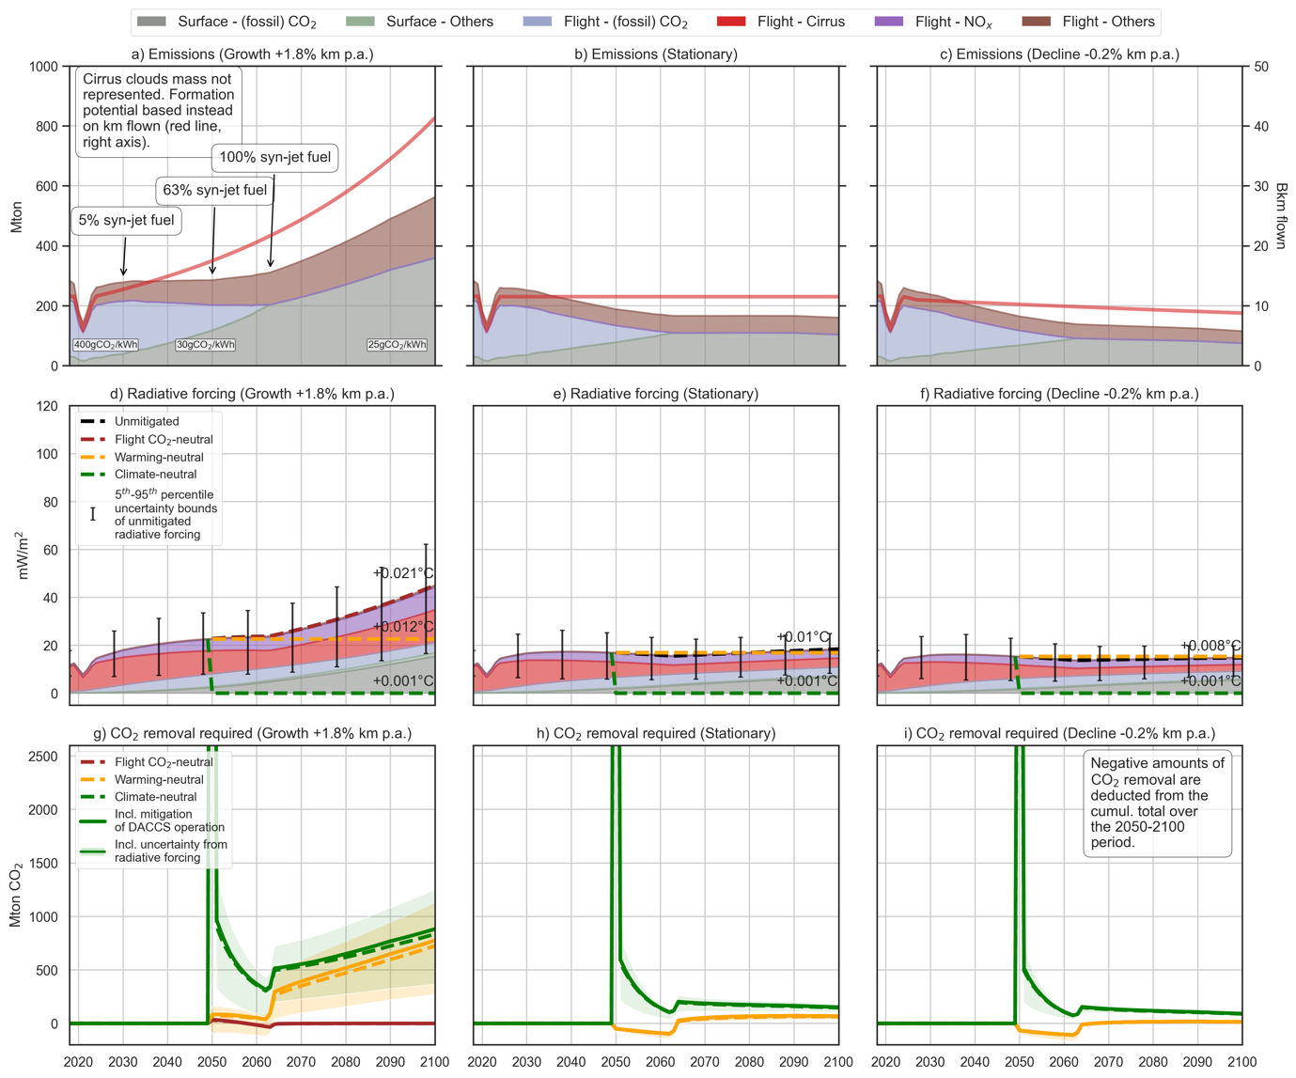
Fig. E.2: European aviation fleet activity for the period 2018-2100 relying on syn-jet fuel and CDR performed via DACCS to meet the mitigation scope, for the three air-traffic demand trajectories, under the 2° C climate scenario. Top row: amount of climate forcers emitted (left y axis) and of kilometers flown (right y axis); middle row: RF of climate forcers and forcing trajectories for the mitigation scopes considered (note: the additional RF caused by DACCS is calculated iteratively and included in the total RF, see Supplementary Information); bottom row: CDR requirement (with and without additional removal needed to mitigate DACCS operations) to meet a given mitigation scope over the 2050-2100 period. Error bars represent the uncertainty around the radiative efficiency of flight SLCF emissions.
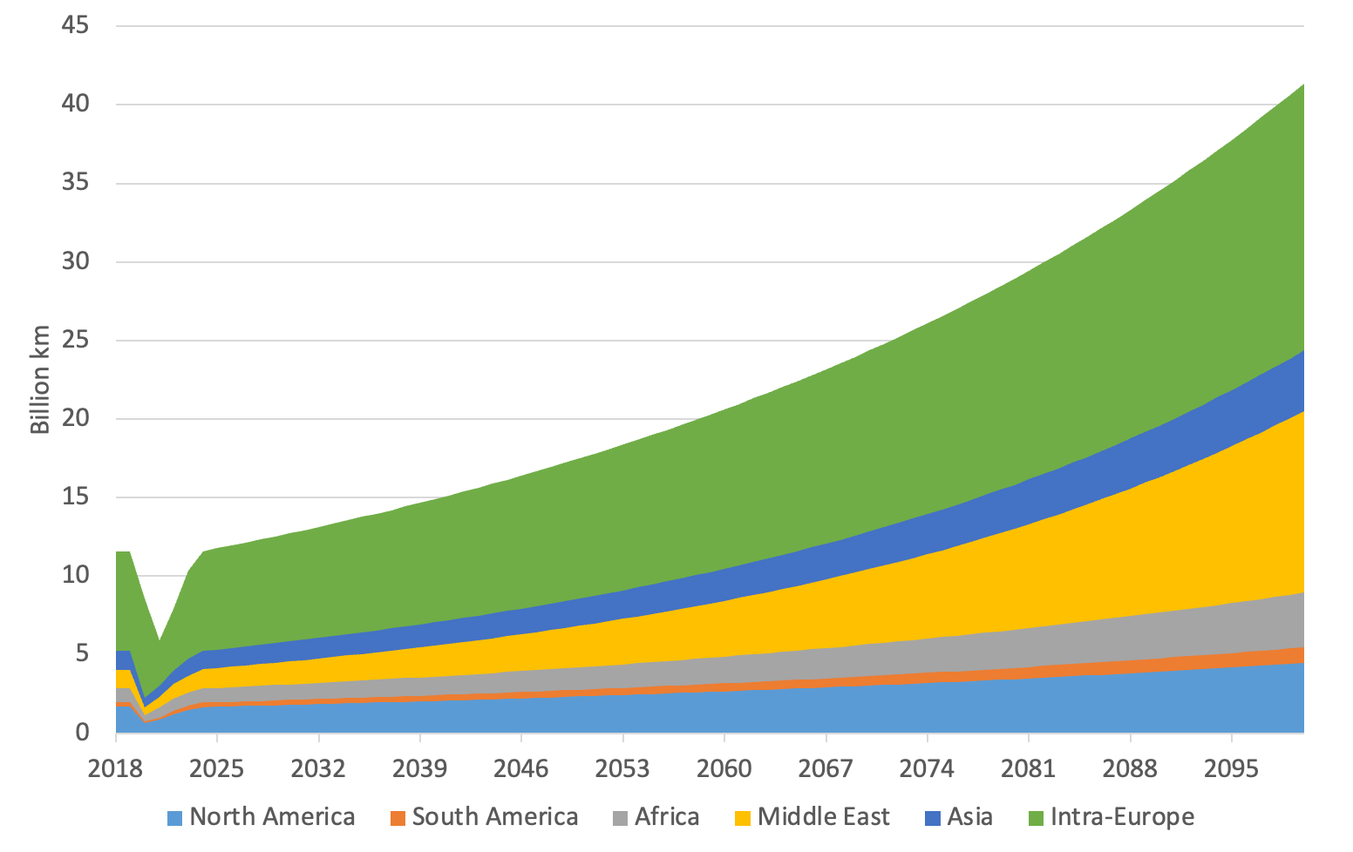 | 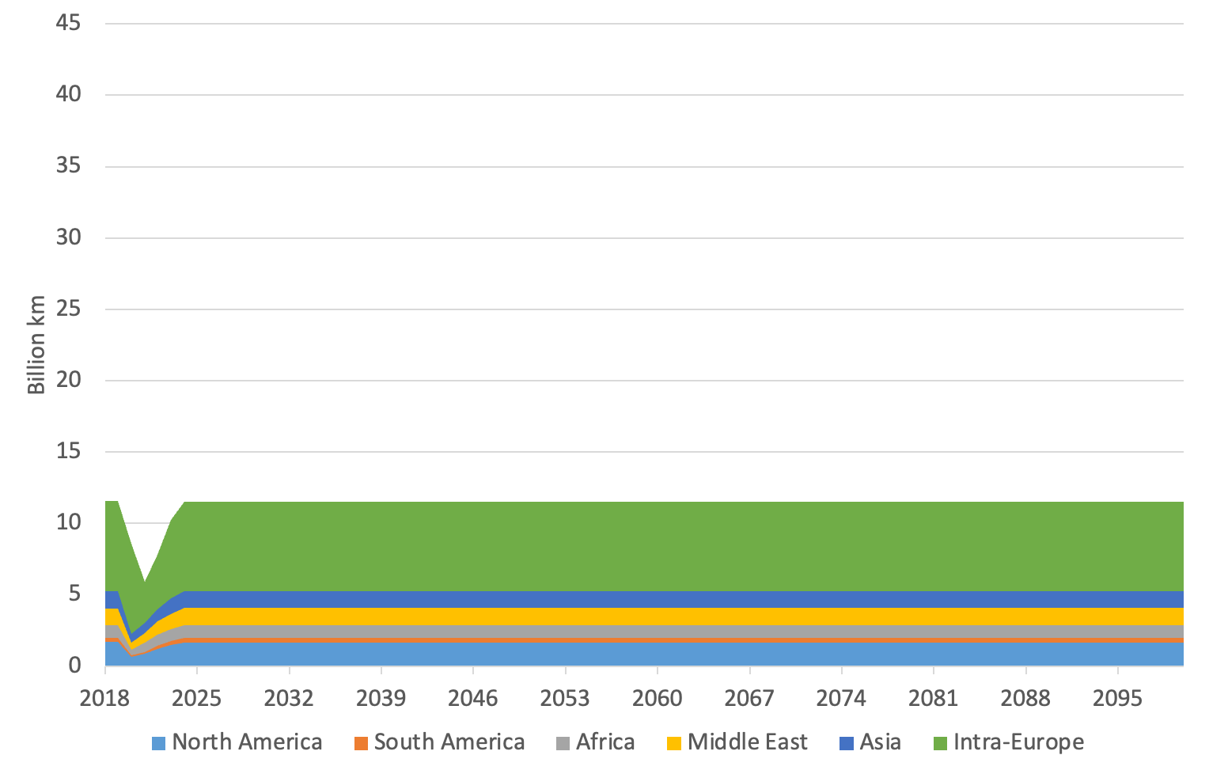
- Growing demand trajectory (+1.8% p.a.) | - Stationary demand trajectory
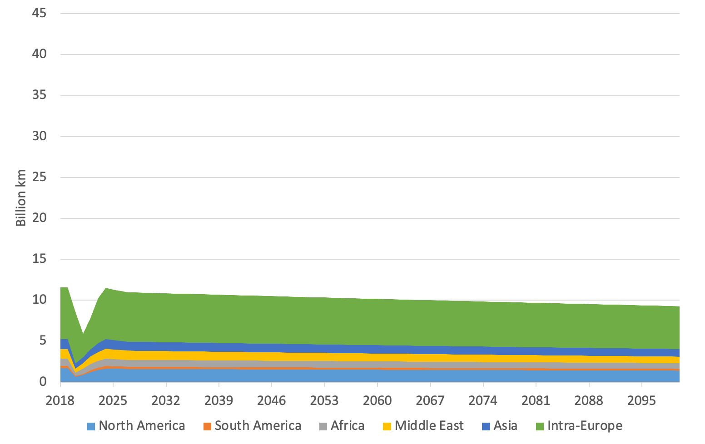 | 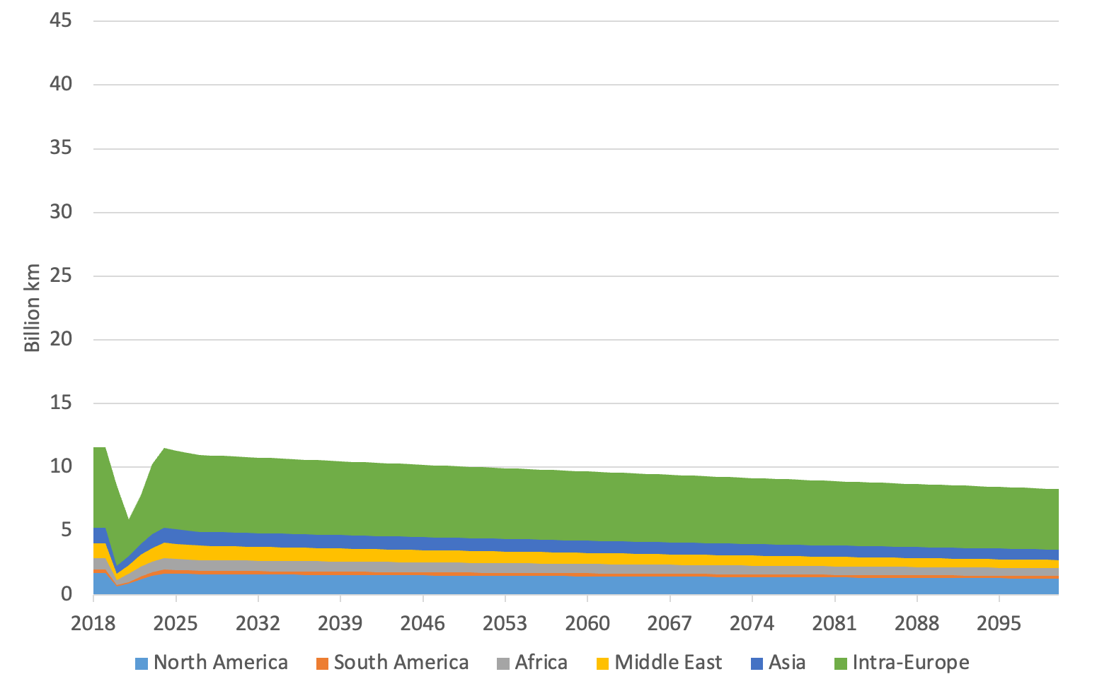
- Declining demand trajectory (-0.2% p.a.) | - Declining demand trajectory (-0.4% p.a.)
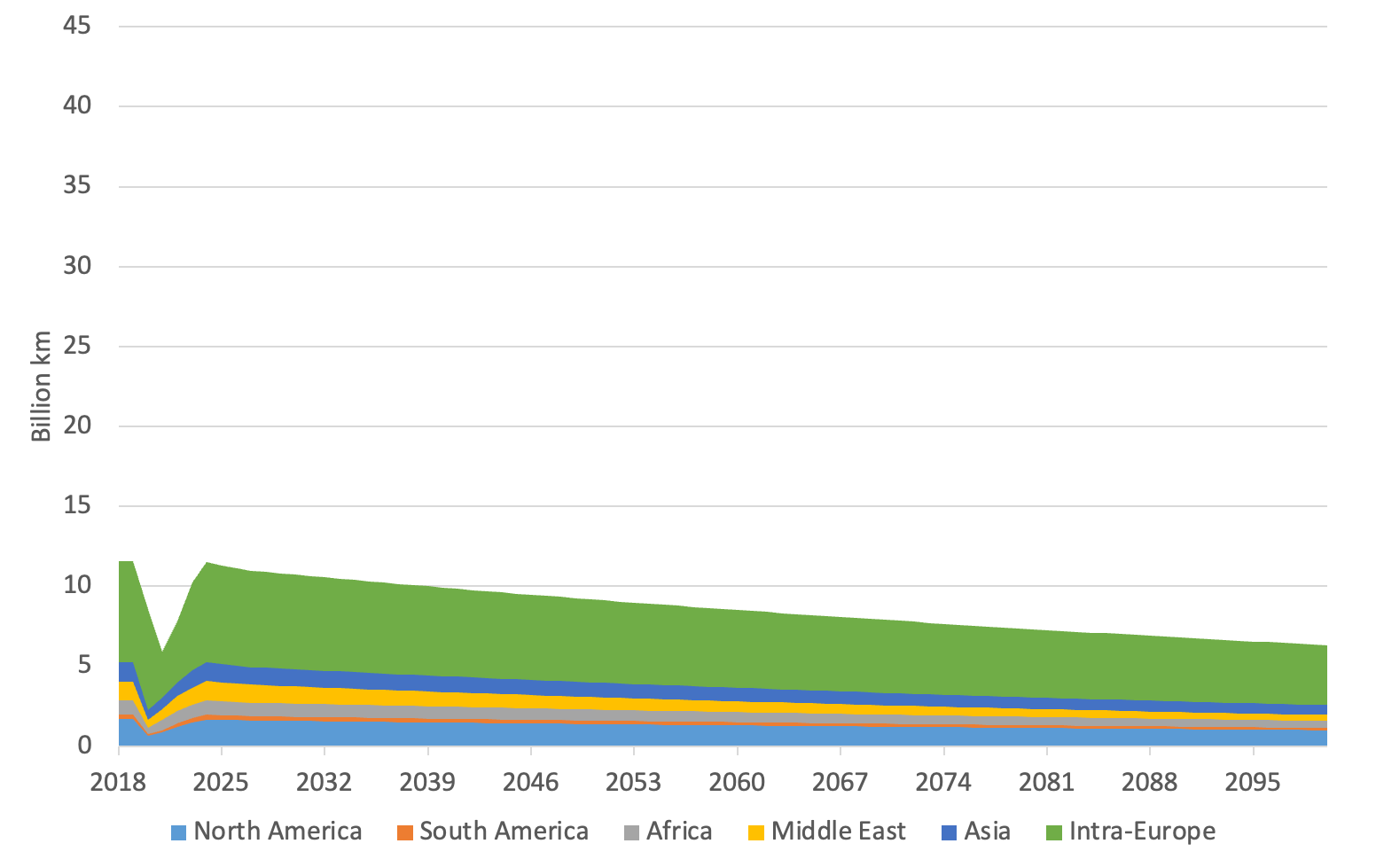
- Declining demand trajectory (-0.8% p.a.)

Fig. E.3: Demand trajectories for the European passenger fleet, in billions of kilometers flown, by destination

