Supplementary Information 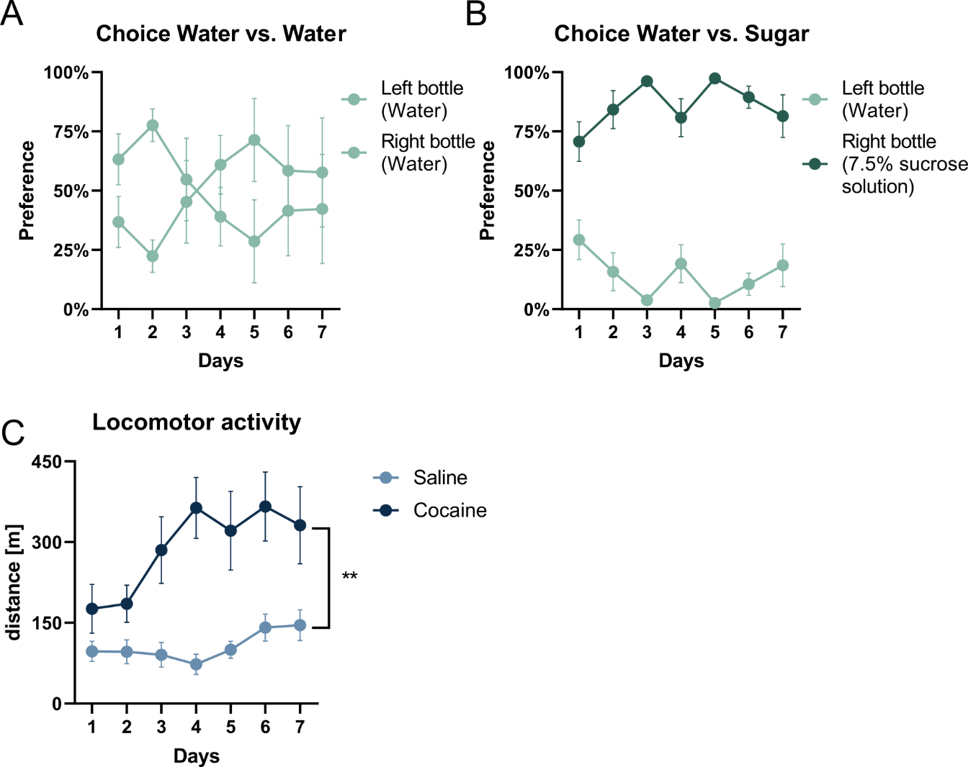
Fig. Supp. 1: Mice responses to natural (green) and addictive (blue) rewards.
A) Percentage of mice’s preference of drinking from two separate bottles filled with water. B) Percentage of mice preference of drinking mice from two separate bottles filled with water (shallow green) or 7.5 % sucrose solution (dark green). C) Locomotor activity of mice treated with either saline or cocaine IP injections. N Water=9, N Sugar 7 d=9, N Saline=11, N Cocaine 7 d=13.**=p<0.001.
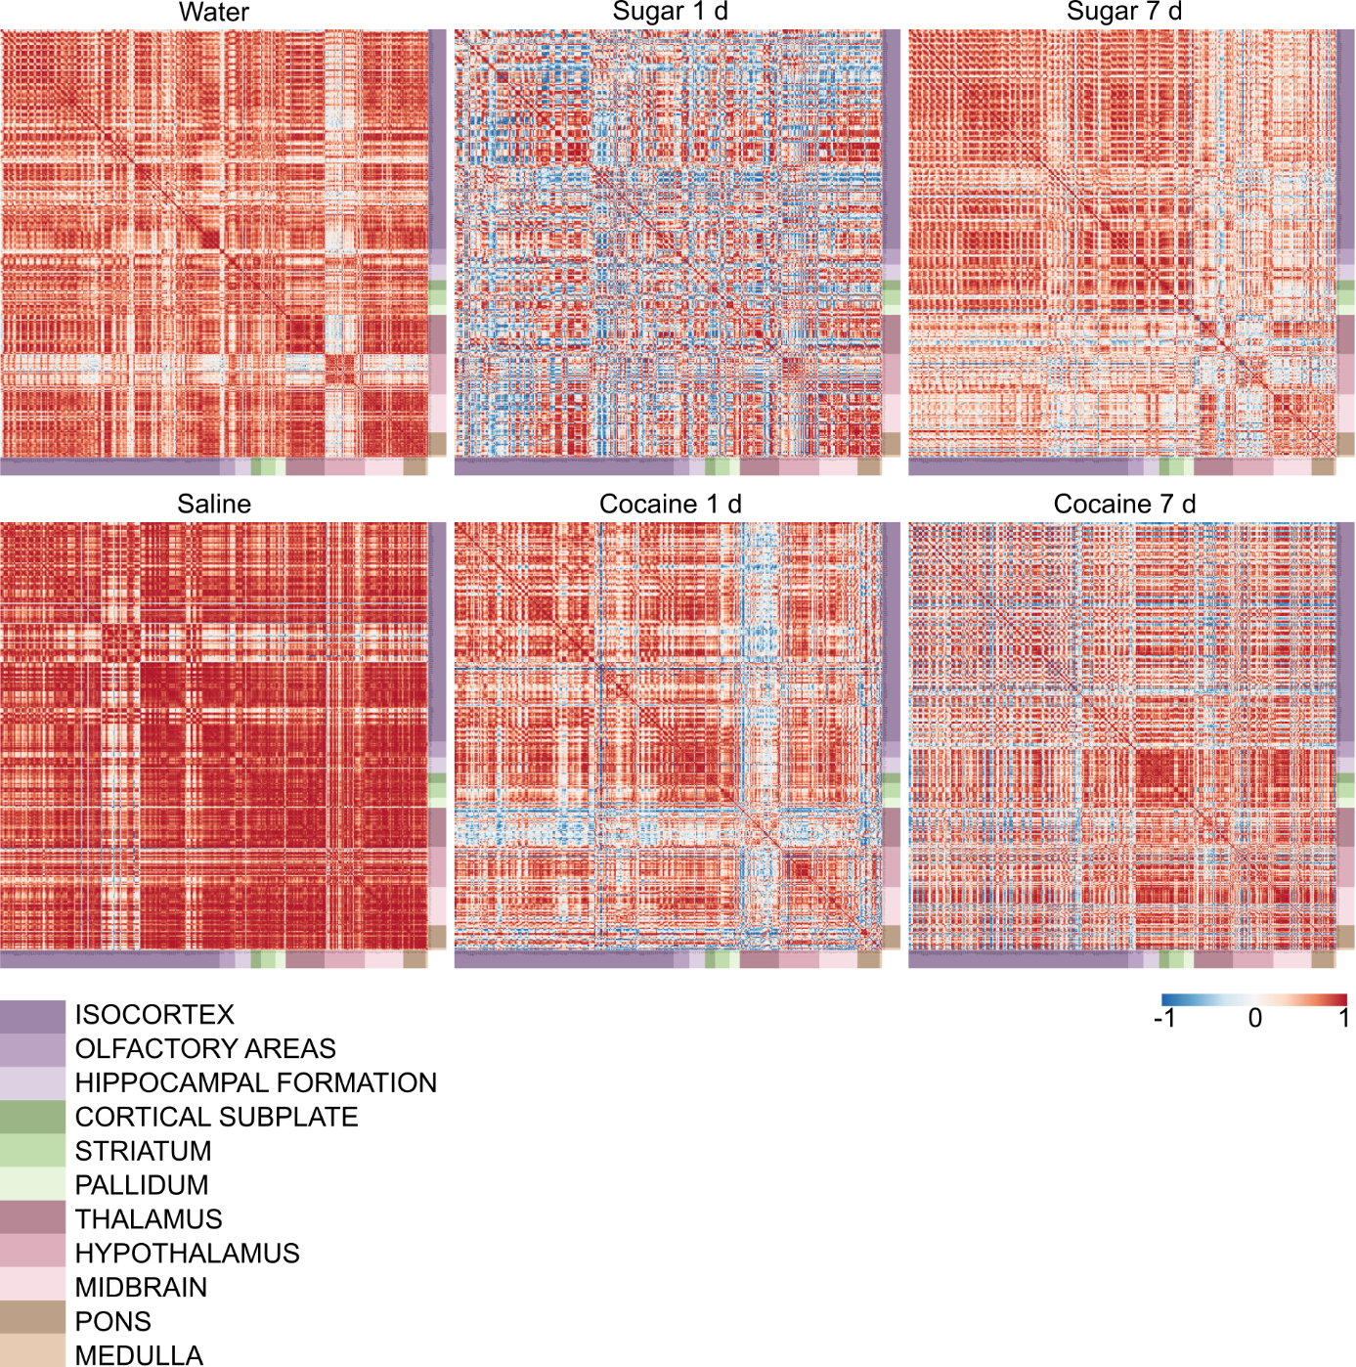
Fig. Supp. 2: Brain region correlation heatmaps organized according to the Allen Brain Atlas.
Correlation map for groups treated with natural (upper row) and addictive (lower row) rewards. Color-coded anatomical annotations are depicted below the heatmaps. R indicates the correlation strength between single structures, in which warmer colors indicate more similar signal densities between two structures in all mice. N Water=7, N Sugar 1 d=5, N Sugar 7 d=7, N Saline=7, N Cocaine 1 d=6, N Cocaine 7 d=6.
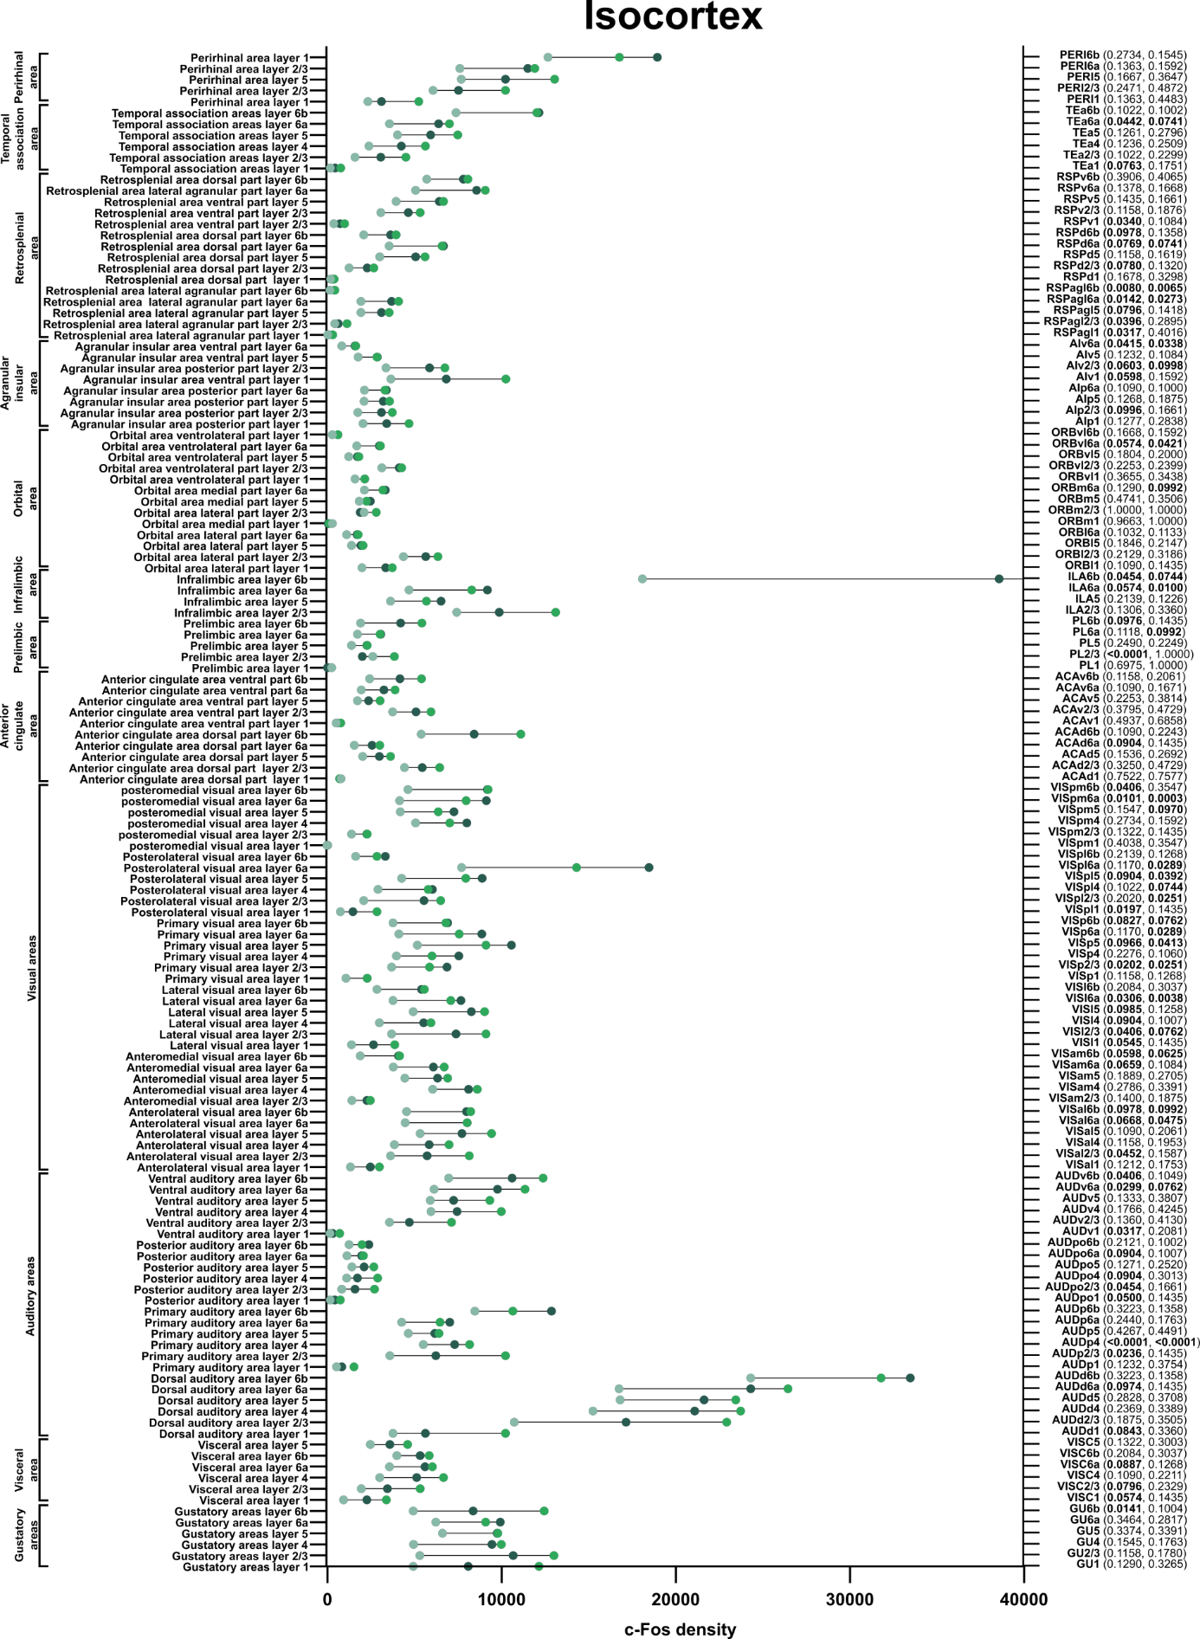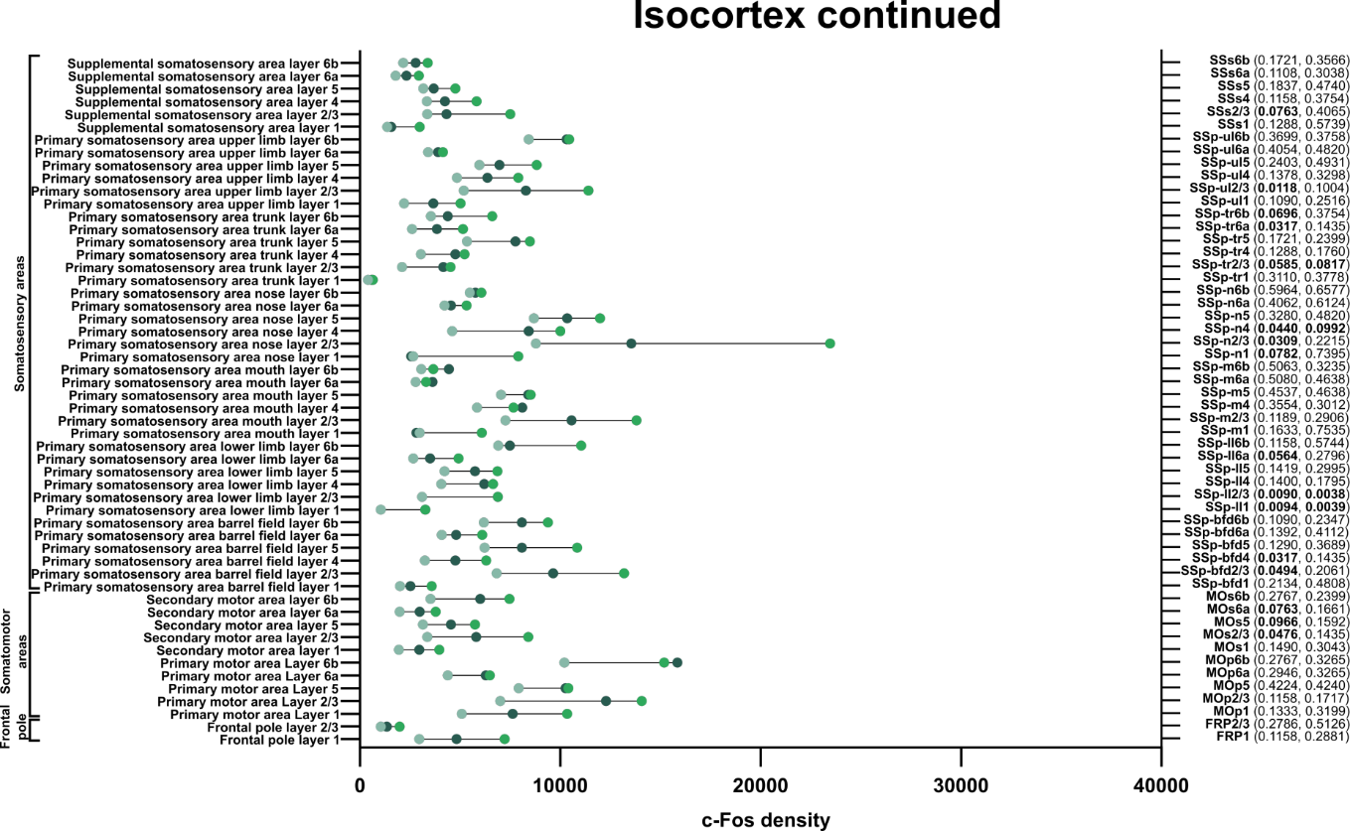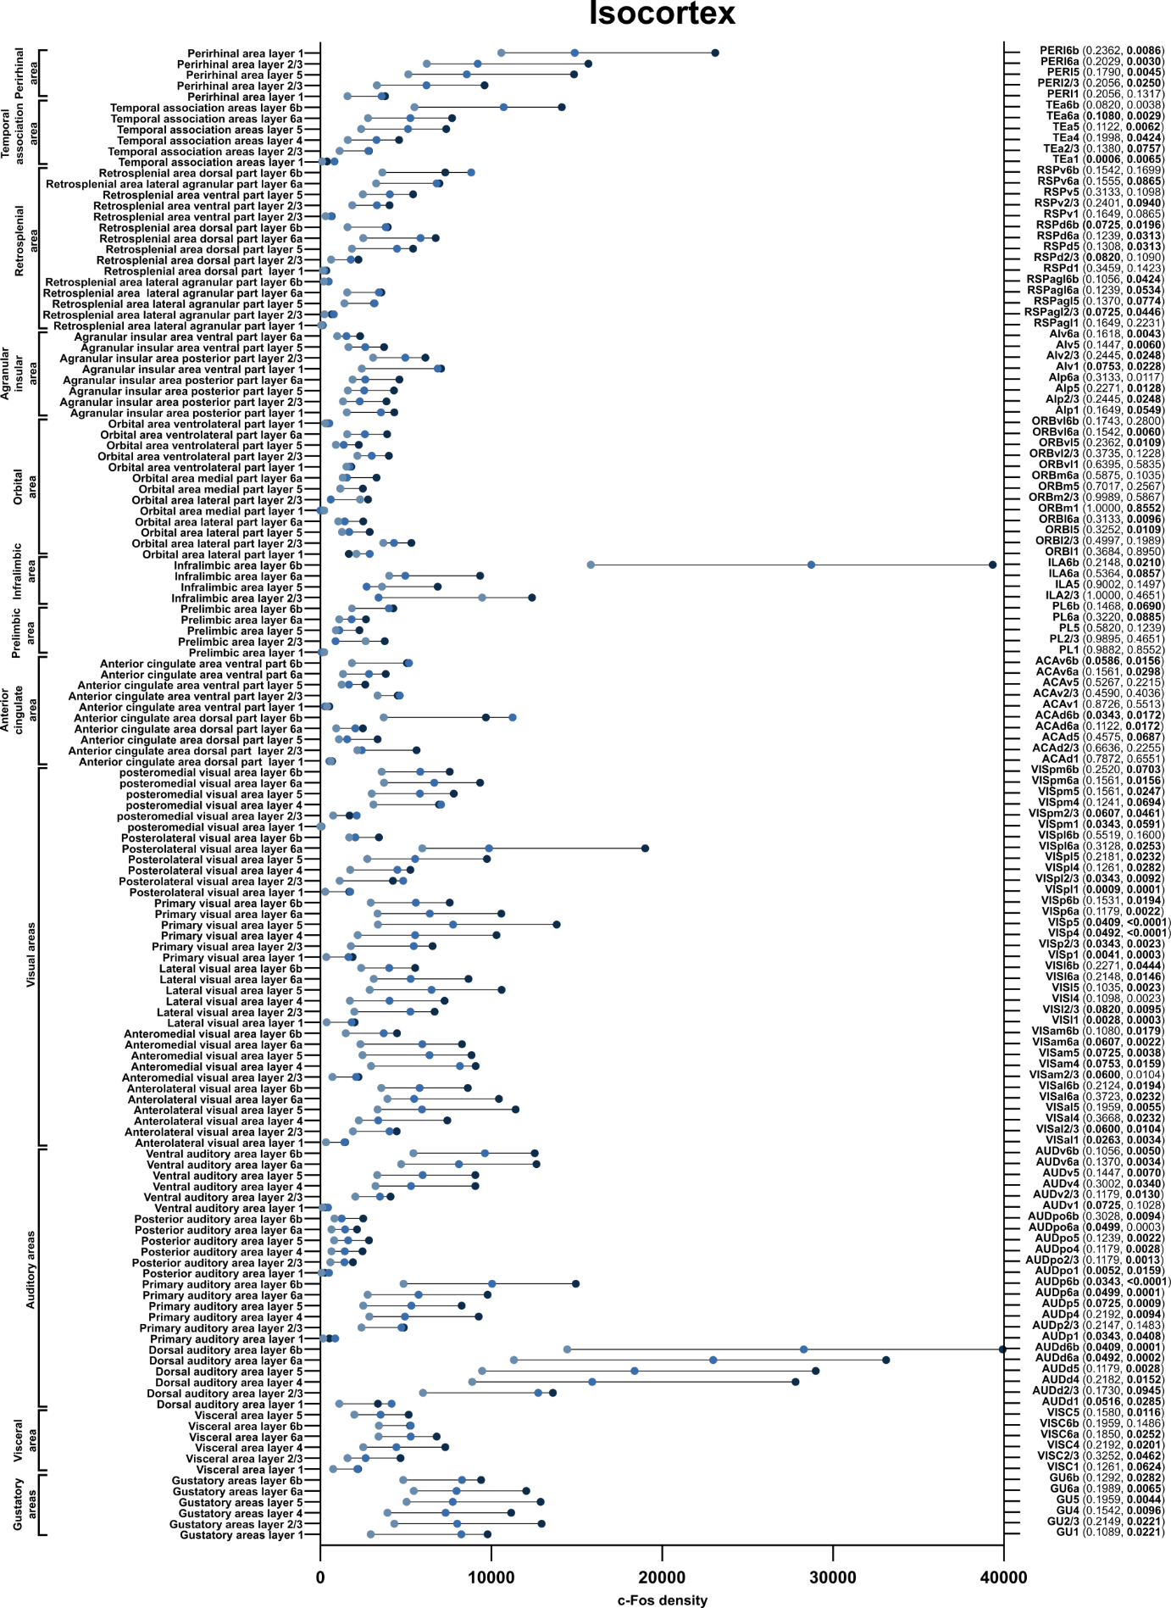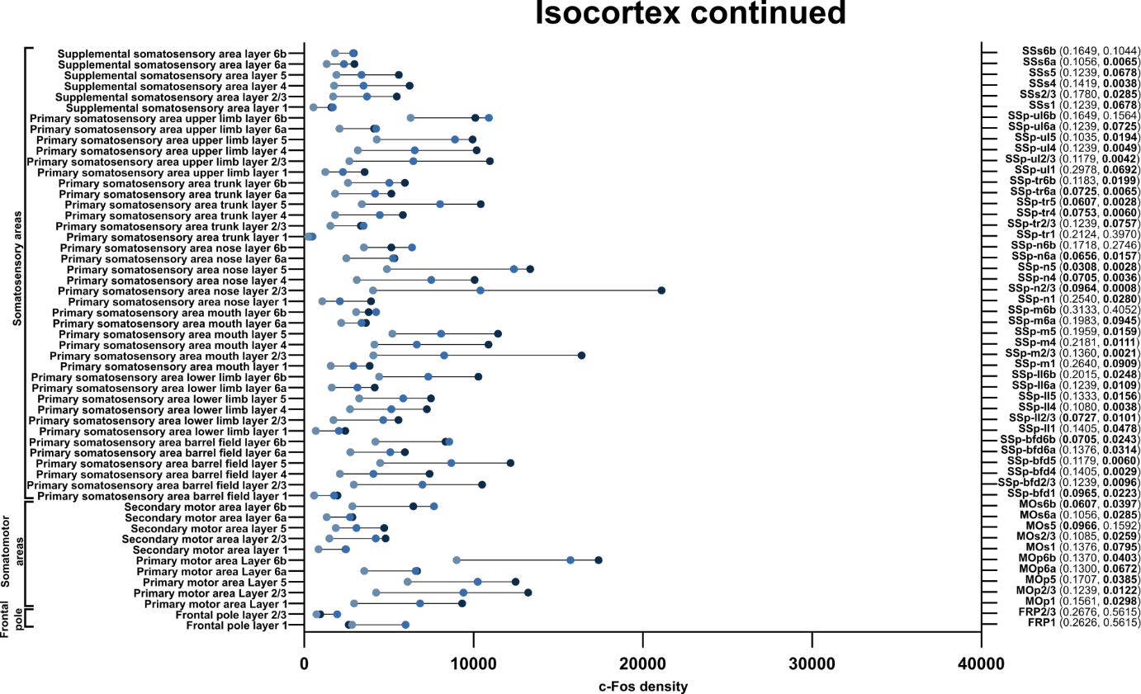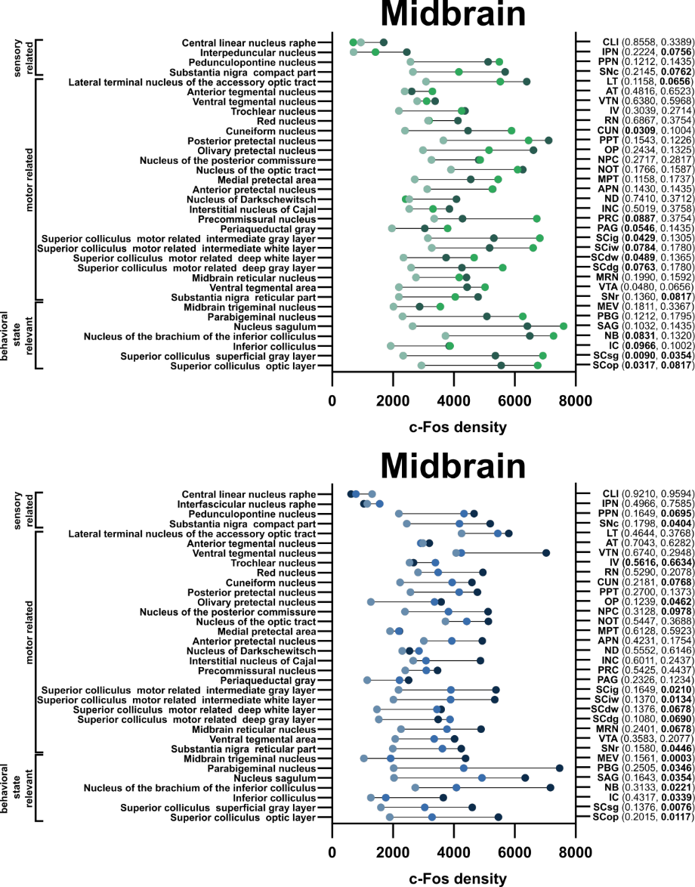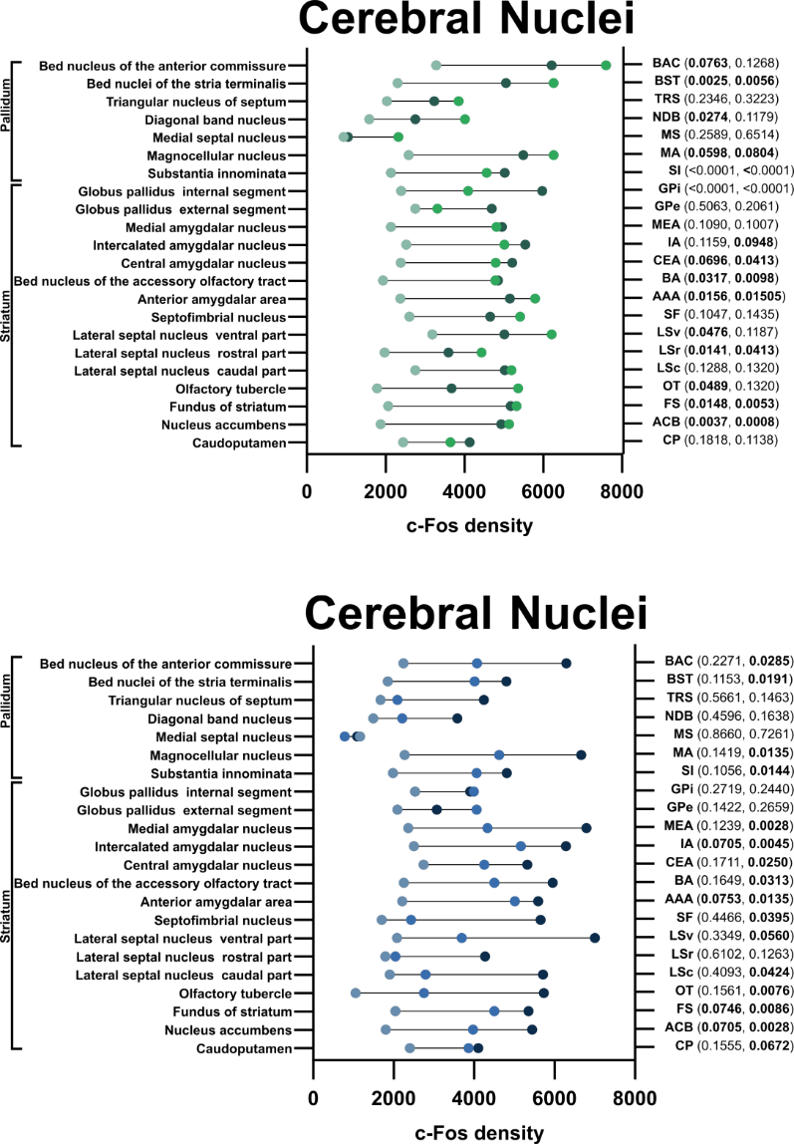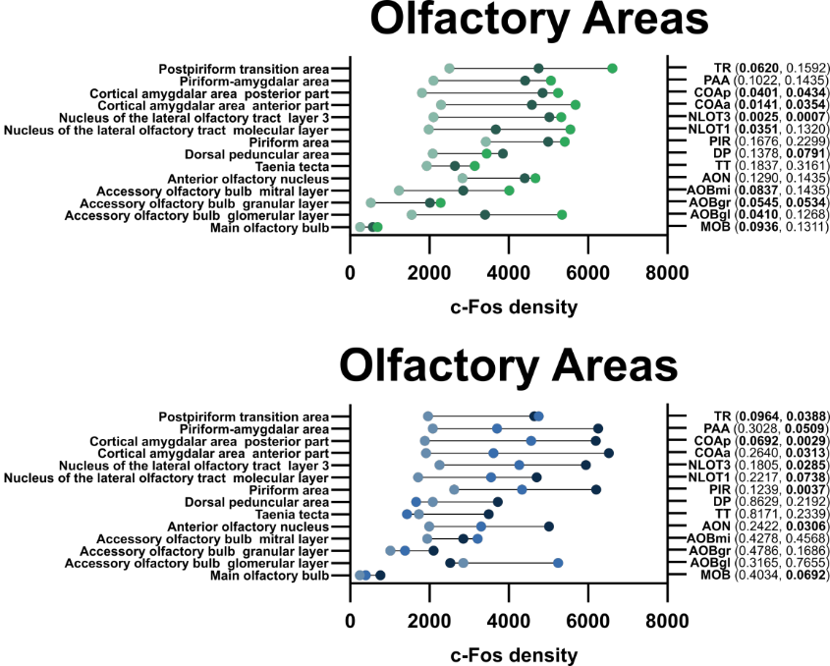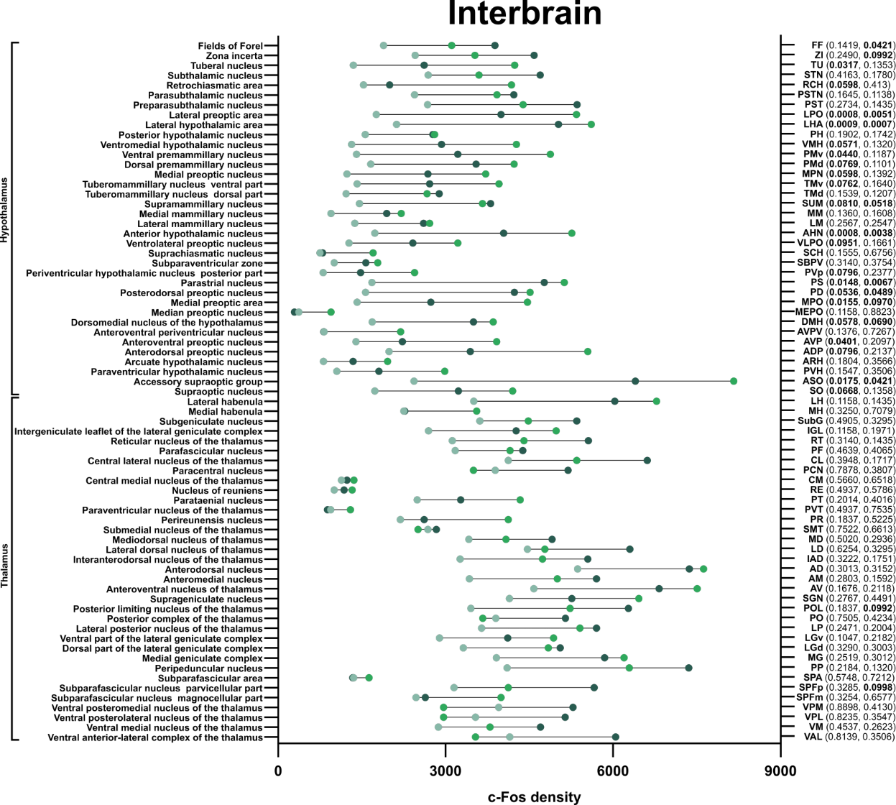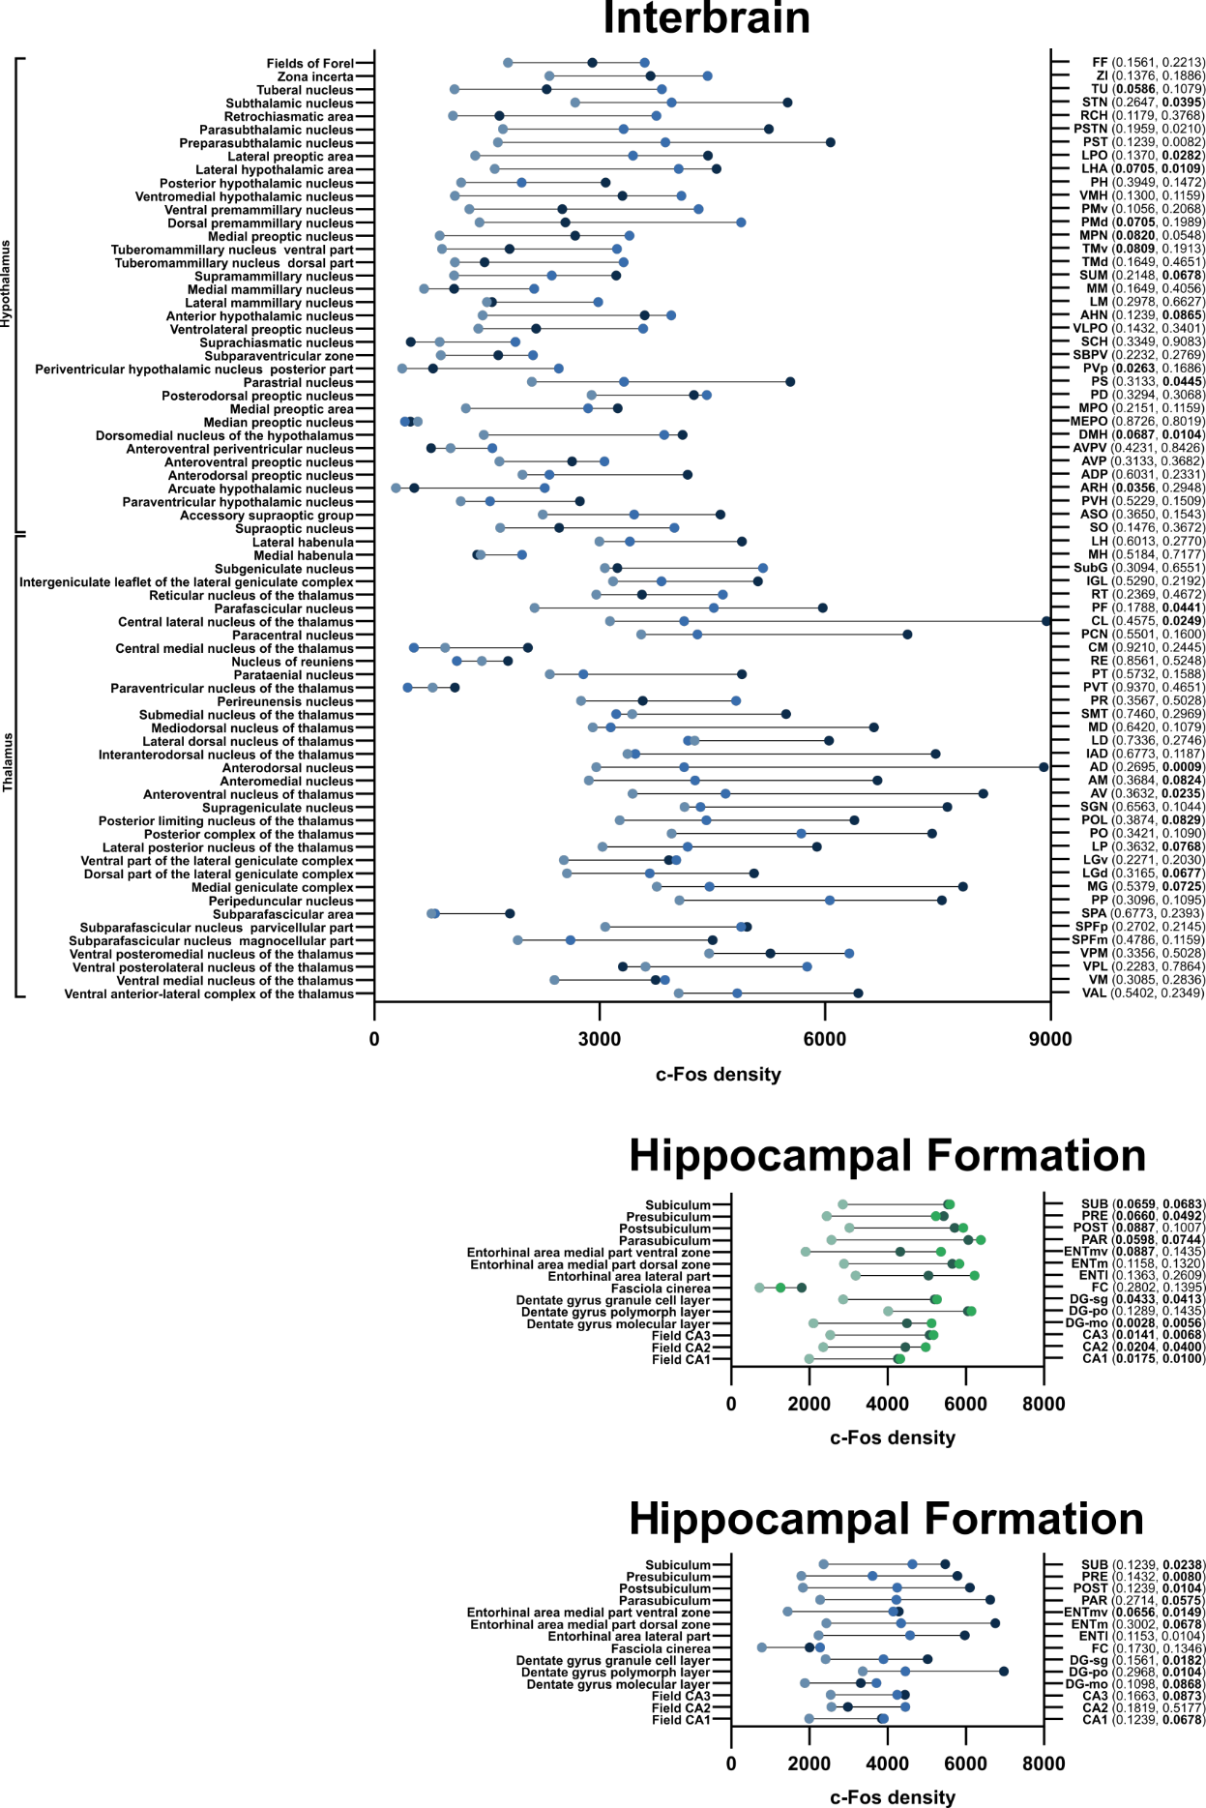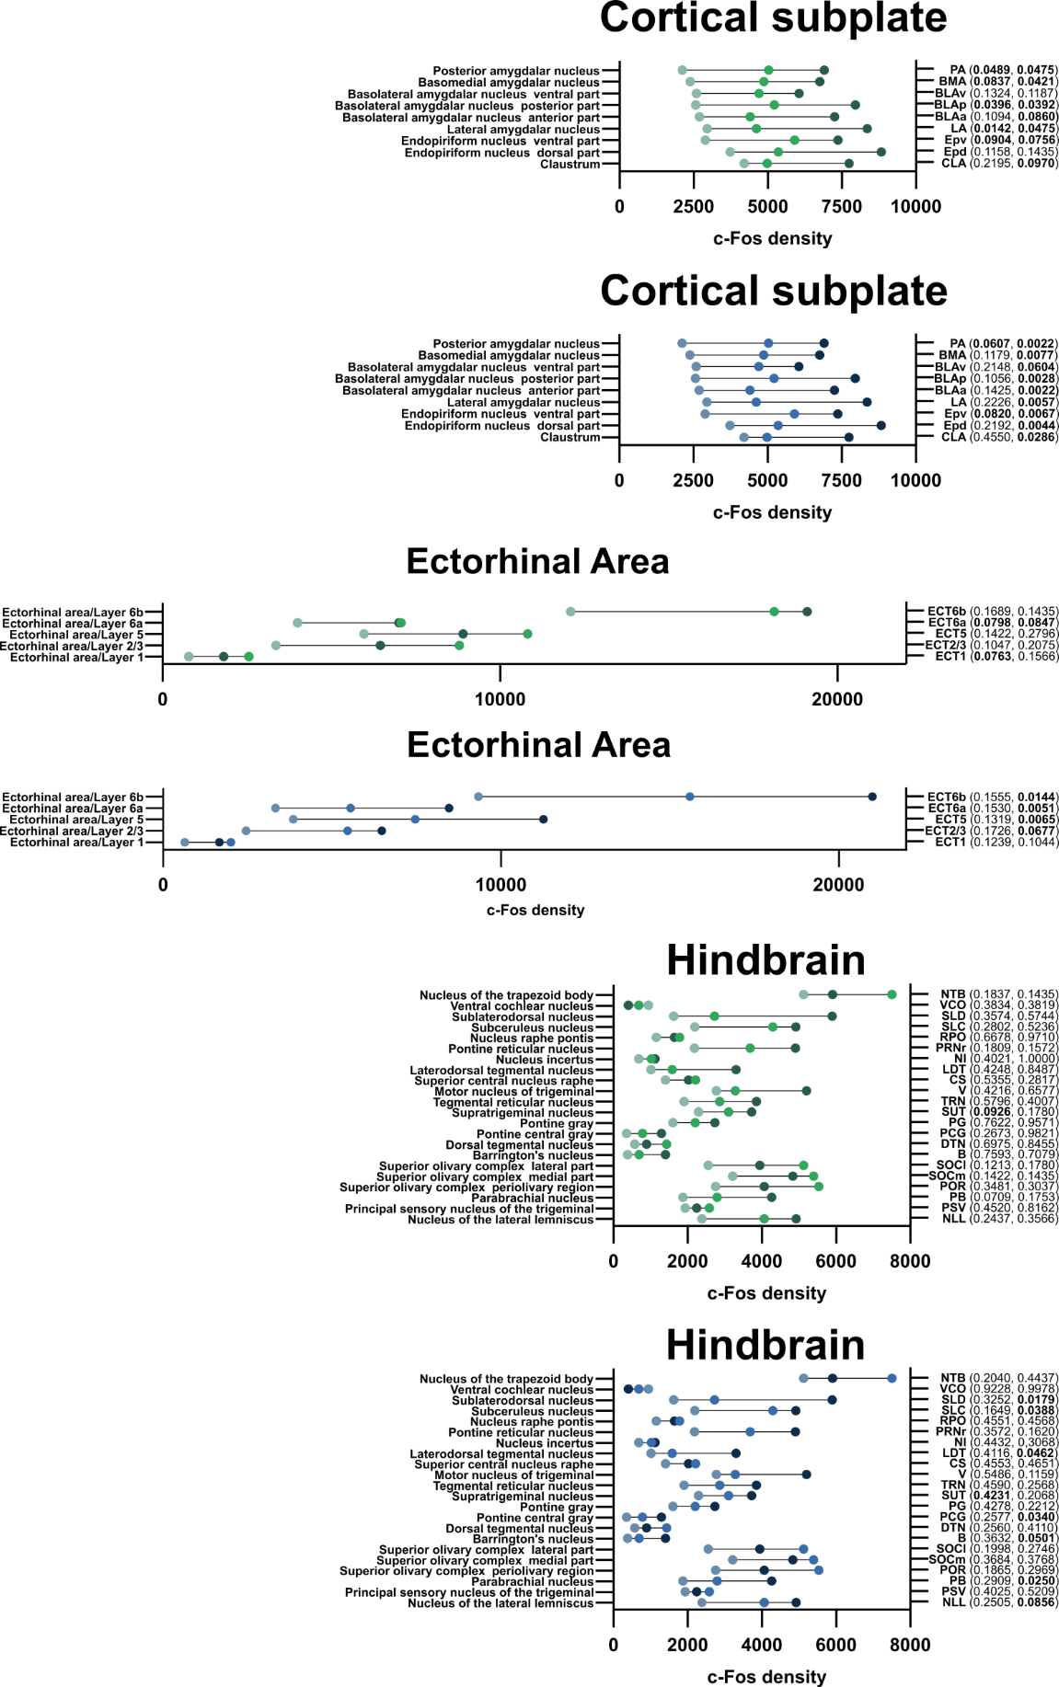

Fig. Supp. 3: c-Fos signal after natural and addictive treatment across the brain.
Green colors correspond to the mean signal from mice after sucrose treatment (light - Water, medium - Sugar 1 d, dark - Sugar 7 d) and blue colors correspond to cocaine treatment (light - Saline, medium - Cocaine 1 d, dark - Cocaine 7 d). On the left axis are names of the structures and on the right corresponding abbreviations and statistical differences among groups in brackets. In brackets for natural (Water vs. Sugar 1 d, Water vs. Sugar 7 d) and for addictive (Saline vs. Cocaine 1 d, Saline vs. Cocaine 7d). Bolded differences p<0.1. For each structure p-value was calculated. First, a generalized linear model (GLM) was calculated. For each GLM a Dunnett’s test was performed. Finally, due to a large number of structures a Benjamin-Hochberg false discovery rate correction was performed on p-values with a 0.1 cut-off. N Water=7, N Sugar 1 d=5, N Sugar 7 d=7, N Saline=7, N Cocaine 1 d=6, N Cocaine 7 d=6.

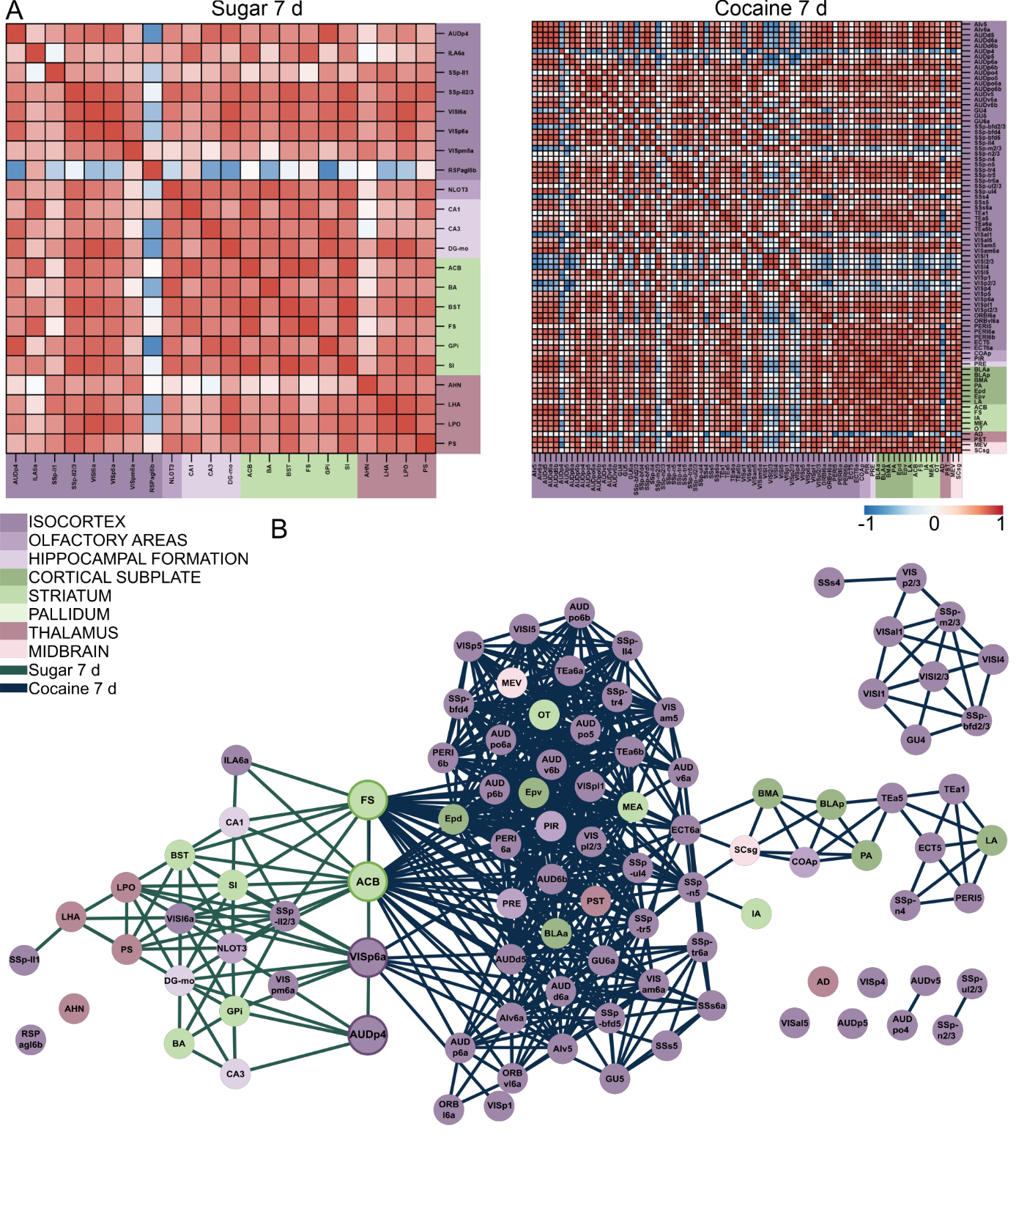Fig. Supp. 4: Brain region correlations in structures with the highest probability of activation
upon prolonged treatment with natural or addictive rewards.
A ) Correlation map for groups treated with natural (sugar 7 d) and addictive (cocaine 7 d) rewards. Color-coded anatomical annotations are depicted below the heat maps. R indicates the correlation strength between single structures, in which warmer colors indicate more similar signal densities between two structures in all mice. B) Graph Network combined from the correlation matrices of structures activated by 7 days of sugar (left, green) or cocaine (right, blue) exposure. Each dot represents a single structure and lines represent a positive correlation between two structures. Color-coded anatomical annotations are the same as in correlation matrices. Distance and position between nodes were determined by the hierarchical repulsion model. Four structures activated by both rewards (the fundus of striatum (FS), the nucleus accumbens (ACB), the primary visual area layer 6a ( VISp6a), the primary auditory area layer 4 (AUDp4)) were manually positioned in the center. N Water=7, N Sugar 1 d=5, N Sugar 7 d=7, N Saline=7, N Cocaine 1 d=6, N Cocaine 7 d=6. For network graph r>0.75.

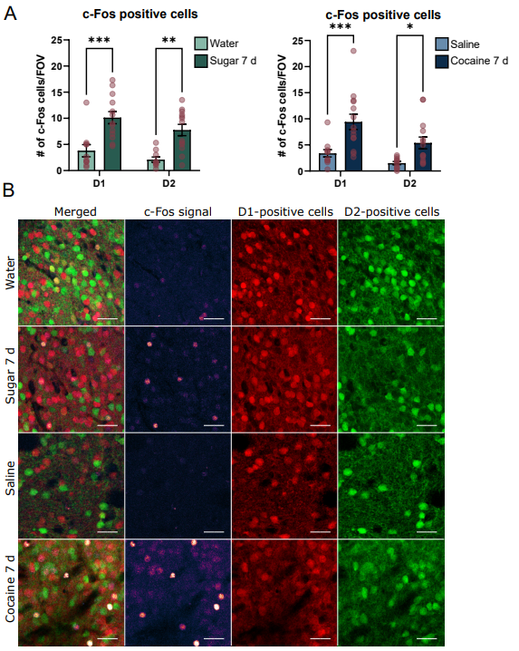
Fig. Supp. 5: c-Fos distribution in D1- and D2-positive cells in Nucleus Accumbens.
A) Number of c-Fos positive cells in D1- and D2-positive cells in Nucleus Accumbens after natural (green) and addictive treatment (blue). B) Exemplary images of c-Fos (HiLo) signal in D1- (red) and D2-positive (green) cells. Scale bar=40 μm.
For c-Fos N Water=10(28); N Sugar 7 d=13(38); N Saline = 11(33), N Cocaine 7 d=14(40) and for Arc
N Water=9(68); N Sugar 7 d=7(44); N Saline=13(77), N Cocaine 7 d=12(68), where N=Number of mice
(Number of planes). P–values were determined with the Two-way ANOVA test. *=p<0.05; **=p<0.01;
***=p<0.001. For c-Fos p–value D1 Water vs. D1 Sugar 7 d=0.0003; D2 Water vs. D2 Sugar 7 d=0.001; D1 Saline vs. D1 Cocaine 7 d=0.0007; D2 Saline vs. D2 Cocaine 7 d=0.0326.

