Effects of Lateral Cerebellar Nucleus Stimulation on Seizures in Rats Kindled to Different Levels of Seizure Severity with PTZ

The Cerebellum

Leonid S. Godlevsky¹ ⁰⁰⁰⁰⁻⁰⁰⁰³⁻⁰⁹³⁵⁻⁸²⁵⁵, Mykhailo P. Pervak¹ ⁰⁰⁰⁰⁻⁰⁰⁰²⁻⁰³⁶⁰⁻⁵⁷⁵⁶, Olesya B. Poshyvak ² ⁰⁰⁰⁰⁻⁰⁰⁰¹⁻⁶²⁷⁷⁻⁸²³⁸, Suliman N.A.Hathal ², Olha S. Yehorenko¹, Zuleyha Doganyigit³ ⁰⁰⁰⁰⁻⁰⁰⁰²⁻⁶⁹⁸⁰⁻³³⁸⁴, Enes Akyuz⁴ ⁰⁰⁰⁰⁻⁰⁰⁰²⁻³⁹⁴²⁻²⁰⁹⁷

¹Odesa National Medical University, Odesa, Ukraine (e-mail: godlevskyleonid@yahoo.com);
lashelgo@gmail.com (Pervak M.P.); olhayehorenko@gmail.com (Yehorenko O.S.)
²Danylo Halytsky Lviv National Medical University, Lviv, Ukraine olesya.poshyvak@gmail.com (Poshyvak O.B.); snnasser2@gmail.com (Hathal S.N.A.)
³Yozgat Bozok University, Medical Faculty, Yozgat, Turkey zuleyha.doganyigit@yobu.edu.tr
⁴Department of Biophysics, University of Health Sciences, International Medicine Faculty, Istanbul, Turkey, enesakyuz25@gmail.com

Corresponding author:

Leonid Godlevsky
Department of Biophysics, Informatics and Medical Devices, Odesa National Medical University, 2, Valikhovsky Lane, Odesa 65082, Ukraine
godlevskyleonid@yahoo.com

Time course of EEG and myoclonus appearance in PTZ kindled rat after LCN ES (early stage of kindling)
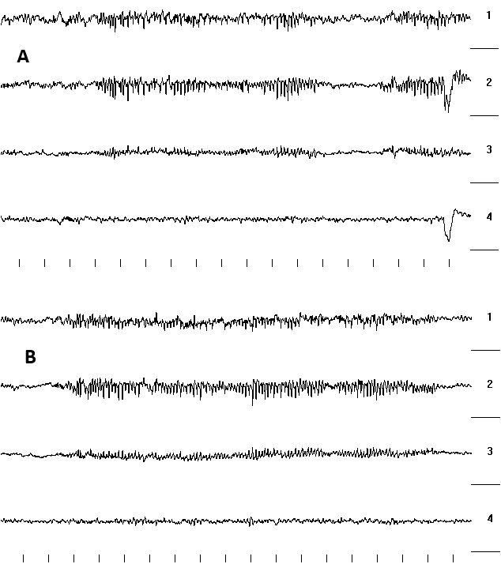

Fig. 1 Notes: A- 7.5 min after PTZ (35.0 mg/kg, i.p.) and 39.0 min after 5th LCN ES.
B-3.5 min after “A” and 11.0 min after 5th LCN ES.
1-and 3-frontal cortex (right and left hemisphere correspondently); 2-and 4- ventral hippocamp (right and left hemisphere correspondently);
Vertical lines in a row at the bottom of EEG fragments (seconds). Calibration: the distance between horizontal lines between leads (right side of EEG fragments – 2250 mcV. (The same at all fragments).
Comment: the duration of SWD bursts increased
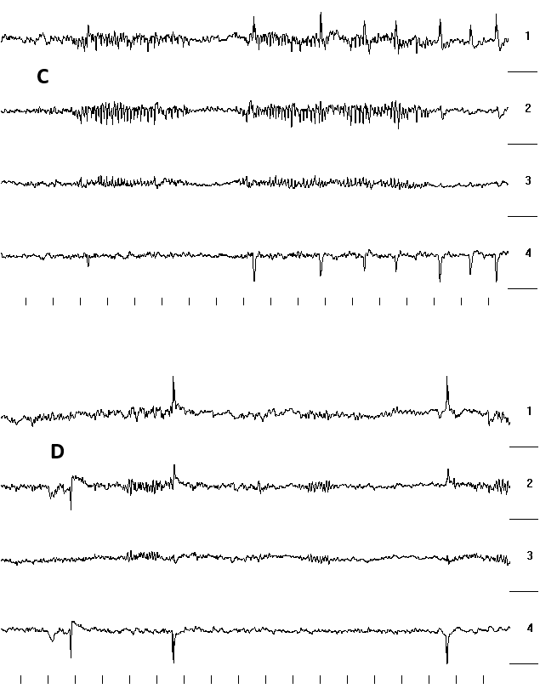
Fig. 2 Notes: C- 8.0 min after “B” and 19.0 min after 5th LCN ES.
D- 5.0 min after “C” and 24 min after 5th LCN ES.

Comment: appearance of spikes intermingled with SWD bursts.
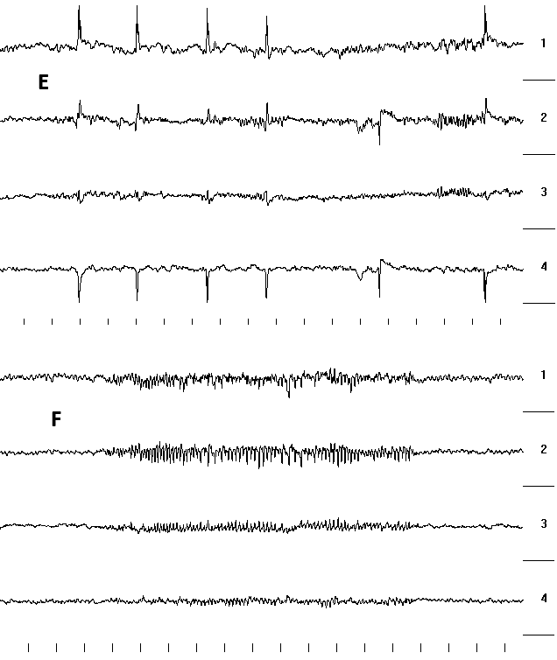

Fig. 3 Notes: E- 6.0 min after “D” and 30.0 min after 5th LCN ES.
F-1.5 min after “E” and 31.5 min after 5th LCN ES.

Comments: rise of spikes frequency and their grouping (E). Period of SWD generation is also present (F).
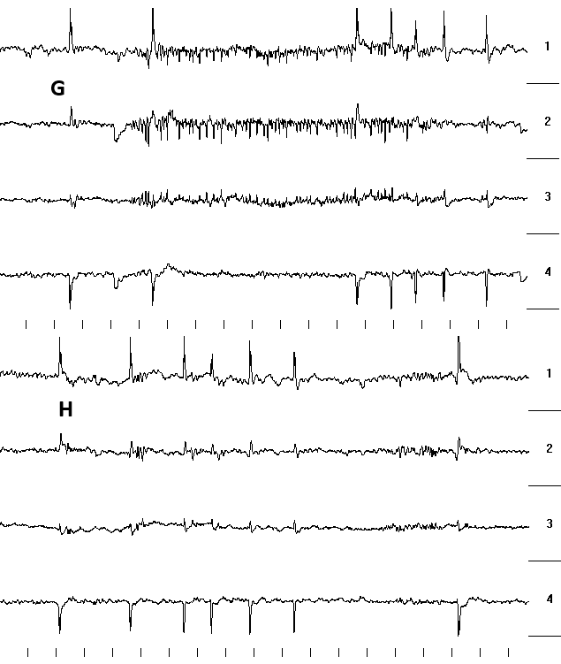

Fig. 4 Notes: G- 11.5 min after “F’ and 43.0 min since the last (5th) LCN ES.
H-2.0 min after “G” and 45.0 min since the last (5th) LCN ES.

Comment: mixed generation of not regular low amplitude burst of SWD-like activity and spikes (G).
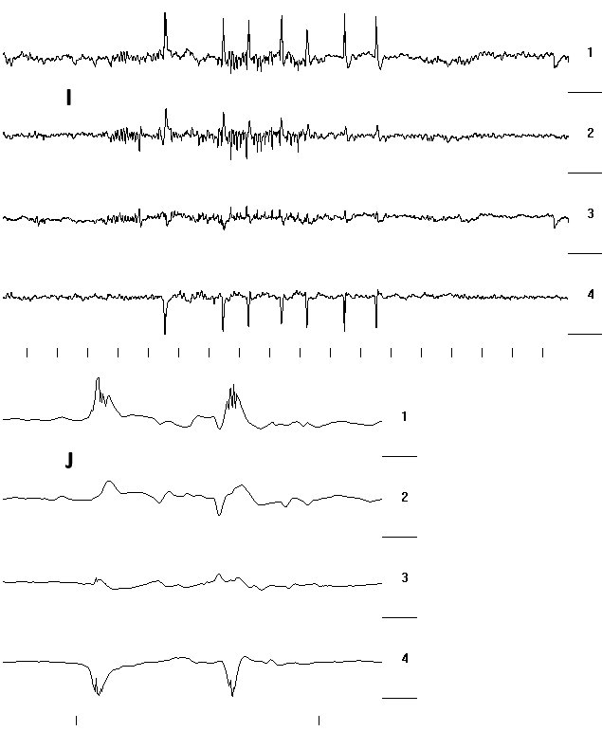
Fig. 5 Notes: I-10.0 min after “H” and 55.0 min since the last (5th) LCN ES.

Comment: J- Ripple – like discharges registered in the first lead at high speed of registration.

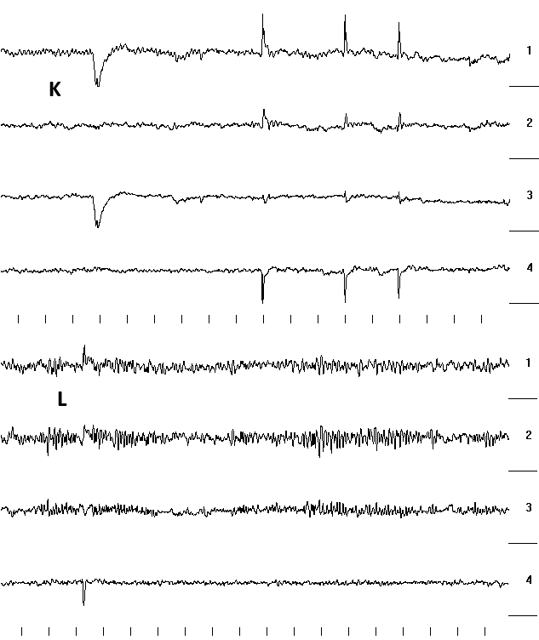

Fig. 6 Notes: K- 21.0 min after “J” and 76.0 min since the last (5th) LCN ES.
L-11.0 min after “K” and 87.0 min since the last (5th) LCN ES.

Comment: decrease of spike’s frequency and amplitude (“K”); spikes disappearance while not regular SWD-like activity is registered (“L”).

