Effects of Lateral Cerebellar Nucleus Stimulation on Seizures in Rats Kindled to Different Levels of Seizure Severity with PTZ

The Cerebellum

Leonid S. Godlevsky¹ ⁰⁰⁰⁰⁻⁰⁰⁰³⁻⁰⁹³⁵⁻⁸²⁵⁵, Mykhailo P. Pervak¹ ⁰⁰⁰⁰⁻⁰⁰⁰²⁻⁰³⁶⁰⁻⁵⁷⁵⁶, Olesya B. Poshyvak ² ⁰⁰⁰⁰⁻⁰⁰⁰¹⁻⁶²⁷⁷⁻⁸²³⁸, Suliman N.A.Hathal ², Olha S. Yehorenko¹, Zuleyha Doganyigit³ ⁰⁰⁰⁰⁻⁰⁰⁰²⁻⁶⁹⁸⁰⁻³³⁸⁴, Enes Akyuz⁴ ⁰⁰⁰⁰⁻⁰⁰⁰²⁻³⁹⁴²⁻²⁰⁹⁷

¹Odesa National Medical University, Odesa, Ukraine (e-mail: godlevskyleonid@yahoo.com);
lashelgo@gmail.com (Pervak M.P.); olhayehorenko@gmail.com (Yehorenko O.S.)
²Danylo Halytsky Lviv National Medical University, Lviv, Ukraine olesya.poshyvak@gmail.com (Poshyvak O.B.); snnasser2@gmail.com (Hathal S.N.A.)
³Yozgat Bozok University, Medical Faculty, Yozgat, Turkey zuleyha.doganyigit@yobu.edu.tr
⁴Department of Biophysics, University of Health Sciences, International Medicine Faculty, Istanbul, Turkey, enesakyuz25@gmail.com

Corresponding author:

Leonid Godlevsky
Department of Biophysics, Informatics and Medical Devices, Odesa National Medical University, 2, Valikhovsky Lane, Odesa 65082, Ukraine
godlevskyleonid@yahoo.com

Morphological investigations (linear density of Purkinje Cells)
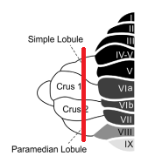
Fig. 1 Tissue located laterally from the vertical red line was used for histological investigations

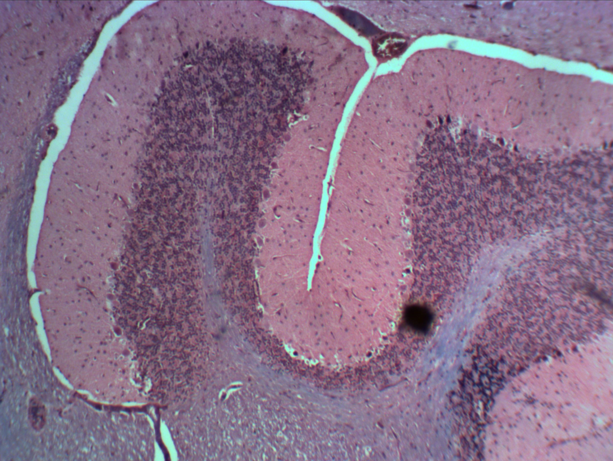
Fig. 2 Fully kindled rat degenerative changes in PC layer (reduction in PC number) (x40)
Note: All the rest of the samples were stained with Harris Hematoxylin and Eosin.
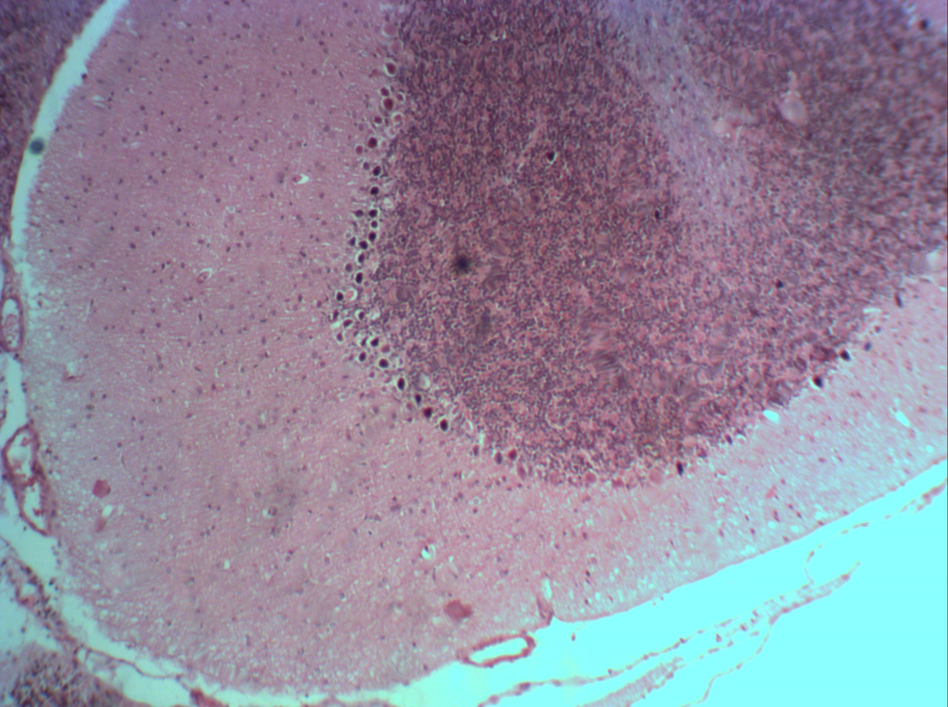

Fig. 3 Myoclonus-kindled rat (x40)

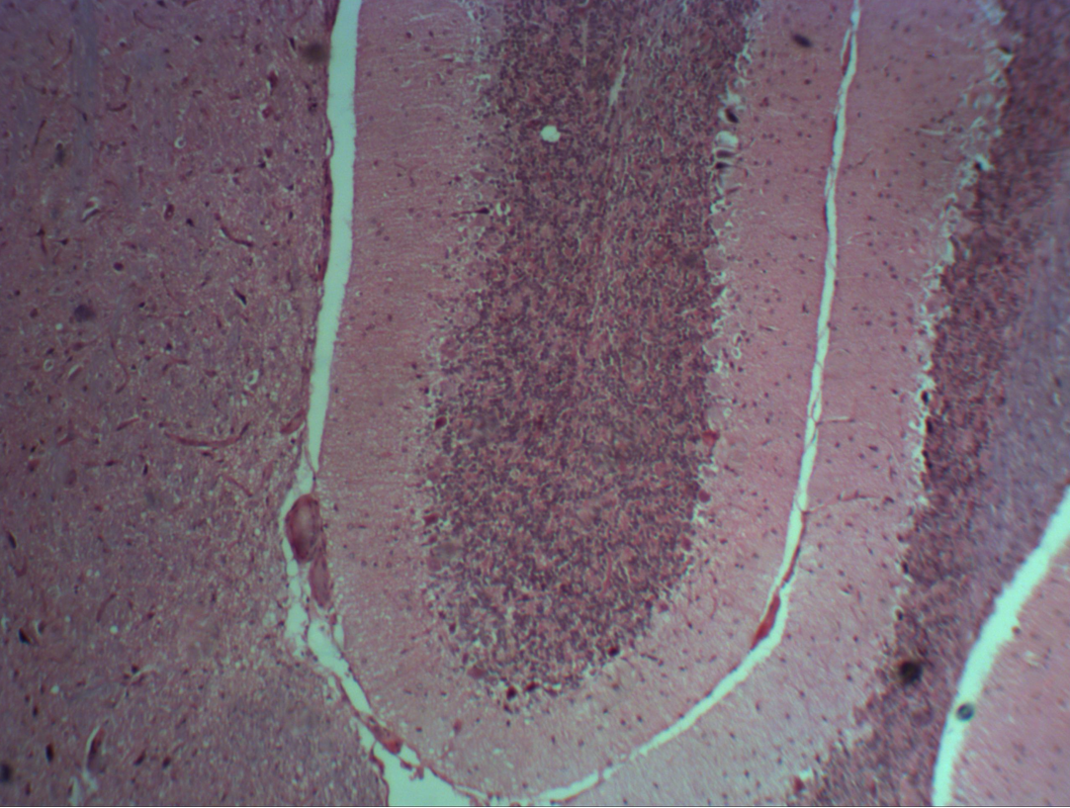

Fig. 4 Fully kindled rat (prone to kindling) x 40
Reduction of PC is observed.
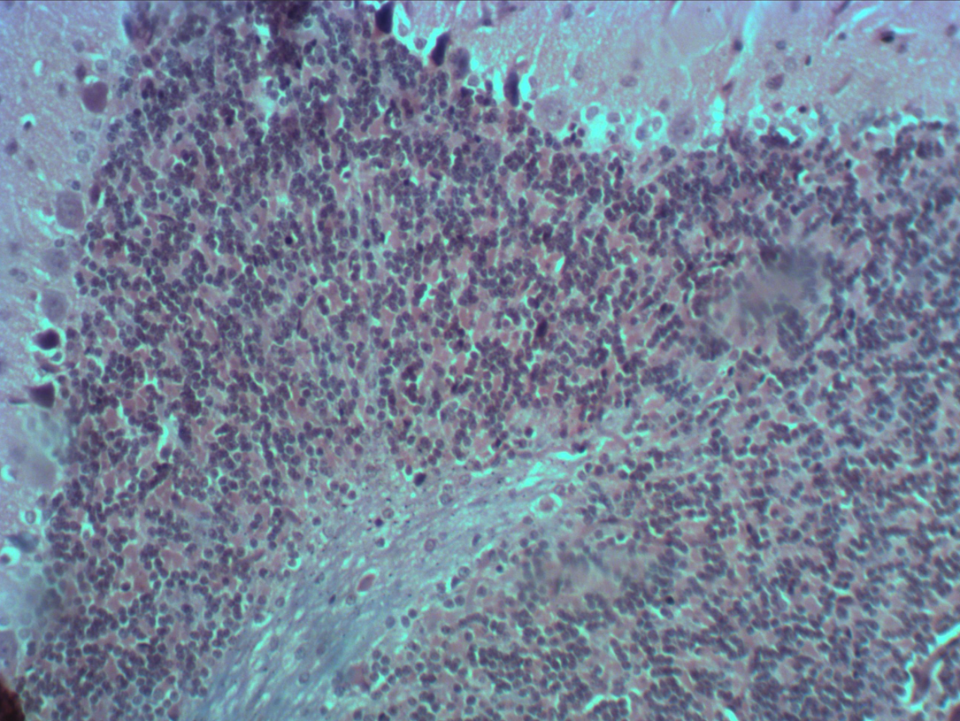

Fig. 5 Deterioration of PC layer in fully kindled rat (kindled prone animals) (x100)

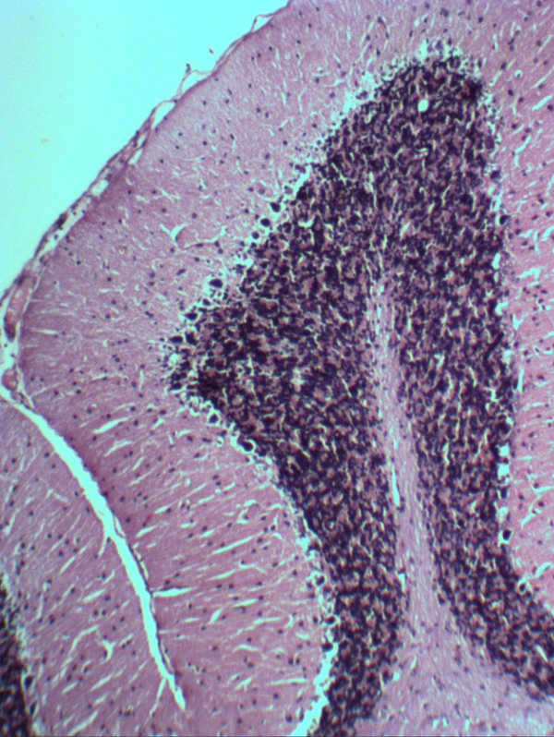

Fig. 6 Control rat (x100)

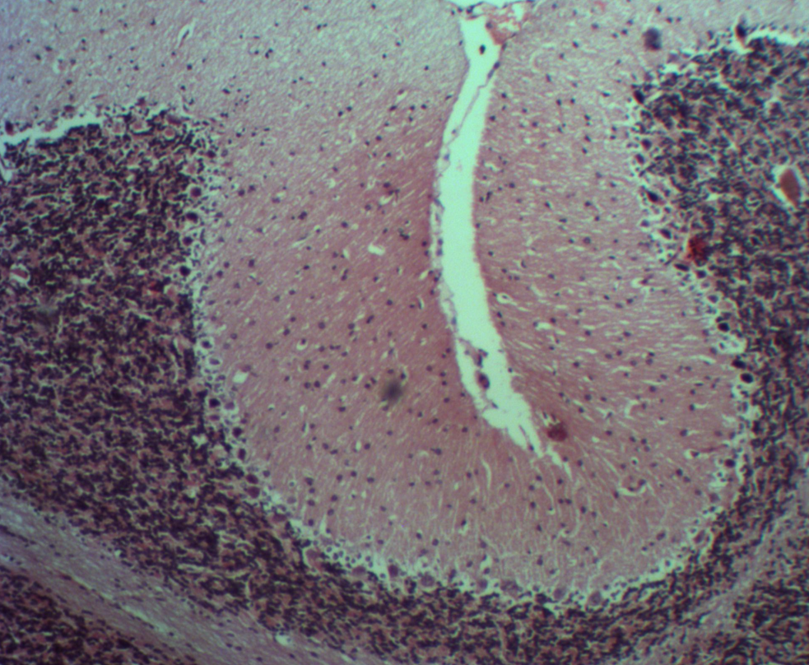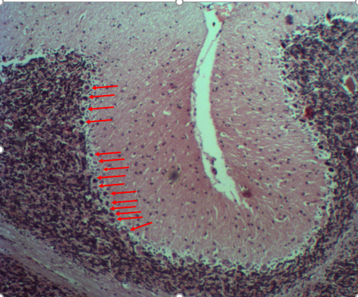
Fig. 7 and 8.Control rats (x40 – PC pointed with arrows)

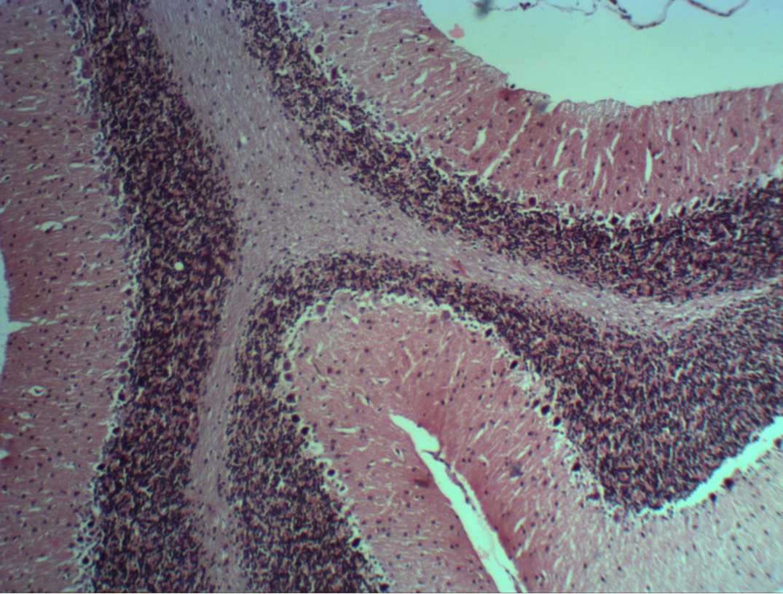
Fig. 9 Control rat (x40).

