Communications earth & environment
Supporting Information for
Inversion of time-varying gravity field before and after the 2013 Lushan Ms7.0 earthquake
Linhai Wang¹, Shi Chen^{1,3†}, Jiancang Zhuang^{2,4†}, Bei Zhang^{1,3}, Wen Shi^{1,3}, Jinling Yang^{1,5}, Weimin Xu¹
1 Institute of Geophysics, China Earthquake Administration, Beijing 100081, China.
2 The Institute of Statistical Mathematics, Research Organization of Information and Systems, Tokyo 106-8569, Japan.
3 Beijing Baijiatuan Earth Science National Observation and Research Station, Beijing 100095, China.
4 Department of Statistical Science, The Graduate University for Advanced Studies (SOKEN), Tokyo 190-8562, Japan.
5 Fujian Earthquake Agency, Fuzhou 350003, China.

Contents of this file

Text S1
Text S2
Figures S1
Figures S2
Figures S3
Figures S4
Figures S5

Introduction
This supporting information provides the details of the forward modeling using gravity change and the figures of the adjusted results obtained by the Modified Bayesian gravity adjustment (MBGA) method and results of checkerboard test for apparent density model.

Text S1.
The apparent density model for the inversion of the time-varying gravity field from terrestrial gravity observation can be represented as the least squares problem of the objective function (Zhang et al., 2021; Yang et al., 2021; Chen et al., 2022):
$Ψ=W_{obs}{\left\|Gm-f(x,y,z,t)\right\|}^{2}+W_{S}Ψ_{S}^{2}(m)+W_{T}Ψ_{T}^{2}(m)$, (1)
where the vector $f\left(x,y,z,t\right)$ indicates the observed gravity value for gravity station ($x$: latitude, $y$, longitude and $z$: elevation) at different observation epochs $t$, G is the Green’s function for the apparent density model and gravity observation data, $m$ indicates the near-crust field source model to be calculated. $W_{obs}$ represents the weight of gravity observation, inversely proportional to the observation noise, $W_{ s}$ indicates a weight coefficient (hyperparameter) for the smoothness constraint in space,
$Ψ_{S}\left(m\right)=\int{\int{\int{\left({\left(\frac{∂^{2}m}{{∂x}^{2}}\right)}^{2}+2{\left(\frac{∂^{2}m}{∂x∂y}\right)}^{2}+{\left(\frac{∂^{2}m}{{∂y}^{2}}\right)}^{2}\right)}}}dxdydt$. (2)
and, $W_{t}$ is a weight coefficient (hyperparameter) for the smoothness constraint of time,
$Ψ_{T}\left(m\right)=\int{\int{\int{{\left(\frac{∂^{2}m}{∂t^{2}}\right)}^{2}}}}dtdxdy$. (3)
The three weights $W_{obs}$, $W_{ s}$, and $W_{t}$ in equation (1) to (3) can be estimated as hyperparameters. In this study, the Akaike Bayesian information criterion (ABIC) of Bayesian method is introduced to realize the optimal calculation of hyperparameters (Akaike, 1980).
$ABIC=-2×\log\left[P\right]+2×N,$ (4)
where $P$ and $N$ represent the likelihood function and the number of hyperparameters in the model. Then, the optimal values of three hyperparameters $W_{obs}$, $W_{ s}$, and $W_{t}$ can be obtained, when the value of $ABIC$ is minimum. The ABIC minimization problem is a nonlinear optimization problem, which can be solved by Simplex algorithm or quasi-Newton method with multi parameter nonlinear optimization ability (Bonnans et al., 2006).

Text S2.
Equation of gravity anomaly $∆g\left(x,z\right)$
We used the analytical solution to forward gravity change with a disk geometry [Singh, 1977].
$∆g\left(x,y\right)=2Gρ{\left|\frac{R^{2}-x^{2}}{\sqrt{{\left(x+R\right)}^{2}+y^{2}}}Κ\left(k\right)+\sqrt{{\left(x+R\right)}^{2}+y^{2}}Ε\left(k\right)+0.5πyΛ\left(φ,k\right)-πy\right|}_{Z+H}^{Z}$
where the $∆g$ is the gravity change with a uniform density $ρ$, $G$ is gravitation constant. The $x$ and $y$ are the horizontal and vertical position of observed station, respectively. The $R$, $Z$ and $H$ are the radius, top depth and thickness of disc model, respectively. $Z=Z_{h}+Z_{t}$ and $Z_{h}$ is the known quantity and equal to the elevation. The $K(k)$ is the first kind complete elliptic integral:
$$Κ\left(k\right)=\int_{0}^{π/2}{\frac{dt}{\sqrt{1-k^{2}\sin^{2}t}}}$$
and $E(k)$ is the second kind complete elliptic integral:
$$Ε\left(k\right)=\int_{0}^{π/2}{\sqrt{1-k^{2}\sin^{2}t}dt}$$
and the Heuman Lambda function is:
$$Λ\left(φ,k\right)=Ε\left(k\right)F\left(φ,k\right)+K\left(k\right)Ε\left(k\right)-K\left(k\right)F\left(φ,k\right)$$
where $k$ and $φ$ as follows:
$$k^{2}=\frac{4Rz}{{\left(x+R\right)}^{2}+z^{2}}$$
$$φ=\frac{π}{2}+\tan^{-1}{\frac{x-R}{z}}$$

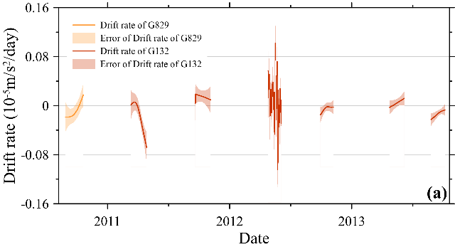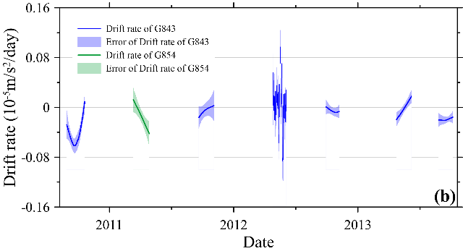
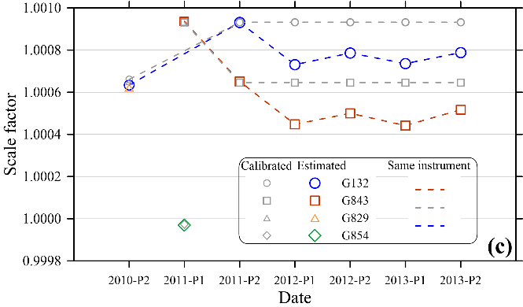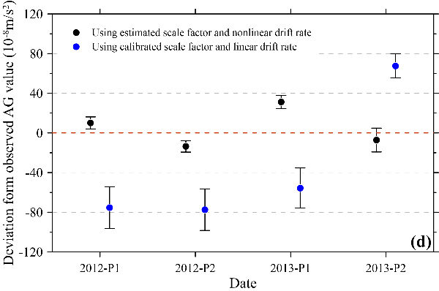

Figure S1. (a) and (b) are the estimated drift rates of the four relative gravimeters from 2010 to 2013 obtained by the MBGA method; (c) The comparison between the scale factor estimated using the MBGA method and the calibrated results; (d) The gravity value deviation of the Panzhihua station obtained using different scale factor and drift models from the absolute gravity measurement results.

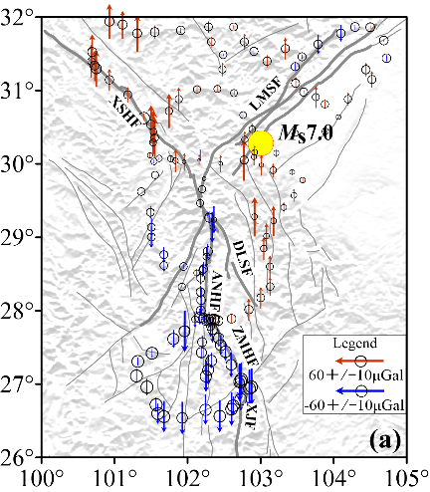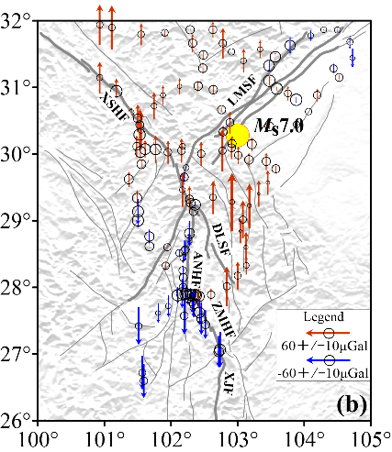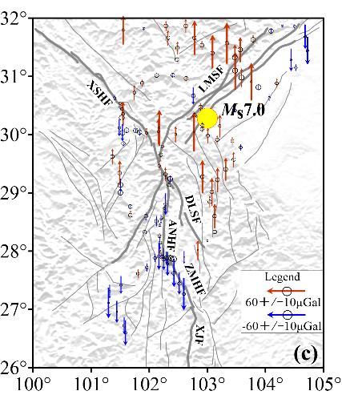
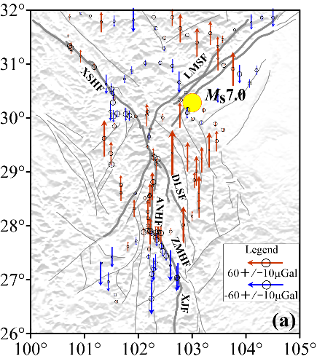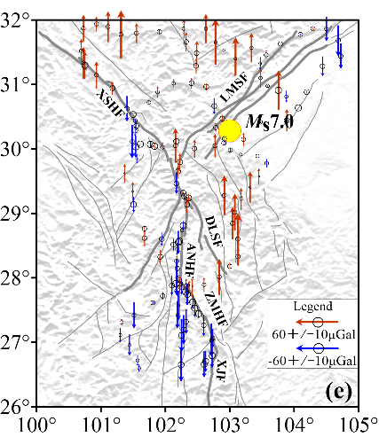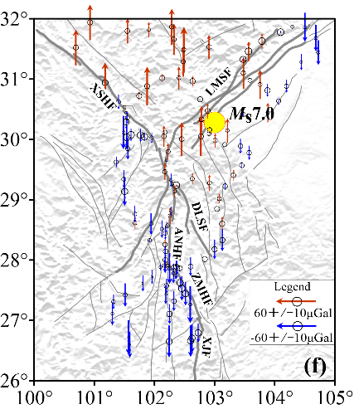

Figure S2. The cumulative changes of gravity value at each gravity station calculated by selecting the gravity values of 2010-08 as the time reference. We used the MBGA method to obtain the gravity values at each epoch, and calculated the cumulative change of gravity value at each station by selecting the gravity values of 2010-08 as the time reference.

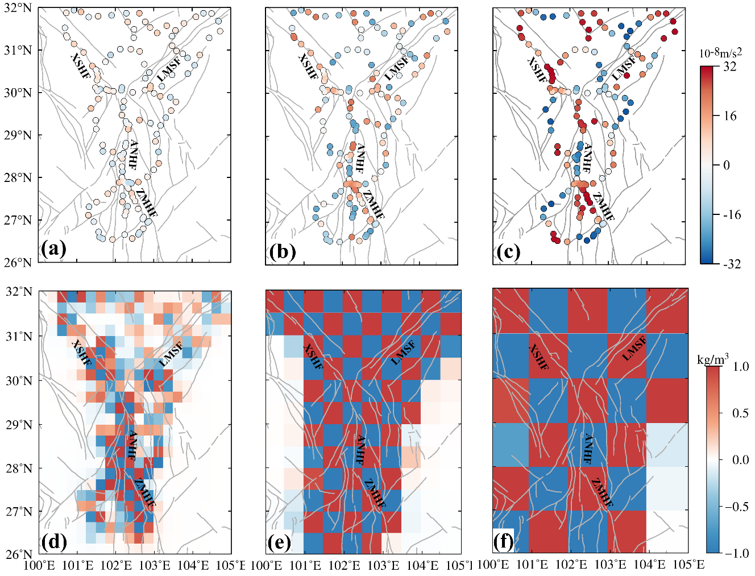
Figures S3. Results of checkerboard test with different spatial resolutions. (a) (b) (c) show the three observable theoretical gravity anomalies by respectively forwarding the three checkerboards of the deep source body (0.25°, 0.5°and 1°); (d) (e) (f) show the three recovered deep source body densities respectively inverted from the three observable theoretical gravity anomalies. When the size of the deep source body is 0.25°, the checkerboard cannot be successfully recovered in the north of the survey network between XSHF and LMSF. In contrast, for deep sources body of 0.5° and 1°, the deep source body densities in the survey network area can be effectively restored, with the residuals ranging from -0.14 kg/m³ to 0.15 kg/m³. It is deduced that the Sichuan survey network can monitor the deep sources body with a spatial resolution of about 55 km.
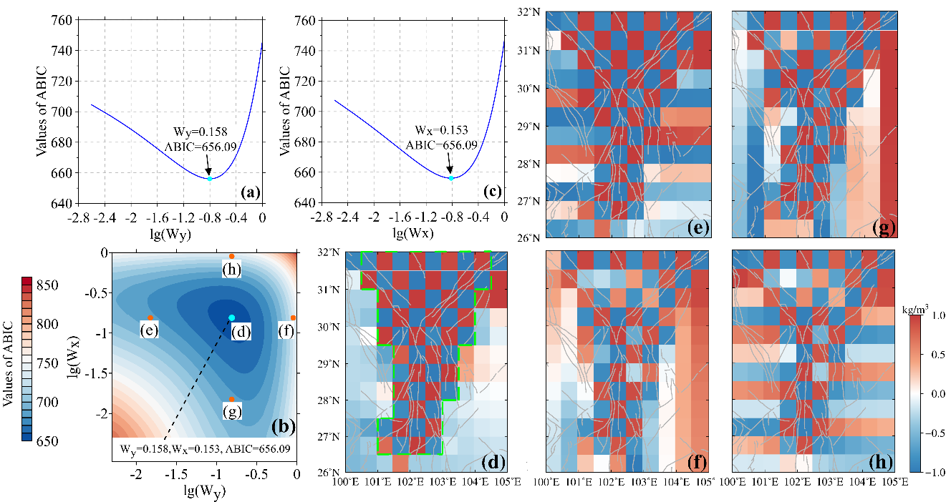
Figures S4. ABIC minimization process of two spatial smoothness hyperparameters in the Bayesian apparent density inversion method (BADI) and the inverted checkerboard. (a) and (c) are the ABIC minimization process of $x$-direction and $y$-direction smooth constraints respectively. (b) the ABIC minimization process of $x$-direction and $y$-direction smooth constraints and the selected sensitivity test points. (d) is the case of optimal $x$-direction and $y$-direction smooth constraints. (e) and (f) are the cases of insufficient and excessive $y$-direction smooth constraints respectively; (g) and (h) are the cases where the smooth constraint in the $x$ direction is insufficient and excessive. The green dotted line range is the area where the field source density can be accurately inversed.

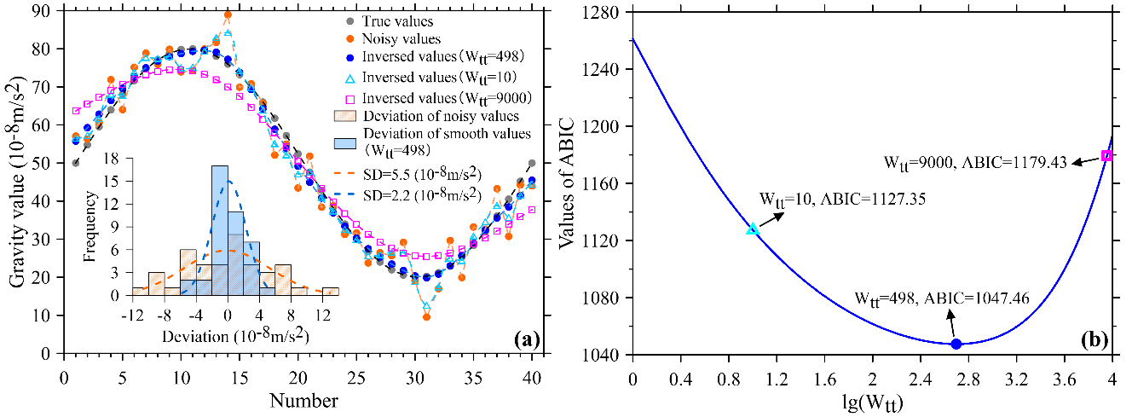
Figures S5. (a) the forty-epochs checkerboard inversion results obtained by the BADI using different temporal smoothness constraint $W_{tt}$; (b) ABIC minimization process and ABIC values corresponding to different temporal smoothness constraint $W_{tt}$. The inversed gravity anomalies obtained by the BADI method using optimal temporal smoothness constraint ($W_{tt}$=498) are shown as the blue dots in (a), which are basically consistent with the true value (gray dots).

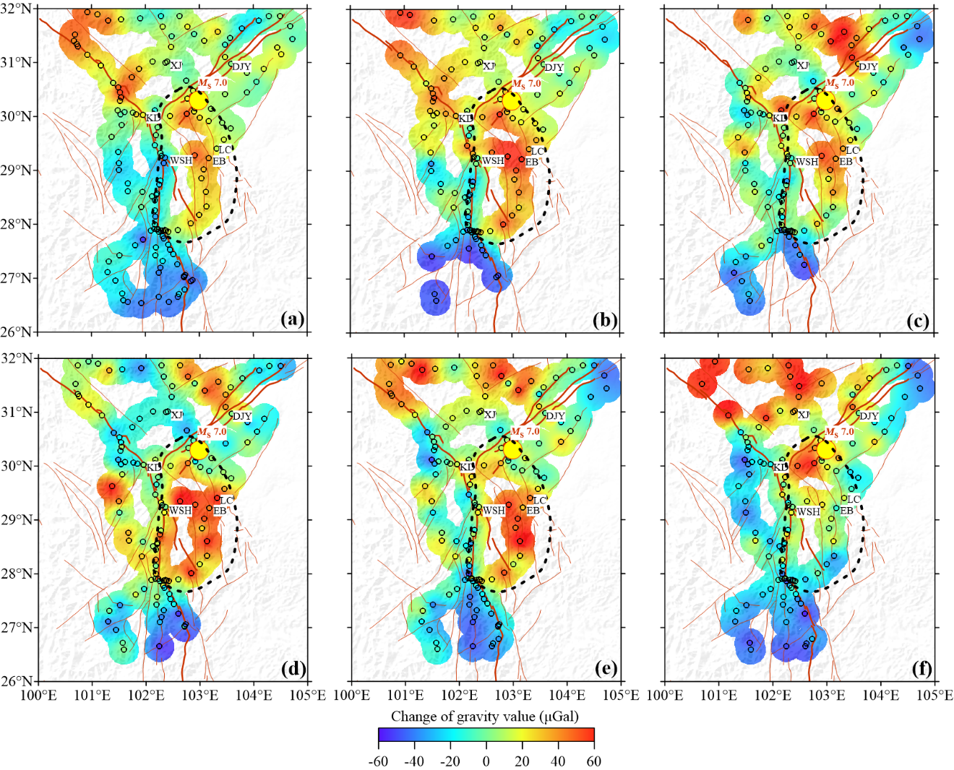

Figure S6. The cumulative changes of gravity value at each gravity station calculated by the MBGA method. The gravity change value is the same as that in Fig. 2, but different from the arrow in Fig. 2, we use the dot to indicate the gravity change at each station.

References
Bonnans, J. F., Gilbert, J. Ch., Lemaréchal, C., Sagastizábal, C. A. (2006), Numerical Optimization : Theoretical and Numerical Aspects (Second ed.). Springer. ISBN 3-540-35445-X.
Chen, Z., Chen, S., Zhang, B., Wang, L., Shi, L., Lu, H., Liu J., & Xu, W., (2022), Uncertainty Quantification and Field Source Inversion for the Continental-Scale Time-Varying Gravity Dataset: A Case Study in SE Tibet, China. Pure Appl. Geophys. https://doi.org/10.1007/s00024-022-03095-9
Singh, S.K. (1977), Gravitational attraction of a vertical right circular cylinder, Geophysical Journal of the Royal Astronomical Society, 50, 243–246.
Yang, J., Chen, S., Zhang, B., Zhuang, J., Wang, L. & Lu, H. (2021), Gravity observations and apparent density changes before the 2017 Jiuzhaigou Ms7.0 earthquake and their precursory significance, Entropy, 23(12):1687. doi:10.3390/e23121687
Zhang, B., Chen, S., Li, H., Yang, J., Han, J. & Lu, H. (2021), Time-varying gravity inversion using spherical model and synthetic test, EARTHQUAKE, 41(1), 13-24. doi:10.12196/j.issn.1000-3274.2021.01.002

