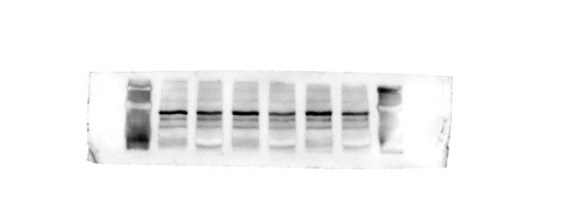
MMP2 - EMT6 (Fig.1 D)
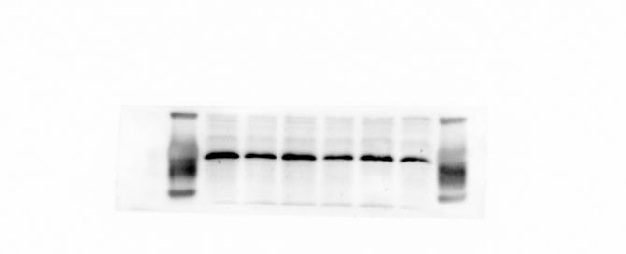
MMP9 - EMT6 (Fig.1 D)
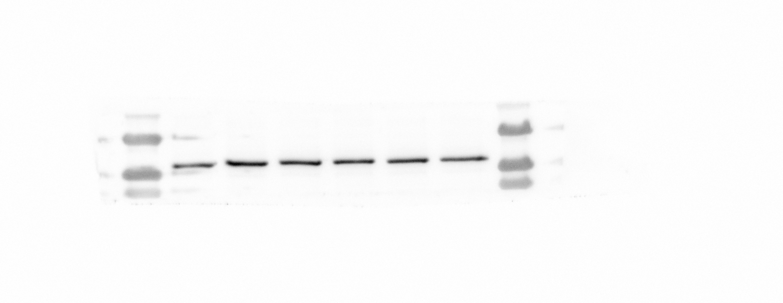
βactin - EMT6 (Fig.1 D)
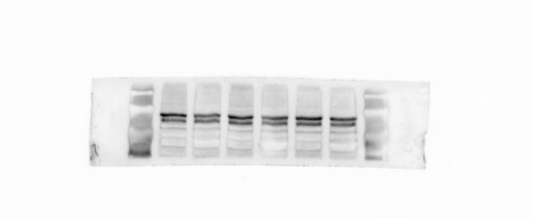
MMP2 - 4T1 (Fig.1 D)

MMP9 - 4T1 (Fig.1 D)
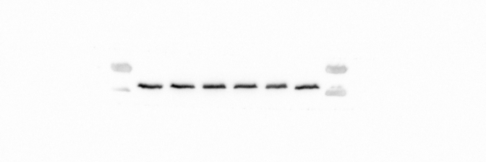
βactin - 4T1 (Fig.1 D)
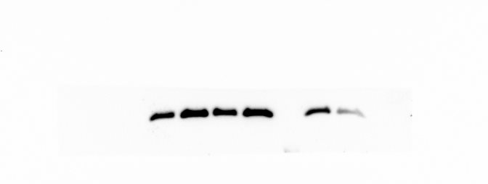
BAX - EMT6 (Fig. 3B)
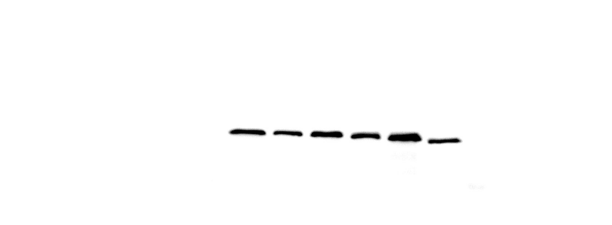
CASPASE 3 - EMT6 (Fig. 3B)
CLEAVED CASPASE3 - EMT6 (Fig. 3B)
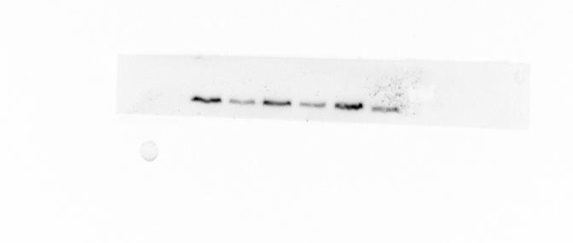
GSDME - EMT6 (Fig. 3B)
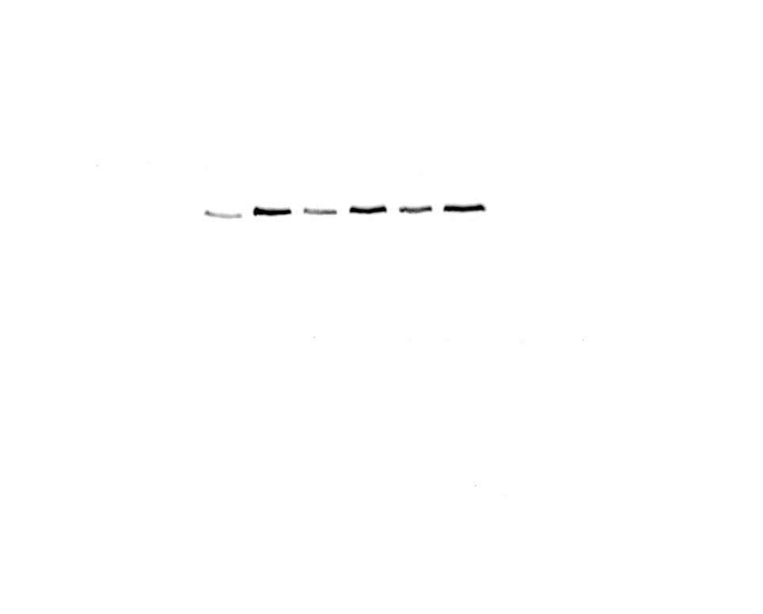
GSDME-N - EMT6 (Fig. 3B)
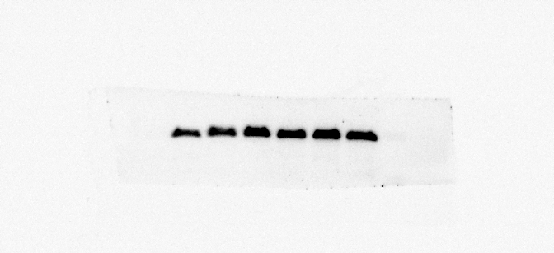
BAX - 4T1 (Fig. 3C)
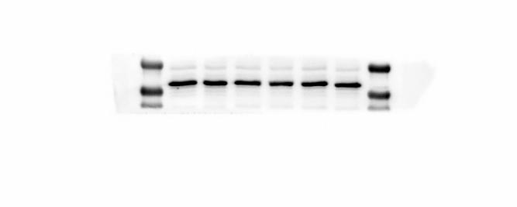
CASPASE 3 - 4T1 (Fig. 3C)
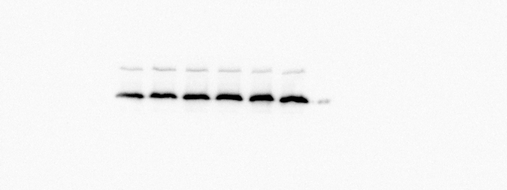
CLEAVED CASPASE3 - 4T1 (Fig. 3C)
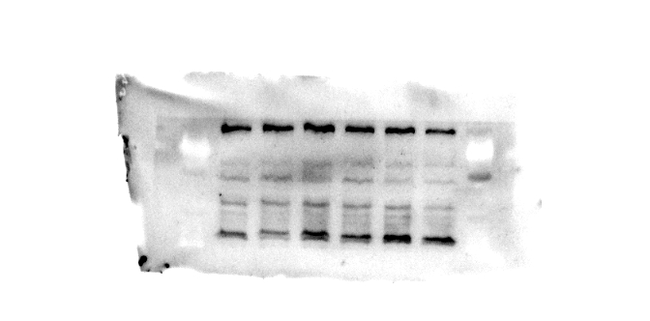
GSDME - 4T1 (Fig. 3C)
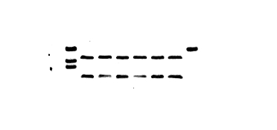
GSDME-N - 4T1 (Fig. 3C)

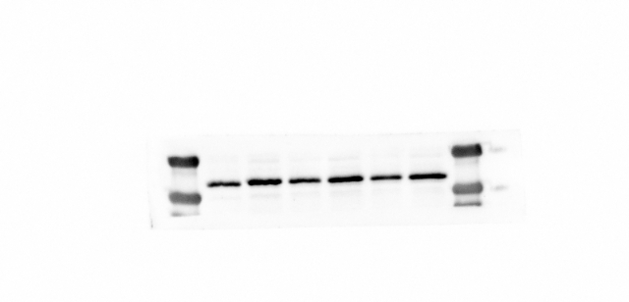
GZMB - 4T1 (Fig. 3C)
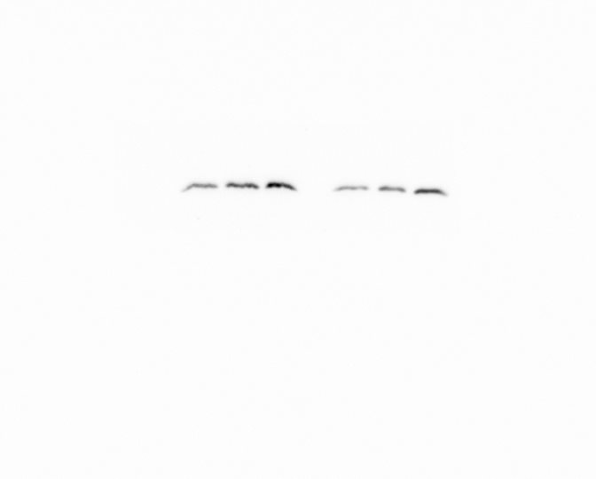
BAX - mouse tumor (Fig. 4K)
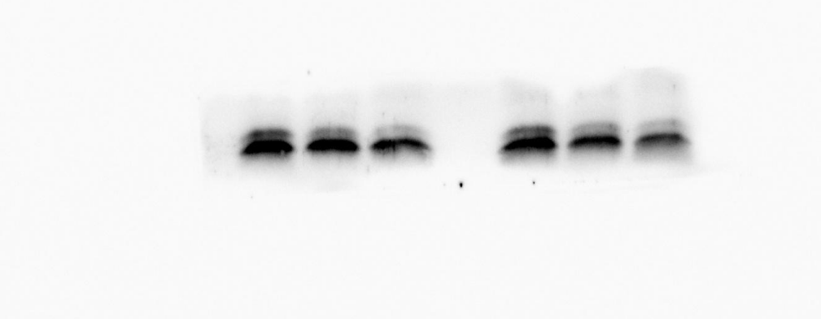
CASPASE-3 - mouse tumor (Fig. 4K)
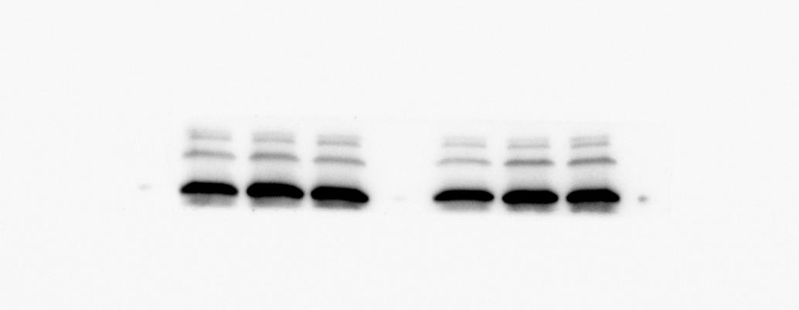
CLEAVED CASPASE-3 - mouse tumor (Fig. 4K)

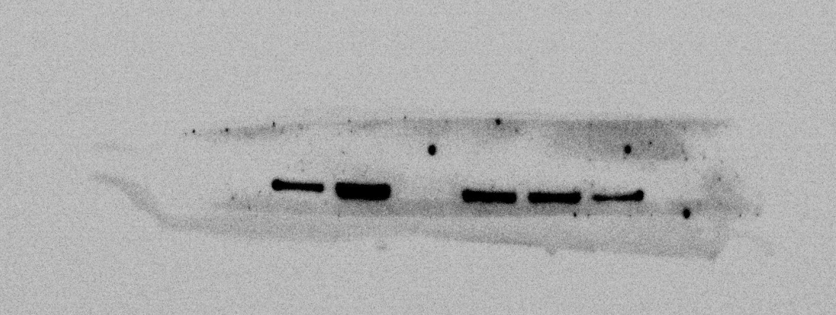
GSDME - mouse tumor (Fig. 4K)

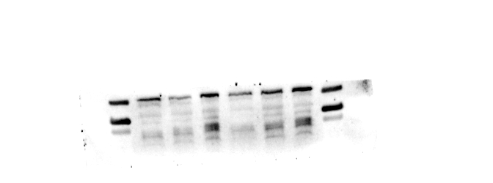
GSDME-N - mouse tumor (Fig. 4K)
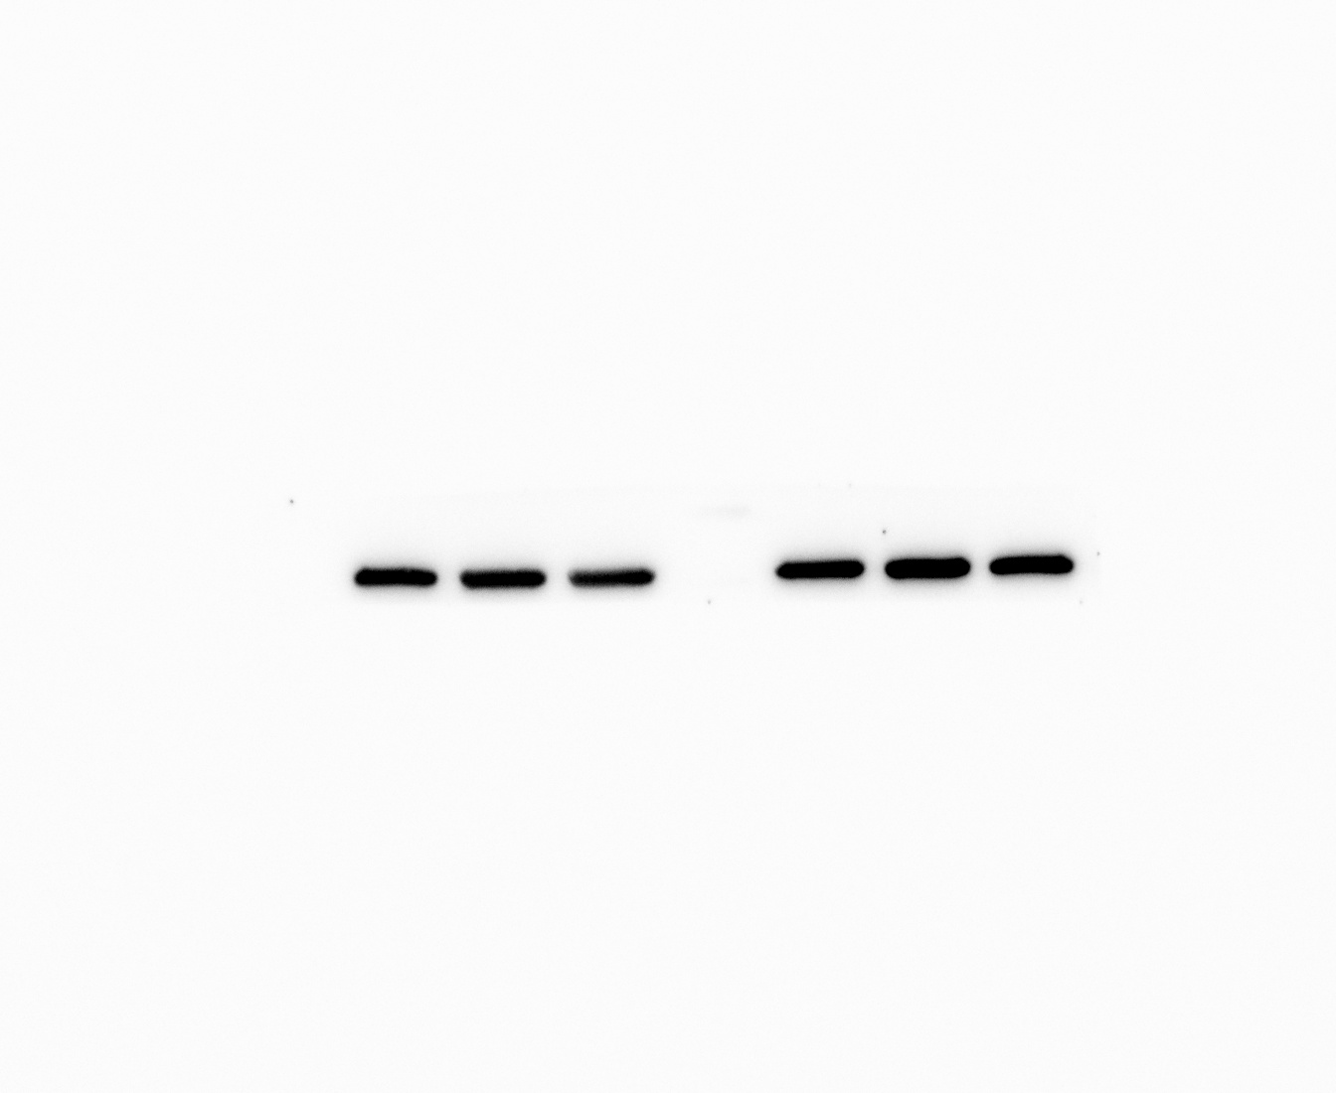
βactin - mouse tumor (Fig. 4K)
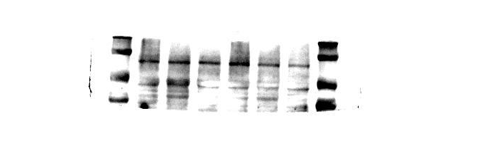
HIF-1α- mouse tumor (Fig. 11S)

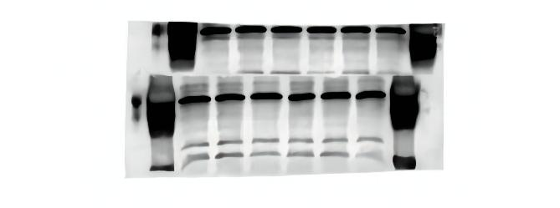
VEGFA - mouse tumor (Fig. 11S)
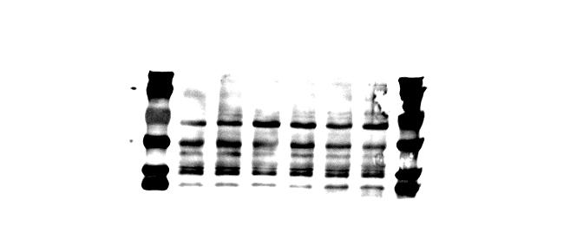
MMP2 - mouse tumor (Fig. 11S)

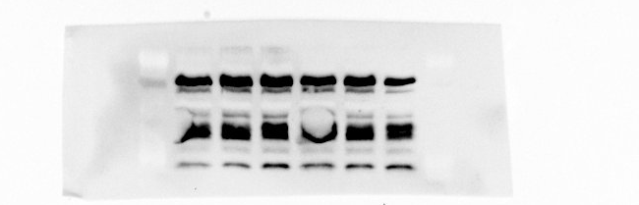
MMP9 - mouse tumor (Fig. 11S)
βactin - mouse tumor (Fig. 11S)

