Supplementary Material

Title: Rapid detection of duck ingredient in adulterated foods by isothermal recombinase polymerase amplification assays

Journal: Food Analytical Methods
Authors: Cang Zhou, Jinfeng Wang, Jialin Xiang, Qi Fu, Xiaoxia Sun, Libing Liu, Lianfeng Ai, Jianchang Wang*

Correspondence:
Jianchang Wang, E-mail: jianchangwang1225@126.com.
Food Microbiology and Animal Quarantine Laboratory, Technology Center of Shijiazhuang Customs, Shijiazhuang 050051, China

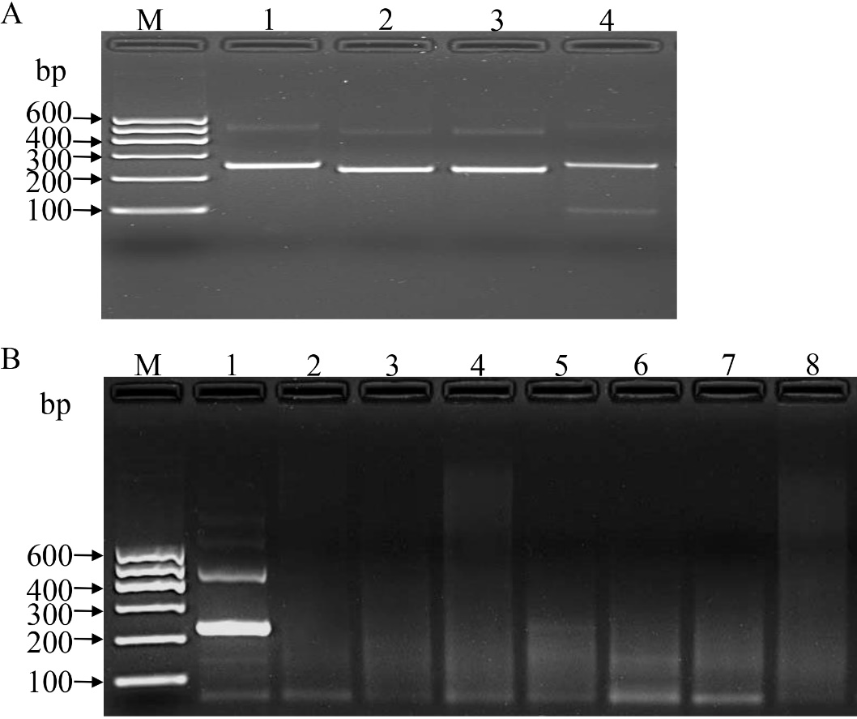
Supplementary Figure 1. Basic RPA reactions used during primers screen. (A) Primary candidate screen. Lane M: DNA Marker. Lanes 1-4: CytbF₁₋₁R₁, CytbF₁₋₂R₂, CytbF₂R₂, CytbF₃R₃ with the expected amplification sizes of 243, 226, 227 and 251 bp, respectively. (B) Preliminary evaluation of the specificity. Lines 1-8: duck, donkey, chicken, pig, goat, sheep, cattle, ddH₂O.

Supplementary Figure 2. Detection results of duck ingredient in different kinds of foods by real-time RPA and RPA-LFS combined with different DNA extracted methods. (A) Real-time RPA combined with DNA extracted method 1. Lane 1-13: duck genomic DNA (1×10⁵ pg), small wonton (fresh pork), thin crust pies (black pepper beef flavor), thin crust pie (pork and scallion), ddH₂O, fried duck, fried duck frame, roasted duck, roasted duck wing root, roasted duck wing, sauteed duck breast, duck genomic DNA (1×10² pg), canned whole duck. (B) Real-time RPA combined with DNA extracted method 2. Lines 1-11: duck genomic DNA (1×10³ pg), small wonton (fresh pork), thin crust pies (black pepper beef flavor), thin crust pie (pork and scallion), diced beef (satay), red sausage, ddH₂O, two kinds of sheep slices and two kinds of beef slices. (C) RPA-LFS combined with DNA extracted method 2. Lines 1-6: diced beef (satay), small wonton (fresh pork), red sausage, canned whole duck, spicy grilled sausage, sheep slices.
Supplementary Figure 3. Comparison between results of real-time RPA and real-time PCR for duck ingredient in different kinds of foods. One hundred and thirteen DNA extracts of the actual samples with method 1 were detected. The duck-derived component positive rate was 26.55% (31/113) both for real-time RPA and real-time PCR. Linear regression analysis of real-time RPA threshold time (TT) values (y axis) and real-time PCR cycle threshold (Ct) values (x axis) were determined by Prism software. R² value was 0.8674.

Supplementary Figure 4. Detection results of duck ingredient in different blood-related products by real-time RPA and RPA-LFS. Detection results of original DNA solution were showed in (A), (C) and (E); detection results of ten-fold diluted DNA solution were showed in (B), (D) and (F). The results of real-time RPA combined with DNA extracted in Method 1 were showed in (A) and (B); the results of real-time RPA combined with DNA extracted in Method 2 were showed in (C) and (D); and the results of RPA-LFS combined with DNA extracted in Method 2 were showed in (E) and (F). The numbers in the above figures indicated (1) duck genomic DNA (1×10³ pg); (2) duck blood #1; (3) duck blood #2; (4) duck blood #3; (5) pig blood #1; (6) ddH₂O.

