Environmental toxin biliatresone can induce biliary atresia: evidence from human liver organoids
Haibing Yue,¹ Sudheer Sivasankaran Menon,¹ Rosana Ottakandathil Babu,^{1,#} Zhongluan Wu,¹ Man-Ting So,¹ Patrick Ho-Yu Chung,^{1,2} Kenneth Kak-Yuen Wong,^{1,2} Paul Kwong-Hang Tam,^{1,2,3} Vincent Chi-Hang Lui^{1,2}
Supplementary information

Supplementary Figures
Figure S1. Immunostaining of control and day-2 biliatresone-treated human liver organoids for ZO-1 (green) and CK19 (red). Nuclei were stained with DAPI (blue).
Figure S2. Setup of calcium signal evaluation of human cholangiocytes after perfusion stimulation. (A) Left panel, perfusion setup for the microfluidic chip mounted on the microscope. Boxed region was magnified and shown below. Right panel, diagram of the microfluidic chips with human cholangiocyte monolayer, and representative image of the cholangiocyte monolayer cultured in the channel of microfluidic chip immunostained for ZO-1 (green). Nuclei were stained with DAPI (blue). (B) Left panel, representative images of cholangiocytes stained with Calbryte 520 before and after perfusion stimulation. Right panel, plot profile of fluorescent intensity changes of highlighted region (ROI: region of interest) for 20 seconds after perfusion stimulation.
Figure S3. Gene expressions in liver ductal organoids with or without biliatresone treatment for 2 day and 5 days. (A) mRNA expression levels were characterized by real-time PCR for SOX17 normalized to GAPDH. (B) GSH levels were measured in liver organoids from 0 to 48 hours without (Ctrl) or with biliatresone. Data was obtained from 3 wells in each group; *, p<0.05, student’s t-test; error bars indicated the standard deviation.
Supplementary movies
Movie S1. Analysis of the intracellular calcium concentration changes of the control and biliatresone-treated human cholangiocytes after perfusion stimulation.

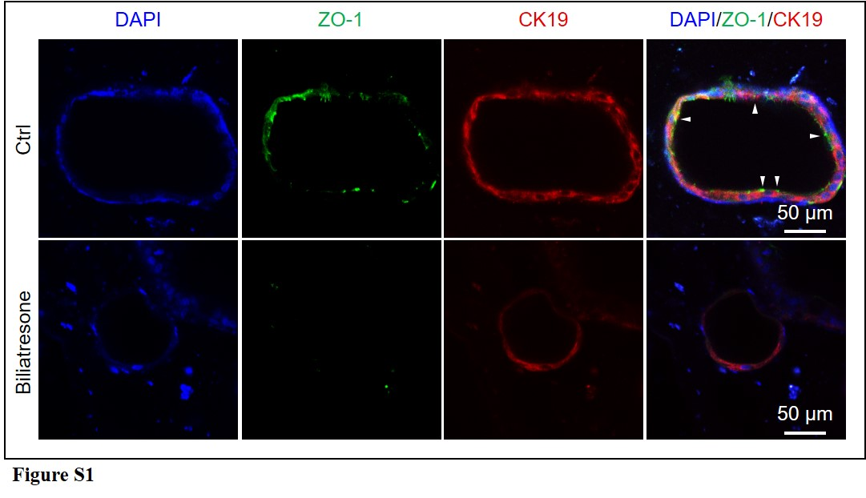

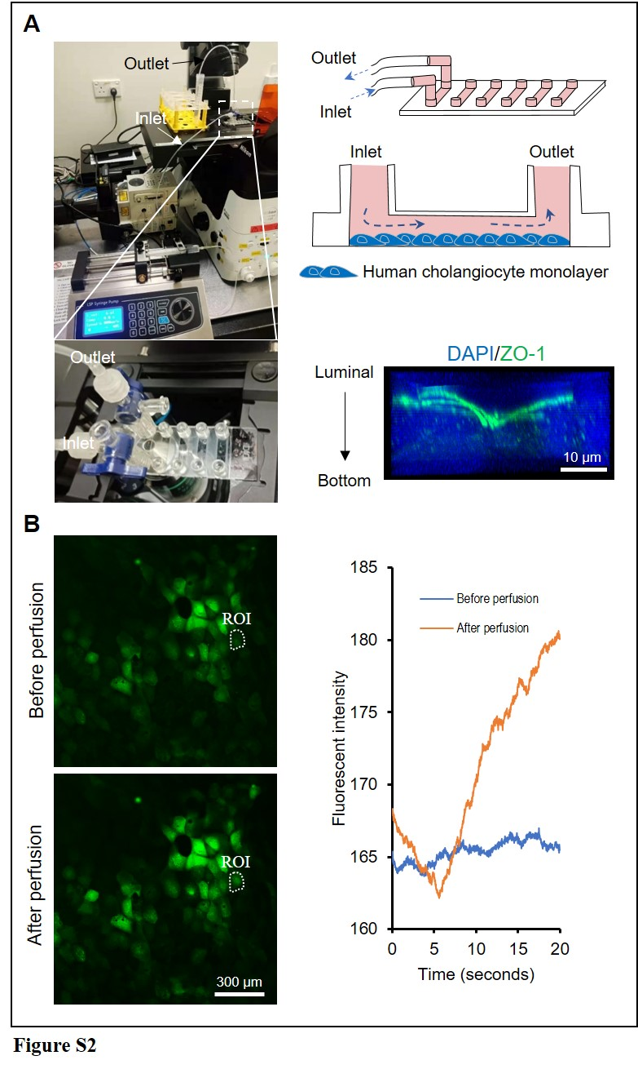

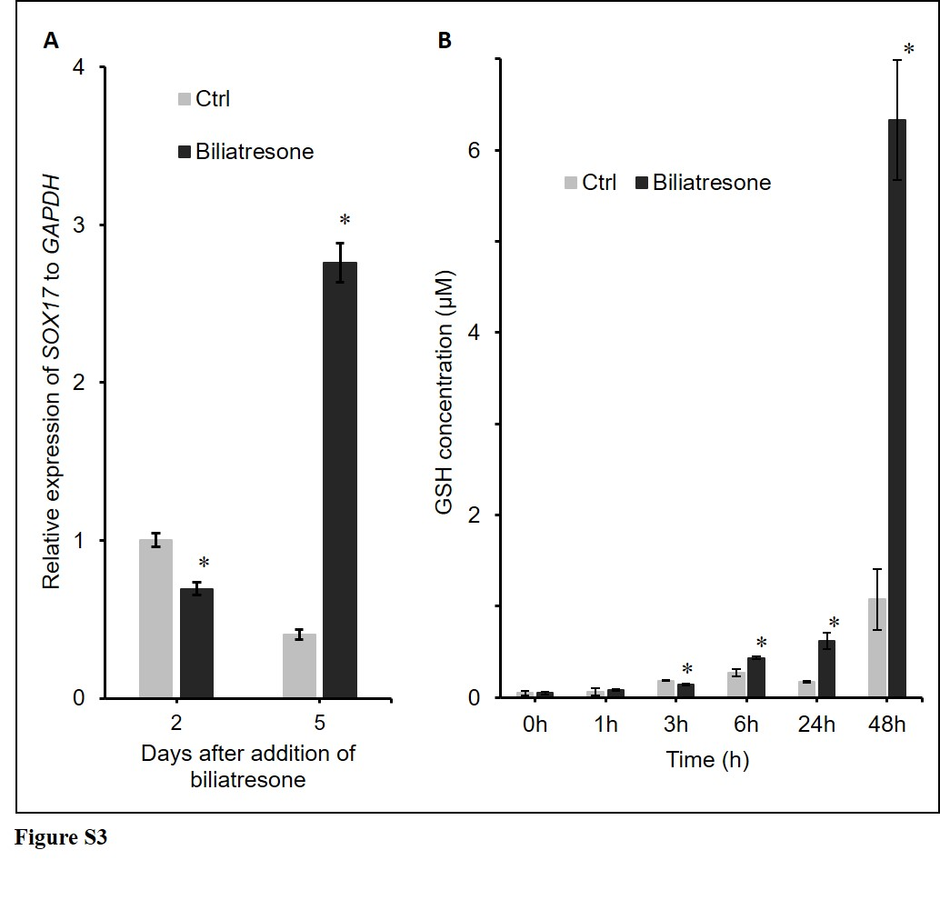



Movie S1

