Extended Data Figures and Legends
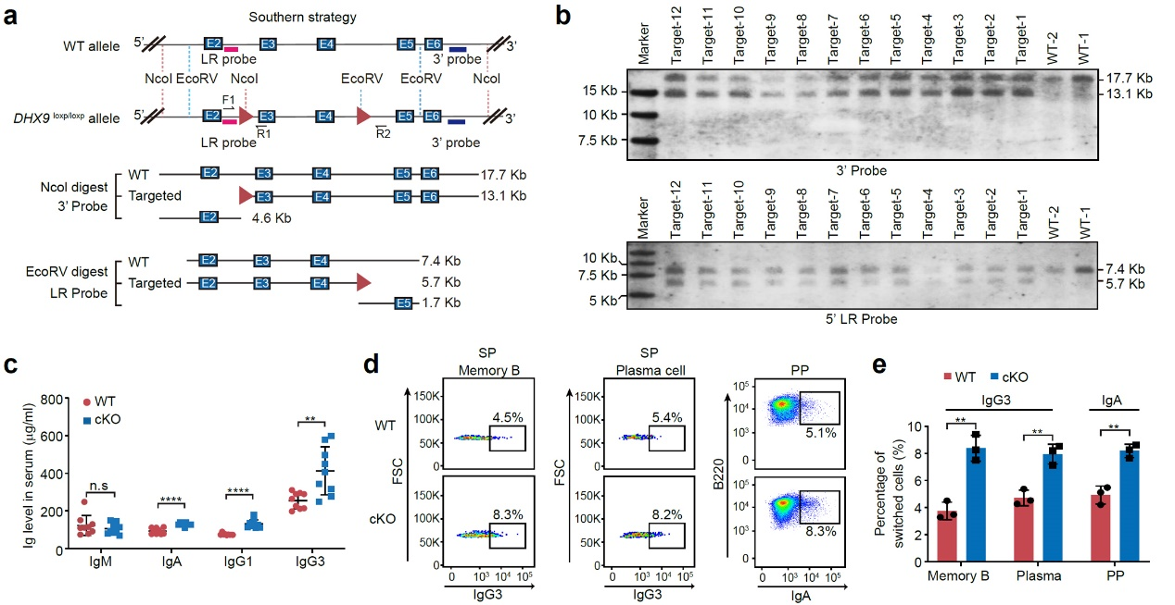
Extended Data Figure 1. Increased CSR in DHX9-deficient B cells. a. Diagram of the Southern blot strategy to identify loxp/loxp insertions. The red triangles represent loxp sites. The 3’ and LR probes are shown in blue or red boxes. The size of NcoI and EcoRV digested genomic fragments are listed. b. Loxp insertions were confirmed by Southern blotting using Digoxin-labeled 3’ or LR probes. c. Serum Ig concentrations were examined by ELISA in WT and DHX9-deficient mice (n = 9). d. FACS analysis showed that the expression of IgG3 and IgA are markedly increased in DHX9-deficient naïve B cells compared with WT cells. SP, spleen; PP, Peyer’s patches. e. Quantifying IgG3 and IgA CSR efficiency as shown in d (n = 3). **P < 0.01 and ****P < 0.0001 by two-tailed Student’s t-test. The data are presented as the mean ± S.D.
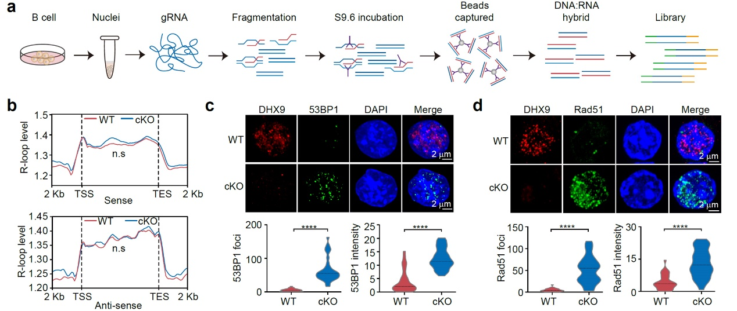
Extended Data Figure 2. ssDRIP-seq mapping shows that R-loops are barely changed in DHX9-deficient B cells. a. Diagram of ssDRIP-seq library construction using WT or DHX9-deficient B cells. b. Meta-profile shows similar ssDRIP-seq signals between WT (red) and DHX9-deficient B cells (cyan). c. Immunofluorescence staining shows induced 53BP1 expression in DHX9-deficient B cells. The number and intensity of 53BP1 foci in WT and DHX9-deficient B cells are calculated and shown at the bottom (n = 30 cells). d. Rad51 staining shows gross DSBs in DHX9-deficient B cells compared to WT cells. The number and intensity of foci in WT (n = 31) or DHX9-deficient (n = 28) B cells are quantified and shown at the bottom. Scale bar: 2 μm. ****P < 0.0001 by two-tailed Student’s t-test.
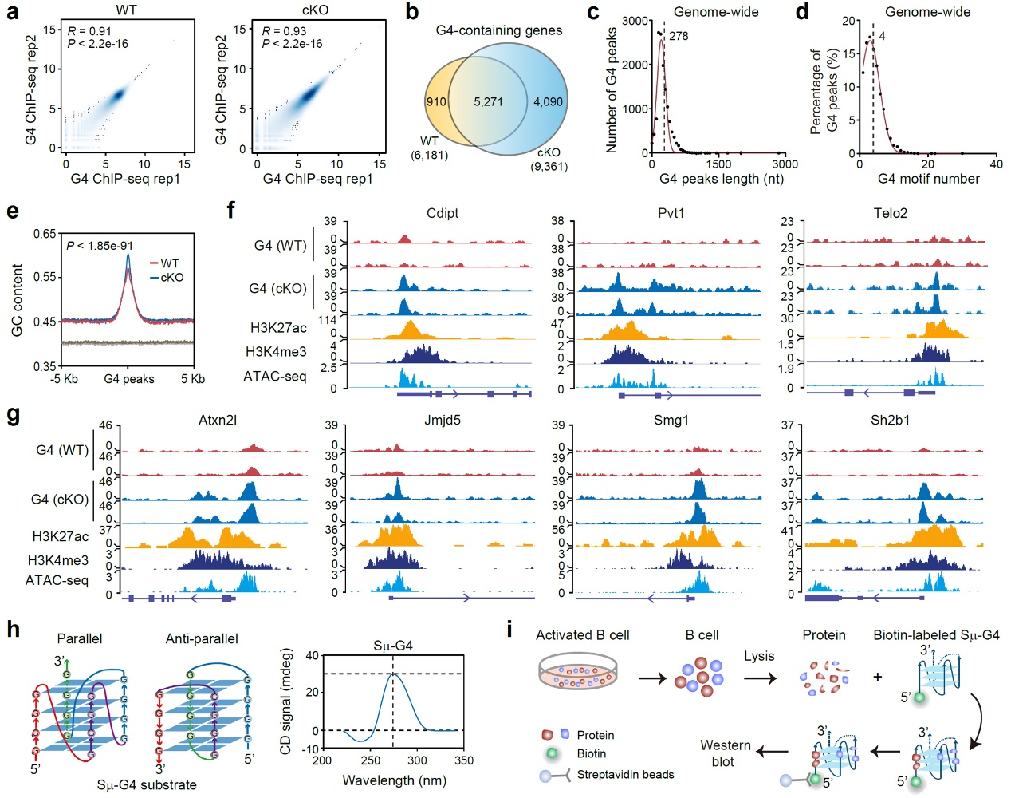
Extended Data Figure 3. G4 accumulation in DHX9-deficient B cells. a. G4 ChIP-seq reads in two biological replicates of WT and DHX9-deficient B cells are highly correlated. R, Pearson correlation coefficient. b. Venn diagram showing that the G4-containing genes identified in WT cells are largely recapitulated by the genes identified in DHX9-deficient B cells. c. Length distribution of genome-wide G4 ChIP-seq peaks. d. G4 motif distribution among genome-wide G4 peaks. e. GC content in the regions around G4 peaks identified in WT (red) and cKO (cyan) cells is higher than that in randomly selected control regions (100 replicates, n = 100). f. Snapshot of G4 ChIP-seq signals at the Cdipt, Pvt1, and Telo2 loci. The H3K27ac, H3K4me3, and ATAC-seq signals are shown in yellow, blue, and cyan, respectively. g. Snapshot of G4 ChIP-seq, H3K27ac ChIP-seq, H3K4me3 ChIP-seq, and ATAC-seq signals at the Atxn21, Jmjd5, Smg1 and Sh2b1 loci. h. CD spectroscopy showing G4 structures in Sμ DNA in 100 mM KCl solution. i. Diagram of Sμ-G4 pulldown assay in the activated B cells. All the P-values are calculated by the two-tailed Wilcoxon test.
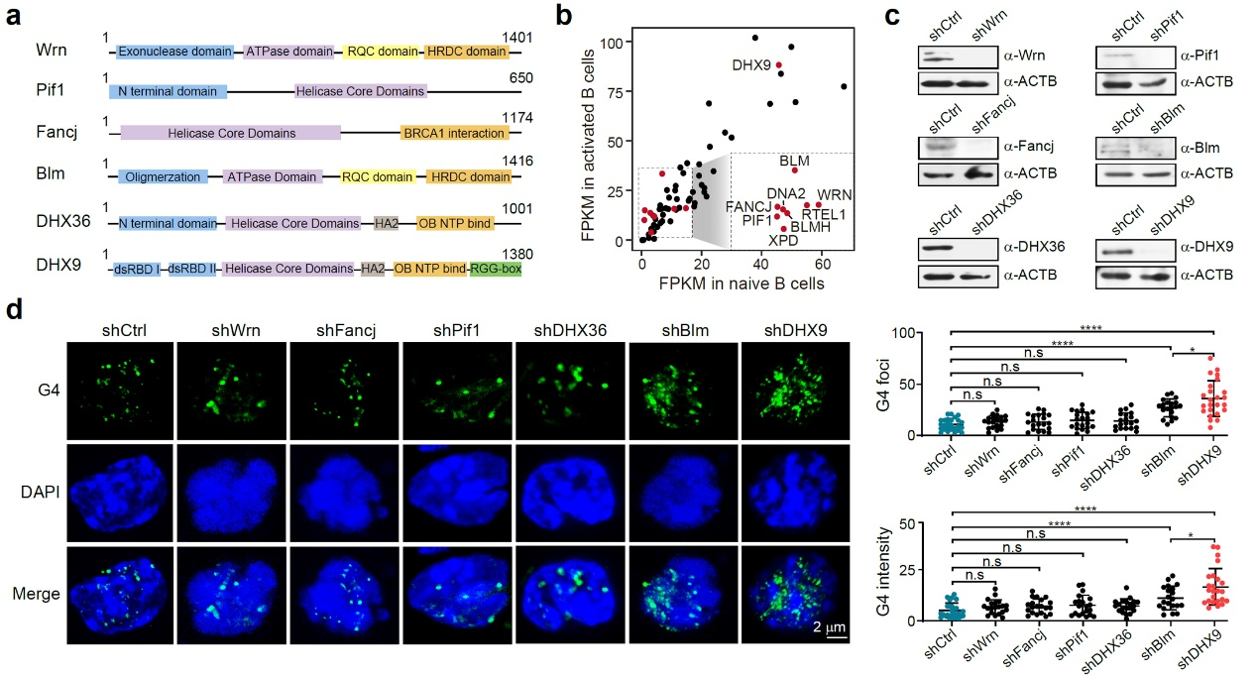
Extended Data Figure 4. DHX9 knockdown leads to dramatically increased G4s in B cells. a. RNA helicases might be involved in G4 regulation. Domain structures are shown in colored boxes. b. Dot plot showing the expression levels of DHX9 compared to other helicases in B cells (determined by RNA-seq). c. Western blot showing shRNA knockdown efficiency of different helicases in CH12F3 cells compared to shCtrl. ACTB served as the loading control. d. Immunofluorescence staining shows elevated G4 signals in DHX9 knockdown CH12F3 cells. The number and intensity of G4 foci in WT and knockdown cells are quantified (n = 24 nuclei) and shown on the right. Scale bar: 2 μm. *P < 0.05 and ****P < 0.0001 by two-tailed Student’s t-test. Data are mean ± S.D.
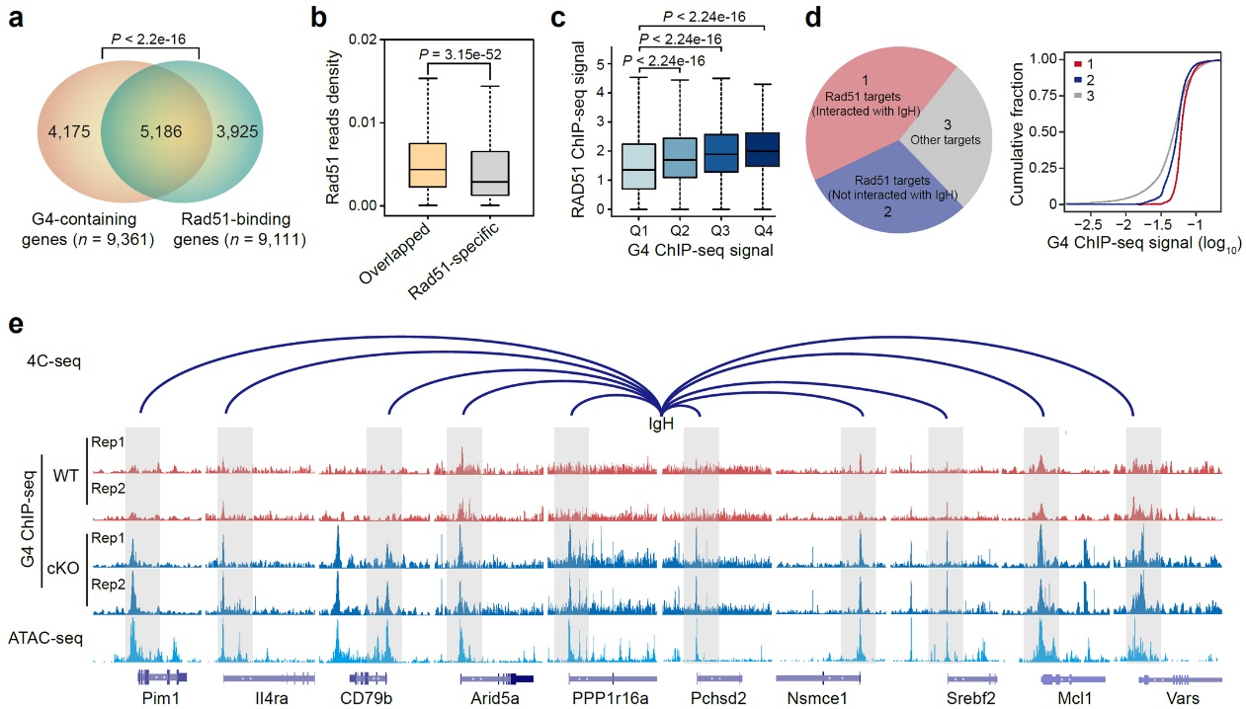
Extended Data Figure 5. DSBs and IgH proximal interaction sites showing accumulated G4 ChIP-seq signals. a. Venn diagram showing significantly overlapped Rad51 and G4 ChIP-seq targets in DHX9-deficient B cells. P-value is calculated by Fisher’s exact test. b. Box plots show that the overlapping G4 and Rad51 targets have higher Rad51 ChIP-seq read densities than the Rad51-specific targets. c. Box plot shows that G4 ChIP-seq signals positively correlate with Rad51 ChIP-seq signals. G4 ChIP-seq peaks are classified into four equal categories (Q1 to Q4, 3357 peaks for each quarter). P-values are calculated by a two-tailed Wilcoxon test in b and c. d. Cumulative distribution function (CDF) plot shows that the IgH interacted and Rad51 bound targets have higher G4 ChIP-seq signals than other targets (group 2 and group 3). All the genes are classified into IgH interacted and Rad51 bound targets (group 1), other Rad51 bound targets (group 2), and targets without Rad51 ChIP-seq signals (group 3). e. Genes interacting with the IgH locus tend to contain G4 ChIP-seq peaks (gray-boxed regions). 4C-seq detected proximal DNA contacts are shown as blue arcs.
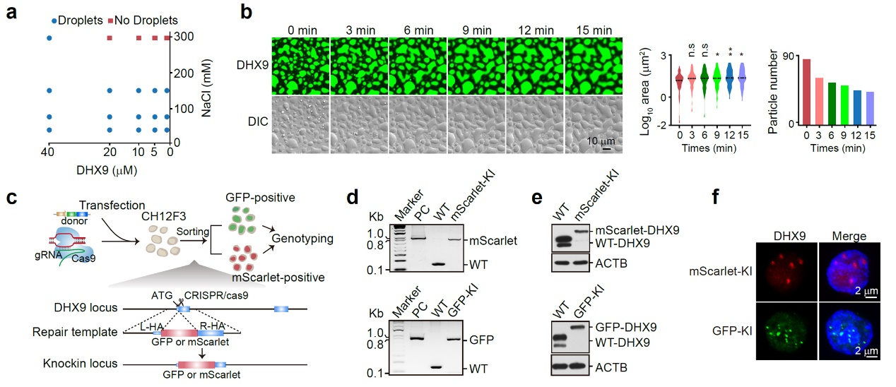
Extended Data Figure 6. Features of DHX9 phase transitions in vitro and in vivo. a. Phase diagram of DHX9 in the presence of different concentrations of NaCl. A higher concentration of salt disrupts the phase separation ability of DHX9. The cyan circles denote droplet formation by DHX9, while the red squares indicate the absence of droplets under salt conditions. b. The wetting assay shows that DHX9 droplets in the liquid wet the coverslip and formed irregular shapes over time. The droplets are formed in tubes for 30 min and then spread over the coverslip. The area and number of particles are quantified at the indicated time points. Scale bars: 10 μm. c. Diagram of the CRISPR-Cas9-mediated knock-in strategy to generate GFP- or mScarlet-tagged DHX9 CH12F3 cell lines. d. Genotyping analysis shows that the GFP and mScarlet tags were successfully inserted after the ATG codon of DHX9 in CH12F3 cells. e. Western blot confirmed the expression of GFP- and mScarlet-tagged DHX9 in CH12F3 cells. ΑCΤΒ served as the loading control. f. The endogenously tagged GFP- or mScarlet-DHX9 phase separated within CH12F3 cells. Scale bars: 2 μm. *P < 0.05 and **P < 0.01 by two-tailed Student’s t-test. Data are mean ± S.D.
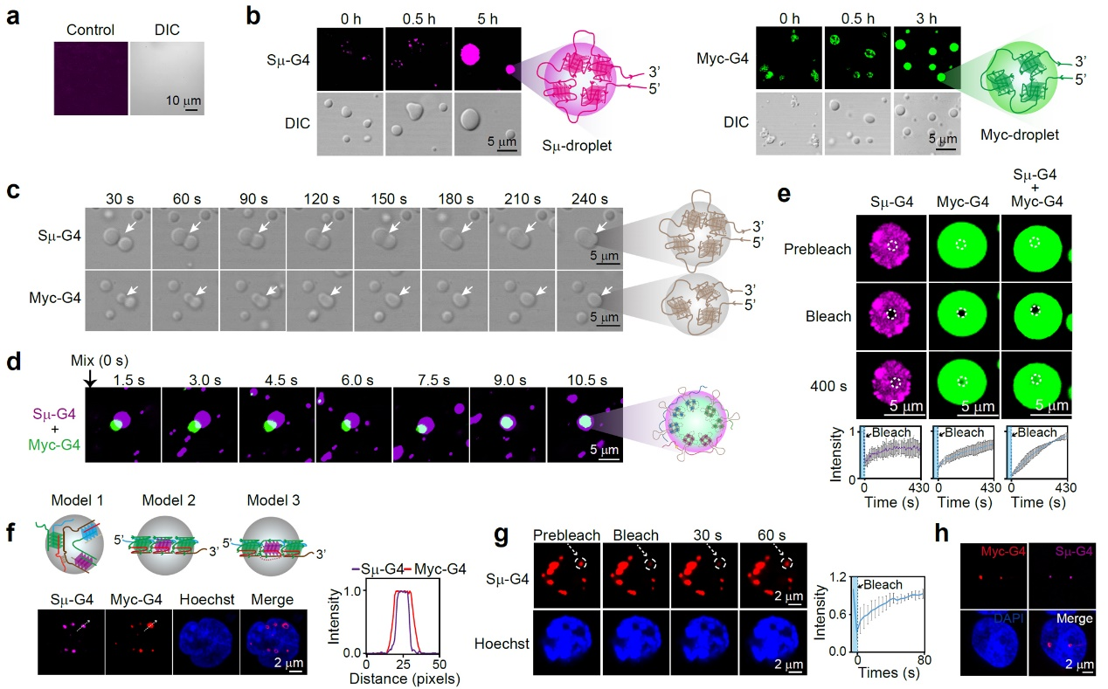
Extended Data Figure 7. Features of G4 phases in vitro and in vivo. a. Alexa Fluor 647-labeled ssDNA without G4 motifs failed to undergo phase separation in vitro. Scale bar: 10 μm. b. Fluorescently labeled Sμ-G4-Alexa 647 or Myc-G4-Alexa 488 DNA gradually forms large droplets if incubated for longer. Scale bar: 5 μm. c. Time-lapse imaging of the Sμ-G4 and Myc-G4 droplet fusion process. Scale bar: 5 μm. d. Time-lapse imaging of droplets fusion between fluorescently labeled Sμ-G4 and Myc-G4. Scale bar: 5 μm. e. FRAP assay shows that the intermolecular Sμ-G4 and Myc-G4 condensates recovered faster than either Sμ-G4 or Myc-G4 condensates after photobleaching. Scale bar: 5 μm. The recovery of photobleached regions over a 430 s time course was quantified. n = 3 biological replicates. f. Transiently transfected Sμ-G4 and Myc-G4 DNA form liquid droplets in living CH12F3 cells. The relative distances between overlapping foci are quantified and shown on the right. Scale bar: 2 μm. n = 20 cells. g. FRAP assay showing the droplet dynamics of Sμ-G4 DNA in living cells. The region marked with a white circle is photobleached, and the recovery rate is recorded over time. Scale bar: 2 μm. n = 3 biological replicates. h. DNA FISH showing the colocalization of Sμ-G4 and Myc-G4 in LPS-activated B cells. Scale bar: 2 μm. Scale bar: 2 μm.
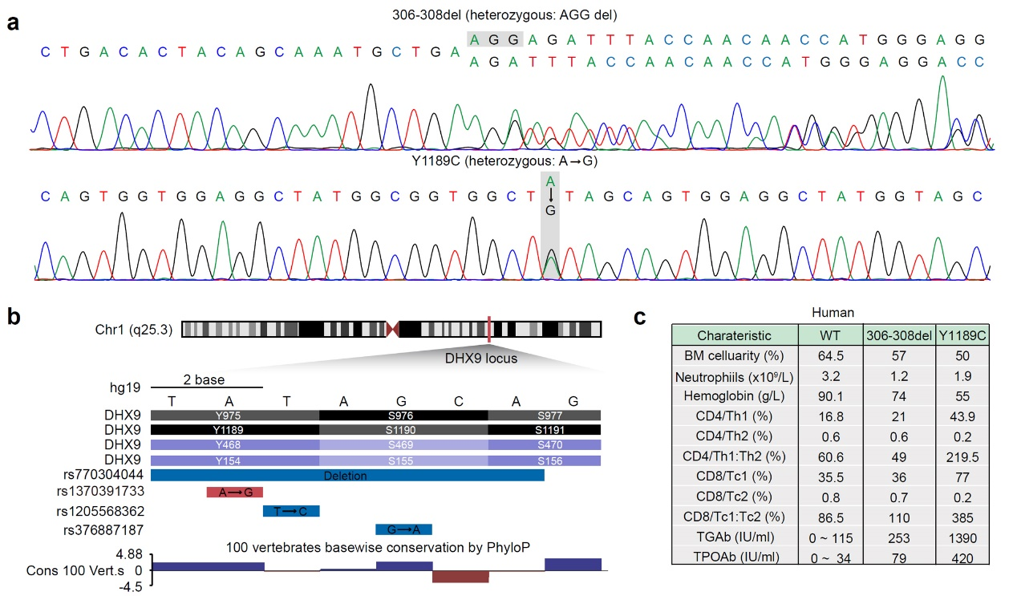
Extended Data Figure 8. Hashimoto’s thyroiditis patients with p.Y1189C mutation have high levels of thyroid peroxidase and thyroglobulin antibodies. a. Sanger sequencing confirmed the observed p.Y1189C and c.306-308del mutations in DHX9 in patients. b. Y1189C mutation is also present in the human SNP database dbSNP. c. Patients with p.Y1189C mutation showed dramatically elevated serum levels of TGAb and TPOAb.
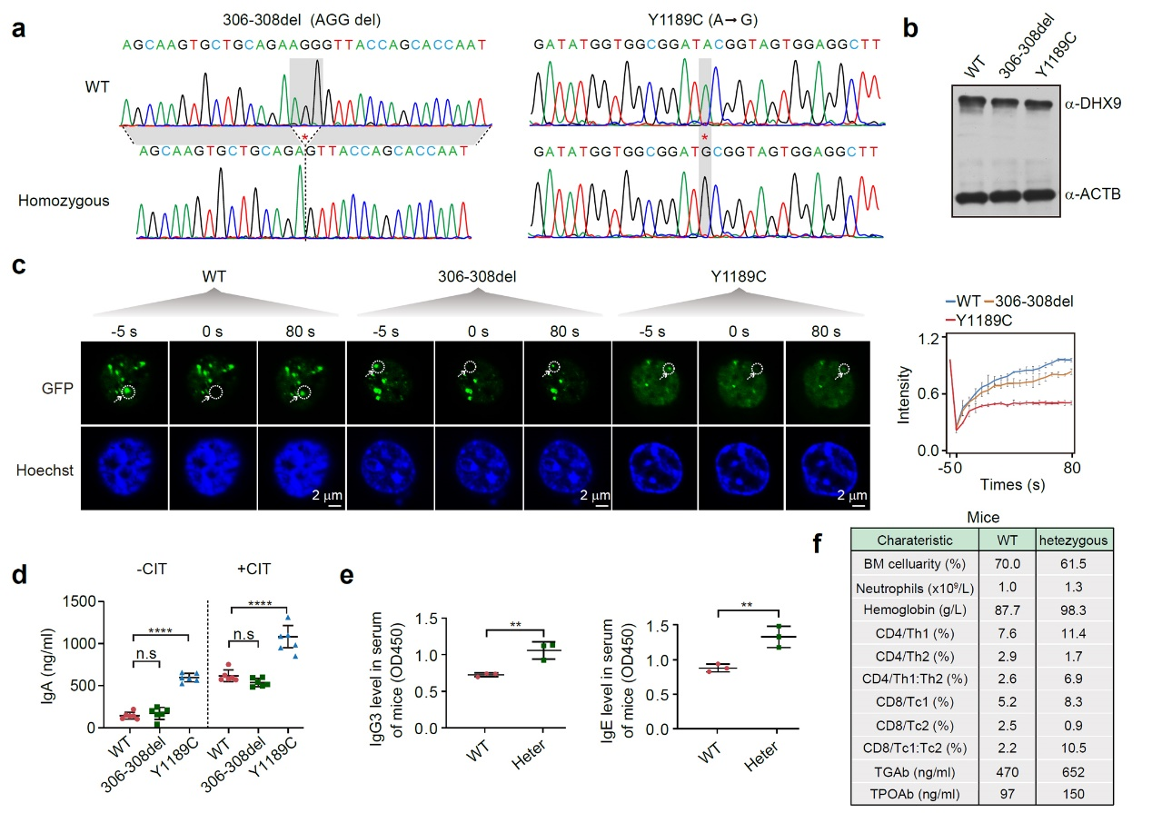
Extended Data Figure 9. Features of DHX9 and Y1189C phases in vivo. a. Sanger sequencing confirmed the successful introduction of the p.Y1189C and c.306-308del mutations into the GFP-tagged DHX9 locus. b. Western blot shows that the expression levels of GFP-tagged WT and mutant DHX9 were similar in CH12F3 cells. ACTB served as the loading control. c. FRAP assay shows that the recovery ability of the Y1189C mutant is compromised compared to that of the WT and 306-308del mutant. The intensity curves of the droplets are quantitatively analyzed on the right. Scale bar: 2 μm. n = 3 biological replicates. d. The IgA titer in the supernatant of WT and DHX9 mutant CH12F3 cells is quantified after stimulation with or without CIT for 72 h (n = 6). e. ELISA shows that the heterozygous DHX9 cKO mice have higher serum titers of IgG3 and IgE than WT. n = 3 mice per group. f. Heterozygous DHX9 cKO mice have higher serum levels of TGAb and TPOAb than WT. n = 3 mice per group. **P < 0.01 and ****P < 0.0001 by two-tailed Student’s t-test. Data are mean ± S.D.
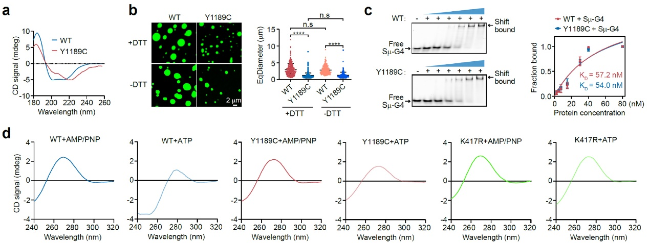
Extended Data Figure 10. The Y1189C mutant fails to unwind G4 DNA. a. Circular dichroism (CD) spectroscopy analysis showing configuration difference between WT and Y1189C mutant proteins. The experiment was independently repeated twice with similar results. b. The EqDiameter of the Y1189C mutant is smaller than that of the WT protein in the presence or absence of DTT. c. EMSA shows that the Y1189C mutant and WT DHX9 have comparable binding affinity to Sμ-G4 DNA. K_{D}, dissociation constant. n = 3 biological replicates. d. CD spectroscopy analysis shows that the Sμ-G4 DNA unwinding ability is significantly reduced for Y1189C or K417R mutant compared with WT proteins in the presence of ATP. The experiment was independently repeated twice with similar results. ****P < 0.0001 by two-tailed Student’s t-test. Data are mean ± S.D.

