Appendix- Figure 1. pairwise Pearson’s correlations between all survival-associated parameters.

Figure 1A.
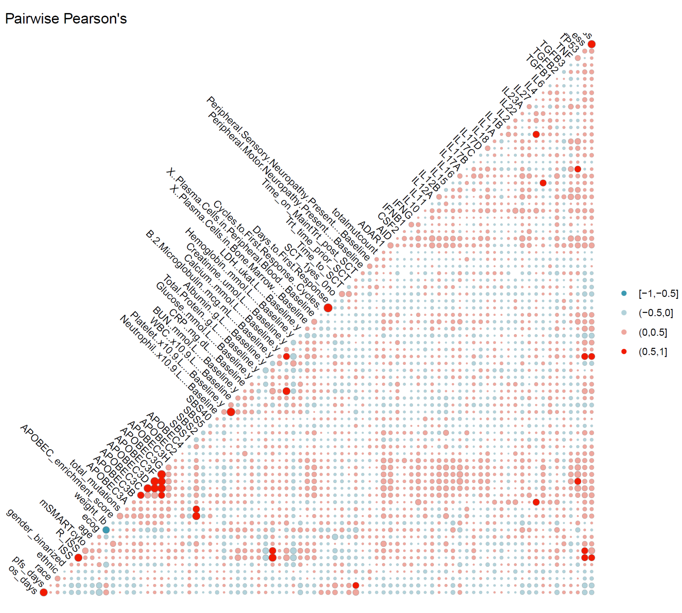

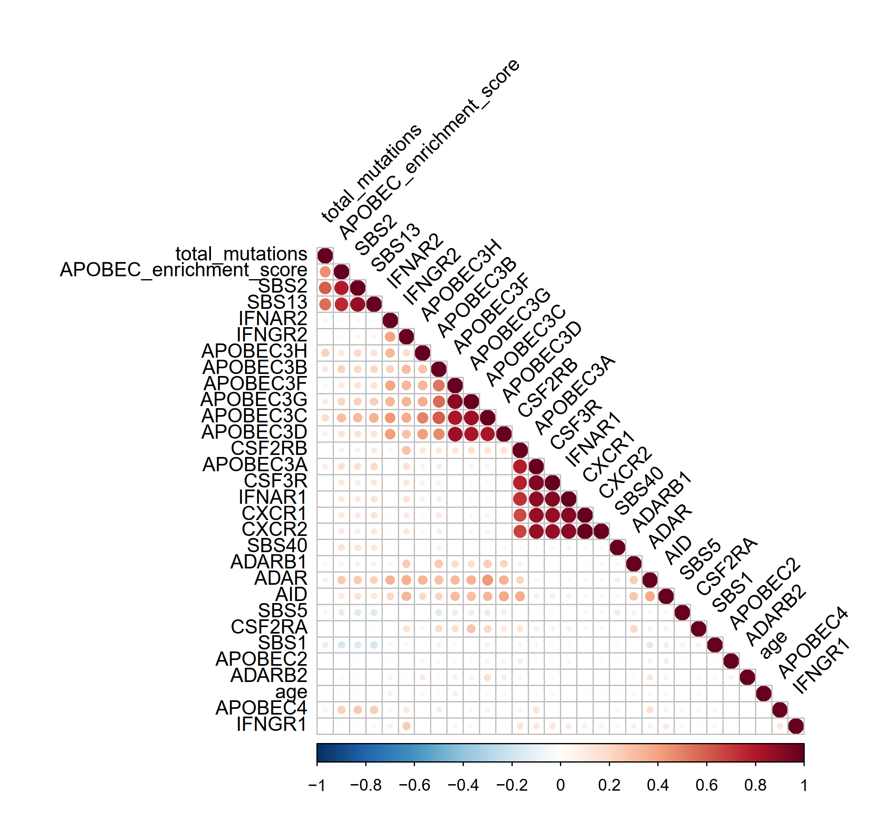
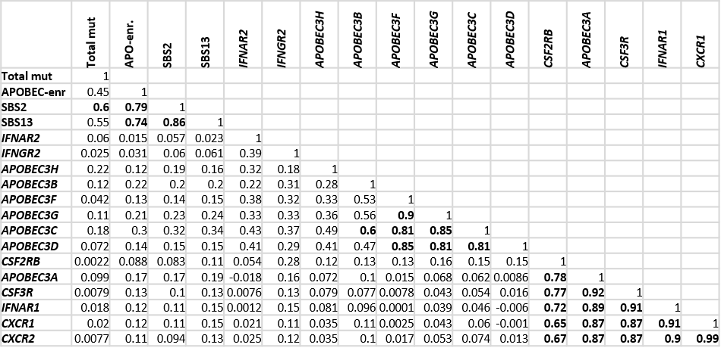
Figure 1B.

