Table S1. Description of national indicators of policy, regulation and engagement, their relevance to coastal wetland conservation, the temporal range of the underlying data, source information, and the percentage of missing indicator values.
Category | Indicator | Description | Relevance | Temporal range (years) | Source | % missing values
Policy | Nationally Determined Contribution (NDC) commitment | The commitment of a country to reducing green-house gas emissions, pledged as Nationally Determined Contributions (NDC). Source data scored countries as: Sufficient = 3, Partially Sufficient = 2, Partially Insufficient = 1, and Insufficient = 0 (Watson et al. 2019). The original NDC commitment score was converted to a binary score where 1 = 'Sufficient' and 'Partially sufficient', and 0 = 'Partially Insufficient' and 'Insufficient'. Countries without a commitment score do not have an NDC strategy, and so were grouped with 'Insufficient' countries. | Indicates whether policy commitment will sufficiently contribute to halving global emissions by 2030 (Watson et al., 2019). | 2015 – 2019 | Watson, R., McCarthy, J.J., Canziani P., Nakicenovic, N., Hisas, L. 2019. The truth behind the climate pledges. The Universal Ecological Fund (FEU-US) | 0
Policy | Nationally Determined Contribution (NDC) mitigation | Whether coastal wetlands are included in a country’s Nationally Determined Contribution (NDC) mitigation strategy (1 = yes, 0 = no). | Represents policy commitment to consider coastal wetland conservation for the purpose of mitigating climate change (Herr & Landis, 2016). | 2015 | Herr, D., & Landis, E. 2016. Coastal blue carbon ecosystems Opportunities for Nationally Determined Contributions. Policy brief. Gland, Switzerland: IUCN and Washington, DC, USA: TNC. Retrieved from www.bluecsolutions.org | 0
Policy | Nationally Determined Contribution (NDC) adaptation | Whether coastal wetlands are included in a country's Nationally Determined Contribution (NDC) adaptation strategy (1 = yes, 0 = no). | Represents policy commitment to consider coastal wetlands for climate change adaptation (Herr & Landis, 2016). | 2015 | Herr, D., & Landis, E. 2016. Coastal blue carbon ecosystems Opportunities for Nationally Determined Contributions. Policy brief. Gland, Switzerland: IUCN and Washington, DC, USA: TNC. Retrieved from www.bluecsolutions.org | 0
Policy | Multilateral environmental agreements (MEAs) | Cumulative count of a country's multilateral environmental agreements (MEAs) since the year of its first MEA membership until 2019. | Represents commitment to cooperate internationally to prevent or manage human impacts (Mitchell et al., 2020). | 1850 – 2019 | Ronald B. Mitchell. 2020. IEA Membership Count Dataset from the International Environmental Agreements Database Project (Version 20200214). Eugene: IEADB Project. Dataset generated on: 14 February 2020 | 1
Policy | Bilateral environmental agreements (BEAs) | Cumulative count of a country's bilateral environmental agreements (BEAs) since the year of its first BEA membership until 2019. | Represents commitment to cooperate internationally to prevent or manage human impacts (Mitchell et al., 2020). | 1850 – 2019 | Ronald B. Mitchell. 2020. IEA Membership Count Dataset from the International Environmental Agreements Database Project (Version 20200214). Eugene: IEADB Project. Dataset generated on: 14 February 2020 | 1
Policy | Governance effectiveness | Several indicators of perceptions of the quality of a country's public services, civil service, degree of its independence from political pressures, quality of policy formulation and implementation, and credibility of its government’s commitment to such policies were aggregated into a single standard-normal score ranging from -2.5 to 2.5 using an unobserved components model. | Represents likelihood that policy commitments will effectively enable conservation (e.g., Amano et al., 2018). | 2019 | Worldwide Governance Indicators, The World Bank. 2019. www.govindicators.org, accessed on [24/11/2020] | 0
Policy | Marine protected areas (MPA) target | The percent of a country’s Economic Exclusion Zone (EEZ) set aside as a marine protected area, re-scaled as a performance indicator so that 10% = best, 0% = worst. | Represents degree to which marine and coastal areas are protected (Wendling et al., 2020). | 1990 – 2020 | Wendling, Z., Emerson, J., de Sherbinin, A., and Esty, D. 2020. Environmental Performance Index 2020. New Haven, CT: Yale Center for Environmental Law & Policy. Retrieved from epi.yale.edu | 2
Policy | Ramsar protection | The area of coastal wetlands under Ramsar jurisdiction in a country standardised by coastline length. Ramsar sites with coastal wetlands were selected according to the Ramsar definition of intertidal marshes, intertidal forested wetlands, and marine subtidal aquatic beds. | Represents degree to which internationally-important coastal wetlands are protected (Finlayson et al., 2011). | 1974 – 2021 | The Ramsar Convention Secretariat. 2014. https://rsis.ramsar.org/, accessed on [04/04/2021] | 0
Regulation | Ramsar management | Whether a country has Ramsar-listed coastal wetland sites (i.e., intertidal marshes, intertidal forested wetlands, and marine subtidal aquatic beds) with management plans implemented (0 = no, 1 = yes). If a country did not have any Ramsar-listed coastal wetlands the value was NA. | Represents whether action has been taken towards regulating impacts on protected coastal wetlands (Mauerhofer et al., 2015). | 1974 – 2021 | The Ramsar Convention Secretariat. 2014. https://rsis.ramsar.org/, accessed on [04/04/2021] | 27
Regulation | Regulatory quality | Several indicators of regulatory quality that represent the ability of a country's government to formulate and implement sound policies and regulations that permit and promote private sector development were aggregated into a single standard-normal score ranging from -2.5 to 2.5 using an unobserved components model. | Represents capacity to regulate and manage impacts to the environment (Kaufmann et al., 2010). | 2019 | Worldwide Governance Indicators, The World Bank. 2019. www.govindicators.org, accessed on [24/11/2020] | 0
Regulation | Wastewater treatment | The percentage of wastewater that undergoes at least primary treatment in each country, normalised by the proportion of the population connected to a municipal wastewater collection system. | Represents capacity to manage wastewater pollutants that may degrade water quality (Wendling et al., 2020) and negatively impact coastal wetlands. | 2018 | Wendling, Z., Emerson, J., de Sherbinin, A., & Esty, D. 2020. Environmental Performance Index 2020. New Haven, CT: Yale Center for Environmental Law & Policy. Retrieved from epi.yale.edu | 1
Regulation | Sustainable nitrogen use | How far a country is from achieving sustainable nitrogen use for crop fertilisation. The Euclidean distance from an ideal point with optimal nitrogen use efficiency (NUE) and crop yield is measured and rescaled as a performance indicator so that 0 = best performance, 99th percentile = worst performance. | Represents capacity to manage negative impacts of nutrient pollution to coastal wetlands (Schaffelke et al., 2005). | 1961 –s 2015 | Wendling, Z., Emerson, J., de Sherbinin, A., & Esty, D. 2020. Environmental Performance Index 2020. New Haven, CT: Yale Center for Environmental Law & Policy. Retrieved from epi.yale.edu | 1
Regulation | Sulphur dioxide (SO₂) emission reduction | The average annual rate of increase or decrease in SO₂ adjusted for economic trends to isolate change due to policy rather than economic fluctuation and rescaled as a performance indicator so that the most negative trend = best performance, and the trends in the top 95th percentile = worst. | Represents capacity to manage negative impacts of air pollution (e.g., acidification and poor water quality (Wendling et al., 2018)) that may degrade coastal wetlands. | 2005 – 2014 | Wendling, Z., Emerson, J., de Sherbinin, A., & Esty, D. 2020. Environmental Performance Index 2020. New Haven, CT: Yale Center for Environmental Law & Policy. Retrieved from epi.yale.edu | 3
Regulation | Nitrous oxide (N₂O) emission reduction | The average annual rate of increase or decrease in N₂O adjusted for economic trends to isolate change due to policy rather than economic fluctuation and rescaled as a performance indicator so that the most negative trend = best performance, and the trends in the top 95th percentile = worst. | Represents capacity to manage negative impacts of air pollution (e.g., acidification and poor water quality degradation (Wendling et al., 2018)) that may degrade coastal wetlands. | 2005 – 2014 | Wendling, Z., Emerson, J., de Sherbinin, A., & Esty, D. 2020. Environmental Performance Index 2020. New Haven, CT: Yale Center for Environmental Law & Policy. Retrieved from epi.yale.edu | 3
Regulation | Environmental taxes | A measure of the number of taxes, charges, or fees for the following categories: 1) environmental management, 2) air pollution, 3) energy, 4) noise pollution, 5) fossil fuels, 6) transport management, 7) waste management, and 8) water management. A final 'environmental fee' score for each country was calculated as the sum of the number of taxes, fees, or charges (rescaled between 0 and 1) across all eight categories. | Represents the implementation of pricing instruments that can improve environmental quality (Bashir et al., 2020). | 1980 – 2020 | OECD, Policy Instruments for the Environment (PINE) Database, http://oe.cd/pine , accessed on [24/11/2020] | 40
Engagement | Conservation spending | Average annual conservation investment (I$m) for countries that are signatories to the Convention on Biological Diversity (CBD) and Sustainable Development Goals (SDGs). Sources of investment include government, donors, trust funds and self-funding via user payments. For countries that were not signatories to the SDGs or CBDs, or data was insufficient to estimate average annual conservation investment, values were gap-filled (see methods). | Represents engagement in conservation through domestic financial investment (Waldron et al., 2017). | 1992 - 2003 | Waldron, A., Mooers, A. O., Miller, D. C., Nibbelink, N., Redding, D., Kuhn, T. S., Timmons Roberts, J., & Gittleman, J. L. 2013. Targeting global conservation funding to limit immediate biodiversity declines. https://doi.org/10.5061/dryad.p69t1  Waldron, A., Miller, D. C., Redding, D., Mooers, A., Kuhn, T. S., Nibbelink, N., Roberts, J. T., Tobias, J. A., & Gittleman, J. L. 2017. Reductions in global biodiversity loss predicted from conservation spending. Nature, 551, 364–367. https://doi.org/10.1038/nature24295 | 46
Engagement | Biodiversity projects | The number of biodiversity-related conservation projects in a developing country that are receiving funding from OECD (Organisation for Economic Cooperation and Development) countries, standardised by country area (km²). High income countries generally do not receive development assistance, although there are some exceptions (8 countries). | Represents foreign investment in biodiversity conservation (e.g., Miller, 2014). | 2002 – 2017 | http://www.oecd.org/dac/stats/biodiversity.htm, accessed on [24/11/2020] | 0
Engagement | Environmental NGO projects | The number of environmental NGO aid projects in a country standardised by country area (km²). Note that data is provided on a voluntary basis and so is not fully comprehensive. | Represents capacity for NGO aid and advocacy to bolster conservation initiatives (e.g., Pacheco-Vega & Murdie, 2021). | 1970 – 2020 | https://ngoaidmap.org/, accessed on [24/11/2020] | 0
Engagement | Biodiversity engagement | A score based on the number of times biodiversity key words have been sourced from twitter, online newspapers and google in a country (per month). The percentage of tweets or online newsletters that contain a species or keyword in each country was calculated and then rescaled between 0 and 100. Google trends data (already rescaled between 0 and 100) for each keyword are averaged for a country. A final score was calculated by averaging across scores for tweets, online newsletters and google trends. | Represents public awareness of biodiversity topics (Cooper et al., 2019) and is a proxy for social willingness to engage in conservation action. | 2017-2019 | http://biodiversityengagementindicator.com/, accessed on [24/11/2020] | 9

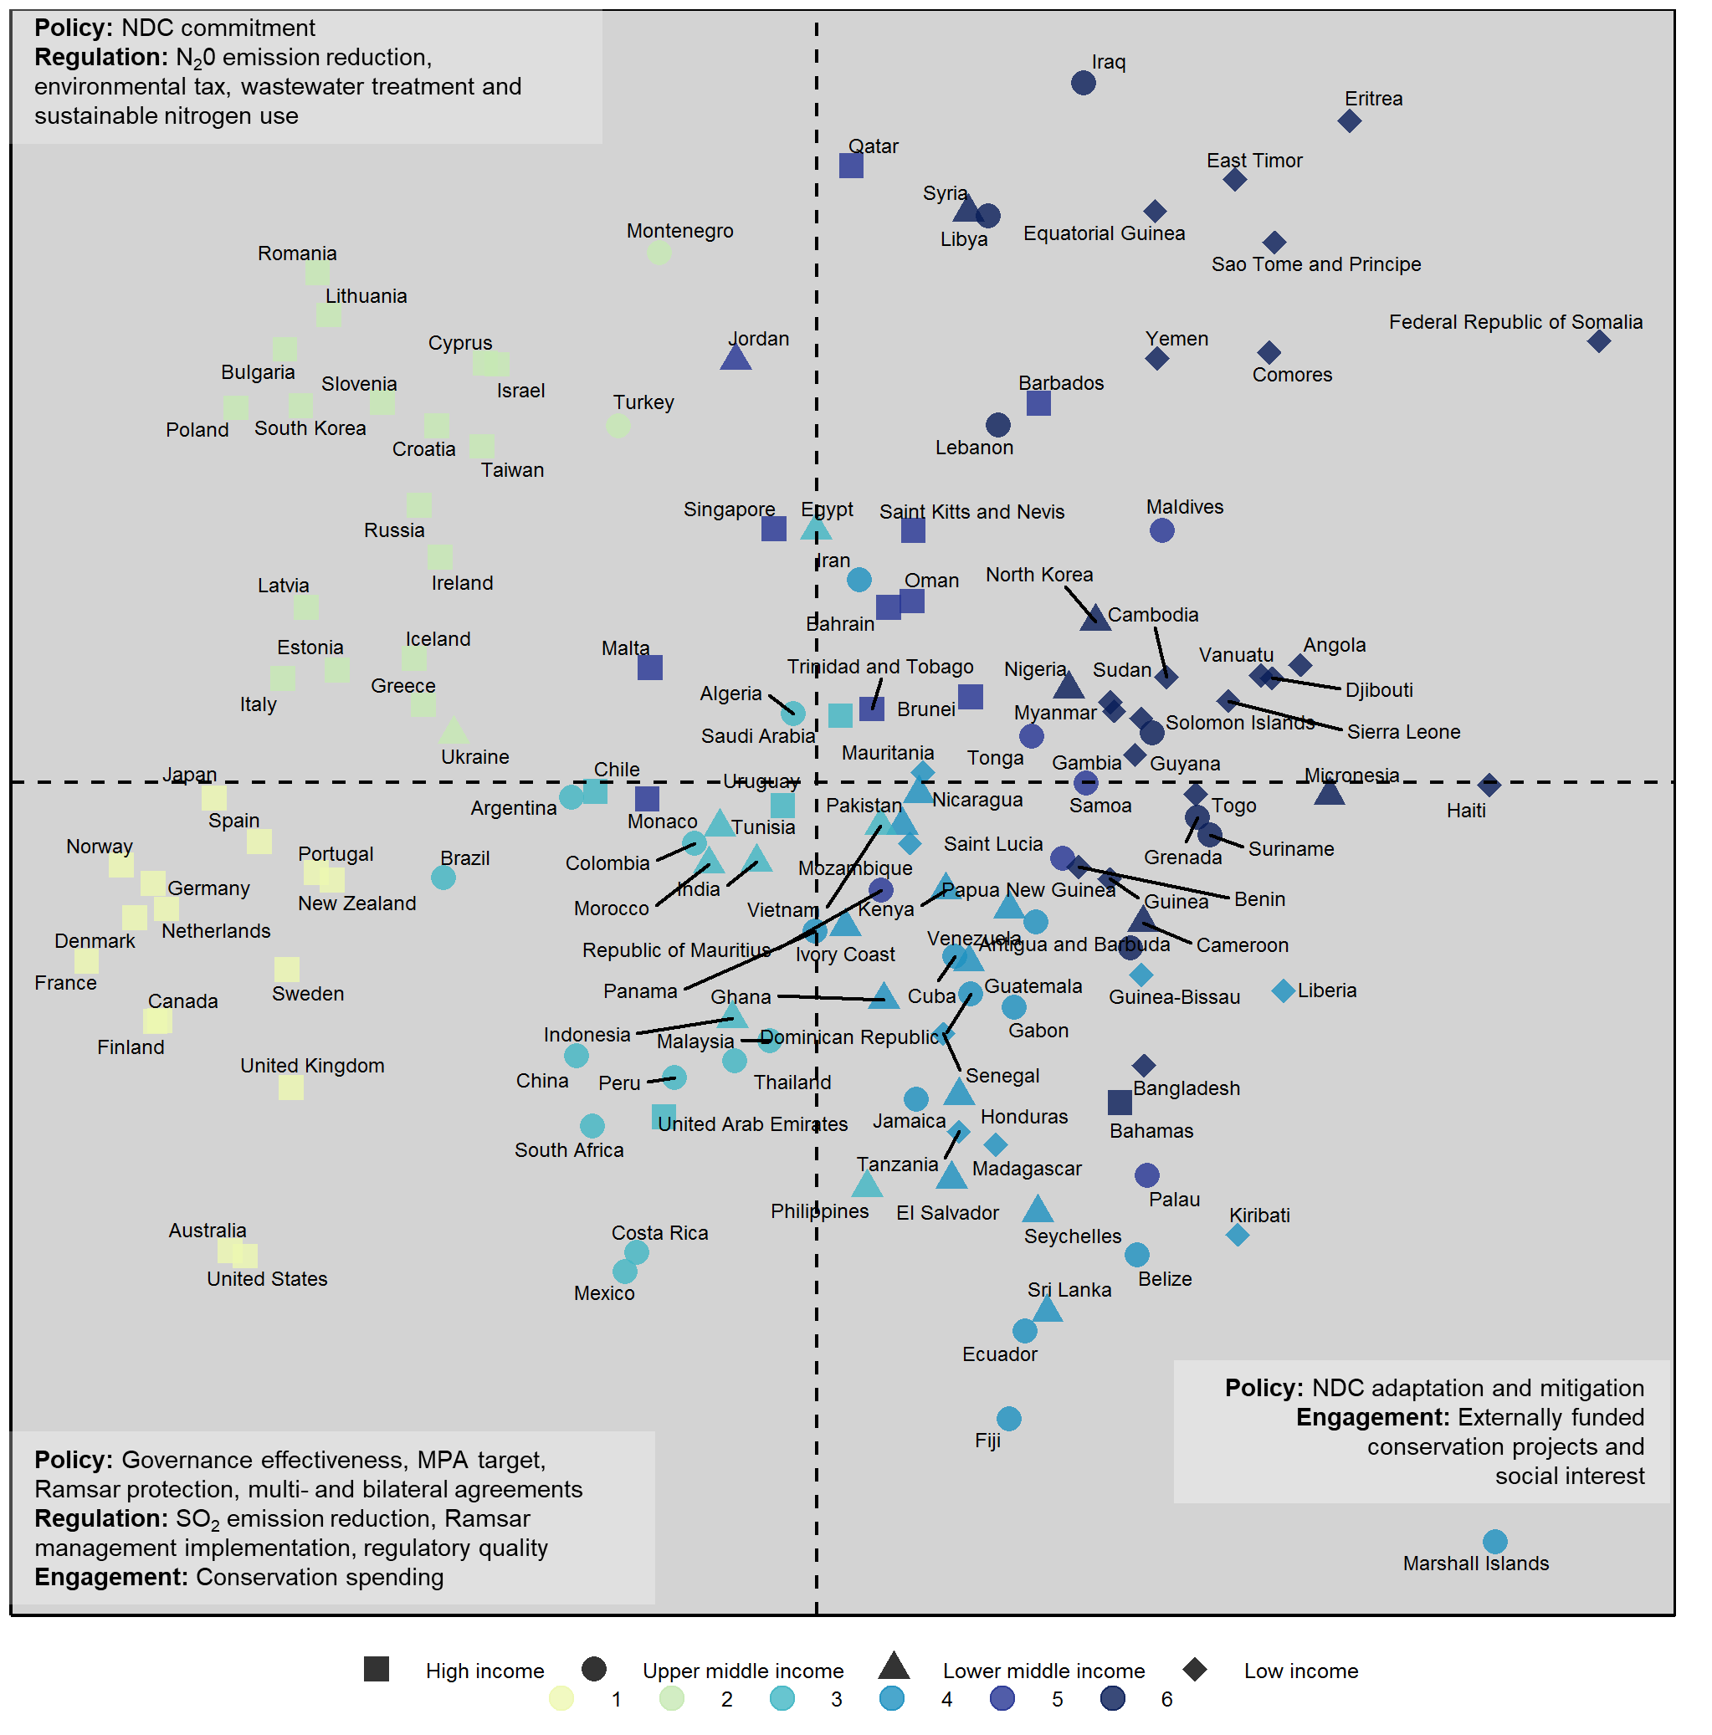
Fig. S1. Ordination of countries according to their national indicator values using principal components analysis. Indicators positively correlated with each quadrant of the ordination are listed. Colours represent global enabling profiles (see Table S2 below for details) and shapes represent country income status.

Table S2. Theories of Change for mangrove and seagrass conservation in each enabling profile. Enabling conditions are described as the current status of policy, regulatory and engagement mechanisms (classified as ‘low’, ‘moderate’, or ‘high’ based on the relative ranking of indicator thresholds across enabling profiles in Figure 1C). Drivers of loss were identified differently for mangroves and seagrass. For mangroves we chose the most prevalent driver of loss, while for seagrass we chose the driver of loss that was shared across all continents belonging to a profile. Potential pathways for addressing drivers of mangrove and seagrass loss given enabling conditions are described for each profile, supported by a case-study example.
Enabling profile | Enabling conditions (status of policy, regulatory and engagement indicators) | Driver of loss | Implementation pathway/nested ToC | Case-study example (qualitative validation of implementation pathway)
1 | Policy: high, except for prioritisation of vegetated coastal wetlands in NDC mitigation and adaptation strategies.  Regulation: high.  Engagement: moderate to high, except foreign investment in biodiversity projects. | Mangroves: clearing/non-productive conversion  Seagrass: catchment processes (e.g., coastal development & poor water quality) and climate/storm events | Mangroves: Monitor indirect effects of development on mangroves ->  Tailor policy/regulations to mitigate indirect effects -> decreased loss of mangroves to non-productive conversion  Seagrass: Establish seagrass as an indicator of ecosystem health in catchment policy -> improved monitoring and management of catchment threats to seagrass -> reduced loss of seagrass to catchment processes | Mangroves: Herbicide run-off from crops caused mangrove dieback in Australia (Duke et al. 2005). Focussed regulation of herbicides could help to avoid future losses of mangroves due to the indirect effects of nearby agricultural production (King et al. 2013).  Seagrass: Seagrass was established as a biological quality element (BQE) to be used as an indicator of ecosystem health (when compared to reference conditions and integrated with other BQEs) in the EU Water Framework Directive, leading to improved management and seagrass recovery (de los Santos et al., 2019).
2 | Policy: high, except for prioritisation of vegetated coastal wetlands in NDC mitigation and adaptation strategies, and protection via the Ramsar convention.  Regulation: high.  Engagement: moderate to low. | Mangroves: not present in this profile  Seagrass: Aquaculture/fishing | Mangroves: not present in this profile  Seagrass: Establish policy that prevents fish farms from being established near seagrass -> reduced loss of seagrass to anoxia associated with fish-farm pollution | Mangroves: not present in this profile  Seagrass: Following substantial seagrass loss, managers in Cyprus only allowed fish farms to operate in deep waters and seagrass expansion and recovery was documented (Kletou et al. 2018).
3 | Policy: moderate to high.  Regulation: moderate to high.  Engagement: moderate. | Mangroves: commodities and erosion  Seagrass: catchment processes (e.g., coastal development & poor water quality) and climate/storm events | Mangroves: Establish national policy to protect mangroves from conversion to commodities and restore areas that have been converted -> incentivise community-lead restoration and sustainable management -> reduced loss of mangroves and livelihoods maintained  Seagrass: NGOs raise awareness and lobby for management of catchment-based threats to seagrasses -> government establishes policy to manage catchment-based threats -> reduced seagrass loss | Mangroves: The Indonesian government established policy to naturally rehabilitate mangroves via permeable dams, a ‘Building with Nature’ hybrid engineering approach to preventing erosion, while also fostering community involvement and ownership with assistance from an NGO (Winterwerp et al. 2020).  Seagrass: An NGO has partnered with the Malaysian government to establish seagrass conservation projects in Malaysia, given the critical role of seagrass as habitat for dugongs (https://www.dugongconservation.org/where-we-work/malaysia/).
4 | Policy: moderate to low, except that capacity for Ramsar protection and prioritisation of vegetated coastal wetlands in NDC mitigation and adaptation strategies was high.  Regulation: moderate to low, except that capacity for implementation of management plans in Ramsar-listed wetlands and reduction of sulphur dioxide emissions was high.  Engagement: high, except for domestic conservation spending. | Mangroves: clearing/non-productive conversion  Seagrass: aquaculture/fishing | Mangroves: NGO and governmental support for establishing community-lead sustainable management of mangroves -> reduced mangrove loss of mangroves for timber harvesting and livelihoods maintained  Seagrass: External support and funding secured to incentivise community-based management of fishing threats through payments for ecosystem services -> decreased loss and degradation of seagrass from fishing | Mangroves: In Madagascar a small-scale crab fishery lead to increased harvesting of mangroves for timber, but community-lead management supported by NGOs and government actors resulted in reduced mangrove loss (Long et al. 2021).  Seagrass: Support from an NGO and external funding established a payments for ecosystem services (PES) project in Kenya that enables carbon credits to be secured from seagrass, thereby providing an alternative source of income for local communities that depend on seagrass for fishing (via destructive practices; i.e., beach seining and trawling) (Shilland et al. 2021).
5 | Policy: moderate to low, except for commitment to NDCs, prioritisation of vegetated coastal wetlands in NDC mitigation and adaptation strategies, and governance effectiveness.  Regulation: moderate to low, except that capacity for Ramsar management and sustainable nitrogen use high.  Engagement: moderate to high, except for domestic conservation investment. | Mangroves: clearing/non-productive conversion  Seagrass: not present in this profile | Mangroves: External NGO support for developing community-based sustainable management of mangrove forests with well-defined resource-use rights ->  Government establishes policy that recognises communities as management authority ->  reduced mangrove clearing for fuel and timber  Seagrass: not present in this profile | Mangroves: Mangroves in St. Lucia were historically cleared for charcoal production. Establishment of a common property institution that recognised resource rights of the local community and incentivised sustainable management resulted in reduced mangrove degradation (Smith and Berkes 1993). Subsequently, the St. Lucian government supported community-based management of mangroves by establishing policy that protected the mangroves but also formalised charcoal producers as the management authority.  Seagrass: not present in this profile
6 | Policy: low, except for prioritisation of vegetated coastal wetlands in NDC mitigation and adaptation strategies.  Regulation: low.  Engagement: moderate to high, except for domestic conservation investment. | Mangroves: erosion  Seagrass: catchment processes (e.g., coastal development & poor water quality) | Mangroves: External NGO and industry actors provide support for installing permeable dams that trap sediment and provide space for mangrove regeneration and planting -> develop ecotourism as a livelihood that incentivises community involvement in mangrove conservation -> self-sustaining management of mangroves that reduces loss to erosion  Seagrass: External and state actors establish policy to raise awareness of the importance of seagrass -> build seagrass research and monitoring capacity -> inform catchment-based management plans -> reduced loss of seagrass from catchment-based threats | Mangroves: Erosion is a driver of loss in Suriname, and several external actors (industry and NGOs) installed permeable dams and initiated mangrove planting in Suriname to raise awareness and involve local communities in mangrove conservation (Winterwerp et al. 2019).  Seagrass: In the Solomon Islands, terrestrial logging is a major threat to seagrass due to increased sedimentation and turbidity in the coastal zone (Brodie et al. 2020). To inform watershed management planning, the Solomon Islands government secured external support and funding to establish policy that aimed to raise awareness of the need for seagrass conservation and improve research and monitoring to enable better protection of seagrass as critical habitat for dugongs (WorldFish 2018)

Table S3. Caveats of the data and analysis.
Caveat | Description
Temporality of indicators | Data underlying indicators have different temporal ranges (Table S1) and all indicators are dynamic, therefore enabling conditions within countries are subject to constant change, such as with policy revisions or nations signing onto international agreements.
Interpolation of missing indicator values assumed ‘missing at random’ | Missing values for the ‘Conservation spending’ and ‘Ramsar management’ indicators were not missing at random. However, assessment of the sensitivity of the latent variable model parameter estimates to the violation of this assumption demonstrates that predictions were robust (Figure S2 & S3).
Data gaps in drivers of seagrass and saltmarsh loss | Globally comprehensive data on drivers of seagrass and saltmarsh loss was not available, constraining the opportunities for vegetated coastal wetland conservation that were able to be identified.
Indicators not specific to coastal wetlands | Not all indicators were specific to vegetated coastal wetlands (e.g., MPA target), but were included for their relevance to conservation more broadly.
Current and future drivers of coastal wetland loss were not considered | Only historical drivers of mangrove and seagrass loss were used to identify opportunities for vegetated coastal wetland conservation.
Identification of conservation opportunities assumes drivers act additively | Drivers of ecosystem loss can interact to accelerate or mitigate loss, so sub-national analysis of opportunities should consider the potential for interactions.
Indicator bias | Two engagement indicators, ‘Biodiversity projects’ and ‘Environmental NGO projects’ were biased towards middle and low-income countries, as high-income countries are less likely to receive Organisation for Economic Cooperation and Development (OECD) and non-governmental organisation (NGO) aid funding.
Seagrass drivers | Data on drivers of seagrass loss was obtained from a literature synthesis (Dunic et al. 2021) but was not systematically reviewed or comprehensive to the global distribution of seagrass. For instance, invasive fauna such as tunicates, crabs and lugworms were not reported in the peer-reviewed literature, and therefore we opted to exclude this driver category to avoid mis-representation.

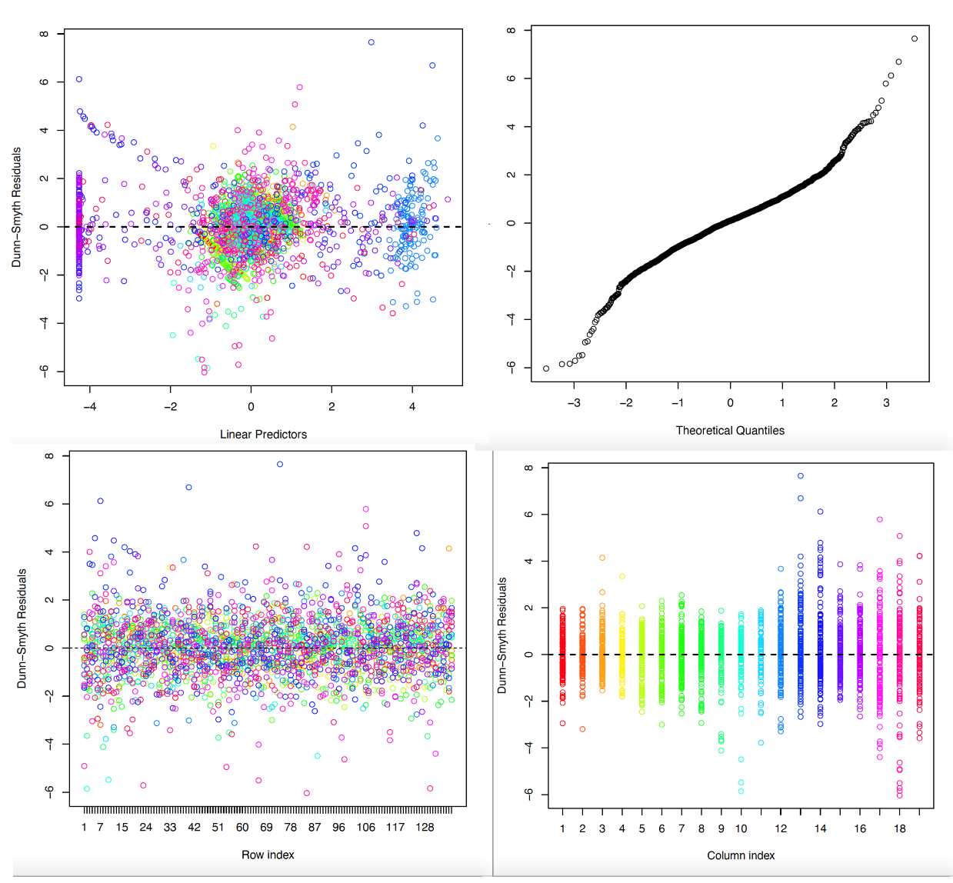
Fig. S2. Randomised quantile residual plots for the latent variable model.

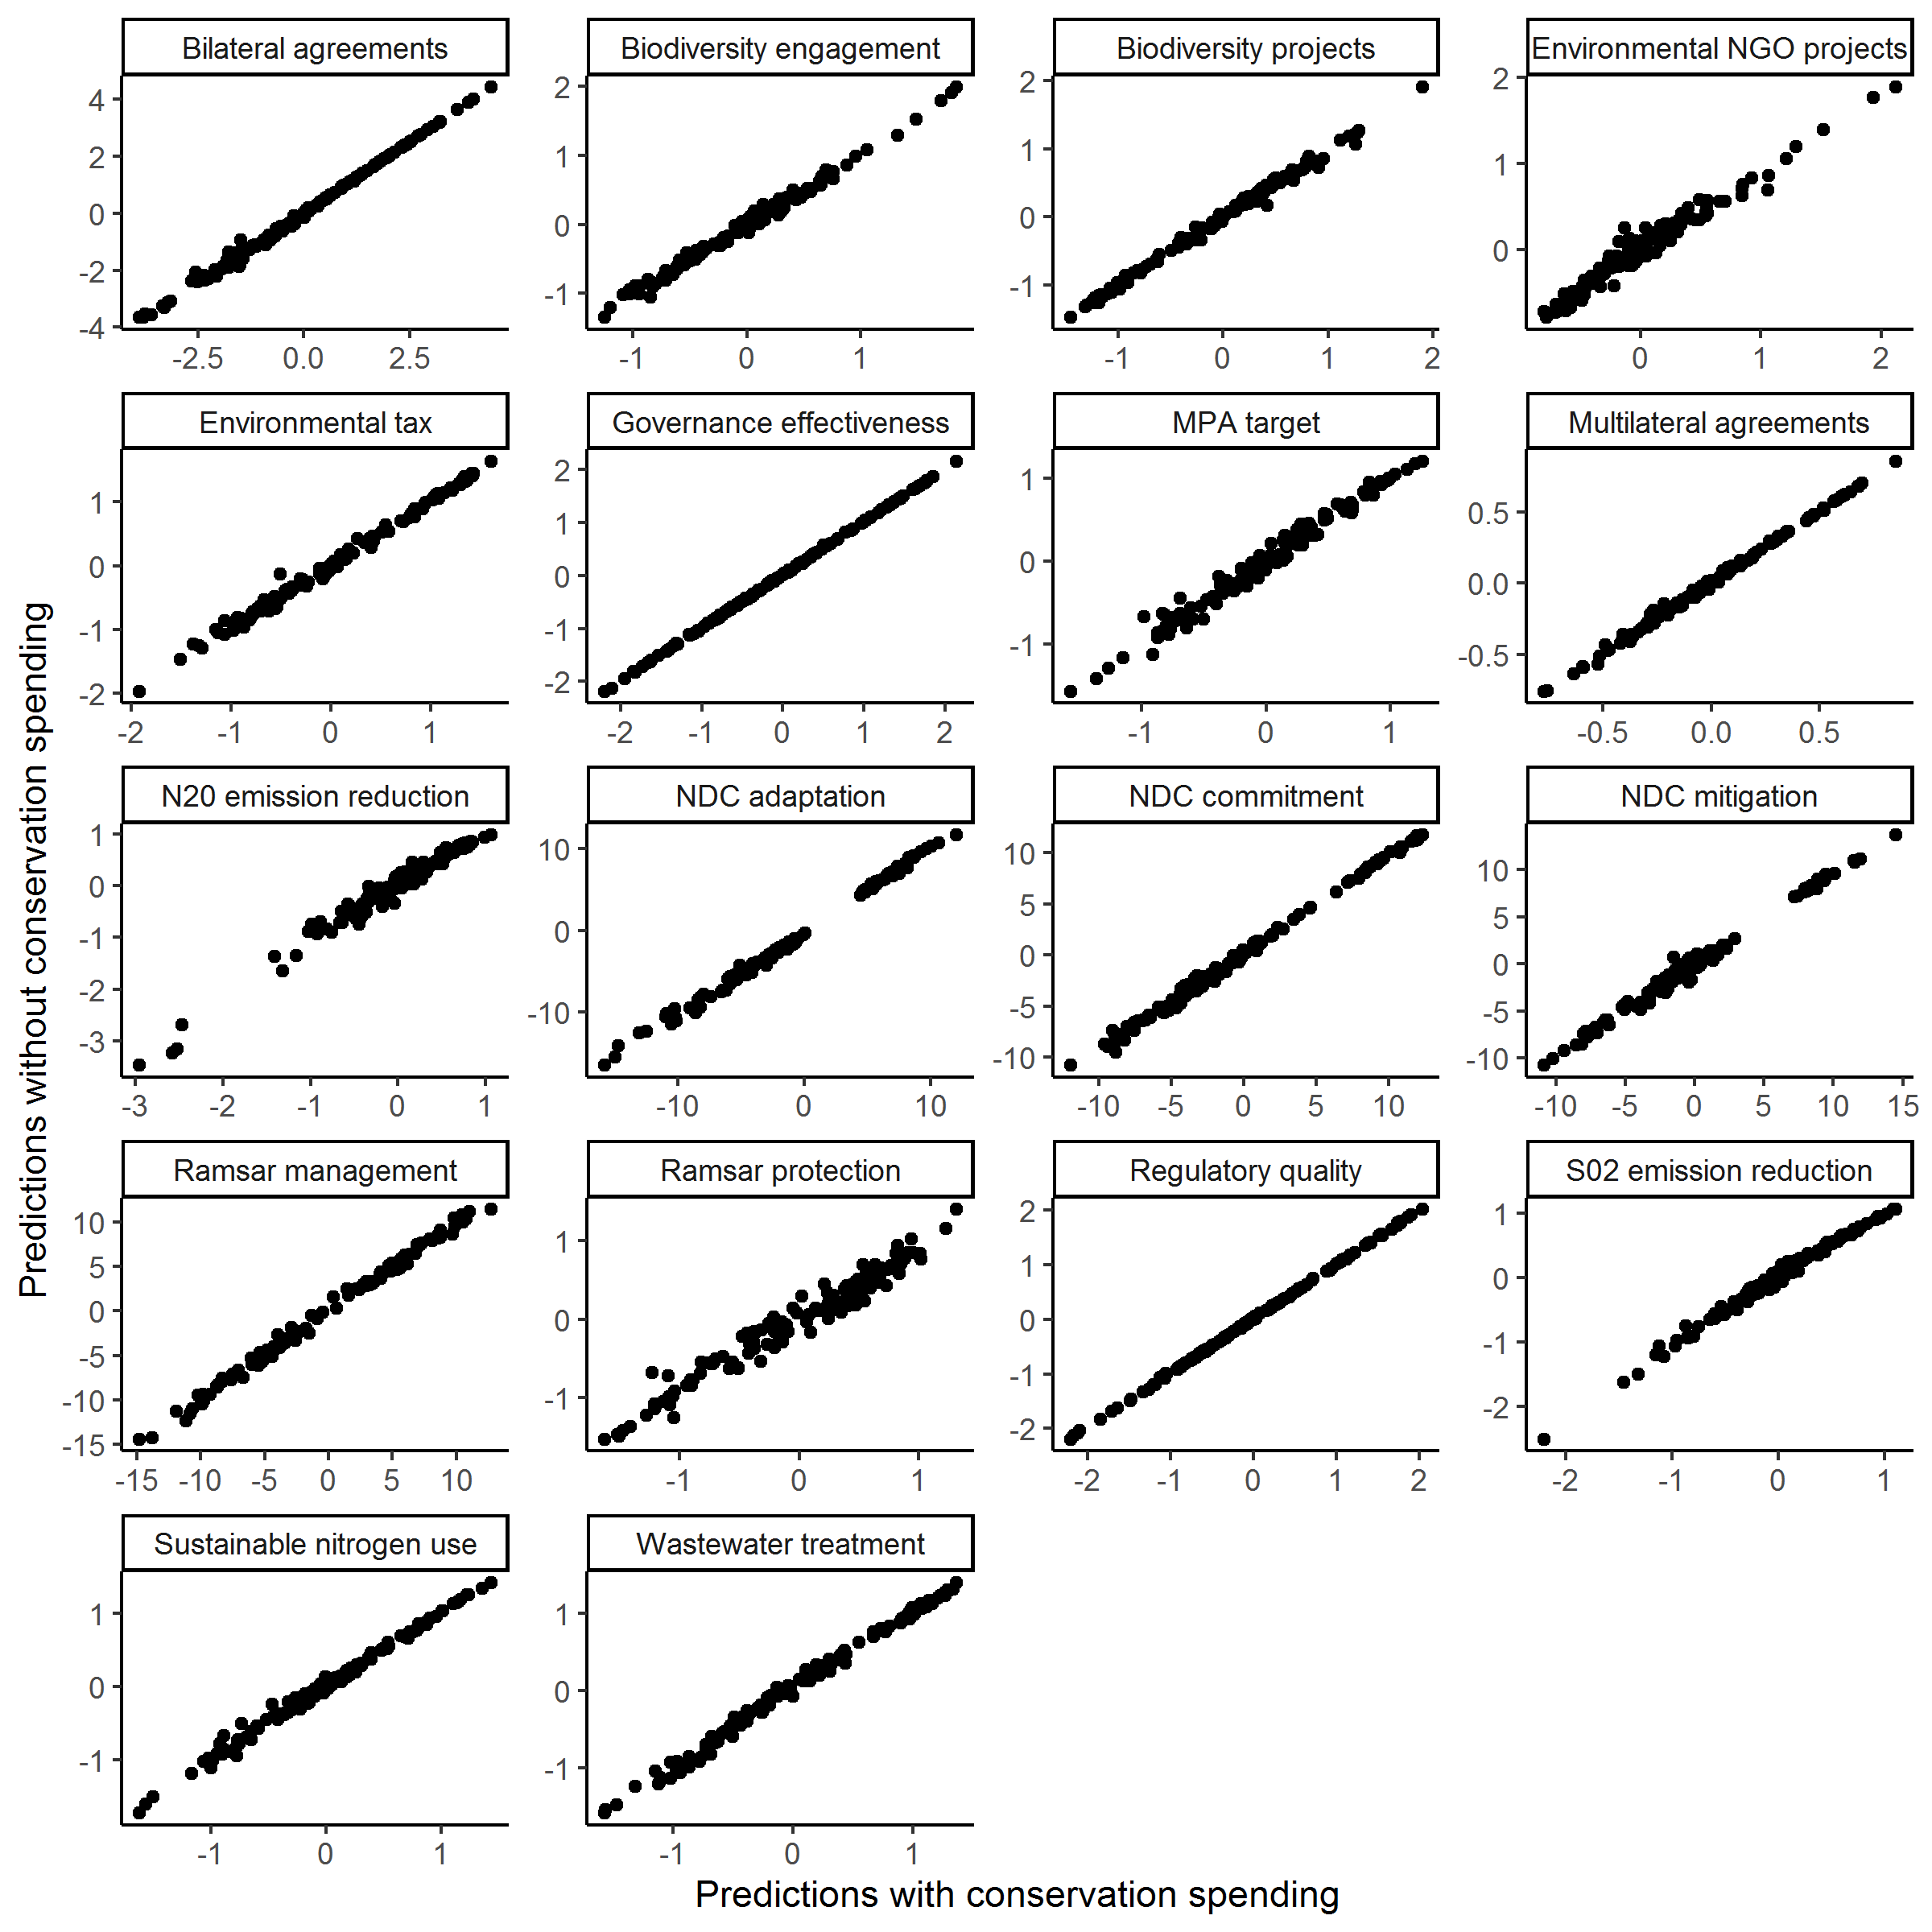
Fig. S3. Correlation of predictions from latent variable models fit with and without the ‘Conservation spending’ indicator.
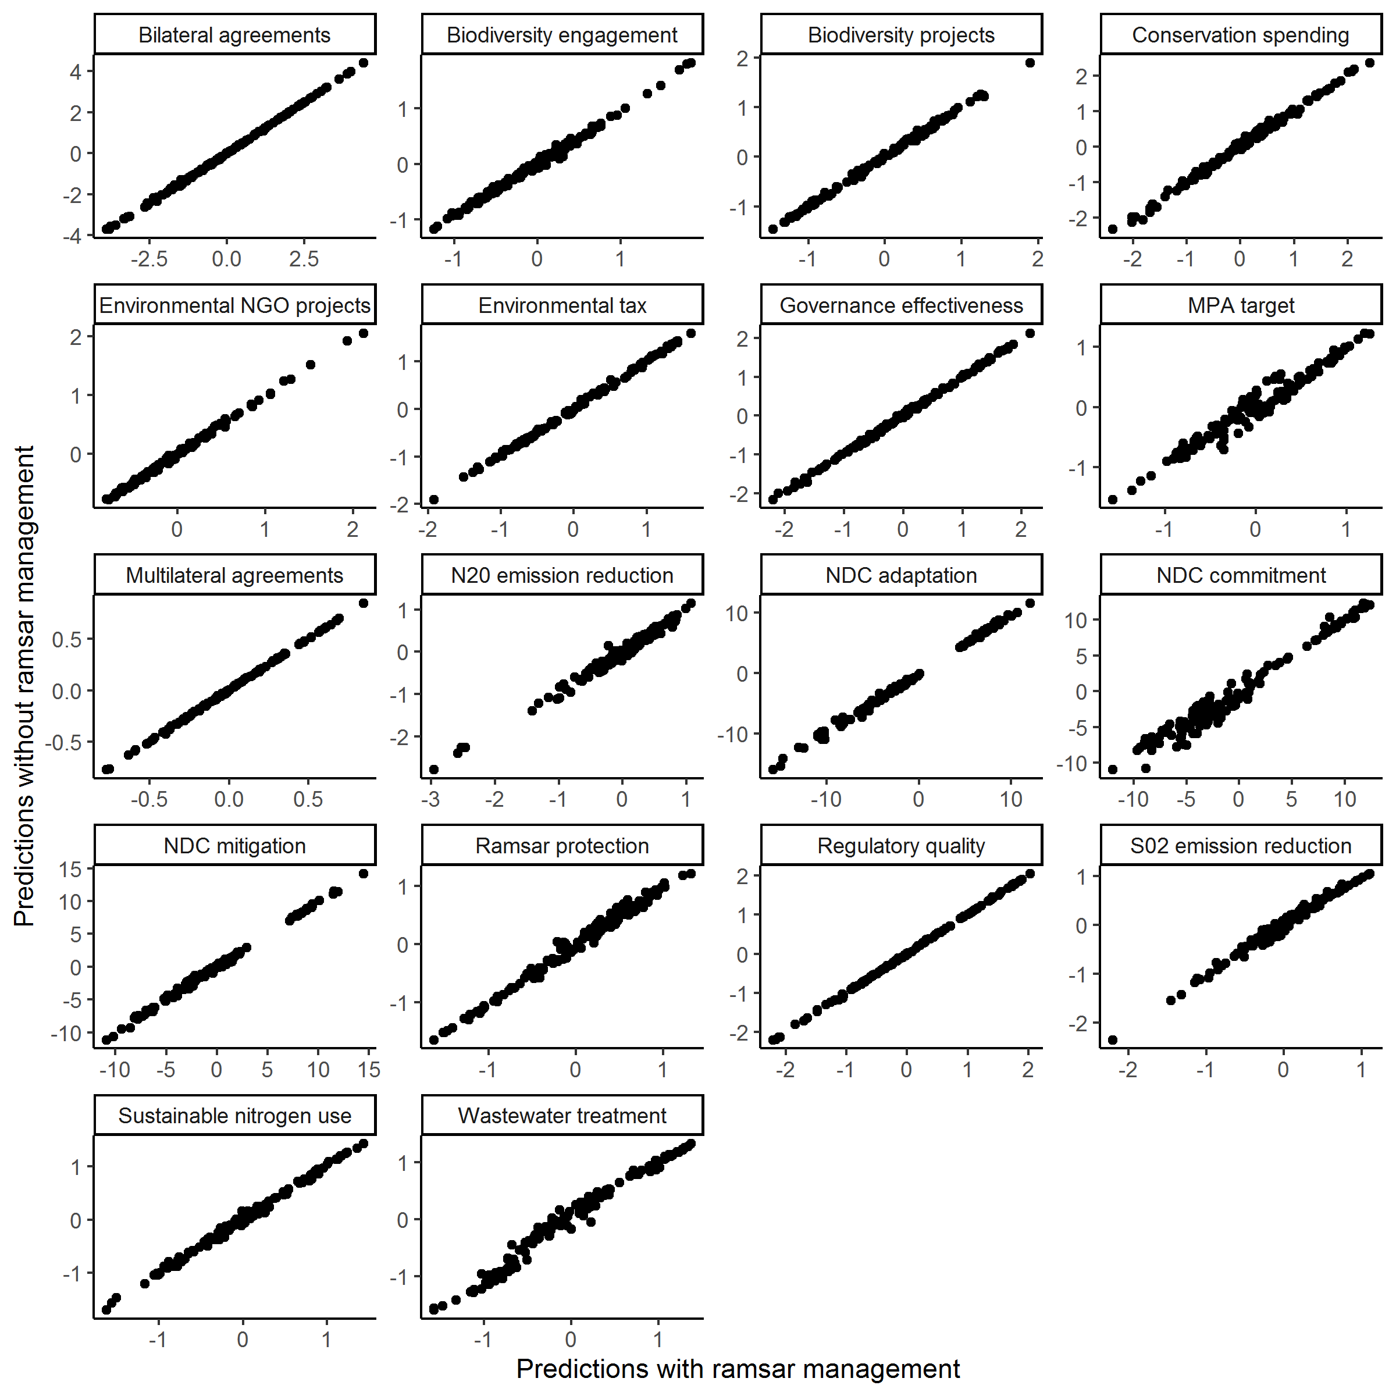
Fig. S4. Correlation of predictions from latent variable models fit with and without the ‘Ramsar Management’ indicator.

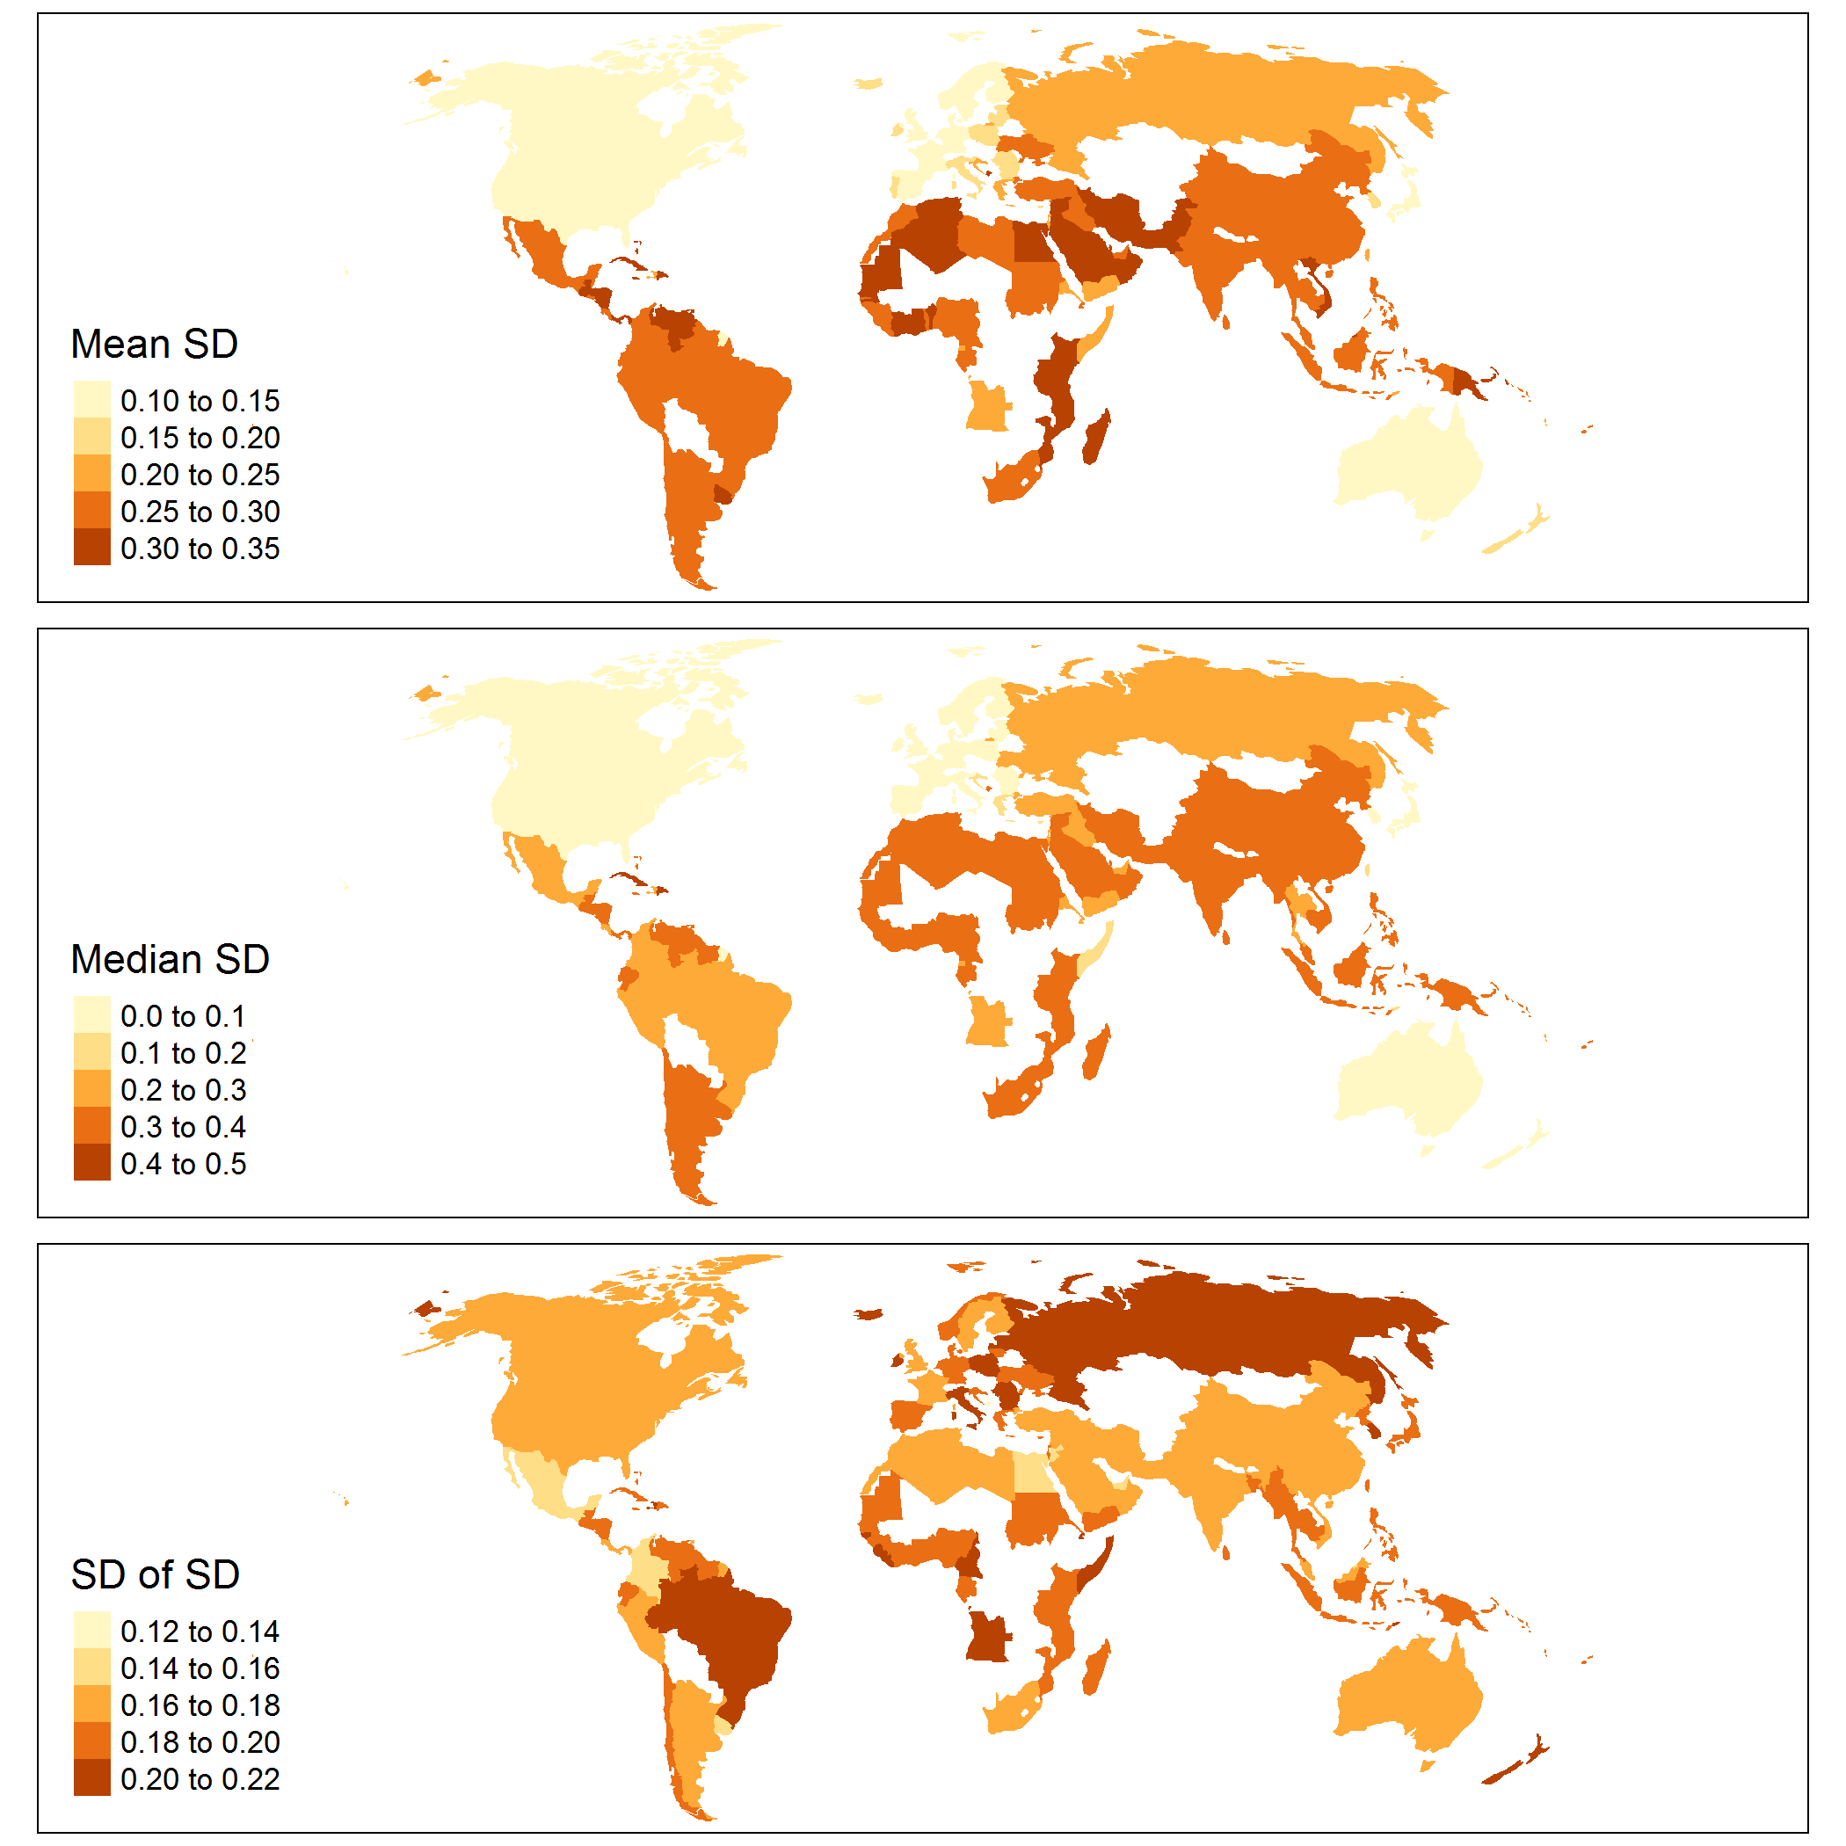
Fig. S5. Maps showing statistics for each country that measure how much uncertainty there was in the inclusion or exclusion of other countries in its cluster. Low mean or median SD values indicate that a country was highly likely to be clustered with the same countries across the full distribution of indicator values predicted by the latent variable model. Low standard deviation of SD values indicates that there was low variability in whether a country was likely to be clustered with the same countries.

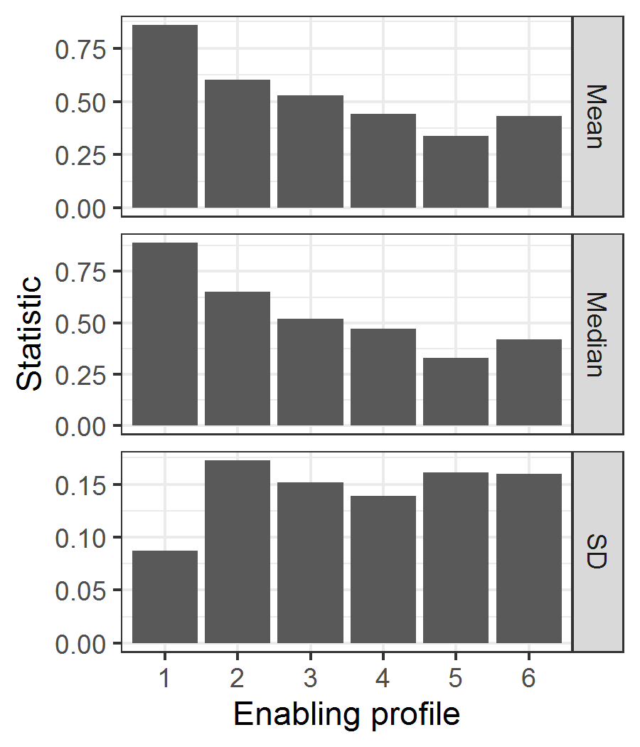
Fig. S6. Statistics that measure how much uncertainty there was in the pairwise probability of countries being included in each enabling profile. Higher mean and median values indicate there was higher probability of pairwise inclusion of countries in a profile. Higher standard deviation values indicates there was higher variation in the pairwise inclusion of countries in a profile.
Table S4. Description of drivers of mangrove loss (Goldberg et al. 2020) and seagrass trends (Dunic et al. 2021).
Category | Driver | Seagrass sub-drivers (Dunic et al. 2021) | Description
Mangrove | Human settlement | - | Human settlements such as cities and villages.
Mangrove | Commodities (agri/aquaculture) | - | Agriculture, aquaculture, oil palm, rice.
Mangrove | Erosion | - | Conversion to open water or mudflat.
Mangrove | Non-productive conversion | - | Mining, oil extraction, etc., and mangrove loss within a 5.5km of human settlements and roads.
Mangrove | Extreme weather event | - | Drought, cyclone, etc.
Seagrass | Aquaculture and fishing | Aquaculture/  fishing | Oyster farming, fish farming, bait grubbing, bivalve trawling, recreational bivalve harvesting.
Seagrass | Boating | Boating | Mooring, propellor scarring.
Seagrass | Catchment processes | Coastal development/ Management/restoration/ Water quality/ Pollution/ Hydrology | Land appropriation, shoreline armouring, coastline construction, land use change (e.g., logging, agriculture), dredging, port construction, urbanisation, removal of dikes/coastal armouring, storm water run-off regulations, relocation of wastewater outfalls, algae blooms, chlorophyll, depth, nutrients (nitrogen, phosphorous), oxygen, ocean acidification, salinity, sedimentation, turbidity, water quality metrics, herbicides, oil spills, land based pollution (non-nutrient), coastal erosion, flood, sea level, sediment deposition patterns (e.g., sand banks), water velocity.
Seagrass | Disease | Disease | Wasting disease (e.g., Labyrinthula zosterae).
Seagrass | Climate and storms | Climate/Storms | Precipitation, temperature, drought, warming, above average wet seasons, El Niño, ice cover, hurricanes/typhoons, flooding, storm swell, wind velocity.

Appendix 1: Supplemental methods
Azerbaijan, Turkmenistan and Kazakhstan EEZ boundaries intersected with seagrass in the landlocked Caspian Sea but were not included in our analysis due to lack of oceanic coastline. Indicator coefficients were estimated with Markov Chain Monte Carlo (MCMC) sampling using weakly informative normal priors (mean = 0 and variance = 10) and likelihoods appropriate to the distributions of each indicator (i.e., a normal distribution (with identity link) for continuous response variables, a Poisson (with log link) for count response variables, and a binomial (with probit link) for binary response variables). We set the length of the MCMC chain to 50,000, discarded 2,000 in the burn-in period, and used a thinning rate of 5, leaving 9,600 samples. The convergence of MCMC chains was verified with Geweke convergence diagnostics adjusted for multiple comparisons (Geweke 1992) and visual inspection of MCMC trace plots. Model fit was assessed with randomized quantile residuals (Dunn and Smyth 1996). Analyses were performed in R version 3.5.2 (R Core Team 2018). LVMs were fit in using the R package ‘boral’ (‘Bayesian ordination and regression analysis’; Hui 2020), cluster analysis with the R package ‘cluster’ (Maechler et al. 2019), and classification trees with the R package ‘rpart’ (Therneau and Atkinson 2018).
References
Brodie, G., Holland, E., N’Yeurt, A. D. R., Soapi, K., & Hills, J. (2020). Seagrasses and seagrass habitats in Pacific small island developing states: Potential loss of benefits via human disturbance and climate change. Marine Pollution Bulletin, 160. https://doi.org/10.1016/j.marpolbul.2020.111573
de los Santos, C. B., Krause-Jensen, D., Alcoverro, T., Marbà, N., Duarte, C. M., van Katwijk, M. M., Pérez, M., Romero, J., Sánchez-Lizaso, J. L., Roca, G., Jankowska, E., Pérez-Lloréns, J. L., Fournier, J., Montefalcone, M., Pergent, G., Ruiz, J. M., Cabaço, S., Cook, K., Wilkes, R. J., … Santos, R. (2019). Recent trend reversal for declining European seagrass meadows. Nature Communications, 10(1). https://doi.org/10.1038/s41467-019-11340-4
Duke, N. C., Bell, A. M., Pederson, D. K., Roelfsema, C. M., & Nash, S. B. (2005). Herbicides implicated as the cause of severe mangrove dieback in the Mackay region, NE Australia: Consequences for marine plant habitats of the GBR World Heritage Area. Marine Pollution Bulletin, 51(1–4), 308–324 https://doi.org/10.1016/j.marpolbul.2004.10.040
Dunic, J. C., Brown, C. J., Connolly, R. M., Turschwell, M. P., & Côté, I. M. (2021). Long-term declines and recovery of meadow area across the world’s seagrass bioregions. Global Change Biology, 27, 4096–4109. https://doi.org/10.1111/gcb.15684

Dunn, P. K., & Smyth, G. K. (1996). Randomized Quantile Residuals. Journal of Computational and Graphical Statistics, 5(3), 236–244.

Geweke, J. (1992). Evaluating the accuracy of sampling-based approaches to the calculations of posterior moments. Bayesian Statistics, 4, 641–649.

Goldberg, L., Lagomasino, D., Thomas, N., & Fatoyinbo, T. (2020). Global declines in human‐driven mangrove loss. Global Change Biology, gcb.15275. https://doi.org/10.1111/gcb.15275

Hui, F. (2020). boral: Bayesian Ordination and Regression Analysis. R Package Version 1.8.1.

King, J., Alexander, F., & Brodie, J. (2013). Regulation of pesticides in Australia: The Great Barrier Reef as a case study for evaluating effectiveness. Agriculture, Ecosystems and Environment, 180, 54–67. https://doi.org/10.1016/j.agee.2012.07.001
Kletou, D., Kleitou, P., Savva, I., Attrill, M. J., Antoniou, C., & Hall-Spencer, J. M. (2018). Seagrass recovery after fish farm relocation in the eastern Mediterranean. Marine Environmental Research, 140, 221–233. https://doi.org/10.1016/j.marenvres.2018.06.007
Long, S., Jones, P. J. S., Randriana, Z., & Hadj-Hammou, J. (2021). Governance analysis of a community managed small-scale crab fishery in Madagascar: novel use of an empirical framework. Marine Policy, 127. https://doi.org/10.1016/j.marpol.2017.11.022
Maechler, M., Rousseeuw, P., Struyf, A., Hubert, M., & Hornik, K. (2019). cluster: Cluster Analysis Basics and Extensions. R Package Version 2.1.0.

R Core Team. (2018). R: A language and environment for statistical computing. R Foundation for Statistical Computing, Vienna, Austria.

Shilland, R., Grimsditch, G., Ahmed, M., Bandeira, S., Kennedy, H., Potouroglou, M., & Huxham, M. (2021). A question of standards: Adapting carbon and other PES markets to work for community seagrass conservation. Marine Policy, 129. https://doi.org/10.1016/j.marpol.2021.104574

Smith, A. H., & Berkes, F. (1993). Community-based use of mangrove resources in st. lucia. International Journal of Environmental Studies, 43(2–3), 123–131. https://doi.org/10.1080/00207239308710819
Therneau, T., & Atkinson, B. (2018). rpart: Recursive Partitioning and Regression Trees. R Package Version 4.1-13.

Winterwerp, J. C., Albers, T., Anthony, E. J., Friess, D. A., Mancheño, A. G., Moseley, K., Muhari, A., Naipal, S., Noordermeer, J., Oost, A., Saengsupavanich, C., Tas, S. A. J., Tonneijck, F. H., Wilms, T., van Bijsterveldt, C., van Eijk, P., van Lavieren, E., & van Wesenbeeck, B. K. (2020). Managing erosion of mangrove-mud coasts with permeable dams – lessons learned. Ecological Engineering, 158. https://doi.org/10.1016/j.ecoleng.2020.106078

WorldFish. (2018). Conservation strategy for dugongs and seagrass habitats in Solomon Islands. Penang, Malaysia: WorldFish. Strategy 2018-22.

